# Web Development 1 – Lab Session 8

**Using flex boxes for horizontal nav bars**

Today you will be using CSS styling to create navigation bars from simple lists of links. We’ll build a professional looking horiontal navigation bar from scratch, step-by-step.

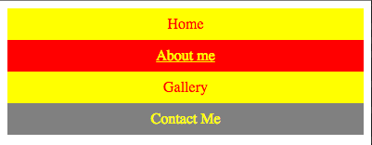 **Exercise 1: Build a vertical nav bar**

First create a vertical navigation bar from an   
unordered list (or use your one from previous lab exercise):

* Create an unordered list of links: Home / About me / Gallery / Contact Me
* Remove list styling
* Make ‘a’ elements display as block
* Default – red text / yellow background / no underline
* Mouse hover – yellow text / red background / underline
* Current page – yellow text / grey background / no underline

**Exercise 3: Declare the ‘ul’ element to display as a ‘flex’ box**

Macintosh HD:Users:matt:Copy:_m_2015_TEACHING:comp_1_webDev1:05_units:week 08:lab08_navbars_horizontal:SOLUTIONS:ex2:screenshots:Screen Shot 2014-11-04 at 11.37.26.pngAdd a CSS rule to make the ‘ul’ list block element display as a ‘flex’ box.

**Hints:**

nav ul {

display: flex;

**You should now see all the link blocks stacked left-to-right, horizontally on the same line … The magic of ‘flex’ – it allows blocks to stack next to each other if there is room.**

**Exercise 3: Declare the ‘li’ elements to equally share flex space**

Macintosh HD:Users:matt:Copy:_m_2015_TEACHING:comp_1_webDev1:05_units:week 08:lab08_navbars_horizontal:SOLUTIONS:ex3:screenshots:Screen Shot 2014-11-04 at 11.39.14.pngAdd a CSS rule to make ‘li’ elements share spare space equally (all share ration of 1 share each):

**Hints:**

nav li {

flex: 1;

**Exercise 4: Add border and make elements ‘wrap’ if squashed to small**

Add a CSS rule to add a 0.1rem border to each ‘a’ element.

Add CSS rule to the ‘ul’ to set flex-wra to **wrap**

Change CSS rule to the ‘li to set minimum width at which point to wrap to next line (WARNING: don’t make this minimum too small, otherwise it is unlikely to ever wrap)

Duplicate the list elements, so you have twice as many links.

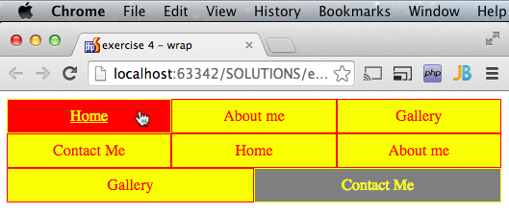

**Hints:**

nav ul {

flex-wrap: wrap;

nav li {

flex: 1 0 10rem;

nav a {

border: 0.1rem solid;