1. Write a program which accepts a sequence of comma-separated numbers from console and generate a list

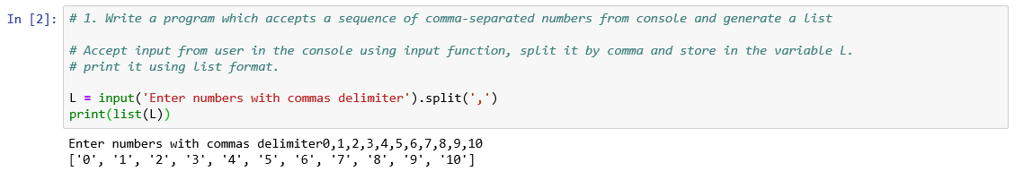

2. Create the below pattern using nested for loop in Python.

\*

\* \*

\* \* \*

\* \* \* \*

\* \* \* \* \*

\* \* \* \*

\* \* \*

\* \*

\*

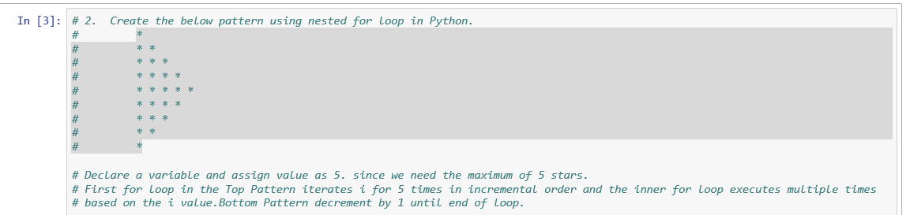

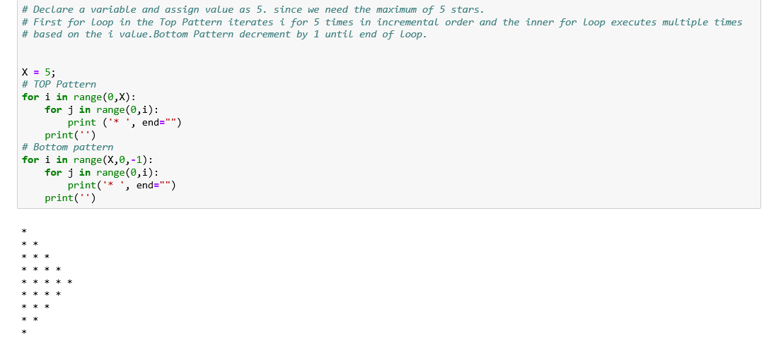

3. Write a Python program to reverse a word after accepting the input from the user.

Sample Output:

Input word: AcadGild

Output: dilGdacA

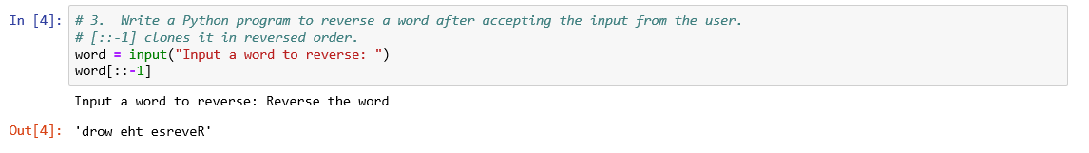

4. Write a Python Program to print the given string in the format specified in the ​sample output.

WE, THE PEOPLE OF INDIA, having solemnly resolved to constitute India into a SOVEREIGN, SOCIALIST, SECULAR, DEMOCRATIC REPUBLIC and to secure to all its citizens

Sample Output:

WE, THE PEOPLE OF INDIA, having solemnly resolved to constitute India into a SOVEREIGN, ! SOCIALIST, SECULAR, DEMOCRATIC REPUBLIC and to secure to all its citizens

