**Interactive Instructions**

* Download the free g*power software and manual from the following website: <http://www.gpower.hhu.de>
* Identify the types of models that we cover in the course and simulate various scenarios to see how changing effect size, alpha level, etc. changes the required sample size for the research analysis

Small, medium and large effect sizes

G*Power Example

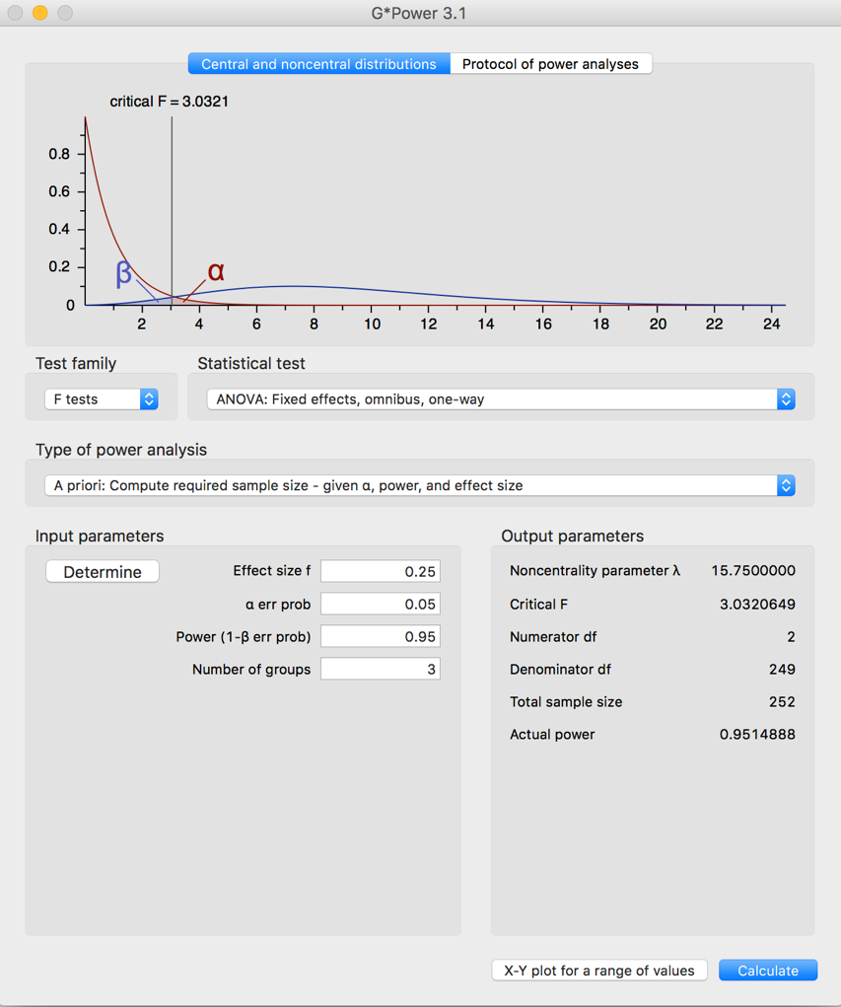Cohen’s d (e.g. t-test)

d = .2

d = .5

d = .8

Correlation coefficient

r = .10

r = .30

r = .50

Chi-square

w = .10

w = .30

w = .50

F-test (ANOVA)

f = .10

f = .25

f = .40

R2 (multiple regression)

f2 = .02

f2 = .15

f2 = .35

Notes: The default appears to be a medium effect size and alpha level (Type I error rate) of .05. You will need to put in the number of groups, if using F tests: ANOVA. You should always do the a priori power for the proposal stage or prior to conducting the research.