Section 2: Week 5: Interpreting Results

Nate Bachmeier

TIM-7101: Statistics for Technology Leaders

August 2, 2020

Northcentral University

# Interpreting Results

NCU-Cares (NCU-C) is a politically neutral non-profit that seeks to improve the work through targeted lobbying efforts. The death of George Floyd has risen the debate of police violence and reform to the national stage (Crary & Morrison, 2020). While the topic rests on American’s hearts and minds, it has also become highly partisan with many efforts to undermind the conversation (McCaskill, 2020). After collecting and assessing information from the Washington Post, the organization needs to frame those results into actionable recommendations and enumerate any limitations. Limitations always exist in research due to insufficient time and resources to consider all aspects of a problem (García-Pérez, 2012). Through clarification of these issues, researchers can reduce the impression of being bias or misleading and guide further conversations.

# What are the observations

## Expected Outcome

The Washington Post’s collects demographic, location, and contextual information on victims of police violence from January 2015 through the present. Researchers and media sources use this data to quantify the racial basis of law enforcement. Their observations become statistical statements such as “unarmed Blacks are twice as likely as Whites to be the victim (Nix, Campbell, Byers, & Alpert, 2017).” Another frequently cited metric that “Black people were 24% of those killed despite being only 13% of the population (KBP, 2020).” Over 200 publications that reference Nix et al.’s paper in Nature magazine and Google returns 7.7 million results for the second quote. When NCU-C set out to assess the problem, the initial expectation was to find racial inequality and bias decisions against people of color. While both of these conclusions are true, that does not appear to be the entire story about police brutality in America.

## Actual Outcome

Figure 1: Fatalities by State (2015-2019)

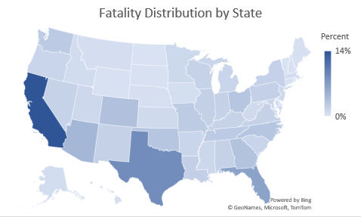 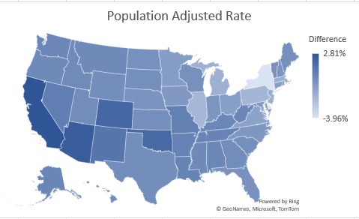

NCU-C’s investigations show that the method of sub-grouping and classification has significantly more impact on the results than any arbitrary feature. For instance, of the 4937 records, California and Texas own 14% and 9% of incidents, respectively (see Figure 1). There might be specific challenges within those states; however, they are also home to 12% and 9% of the national population (Census Bureau, 2019). Assuming all other things are equal, the actual number of fatalities less expected fatalities based on population shows the rates are relatively stable across the country.