Section 2: Week 6: Evaluate the Process

Nate Bachmeier

TIM-7101: Statistics for Technology Leaders

September 6th, 2020

Northcentral University

# Evaluate the Process

Now that NCU-Cares (NCU-C) has completed its data inference, the final step is to evaluate the process retrospectively. There are often limitations to research projects, and this results in needing to adapt either the scope or approach of the statistical application. From retrospectively assessing these situations, the business can identify deficiencies and critical learning to improve future efforts. Finally, a plan for gaining stakeholder buy-in must exist, so that the recommendations transcend into business priorities and actions.

# Review the Business Case

## Primary Objective

NCU-CARES (NCU-C) is a politically neutral nonprofit organization that seeks to make the world a better place by lobbying for policy changes to social-economic challenges. The group begins each project by understanding the landscape of an issue through the lens of statical models. These models feed into every aspect of the decision process to maximize the impact while also minimizing resource expenses. NCU-C’s portfolio contains several high profile efforts such as reducing climate change, improving access to clean water, and providing medical resources to underserved nations. After recently receiving a sizable donation, the institution can hire a dedicated staff to pursue one more initiative. Rarely does such an event occur, and NCU-C does not want to waste this opportunity. Three areas of particular interest include COVD-19, the presidential election, and the police violence debate.

## Decision Rationale

While there is substantial value in each topic, the organization believes that addressing police violence is the best use of its talents and skills. This issue is challenging to investigate because its a highly partisan matter with many efforts to undermind the conversation (McCaskill, 2020). On the one hand, an argument exists that defunding the police will force systematic change (BLM, 2020). After cutting the law enforcement budget, the state department could repurpose those monies into civil and medical services. On the other hand, are concerns that these changes would enable a “symbol of hate (Trump, 2020)” and reducing the safety of all parties. It is unlikely that either side is entirely right or wrong, and this situation requires an unbiased mediator to assess claims quantitively before the punitive rhetoric will abate (Smith, 2020). Working to restore public confidence and fill this gap represents a unique opportunity for the organization.

# Review the Process and Outcomes

## Data Sourcing

There are numerous strategies for approaching this problem with varying levels of sophistication and planning. One standard solution is to perform statistical application analysis on the Washington Post’s police shootings data set (Nix, Campbell, Byers, & Alpert, 2017). This data source contains demographic, location, and contextual information on all publically known fatalities of police violence between 2015 to the present (Washington Post, 2020). While there are several limitations to this aggregate feed, it does provides an unbiased sampling of the broader population.

## Identifying Questions

Annually nearly one thousand citizens die from police violence, which raises the central question, why? The collective perspective of the Black Lives Matter movement is that police exert disproportionate force against people of color (BLM, 2020). This perspective often comes with the quote that “Black civilians were more than twice as likely as White civilians to be unarmed (Nix, Campbell, Byers, & Alpert, 2017)” during the fatality. Nevertheless, others argue the brutality victims are experiencing a mental health crisis, and this is the actual reason (Lamb, Weinberger, & DeCuir, 2014). While these perspectives efficiently drive media headlines, are they both missing the forest among the trees? Does another factor more accurately explain the challenges that are occurring? Instead, NCU-C hypothesizes that neither *sanity* nor *race* is the driving cause of police violence. Alternatively, *provocation* might better explain the need for violent escalations that result in death.

## Collecting the Results

Figure 1: Victims by Race

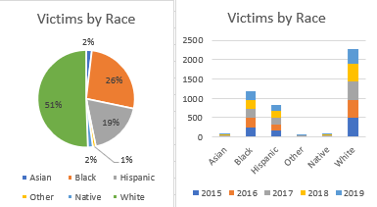

NCU-C began the exploration process by collecting descriptive statistics about the victims in terms of *age*, *race*, and *sanity* (see Figure 1). Using a variate of measurements and pivots, then assessed the statistical effect of these features against one another. These suggest that people of color tend to have fatal altercations younger than White people (see Table 1).

Table 1: Influence of Age

|  |  |  |  |  |  |
| --- | --- | --- | --- | --- | --- |
| Race | Mean | Standard Deviation | Effect vs. White | Effect vs. Black | Effect vs. Hispanic |
| All | 37.12 | 13.12 | -0.11 | 0.38 | 0.30 |
| White | 39.95 | 13.37 | -- | 0.61 | 0.54 |
| Black | 32.47 | 11.33 | -0.38 | -- | -0.10 |
| Hispanic | 33.54 | 10.87 | -0.30 | 0.10 | -- |

DeCarlo (2018) states that quasi-experiments are particularly useful in social welfare policy research (see chapter 12.2). Under a quasi-experiment, the researcher team does not use random assignment and instead looks at different populations. This method could be highly effective for examining the impact of both *race* and *sanity* variables. Using this method to perform all-versus-one comparisons concludes that *race* and *age* are not the dominant traits. Similarly, *sanity,* asreported in the signs of mental illness column, does not a robust statistical prediction of these records (see Table 2).

Table 2: Effect of Mental Health

|  |  |  |  |  |
| --- | --- | --- | --- | --- |
| Mental Illness | Mean (Age) | Standard Deviation | Effect vs. All | Effect vs. Sane |
| Yes | 39.74 | 13.87 | 0.20 | 0.25 |
| No | 36.35 | 12.80 | -0.06 | -- |

## Alternative Variable

The data set includes the ‘armed’ column that contains free-form text describing any weapons on the victim. One of the challenges with analyzing this field comes from the various subtle differences in its values (e.g., *baseball bat* versus *baseball bat and bottle*). Enhancements of each record include categorical-features that bucket the weapons by genre. These buckets are named projectiles, sharp/blunt instruments, tool/small objects, explosive, unspecified, vehicles, and unarmed. When the suspect has multiple weapons, such as both gun and knife, the higher risk object dictates the category. According to these categorical-aggregations, roughly 58% of victims had a firearm, plus another 18% had a sharp/blunt instrument (see Figure 2).

Nationally fifty-three million people have an interaction with a law enforcement officer each year (BJS, 2015). Of this population, annually, approximately one thousand dies. These figures suggest that roughly 0.0019% of all interactions end with the officer killing the suspect. Further removing situations with guns and knives (76%) reduces the figure to 0.00046% of interactions result in death!

Figure 2: Victim Weapon Category

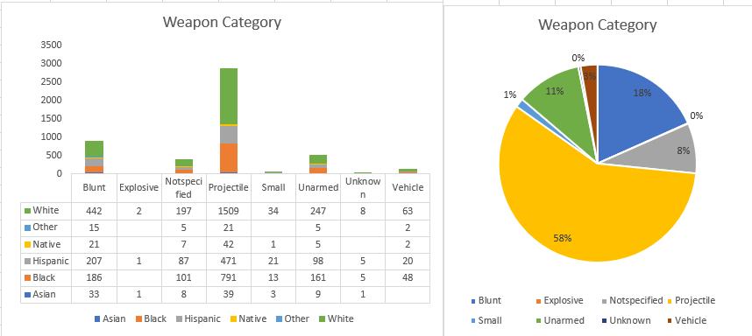

# Learnings and Process Changes

## Results versus Popular Opinion

Researchers and media sources use the Washington Post’s data to quantify the racial basis of law enforcement. Their observations become statistical statements such as “unarmed Blacks are twice as likely as Whites to be the victim (Nix, Campbell, Byers, & Alpert, 2017).” Another frequently cited metric that “Black people were 24% of those killed despite being only 13% of the population (KBP, 2020).” Over 200 publications that reference Nix et al.’s paper in Nature magazine and Google returns 7.7 million results for the second quote. When NCU-C set out to assess the problem, the initial expectation was to find racial inequality and bias decisions against people of color. While both of these conclusions are true, that does not appear to be the entire story about police brutality in America.

## Changes to Explain Difference

Since the initial statistical exploration suggests that these crimes are not racially bias, then the change in direction is necessary to explain these commonly cited metrics. This change rejects the perspective that its acceptable to treat the country as a homogenous cluster. Instead, decomposing America into regions allows for a more accurate assessment of the relevant population counts to include. For example, since at least 2015, no police officer has killed a Hispanic person in Montana (Washington Post, 2020). However, this group also only represents 38,000 (less than 4%) of that state’s inhabitants (Census Bureau, 2019). Then consider that Texas has over 11 million (39.4%) residents of Hispanic and Latino descent. Police violence in this state has killed 432 people during this same period, of which 143 (33%) were Hispanic (see Figure 3).

Figure 3: Hispanic Victims by State

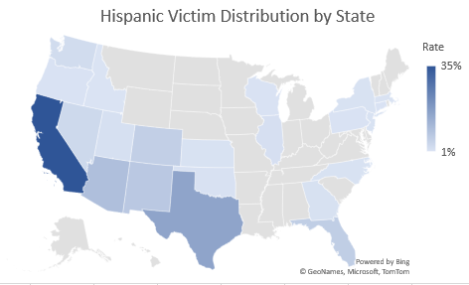 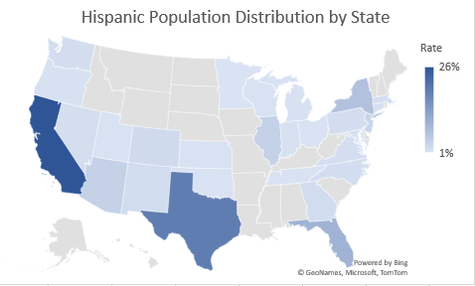

After plotting the distribution of other groups, like Black victims in terms of population per state, results in similar charts (see Figure 4). These pivots suggest that the deaths are not racially motivated, and instead, a function of the locale-specific population make-up. If that was not the case, then more pronounced outliers should exist with substantially higher victim rates relative to the group’s population. This outcome also hints that some other motivator outside of the *race* is likely to exist.

Figure 4: Black Victims by State

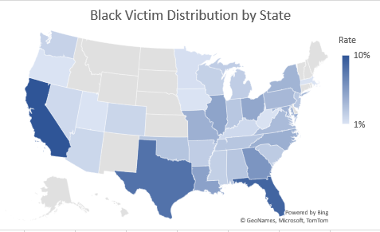 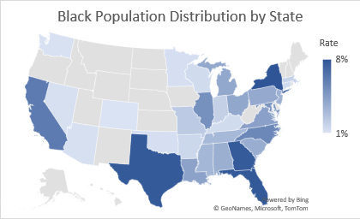

# Obtaining Stakeholder Buy-in

## Recommended Strategy

There are fifty-three million people who have an interaction with the police each year (BJS, 2015). Annually, 167 (+/- 6) officers and 66 (+/- 16) unarmed civilians die during these altercations (NLEOMF, 2019). These situations have to introduce a wide range of emotions and hostility, which creates challenges while balancing the safety of officers and civilians. NCU-C should invest additional resources into exploring solutions to reduce this friction. For instance, of the incidents that result in death, 76% (3853 of 4937) involve the suspect having a weapon (see Figure 5). Training and procedures could exist to address these scenarios in a manner that improves the probability of a peaceful resolution. While it does not address all of the concerns, this is a significant source of police brutality. Specifically, the unarmed and unspecified groups need further consideration to reduce the loss of life for these subgroups. However, it might be impossible to eliminate due to this group representing 0.00002% (119 of 53 million) interactions per year.

Figure 4: Suspect Armed Category 2015-2019 Total

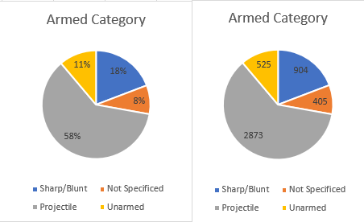

# References

BJS. (2015, October). *Contacts between police and the public*. Retrieved from Bureau of Justice Statistics: https://www.bjs.gov/content/pub/pdf/cpp15_sum.pdf

BLM. (2020, May 30th). *#DefundThePolice*. Retrieved from Blac Lives Matter: https://blacklivesmatter.com/defundthepolice/

Census Bureau. (2019). *Quick facts*. Retrieved from United States Census Bureau: https://www.census.gov/quickfacts/fact/table/US/PST045219

DeCarlo, M. (2018). *Principles of Sociological Inquiry: Qualitative and Quantitative Methods.* Blackstone Textbooks. Retrieved from https://scientificinquiryinsocialwork.pressbooks.com/chapter/12-1-experimental-design-what-is-it-and-when-should-it-be-used/

KBP. (2020, August 11th). *Police shootings database*. Retrieved from Killed By Police: https://killedbypolice.net/

Lamb, H., Weinberger, L., & DeCuir, W. (2014). The police and mental health. *Psychiatric Services, 53*(10), 1266-1271. doi:https://doi.org/10.1176/appi.ps.53.10.1266

McCaskill, N. (2020, July 16th). *Trump has tried to make 'Black Lives Matter' a partisan issue. A federal agency says it is not.* Retrieved from Politico: https://www.politico.com/news/2020/07/16/trump-special-counsel-black-lives-matter-366177

Nix, J., Campbell, B., Byers, E., & Alpert, G. (2017, February 8th). A bird's eye view of civilians killed by police in 2015. *Criminology and public policy, 16*(1), 309-340. doi:https://doi-org.proxy1.ncu.edu/10.1111/1745-9133.12269

NLEOMF. (2019, April 10th). *A year-by-Year breakdown of law enforcement deaths throughout U.S. history*. Retrieved from National Law Enforcement Officers Memorial Fund: https://nleomf.org/facts-figures/officer-deaths-by-year

Smith, C. (2020, Spring). Blue lives matter versus black lives matter: beneficial social policies as the path away from punitive rhetoric and harm. *Vermont Law Review, 44*(3), 463-291. Retrieved from https://search-ebscohost-com.proxy1.ncu.edu/login.aspx?direct=true&db=ofs&AN=143809860&site=eds-liv

Trump, D. (2020, July 1st). *@realDonalTrump*. Retrieved from Twitter: https://twitter.com/realDonaldTrump/status/1278324681477689349

Washington Post. (2020, August 1st). *Data police shootings*. Retrieved from GitHub: https://github.com/washingtonpost/data-police-shootings/commit/2ea87a4ed725b164be1489878e20827fb5944d1b