Section 3: Week 7: Formulate a Strategic Plan

Nate Bachmeier

TIM-7101: Statistics for Technology Leaders

September 13, 2020

Northcentral University

# Formulate a Strategic Plan

NCU-CARES (NCU-C) is a politically neutral nonprofit organization that seeks to make the world a better place by lobbying for policy changes to social-economic challenges. The group begins each project by understanding the landscape of an issue through the lens of statical models. These models feed into every aspect of the decision process to maximize the impact while also minimizing resource expenses. After recently receiving a sizable donation, the institution can hire a dedicated staff to pursue one more initiative. Rarely does such an event occur, and NCU-C does not want to waste this opportunity. The organization chose to focus on police violence and devise a campaign to address its challenges.

## Research Objectives and Biases

Before entering the details of the analysis, it is essential to call out the scope and focus of this effort. NCU-C is specifically evaluating situations that result in a civilian fatality and then framing those results into a macro-economic perspective. The organization is explicitly avoiding micro-economic views that focus on individual events. Racial issues quickly diverge into anecdotal evidence and historical challenges. Likewise, controversy often proceeds from preventable death and is bound to create skepticism and frustration. NCU-C does not have any vested interest in proving or disproving any perspective and is objectively seeking a statistically sound strategy to reduce police brutality.

# Executive Summary

In May, thousands of people joined in protest over the death of George Floyd, raising to the national debate stage several critical questions about police violence. This debate pointedly asks if systematic racism is disproportionally killing minorities, and what changes would be most effective at preventing these issues. It can be challenging to examine the situation pragmatically because this is not a race issue, but a human issue, and full of emotional responses on both sides. A reoccurring theme in the conversation proposes defunding law enforcement budgets; instead, proposing those monies should flow to mental health and related civil services. Others suggest the opposite believe a solution requires more funding toward better training programs.

NCU-C wants to understand this highly-partisan environment so that it can introduce impactful changes at the crux of the problem. Accomplishing this goal requires a data collection, analysis, and inference of facts that answer these questions. Specifically, is police racially bias and would investing in mental health services resolve the scenario? Using the Washington Post Police shooting dataset, the organization concludes the answer to both is no. Police brutality is an onion, and it stinks. Ideally, no one should ever die, but that does not mean the officers are racially profiling victims. Nor can one entirely blame any mental illnesses in these situations.

Peeling the next layer places the focus on weapons at the scene of the crime. According to simple aggregation counts, nearly 72% of all victims possessed a gun or knife during the fatal altercation. There needs to be additional research into this cluster as it presents the highest safety risk and greatest reward. Of the remaining people either unarmed or defending themselves with low-risk weapons (6-12%), these also warrant further thought. However, it might be impossible to eliminate the unarmed fatality group, due to only representing 0.00002% (119 of 53 million) of police interactions per year.

The organization concludes that a holistic strategy into increasing officer safety could result in fewer civilian deaths. Specifically, the identification of solutions that reduce armed stand-offs creates an environment where police are less inclined to shoot. While this approach focuses on one a central catalyst, that does not discredit other avenues from being explored. Fault exists on both sides of the fence, and it will take support from both sides to mend.

# Statement of Problem and Hypothesis

## Why this topic matters

The death of George Floyd has risen the debate of police violence and reform to the national stage (Crary & Morrison, 2020). While the topic rests on American’s hearts and minds, it has also become highly partisan with many efforts to undermind the conversation (McCaskill, 2020). On the one hand, an argument exists that defunding the police will force systematic change (BLM, 2020). After cutting the law enforcement budget, the state department could repurpose those monies into civil and medical services. On the other hand, are concerns that these changes would enable a “symbol of hate (Trump, 2020)” and reducing the safety of all parties. It is unlikely that either side is entirely right or wrong, and this situation requires an unbiased mediator to assess claims quantitively before the punitive rhetoric will abate (Smith, 2020). Working to restore public confidence and fill this gap represents a unique opportunity for the organization.

## Reocurring Themes

The central idea of the Black Lives Matter (BLM) movement is that police violence disproportionally victimizes people of color (Pierce, 2019). Assuming this statement is true, to what extent is this true? Data collectors are quick to cite that “black people represent 24% of all police killings, despite being only 13% of the population (KilledByPolice, 2020).” However, can these two data points be uniformly compared? Alternatively, does a demographically adjusted accounting provide greater insight into racial injustice hotspots? Processes that can uncover such disparity could lead to laser-focused policies versus broad debate on the national stage. These actions would not represent the final stage, but do offer a path for measurable short term improvements.

Another central theme is that shifting funding from police departments to civil services will change the risk calculus. Assuming this statement is true, to what extent? What portion of the population is going through a medical crisis during their time of demise? Until examining the data, it can be challenging to separate the norm from media machines selling advertising. Perhaps a more accurate perspective is that scenario-specific categories exist, and additional training programs can target those situations, reducing the mortality rates.

## Research Questions

R1. Does the *race* or *sanity* explain the Washington Post Data?

R2. Are these even-handed or racially profiled?

R3. Does another variable better explain the data set?

# Overview of Design

## Data Sourcing

There are numerous strategies for approaching this problem with varying levels of sophistication and planning. One standard solution is to perform statistical application analysis on the Washington Post’s police shootings data set (Nix, Campbell, Byers, & Alpert, 2017). This data source contains demographic, location, and contextual information on all publically known fatalities of police violence between 2015 to the present (Washington Post, 2020). While there are several limitations to this aggregate feed, it does provides a best-intentioned sampling of the broader population.

## Data Requirements

For an experiment to be successful, it needs to have sufficient *power* to measure the *effect* in question. Several knobs feed into the power of an experiment, such relaxing the confidence interval, using parametric statistics, converting to a one-tail model, increasing the samples, or adjusting the sensitivity (Donovan, 2016). Choosing an appropriate value is scenario-specific and can be somewhat of an art form.

While the effect size is unknown before experimenting, it is possible to determine the range of sample sizes that are necessary (see Table 2). G*Power version 3.1.9.7 projects that t-tests of the “difference between two independent means (two groups)” for a one-tail model will need somewhere from 4 to 1580 examples. The Washington Post data set contains roughly 5000 records, and that makes it possible to validate several population comparisons.

Table 2: Sample Sizes

|  |  |  |  |  |  |
| --- | --- | --- | --- | --- | --- |
| Power | Effect Size | Confidence – 50% | Confidence – 80% | Confidence – 95% | Confidence – 99% |
| 70% Adequate | 0.20 – Small | 28 | 188 | 472 | 816 |
| 0.50 – Medium | 6 | 32 | 78 | 134 |
| 0.80 – Large | 4 | 14 | 32 | 54 |
| 95% Excellent | 0.20 – Small | 272 | 620 | 1084 | 1580 |
| 0.50 – Medium | 44 | 100 | 176 | 256 |
| 0.80 – Large | 18 | 40 | 70 | 102 |

## Methodology

There are multiple strategies for determining which variable has more effect on a situational outcome. News articles typically approach the problem by looking at the raw descriptive statistics, such as the ratio of victims that were experiencing a mental crisis. A challenge with this solution is that the telemetry only communicates what happened, not why. Consider the extreme example that one hundred percent of all police violence within a given community is against a specific race. While this scenario immediately raises questions around racial profiling, it should also invite a discussion around the diversity of the inflicted population. An alternative solution could look at changes after significant interventions (DeCarlo, 2018). Starting in the late 1960s, health institutions began releasing and turning away thousands of patients due to insufficient funding (Lyons, 1984). The impact of these decisions has likely left an imprint in arrest policies and statistics. If such an imprint does exist, then examining funding records on mental health and drug addiction facilities might surface a correlation.

DeCarlo (2018) states that quasi-experiments are particularly useful in social welfare policy research (see chapter 12.2). Under a quasi-experiment, the researcher team does not use random assignment and instead looks at different populations. This method could be highly effective for examining the impact of both *race* and *sanity* variables. For example, how does *race* impact police violence when comparing diverse metropolitan areas (e.g., Chicago and Detroit) to homogenous cities (e.g., Brandsen or Sioux Falls)? Likewise, for every dollar that Nevada spends on public health, Alaska invests six (United Health Foundation, 2017). From examining these groups that are both similar and complete opposites, it should lead to a quantitative sense of the underlying effect of these variables.

# Data Analysis

The Washington Post provides demographic and contextual information about victims from January of 2015 to the present day. Each entry captures the threat level, flee status, any weapons, age, gender, race, and city. NCU-C enhanced these 5489 records to include several nominal features, such as ‘has a projectile,’ to simplify analysis on the free form weapons column. The inclusion of an ‘age group’ property also exists for smoothing visualization charts by partitioning into five-year windows. Aside from these transformations, no alterings of the original data set are present.

## By Race

America’s racial make-up is approximately 63% white, 15% Hispanic, 13% black, and 9% other (Census Bureau, 2019). If all things are equal, then looking at the raw victim statistics should convey a similar breakdown. These initial expectations are comparable though slightly skewed in Washington Posts’ data set when grouping by *race* (see Figure 1). After adding a second level of grouping by *year*, it also raises an observation that the number of victims is relatively stable across time. From January 2015 to December 2019, the mean death rate is 905, with a standard deviation of 35. While the situation is not getting any better, it is also not becoming worse.

Figure 1: Victims by Race

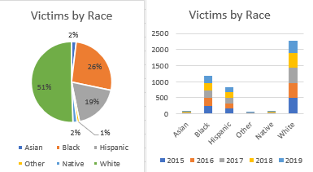

## By Age

A normal distribution exists for the victim’s age around the mean of 37 with a standard deviation of 13 years. After grouping by race, the data shows that minorities encounter deadly confrontations with the police roughly seven years younger. From these initial range values, it is possible to calculate the statistical effect of a person’s *race* and *age* relative to a similar group. An effect size is a measurement in z-scores with values typically between zero to one. This two-level comparison conveys that a medium-level effect exists for Whites, and a minimal difference exists between Blacks and Hispanics (see Table 3). These results roughly align with the exploration of race, which suggests that a skew exists in the data, but its not the smoking gun.

Table 3: Influence of Age

|  |  |  |  |  |  |
| --- | --- | --- | --- | --- | --- |
| Race | Mean | Standard Deviation | Effect vs. White | Effect vs. Black | Effect vs. Hispanic |
| All | 37.12 | 13.12 | -0.11 | 0.38 | 0.30 |
| White | 39.95 | 13.37 | -- | 0.61 | 0.54 |
| Black | 32.47 | 11.33 | -0.38 | -- | -0.10 |
| Hispanic | 33.54 | 10.87 | -0.30 | 0.10 | -- |

## By Sanity

An argument exists that the solution to police violence is defunding the police and using those resources for drug rehabilitation and civil service programs (BLM, 2020). Assuming those changes went into effect, would it make a difference? Washington’s data suggests that 22% of all fatalities are people experiencing a mental health crisis. Next, comparing the effect of *sanity* against the age distribution concludes that a small size exists (0.20). Based on these results, it does not seem that trading funding would produce the desired outcome. There are likely other potential benefits that come from changing funding levels of police and civil services. However, those are outside the scope of this research project. NCU-C needs to continue its searching into other variables of the dataset before concluding on the best lobbying action.

Table 4: Effect of Mental Health

|  |  |  |  |  |
| --- | --- | --- | --- | --- |
| Mental Illness | Mean (Age) | Standard Deviation | Effect vs. All | Effect vs. Sane |
| Yes | 39.74 | 13.87 | 0.20 | 0.25 |
| No | 36.35 | 12.80 | -0.06 | -- |

## By Weapon Type

The data set includes the ‘armed’ column that contains free-form text describing any weapons on the victim. One of the challenges with analyzing this field comes from the various subtle differences in its values (e.g., *baseball bat* versus *baseball bat and bottle*). Enhancements of each record include categorical-features that bucket the weapons by genre. These buckets are named projectiles, sharp/blunt instruments, tool/small objects, explosive, unspecified, vehicles, and unarmed. When the suspect has multiple weapons, such as both gun and knife, the higher risk object dictates the category. According to these categorical-aggregations, roughly 58% of victims had a firearm, plus another 18% had a sharp/blunt instrument (see Figure 2).

There are nationally fifty-three million people who have an interaction with a law enforcement officer each year (BJS, 2015). Of this population, annually, approximately one thousand dies. These figures suggest that roughly 0.0019% of all interactions end with the officer killing the suspect. Further removing situations with guns and knives (76%) reduces the figure to 0.00046% of interactions result in death.

Figure 2: Victim Weapon Category

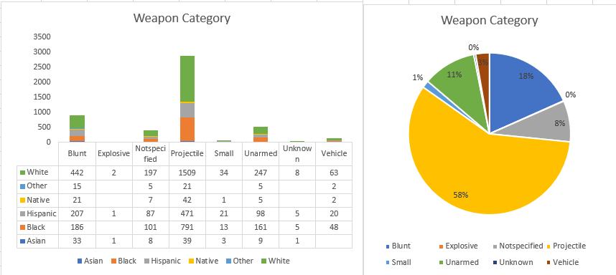

## By Location

Figure 3: Fatalities by State (2015-2019)

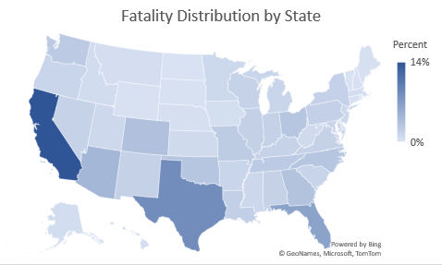 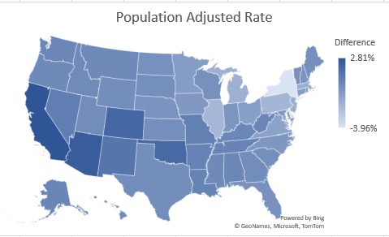

NCU-C’s investigations show that the method of sub-grouping and classification has significantly more impact on the results than any arbitrary feature. For instance, of the 4937 records, California and Texas own 14% and 9% of incidents, respectively (see Figure 1). There might be specific challenges within those states; however, they are also home to 12% and 9% of the national population (Census Bureau, 2019). Assuming all other things are equal, the actual number of fatalities less expected fatalities based on population shows the rates are relatively stable across the country.

Figure 4: Hispanic Victims by State

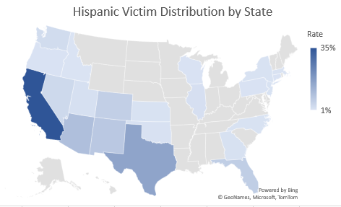 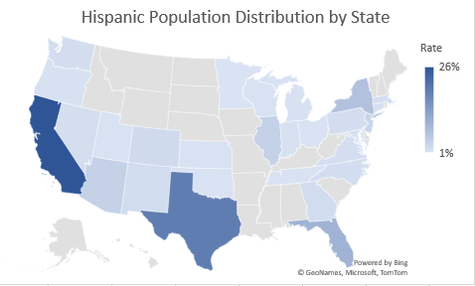

Next, an analysis of the total number of Hispanic victims in each state shows a strong correlation with the group’s natural population distribution (see Figure 2). This perspective highlights some of the challenges associated with treating the country as a homogenous cluster. Instead, decomposing America into regions allows for a more accurate assessment of the relevant population counts to include. For example, since at least 2015, no police officer has killed a Hispanic person in Montana (Washington Post, 2020). However, this group also only represents 38,000 (less than 4%) of that state’s inhabitants (Census Bureau, 2019). Then consider that Texas has over 11 million (39.4%) residents of Hispanic and Latino descent. Police violence in this state has killed 432 people during this same period, of which 143 (33%) were Hispanic.

Figure 5: Black Victims by State

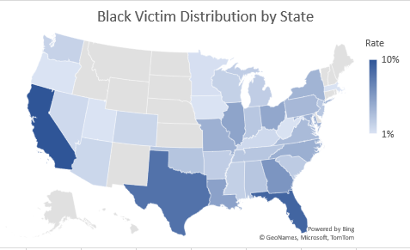 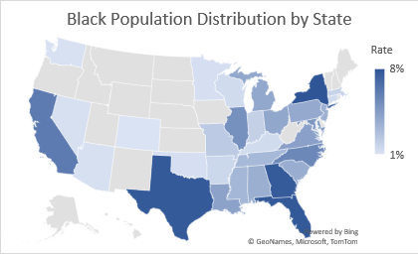

An extrapolation of comparable ratios exists in many other locations and ethnic groups. For example, approximately 39 million Black citizens live across the United States, of which 1277 have been killed by police violence since 2015. By plotting the distribution of these groups in terms of population per state, results in similar charts (see Figure 3). These pivots suggest that the deaths are not racially motivated, and instead, a function of the locale-specific population make-up. If that was not the case, then more pronounced outliers should exist with substantially higher victim rates relative to the group’s population. This outcome also hints that some other motivator outside of the *race* is likely to exist.

## Only Unarmed

One particular subset that gains much attention is unarmed citizens that die during police encounters. According to the dataset since 2015, this represents 349 of the 5489 (6.36%) of fatal incidents. These victims are nearly universally 33 years old, with a standard deviation of 11, regardless of race (see Table 5). An alternative statistic directly compares the counts of entries marked as unarmed and finds that there is no substantial difference within the data. While Nix’s frequently cited paper is accurate in stating that “unarmed Blacks die at nearly twice the rate of Whites,” the differences are within the margin of error (see Table 6). Further expanding the definition of unarmed to include non-weapons, such as staplers and pens, makes the low-risk situations approximately equal regardless of race.

Table 5: Effect of Race, Age, and Unarmed Status

|  |  |  |  |  |
| --- | --- | --- | --- | --- |
|  | Mean | STD | Count | Effect versus White |
| All | 32.37 | 11.04 | 349 | -0.03 |
| White | 33.18 | 11.34 | 146 |  |
| Black | 32.17 | 10.92 | 121 | -0.02 |
| Hispanic | 31.10 | 11.11 | 63 | 0.10 |

Table 6: Unarmed or Low-Risk Status by Race

|  |  |  |  |  |
| --- | --- | --- | --- | --- |
| Race | Unarmed  Rate | Unarmed  Total | Low-Risk Situation Rate | Low-Risk Situation Total |
| Black | 9.50% | 124 | 12.95% | 169 |
| Whites | 5.83% | 146 | 10.11% | 253 |
| Hispanics | 6.92% | 63 | 11.32% | 103 |

## Design Limitations and Challenges

The four major threats to research projects are internal, external, statistical conclusion, and construct validity (Parker, 1993) (see Table 2). While efforts to minimize these risks do exist, the time and resources of this project are relatively finite.

Table 2: Threat Sources

|  |  |
| --- | --- |
| Source | Description |
| Internal Threat | Contamination by the research team |
| External Threat | Contamination outside of the study’s controls |
| Statistical Conclusion Validity | Results are arbitrary or non-reproducible |
| Construct Validity | Controls are not enforceable or consistent |

### Internal Threats

An internal threat exists when the researcher does not accurately represent the results. This scenario could exist from biases during the categorization and groupings of the victims. For instance, the Washington Post data set uses a free-form text field to record the weapon and threat level. The analysis uses a few general buckets versus other researchers propose using more fine-grained options (Nix, Campbell, Byers, & Alpert, 2017). Minor forms of selection bias might also exist due to the filtration rules of the data set. Expressly, the analysis only includes records that provide the racial demographic and location of properties.

### External Threats

An external threat comes from a variable that is outside of the researcher’s control. The government does not require law enforcement agencies to report incidents that result in police brutality. Since official sources do not exist, researchers must rely on open-source data sets like the ones provided by the Washington Post. The Post uses news and social media reports, which could be both erroneous and lossy. There are also risks that the manual entry process could have inaccurate values for a record in the table (e.g., wrong *race*). Another class of risks comes from the data set being immature and starting in 2015. Ideally, having more longitudinal data to understand trends or alternative sources for cross-validation would improve the validity of results.

### Statistical Conclusion

Invalid statistical conclusions arise from not having sufficient samples or encountering too many uncontrolled parameters. The filtered data set only contains 4937 records, which does not provide sufficient evidence for some pivots (see Figure 5). For example, assessing Asian and Native American victims independently likely result in overfitting. Due to time constraints, the evaluation of only a subset of features took place, and this could have missed an important or confounding variable (e.g., age group).

### Construct Validity

Threats to the construction of the experiment occur when controls do not protect against information leaks between tests or controls between variables. These risks might exist due to the analysis evolving with the research project. While a general outline and strategy exist, the budget to procure sufficient causes a more relaxed set of requirements than during the onset. It is also possible that initial observations encouraged exploration of specific portions of the dataset because it more easily aligns with the topic. Instead, a more thorough effort could exist that examines other pivots and asks other questions of the information.

# Strategic Planning

NCU-C predicts that improvements to police safety will translate into a reduction of civilian fatalities. This strategic position differs from other mainstream views around police funding, mental health facilities, and racial inequality.

## Rationale of Plan

There are fifty-three million people who have an interaction with the police each year (BJS, 2015). Annually, 167 (+/- 6) officers and 66 (+/- 16) unarmed civilians die during these altercations (NLEOMF, 2019). These situations have to introduce a wide range of emotions and hostility, which creates challenges while balancing the safety of officers and civilians. NCU-C should invest additional resources into exploring solutions to reduce this friction. For instance, of the incidents that result in death, 76% (3853 of 4937) involve the suspect having a weapon (see Figure 6). Training and procedures could exist to address these scenarios in a manner that improves the probability of a peaceful resolution. While it does not address all of the concerns, this is a significant source of police brutality. Specifically, the unarmed and unspecified groups need further consideration to reduce the loss of life for these subgroups. However, it might be impossible to eliminate due to this group representing 0.00002% (119 of 53 million) interactions per year.

Figure 6: Suspect Armed Category 2015-2019 Total

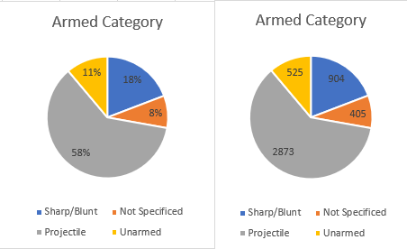

## Monitoring Progress

The conversation of police brutality needs to consider the safety of all participants, including both law enforcement and civilians. Progression into that journey is monitorable through descriptive statistics of injury and death on either side. These metrics should feed into one another, acting as a catalyst to reciprocally accelerate the other. For instance, a police officer that is confident of returning home should be less dispositioned to draw a weapon. With fewer fatal alternations, incentives exist for suspects to surrender versus resisting arrest. As these challenges de-escalate, the number of unarmed civilian deaths should naturally diminish into the smaller population.

# Conclusions

Researchers and media sources use the Washington Post’s data to quantify the racial basis of law enforcement. Their observations become statistical statements such as “unarmed Blacks are twice as likely as Whites to be the victim (Nix, Campbell, Byers, & Alpert, 2017).” Another frequently cited metric that “Black people were 24% of those killed despite being only 13% of the population (KBP, 2020).” Over 200 publications that reference Nix et al.’s paper in Nature magazine and Google returns 7.7 million results for the second quote. When NCU-C set out to assess the problem, the initial expectation was to find racial inequality and bias decisions against people of color. While both of these conclusions are true, that does not appear to be the entire story about police brutality in America.

Fundamentally these differences are a matter of contextualizing what filtration and inclusion encroach into the calculus. For example, a previous statement claims, “13% of the population,” referring to the national total. While this summation is perfectly valid, it will come to a different outcome than a demographically adjusted formula. Similarly, subtle changes to other data partitioning schemes can vastly influence conclusions. These distinctions make it critical that researchers clarify the methodology and strategy to their approach. Without that information, the results can arbitrarily confirm any result and prevent the formation of strategic decision making.

# References

BJS. (2015, October). *Contacts between police and the public*. Retrieved from Bureau of Justice Statistics: https://www.bjs.gov/content/pub/pdf/cpp15_sum.pdf

BLM. (2020, May 30). *#DefundThePolice*. Retrieved from Blac Lives Matter: https://blacklivesmatter.com/defundthepolice/

Census Bureau. (2019). *Quick facts*. Retrieved from United States Census Bureau: https://www.census.gov/quickfacts/fact/table/US/PST045219

Crary, D., & Morrison, A. (2020, June 11). *Black Lives Matter goes mainstream after Floyd's death*. Retrieved from AP News: https://apnews.com/347ceac3ea08978358c8c05a0d9ec37c

DeCarlo, M. (2018). *Principles of Sociological Inquiry: Qualitative and Quantitative Methods.* Blackstone Textbooks. Retrieved from https://scientificinquiryinsocialwork.pressbooks.com/chapter/12-1-experimental-design-what-is-it-and-when-should-it-be-used/

Donovan, C. (2016, August 30). *Power and effect size*. Retrieved from YouTube: https://www.youtube.com/watch?v=9LVD9oLg1A0

KBP. (2020, August 11). *Police shootings database*. Retrieved from Killed By Police: https://killedbypolice.net/

KilledByPolice. (2020, August 2). *Police Shootings Database*. Retrieved from Killed By Police: https://killedbypolice.net/

Lamb, H., Weinberger, L., & DeCuir, W. (2014). The police and mental health. *Psychiatric Services, 53*(10), 1266-1271. doi:https://doi.org/10.1176/appi.ps.53.10.1266

Lyons, R. (1984, October 30). *How the release of mental-patients began*. Retrieved from The New York Times: https://www.nytimes.com/1984/10/30/science/how-release-of-mental-patients-began.html

McCaskill, N. (2020, July 16). *Trump has tried to make 'Black Lives Matter' a partisan issue. A federal agency says it is not.* Retrieved from Politico: https://www.politico.com/news/2020/07/16/trump-special-counsel-black-lives-matter-366177

Nix, J., Campbell, B., Byers, E., & Alpert, G. (2017, February 8). A bird's eye view of civilians killed by police in 2015. *Criminology and public policy, 16*(1), 309-340. doi:https://doi-org.proxy1.ncu.edu/10.1111/1745-9133.12269

NLEOMF. (2019, April 10). *A year-by-Year breakdown of law enforcement deaths throughout U.S. history*. Retrieved from National Law Enforcement Officers Memorial Fund: https://nleomf.org/facts-figures/officer-deaths-by-year

Parker, R. (1993). Threats to the validity of the research. *Rehabilitation Counseling Bulletin, 36*(3), 130-138. Retrieved from https://search-ebscohost-com.proxy1.ncu.edu/login.aspx?direct=true&db=eric&AN=EJ458938&site=eds-live

Pierce, A. (2019, October 25). Whose lives matter? The black lives matter movement and the contested legacy of philosophical humanism. *Journal of Social Philosophy, 51*(2), 261-282. doi:https://doi-org.proxy1.ncu.edu/10.1111/josp.12305

Smith, C. (2020, Spring). Blue lives matter versus black lives matter: beneficial social policies as the path away from punitive rhetoric and harm. *Vermont Law Review, 44*(3), 463-291. Retrieved from https://search-ebscohost-com.proxy1.ncu.edu/login.aspx?direct=true&db=ofs&AN=143809860&site=eds-liv

Trump, D. (2020, July 1). *@realDonalTrump*. Retrieved from Twitter: https://twitter.com/realDonaldTrump/status/1278324681477689349

United Health Foundation. (2017). *Public health funding*. Retrieved August 16, 2020, from America's health rankings: https://www.americashealthrankings.org/explore/annual/measure/PH_funding/state/ALL

Washington Post. (2020, August 1). *Data police shootings*. Retrieved from GitHub: https://github.com/washingtonpost/data-police-shootings/commit/2ea87a4ed725b164be1489878e20827fb5944d1b