Week 2: Empirical Analysis of F-Droid

Nate Bachmeier

TIM-7140:Software Engineering

March 7, 2021

Northcentral University

# Empirical Analysis of F-Droid

F-Droid is an installable catalog of FOSS (Free and Open Source) apps for the Android platform (F-Droid, 2021). There are roughly four thousand applications within their collection. Each project’s entry contains downloadable links to source repositories and official milestone releases. Numerous researchers are leveraging this information to publish papers on trends across the mobile community. While these efforts shine light into the problem space, they are not complete. Even thoroughly analyzed, F-Droid represents 0.1% of the size of Google Play Store’s three million apps (Statista, 2021). Comprehensively analyzing this fraction generates enormous data volumes, requiring significant processing power, which introduces a need for additional sampling.

## Identifying Research Questions

Krutz et al. (2015) collected and analyzed metadata across 4416 versions of 1179 F-Droid projects. They used a series of static analysis tools to populate an SQLite database (see Table 1). Academic lesson plans continue to incorporate their results, but this project is not maintained.

The dataset contains several data points regarding permission misuse, code quality, and the breadth of contributors. There is sufficient data to explore the following research topics.

* **R1:** Does a correlation exist between app categories and permission misuse?
* **R2:** Does a correlation exist between security and code quality?
* **R3:** Does a correlation exist between commit counts and permission misuse?
* Table 1: Static Analysis Tooling

|  |  |
| --- | --- |
| Tool | Description |
| Stowaway | Static analysis tool for finding under/over permissions |
| Androrisk | Androguard reverse engineering tool that calculates risk indicators of an app |
| Sonar | Source code analyzer covering seven axes of code quality |
| FindBugs | Static analysis tool for finding Java issues |
| Checkstyle | Java source analysis tool |
| Git | Software versioning solution with revision log |

## Extending the Database

The data set reduces physical file size and promotes data consistency through normalized schema. This analysis extends that schema with several SQL views that ease exploration (see Table 2).

Table 2: Custom SQL Views

|  |  |  |
| --- | --- | --- |
| View Name | Description | Joins |
| over_permissions | Unused permissions detected by Stowaway | Version, Permission, and OverPermission |
| under_permissions | Missing permissions detected by Stowaway | Version, Permission, and UnderPermission |
| code_risks | Combines Sonar code metrics and Androrisk score | Version, Vulnerability, and CodingStandard |
| app_committers | App-level aggregate counts of committers | AppData and GitHistory |
| result_set | Denormalizes per version data points into wide rows | AppData, Version,  code_risks, app_committers,permission |

## R1: Category and Permission Misuse

The first research question attempts to find a correlation between app categories and permission misuse. Stowaway analyzed 1621 versions of 853 sampled apps with static analysis of the Android Packages files (APK). Since Stowaway is no longer maintained, it would be challenging to examine the remaining 63% of versions retroactively (Chromium, 2021). Instead, answers to this question only consider the most recent per-app scan result. Next, a filter retains only Games, Internet, Office, Multimedia, and System categories (703 of 853 entries). After removing erroneous and single-valued clusters, the data preparation is complete (see Figure 1).

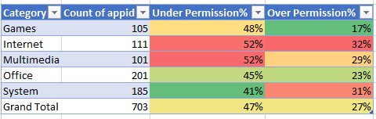

Using a pivot chart suggests that between 41 to 52% of apps miss at least one required permission. Meanwhile, between 17 to 32% have too many permissions. Internet and Systems are the worst offenders due to frequently missing contacts, wake lock, and audio rights. These same categories are overprivileged with wifi, internet, and storage access.

Figure 2: Permission Misuse by Category

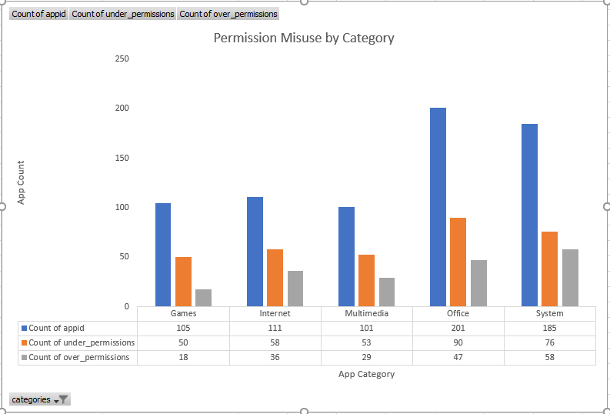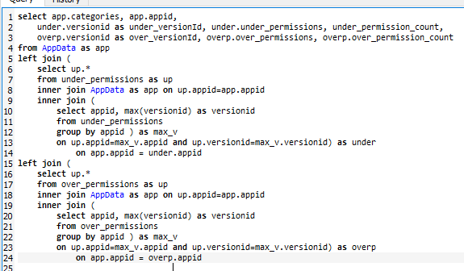

## R1.5: Are Internet and System categories risker

However, these are meaningless statistics because not all Android permissions are created equal. In 2017, Google restructured the permission system to consist of standard and dangerous rights (Android, 2021). Dangerous permissions can compromise the user’s privacy and security expectations. Meanwhile, when an application is over permissive with non-dangerous rights, it creates technical debt, not an increased attack surface. This Android-specific behavior raises a new question, “what app categories are misusing dangerous permissions?”

Filtering the OverPermission table to the most recent Stowaway results returns 422 violations. After comparing these permissions against Android’s official list determines that 63 issues exist across 52 apps. From an initial glance, the System category appears to have the most issues (see Figure 3). In reality, nearly all vulnerable apps only have one additional permission (mean=0.6), which artificially inflates the most popular categories.

Figure 3: Finding Dangerous Permissions

|  |  |
| --- | --- |
|  |  |

## R2: Security and Quality Metrics

The second research question seeks a correlation between the Androrisk and Sonar results. Alenezi & Almomani (2018) address a similar problem using a random forest classifier. They first collect twenty-one code metrics such as class complexity, duplicate blocks, and total lines of code. They combine these features with the Androrisk security score to empirically show that poorly documented complex code contains more security issues.

Figure 4: Fuzz Score Distribution

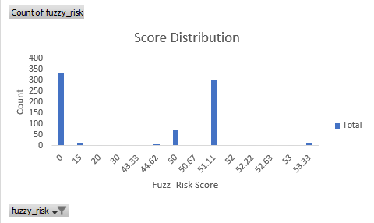

Analogously, exporting the code_risks view into Comma Separated Value files (CSV) allows Sci-Kit Learn to process the data. This process began with removing identifier columns and scoping the dataset to twelve code metrics for 753 apps. A binary classifier is ideal for the score distribution (label = score > 30)(see Figure 4). Next, training a random forest binary classifier used 65% of the records. The trained model is 68% accurate with 90% precision and recall metrics (see Figure 5). While there is room for improvement, these initial results suggest it is possible to predict Androrisk scores from code complexity. This characteristic infers that a correlation between the two systems must exist.

Figure 5: Training the Random Forest

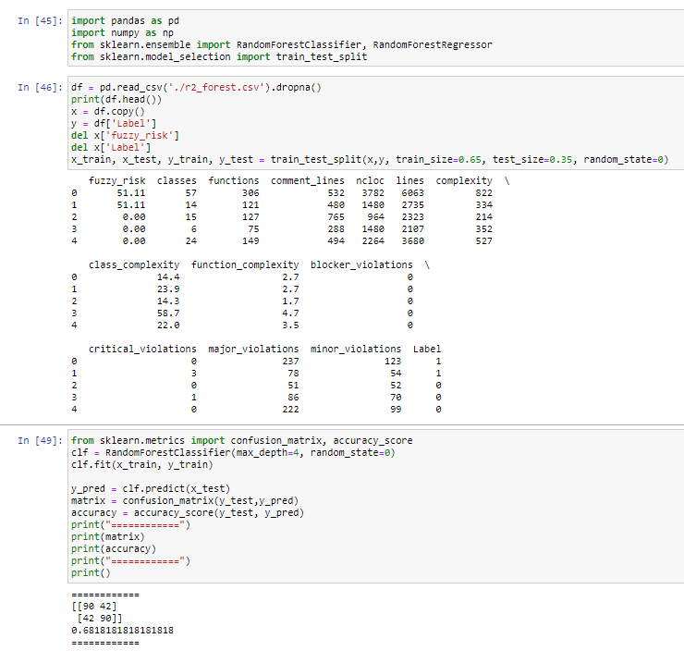

## R3: Breadth of Committers and Permission Misuse

The third research question seeks to identify a correlation between the number of committers and the likelihood of permission misuse. An experiment began with exporting a CSV file containing the appId, team size, number of commits, and total excessive permissions (see Figure 6). A correlation was not detected using several linear regression algorithms (e.g., SGD, Poisson, and Perceptron). Perceptron has the best performance (50% accuracy) but does not beat a lucky coin.

After the qualitative methods failed, a quantitative exploration took place. There appear to be multiple distinct use-cases spanning everything from solo teams, aggressive committers, and aggregate build accounts. Future research could collect more data and cluster the different account types. Then the research question can evolve to examine which account types introduce the most significant security risk.

Figure 6: Linear Regression Model

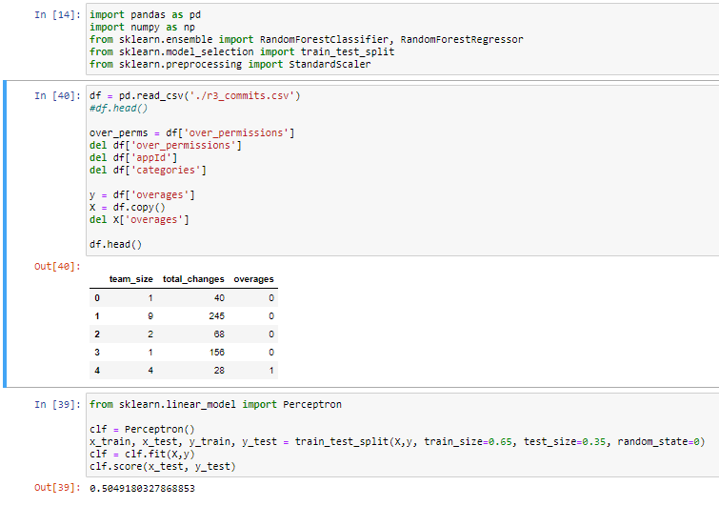

# Conclusions

Krutz et al. (2015) built a valuable data set for academic lesson plans. Unfortunately, it is becoming “bit-rotten” and failing to keep pace with Android development. These cracks are evident with the legacy permission metadata, deprecated tools, insufficient training data, and missing code metrics. Despite these technical limitations, there was sufficient information within the database to answer the three questions (see Table 3).

Table 3: Research Answers

|  |  |
| --- | --- |
| Question | Answer |
| R1: Does a correlation exist between app category and misused permissions | Yes, there is a slight skew in the data toward Internet and System categories.  However, scoping this analysis to only dangerous permissions disproves that position. |
| R2: Does a correlation exist between code quality and security risk | Yes, defects typically reside in poorly documented complex software. |
| R3: Does a correlation exist between the number of committers and permission misuse | Inconclusive, the most accurate model was 50% accurate.   There need to be a further investigation of different committer features and behaviors |

# References

Alenezi, M., & Almomani, I. (2018). An empirical analysis of static code metrics for predicting risk scores in Android applications. *International Symposium on Data Mining Application* (pp. 84-94). Springer International. doi:10.1007/978-3-319-78753-4_8

Android. (2021, March 7). *Requesting Permissions*. Retrieved from Android Developer: https://developer.android.com/training/permissions/requesting#normal-dangerous

Chromium. (2021, March 7). *Stowaway*. Retrieved from Android Permissions: http://www.android-permissions.org/

F-Droid. (2021, March 7). *What is F-Droid*? Retrieved from F-Droid Organization: https://f-droid.org/en/about/

Krutz, D., Mirakhorli, M., Malachowsky, A., Ruiz, a., Peterson, J., Filipski, A., & Smith, J. (2015). A dataset of open-source Android applications. *12th Working Conference on Mining Software Repositories* (pp. 522-525). IEEE Press. doi:10.5555/2820518.2820603

Statista. (2021, March 7). *The number of available applications in the Google play store*. Retrieved from Statista: https://www.statista.com/statistics/266210/number-of-available-applications-in-the-google-play-store/