Section 3: Week 6: Clock Synchronization

Nate Bachmeier

TIM-8120: Distributed Systems

October 27th, 2019

North Central University

# Clock Synchronization

A common challenge of presenting a single system image across multiple nodes is ensuring that the sequence of events processed, is correct. Many strategies to address this issue focus on time stamps, though this approach has challenges as most clock implementations are imperfect. Clock skew causes these imperfections and needs Clock Synchronization Protocols to mitigate.

# Physical Clocks

Most mechanical devices have timers, not clocks. These timers rely on the oscillation of quartz crystal as a means to decrement a counter, signifying the duration until the clock tick system interrupt occurs (Ubolkosold, Knedlik, & Loffeld, 2005). These crystals “suffer from large frequency shifts due [to] the the high sensitivity to external or internal factors (Zhang, et al., 2019).” According to Zhang et al., atomic clocks rely on energy transitions to achive 100,000 times better precision than quartz after ten days. These more precise instruments are difficult to deploy more broadly due to both their physical size and power consumption. Researchers are continuing to explore methods to reduce these limitations.

As these timers raise clock ticks, the more extensive system needs to report that it is relative to some universal reference point. Universal Coordinated Time (UTC) is the de-facto solution as alternatives, such as regional time zones, are impacted by political cross cutting concerns. For example, Eastern Time in America changes at different points of the year for day light savings. Another solution is to rely on the local time zone of the device. This design introduces additional challeges for systems spanning multiple locations as the example value “2019-10-27 10:03:00” occurs numerous times.

# Clock Synchronization Algorithms

|  |  |  |  |
| --- | --- | --- | --- |
| Protocol | Description | Structure | Benefit |
| Network Time Protocol (NTP) | A protocol for replicating time stamps across the Internet. | Hierachial with parent servers using more precise hardware. | Measurements from expensive hardware repeat economically. |
| Berkeley Algorithm (Gusella & Zatti, 1989) | A group of peers performing an election process to choose a master. The master periodically polls the slaves for their local time, then adjustes itself based on the average value after accounting for round trip time (RTT). | Centralized group of peers. | Easy to deploy for a cluster that only needs to be precise to itself. Works in labs without Internet access. |
| Reference Broadcast Synch (Akbar, Ichsan, & Darmawan, 2019) | Relies on a beacon to periodically broadcast reference packets to receivers, which compares the arrival time against the local time. The beacon message contains a sequence number, not a timestamp. The receiver then compares the reference message timestamp against its peers. | A broadcast model for decentralized peers to gain a shared synchronization object. | It removes the distorsion caused by network latency between wireless sensors. |
| Logical Clocks | A message counting protocol. Alice sends a message (with counter=0) to Bob, then Bob forwards then the message (with counter=1) to Charlie. Afterward, an observer of the transactions can efficiently determine the *happened-before* flow using only the counter. | A simple message counter that increments at each hop. | It addresses scenarios that need local relative offsets, not UTC timestamps. |
| Total Ordered Multicasting (Defago, Schiper, & Urban, 2004) | A collection of strategies for broadcasting in-order events to multiple consumers. | A multicasting solution of sequenced events. | Improves the performance of scenarios, such as database replication, that avoids reordering on the consumer side. |
| Vector Clocks | A similar strategy to Logical Clocks, except an array of multiple process’s local counters, is used, instead of a single scalar. | Each process updates a unqiue event counter on the local message. | It allows for more sophisticated modeling of causality relationships. Perhaps a multicast began a scatter/gather operation, making a single counter erroneous. |
| Token-Based Solutions | A strategy where a process that possesses a *token* is allowed to enter a critical section. This solution differs from non-token systems that use *timestamps* to sequence afterwards. | A process requests the token from a store and must wait until it is received. Afterward, it can exclusively use a resource. | Removes the challenges of resolving conflicts, at the cost of performance due to increased lock contention. |

# Using Clock Synchronization

Contoso’s Retail eCommerce Platform (see Figure 1) needs to use a varienty of event synchronization strategies.

Systems within the data center periodically poll from a centralized network time services node, which in turn is regularly querying public government NTP services. This strategy ensures that clocks are generally aligned, but can still fall victim to clock drift. For instance, the shopping cart service runs on virtualized hardware, and the multi-tenant computation environment does not guarantee every system interrupt is timely delivered. Similar, the authentication services run in a part of the data center that abnormally hot, and causes the quartz to oscilate slightly faster.

As the customer adds and removes items into the shopping cart, these operations need to be sequenced. These requests flow across multiple service instances into an eventually consistent data store. To sequence these operations after the fact, the system designers can use event counters that are managed by the web-portal. After deploying the solution, they discover that this strategy does not scale, as multiple web portal instances need to use token based locking to manage the central counter. They replace the counter management with a total ordered multi-casting solution. An additional benefit of this change is that the recommendation services can remove much of the event reordering logic. Total ordered multicasting also exists within the datastores as they perform replication.

A business requirement of the payment service states that a user can only proceed through one checkout process at a time. This check exists to ensure the third-party partner does not create partially redundant customer orders. The system enforces the distributed mutual exclusion through the use of a token that represents the user context. If a customer attempts to checkout from a different shopping cart, they cannot acquire the token, and the web portal guides them through a workflow to either cancel or wait.

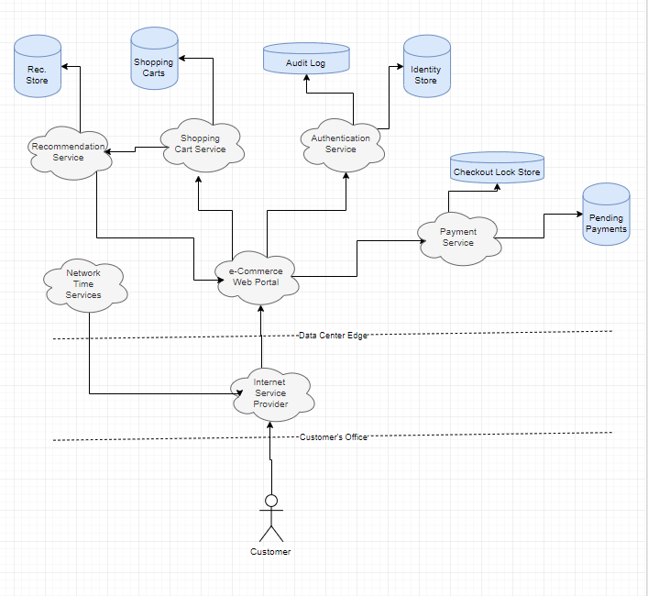

Figure 1: High Level SoA