Section 2: Week 4: Techniques to Discover Logic

Nate Bachmeier

TIM-8130: Data Mining

March 1, 2020

North Central University

Techniques to Discover Logic

# Section I: Determining Relevance

## Identify Business Value

It is impossible to answer a question if either the question or the necessary facts are unknown. Consider the scenario where the organization wants to execute the most efficient marketing campaign using the least resources. Without proper planning, the business might stumble upon an acceptable deliverable (local maxima). However, they are unlikely to encounter the global maxima. If, instead, the company explicitly defined the objective as “increase awareness of their product to minorities and underserved rural populations,” it becomes possible to rate the quality of supporting evidence. Now that a logical base case exists, the company can review public and private data providers and perform an initial inclusion filter. For instance, governmental census information contains population statistics that describe high-value segments to target physical advertisements. Even within this vast dataset, only a subset will be useful today or tomorrow. Perhaps the organization has a strong presence in the southwest. The business model does not support expanding into the northeast (e.g., licensing or political concerns). These limitations remove the need to have either humans or machines mine those areas (partitions), as there is no potential value.

## Identify Completeness

After repeating this filtration process multiple times, the conversation can transition the focus to the shape and volume of these facts. Suppose the analyst is attempting to build a statistical model across five thousand features. In that case, they will need more data than an alternative design containing five features. Waal and Toit (2011) suggest that a minimum of ten examples need to exist for every parameter. That logically makes sense as a deficit of information leads to speculation and bias. Imagine asking two random people at an NYC Metro bus stop their income and then predicting the median for the region. Alternatively, a person that samples from different neighborhoods along the Metro is more likely to estimate this value accurately. Hsu et al. (2017) cautioned that the absence of evidence is not evidence of absence. Under-generalizations frequently occur in sparse data. For instance, if the collection of these samples takes place during the afternoon, it is likely to miss high-earning professionals that commute during the mornings and evenings. Data miners can detect these gaps by looking at descriptive statistical and broad aggregates. Consider how a pivot against time or industry (e.g., financial, technology, and hospitality) would highlight missing examples from the metro scenario. When the shape of these pivots does not align with expectations, a problem exists.

## Identify Shape

Understanding the business value and determining a complete data collection enables the organization to begin testing its hypothesis. Snee (2015) directs research towards a graphical investigation first. For instance, plotting a simple line chart of market segment growth over time makes specific cyclical trends visually discoverable. A detailed analysis of rows in a table can be challenging. Another critical strength of graphically approaching the data’s shape is the relative ease of explaining the conclusion’s rationale to other parts of the institution. Not all team members are ‘deep in the trenches’ and need some mechanism to connect the discoveries to their external perspectives. Consider the distinction between presenting *only* a polynomial equation that predicts housing prices versus the inclusion of a scatter plot and estimated curve. Aside from data visualizations, the input shape is an essential characteristic of mining algorithms. If the algorithm learns on individual instances, aggregate counts are not useful regardless of their relevance to the problem. Similar requirements are present concerning time components and multi-dimensional data (e.g., images). These constraints can force the researchers to search for more supporting evidence or alternative expressions of the problem. However, specific scenarios are inherently spare. It is prohibitively expensive to acquire more data, such as collecting project bids from contractors. Instead of mapping these bids to precise *quantitative* estimates through regression (e.g., $152,593.22)—the company could use a *qualitative* bucketing strategy (e.g., cheap versus expensive). While the qualitative approaches are less specific, they provide a mechanism to reduce the search space further and can ensemble with other algorithms to form a unified collection of signals.

# Section II: Compare Predictive Techniques

## Markov Chains

A core challenge to applying basic statistics to real-world data is the assumption that each action is independent. However, many scenarios contain a conditional state transition probability dependent on the current state. If the stock market falls 5%, should an investor buy? The binary question requires a contextually sensitive answer that considers their net position (short the market), outlook (2008 financial crisis versus 2017 Trump bump), and similar factors. Markov chains provide the mathematical basis for making statistical models that incorporate these dependencies (Kahn Academy, 2014). Creating the hypothetical purchasing model (see Figure 1) begins with a state diagram representing the different actions available. Then Monte Carlo solutions can approximate each edge’s weight by random sampling and recording the decisions. At the same time, multiple use-cases can follow the same model, the scenario-specific decision weights. For instance, consider the differences between investing in (a) 401k retirement account that only adds index funds versus (b) delta-neutral (directionless) options trader. This trait is similar to other algorithms where efficient training requires relevant facts to specific questions.

Figure 1: Purchasing Model

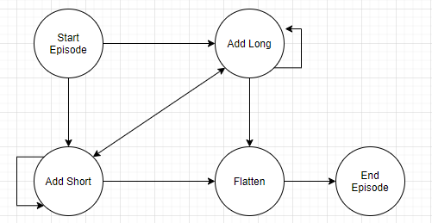

## Markov Experiment

Many online tutorials recommend exploring Markov chains as a solution to predict the next token in a sequence. Mason (2003) maintains an open-source repository of Shakespeare plays, which is easy to mine for different related sentences. An experiment began with downloading each script and normalizing the text into a corpus of lowercase words. Next, an iterator constructs a word_dictionary that maps n-gram tuples to a word bag of immediately following values. Then traversal of the Markov model chooses a random starting point, then selects a random next word, iterating until a stop condition. Across the test iterations, tests of different n-gram sizes (degrees of freedom) ranged from one to six. The higher the count, the more natural the sentences sound, primarily due to overfitting. Even at low n-gram terms, a frequent challenge arose from many unique words causing long sequences of static choices.

Figure n-gram Examples

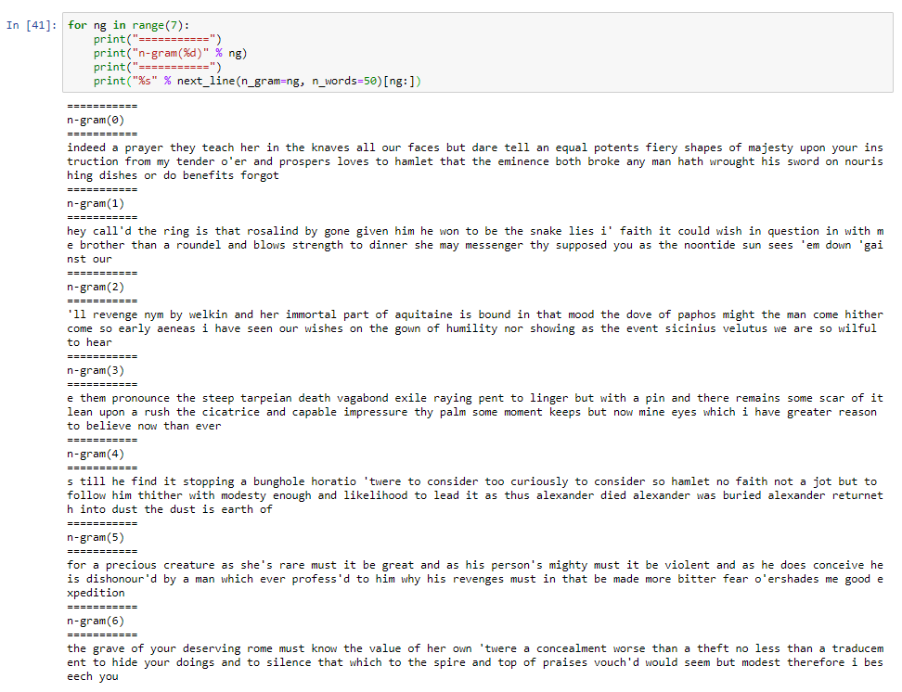

## Neural Networks

A Multi-Layer Perceptron (MLP) algorithm aims to map a non-parametric set of inputs to a parametric set of outputs by approximating an intermediary mapping function (the hidden layer). A fully connected graph can represent this structure. All inputs connect to the hidden layer, which connects to all outputs. Next, an iterative process forward-feeds examples through the network. Lastly, backpropagation updates the network weights and performs error corrections concerning the expected value (Ng, 2016). According to Fridman (2017), backpropagation is a recursive process of taking the partial derivative of two logic gates and applying a weighted update. He expands on the idea of these connected graphs with an example of image classification passing through several three layers (extracting edges, corners, object parts, and object identities). While the mathematical basis and engineering steps are somewhat procedural, the efficient design of the network architecture requires both art and science.

Perhaps the artfulness comes from a lack of planning or awareness of how the *ensemble* of distinct training subsystems combines. There is no reason to assume that every node is fully connected or has an edge weight above zero (see Figure 3). A logical representation might consider feature ‘x1’ connected to N neurons that regress one output, with feature ‘x2’ implementing some classification pattern. These network segments produce signals that collaborate to provide a more productive inference about the broader topology. These network segment microstructures extrapolate and remain present in more complex architectures. The solutions by both BellKor (2007) and Li et al. (2019) suggest that this assumption is generally accurate.

Figure GANN Architecture (Waal & Toit, 2011, p. 399)

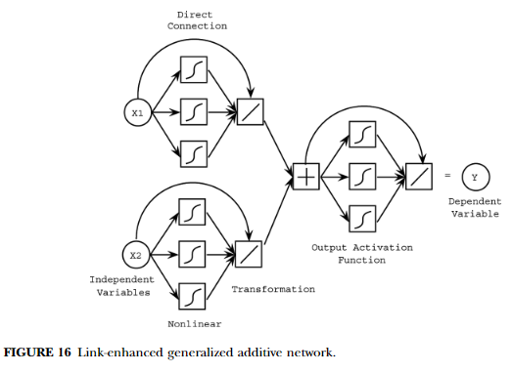

## Neural Network Experiment

Consider the scenario of mapping 28x28 images of clothing to ten categorical labels (e.g., hats versus coats). The number of input features (neurons) is 784, and there will be ten output neurons—how many neurons should exist in the middle? Rosebrock (2019) provides an example solution (see Figure 4) to Fashion MNIST that begins with feature reduction through two max-pooling hidden layers and batch normalization. After cleaning, the solution uses a single 512-neuron hidden layer to predict one of ten output categories (with softmax). Reducing the hidden layer's size to 128 or 256 has minimal impact on the cross-validation scores, though really low values of 5 to 16 negatively impact accuracy. In this specific example, changing the activation functions (e.g., softmax to tan-h) creates more performance fluctuation than any other knob, with model accuracy ranging from 20 to 85%.

Figure : Fashion MNIST

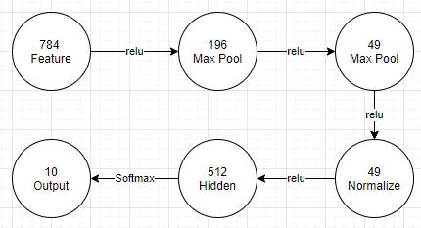

# Conclusions

The first and most critical step in any data mining exercise is to determine the question and discover supporting evidence. Until this action occurs, the business is unlikely to have a successful deliverable and will spend excessive resources investigating irrelevant materials. After clearly articulating the business value, the engineer teams can perform broad filtration of data sources based on their ability to address those questions. During filtration, having a logical framework can improve the search process through partition pruning of the relevant data stores. For instance, if the business operates in Michigan, there is potentially minimal value in exploring Texas-specific data. After coalescing the supporting facts into a central location, cleaning and curation processes need to confirm that the data is complete and pristine. Perfect information needs to be both the right size and volume, or it might be incompatible with the analysis algorithms. For example, an instance learning algorithm expects individual records, not aggregate counts.

Markov Chains and Neural Networks are two strategies for making predictions on data through graph-like structures. Unlike basis statistics, Markov removes the need for actions to be independent and instead expresses them as weighted state machines. These state machines can improve accuracy in workflows, such as guessing the next word in a sentence. Neural Networks and related MLP algorithms rely on weighted graphs and backpropagation to make predictions. While there is some artfulness, an alternative perspective asks if these are ensembles of small network segments. Evidence towards this interpretation exists in multiple advanced papers and helps to demystify the “machine learning black box.” It also means that several related concepts, patterns, and practices of data processing networks should also appear within more advanced neural network architectures.

# References

Bell, Koren, & Volinsky. (2007). The BellKor solution to the Netflix Prize.

Fridman, L. (2017, January 16). *MIT 6.S094: Introduction to Deep Learning and Self-Driving Cars*. Retrieved from YouTube: https://www.youtube.com/watch?v=1L0TKZQcUtA&feature=youtu.be

Kahn Academy. (2014). *Origin of Markov Chain*. Retrieved from Kahn Academy: https://www.khanacademy.org/computing/computer-science/informationtheory/moderninfotheory/v/markov_chains

Li, Zhao, Zhang, & Chen. (2019). Reinforcement Learning and Deep Learning Based Lateral Control for Autonomous Driving. *IEEE Computational Intelligence Magazine May*, 83-98.

Mason, G. (2020, March 1). *Shakespeare’s plays*. Retrieved from OpenSource Shakespeare: https://www.opensourceshakespeare.org/views/plays/plays.php

Ng, A. (2016). *Machine Learning*. Retrieved from Coursera: https://www.coursera.org/learn/machine-learning

Rosebrock, A. (2019, February 11). *Fashion MNIST with Keras and Deep Learning*. Retrieved from PyImageSearch: https://www.pyimagesearch.com/2019/02/11/fashion-mnist-with-keras-and-deep-learning/

Snee, R. (2015). Practical Approach to Data Mining: I Have All These Data; Now What Should I Do? *Quality Engineering, Volume 27*, 477-487.

Waal, d., & Toit, d. (2011). AUTOMATION OF GENERALIZED ADDITIVE NEURAL NETWORKS FOR PREDICTIVE DATA MINING. *Applied Artificial Intelligence. May/Jun2011, Vol. 25, Issue 5*, 380-425.