Section 3: Week 5: Mining Theories Through Data Problem

Nate Bachmeier

TIM-8130: Data Mining

February 9th, 2020

North Central University

# Imagine Boston 2030

As the city of Boston continues to grow, the Mayor has recognized that not all citizens are equally gaining those rewards. The dichotomy of the metropolitan area has led to distinct clusters, disproportionally filled with wealth and crime. Nearly one in five residents live in poverty and do not have a path to improve their situation. Instead, Walsh asks the community to imagine a different Boston, one that within a generation creates access to affordable housing, reduce crime, and improve wage inequality (Kovatch et al., 2017). This transformational process not only raises the standard of life for Bostonians, but it also encourages investment through tourism and economic expansion. Meeting their ambitious goals requires a strategy to track progress and ensure the progressive agenda is unfolding correctly. The Boston Planning and Development Agency (2017) publishes several Key Performance Indicators (KPI) around each of the major pillars of the plan, in addition to estimating previous intervals. This approach produces a highly efficient hierarchical reporting structure that aligns the mission with specific questions and supporting evidence. For instance, the objective *Reduce Housing Cost Burden for Bostonians* qualifies success as low-income residents are not living paycheck to paycheck, and quantifies it through the ratio of wages to housing costs. According to their chart, the ratio has held steady for low-income residents between 45-50% since 2000 (see Figure 1). When a population does not have disposable income, they are at high risk that minor incidents can become life-impacting. Consider the cascade of events from a 150$ auto-part failure, a broken leg, or a sick child—each scenario forcing the person to take on debt, further compounding their problems, and getting further from the finish line. These human problems need solutions, but what moves the needle the most in the least amount of time? Merely writing a blanket check or applying broad policy can be ineffective without addressing the crux of the issue.

Figure 1: Severely Burdened Households (Imagine Boston, 2020)

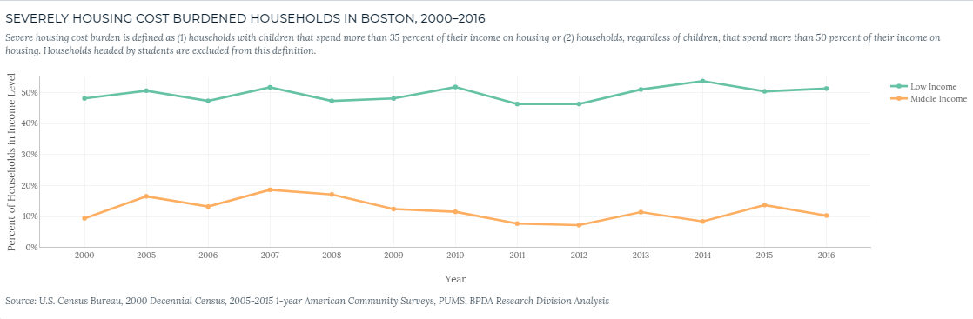

## Improving Housing Affordability

The improvement plan suggests that the price of housing is too high, and this limits access to a broad audience. While their evidence supports this observation, does it tell the entire story? Wikipedia (2020) states that Boston is 89.63 square miles, of which land encompasses 48.42, and this needs to accommodate approximately 700,000 residents. According to the US Census, the population is consistently increasing at 1.25% annually (ZipAtlas, 2020). With the supply of land being finite and the continuous increase in demand, one needs to reassess the initial statement. That reassessment requires an agreement whether housing prices (a) are too high or (b) are fair. Redfin (2020) specializes in listing housing quotes and supports exporting query results into Comma Separated Value (CSV) files. An analysis of 351 homes in the Boston area shows that the median listing period is five days long, and within sixteen days, 95% of homes sell (see Figure 2). If houses are selling within one to two weeks, that suggests that prices are *fair* and a different knob needs to turn (e.g., wages or commutability). Reviewing descriptive statistics shows the housing inventory quartiles as (600k, 900k, 1.3M, 7.3M) and highlights the diverse price ranges available. These ranges naturally form in alignment with the demographic distribution of the city. For instance, in the financial district (02110), housing is at the 75th percentile with median income at 152,000$. Roxbury (02119) has a median income of 27,000$ with housing at the 25th percentile. These vast community differences provide evidence that the government needs neighborhood-specific policies that classify each community based on a series of economic attainability features. Present accounting and reporting strategies focus solely on the person’s race and treat Boston as a single cluster. However, this stark pivot from the current administration removes racial bias and focuses the efforts area most in need. The city needs to focus on the fact that a median person in Roxbury cannot afford the median mortgage, not demographic distribution.

Figure 2: Imagine Boston Wealth Inequality Chart

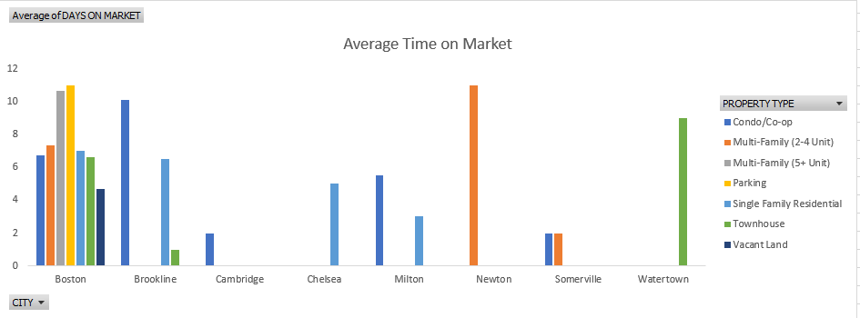

## Improving Wages

If housing prices are fair but unattainable, then another lever such as wages needs to be explored. The median income in Boston is 72,000/year in part due to a booming professional and business service industry, and because unemployment is near 2.0% (BLS, 2020). However, a more in-depth analysis shows that that the top 1/3rd of zip codes account for 56% of the wealth. Also, by ignoring the top 3 districts, the city’s median income reduces to 39,000$. This price point makes attainable housing for the actual middle class at roughly 1137.50$/month, assuming a 35% wage to rent ratio. For members of the lower-class (see Figure 3), such as food services and health care support, they earn between 12.50 to 16.99$ per hour (13 to 18k per year) (DataUSA, 2020). This group would need median rent of around 400$/month. Even with the cities commitment to building 69,000 additional low-income housing by 2030 (Boston.gov, 2019), that does not meet the current needs of the bottom eight neighborhoods. In both scenarios, the manageable housing price is below the fair market price and requires either a wealth redistribution or population migration. A wealth redistribution could be either implicit (e.g., higher minimum wage) or explicit (e.g., taxation). Alternatively, subsidies can improve the commuter experience and enable people to trade extended travel to work for lower housing prices. Evaluating the political or sociological impact of these trade-offs is outside the scope of this research.

Figure 3: Median Wages (Imagine Boston, 2020)

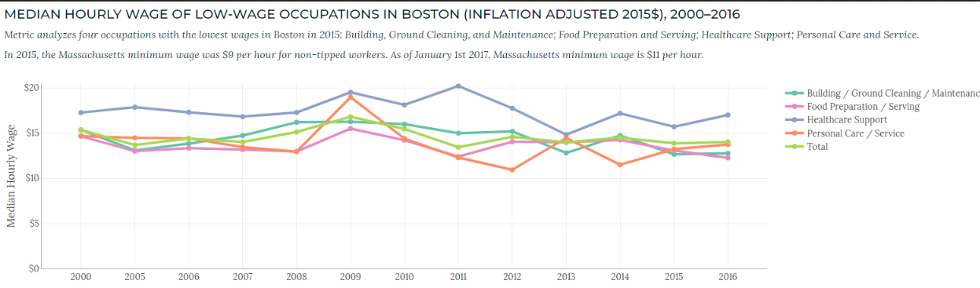

## Reducing the Wealth Inequality

An ability to accumulate housing equity has considerable influence over the net wealth of a family. For most families, it is the most expensive purchase they will ever make and their only leveraged investment. Munoz et al. (2015) report that the lack of homeownership causes many non-white Bostonians to have a median net worth of less than 10,000$ (see Figure 4).

Figure 4: Imagine Boston Wealth Inequality Chart

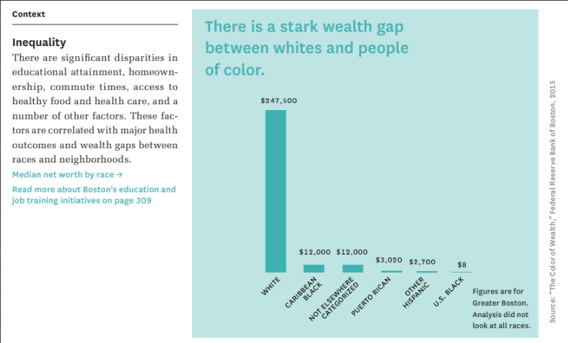

While some of their numbers are misleading, such as segmenting specific groups arbitrarily, causing an equal emphasis on say Native Hawaiians (0.04%) versus the African Americans (25.26%). That is not to say one group is less important than another, but group populations of 247 versus 175k people will likely have different error rates, making direct comparisons challenging. Similar to other literature, Munoz et al. use a single partition per race for analysis. This limited approach might distort the reality compared with say, slicing the data by industry and age group. Any attempt to partition solely on race will miss that the distribution is 50% white, 25% black, and 25% other—with 50% of the wealth controlled by 7.5% of the population. Since this subset has the same influence as the other 92.5%, the make-up of that group has tremendous potential to skew derived wealth statistics.

Figure 5: Imagine Boston Wealth Inequality Chart

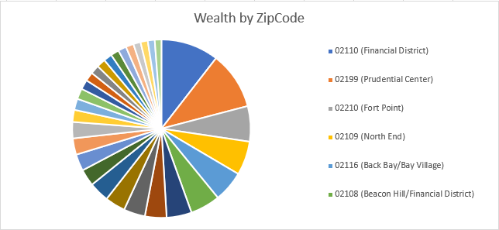

## Reducing Crime

Boston claims to be the fourth safest major city in the country, with 2,852 severe crimes per 100k residents. Imagine Boston (2020) defines severe crimes to include homicide, rape, robbery, aggravated assault, burglary, larceny, vehicle theft, and arson. When these types of crime occur, it impacts the local community by discouraging tourism and consumer spending at local establishments. The Boston dashboard reports that the trend is decreasing; however, this is partially due to the accounting system. Analyzing the Crime Incident Reports (2020) provides a different perspective, such as the number of shootings and sexual assault cases increase year over year. There are also nearly 2,000 larceny reports annually, so while the percentages are decreasing due to population growth, the count is not. To the defense of Boston, 63% of all police reports are for property damage or theft. However, the distribution of crime is not uniform across the city, with Roxbury (B2) the highest followed by Dorchester (C11), Suffolk (D4), and then Downtown (A1). The crime wave also fluctuates based on the area and day of the week (see Figure 6). For instance, Tuesday is the safest period for women due to being an extreme outlier for sex and alcohol-related reports. Downtown (A1) experiences 15% more complaints between the start and end of the week. Meanwhile, Roxbury (B2) and Monument Square (A15) police report decline on Saturday.

Figure 6: Reports Per Day of Week

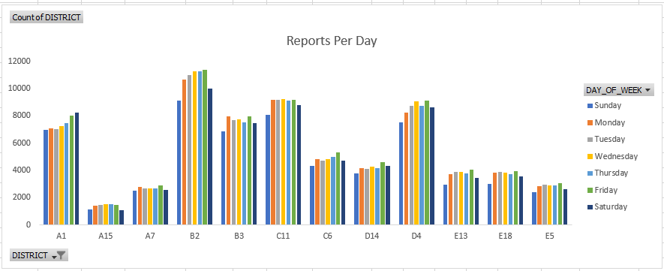

# Conclusions

Imagine Boston 2030 is a progressive initiative to make the city more inhabitable by all of its residents. They are approaching this mission from a data-driven approach that begins with specific questions and then finds supporting evidence to derive KPIs. One of the most critical KPIs is the wage to rent ratio, as that describes the disposable income that a family uses either at restaurants or as a safety net. While the city is continuing to invest heavily in low-income housing, it is unlikely to be successful in the long term. The crux of the issue comes from supply and demand economics that suggests that housing is not too high, only unattainable to a broad audience. The government will need to consider solutions that focus on wealth redistribution or population migration, as the target rental fee needs to be around 400$ for low-income residents under the current system. Another concern is the wealth inequality gap that claims most non-whites have less than 10,000$ of net worth. Monitoring of the gap centralizes on the specific races and their growth over time. However, this approach does not account for 7.5% of the population controlling 50% of the wealth and skewing specific derived statistics. Alternative partition schemes could consider employment industries, age groups, or neighborhood classifications. For specific areas, the median resident cannot afford the median mortgage, and this statistical property transcends physical characteristics. Exploration of the crime report details suggests that particular crimes are decreasing, but many offenses like sexual assault are increasing. There are specific trends, such as avoiding downtown on Saturday nights, that could allow a person to reduce their exposure. Except for a small subset of areas, the city is generally safe, with most reports targeting property damage or theft.

# References

BLS. (2020, March 7th). *Area Employment of Boston*. Retrieved from Bureau of Labor Statistics: https://www.bls.gov/regions/new-england/news-release/areaemployment_boston.htm

Boston Planning and Development Agency. (2017, September 7th). *Imagine Boston 2030: Tracking Our Progress*. Retrieved from YouTube: https://www.youtube.com/watch?v=V0XVU1gQqzA&feature=youtu.be

Boston Police Department. (2020, March 8th). *CRIME INCIDENT REPORTS (AUGUST 2015 - TO DATE)*. Retrieved from Analyze Boston: https://data.boston.gov/dataset/crime-incident-reports-august-2015-to-date-source-new-system/resource/12cb3883-56f5-47de-afa5-3b1cf61b257b

Boston.gov. (2019). *Executive Summary.* Retrieved from Google Drive: https://www.boston.gov/sites/default/files/embed/i/imagine-boston-executive_summary.pdf

DataUSA. (2020, March 8th). *Boston Median Income*. Retrieved from DataUSA: https://datausa.io/profile/geo/boston-ma/

Imagine Boston. (2020, March 8th). *Analytics*. Retrieved from Imagine Boston: https://analytics.boston.gov/app/imagine-boston

Kovatch et al. (2017, May 20th). *Walsh announces the release of the final draft of the Imagine Boston 2030 Plan*. Retrieved from UWIRE Text: https://link-gale-com.proxy1.ncu.edu/apps/doc/A492301020/AONE?u=pres1571&sid=AONE&xid=bb7eece4

Munoz et al. (2015). *The Color of Wealth in Boston.* Boston: Duke University and The New School.

Redfin. (2020, March 7th). *Boston*. Retrieved from Redfin: https://www.redfin.com/city/1826/MA/Boston

Wikipedia. (2020, March 8th). *Boston*. Retrieved from Wikipedia: ttps://en.wikipedia.org/wiki/Boston

ZipAtlas. (2020, March 8th). *Boston Population Density*. Retrieved from ZipAtlas: http://zipatlas.com/us/ma/boston/zip-code-comparison/population-density.htm