Week 5: Smart cars

Nate Bachmeier

TIM-8150: Artificial Intelligence

November 1, 2020

Northcentral University

# Smart Cars

The most powerful artificial intelligence applications use machines to enhance human capabilities rather than replace them (Heer, 2019; Boire, 2017). For instance, a person can write a more profound business case than a machine; however, the same machine will have fewer misspellings and grammatical errors. This dichotomy exists because humans specialize in contextualizing thought versus automation uses patterns to make predictions (Schleer et al. 2019). Smart vehicles are an area of research that seeks to fuse this symbiotic relationship. As this partnership flourishing, it will continue creating advancements across safety, convenience, resource utilization, and smart city integrations.

# Practical Applications of Intelligence

Machine learning can enhance every aspect of the drive, from extending the physical parts’ lifespan to increasing the driver’s overall satisfaction. Figure 1 contains a non-exhaustive taxonomy of uses-cases for artificial intelligence in motor vehicles, such as reducing wear and tear and object detection. The primary deciding factor for item assignment within the tree is the central application topic. Many items, such as Voice Assistance (VA), could arguably live under a different pillar (e.g., Safety). However, safety systems could exist in the same capacity using more traditional input interfaces, making this example fall under conveniences.

Figure 1: Taxonomy of Example Use-Cases

## Safety Control Systems

Annually, 32,000 Americans die from automotive accidents, and another 2 million are injured (CDC, 2016). These statistics are unacceptably high and require innovations that increase all participants’ safety on the road (see Figure 2). Artificial intelligence can assist in these scenarios by collecting sensor data and then predicting risks and opportunities. However, numerous open problems exist throughout the safety domain. These challenges should not discourage investments in these areas as they are essential to public safety.

Figure 2: Taxonomy of Participants and Example Challenges

For example, several manufacturers, like Subaru and Lexus, include audible collision alerts during lane changes or reversing. While these capabilities exist today, they are often incomplete models due to the high volume of edge cases, such as children fetching a ball from the street. Even after detecting the example child, several open problems span ethical and philosophical debate. Lex (2017) asksif avoiding the pedestrian requires killing the driver— what calculus dictates that autonomous decision? These situations might play-out in fractions of a second, limiting the value of human intuition. Since concrete answers do not exist, machines must resort to static guardrails (e.g., slamming on the breaks or swerving) that could risk a multi-vehicle accident.

## Convenience Systems

During a road trip, there are often long monotonous segments necessary to arrive at the destination. This requirement forces the driver to expel significant amounts of concentration relative to the mundane task. Instead, auto-pilot systems can take the wheel and allow the motorist to relax and participate in leisure activities (e.g., conversing with passengers). Some manufactures tackle these needs with adaptive cruise control technologies. This approach is useful in static environments (e.g., open highways) but encounters limitations in more dynamic environments (e.g., urban cities). Researchers are closing this gap by including more sensors that feed into sophisticated reinforcement learning algorithms (Fridman, 2020). However, continuing to scale these monolithic expert systems is challenging.

Figure 3: Example Microservice Architecture

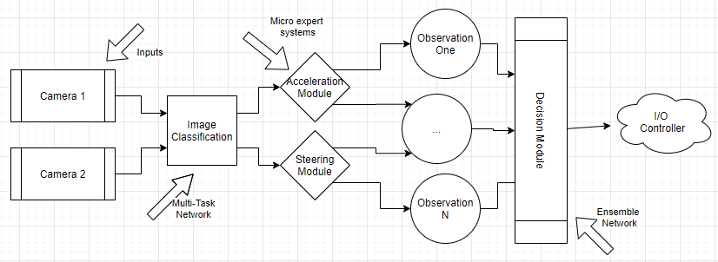

V-TORCS (Virtual The Open Racing Car Simulation) and other modern architectures address these issues using combinations of ensemble and multi-task learning methods (Li et al. 2019). Consider a decision process that feeds camera frames into an image classification Convolutional Neural Network (CNN) to extract objects and contextualize the environment (see Figure 3). CNN algorithms mimic an eye’s biological structures by normalizing neighboring pixels blocks together to derive structure (Keller et al. 2016). These results flow into various expert subsystems that control the car, such as turning the wheel or accelerating. An ensemble of subsystems observations merges into a broader system-wide decision model that controls one or more I/O (Input/Output) controllers. Like other microsystem architectures, each subsystem’s implementation can evolve independently of peer components—enabling greater agility and innovation.

## Optimization Systems

Modern personal vehicles have a lifespan of over 200,000 miles and often travel 24,000 miles per year (Ford, 2012). Assuming a driver purchases a $25,000 car and keeps it that entire usable period, they will likely spend at least that much on fuel and repairs (see Table 1). Data scientists can improve this situation by introducing micro-optimization systems across the automobile. For instance, traditional cruise control maintains a specific speed (e.g., 70mph) without considering any environmental context. Meanwhile, a smarter system can factor in the road’s incline, the driver’s profile, and metrics about the trip to create a dynamic profile ranging from, e.g., 65-70mph. As this idea expands outward, it results in collections of micro-optimizers that monitor all aspects of the driving experience, potentially saving hundreds of dollars in costs.

Table 1: Ongoing Fees

|  |  |
| --- | --- |
| Line Item | Total |
| 200,000 miles @ 30 miles/gallon | 6,667 gallons |
| x $2.50/gallon | $16,700 |
| + Typical Repairs | $10,000 |
|  |  |
| Total Costs | $26,700 |

When the driver has advance notice that a component is likely to fail, they can schedule the maintenance and minimize costs. Preventative Maintenance Systems (PMS) provides this capability by first collecting component-level telemetry and looking for anomalous metrics (see Figure 4). For instance, an engine monitoring solution might observe the RPMs (Revolutions per Minute) and the electrical output. Sensor time series data are noisy and require a curation process (e.g., Kalman filter) to derive a stable moving average signal (Jackson & Rege, 2019). Next, the curated signal flows into a Recurrent Neural Network (RNN), which uses sequences of previous tokens to predict future values (Keller et al. 2016). When new observations deviate outside of these predictions, an anomaly exists and needs surfacing to a decision control process.

Figure 4: Preventative Maintenance System

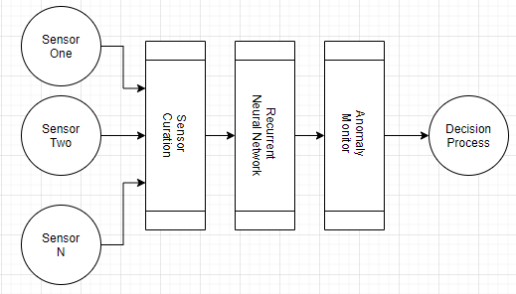

## Smart City Integration

The future evolution of city planning makes urban areas highly connected with fast wireless networking and intelligent machines emitting enormous telemetry data volumes (Balduccini et al. 2018). A central participant in this ecosystem is the autonomous vehicle, as it transmits metrics to infrastructure (V2I) and other vehicles (V2V). These metadata feeds will enable more efficient traffic shaping, alertness to potential risks, and more insights into driver patterns (Tong et al. 2019). For instance, today, each driver inputs their GPS destination and follows the route in an isolated silo. Tomorrow, aspects of those routing decisions can become centralized, resulting in less route congestion. While ideas of this ideal state are already coming to life in areas like Seattle, Boston, and New York; the large scale implementation is still years out (Cohen, 2013). Completely modernizing these areas will require significant infrastructure investments, consensus on V2X communication protocols, and machines that implement those standards. Until then, machine learning technologies will need to synthesis those capabilities by making predictions by pairing vehicle-local sensors with ubiquitous cloud services.

# Conclusions

Three takeaways of this paper are (1) that artificial systems need to augment human processes; (2) a suitable starting place is safety and cost optimization, and (3) smart cities several years away, requiring cloud services to fill that void.

The most powerful artificial intelligence applications use machines to enhance human capabilities rather than replace them. Motor vehicles contain a wealth of integration points where machine learning can handle tedious aspects of the journey with greater precision and accuracy than humans. After freeing the driver from the burden of mundane work, she can focus on value-differentiating traveling qualities, such as talking with passengers and thinking about the day ahead. Meanwhile, intelligent systems remain vigilant in the background looking for risks like a child running into the road. Another collection of machine learning tasks revolve around cruise control capabilities, as these systems keep us out of harm’s way and reduce wear-and-tear on internal parts. Looking further into the future, the integration of smart vehicles within smart cities brings a promise of more efficient traffic shaping and risk awareness. However, the necessary infrastructure investments are unlikely to arise in the next decade. Instead, machine learning will pair vehicular telemetry into ubiquitous cloud computing to provide a similar experience.

# References

Balduccini, M., Griffor, E., Huth, M., Vishik, C., Burns, M., & Wollman, D. (2018). Reasoning about Smart Cities. *IEEE International Conference on Smart Computing* (pp. 381-386). Institute of Electrical and Electronics Engineers. DOI:10.1109/SMARTCOMP.2018.00033

Boire, R. (2017). Artificial Intelligence, automation, and its impact on data science. *IEEE International Conference on Big Data* (pp. 3571-3574). Boston, MA: Institute of Electrical and Electronics Engineers. DOI:10.1109/BigData.2017.8258349

CDC. (2016, July 6). *Motor Vehicle Crash Deaths*. Retrieved from Centers for Disease Control and Prevention: https://www.cdc.gov/vitalsigns/motor-vehicle-safety/index.html

Cohen, B. (2013, November 14). *The Ten Smartest Cities In North America*. Retrieved from Fast Company: https://www.fastcompany.com/3021592/the-10-smartest-cities-in-north-america

Ford, D. (2012, March 18). *As Cars are kept longer, 200,000 Is New 100,000*. Retrieved from The New York Times: https://www.nytimes.com/2012/03/18/automobiles/as-cars-are-kept-longer-200000-is-new-100000.html

Fridman, L. (2017, January 16). *MIT 6.S094: Introduction to Deep Learning and Self-Driving Cars*. Retrieved from YouTube: https://www.youtube.com/watch?v=1L0TKZQcUtA&feature=youtu.be

Fridman, L. (2020, January). *Deep Learning State of the Art*. (Massachusetts Institute of Technology (MIT)) Retrieved from YouTube: https://youtu.be/0VH1Lim8gL8

Heer, J. (2019). Agency plus automation. *Proceedings of the National Academy of Sciences of the United States of America, 116*(6), 1844-1850. DOI:10.1073/pnas.1807184115

Jackson, B., & Rege, M. (2019). Machine learning for classification of economic recessions. *IEEE 20th International Conference on Information Reuse and Integration for Data Science* (pp. 31-38). Los Angeles, CA, USA: Institute of Electrical and Electronics Engineers. DOI:10.1109/IRI.2019.00019

Keller, J., Liu, D., & Fogel, D. (2016). *Fundamentals of Computational Intelligence.* John Wiley & Sons.

Li, D., Zhao, D., Zhang, Q., & Chen, Y. (2019, May). Reinforcement Learning and Deep Learning Based Lateral Control for Autonomous Driving. *IEEE Computational Intelligence Magazine May, 14*(2), 83-98. DOI:10.1109/MCI.2019.2901089

Schleer, P., Drobinsky, S., de la Fuente, M., & Radermacher, K. (2019). Toward versatile cooperative surgical robotics: a review and future challenges. *International Journal of Computer Assisted Radiology and Surgery, 14*(10), 1673-1686. DOI:10.1007/s11548-019-01927-z

Tong, W., Hussain, A., Bo, W., & Maharjan, S. (2019). Artificial Intelligence for Vehicle-to-Everything. *IEEE Access, 7*, 10823-10843. DOI:10.1109/ACCESS.2019