Week 6: Intelligent Agents

Nate Bachmeier

TIM-8150: Artificial Intelligence

November 8, 2020

Northcentral University

# Intelligent Agents

The North American electrical network is the world’s most massive machine, spanning across the continent (Wildberger, 1996). Making predictions across this example system is exceptionally complex due to the variability and inter-relationship of black box decisions. Traditionally, physicists and statisticians approach these issues with very sophisticated equations that seek to model the problem’s domain. However, those methods are challenging to scale, expensive to operate, and updates require expertise. In contrast, businesses desire elegant solutions that promote agility through experimentation with low entry barriers and minimal economic overhead. Meeting those expectations requires a different paradigm for simulating the environment.

# Definitions and Terminologies

Engineers consistently find that maintaining monolithic technologies requires substantial overhead. Alternatively, using microsystem architectures enables them to build and replace components rapidly in isolation. A similar idea exists with simulations with a decomposition of the environment into multiple intelligent agents (see Table 1).

Table 1: Principal Components

|  |  |
| --- | --- |
| Aspect | Definition |
| Intelligence | The ability to reason about a problem |
| Simulation | An experiment that produces a statistical model |
| Environment | The universe contains the agents |
| Agent | An automaton that follows a predefined script |
| Objective | The goal of the agent |
| Tasks | The steps necessary to complete the objective |
| Notification | A collaborative or competing message between agents |
| Swarm | A group of agents |
| Choice | The random decision of an agent within its action space |
| Aggregate Choice | The net effect of multiple independent agent decisions |

A simulation experiment first identifies the environment, participants, and one or more objectives. Each participant, called an agent, attempts to complete its objective under a set of guiding rules and principles. For instance, NetLogo’s BeeSmart environment contains multiple bees that attempt to maximize food production from various honey pots within a given scene (Wilensky, 2014). Initially, the swarm fumbles around until discovering a couple of locations. After some time, the colony will divide across multiple honey pots and compare site values with neighboring peers. Eventually, the bees converge to the optimal configuration that provides the maximum food for the hive.

Figure 1: BeeSmart Simulation (Wilensky, 2014)

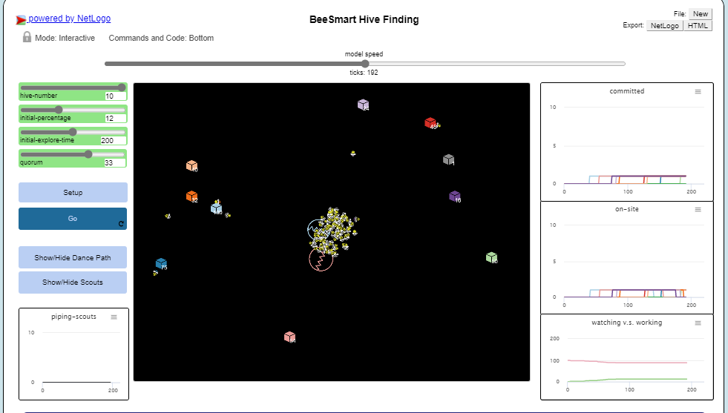

While no individual agent (bee) understands the ideal distribution across the environment, the aggregate of independent decisions enables analysts to extract sophisticated observations about the broader objectives. It is also possible to quickly expand upon this simulation by designing expert agents, such as communication specialists, that propagate messages twice as fast. After defining the role and its local rules, the existing simulation can immediately incorporate those customizations.

# Theoretical and Practical Perspectives

In addition to executing rapid experimentation at scale, organizations require algorithms that enable their agents to evolve. Traditionally evolutionary computation leverages Genetic Algorithms (GA) and Cellular Automata (CA) (Keller et al., 2016; Wildberger, 1996). Others have extended these strategies to create more adaptive simulations, such as Multi-Level Agent-Based Modeling (ML-ABM)(Hijorth et al., 2020).

## Genetic Algorithms (GA)

The Traveling Salesman is a classical graph puzzle that attempts to find the most efficient route through N-cities. Even with ubiquitous access to cloud computing, enumerating through an exhaustive search is not practical due to the combinations growing at $\frac{\left(n-1\right)!}{2}$ (Keller et al., 2016). As the simulation continues to scale-out, it requires a mechanism to prune that search space and quickly discover the optimal answers. The Theory of Evolution states that biology weeds out inferior strains through the Natural Selection Process (Darwin, 1859). Computers can replicate this model through Genetic Algorithms to converge on optimal configurations (see Figure 2).

Figure 2: Genetic Algorithm

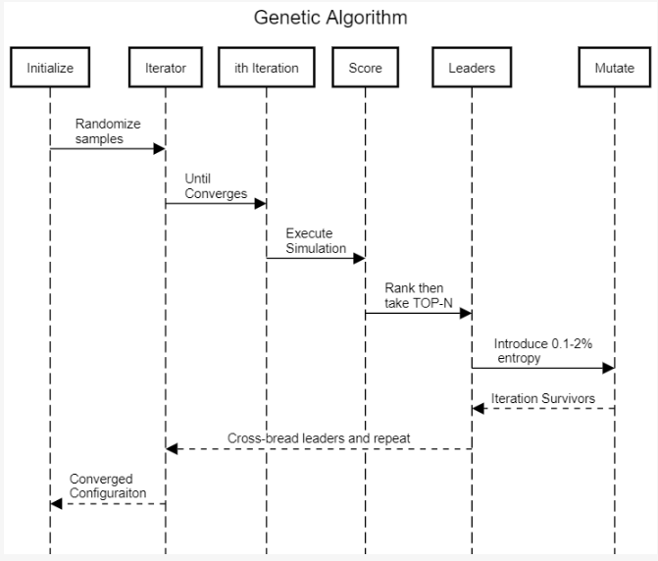

The solution begins by modeling a potential answer as a vector of classification features. First, hundreds to thousands of randomly initialized instances run through the simulation to compute a per-instance score. Then a TOP-N ranking keeps the best instances, discarding the remainder. Next, a cross-breeding and mutation process mixes features from the fittest combinations to produce the offspring. Those offspring cycle through this system thousands of times until only superior specimens remain.

## Multi-Level Agent-Based Modeling (ML-ABM)

After decomposing complex models into individual agents, a mechanism must aggregate the independent decisions into more macro observations. Cellular Automata (CA) paints this picture by grouping related swarms into “a hierarchical series of discrete systems (Makarenko & Osaulenko, 2018).” Through multiple levels of aggregation, agents can feed into swarms and those individual-swarms into swarm-networks.

For instance, a financial market environment has individual buy-and-sell participants that react to fluctuations in supply-and-demand (see Figure 3). This specific example simulation contains thousands of individual portfolio accounts (agents) that frequently make rational transactions. An analysis could apply CA across these portfolios by aggregating the multitude of data points to improve the data’s usability for professional traders. However, an inefficiency exists within this design because some individual portfolios (agent state) are nearly identical. Other aspects, like the risk-free rate, do not require the fidelity that swarms of agents produce. These situations can rely on ML-ABM to approximate irrelevant details (e.g., with caches) and enable fine-grained influence over critical decisions (e.g., with swarms of agent) (Hijorth et al., 2020).

Figure 3: Financial Market

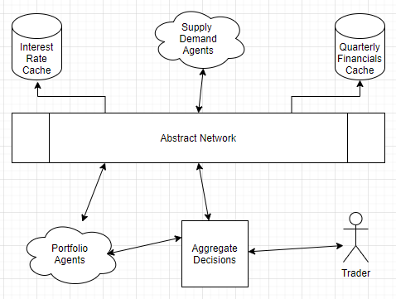

# Applications for Business and Science

## Today

Using agent technologies to simulate complex processes is not a new concept that dates back to the late 1980s (Wildberger, 1996). However, since that time, the computing industry has exponentially matured IoT, Cloud, Big Data, and Mobile (ICBM) technologies (Al-Sai et al., 2019). These advancements allow businesses to ingest vast oceans of historical data into their simulation environments and access sufficient resources to process it. High-speed networking in factories and branch offices now powers sophisticated Cyber-Physical Systems (CPS), enabling business decision processes to reach into the office space, literally.

Smart manufacturing facilities are prime locations for combining machine learning, CPS, and AI. For instance, monitoring systems can detect safety hazards and minimize employees’ risk (Friedberg et al., 2017). Meanwhile, other situations require removing humans entirely and relying solely on robots to operate in dynamic environments (Sandkuhl et al., 2013). When organizations transition the responsibility to automation, it creates an opportunity to reduce costs and increase consistency. However, there are potential challenges for this automation to adapt to new scenarios.

## Tomorrow

Intelligent agents form decisions from a predefined action space using static rules or Neural Networks (NN). Artificial neural networks (ANN) are inferior to humans because they are greedy, brittle, rigid, and opaque (Hole & Ahmad, 2019). These technologies excel at memorizing or patterns, not contextually understanding them, which causes erroneous behavior under novel conditions. While researchers are quick to highlight this issue (Hole & Ahmad, 2019; Wildberger, 1996), does it matter in the world of tomorrow?

Figure 4: Blended Cyber-Physical System

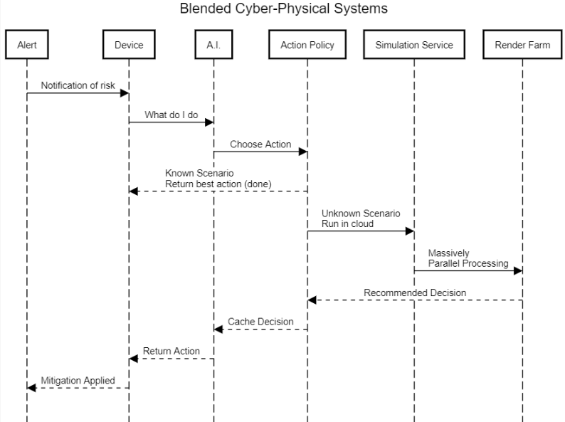

With the availability of Massively Parallel Processing (MPP) and high-speed networking, administrators can further blur the lines between cyber-physical systems. When unknown situations arise, an artificial brain can treat it as a cache miss and fetch the appropriate response from a simulation service (see Figure 4). Next, the simulator will render the calling agents state before searching for the best reaction. After confirming the virtual world’s behavior meets administrative policies, the decision can safely execute in the physical world. This mechanism is not appropriate for every situation but could apply to broad types of problems.

# Conclusions

It can be challenging to model real-world business scenarios due to the volume of interactions and their inter-relationships. Some organizations approach these issues by building monolithic models that are difficult to scale, operate, and update. Instead, businesses need to decompose the problem into an environment, participants, and objectives. An agent program manages the state of an individual and any behavior policies. When additional scenarios or behaviors are necessary, engineers can create isolated changes, enabling agile experimentation.

An analyst can study macro-systems by invoking multiple instances of the agent programs and aggregating the individual decisions into swarms.

Many simulation environments need to find the best choice from K-states across L-decisions. This setup creates exponential permutations (e.g., KL choices), which is difficult to enumerate even with cloud computing. Using Genetic Algorithms (GA) reduces the search by cross-breeding the fittest specimens. Simulation models can also require different levels of fidelity and precision. Administrators can incorporate these needs into Multi-Level Agent-Based Modeling (ML-ABM) to approximate tedious values and provide supporting evidence for critical data points.

Businesses and science have already been deploying agent-based simulation technologies since the late 1980s. However, today, those systems can leverage IoT, Cloud, Big Data, and Mobile (ICBM) to ingest vast amounts of historical data and processing power. The line between CPS continues to blur, providing further integration opportunities. This evolution is most evident in smart factories as they offload safety, manufacturing, and logistical operations onto robots. As companies mature and embrace the ability to model complex interactions, it will revolutionize every aspect of science and business.

# References

Al-Sai, Z., Abdullah, R., & Husin, M. (2019). Big Data Impacts and Challenges: A Review. *Jordan International Joint Conference on Electrical Engineering and Information Technology (JEEIT)* (pp. 150-155). Institute of Electrical and Electronics Engineers. DOI:10.1109/JEEIT.2019.8717484

Darwin, C. (1859). *On the origin of species.*

Friedberg, I., McLaughlin, K., Smith, P., Laverty, D., & Sezer, S. (2017). STPA-SafeSec: Safety and security analysis for cyber-physical systems. *Journal of Information Security and Applications, 34*(2), 183-196. doi:10.1016/j.jisa.2016.05.008.

Hijorth, A., Head, B., Brady, C., & Wilensky, U. (2020). LevelSpace: a NetLogo extension for multi-level agent-based modeling. *Journal of Artificial Societies & Social Simulation, 23*(1), 1-24. DOI:10.18564/jasss.4130

Hole, H., & Ahmad, S. (2019). Biologically driven artificial intelligence. *Computer, 52*(8), 72-75. DOI:10.1109/MC.2019.2917455

Keller, J., Liu, D., & Fogel, D. (2016). *Fundamentals of Computational Intelligence.* John Wiley & Sons.

Makarenko, O., & Osaulenko, V. (2018). Application of cellular automates in some models of artificial intelligence. *IEEE First International Conference on System Analysis & Intelligent Computing* (pp. 1-4). Kyiv, Kyiv City, Ukraine: Institute of Electrical and Electronics Engineers. DOI:10.1109/SAIC.2018.8516837

Sandkuhl, K., Lin, F., Shilov, N., Smirnov, A., Tarasov, V., & Krizhanovsky, A. (2013). Logistics-as-a-Service: Ontology-based architecture and approach. *Revista Investigacion Operacional, 34*(3), 188-194. Retrieved from https://search-ebscohost-com.proxy1.ncu.edu/login.aspx?direct=true&db=edsgao&AN=edsgcl.353211525&site=eds-live

Wildberger, A. (1996). Introduction and overview of artificial life evolving intelligent agents for modeling and simulation. *Winter Simulation Conference* (pp. 161-168). DOI:10.1109/WSC.1996.873274

Wilensky, U. (2014). *BeeSmart hive finding*. Retrieved from Netlogo: https://ccl.northwestern.edu/netlogo/models/BeeSmartHiveFinding