Week 8: Artificial Intelligence for Business

Nate Bachmeier

TIM-8150: Artificial Intelligence

November 22, 2020

Northcentral University

# Artificial Intelligence for Business

The most powerful artificial intelligence applications use machines to enhance human capabilities rather than replace them (Heer, 2019; Boire, 2017). For instance, a person can write a more profound business case than a machine; however, the same machine will have fewer misspellings and grammatical errors. This dichotomy exists because humans specialize in contextualizing thought versus automation uses patterns to make predictions (Schleer et al., 2019). Smart vehicles are an area of research that seeks to fuse this symbiotic relationship. As this partnership flourishing, it will continue creating advancements across safety, convenience, resource utilization, and smart city integrations.

# Technical Characteristics of Systems

Dreams of artificial intelligence trace back to philosophical debates in ancient Greece. Prometheus would mold handfuls of clay into images of the gods, and later these creatures were given life. The sprouting of ideas came from mathematics, biology, and computer science before eventually producing modern artificial intelligence. While these different domains have unique perspectives, they collectively land at four categories of intelligent systems (Lukac et al., 2018). The first divide asks if the system *thinks* or *acts* or can reason about the problem more precisely. Each of these top-level categories contains subcategories of applications that mimic *humans* versus *rational* actors.

Within a smart car are multiple features that fit into these various areas. For instance, traditional cruise controls attempt to *act human* by following a fixed speed. Meanwhile, a vehicle with an adaptive cruise will *act rationally* through avoid an accident by compensating to slow traffic. Some autonomous cars’ design includes capabilities that *think human*, like crawling toward a stop sign, giving a human driver appearance.

## System Requirements

Machine learning can enhance every aspect of the drive, from extending the physical parts’ lifespan to increasing the driver’s overall satisfaction. Figure 1 contains a non-exhaustive taxonomy of uses-cases for artificial intelligence in motor vehicles, such as reducing wear and tear and object detection. The primary deciding factor for item assignment within the tree is the central application topic. Many items, such as Voice Assistance (VA), could arguably live under a different pillar (e.g., safety). However, safety systems could exist in the same capacity using more traditional input interfaces, making this example fall under conveniences.

Figure 1: Taxonomy of Example Use-Cases

## Resources Requirements

NPAC operates a distributed system that is continuously mining social media platforms and persisting that information into a data lake (see Figure 2). This aspect of the system utilizes WebSockets to stream updates into the big data system. When these results arrive in the data lake, they are semi-structured JSON (JavaScript Object Notation) with numerous opaque strings. Additional details of this subsystem are outside the scope of this paper.

Figure 2: System Design

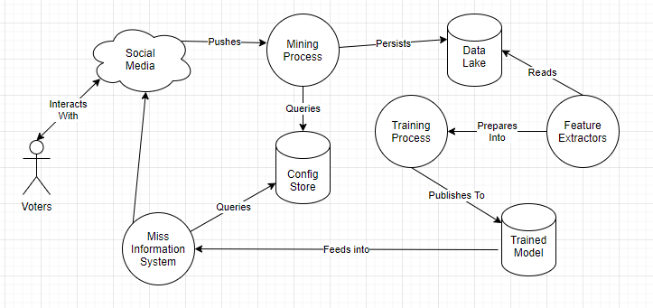

Around 2014, GAN (Generative Adversarial) Networks became the state-of-the-art approach to produce high-quality fabricated content (Fridman, 2020). These systems utilize a feedback loop between a Generative NN (GNN) and Discriminator NN (DNN). Each iteration outputs a ‘Deep-Fake’ asset and assesses its likelihood of being legitimate. This process enables both systems to learn from one another, continuously improving. According to Fridman (2020), it an arms race to detect Deep Fakes because any advances in DNN naturally improve GNN results. NPAC leverages this methodology for self-teaching its systems to deliver more accurate content (see Figure 3). The organization’s solution uses the NLP transformer to improve parallelization over LSTM and a second RNN classification network. During the training process, periodic snapshots archive the content and model state for offline troubleshooting use cases.

Figure 3: Training Configuration

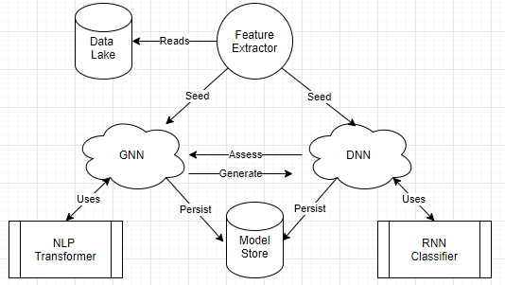

# Timelines

## Acquisition

## Custom Development

# User Considerations

## Interactions

Traditional software follows the model of $data+rules=outcomes$*.* In contrast, intelligent systems derive $rules= data+outcomes$. This distinction can be valuable when the *rules* are fuzzy or not entirely understood. After extracting those rules into a model, researchers and engineering teams can predict actions across mechanical, thinking, and feeling tasks (Huang et al., 2019). As the task type moves from left to right (see Table 1), it requires substantially more sophistication to produce quality results.

Table 1: Task Types

|  |  |  |  |
| --- | --- | --- | --- |
|  | Mechanical | Thinking | Feeling |
| Description | Highly repetitive actions that benefit from automation | Operations that require analysis and rationalization | Emulate interpersonal experiences, and express empathy toward the users |
| Examples | * Turning on lights * Assembly line construction | * Image recognition * Grammar validation * Safe to change lanes | * Empathizing with a driver after an accident * Human Resource Systems |

## Experiences

Artificial intelligent systems that augment existing business processes are more likely to succeed (Garbuio & Lin, 2019). Accomplishing this goal begins with identifying what problem exists, its impact, and potential value. Today, Contoso Motors employs several staff members to read and monitor social media. The business can use sentiment analysis to classify and prioritize only the messages that require human intervention. Since the team does not need to review every tweet, this automation change frees them to perform additional customer relationship tasks. In addition to providing immediate value to the organization, its statement of work and purpose is explainable to senior leadership.

Huang et al. (2019) state that incorporating human emotion into AI systems is a decade away. Perhaps this is true for the general case, but initial wins also exist along the way. For instance, the system could also capture sentiment analysis information about the thread before commenting. Those reactions can then feed into a stylistic decision model that chooses more appropriate tones. This capability would allow the publishing pipeline to emit more impactful content that harnesses the customer’s emotions.

# Performance Metrics

## Measuring Success

Artificial intelligence comes in many forms and applies to a wide array of scenarios, making it challenging to define success arbitrarily. Instead, organizations should identify both the value and resource constraints involved with the project, similar to any other Information Communication and Technology (ICT) system (Jain, 2018). For instance, Contoso Motors wants to implement a smarter cruise control with 3% better fuel mileage for its SUV (Sport Utility Vehicles). According to the data, the vehicle expends significant fuel on inclines, so the engineering team chooses to optimize this aspect with a terrain classification system. Now that the researchers have a problem definition, performance metrics, and potential solution, they can report what level of success is delivered. However, alternative solutions might also exist that do not require artificial intelligence. Instead, the engineering team might implement business policies as static firmware code. Perhaps upgrading the hardware of the onboard firmware also results in a three percent improvement.

## User Training

## Monitoring

# Limitations and Challenges

## Potential Issues

It can be challenging to model real-world business scenarios due to the volume of interactions and their inter-relationships. Some organizations approach these issues by building monolithic models that are difficult to scale, operate, and update. Instead, businesses need to decompose the problem into an environment, participants, and objectives. An agent program manages the state of an individual and any behavior policies. When additional scenarios or behaviors are necessary, engineers can create isolated changes, enabling agile experimentation.

An analyst can study macro-systems by invoking multiple agent program instances and aggregating individual decisions into swarms.

Many simulation environments need to find the best choice from K-states across L-decisions. This setup creates exponential permutations (e.g., KL choices), which is difficult to enumerate even with cloud computing. Using Genetic Algorithms (GA) reduces the search by cross-breeding the fittest specimens. Simulation models can also require different levels of fidelity and precision. Administrators can incorporate these needs into Multi-Level Agent-Based Modeling (ML-ABM) to approximate tedious values and provide supporting evidence for critical data points.

## Potential Solutions

Intelligent agents form decisions from a predefined action space using static rules or Neural Networks (NN). Artificial neural networks (ANN) are inferior to humans because they are greedy, brittle, rigid, and opaque (Hole & Ahmad, 2019). These technologies excel at memorizing or patterns, not contextually understanding them, which causes erroneous behavior under novel conditions. While researchers are quick to highlight this issue (Hole & Ahmad, 2019; Wildberger, 1996), does it matter in the world of tomorrow?

Figure 4: Blended Cyber-Physical System

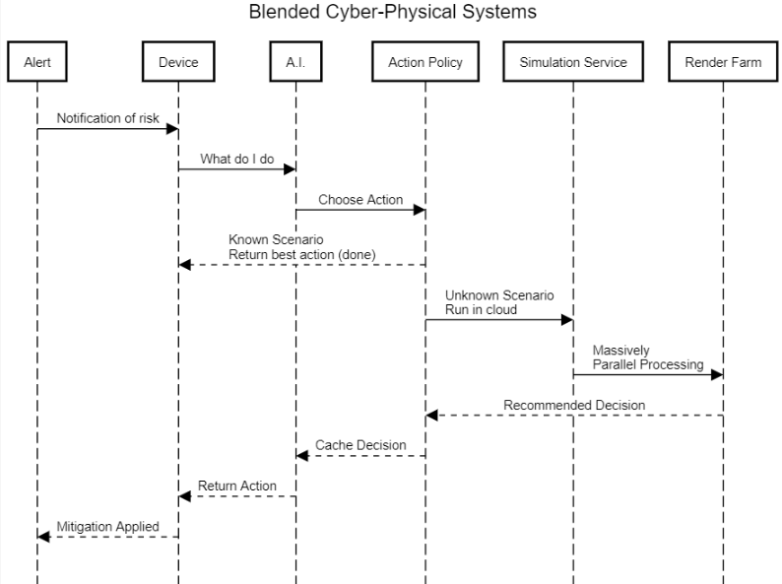

With the availability of Massively Parallel Processing (MPP) and high-speed networking, administrators can further blur the lines between cyber-physical systems. When unknown situations arise, an artificial brain can treat it as a cache miss and fetch the appropriate response from a simulation service (see Figure 4). Next, the simulator will render the calling agent’s state before searching for the best reaction. After confirming the virtual world’s behavior meets administrative policies, the decision can safely execute in the physical world. This mechanism is not appropriate for every situation but could apply to broad types of problems.

# Ethical Considerations

Before 1949, digging a ditch would take hours or even days with a crew of manual workers. After the invention of the backhoe, these jobs required less time with fewer employees. From the organization’s perspective, these efficiencies translate into faster time to market at lower costs. Meanwhile, the former diggers became displaced into new roles, repairing, operating, and supervising the machinery. Each of these positions requires entire supply chains of support. For instance, it takes factories to produce the backhoe parts, each staffed with hundreds of blue-collar jobs. Cities must also build universities and technical schools to train team members that will fill these roles, further expanding the job market.

Similarly, modern businesses are actively seeking methods that reduce costs and improve efficiencies through automation. The most powerful artificial intelligence applications use machines to enhance human capabilities rather than replace them (Heer, 2019; Boire, 2017). For instance, a person can write a more profound business case than a machine; however, the same machine will have fewer grammatical errors. This dichotomy exists because humans specialize in contextualizing thought versus automation uses patterns to make predictions (Schleer et al., 2019). Many professions exist as a combination of decision-making, pattern recognition, and mechanical tasks. Expert systems address specific aspects of the job requirements; however, superseding the soft-skills that unify these role components is challenging (Huang et al., 2019).

Specific low-skilled jobs, such as bank tellers and office clerical staff, are at risk of being replaced (Hamid et al., 2017). Similarly, expert pattern matching tasks like identifying tumors in MRI (Magnetic Resonance Imaging) becomes commoditized through AI systems. Given the lower entry barrier, some low-skilled workers will transition to better-paying jobs that operate those sophisticated and commoditized systems. For instance, many workers cannot access foreign markets due to language and communication limitations. Artificial intelligence can aid these in these translation scenarios while leaving control with humans.

# Strategic Implications of the System

Artificial intelligence is a tool that can automate mechanical tasks, pattern match data, and enhancing human capabilities. Organizations can use these means to improve efficiency and reduce wastefulness. These innovations deprecate the need for specific skill sets and lower the entry barrier into other expert systems. While this causes an initial decrease number of jobs necessary, entirely new industries follow shortly afterward. When a society can replace low-paying jobs with high-paying alternatives, this promotion justifies the short term pain.

Machine learning technology is too immature to delegate business-critical decisions. Instead, professionals should consider these technologies for initial recommendations and to verify their choices are free of unconscious biases. For example, a court judge should assess their sentencing aligns with a regression algorithm’s prediction, not blindly issue that verdict. Humans must maintain control of our actions and consequences. However, it can be challenging to prevent machines from manipulating our free will.

Laws cannot keep up with technology’s high-velocity innovation, causing businesses to define and self-regulate their ethical behavior. Without an official solution for maintaining accountability, this ethical desire must compete against existing business priorities. Those priorities will vary significantly between organizations, as even defining ‘human-centric systems’ is ambiguous. Moving past those challenges are issues with the fundamental integrity of neural network technologies. Implementing transparency and explainability are open research problems for all but the most trivial systems. After solving those issues, ensuring the training data is inclusive requires significant investments into unverifiable results.

These limitations bring the discussion around full circle to the beginning. Artificial intelligent systems are not ethical, evil, or corruptive. They are tools that automate everyday tasks and lower the barrier to entry. Users of that tool need to be cognizant of what these predictions mean and how they influence decisions. However, that is not the same thing as delegating control with impunity.