Week 2: Business Needs Assessment

Nate Bachmeier

TIM-8190: Computer Science Policy and Strategy

September 12, 2021

Northcentral University

# Business Needs Assessment

NCU Financial wants to democratize financial serves through a comprehensive portfolio of capabilities. The organization’s primary growth model is through acquisition which is leading to inconsistent strategies and goal prioritization. NCU-F wants to mitigate these challenges with a business needs assessment. Senior leaders will use this assessment to align corporate goals and Information Technology and Communication (ITC) projects.

## Description and Purpose

Organizations use needs assessments to uncover gaps between a feature or capabilities’ current and desired performance levels (US OPM, 2021). For instance, customers can transfer money to friends and family through the NCU-F mobile app. Today, completing that process takes nearly three minutes on average, significantly longer than competing products. Business Development Managers (BDM) demand a more responsive customer experience that requires no more than fifteen seconds. However, closing the distance between these durations necessitates both time and capital investments.

Meanwhile, the Investment Accounts division is requesting those same resources to support their newly acquired trading platform. Their leadership has concerns that product stability is creating negative press through social media channels. Recently, customers could not access the web application for over sixteen hours last month. Specific leaders might view this request as the IT department wanting to work on IT projects. Nevertheless, a challenging premier release might irrevokably damage the trading platform’s credibility and potentially limit future returns (Kang, 2016). The organization must balance these decisions within a broader context.

NCU-F only has time to complete one project and needs to examine the Political, Economic, Social, and Technology (PEST) factors (Langer & Yorks, 2013). This strategy seeks to rationalize the risks and rewards derived from various external forces (see Table 1). According to that analysis, the trading platform must be the business priority because of the substantial economic and brand risks. Meanwhile, the mobile app’s performance is not a regression. Customers that accept the current latencies today are unlikely to expect sudden improvements.

Table 1: PEST Analysis

|  |  |  |
| --- | --- | --- |
| Factor | Mobile App | Trading Platform |
| Political | High. The payment processing team is a cash cow | High. The application is a rising star |
| Economic | Low. Most customers use the service for free | High. Each customer spends thousands of dollars annually |
| Social | Medium. Customers view it as a free service | High. The release’s marketing campaign is colliding with negative reviews |
| Technology | Medium. Requires upgrading hardware and software systems | High. Requires upgrading hardware and software systems |

## Importance of Current Platform

Hundreds of platforms enable customers to trade financial instruments through mobile, web, and desktop applications. However, those solutions focus on streamlining order entry, not providing customers with the best long-term focused experience. For instance, when the market dips, most brokers flood the screen with flashing red text and induce unnecessary stress. Instead, NCU-F’s solution uses a color gradient based on the long-term trend. This subtle behavioral economic “trick” discourages our customers from buying high and selling low. Across the platform, there are numerous additional mechanisms like intelligent search result sorting to prevent purchasing the wrong instruments.

NCU-F set an aggressive timeline for delivering the trading platform to customers. It met this expectation through numerous outsourcing engagements and licensing existing technologies (see Table 2). While this approach decreased time-to-market, it left them with a heterogeneous platform that spans several vendors. For example, the Identity Services is a service façade to Microsoft Active Directory. This design simplifies specific integrations in exchange for higher licensing costs and fewer concurrent transactions.

Table 2: Trading Platform Subsystems

|  |  |  |  |
| --- | --- | --- | --- |
| Component | Scale | Primary Vendor | Bounding Resource |
| Edge Connectivity | 4 x circuits | Akamai | Networking |
| Container Services | 32 x servers | Open-Source | CPU and Disk |
| Frontend Portal | 8 x servers | Consultants | Networking |
| Identity Services | 4 x replicas | Microsoft | Active Directory |
| Alerting & Messaging | 8 x servers | COTS / PostgreSQL | Database Queries |
| Trade Broker | 16 x servers | COTS | CPU |
| Portfolio Manager | 4 x replicas | In-house | Memory |
| Ticker Plant Services | 32 x servers | In-house | Networking |
| Casandra Cluster | 8 x nodes | Open-Source | CPU and Disk |
| Audit Manager | 4 x replicas | Consultant Firm | Disk |

## Impact of Developing Policies, Standards, and Procedures

The business must strategically decide which governance policies to enforce versus recommend. When the organization mandates a shift in direction, it creates additional work and deprioritizes competing efforts. One approach is defining maturity levels and target groups, then slowly raising expectations on specific critical resources first. For instance, Identity Services’ recent outage makes it a candidate for targeted investments, such as reducing Domain controller requirements through data caching policies.

NCU-F must also devise plans for removing technical debt and implementing standards across the platform. That standardization enables the company to move faster with greater consistency. However, the business must be cognizant of the current business cycle since paying down debt also implies fewer new features. Without an adequate volume of improvements, the customer’s experience becomes stale and fails to meet expectations.

Lastly, formalizing organizational procedures such as disaster recovery and incident management will pay dividends later. For instance, the initial release of the trading platform stores customer data across eight different storage technologies. This approach decouples the implementation between microsystems and promotes engineering efficiency. However, end-users do not care. Instead, they want a consistent system state that withstands an individual server or partition failure.

## Critical Parameters and Configuration Settings

Several subsystems exist within the trading platform composed of various micro-services and vendor products (see Figure 1). Those services discover each other through Domain Name Service (DNS) queries to an internal zone. This approach decouples the network topology from the component implementations. After locating a dependent service, the caller sends the request and client certificate to the endpoint. NCU-F verifies those certificates with their Microsoft Public Key Infrastructure (PKI) services. If these core infrastructure services are unavailable, any dependent services will also miss its Service Level Agreements (SLA).

Figure 1: Abstract Architecture

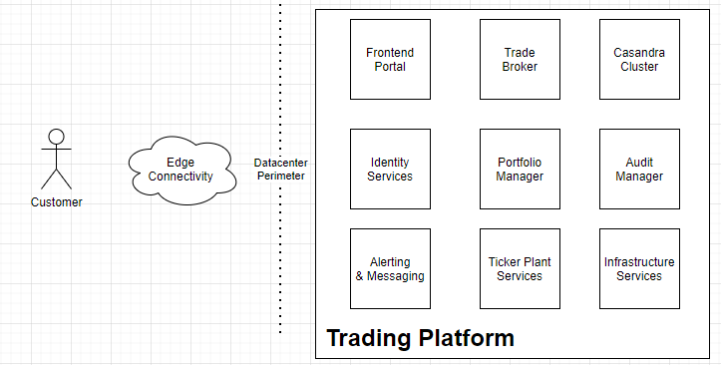

Specific critical parameters are outside of NCU-F’s control, such as regulatory and compliance requirements. For instance, the application must maintain an audit trail of every transaction for at least seven years. Other requirements state that the system must enforce customer privacy and the right to be forgotten (e.g., GDPR). When administrators fail to deliver those artifacts, it invites ethical and legal challenges.

## Critical Processing Controls

There needs to be a balance between technology investments and maturing processes versus business drivers. For instance, the organization can engineer zero-downtime deployments and then continuously deliver value. Though, under this particular scenario, it is worth exploring the total return. Trading applications have natural utilization periods, such as 9:30 am to 4:30 pm. After the market closes, most users disconnect or only require read-only access.

While, e.g., an online retailer does not have such luxuries, NCU-F can exploit its industry-specific flexibility. However, the organization must still implement policies that align with industry-standard practices, like code reviews and release management procedures. Those patterns and practices exist to catch erroneous behaviors and enforce high-quality standards. The business might also choose to implement an authorization scheme that limits changes to the production environment.

## Network Parameter Controls

The trading application maintains a treasure trove of financial information that hackers want to steal. NCU-F must prevent this scenario with policies that limit how trusted users can access the production environment. For example, only the operations team should connect to the production environment using Multi-Factor Authentication and Virtual Private Networking (VPN) software. Next, controls must exist for auditing data access and limiting data exfiltration. Finally, mechanisms and processes must review those business justifications that require the ops team near sensitive information. Over time those policies need to mature and remove manual interactions, further avoiding negligence and unauthorized state changes.

# References

Kang, H. (2016). Technology-focused strategic planning In service businesses. *Franklin Business & Law Journal, 1*, 8-19. Retrieved from https://search.ebscohost.com/login.aspx?direct=true&AuthType=ip,sso&db=bth&AN=112407344&site=eds-live

Langer, A., & Yorks, L. (2013). *Strategic IT.* Wiley.

US OPM. (2021). *Policy, Data, Oversight*. Retrieved from Planning and Evaluation: https://www.opm.gov/policy-data-oversight/training-and-development/planning-evaluating/