6 PLAN, PLAN AND PLAN AGAIN

**A plan is a detailed proposal for doing or achieving something which specifies the what, when, how and by whom.**

OGC (2009)

This PRINCE2 definition of planning is precise; however, it does not tell the full story. We also need to know the ‘why’ and ‘wherefore’ of plans and of the planning process.

This chapter describes some guiding principles of planning. It describes what the project manager should focus on and how to give subordinate team leaders the freedom to set out and manage detailed plans. Throughout, we emphasise the need to understand what the plan is about and how it sets out the path to success. This is more pertinent than just having a list of tasks and dependencies to hand.

We first describe the initial planning effort, then move on to cover re-planning – why it is done and the types of changes required, especially if the project’s situation may be changing extensively.

However, before diving into the detail, a word of caution. Planning can easily get out of control. During the writing of this book we received a most pertinent piece of advice from a colleague:

Thinking about planning, a comment from a successful business man I once worked for kept recurring: ‘It is better to start without a plan than to plan without a start.’

The idea of ‘plan, plan and plan again’, is consistent with this. Build a **simple plan** to outline what will be achieved before the next review and keep revising it and confirming buy-in from stakeholders, but don’t plan for the sake of it; plan ahead, but not too far ahead.

Consider this quote from General Dwight D. Eisenhower, Commander of the Allied Forces responsible for the D-Day invasion: ‘In preparing for battle I have always found that plans are useless, but planning is indispensable’ (Nixon 1962).

Little is learned if you see the planning process as a set of steps you go through and then mark as ‘done’; you need to have a deep knowledge and understanding of how the plan fits together and how all the different parts work. Planning is also a learning process, one that continues throughout the project’s life.

Gantt charts and schedules may give little understanding of what the project is attempting, instead presenting a long (mostly, overlong) list of tasks; too often this obscures rather than highlights critical points in the project. Your plan should show the key points, make responsibilities clear, and show what will happen at each stage. It should set out risks and when they are likely to become worthy of attention. It should do all of this in a set of statements and diagrams that require a minimum of explanation. The project plan is often the first product of the team in operation. An incoherent, complicated or unclear plan creates a poor first impression.

A plan does not predict or guarantee success. What it should do, though, is record what you have agreed to do to make the project succeed.

It shows how the work is going to be done and how the objectives will be achieved. It shows this to management, to suppliers, to customers, to users, to the project team and to anyone who has a legitimate interest in the work (such as reviewers and quality inspectors).

It provides the means to measure progress in meeting the objectives, to understand when further actions are required, and to judge the relative merits of courses of action that will satisfy the quality, schedule and budget constraints.

If the plan indicates that an objective is not achievable you should have a rational case for saying so and have some options available. Anticipate the question, ‘Well, what can you achieve in the time?’

The plan drives the project, so it should:

* explain, in business terms, the result(s) the project is expected to achieve and, in summary, how it is going to achieve it;
* explain the objectives of the project and help people identify with them;
* imbue a sense of realism and of confidence that the team can do it;
* help you identify and eliminate tasks that do not contribute to achieving the objectives;
* identify what might get in the way – risks, for example;
* not give a sense that the plan is ‘all or nothing’, instead show that the team is ready to respond to changes;
* get the team off to a fast start.

That last point has sometimes been the excuse to present some ‘quick hits’ – early results that are supposed to show the project is bearing fruit even though it has just started. Don’t insult the intelligence of the reader with ‘quick hits’ that aren’t – a ‘quick hit’ should have significance for progressing the work. The test is that if the project were canned next week, would the progress made still make a difference for the future? If it would not, then that quick hit isn’t important.

A PLAN AS THE ‘PATH TO SUCCESS’

As work progresses you aim to complete tangible products regularly, so that significant completions occur in each reporting period.

Your plan should have intermediate milestones, representing tangible progress, to dispel any feeling that nothing is happening. Use work breakdown[**1**](https://learning.oreilly.com/library/view/managing-it-projects/9781780171609/26_notes.xhtml#ch06fn-1) or product breakdown structures to help identify important sub-products that can be delivered at these intermediate milestones.

Planning for acceptance

We discuss the acceptance process in [Chapters 5](https://learning.oreilly.com/library/view/managing-it-projects/9781780171609/15_chapter5.xhtml) and [8](https://learning.oreilly.com/library/view/managing-it-projects/9781780171609/18_chapter8.xhtml) – for now, you record the project completion criteria and acceptance criteria in the plan. Acceptance criteria are the agreed rules for determining whether the project’s deliverables have been successfully completed; this includes any performance criteria (response times, reliability, maintainability and so on) that are to be met. Project completion criteria cover project closure and set out, for example, how assets should be disposed of, how project finances are completed and how lessons learned are recorded and made available to other projects.

The importance of reviews

We discuss the importance of reviews for quality and configuration management in [Chapter 8](https://learning.oreilly.com/library/view/managing-it-projects/9781780171609/18_chapter8.xhtml). Here, we want to emphasise the importance of reviews to the plan. Review points are the skeleton of a plan, they are often key milestones and may involve stakeholders. They mark progress, resource commitment and devolution of responsibility, as the following example shows.

SYSTEM DESIGN REVIEW

When working for government organisations, particularly in defence contracts, the system design review (SDR) is an important event. It comes at the **end** of system design. Its purpose is to evaluate the overall (high-level) design and allocate the customer’s requirements to all of the subsystems, each of which becomes a configuration item. Once the SDR is successfully completed:

* Subsystems – hardware or software – are developed independently from the allocated requirements, allocated acceptance criteria and system interface control documents. Responsibility for each development is devolved to the project sub-teams.
* Resources are allocated to sub-teams or to a coordinating team (systems engineering).
* The subsystem configuration is placed under configuration management and is then planned and reported on separately.

The SDR is a key break point in the plan, often a contractual breakpoint. After the SDR is complete detailed plans are worked out in parallel, being brought together within the umbrella of the high-level plan.

An IT project is framed by ‘requirements’ and ‘system operation’. Requirements are the statements made by the customer and accepted by the project team that determine the properties of the IT system the customer will eventually operate. System operation is the completed system, where ‘completed’ means designed, developed, integrated, system-tested and tested in operation. This framework is valid whatever methods and tools are used. From this comes a set of reviews that should be shown in the plan for any IT project. (See [Table 6.1](https://learning.oreilly.com/library/view/managing-it-projects/9781780171609/16_chapter6.xhtml#Table6.1))

Table 6.1 IT project review structure

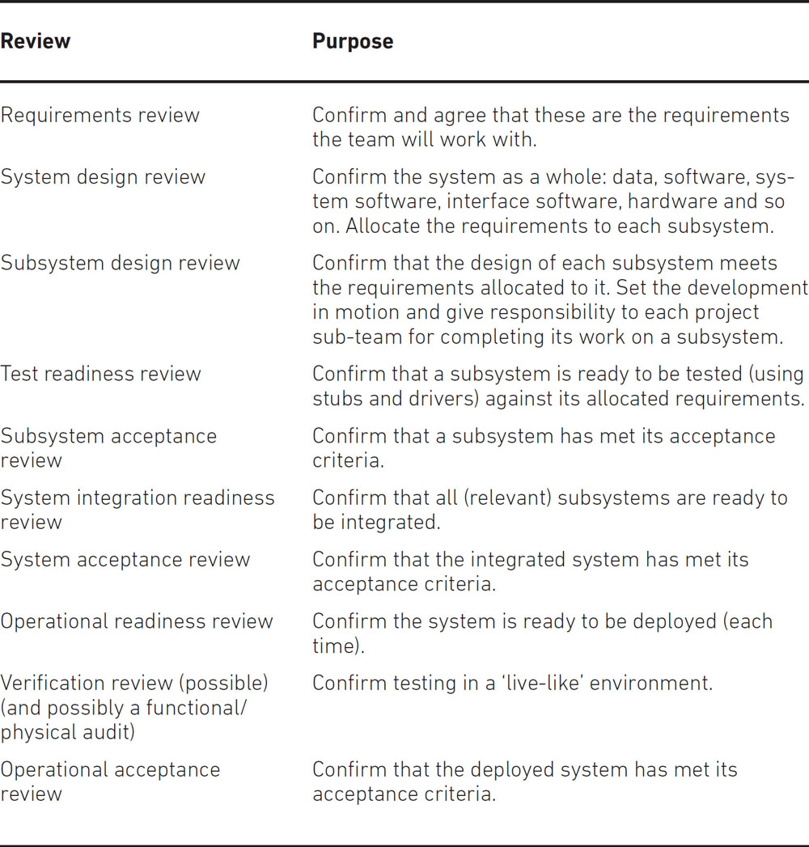

These are the reviews you expect to see. Others will be needed, depending on the development methods and tools used. For example, the extra reviews needed to support an iterative or Agile method[**2**](https://learning.oreilly.com/library/view/managing-it-projects/9781780171609/26_notes.xhtml#ch06fn-2) will differ in kind from those supporting a waterfall method. The number of reviews depends on the complexity of the system being developed and the number of subsystems it has. In principle there will always be more than one subsystem – the software being developed, the user interface support and the hardware. At a minimum the team demonstrates that the subsystem does interpret messages from the user interface properly, on the target hardware, even if there is minimal tailoring of both.

LAYERING OF PLANS

Plans need to be responsive to change and need to be kept current. Once a plan starts to drift it loses credibility and this reduces any enthusiasm to keep the plan current, leading to a cycle of decline that can eventually only be halted by re-planning everything – not an appealing prospect.

In our experience the cause of a drift is not inattention or lack of effort.[**3**](https://learning.oreilly.com/library/view/managing-it-projects/9781780171609/26_notes.xhtml#ch06fn-3) Rather, it is because the way a plan is built can make it difficult to maintain. If a plan is laid out logically with activities associated by time, by responsibility and by similarity, then it is easier to maintain.

To associate activities by time, set out the activity network against the timeline. Place activities strictly parallel to each other if they take place at the same time.

To associate by responsibility, show all activities undertaken by a team as a sub-unit, separable from the rest, with cross-dependencies clearly marked.

To associate by similarity, first associate activities related to hardware, software, workplace development, process and organisation change, integration testing, system testing, implementation and initial operation. Then, taking account of the system architecture, split work on subsystems and data so that it is clear in the plan where components of the system are worked on.

THE LONDON STOCK EXCHANGE ‘BIG BANG’

‘Big Bang’ was the colloquial name for the set of projects instituted to bring electronic trading to the stock exchange. Prior to this, trading was carried out face to face on the exchange floor.

In 1986, in the run-up to the ‘Big Bang’, the project to create systems for electronic trading surveillance was running late. It had to be completed – or at least the important parts – in time for cutover. Not only that, but the cutover date could not change as so many other groups were working to it. We needed a plan to lead the project to successful completion.

The critical path network showed that nearly all paths were critical or over-critical and that nearly all resources were overloaded. Our goal was to manage the scope of the project so that the high-priority items would be completed in time. We needed a plan that could be easily altered, with the aim of also completing as many lower priority items as possible, the rest being part of a tidy-up after the cutover.

The plan consisted of copies of a template network to design, develop, test and accept each module. Each module was a unit of scope separate from most or all others – each was a configuration item. We tracked progress using earned value methods. We could see, week on week, which modules were keeping to the schedule. If progress slipped on an item that was part of the core scope, resources were diverted to make up the delay. Less important items were delayed or dropped.

The plan was easy to update: we disconnected the appropriate network and reallocated the freed resources. We did not have to track resource usage at all, as the key aim was to complete irrespective of cost.

The project was completed on time, the scope having been reduced but all of the essential parts completed. The modules that had been dropped could be completed after cutover. This worked because:

* Having a template meant that reports of all design, development and testing effort over all modules were easy to obtain. This made it easy to see the skills available for redeployment at any time.
* Revising the plan took little time, rarely more than a couple of hours. Not only that but the revision was fully and easily traceable to previous versions: activity naming was standard, identifying the task within the template and the identifier of the module concerned.
* The plan was easy to view as modules could be selected by simple criteria, as could development steps.

We spent less time on administration and gained time for the important activities of monitoring, controlling and ‘what-if’ analysis. Without this approach the management task would have been much more difficult.

[Figure 6.1](https://learning.oreilly.com/library/view/managing-it-projects/9781780171609/16_chapter6.xhtml#Figure6.1) is a simple example of association. It shows a standard activity path for developing a subsystem, with design, development and testing separated by review points. The grey-scale is used to show team responsibilities and each subsystem is designated as a configuration item. Using such a layout it is easy to see (and extract) activities by team and also to add or subtract a subsystem.

**Figure 6.1 Example of planning with templates for sets of activities**

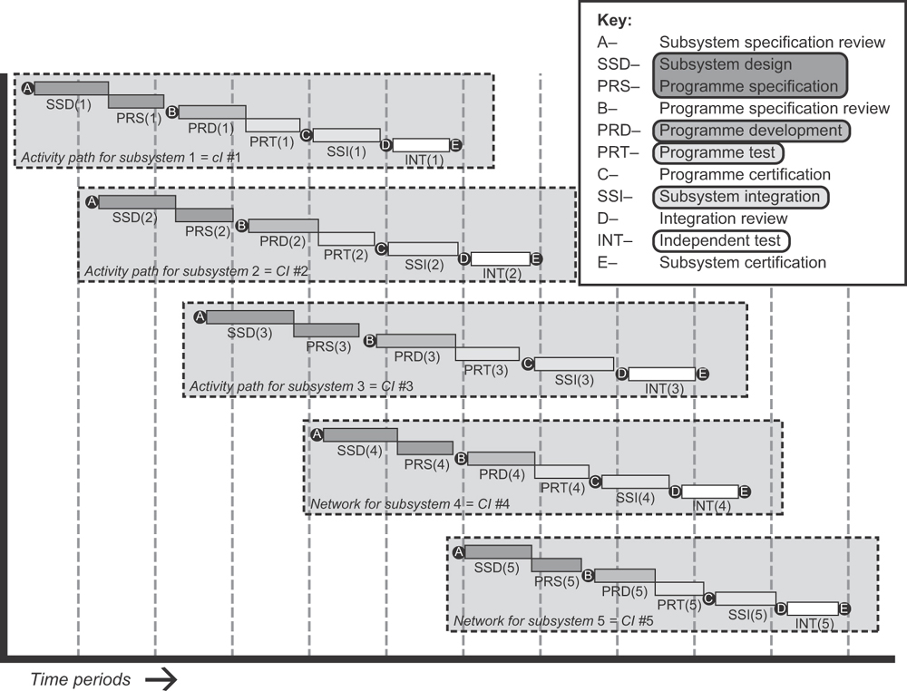

Of course, planning tools can help enormously with the above by allowing plans to be viewed from various perspectives, and at varying levels of detail. But the outputs of a planning tool, whether on a screen or on paper, can be both complex and cryptic. It is important to take care to present the information clearly, using language and terminology that will be understood by all who will use the plan. Do not assume that the all-powerful tool can render your spaghetti planning in a way that will be clear to your team and customer. Do not assume that others using the plan will be as adept as you at navigating through its complexities.

Layering the plan proved to be a decision that made a difference to the result of the ‘Big Bang’ project. Plans are layered broadly in accord with [Table 6.2](https://learning.oreilly.com/library/view/managing-it-projects/9781780171609/16_chapter6.xhtml#Table6.2).

Table 6.2 Layering of plans

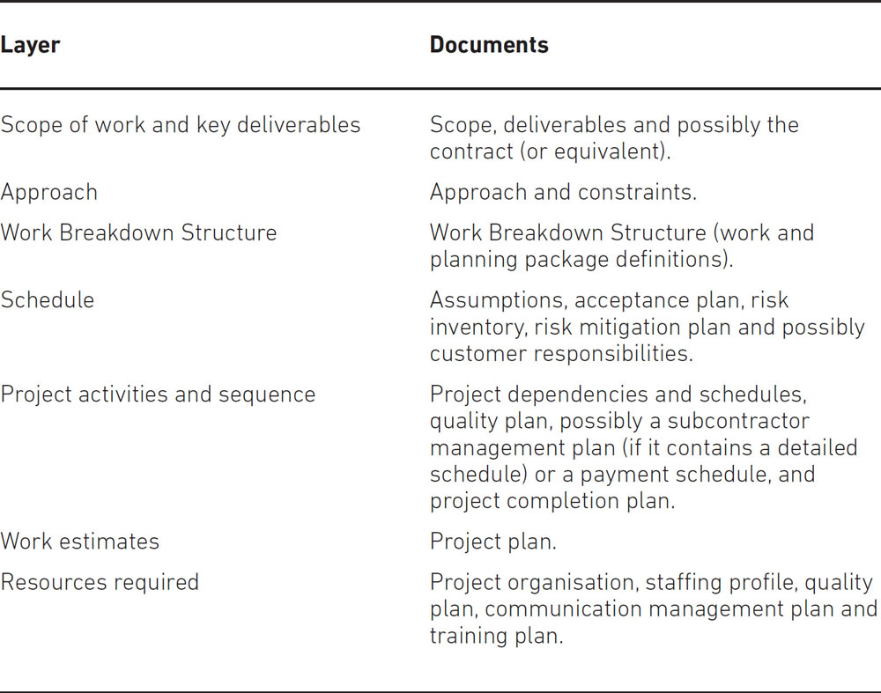

UNDERSTANDING A PLAN

Over many years of creating and using project plans, we finally realised that understanding a plan has little to do with your knowledge of the mechanics of planning. While mechanics are completely necessary, they do little to explain the plan or what it means.

In the following example, a critical path network was created that had 4,000 activities and many, many dependencies. Presented as such, it was completely beyond anybody’s ability to follow, but by looking at the contract it was easy to establish that the first key date was (probably) impossible to meet.

A PLAN THAT FAILED, BUT IT MATTERED NOT

The project started on 1 January and the first drop, for the first field installation, was to be 30 June. The package software was new to the team and needed to be integrated with business processes that were already in use. These could be changed but not drastically. There was a strict seven-step, sequential, testing process; each step had to be approved and all seven had to be complete before the field installation could start. The project team had to be expanded from about 30 up to 200–300 at the same time, and the new people had to undertake key tasks such as integration with the business processes. The team providing the software package had not worked with the systems integration team before.

Twenty-six weeks were available and each test step would take about two weeks to complete (one week to test and one to approve). That left 12 weeks to build a team of 200–300, do the business workshops, learn about the package and make the changes to fit the business processes, recommend business process alterations to fit the package, develop and test (internally) the alterations, check them off against the revised processes, and manage the whole lot. Jeff concluded that the date was not achievable.

A giant critical path network had been constructed, but Jeff found that right in the middle of the network there was a critical dependency on a supplier working to a separate contract, developing a communications link without which our work could not be completed. This link was very complicated and involved a great deal of work. Jeff did not believe the other supplier, though technically capable of completing the work, could complete to their timetable and therefore our work would be delayed in any case. We would not be in the hot seat. No worries, then.

It is important to understand a plan as a whole, working back from the objectives through the key deliverables to the work involved. Identify the important actions and activities and concentrate on getting them right.

If you are working to a document that outlines what the project needs to accomplish – anything from a formal contract to a project brief – then you should see that as an immense help to your understanding. Sometimes it will lead you to believe that the project simply cannot succeed, but before raising concerns, you must complete enough planning to have a well-argued case against the brief as it stands.

CREATING A PROJECT MANAGEMENT PLAN (PMP)

Consider the breadth (scope) of work and the depth (level of detail). At the same time, lay out the key events that will lead to completion of the top-level products and services the customer wants. Most if not all of these should have been set out in a formal contract, in your proposal or in records of previous discussions.

You should not yet be concerned with whether the work can actually be done in the given time or budget. First you need to understand the work involved, as if there were no constraints at all.

Plans are rarely accurate beyond a horizon of six months. Therefore you will not be concerned with detailed activity lists or dependency networks. Such detail is separated and planning allowed to proceed in ‘waves’ either by project stage (phase) or, if a stage is long, by three-monthly increments.

The PMP will then contain a WBS, top-level schedule and budget. It includes information important to the customer, management, team, users and other stakeholders, unobscured by detail.

The PMP may include plans for risk, quality and configuration management and for communication. All are set out at a high level first; details are added later. If plans are too detailed now revisions will be required even for small changes – to estimates, activity durations and so on – making the process unwieldy.

By placing all these plans at an equivalent level, they can be cross-referenced in a way that is easy to follow.

Once agreed, the PMP is placed under configuration control.

Scope and approach

When creating a PMP, the first task is to create a WBS. This starts from a list of the major deliverables[**4**](https://learning.oreilly.com/library/view/managing-it-projects/9781780171609/26_notes.xhtml#ch06fn-4) to the customer and breaks them out, by product, into smaller components. These are used to support accurate time and resource estimates and to allocate team responsibilities for delivery. The WBS is also the basis for earned value calculations.

WORK BREAKDOWN STRUCTURE

A WBS is a **hierarchical decomposition of the project into product-based work**. It includes everything that the team, any subcontractors and the customer must deliver in order to achieve success.

A WBS is product-based, not activity-based. Completion of a product can be tested objectively, whereas completion of an activity may be more difficult to determine. Products include those delivered by the customer, for example to support use of the system.

An example WBA is shown at Appendix A.

The top level of a WBS is a short document. Each entry is accompanied by a description sufficient for the reader to understand the nature of the product to be delivered. Reference can be made to detailed descriptions and to quality, industry, environmental and other standards that will be used to determine its acceptability.

There are two types of description: a work package, with a well-defined scope, schedule and resource profile; and a planning package that does not have these details, but may have an initial budget. Planning packages are converted to work packages as detailed plans are extended.

A WBS description may refer to a development product, for example a requirements specification or top-level design. It may refer to products such as subsystem design, test and programme specifications, which start as planning packages and are defined in detail later.

To create a WBS start with the scope of work. Find the highest level at which products can be defined that meet project objectives. If one of the objectives is:

‘To complete the sales analysis subsystem by month 14.’

the product is the sales analysis subsystem.

Go through the objectives to determine applications, data(bases), technical components, business processes, workplaces and possibly organisation changes that the project has to work on. The complete list of deliverables is shown at the top level of the WBS and each can be traced back to the objective it supports. Any other desired deliverable is out of scope and requires a change of project objectives before it can be included.

To break out the top-level products of a WBS into more detail you will need a good understanding of the **technical and management approaches** to the project (as described in [Chapter 5](https://learning.oreilly.com/library/view/managing-it-projects/9781780171609/15_chapter5.xhtml)).

As a brief reminder, these describe the methods, processes, tools and so on that will be used to develop the solution and manage the project. You take into account standards for management and IT systems development (both business and industry), technical methods mandated by the objectives (for example in safety-critical projects), legislative constraints or security requirements. You should now confirm the associated costs – of, for example, applications and equipment to be purchased, skills to be developed or obtained or any need for specialist external support.

You need to determine how the technical approach is to be planned – for example, in an accelerated development approach there are many workshops and time-boxed activities – and whether associated management tasks need to be planned.

The technical approach provides intermediate work products with well-defined acceptance criteria. If product verification and validation are not built in via standard reviews or inspections, you will need to add them.

WBS OR PBS: WHAT’S IN A NAME?

If you are familiar with PRINCE2, you will know the term Product Breakdown Structure (PBS). You may wonder why we choose a different term for what appears to be the same thing. In fact there is an important distinction between work and product breakdown.

The PBS includes all **products** that the project is required to produce. It contains the complete scope of the project’s delivery work.

The WBS contains the total **budget** for the project. It includes products and services required of the project team, suppliers or subcontractors, the customer and the users. A WBS may have entries such as ‘management reserve’, ‘undistributed budget’, ‘warranty’ and ‘constructive changes’ that would not be seen in a PBS.

In cases where the project is contained within departmental budgets, these differences disappear and the WBS and PBS are identical, but they will be significant if the project is performed to a contract, especially if the project is of any significant size.

Thinking through these items can lead to risks being raised and issues found that need to be resolved. For example, suppose the proposed technical approach is new to the project team or the customer. How is the risk of misstep to be mitigated or managed? What if customer mandates and quality standards are inconsistent? You would need to resolve these matters before proceeding to avoid severe disputes later on.

PLANS AND ISSUES

Determine whether any issues are coming to light. The formal process of managing issues starts properly when the team get to work, but issues tend not to wait for formal processes. You may be the only person available to deal with an issue. In principle issues are best resolved quickly and, whether resolvable or not, if you pay attention and respond you will start on a positive note. You also stand to learn more about future difficulties, whether opposition to the project or caution about it, than you will by ignoring or delaying consideration of issues.

In our experience, it is essential to have a well-defined system architecture (IT) to create a well-defined plan. The structure of the architecture should be visible in the plan, and that can only happen if the architecture is well defined.

Ask yourself whether, using this technical approach, you could build the system cumulatively, adding piece to piece until the complete system is ready for delivery. If so, this will help you reduce risk significantly. You will get early warnings of problems, and many more opportunities to learn about the system you are building. The users will have early opportunities to contribute or comment on the system. This is often better than having to commit all your confidence to one ‘big-bang’ delivery.

You need to think about the balance of technical and business risks. Consider two examples, similar at first glance but with different consequences.

In the first case, a business wants to have a project completed because it will not be able to allocate budget to it beyond the due date. If the project is delayed the business might be badly affected, though it would survive. In the second case a project must be completed by a given date, else the business will not survive.

In the first case, you reduce the risk of delay by adopting a well-proven, predictable, technical approach that the team are already familiar with. In the second case ‘time is of the essence’ and you may need to adopt a challenging or little-known technical approach that will deliver results quickly, despite the risk of, for example, the team failing to use it properly because of unfamiliarity.

These considerations lead to more risk analysis, all of which must be recorded. The end result is that high-level products are broken out in a way that is consistent with the agreed, documented, technical approach.

Having completed the WBS with accompanying work package descriptions and references, the next tasks are to develop resource estimates, activities, activity sequences and dependencies, resources required and a project schedule. These tasks can be carried out in parallel. They are sufficiently interdependent that a parallel, iterated evolution is often the best way to obtain a consistent plan.

One extra task may be required: to define the project’s budget and payment schedules, both for purchasing resources and for customer stage payments. This is closely linked to the project schedule. It may even influence the schedule if, for example, a supplier has payment conditions that might affect the allocation of cash to a project over an accounting year-end.

Earned value

If you want to track progress objectively and robustly, adopt the earned value technique. Earned value is ‘the sum of the approved cost estimates (including overhead allocation) for the work package completed during a given period’.[**5**](https://learning.oreilly.com/library/view/managing-it-projects/9781780171609/26_notes.xhtml#ch06fn-5)

The earned value technique works by allocating budget value to each item in the WBS, at the level where you intend to measure. The value is either in money terms or man-days to complete; don’t mix the two. Whether you use money or days, the value you attach to an item is the estimate you made in calculating the project budget. Once you have completed the item (100 per cent) then you have earned the value you allocated. You need to keep a running total of the value earned; this is the objective measure of what you have achieved.

You **must reach an agreed milestone** to earn the value. When you define work packages in the WBS (or PBS), what you have in mind is a tangible result – a product or service – defined so that you can agree completion by independent, objective, review.

You allocate a budget to complete the work package in days of effort or in cost to purchase. You add whatever overheads should be allocated according to the organisation rules. The total is the budget for that work package.

You add up all of the budgets for all of the work packages and (of course) the result matches exactly the budget you were given for the project.

When that proves not to be the case you must challenge the estimates and arrive at a budget that matches the one you are given.

If you decide to use earned value to measure progress, you credit the value for every work package only when it is complete. No messing, no finessing. That way you can, hand on heart, point to the total earned value so far to represent an objective measure of progress. It is the value of the work you already agreed to in the project budget.

So far, so good. However …

Suppose the work package is ‘30 web pages completed, tested and functioning’. You reach a point where you have a functional site with, say, 20 pages – but no value earned at all. That underestimates the project’s achievement. To cater for such situations you have a choice of methods, nearly all objective, that let you measure achievement before the work package is complete. Some available methods are set out in [Table 6.3](https://learning.oreilly.com/library/view/managing-it-projects/9781780171609/16_chapter6.xhtml#Table6.3), starting with the most objective.

Table 6.3 Earned value methods

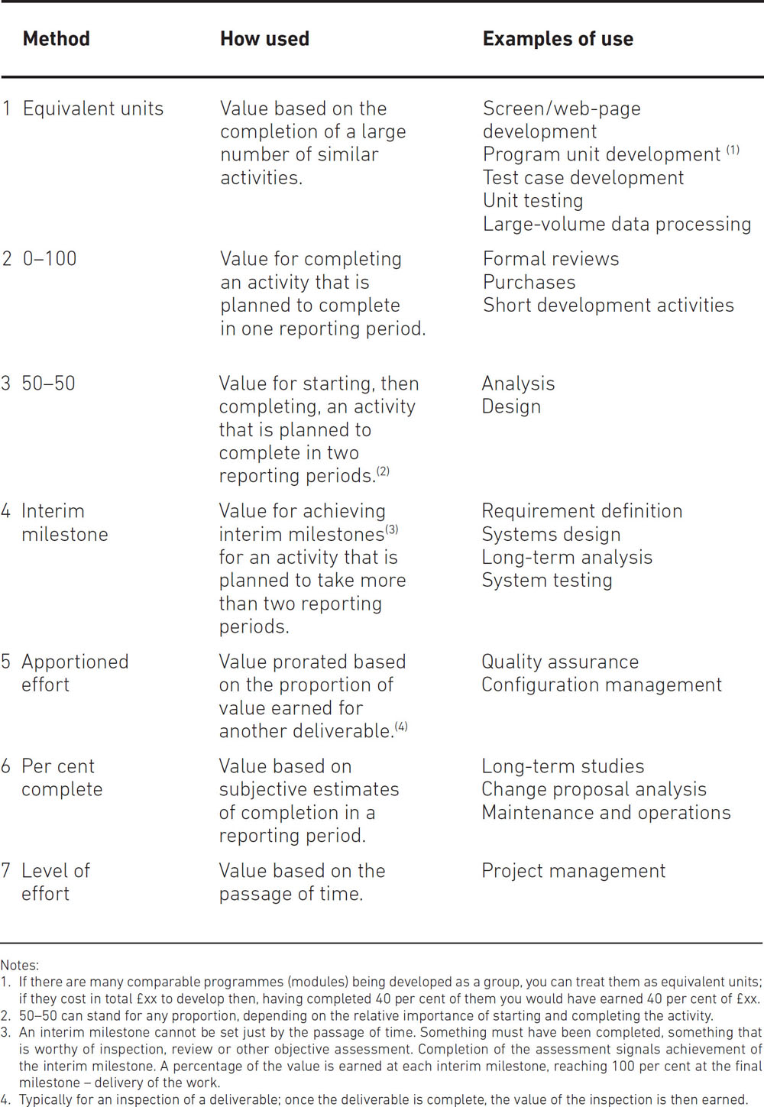

You decide what method to use for each work package when you are planning the work, then stick strictly to that throughout project execution. You always will prefer to determine completion by an objective review; a formal quality review is by far the best way. If you pursue this approach rigorously it will give you an objective measure of progress that will pinpoint sources of trouble before they spiral out of control.

We discuss earned value again in [Chapter 7](https://learning.oreilly.com/library/view/managing-it-projects/9781780171609/17_chapter7.xhtml).

Resource estimates

To estimate resources you need expert knowledge, ideally supported by relevant historical data. If policy dictates, you may also use estimating tools such as COCOMO (Boehm 1981, Boehm et al. 2000). However, research shows that expert judgement is likely to be at least as accurate as using an estimation model (Jørgensen 2004), so be wary of using models unless you have to, and always use expert[**6**](https://learning.oreilly.com/library/view/managing-it-projects/9781780171609/26_notes.xhtml#ch06fn-6) judgement as well. You will also need to estimate the level of staffing and you may need to estimate the amount of equipment, accommodation or supplies needed to carry out the work.

Create estimates for each product in the WBS and drive down into more detail if necessary, without having to include that detail in the WBS. Record everything – historical data used, opinions, assumptions and calculations. Otherwise, later on, you will find it much more difficult to evaluate the effects of changes.

DO NOT USE HOPELESSLY OPTIMISTIC ESTIMATES

A US Air Force study (Christensen 1994) examined 64 US defence acquisition contracts. The following quotations are instructive:

… research has shown that, once a [project] is more than 15 percent to 20 percent complete, it is highly unlikely that the final cost overrun will be less than the present cost overrun … These results were found insensitive to contract type (cost, price), contract phase (development, production) …

Thus, a projected overrun at completion is defined as unrealistically optimistic if it is less than the present cost overrun.

Estimates need some sort of reasoned judgement behind them; if you have past data for similar work, so much the better. That depends, of course, on whether your organisation bothered to complete past projects properly. Estimates based on nothing much at all can land you in difficulty quickly, so if you want to avoid cost overruns, the first and wisest step is to furnish realistic estimates.

Assumptions and constraints

Assumptions allow decisions to be made so that work can proceed; constraints can be caused by legislation, business policies, having limited accommodation, limited access to business staff, budget limits or fixed delivery dates. You need to negotiate these before accepting them, and those that remain must be recorded in the plan and worked into the activities, resource estimates, dependencies, and so on. Every assumption needs to be recorded and monitored.

Working to a contract

If the project is governed by a contract then you will need to take even more care about assumptions and constraints. A well-designed contract can be the most helpful aid you have; if it is clear and has a simple way for the parties to resolve differences, consider yourself fortunate. However, you need to look for danger signs – for example, if the process for resolving issues involves negotiating with many different parties. If requirements are rigid you can expect trouble in making necessary changes. A good indicator of rigidity is the frequency of the word ‘shall’ in the requirements (as opposed to ‘should’ or ‘may’).[**7**](https://learning.oreilly.com/library/view/managing-it-projects/9781780171609/26_notes.xhtml#ch06fn-7)

The more ‘shall’ is used the worse the difficulties are likely to be. It does not, in legal terms, allow flexibility so the meaning must be clear. Unfortunately this is rarely possible. As an example, suppose a requirement is worded:

‘The supplier shall provide all facilities to support order queue management.’

This could mean a new software system, staff on hand to process the queue, a new fancy office for the queue manger…. In case anyone might doubt that a requirement would be worded so, we have seen similar examples.

Activities and their sequence

When determining activities to be carried out to produce the deliverables set out in the WBS (or PBS), make sure you include all the important activities, no matter who carries them out. Consider these two examples:

**Subsystem.** To produce a subsystem you need a design, a set of program specifications, interface specifications, a test plan, test specifications and data, programs and test programs. You may need business process interface definitions, screen layouts, menus and scripts.

**Business process.** To produce a business process you need (at least) business rules, any supporting system definitions, interfaces and interactions, roles and organisation change documents, location types where the work takes place, data requirements and data, and integration test scripts and data.

In each case, the project will do some of the work but the customer, users or outside suppliers may provide elements as required. For example, business rules may already exist; if so, you will have identified **dependencies** for the project, for obtaining the information.

There is no need at this stage to go into great detail, but you need experienced people to help define the activities. Record everything: it will be the basis for estimating the work involved and will be immensely valuable later on.

PRINCE2 practitioners will no doubt have prepared a product dependency diagram at the same time as preparing a PBS. If not, now is a good time to create one and either the PBS or the WBS can be used. Start with inherent dependencies: for example, design activities must precede development activities. Then add resource dependencies: for example, a key resource (skill, equipment or supply) may only be available to support one activity at a time, so activities which might otherwise take place in parallel must be sequenced.

Resources required

Having defined the activities, you need to identify the skills and numbers of staff required to carry them out, as well as resources such as office space, computer support, special technology items or external expertise. Build up a staffing profile and role definitions, ensuring that roles are defined so that project team members have coherent and related activities to work on.

Record the need for special and general equipment, or external expertise. These will be part of your external dependencies, to be scheduled and tracked.

***The project team***

You may have already mentally selected people you want to be on the team, but you may not get them; also you may get people you have not met before. You need to identify tasks that are critical to success and tasks that require skills and experience that are not easy to come by, and then you should decide how to pitch for the right people. Be clear about where you are willing to compromise. As an example, you might need an expert on data architecture but perhaps only for key design activities.

You will almost always need to negotiate, so you need to get your position and justification clear. The result of negotiation will affect the activity estimates. If you manage to get someone with lots of relevant experience for the work you will be able to justify a tighter estimate for completion.

The project schedule

To help with schedule calculations, use templates and project management tools to create a critical path or PERT (Project Evaluation and Review Technique) network. Use Gantt or milestone charts to show start and finish dates and duration of all major activities. Plan at the top level, with no more than 100 activities, so that the network occupies only one page (at most two).

***Understanding the critical path network***

If you have developed a critical path network, look at the items that are nearly critical. Think about situations in which these items would become critical and, if they did, what the consequences would be for the schedule. Consider items that are well off the critical path but whose delay would have a serious effect on the project: can you think of circumstances where such delays would come about? If you have time, work up alternative critical path calculations to show the effects. When you are thinking about this you need to make notes for risk mitigation and management.

Your customer, or a supplier who is not part of your team, may be providing an important piece of equipment, software, expertise or staff training. What would happen if this were delayed or turned out to be not as helpful as you expected it would be, or as it was promised?

What major upgrades are expected to software or equipment you are going to use? Are they expected to happen anywhere near important dates for your project work? If they do, what could you do to mitigate the effect?

Consider the effect of assumptions you must make to get started or progress. If your assumptions are wrong, what are the risks? How much information can you obtain to clarify the assumptions?

Also, incorporate constraints in the critical path. A delay until accommodation is ready, access to key staff, fixed delivery dates, customer business cycles or legislation due to come into force: all these may affect the project.

A NOTE ABOUT ‘WHAT-IF?’ PLANS

The best project managers take time to think about the consequences of events that are not certain to happen. It does **not** follow that you plan for every event; rather, you think about events with important consequences that cannot be contained in small changes to the plan. You spend time investigating what can be done to keep the project aimed at the original objectives – or whether the event is so significant that it raises questions about whether that would still be possible. This is tricky, as these plans require effort that may never bear fruit. But you must do this if you can.

Budget and payment schedule

Develop the time-phased budget for the project from the schedule. The costs are generated from the resource profile (for staff, equipment and working space) and whatever rates apply to them. If you are working to a contract that specifies payment milestones, include these so that you can also produce a project cash-flow that you can use to track financial performance.

A NOTE ON PROJECT FINANCES AND ACCOUNTING

The least you must do is manage the budget. However, projects employ people, things and workplaces to get the job done, so you might have to do more. This is true if your organisation is carrying out the project on behalf of a business, or if the project is one of many conducted by the business itself. If your project is one of these common cases then you will need a financial plan. You will need to plan and account for:

* The cost of people and how that is shared with others; also how the cost of actual time spent is to be allocated.
* The cost of assets (things) the project uses, either by paying for their use or by purchasing them and then (after depreciation and so on) recovering cost by selling them on.
* The cost of renting or leasing or cost-sharing the workplaces used by the project.

At this stage you should not create policies for the project beyond those required by the business or by the contract. You can and should obtain guidance about these policies and any requirements for financial control over and above the minimum of managing the budget.

We will look at asset acquisition, use and disposal in [Chapters 8](https://learning.oreilly.com/library/view/managing-it-projects/9781780171609/18_chapter8.xhtml) and [10](https://learning.oreilly.com/library/view/managing-it-projects/9781780171609/20_chapter10.xhtml).

Risk and contingency

Contingency is sometimes taken to mean the budget set aside in case one of the risks identified arises. In our experience that is too restrictive. The *Concise Oxford Dictionary*(1991) defines contingency as ‘a future event or circumstance regarded as likely to occur, or as influencing present action’. This covers risk and includes other possibilities, such as tasks that will happen irrespective of whether a risk comes about.

In large and lengthy projects it is common practice to reserve some budget to cover such things as work on change proposals that have not yet been agreed. This budget will need to be spent, but it cannot be allocated at the beginning.[**8**](https://learning.oreilly.com/library/view/managing-it-projects/9781780171609/26_notes.xhtml#ch06fn-8) If no budget were set aside now, later the budget and resources for other activities would be affected in unpredictable ways. Experienced project managers set amounts aside by taxing other activities (during planning) to create this budget. It is better to challenge and ‘tax’ the budget to reserve time for change analysis, and the challenge is best made at the start of the project to avoid having to cast around for budget later on when the project is in the midst of its main job.

You should treat this provision as separate from any resource or budget you set aside for events identified on the risk register (see [Chapter 5](https://learning.oreilly.com/library/view/managing-it-projects/9781780171609/15_chapter5.xhtml) where this subject is discussed). Having some budget set aside for change recognises and makes provision for the inevitable. It is one reason why the best project managers are less worried when changes arrive.

In-process improvement

In [Chapter 7](https://learning.oreilly.com/library/view/managing-it-projects/9781780171609/17_chapter7.xhtml), we cover the project manager’s tasks during project execution. One area of responsibility is to improve project processes. This, though, has consequences for training and work in progress – and may have knock-on effects on completed deliverables. During planning, the policy for process improvement must be set, as discussed below.

In [Chapter 5](https://learning.oreilly.com/library/view/managing-it-projects/9781780171609/15_chapter5.xhtml), we referred to the Shewart Cycle (Plan-Do-Check-Act). That cycle has its roots in manufacturing and shows its origins as a means of continuous process improvement. It has been usefully employed in many other situations since – but still there is some uncertainty about how best it could be used for projects that are in their nature one-off.

We believe the Shewart Cycle can be applied to ‘in-process’ improvement, when the project changes (improves) its standards or procedures while it is in progress. It does, though, carry risk with it.

In the days when re-engineering was fashionable, a cautionary statement was that is was akin to ‘changing the tyres while the vehicle was still in motion’. This is also a fair analogy to in-process improvement in a project, as it is easy to end up with confusion between old and new practice.

When planning the project, you should make a clear statement about whether – and how – process improvement will be allowed. Typically, that will define who can authorise improvements (for example a project owner, project board or some senior manager) and when they can take place (for example at a stage boundary or a significant mid-stage point). The statement will also set out how products produced in accord with the replaced standards will be treated; whether they will be revised or whether a cautionary note will suffice.

You must do this if the project is a one-off for your business, and we recommend you do this in all other cases.

THE COMMUNICATIONS PLAN

You need to take steps to ensure that the project story is told consistently, regularly and through the appropriate channels. The communications plan describes how you will tell the story – and how you will listen to the responses of stakeholders, especially future users and business managers.

We do not cover the content of a communications plan in detail; most methods deal with such plans (e.g. OGC 2009). Rather, we summarise the content and then give some additional advice based on our experience.

In the communications plan you determine:

* **Your audience(s).**First you list whom are you addressing – the stakeholders and (if needs be) other interested parties. Where are they and how many are there?[**9**](https://learning.oreilly.com/library/view/managing-it-projects/9781780171609/26_notes.xhtml#ch06fn-9) Remember that you may need to include people who are outside the business (investors, for example). This is especially true in a big project or programme that attracts media attention.
* **Your messages.**What do you intend to tell your audience and how relevant is it to them? The relevance of a message determines its frequency and priority. Omit anything not relevant to an audience unless you cannot justify the cost of tailored messages to each audience.[**10**](https://learning.oreilly.com/library/view/managing-it-projects/9781780171609/26_notes.xhtml#ch06fn-10)
* **The channels.** How you will communicate? What means will be used? Anything from web pages or social media to magazines can be considered.
* **Timing.**When, and how often, will you communicate to your audience? Include activities such as reviews, meetings and reports in this part of the plan. Strike a balance between monastic contemplation and tedious hyperactivity.

In a big project or programme you must take care with the messages you send as premature or incorrect reports can cause damage. It is a good idea to work with staff from marketing or corporate public relations to harmonise communications with other messages being sent outside the business.

* **Underlying data.**What project data will be used for communicating? Will you, for example, include summary expenditures and progress data?
* **What to listen for.**What might your audiences be telling you in response? This can be what you would like to know about – and what you think you will get from each audience. The plan will describe both, as far as you can define them.

For example, you’ve identified an event that might have serious consequences for the project. You have put it in the risk register and have the means to avoid or respond to the risk. But what about tracking the event – finding out about it and whether it is more or less likely to occur as time passes? If you can find out more about the event, you will be better placed to manage the risk. If you make your audience aware that you are on the lookout for this event and ask them to be on the lookout as well, you improve your chances of detecting and managing it.

* **Communicators.** Who is responsible for communicating? Include a ‘face-off’ plan if members of the team will be working with particular stakeholders.

If you are delivering the project for another organisation (as a supplier), your team is likely to include managers senior to you, who, while not working on the project, should be committed to its success. It can be tricky to get them onside with your overall aim but if you don’t make the effort you run the risk that a senior manager will mess up your plan because they don’t know what you are trying to do.

* **Reassessment.** How (and how often) will the plan be assessed for effectiveness and improvement? As the project proceeds, the priority, content and importance of messages and their audience will change. So you should review the plan at the end of each break-point of the project – requirements, design, development to test and deployment are examples.

The communications plan generates activities to be included in the project plan. For example, reporting requires data gathering and analysis activities, then further work to provide summaries and recommendations. There is work to be done setting up communications and finding out what is already in place or what methods have worked in the past in similar situations. This will require resources and so it will cost time and money, which need to be included in the project budget.

Consider whether the business has responsibilities for communication – for example to operating divisions that are not affected directly by the project but which may need to accommodate the new system. Senior business managers should at least review the plan and may also need to review the design of media such as magazines or web pages to ensure they don’t cut across established channels. Finally, you need to include activities that allow you to check and possibly change the way you communicate.

Dealing with business change, you need to handle communication with extra care because if you get it wrong you will affect the trust of your audience, which is something you will need. By losing trust you will compromise project success. Here are some things to keep in mind:

* Communicate directly and simultaneously to everyone affected by the change.
* Communicate to all parts of the business, not just to those areas directly affected.
* Schedule messages with their associated actions to ensure that promised actions happen while the message is fresh in the minds of the audience.
* Avoid using the existing management chain, especially if a business reorganisation (including management changes) is a consequence of the project.
* Be sensitive to labour issues and always involve labour union leaders when providing information that affects their members.

COMPLETION PLAN

At this point, you now need to start preparing a **completion plan** for the project. Most project management methodologies include a plan for orderly completion of the project. Often this is interpreted as being the time when all the work has been done. However that is not always the case. Projects complete when:

* the work is done;
* disaster strikes;
* the need is overtaken by events;
* an important phase of work is agreed to be finished.

Here are some of the tasks a completion plan needs to cover. These need to be considered at the start of the project rather than some time ‘later on’:

* disposal or transfer of equipment and facilities;
* redeployment of staff;
* archiving of essential project documentation (and knowing what must be recorded for archiving);
* communication of lessons learned and improved practice recommendations;
* integration of project data into a central repository.

There can be important completion tasks at the end of a stage, such as a design stage, where the staff mix may change greatly. Anticipate such events and include them in the completion plan.

In considering completion you must be aware that a project is part of a broader context and uses people, equipment and working space that will be needed again later. As the manager of this **temporary task**, remember your responsibilities to staff and to the organisation’s understanding, experience and memory. You discharge your responsibilities by planning and executing orderly completion whenever it is needed. Typically, this includes:

* how the organisation learns lessons and stores project data;
* how equipment is disposed of and working space reallocated;
* how members of the team are redeployed. In some cases, for example if the staff are subcontracting or working through an agency, there is a formal process to follow. Even if this is not the case, there are likely to be some formal steps to go through.

Remember that ‘you should leave things as you would expect to find them’.

DETAILED PLANNING

In parallel to the top-level plan, you create a detailed plan for the first project stage or increment. The activities in this level of planning cover shorter periods of time, and three caveats apply when defining them:

* Even when short, an activity must result in a tangible product with objective and (if possible) quantitative review criteria.
* Activities must not be so short that the effort of reviewing the product is disproportionate or – if there are many short activities – overwhelms the team.
* Activities must not be so long that progress (or lack of it) is hidden from an end of period report.

As a consequence of detailed planning you may revise work estimates, milestone dates or activity dependencies. You must be prepared for this.

Other management plans

Other plans that will be prepared at this time include the quality management plan, configuration management plan, risk management plan and the training plan. We summarise the contents of these plans in Appendix B.

RE-PLANNING: PLAN, PLAN AND PLAN AGAIN

The planning process continues throughout project execution. You continually improve your understanding of the plan as results come in, no matter whether they are pleasant or disappointing.

Re-planning can be involuntary or voluntary. Events that trigger a re-plan are:

* The detailed plan is extended, after a major milestone or to a new phase of work.
* Risk mitigation is put into effect.
* New work has to be planned.

The best project managers re-plan voluntarily, in advance, and as a result they avoid being driven to re-plan by the force of events. The best project managers are able to create time and they make use of it by testing the plan. As a result, they are less likely to be caught out, which gives them more time to think about the plan, which then … (and so on).

The scope of re-planning

Through the project’s life, re-planning is required in response to changes in circumstances; the greater the change, the greater the extent to which the project plan is revised.

The following are typical examples, with the scope of change increasing each time:

**Revise estimates and resources required**. This happens often as resource availability varies frequently. It normally involves only the detailed plans, not the top-level plan.

**Revise products, estimates, activities and activity sequence**. This will have some impact on the top-level plan but should not affect the scope or approach (methods of work).

**Revise the approach to cope with unexpected shortfalls**. This will impact the top-level plan, probably leading to a major revision. The project scope may need to be revised, if the working methods cannot provide the required solution.

**Revise the scope and key deliverables**. This will impact the project and possibly the customer’s business. It will result in a complete revision of the plan and may cause the project to be reshaped or abandoned.

***Extending the detailed plan***

The detailed plan is extended when the project will soon pass a major milestone or phase and the plan now needs to cover the next period. It is extended exactly as you created the first detailed plan. It must remain consistent with the top-level plan and thus needs to be checked against it. If you find that the detailed planning of the new phase of work impacts key milestone dates, you must recheck the detailed plan first. If, after the check, you find that some revision of the top-level plan is unavoidable you must raise an issue. Do this sufficiently far in advance of the new phase of work to allow for discussion of the available courses of action with the customer (and, where appropriate, your management).

FOR PRINCE2 PRACTITIONERS

Strictly speaking, needing to revise milestone dates in the top-level plan is not the same as exceeding project stage tolerances. Deviations from tolerances arise from plans that have already been approved by the project board and the detailed plan for the next stage does not come into that category. However, the effect is the same, since the top-level plan has already been approved by the board (possibly with a greater level of tolerance). So you should raise an issue far enough before the end-stage review to allow the project board to consider the options available to them. The issue will of course be accompanied by the extended detailed plan. It should include your analysis of the consequences of the available actions and your recommended action.

As the project enters a new phase of work, different levels and skills of staff will probably be employed in the team. All of these changes will be apparent well before the event and will have been planned in. However, the additional work of partial project completion must now be taken into account:

* Changes to the project team and working space affect the performance of the project. Staff leaving the team will need to have an appraisal and complete the formalities, according to the policies of the organisation. New staff will need time to settle in. Space being released will need to be tidied up and new space will need to be arranged as you want it.
* Staff leaving the team will need a smooth transition back to their normal place of work or to another project. You will already have opened discussions with other managers to ensure this happens.
* Additional working space might need to be checked out – for example, the technology support and security arrangements for testing and development.
* New software may be employed to support the team.
* Project data will need to be baselined and archived.
* It is time to pass any lessons learned from this phase of work to other projects.

This event is a partial completion, for which you have of course already planned, so now is the point to carry out the appropriate completion activities.

***Risk mitigation***

Risk mitigation usually follows a project report. The report will note that a risk already identified is now likely to occur, or has occurred. Risk mitigation action may have started but, whether started or not, it will need formal approval by senior management. None of this should be a surprise because previous reports should have covered the increasing likelihood of the risk coming about. The report will trigger project action and this will result in a change to the operating plan, incorporating additional activities required to mitigate the risk.

***New work***

Typically a report will describe issues, changes and problems that have arisen. These are conveyed to senior management for information and, if necessary, to approve new work that needs to be carried out to resolve issues, correct problems, or change existing products. Management may also decide to approve general corrective actions or process improvements. This is less likely while the project is in process, but it is possible. These approvals for new work mean the detailed plan must be revised and the top-level plan may also need revision.

***A revised budget?***

Just because you have new work to do, it does not follow that the budget will be increased. Instead, you may be asked to take on the additional challenge. If that is the decision, then you might need to ‘tax’ previously planned activities so that you have some budget for the new work. In that event you will need to re-baseline the budget going forward.

You must not, though, touch the budget already spent. Just recalculate the budget elements, revise the schedule, and carry on.

If you are lucky enough to get some more money, allocate the additional budget to the new products, and revise the final budget and schedule. If you are using earned value, add the new elements to the time-phased spend. Whatever you do, **do not forget traceability and disciplined configuration control.**

***Checking viability***

You need to check the viability of the plan every time you re-plan. There are key questions to ask yourself:

* Is the agreed project scope still the basis of work?
* Is progress congruent with the expectations of the customer and the project team?
* Does the project plan still correspond with the work being done by the project team?
* Does the plan still represent a path to success?
* Do project issues remain outstanding beyond their agreed resolution date?
* Are risks being mitigated or avoided?
* Do changes remain outstanding (either not agreed and incorporated, or through extended discussion)?
* Do the project reports present a succinct and accurate account of the work? Are they the basis for informed decisions and actions?

If the answer to one or more of these questions is ‘No’, there is an increased risk that the project will fail.

How much re-planning?

The extent of project plan revision is described in [Table 6.4](https://learning.oreilly.com/library/view/managing-it-projects/9781780171609/16_chapter6.xhtml#Table6.4). The impact of re-planning increases for each subsequent row. However, note that a re-planning exercise that starts with a change in work estimates may eventually affect other aspects of the project plan.

Table 6.4 Levels of re-planning

