Chapter 5  
IT Strategy Creation

Earlier chapters make it clear that IT strategy does not operate in a vacuum, but must take into consideration the strategies of the rest of the organization. Thus a new CIO or a CIO leading an immature IT department hoping to articulate a new strategy should engage the rest of the organization first for their plans before formulating one for IT.

As an IT department and the company around it mature in their ability to plan and to articulate strategic plans, the order becomes less important; insightful conversations can happen on a regular basis as dialogue flows freely in both directions. In that scenario it is still important to document corporate, divisional, and IT strategies, as it gives both junior and senior individuals insights into what will be focal for the year ahead, and what will not be focal, being absent from the plan. It also lets even the most junior staff see how their work ties into the highest-level strategy through the cascade.

**The Listening CIO**

A new CIO, even one promoted to that position from within, needs to listen before developing his or her own plans. Let me provide an example of a CIO who was promoted from within and proceeded to go on a listening tour of sorts before generating her plans. Here is the brief story of Kim Stevenson’s first few months as the CIO of Intel.

**Intel: Expecting Enough Value?**

Kim Stevenson has one of the biggest jobs in information technology. As CIO of Intel, she leads a diverse team of technologists within a company that is historically known as a paragon of technology innovation. When she took her current post, she had been part of the IT leadership team already as a direct report to her predecessor. Yet, as a new CIO, she needed to develop a new relationship with her peers among the division heads and the broader Intel leadership team.

Speaking with other Intel leaders, Stevenson came to a surprising conclusion:

*The curious thing that I found was that our partners across the business were very satisfied with IT. As I dug deeper into the details, however, I discovered that they were using the wrong criteria to judge us. Many of my colleagues believed that Intel IT’s highest calling was to develop programs and to foster service delivery. This is important for any IT department, but it is merely foundational. Believe it or not, I actually went back to my peers and superiors and said, “You are not expecting enough of IT.”*[***1***](https://learning.oreilly.com/library/view/implementing-world-class/9781118634110/xhtml/Chapter05.xhtml#ch05ft1)

More specifically, other leaders had low or moderate expectations as to the innovation capabilities of IT, or didn’t even consider IT as a natural source of innovation. Stevenson understood that if Intel was going to succeed in increasing its pace of innovation, IT needed to be more of a contributor to that innovation:

*Some of the folks I spoke with were flabbergasted. I explained that I want to directly contribute to business value and ultimately transform our business. Since then, I have led several initiatives aimed at raising expectations. This is the really interesting stuff, frankly, and it has been a wonderful way to motivate my team.*

Kim Stevenson hasn’t been the only head of an IT department to make this discovery. In my experience, I’ve worked with other IT leaders who have encountered low expectations of IT on the part of the other business leaders in their organization in terms of both innovation and business-value contribution. However, in one of the world’s leading technology companies, that seems rather curious. In the case of Intel, Stevenson realized that to contribute more business value, her team needed to better understand the strategy of the rest of the organization. As they delved into what, according to Intel’s strategy, was most important to the business units, she uncovered a variety of places where IT could make a difference and have a direct impact on the company’s strategy:

*One of our big strategic imperatives is to accelerate development of systems on chips, which we refer to as SOCs. These are highly integrated chips that enable phones and tablets to be smaller in size, have a longer battery life, and have more capabilities, representing an evolution beyond Intel’s traditional PC-centric microprocessors. Recognizing the importance and the critical role that IT could play, I focused IT’s efforts to get more deeply involved supporting the next-generation SOCs.*

Delving deeper into the strategic imperatives of the business, Stevenson realized that several of IT’s existing strategic pillars remained valid. These included cloud, consumerization of IT, security, and business intelligence. As her team began to do some research into business and technology trends whose full values the company was not capturing, she saw two areas in need of further strategic focus and investment: social media and collaboration.

Stevenson also recognized a virtuous cycle she could create by establishing more strategic dialogue with her colleagues in Intel’s business units:

*My peers and colleagues outside of IT were always available for me to check in with, to test my theories, and to seek their counsel. Thankfully, they never lack opinions, and they are generous in sharing ideas and insights. I was fortunate that my colleagues were quite engaged throughout. The more value we delivered as an IT department, the more inclined my colleagues outside of IT have been to engage us. This has been a powerful paradigm shift.*

**Exploring Cross-Functional Tactical Needs**

While some of the material ahead focuses on other divisions, keep in mind that we are working toward clarifying IT’s own strategy. The fastest path to doing so is to have members of the IT leadership team work with the rest of the divisions of the company as each is formulating plans. The path to a clear, concise, actionable, and valuable IT strategy lies in IT executives’ ability to translate the needs of the various other divisions of the organization.

The first step in so doing is for a CIO to get to know the other leaders and their plans and needs so well that a shorthand develops between the CIO and those other leaders. The CIO gains the insights and eventually the trust of the other division executives to push their thinking, to disagree with them, to present alternatives, and the like. For a midsized or large company, the CIO probably cannot do this alone because as companies grow larger, the chances that they will have multiple business units, multiple geographies, or a greater variety of products and services will make it difficult for the CIO to remain abreast of everything on a week-to-week basis. In that case, being intimately involved in the business unit’s operations becomes the job of a business information officer, or BIO.

**Business Information Officers**

Many companies have created the business information officer (BIO) role to create an easier method of harnessing strategic insights. Some companies refer to the role as business technology officer (BTO) or business relationship manager (BRM), to name just two of a variety of permutations that amount to similar roles. I like BIO because it is connected to the title of the CIO but emphasizes the fact that this is a business-centric role, reinforcing the fact that IT means business.

BIOs typically report to the CIO, but they often have a dotted-line reporting relationship with the head of another division of the company—the part of the company about which they will develop intimate knowledge. In fact, many times, the people who fill these roles are tech-savvy members of those very divisions, which is a wonderful way to bring IT and those divisions much closer, and to do so with a known commodity to the other division who clearly understands the nature of that division intimately. Optimally, the alignment is with a single division, though some IT departments align single individuals to multiple divisions. This may make sense for midsized or smaller companies in which there are limited resources in IT, but it tends not to be a tenable option for the behemoths, as the needs and topics are too varied for any one person to gain the level of depth of knowledge necessary to speak as a peer to the executives of the other divisions.

The BIO should be an advocate between IT and the other division, with an intimate knowledge of the strategy, plans, needs, opportunities, and issues of the division to which he or she is aligned but equal knowledge of IT’s capabilities, skills, and strategy, so as to know what IT can deliver and when, and even suggest when an external partner may be the better option to partner with in order to deliver what is needed in a more timely, more cost-effective, or otherwise better fashion.

The BIO should attend all staff meetings with the CIO and with the leaders of the other division with which he or she is aligned. He or she should be present when each new idea is explained and act as an advisor and consultant.

Another distinct advantage of the BIO role is the opportunity for cross-BIO collaboration. This stimulates cross-divisional ideas, as often an idea generated for one division may apply to another one, but the lack of a forum to raise the possibility means that a higher percentage of the portfolio will be focused more on one-off ideas than should be the case. BIOs become an essential part of allowing IT to be strategic facilitators for the company while applying “glue” to more solidly bring the company closer together.

In the next chapter, we will cover some of the high-level insights regarding the role that enterprise architecture, or EA, plays in strategic planning, but I will briefly mention here that BIOs must develop a close tie with EA in order to understand how new opportunities and the projects that might bring them to life will work within the existing architecture, and the EA team may have new perspectives to provide that will suggest when existing architecture can be leveraged versus those cases in which the truly new must be introduced.

**Searching for IT Strategic Insights in Divisional OGTMs**

Now let’s explore how CIOs, BIOs, and the other IT executives might mine divisional plans for insights, both on what can be delivered for those divisions and on the identification of common needs and ultimately the implications for IT’s own plans. In Chapter Four, we saw how CIOs and their IT teams can work with divisional leadership to define strategic plans using the objectives, goals, tactics, and measures (OGTM) strategic framework. In the main example, the leadership team did so by deriving the inputs that Marketing provided and assembling plans at a level of clarity and granularity that was comparable across divisions. We noted that while some divisional heads may think IT presumptuous to insert itself in such an exercise, the examples of Jo-ann Olsovsky of BNSF Railway and Chris Laping of Red Robin Gourmet Burgers show that there are great rewards for technology leaders in getting more involved in strategic planning, including better prioritization, better demand management, higher-value IT investments, and potentially better work-life balance for staff.

One of the biggest values that IT can offer to the divisions in return for its being involved in planning to a greater degree than before is that IT can suggest areas where comparable needs appear across multiple plans. As an example, let’s look at the strategic OGTM frameworks for Marketing and Sales introduced in the previous chapter side by side, as shown in [Figure 5.1](https://learning.oreilly.com/library/view/implementing-world-class/9781118634110/xhtml/Chapter05.xhtml#figure5-1).

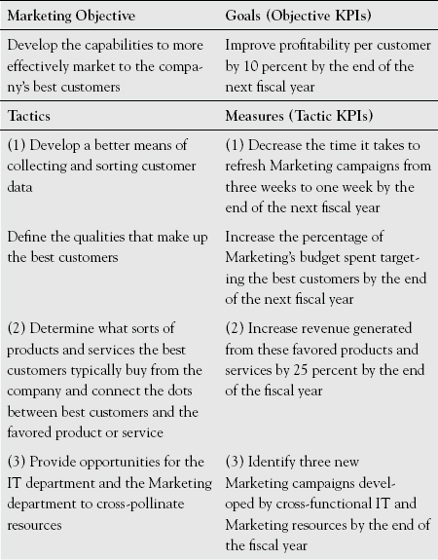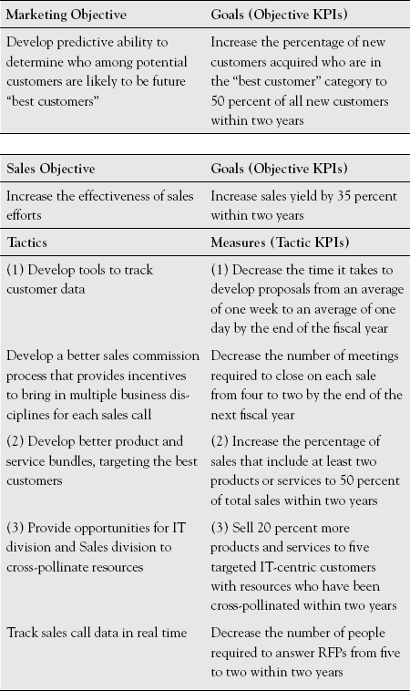

[**Figure 5.1**](https://learning.oreilly.com/library/view/implementing-world-class/9781118634110/xhtml/Chapter05.xhtml#figureanchor5-1)**.** **Common Tactical Needs Identified Across Marketing and Sales.**

The numbers indicate common threads and needs across tactics in at least three places in these two OGTMs alone. The BIOs ought to be closely involved in the creation of these plans, and the similarities ought to be topics of conversation and collaboration for the BIOs associated with each. Let’s explore what the substance of the conversation might be by highlighting similarities across these plans and what they might mean.

**Aligning on Data-Gathering Tools**

In [Figure 5.1](https://learning.oreilly.com/library/view/implementing-world-class/9781118634110/xhtml/Chapter05.xhtml#figure5-1), the two tactics that are annotated with the number “(1)” both involve customer data analysis. Look first at “Develop a better means of collecting and sorting customer data,” which Marketing came up with. Marketing to both existing and potential customers can be improved by first understanding what appeals to current customers, who the best customers are on the basis of metrics such as revenue and profitability per customer, and which products and services are best suited to which customers. With better sources of customer data, Marketing campaigns can be tailored. Likewise, when a potential customer is actually in conversation with the company about purchasing products or services, it is essential for the company to know what comparable customers have purchased, at what price point, and what the customers’ levels of satisfaction are with the purchase. This then allows the Sales team to enter into these conversations with greater confidence that what they are selling and how they are selling it are likely to yield not only a sale but also a positive result for the customer.

Now notice that the [Figure 5.1](https://learning.oreilly.com/library/view/implementing-world-class/9781118634110/xhtml/Chapter05.xhtml#figure5-1) Sales tactic “Develop tools to track customer data” is directly connected to the Marketing tactic; so the two of them belong to the same strategic thread. This leads to a practical implication and benefit for Marketing, Sales, and IT of identifying cross-functional commonalities.

Often marketing departments and sales departments, by following their strategic intentions, invest in their own solutions to aggregate the relevant data, or they use the same solution in differing ways that diminish the opportunity to identify and share insights from across the data set that have an impact on both departments. IT, as a functional area in which technology-related strategic intentions and potential solutions come together, should help reconcile this by having a series of conversations with different business stakeholders in similar capabilities to understand who would be using the tools. They should also evaluate the process to enter data into the tools and the process to analyze the data for insights once the data has been entered. This reconciliation will address the risk of redundancy (pursuing independent, although closely related technology solutions) and maximize the value that could potentially be created from leveraging tools across functions, often beyond the two functions in which commonalities and differences were noticed in the first place. In our hypothetical case, for example, the operations function might also leverage both the tool and the data generated by the tool to optimize its processes and partner or customer engagement across different parts of the value chain.

Only after cross-functional themes are identified and broader applications of a new tool are considered should IT (or anyone else) contemplate specific solutions. BIOs and the enterprise architect function (to be described in Chapter Six) each have a role to play here. Identifying these synergies early and as part of the strategic planning process increases the likelihood of avoiding redundancies, leveraging reuse potential, and realizing economies of scale before significant investments are made, and that project-based execution of the strategic opportunities will not need to be delayed. With these things in mind, it is essential to develop early the right data taxonomy before investing. Many companies do the reverse, and many wind up investing in redundant solutions. That need not be, when IT is the advisor and the shepherd in this process.

Let’s look now at the next set of tactics highlighted in [Figure 5.1](https://learning.oreilly.com/library/view/implementing-world-class/9781118634110/xhtml/Chapter05.xhtml#figure5-1) between Marketing and Sales, which deals in part with bundling. These are related to the set we just discussed, in that it is better data that will allow the organization to determine which products or services can provide more value to clients and more revenue to the company when they are bundled together. Bundled offerings are often creative ways to garner higher revenues from existing customers, and can lead to deeper and therefore “stickier” relationships with customers, as customers come to rely on and, it is hoped, appreciate the company and its offering more. Again, IT sees these tactics in two different plans, and understands them strategically as another opportunity to collaborate, investing once when in the past these might have been two redundant investments.

**Sharing Human Resources**

The third set of tactics highlighted across functions in [Figure 5.1](https://learning.oreilly.com/library/view/implementing-world-class/9781118634110/xhtml/Chapter05.xhtml#figure5-1) is internally rather than externally focused—potentially yielding benefits within the company primarily rather than providing benefits to the customer. With so much value to be derived at the intersection between IT and a variety of disciplines, a wonderful development has been that some companies have begun to share human resources staff across traditional functional areas. Marketing and Sales are two departments in which these “year abroad” programs (as one of my CIO clients refers to his cross-pollination efforts) have worked regarding IT matters, since each is being transformed through the better use of information, and each is becoming much more tech savvy. The two divisions exchange team members for limited periods of time.

Also, IT should jump at the opportunity to send business-savvy technologists into business functions such as Marketing and Sales, and it should welcome technology-savvy marketers or sales representatives to spend time in IT to help develop the business perspective among the IT team members. As with any new person, the kinds of insights people participating in this cross-functional exchange will generate are more likely to be unique, as their ideas will be colored with different recent experiences. Be sure to leverage these people for insights early in their tenures before they get woven too firmly into the fabric of the division.

By the way, cross-pollination opportunities are great ways to reward deserving people who have no higher promotional path within IT. The best IT departments constantly contemplate succession planning, determining who could succeed the CIO and who could succeed each of the direct reports of the CIO from among those who report to each of them. When no one is currently a possible successor, efforts are made to train the best of the current candidates. In this way IT is never caught off guard if someone leaves the company or is promoted. Each leader should have an apprentice of sorts who can take on certain responsibilities from the more senior person when the latter is on vacation or otherwise occupied. Still, high-potential individuals may find their own advancement blocked by a successful person ahead of them who is not ready to be promoted. In that scenario, rather than lose the high-potential individual to another company, IT should instead opt to send them to a different division of the company where new experiences can be garnered, and their value to the company can be enhanced. A positive quality of high-potential individuals is their typically ambitious desire to accrue new experiences. Later, if the original position above them in IT opens up, they will have much broader experiences to bring to bear in the new role. If it does not open up, then the “year abroad” may turn into a permanent move, which will likely also be good for the company.

**From Divisional OGTM Tactics to IT OGTMs**

As I’ve already said, in many companies, strategic frameworks like the charts in [Figure 5.1](https://learning.oreilly.com/library/view/implementing-world-class/9781118634110/xhtml/Chapter05.xhtml#figure5-1) would be developed by each division in isolation. Marketing would develop its plans, and Sales would develop its plans, independently, as would Finance, Operations, Human Resources, and Product and Services divisions. Often in these scenarios, the opportunity to collaborate or the opportunity to eliminate redundant investments is lost. IT has the opportunity to facilitate the necessary collaboration to ensure that a single solution is chosen to address the needs of multiple parts of the organization. In fact, a single project that addresses multiple needs across the company ought to be a higher priority by virtue of the breadth of value that can be attributed to it.

The redundancy in investment I have observed in solutions chosen by different departments in many organizations across industries is exacerbated by the ease with which some of these technology solutions can be procured. With cloud-based, software-as-a-service offerings, they appear relatively simple, straightforward, and cost effective. As a result, and often supported through technology vendors’ sales pitches, the business departments may be lured into the false conclusion that IT need not be involved. As I have also noted before, it speaks volumes of the perception of IT if executives attempt to work around the department more than they work with it.

Ideally, the company will have a well-developed mission and vision statement as well as a corporate or enterprise strategy that should be the starting point for the strategic planning for all departments, including the business and IT functions. After the plans of the other parts of the organization have been developed and IT has woven itself into those plans, then IT should develop its own strategy. The IT strategy should reflect whatever is revealed in the plans of other parts of the organization. In [Figure 5.1](https://learning.oreilly.com/library/view/implementing-world-class/9781118634110/xhtml/Chapter05.xhtml#figure5-1), for example, clearly there is a customer relationship management theme, a data analytics theme, and an HR theme; each is a likely starting point for an IT strategic objective or tactic.

At this stage, IT leaders should ask themselves questions such as these:

1. *Which of the tactics developed by the business areas, such as Sales and Marketing, can be brought to life with technology?*
2. *Do the tactics articulated in the divisional strategies suggest the need for process changes?* Even if divisional-level process change is not in the purview of IT, it is essential that IT understand the process changes before identifying technology to automate process. Too many IT organizations do not adequately contemplate the former, and find that they have invested in irrelevant solutions. In some cases the impact or even disruption caused by a process change may offset the potential benefits of a technology solution.
3. *Do our existing technologies (hardware and software) allow us to achieve what is insinuated in these strategic plans?* Even if the organization decides not to upgrade current technologies, the evolution and maintenance of current technologies will require some IT and business effort. Answering this and other questions as well as decision making more broadly should be about business capabilities and use cases rather than technology features.
4. *Insofar as new technology will be needed, will it replace or even render some existing solutions obsolete?* Sunsetting of these redundant systems should be planned for from the outset.
5. *Do these needs imply skills and knowledge that we have in short supply today?* Are they appropriate to grow (through training and hiring), or would it be better to engage vendor partners to acquire the skills more quickly? Would a hybrid approach be better—vendor partner supplementation in the short term with homegrown talent in the medium and long terms?
6. *What happens to skills and knowledge that may eventually be replaced?* What are the consequences for the staff associated with these—often critical—legacy skills and knowledge?

**How IT Strategy Addresses Both Business and Technology**

Let’s take the example of mobile strategy. Mobility is a strategic area with company and customer implications whose details vary by industry. As a company’s workforce increasingly operates away from a traditional office setting—working on the road, working from home, and the like—the company wants mobile solutions that will ensure that workers—wherever they may be—are as productive as they would be in the office. Likewise, customers of many industries are becoming used to making transactions or using services no matter where they are and on any device they happen to have with them. The mobile opportunity that arises with this increasing mobility will often be defined in the plans of numerous divisions, including product and service divisions, Marketing, Sales, Human Resources, Corporate Communications, and Legal.

As the transcending function that will be responsible for bringing different aspects of these mobile plans to life, IT must push for a higher degree of collaboration among the division leaders. Conversations need to take place in which each division presents to the others the opportunity it sees, so that each division will be better informed of the company-wide opportunity. With this perspective, each division will likely be more cognizant that its individual need should fit into an overall strategy, and this will ensure that a single solution or a limited number of solutions can be chosen to meet the needs of the broadest set of constituents among employees, customers, or both. In this way, IT can truly be a strategic enabler across individual divisions, pushing each division to sharpen plans related to the single mobility strategy while also fostering a greater and cross-functional understanding across the organization.

At the conclusion of these cross-divisional conversations, IT should develop its own plan related to mobility, the overarching strategic issue in this case. An IT strategy for mobile should take into account the needs articulated by each of the relevant divisions, as well as address the technological aspects that are under the purview of IT. In short, IT strategy should ideally be able to address the business and technology aspects.

For example, consider the BIO who has been assigned to Sales. [Figure 5.2](https://learning.oreilly.com/library/view/implementing-world-class/9781118634110/xhtml/Chapter05.xhtml#figure5-2) shows an example of an OGTM for a single Sales objective, which the BIO has assisted in creating. That BIO should know this OGTM and all others for Sales quite well, such that when he or she gathers with the other BIOs, the group can begin to speak cogently about the themes that are common across plans. For example, [Figure 5.3](https://learning.oreilly.com/library/view/implementing-world-class/9781118634110/xhtml/Chapter05.xhtml#figure5-3) shows some objectives and tactics from various divisions, all having a mobile component. (I have simplified here, omitting the goals and measures that would normally be included.) Take a moment with the tactics column, thinking about what a solid basis it begins to lay for creating powerful IT strategy.

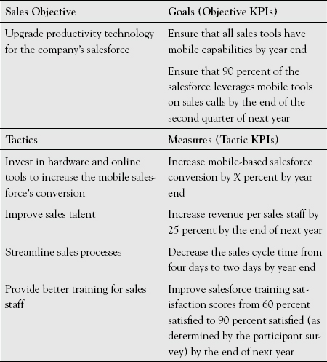

[**Figure 5.2**](https://learning.oreilly.com/library/view/implementing-world-class/9781118634110/xhtml/Chapter05.xhtml#figureanchor5-2)**.** **One Sales OGTM.**

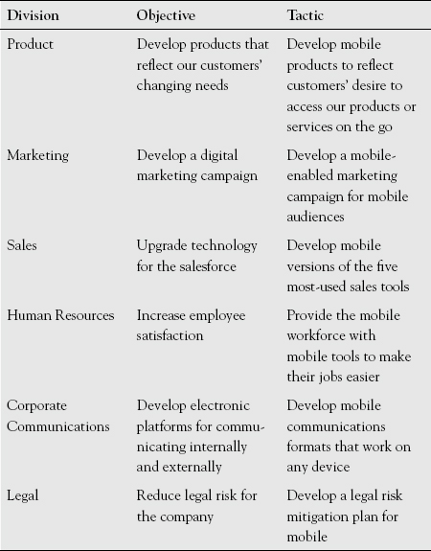

[**Figure 5.3**](https://learning.oreilly.com/library/view/implementing-world-class/9781118634110/xhtml/Chapter05.xhtml#figureanchor5-3)**.** **Comparing Thematically Related Objectives and Tactics Across Divisions.**

I focus your attention on the various divisional tactics because this is the level that will become the corresponding IT objectives at the subordinate strategic level. (Revisit [Figure 2.7](https://learning.oreilly.com/library/view/implementing-world-class/9781118634110/xhtml/Chapter02.xhtml#figure2-7) to refresh your memory about the cascade.)

**Still Improving Divisional Planning for an Optimal IT Strategy Too**

As you see, demand for mobile, and thus the strategic need to address it, emerges from a diverse array of constituents. Since mobile technology is the common component, this is a prime example of when IT needs to bring the leaders of the divisions together to have them fully articulate the opportunity for use of mobile that their respective tactics embody. Not so surprisingly, some of the opportunities are external (for the Product division and for the Marketing division), one is internal (HR), and three are both (Sales, Corporate Communications, and Legal). Quite likely and to some degree understandably, the difference may indicate how well each cluster (external versus internal) has considered the implications of mobile outside its main concern. For example, HR may be less concerned about the customer than the employee, but the IT leader is dealing with other constituents besides HR.

In so doing, IT leaders should develop their own comfort level with topics and ideas relevant to each division, but the BIO should be the in-depth expert of the division. As a result, BIOs should be given in-depth training in the area of expertise of the division to which they are aligned. This means having the Marketing BIO be trained in marketing disciplines, for example. It may also mean drawing IT-savvy employees from those divisions to be BIOs, as mentioned earlier, and in the process more tightly tying IT with those divisions because of the sharing of resources. In that case, it may be necessary to provide IT skills to the new BIO formerly from Marketing. In either case, promoting cross-functional expertise is likely to be incredibly valuable, leading to richer insights and faster paths from opportunity identification to solution creation.

Together with his or her BIOs and more clearly articulated plans, the CIO should understand as well or better than the division heads how the opportunities articulated in the collection of Business objectives and Business tactics (the precursor to the IT strategy) relate to existing processes and technologies, and where they suggest new processes and technologies. This is important for two reasons: first, it will likely have implications for the IT strategy, as I said earlier; but second and arguably more important, the CIO, at the business level, should help articulate what might be done commonly versus that which probably warrants a unique response. Most people think their needs are unique, and it takes a judicious arbiter to help evaluate when that is, or is not, the case.

The CIO should facilitate the conversation, pushing each of the gathered business executives to better articulate his or her needs; the nature of the opportunity; the risk of doing nothing; the people, process, and technology changes that are likely needed; and so on. The CIO and the BIOs should also have done some research and development to understand what innovative solutions exist and how other companies have leveraged them to their advantage. If off-the-shelf solutions are not available, they will also be in a position to provide guidance on the efforts and costs required to build them internally. They should also understand the pitfalls of using certain vendors or solutions, and offer that counsel, at least from a technology perspective, even if vendor management resides in Procurement or another functional area.

After this session or series of sessions concludes, everyone involved should feel they have a better understanding of the mobile opportunity as it pertains to their area of responsibility as well as for the company as a whole. The CIO and his or her leadership team should also have a clearer idea of IT’s role in providing solutions that will benefit the company and its customers alike.

**Example: Translating Divisional Tactics into an IT Objective**

In the case of mobile, divisional tactics might translate into an IT objective as shown in [Figure 5.4](https://learning.oreilly.com/library/view/implementing-world-class/9781118634110/xhtml/Chapter05.xhtml#figure5-4).

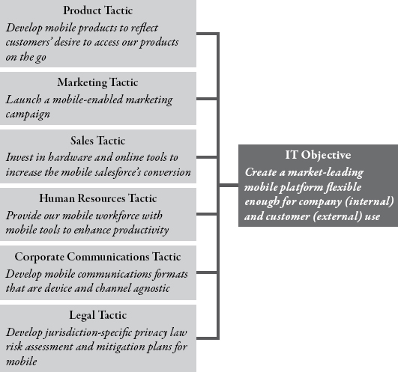

[**Figure 5.4**](https://learning.oreilly.com/library/view/implementing-world-class/9781118634110/xhtml/Chapter05.xhtml#figureanchor5-4)**.** **From Divisional Tactics to an IT Mobile Objective.**

The “Sales Tactic” in [Figure 5.4](https://learning.oreilly.com/library/view/implementing-world-class/9781118634110/xhtml/Chapter05.xhtml#figure5-4) corresponds with the first tactic in [Figure 5.2](https://learning.oreilly.com/library/view/implementing-world-class/9781118634110/xhtml/Chapter05.xhtml#figure5-2). This is one of several tactics related to the Sales objective “Upgrade technology for the salesforce.” That objective would also be one of five to seven objectives that the Sales team developed. (Generally, fewer objectives are better as long as they provide sufficient guidance.)

The IT objective, “Create a market-leading mobile platform flexible enough for company and customer use,” derives from the Business tactics developed within the various divisions. It clearly notes IT’s domain, which is to develop (or purchase) the platform and to provide the technology capabilities to maintain it. Many IT departments have a bias toward purchasing off-the-shelf products whenever possible rather than designing them anew. The IT objective also pledges that IT will take into consideration the needs of the company and the needs of customers in identifying and implementing the platform. It also suggests IT’s desire to limit the number of solutions that the company must design or purchase and maintain. This is also a responsibility of IT, as the divisions, if left to their own devices, are increasingly likely to purchase solutions that suit their needs alone, leaving IT to maintain several potentially redundant solutions, often increasing the cost to run IT in the process.

Please note that the strategic frameworks highlighted so far do not mention projects. It is critically important that the strategic frameworks be developed without specific projects in mind; this avoids creating strategy *around* projects or solutions. Strategy should be developed on the basis of the strategic drivers of the internal and external environment and not upon solutions that may or may not relate to these drivers. Many companies make the mistake of doing this in reverse.

**Don’t Let Projects Run the Show**

This may appear simple, but do not take it for granted that your company currently gets this right. Working in reverse (project precedes strategy) not only constitutes a self-fulfilling prophecy but rids the strategic planning process of some of its main purposes, such as identifying opportunities and allowing for course corrections, if needed. When a strategy is created or retrofitted to justify a dreamed-up project idea that a division or the IT department wishes to pursue, the strategic planning process is shortchanged. That process ought to be about identifying broad strategic opportunities as well as filtering what *not* to pursue, not about retroactively sanctioning projects.

Focusing first on objectives and then cascading through to tactics brings a better chance that the strategic plans at the corporate, divisional, and IT levels will be aligned or integrated as well as more focused. Plans that intend to retrofit projects already approved are likely to point in many directions at once. In that case, chances worsen for mobilizing employees to push in the same direction. In addition, using a strategic framework to encourage and identify ideas will be more difficult, if not impossible. The extent to which new ideas might be solicited for tactics, for instance, is also limited because people will realize that the already-approved project idea must come first. With an OGTM like that in [Figure 5.4](https://learning.oreilly.com/library/view/implementing-world-class/9781118634110/xhtml/Chapter05.xhtml#figure5-4), it is much clearer where the focus is, and in which directions new ideas for tactics might be offered.

**Broad Finalization, Then Project Planning**

Only after related and aligned strategic plans across business divisions and IT are finalized is anyone ready to add projects to the plans of their own division. [Figure 5.5](https://learning.oreilly.com/library/view/implementing-world-class/9781118634110/xhtml/Chapter05.xhtml#figure5-5) shows IT projects aligned to one Sales division OGTM. They are the ones in italics.

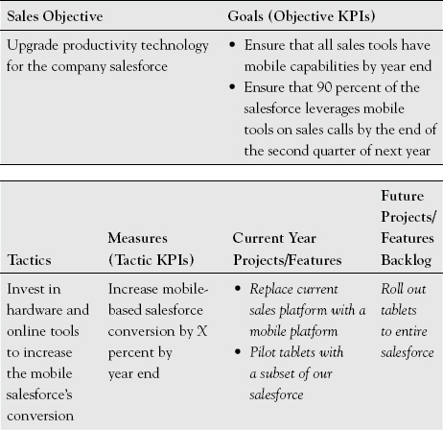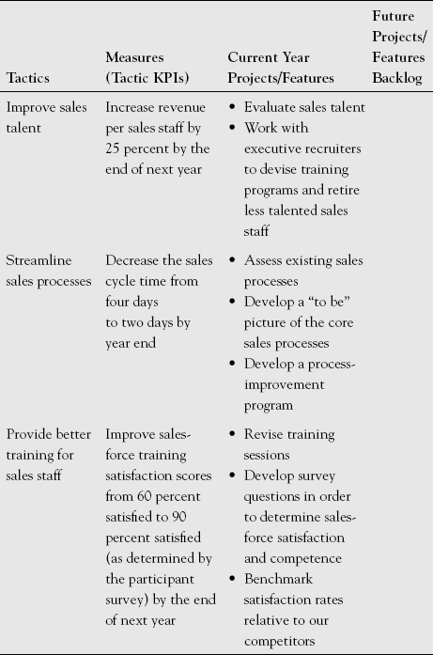

[**Figure 5.5**](https://learning.oreilly.com/library/view/implementing-world-class/9781118634110/xhtml/Chapter05.xhtml#figureanchor5-5)**.** **IT-Related Projects (Italics) in Service of One Sales Objective.**

The italicized projects in the figure are the ones with major IT implications. The second, third, and fourth tactics are less IT-centric, though given the process excellence that IT departments often have, it is possible that IT would be involved in implementing the projects aligned with the tactic “Streamline sales processes.”

Clearly, mobile is a cross-divisional effort. It is appropriate to align projects with multiple strategic plans. At a minimum, this conveys the full importance of the project. Moreover, as has been mentioned multiple times, IT’s perch in the corporate structure means that it should identify projects that have an impact on multiple parts of the organization, so IT leaders should strive to define such projects.

When an IT BIO has been assigned to a business division or function, those units will be integrally involved in the development of the IT aspects of the plan and should push their business team to develop IT-centric tactics where the BIO has identified opportunities; conversely, the BIO will also push IT to develop technology solutions with an eye toward business value-add. As the BIOs get together to discuss the plans of the divisions with which they interface, an opportunity arises to cross-pollinate new ideas and to ensure that the organization is leveraging existing infrastructure and reusing existing processes and technologies to avoid new, redundant spending wherever possible.

**At Last, an IT OGTM**

[Figure 5.6](https://learning.oreilly.com/library/view/implementing-world-class/9781118634110/xhtml/Chapter05.xhtml#figure5-6) shows the IT mobile OGTM with projects aligned to it.

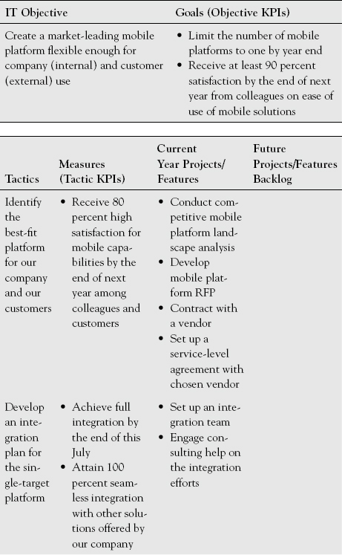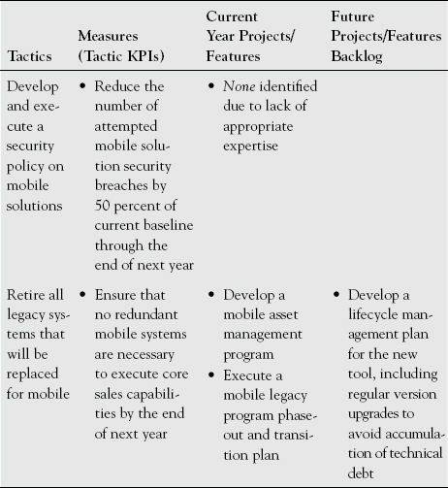

[**Figure 5.6**](https://learning.oreilly.com/library/view/implementing-world-class/9781118634110/xhtml/Chapter05.xhtml#figureanchor5-6)**.** **IT’s OGTM for Company Mobile, Including Projects.**

Whereas the projects that were italicized in [Figure 5.5](https://learning.oreilly.com/library/view/implementing-world-class/9781118634110/xhtml/Chapter05.xhtml#figure5-5) were IT projects directed at Sales, the projects in [Figure 5.6](https://learning.oreilly.com/library/view/implementing-world-class/9781118634110/xhtml/Chapter05.xhtml#figure5-6) are projects that support the organization more broadly. It is up to IT to invest in a common mobile platform for the company, limiting and focusing the necessary investment to implement it and maintain it, but it is also up to IT to ensure that the solution chosen will meet the needs of all relevant constituents.

Other topics that typically require IT-specific strategies include those for which IT is likely to hold primary responsibility:

* Security
* Risk management
* Technology maintenance and refreshment
* Service or help desk
* Business continuity and disaster recovery
* Enterprise architecture

This list is not exhaustive, and it will vary from company to company. In these cases, IT must use its strategic framework to help articulate plans as to how these topics will be managed, how they will evolve, and how they will continue to improve.

Still more strategy-worthy topics will emerge as you explore opportunities across the divisions, like the mobile example. Recent themes I’ve seen include ones akin to those mentioned in Chapter Two:

* Data analytics and other big data opportunities
* Social media
* Content management
* Cloud computing

Each of these has profound business implications that will be obvious to many business leaders. If those leaders do not get creative ideas from IT, they will pursue them on their own. IT needs to be so close with the divisions of the company that it can identify these needs as they emerge. Great IT teams will have already started to think about the implications of these trends before they hear from the business, having read or otherwise learned about how other companies have begun to leverage them to their own advantage. The best IT departments will develop the business case for these ideas even before the divisions of the company (or the competition, for that matter) have articulated these topics and others as opportunities. These forward-looking and innovative IT departments can make a real difference—for their business partners and for their organizations as a whole. This is the way the best IT departments become indispensable advisors to the rest of the organization.

**Owning a Tactic**

In Chapter Two, where I described the success metrics of strategic planning (the goals and measures of OGTM), I called them critical because what gets measured gets done. Nothing gets done, however, unless there are people responsible and held accountable for the measurable improvement. This is another area in which strategic plans sometimes fail. OGTMs or their equivalent are created, and the executive committee or the board agrees that the plan is the right one for the foreseeable future. Who is accountable or responsible for ensuring that the plan is enacted? The easy answer is that the IT strategy is the responsibility of the CIO. This is absolutely true, but the CIO cannot do it alone. He or she must work with the business leaders, as I outlined before, but also engage other leaders in IT, to ensure that the strategy is enacted. The IT objectives as the highest-level part of the strategic framework are the primary responsibility of the CIO, and the tactics are the primary responsibility of members of the IT leadership team and, in certain select cases, the rest of the company. [Figure 5.7](https://learning.oreilly.com/library/view/implementing-world-class/9781118634110/xhtml/Chapter05.xhtml#figure5-7) continues [Figure 5.6](https://learning.oreilly.com/library/view/implementing-world-class/9781118634110/xhtml/Chapter05.xhtml#figure5-6) by adding a column for tactic owners.

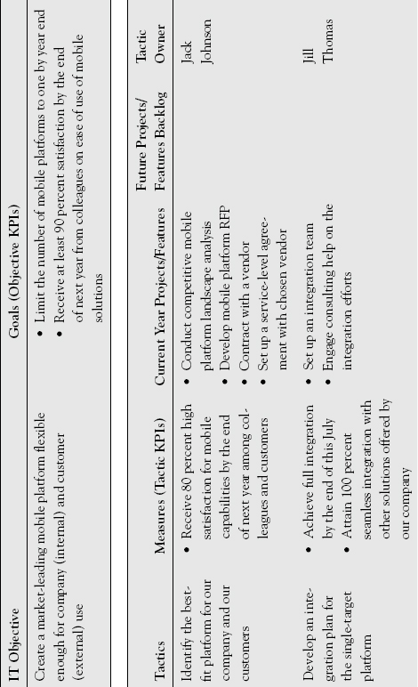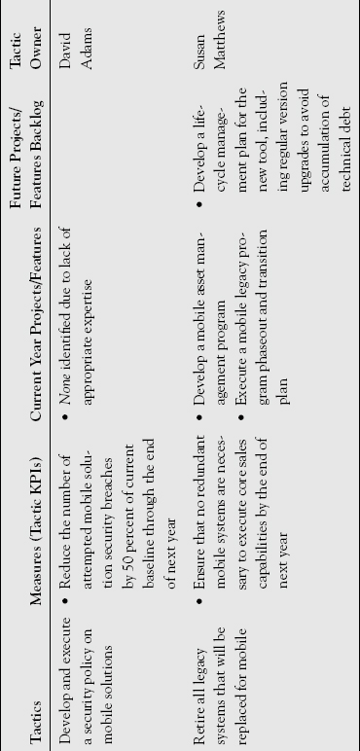

[**Figure 5.7**](https://learning.oreilly.com/library/view/implementing-world-class/9781118634110/xhtml/Chapter05.xhtml#figureanchor5-7)**.** **IT’s Mobile OGTM, Including Ownerships.**

It is important to note that the people assigned in the last column are not necessarily responsible for the projects that may be needed to execute the tactic to which their name is attached. That responsibility would likely fall to project managers, there often being several projects associated with a given tactic; the people named in [Figure 5.7](https://learning.oreilly.com/library/view/implementing-world-class/9781118634110/xhtml/Chapter05.xhtml#figure5-7) are responsible for their tactic, which is still part of the strategy, as a whole. Whether or not they are responsible for some or all of the constituent projects is a different consideration. Other divisions of the company should be encouraged to assign people to be responsible for tactics. Unless there is a person responsible for each tactic, they may not be accomplished in due time, and the objective will suffer in the process. The tactic owner may also be responsible for updating or otherwise maintaining the tactic. While the tactic owner usually is not—and should not be—the person responsible for strategic reviews, he or she may trigger a strategic review if circumstances dictate revising the approach.

It should be clear to tactic owners that they are also responsible for “turning the dial” in the fashion suggested by the measure. Therefore, Jack Johnson is responsible for the tactic that reads “Identify the best-fit platform for our company and our customers.” He is also responsible for the measure that reads “Receive 80 percent high satisfaction for mobile capabilities by the end of next year among colleagues and customers.” The tactic owner may determine that the existing projects aligned with the tactics do not sufficiently accomplish the measure. Not all projects move the needle on a given tactic in the same direction. He or she should solicit submissions for additional project ideas to accomplish each tactic. Of course, he or she should work with the CIO and the rest of the leadership team, as well as with the BIOs, to identify these ideas. Jack would not necessarily be responsible for each of the projects. There would be project managers for those, but he would have oversight of the tactics to ensure that they are on track. For smaller companies, it is possible that the tactic owner would also manage projects, but for larger companies, those roles are likely to be separated.

**Staffing a Tactic**

Next, it is important to think about how to staff each tactic. This is different from the specifics of project staffing, but at a minimum, it is important to understand whether the new capabilities that will be developed as a result of what is suggested by the tactic can be developed with internal capabilities or not. [Figure 5.8](https://learning.oreilly.com/library/view/implementing-world-class/9781118634110/xhtml/Chapter05.xhtml#figure5-8) illustrates how staffing resources can be added to the planning, in this case distinguishing between internal and external sources.

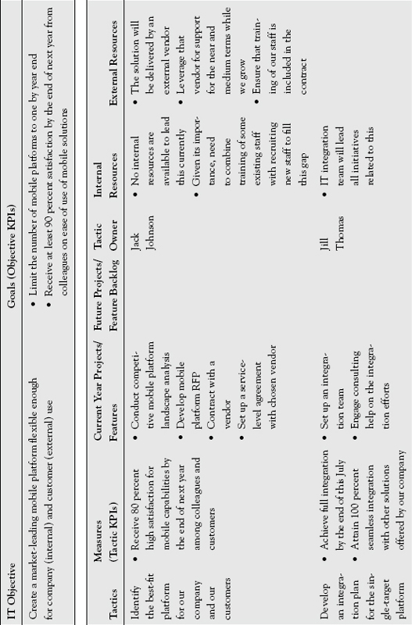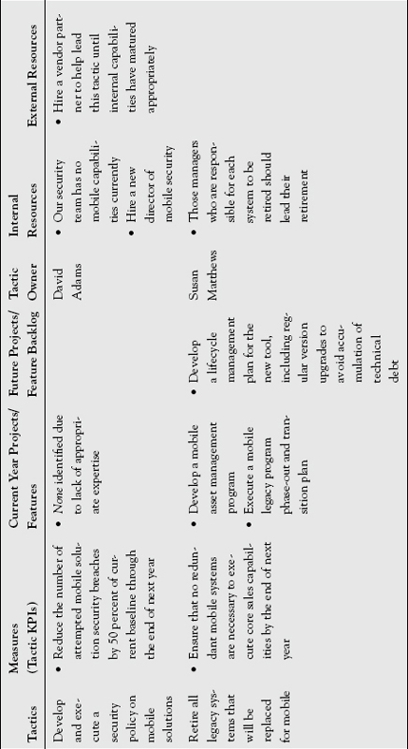

[**Figure 5.8**](https://learning.oreilly.com/library/view/implementing-world-class/9781118634110/xhtml/Chapter05.xhtml#figureanchor5-8)**.** **The IT Mobile OGTM, with Staffing.**

In the figure you will note some tactics that can be accomplished with existing staff and others that cannot. This will especially be the case for IT departments (and companies in general) that focus on new, innovative ideas. Departments often lack the staff to carry out new ideas. In this situation it is important to contemplate whether the skills required are ones that the company wishes to grow internally or to engage from outside—the buy-versus-build decision. Of course, this may not be a black and white decision. In the gray zone in which a combination of internal and external resources are likely to be needed, that should be noted as well. Developing or growing internal skills can be costly, and it may mean adding head count. If the tactic suggests a potential source of competitive advantage, or if it will simply be more efficient to have the core resources be employees, then it is best to plan this way from the outset. Still, some skills are best provided and managed by vendors for the foreseeable future, for example, when it is unclear how long they will be needed and whether the opportunity they support will be long term or not.

**Tactics Currently Lacking Projects**

You may have noticed in [Figure 5.8](https://learning.oreilly.com/library/view/implementing-world-class/9781118634110/xhtml/Chapter05.xhtml#figure5-8) that no project is attached to the tactic “Develop and execute a security policy on mobile solutions.” Actually, it is generally a good sign when there are tactics with as-yet-undetermined projects; it means that some creative new thinking has been going on. This, by the way, is another reason to develop the strategic framework prior to and independent of the projects: to identify white space opportunity. If there are projects supporting every tactic, one wonders whether the truly creative new ideas have been identified among the tactics.

Note that the gap for the security policy tactic is annotated “*None* identified due to lack of appropriate expertise.” This suggests the need to leverage outside experts to help identify project ideas. Depending on how your organization defines what constitutes a “project,” there may be other reasons why a tactic may not show a project. There are certain things that may be strategically valuable but that can be achieved outside of a project. For example, ongoing collaboration or communication that reach a significance beyond day-to-day interactions may rise to the level of strategic significance, in effect implementing a tactic.

Constituents outside the company must be engaged as a key source of innovative ideas. Not enough CIOs have adequate access to the company’s customers. CIOs ought to engage customers to help devise new ideas because customers know the company’s products and services best, and presumably are prepared to purchase the products and services that will emerge through innovation. Regarding IT’s external partners, too many CIOs view them as fulfillers of work exclusively rather than tapping them for their broad sets of experience to develop new, innovative ideas on the company’s behalf. The best external partners (true partners as opposed to simply vendors, mind you) may know your business best from partnering with you over the years. They may understand your strengths and weaknesses nearly as well as the CIO does, and they likely have a wide array of experiences in your industry and in related industries. Tap them effectively for insights, and you will be ahead of most other CIOs the world over.

By laying out your strategic plans as clearly as you see in Figure 5.8, you place the onus on good external partners to deliver new project ideas and possibly even additional tactic ideas that align with your specific OGTMs. External partners who do not have access to these plans either because they do not exist or because the plans are kept too close to the vest are forced to propose new ideas that are to some degree guesswork. As a result, the external partner may be accused of proposing what is best for the external partner rather than for the company or the IT department. Granted, some strategies, such as the desire to acquire another organization or to expand business areas, may need to be kept confidential, but many aspects of strategic plans become more powerful when shared with partners that can help execute them. By sharing this level of detail with them, when appropriate, you remove misunderstanding and make clear to external partners that whenever they propose new ideas, they need to be crystal clear about how those ideas will help advance some aspect of the strategic plan. This helps eliminate wasted time and effort, and it engages a much broader community of strategic contributors in pushing ideas forward.

**Other Strategic Frameworks**

While my firm and I use the OGTM as a strategic framework, the general method of strategic planning can align with another strategic framework you or your company might favor. Here are two examples of how other frameworks can serve much the same ends for IT in its own and broader strategy work. The first is from Procter & Gamble and looks immediately very much like OGTM. The second is from Ecolab, where the framework looks different on the outside but fundamentally parallels OGTM in the essentials.

**Procter & Gamble and OGSM**

Functionally and geographically, Filippo Passerini took a circuitous route to the CIO role at Procter & Gamble. Beginning in his native Italy, he rose through the ranks from junior positions to senior-most ones at P&G’s world headquarters in Cincinnati, Ohio. He started in IT, but also spent time in marketing and operations roles before becoming CIO.

Hoping that IT will run as a typical business function, P&G has a history of hiring CIOs who have traditional business experience. Passerini continued this tradition, and in 2005, as CIO, he led the integration of Gillette. In 2008, Passerini was also named the president of Global Business Services, and in 2011 he was named group president of Global Business Services. Given the breadth of experiences Passerini has had across a variety of businesses, functions, and geographies, he never thought of IT as anything less than a strategic part of the business. In fact, he argued, “All leaders need to think of their areas as strategic and value enhancing to the business, or else they will be underperforming by definition.”[**2**](https://learning.oreilly.com/library/view/implementing-world-class/9781118634110/xhtml/Chapter05.xhtml#ch05ft2)

One way in which IT and Global Business Services have creatively harnessed the power of IT has been by creating digital “war rooms” across the globe, assembling an assortment of leading-edge analytics capabilities to enable the $84 billion colossus to make better decisions through insights drawn from across geographies, product segments, business functions, and the like. Therefore, his organization has managed the “big data” conundrum as well as any organization in the world. What sort of strategic planning process uncovered this war-room idea as an area of opportunity?

P&G employs a model called OGSM, an acronym strikingly similar to OGTM (see [Figure 5.9](https://learning.oreilly.com/library/view/implementing-world-class/9781118634110/xhtml/Chapter05.xhtml#figure5-9)). Both derive O, G, and M from objective, goals, and measures, and use those terms in about the same way. Rather than tactics, the “S” stands for “strategies.” The similarity is reinforced also in the fact that in OGSM, as Passerini likes to simplify things, “the ‘O’ and the ‘S’ are words, and the ‘G’ and ‘M’ are numbers.”

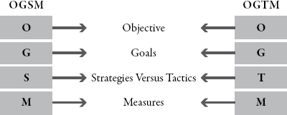

[**Figure 5.9**](https://learning.oreilly.com/library/view/implementing-world-class/9781118634110/xhtml/Chapter05.xhtml#figureanchor5-9)**.** **OGSM Compared with OGTM.**

Passerini made the point that objectives at the highest level are not necessarily surprising. At that corporate level, they center on things such as revenue growth, cost efficiencies, and geographic expansion. P&G’s objectives are likely to be broad enough that they will not change for a few years. Likewise, the goals and measures are somewhat straightforward because they offer feedback on how far to go and how fast, so to speak. The goals are “just a number,” he said, helping to articulate how far and how fast the company should push to accomplish the objective. Of course, he hastened to say, “choosing the right number is essential.”

The strategies, he said, are the more complicated part because, “Strategic planning is about making choices. A world of opportunity is before us, but we need to decide where to focus our attention. Once our choices are made, we know where to focus the attention of our 129,000 people.” In addition, the strategies should change more often, in some cases annually, though some may be relevant for several years.

**Where and How to Win**

The methods that P&G uses to create its strategies are covered well in the book *Playing to Win: How Strategy Really Works*, coauthored by P&G CEO A. G. Lafley. It describes the need to decipher “where to play” and “how to win.” Passerini says the “where to play” question should be answered by the objectives, and “how to win” should be answered by the strategies (the tactics of OGTM). The book holds several key insights, such as

* Strategy is about making specific choices to win in the marketplace.
* Optimization is not strategy.
* Winning should be at the heart of any strategy.
* There is no perfect strategy.
* Make the consumer the boss.
* Measure everything.[**3**](https://learning.oreilly.com/library/view/implementing-world-class/9781118634110/xhtml/Chapter05.xhtml#ch05ft3)

The focus on “winning” rather than simply optimizing what the company already has is key to how Lafley and his colleagues operate. It may not be so surprising to note that P&G’s CEO thinks in this way, but it speaks volumes that Passerini and his team do, too. Historically among IT leaders, optimization has been their area of greater strength, and Passerini and his team certainly do much to optimize processes, and to automate what has traditionally been handled manually. But to a much greater extent, he and his team think about the *new value* they can create in order to help the company achieve its broader objectives to win in the marketplace.

The book’s discussion of its key insights raises many other interesting points, but I’d like to skip now to the last. As I said earlier, “that which gets measured gets done,” but too often plans are put in place without a reliable definition of what the *destination* is. In those cases, it is much more difficult to determine whether the team has been successful or not. In P&G’s methodology, as in the one I’ve used in this book, the goals and measures are key to ensuring that there *is* a well-defined destination and that the percentage of achieving it (incomplete or complete) can be determined.

*Playing to Win: How Strategy Really Works* also goes on to note that, in developing strategic plans, executives must be able to answer the following questions:

* What is your winning aspiration?
* Where will you play?
* How will you win?
* What capabilities must be in place?
* What management systems are required?[**4**](https://learning.oreilly.com/library/view/implementing-world-class/9781118634110/xhtml/Chapter05.xhtml#ch05ft4)

**In Strategy Planning, Is Size a Disadvantage?**

Some people think of size as a hindrance to making better decisions. Large companies are often thought of as being bureaucratic, slow, and conservative. Certainly, there are many companies that fuel this stereotype. P&G is not one of them. Passerini has thought about the advantage of size. From the vast number of products P&G has flowing through most countries on earth and all the different consumers in those various places, P&G collects a tremendous amount of information on its products and its customers. This can be harnessed to get a better picture of who, right now, is buying what and why, but it can also help in making better decisions about consumers’ future buying patterns. This has an impact on marketing plans, sales plans, and product launches, among other areas. Passerini understood that this is the advantage of being large and broad, and he has determined how his part of the company, fueled by IT, can help P&G “win.”

**Ecolab and VSEM**

Ecolab is a St. Paul, Minnesota–based $13 billion revenue developer and marketer of solutions and on-site service for the food, health care, energy, hospitality, and industrial markets in more than 170 countries around the world. The company provides cleaning and sanitizing, food safety, infection prevention, pest elimination, water management, and energy conservation products and programs, as well as equipment maintenance and repair services, to commercial customers. The company has been a tremendous success story in the past decade, growing substantially both organically and through acquisition.

In mid-2011, Ecolab announced that it would acquire Nalco, a company that specialized in chemistries and solutions for industrial water and air applications, for $5.38 billion.[**5**](https://learning.oreilly.com/library/view/implementing-world-class/9781118634110/xhtml/Chapter05.xhtml#ch05ft5) When the deal was official in December of 2011, Stewart McCutcheon was promoted from Nalco’s chief information and productivity officer to Ecolab’s executive vice president and CIO.

In taking over IT for the larger company, seeing cultures, methods, and technologies that needed to be harmonized, McCutcheon realized he needed a better way to plan. He utilized a process called VSEM that, like OGSM, is also similar to OGTM. The acronym captures its four facets: vision, strategy, execution, and metrics. Like the OGTM, there is a cascading logic to the framework. Two essential patterns are to move from high-level principles to granular tactics and to attach measurement that ensures things stay on track. [Figure 5.10](https://learning.oreilly.com/library/view/implementing-world-class/9781118634110/xhtml/Chapter05.xhtml#figure5-10) provides the definitions of the facets of VSEM.

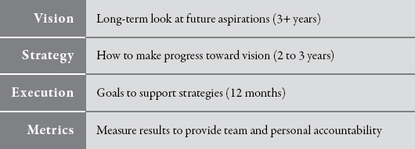

[**Figure 5.10**](https://learning.oreilly.com/library/view/implementing-world-class/9781118634110/xhtml/Chapter05.xhtml#figureanchor5-10)**.** **VSEM.**

*Source:* Stewart McCutcheon and Ecolab.

The framework is equal parts a time-oriented map, as it were, that plots a course today through to the foreseeable future, and a communications framework for making clear to colleagues across the company where IT will contribute value to the corporation. McCutcheon said, “It is essential that we have a common vocabulary and process for setting and measuring goals and objectives throughout the organization. The clearer our plans, the more we can mobilize all of IT to accomplish our goals.”[**6**](https://learning.oreilly.com/library/view/implementing-world-class/9781118634110/xhtml/Chapter05.xhtml#ch05ft6)

This is an essential point. The less clear plans are, the more people will push in different directions. When employees do not work toward a common goal, at best they waste time and money. At worst, through lack of focus they fritter away opportunities and are beaten by competitors with greater strategic clarity. The better that employees understand what the next twelve months through three years and beyond is supposed to entail, the more solid ideas they can develop to help drive the plans forward, and the more satisfied they will be, understanding the connection between their day-to-day tasks and the greater vision of the organization.

To further clarify the intent of each leg of the VSEM framework, I’ve filled in [Figure 5.11](https://learning.oreilly.com/library/view/implementing-world-class/9781118634110/xhtml/Chapter05.xhtml#figure5-11) with some of the actual information from one of McCutcheon’s recent plans.

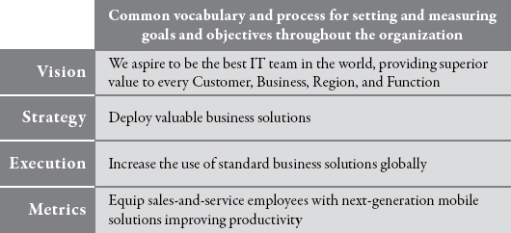

[**Figure 5.11**](https://learning.oreilly.com/library/view/implementing-world-class/9781118634110/xhtml/Chapter05.xhtml#figureanchor5-11)**.** **One Recent VSEM.**

*Source:* Stewart McCutcheon and Ecolab.

The VSEM term *vision* is equivalent to an OGTM *objective.* The vision captured in the figure is one of a set of four that work together. The other three visions refer to growth, productivity, and customer and associate engagement. The one shown here is certainly grandiose. It declares that the organization is shooting to be the best, not just in the industry, but beyond, and that its performance should be felt by a diverse array of constituents, from customers to colleagues within the company.

A VSEM *strategy* begins the qualifying process. Equivalent to an OGTM *tactic*, it clarifies by stating that some of the IT team’s focus needs to be to “deploy valuable business solutions.” This suggests a filter through which to run any contemplated new solution. Planners are pushed to ask, “Does this proposed solution represent a valuable solution for our business?” That question points to the need for IT to understand the rest of the organization sufficiently in order to give an accurate answer.

If projects were aligned with this strategy directly, leaders might infer that it would be appropriate to invest in technologies that are expensive, and to err on the side of purchasing or creating solutions that perfectly meet the needs of the constituents, since one can certainly argue that that would be of great potential value. Therefore, VSEM’s *execution* statement (in some ways like a more granular *tactic* in an OGTM) qualifies the strategy further by pointing out a need to “increase the use of standard business solutions globally.” This articulates a bias toward minimizing the solutions portfolio wherever possible. One good reason for this is that IT bears the brunt of the heavy lifting when solutions are tailored to specific needs.

In addition to the statement pictured, there are two other execution statements:

* Focus on growth, profitability, engagement
* Accelerate solution deployment using Scrum, Cloud, and Virtualization

Since that which gets measured gets done, *execution* statements must be coupled with appropriate *metrics.* With these fully articulated, only then are project ideas formulated and documented. There are three that connect to the execution statement and metric noted:

* Enable integrated supply chain planning and execution
* Expand and accelerate the enterprise resource planning footprint
* Scale standard field and commercial solutions

**Linking IT Strategy with the Strategies of the Rest of the Organization**

I hope that it is clearer now how IT strategy and the strategy of the rest of the divisions and the companies all fit together. I also hope that it is clear that the CIO is well situated to lead the company in this way. Achieving strategic alignment across the company is a noble goal, and one that the CIO is in a good position to undertake. In so doing, the CIO will also glean insights that will help ensure that the right projects are chosen to achieve the highest value across the company.

A better-engaged IT department is likely to have a clearer understanding of how IT projects align across the plans. Each completed project adds to the portfolio of technologies that IT must manage. This is yet another black box that IT must emerge from. Enterprise architecture, the topic of the next chapter, is an ideal way to better understand how each new project fits or does not, and how the architecture that IT manages needs to evolve in order to support the plans of the company. This is another key element to the strategic planning process that IT manages and must communicate with colleagues across the company.

**IT Strategy Take-Aways**

1. As CIO, start by listening.
2. Use a broadly shared strategy framework to map, align, and document strategic planning. (Here, we’ve used the terminology and format of OGTM.)
3. Dedicate IT business information officers (BIOs) to continually collaborate with individual divisions.
   * Their eyes and ears should focus on adding business value.
   * Convene your BIOs to share, cross-pollinate, and spot redundancies.
4. Send IT leaders to other divisions on internal “years abroad,” and offer the same to other functions.
5. From the tactical needs of other divisions, explore cross-functional IT business and technology possibilities, including common threads that can align the company on things such as data-gathering tools and shared people resources.
6. Assist other divisions in creating their OGTMs (see also Chapter Four). Urge them to postpone defining projects until corporate and other parts of the company have also reached that stage.
7. Devise IT’s OGTMs as cascades from corporate and divisional tactics.
   * Take corporate and divisional tactics and measures as starting points for creating IT objectives.
   * Answer the questions: Where can technology work best? Are changes needed in process or in your current hardware and software?
8. Continue helping divisions improve and coordinate the business value of their OGTMs.
9. Bring divisional leaders together to articulate and compare shared themes, opportunities, and tactics.
   * Be a facilitator, pushing everyone to better articulate needs; the nature of the opportunity, the risk of doing nothing; the people, process, and technology changes that are likely needed; and so on.
   * Help them understand each other’s perspective.
10. Understand more fully how the opportunities articulated in the business objectives and business tactics outside IT relate to existing and potential processes and technologies.
11. Develop IT OGTMs for divisions (and their shared interests) and for supporting the organization more broadly.
    * Invest in common platforms. Limit and focus investment needed to implement and maintain them.
    * Ensure that solutions meet the needs of all relevant constituents.
    * Among your OGTMs, also address areas for which the IT department is primarily responsible.
12. Assign an IT owner to every IT tactic.
    * Distinguish that role from that of a project manager.
    * Weigh advantages of developing the capabilities to achieve each tactic with existing or new internal or external human resources.
13. Engage partners outside the company as sources of new ideas.