Which spaceflight biology hardware can be modelled? A metadata audit of NASA’s hardware catalogues and three-dimensional transient CFD of specimen environments
Richard Barker
[Affiliation and co-authors to be confirmed by the corresponding author]
Abstract
Spaceflight biology results are interpreted against the hardware the specimens lived in, yet the physical environment inside that hardware – airflow, gas composition, temperature, humidity, light and nutrient delivery – is rarely documented well enough to be modelled. We assembled the three public NASA hardware sources (the SPLASH instrument catalogue, the OSDR hardware registry and the experiment-platform field of every OSDR study) into 328 hardware entities, of which 164 can carry space-biology payloads and 111 house live specimens in flight. We defined a 15-item minimum-information checklist for computational fluid dynamics (CFD) of a specimen environment, scored every specimen-housing item automatically (validated against two blind raters; weighted $κ=0.89$ between raters, scorer precision 1.00 and recall 0.69) and found that public metadata support a CFD-ready description for 1 of 111 items; SPLASH alone supports none. Airflow rate, specimen metabolic load and heat load are the least documented inputs. Documentation is better for hardware that has been used in OSDR studies (Spearman $ρ=0.54$) and for ISS-era hardware, and worst for cell and microbe culture hardware. Curation also exposed catalogue defects, including a block of 27 SPLASH records whose descriptive fields are displaced from neighbouring rows. Targeted literature curation, with every value tied to a verbatim source quotation, raised a subset of heavily used hardware to CFD readiness; for these we built verified three-dimensional transient OpenFOAM models in flight (0 $g$) and ground-control (1 $g$) conditions, with engineering drawings and four-dimensional field records. In the modelled hardware, gravity changed the specimen-zone CO$​_{2}$ by 0.19% in a ventilated mouse cage and by less than the flow’s own fluctuation in a plant growth chamber, whereas a single undocumented parameter – the vent size of a passive fly box – changed the predicted specimen CO$​_{2}$ 4.64-fold. The missing metadata, not gravity, dominated the uncertainty of the modelled environments. All code, data snapshots and curated specifications are released for reuse.

Introduction
Every spaceflight biology experiment is also an experiment on its hardware. Sealed canisters, fan-ventilated growth chambers, rodent habitats and culture cassettes impose their own gas, temperature and humidity fields on the specimens, and in microgravity the buoyant convection that mixes those fields on Earth is absent. When flight and ground-control specimens differ, part of the difference can therefore arise from the hardware environment rather than from gravity itself. NASA’s Open Science Data Repository (OSDR) now holds hundreds of spaceflight studies (Gebre et al. 2025; Berrios et al. 2021), and the OSDR also publishes two hardware resources: the SPLASH instrument catalogue (NASA Ames Research Center 2026) and a hardware registry linked to payloads and studies (NASA Open Science Data Repository 2026b). Whether these resources describe the hardware well enough to reconstruct the specimen environment has not been assessed.
Here we (i) build a crosswalk across the three public hardware sources and count the hardware able to carry space-biology payloads, where it flies and how it feeds its specimens; (ii) define a minimum information checklist for CFD of a specimen environment and measure, item by item, how much of it the public record supplies, validating the automated scoring against blind human-style rating; (iii) run a meta-analysis of which hardware is under-documented; and (iv) for hardware whose parameters can be sourced, build verified three-dimensional transient CFD models in 0 $g$ and 1 $g$, with orthographic drawings and time-resolved field records. Throughout, every number either comes from a cited source, is computed from cited values, or is declared as a modelling assumption.

Methods

Data sources and snapshot
On 2026-10-12 we downloaded, without authentication, the full SPLASH catalogue (splash-api/public/instruments, 147 records, 62 fields), the OSDR hardware registry (geode-py/ws/api/hardware, 157 records, with every linked payload and experiment record), and the experiment platform, project identifier and organism of every OSDR dataset (641 datasets) together with each dataset’s metadata, including protocol descriptions. We also archived the ISS-cabin and ground-control telemetry (temperature, relative humidity, CO$​_{2}$) and daily absorbed dose of all 24 missions in the OSDR Environmental Data App (NASA Open Science Data Repository 2026a). Raw responses are archived with SHA-256 checksums; every downstream stage reads only this snapshot.

Catalogue integrity
Because SPLASH has no structured links, we tested each record’s internal consistency before using it. For each descriptive field we computed TF–IDF cosine similarity between the field and the identity text (name, alternate names and background) of every record; a field that shared almost nothing with its own record but matched a record within three rows was flagged as displaced, the signature of a row-offset error. Organism classes named in the specimen field were also compared with those named in the record’s own background. Every flag was reviewed by hand and given a verdict with a reason and, where possible, independent evidence from the OSDR registry (Supplementary Table S1).

Crosswalk
SPLASH and registry records were joined into hardware entities by exact match of normalised aliases and by acronyms unambiguous across both sources; joins that would merge two SPLASH records were refused. Study platform strings were split into components and mapped many-to-many onto entities (exact alias, unambiguous acronym or containment of a specific alias), so that a string naming two devices links to both without merging them. Fuzzy matches were never applied automatically: they were written out as proposals and accepted or rejected in a curated decision file, each with a reason.

Classification
Each entity was assigned a role (specimen habitat, hosting facility, processing/fixation, analysis instrument, sensor, exposure facility, ground facility or non-biological) from the SPLASH category where present, otherwise from keywords in its name and registry description, with curated corrections. Organism classes were taken from hardware-specific text and from the organisms of linked OSDR studies. Flight platform was taken from the missions of the hardware’s registry payloads. Nutrient and water delivery modes were assigned only when a verbatim quotation supported them and the mode was compatible with an organism the hardware carries.

Minimum information for CFD (MI-CFD-HW) and its validation
We defined 15 items needed to model a specimen environment (Supplementary Table S2), six of them critical: enclosure dimensions, specimen-container dimensions, ventilation mode, airflow rate, specimen temperature and specimen type. Each item scores 0 (absent), 0.5 (qualitative only) or 1 (quantitative or explicit), with the quotation that earned the score; laboratory preparation, storage and analysis sentences are excluded. A hardware item is Tier A (CFD-ready) when every critical item scores 1, Tier B when every critical item scores at least 0.5, and Tier C otherwise. Two blind raters scored a seeded random sample of 12 specimen-housing entities (180 cells) from the raw text; disagreements were adjudicated with written reasons, and the automated scorer was evaluated against the adjudicated gold standard without further tuning.

Meta-analysis
Completeness (mean item score) was compared across hardware class, flight platform, era, SPLASH status and catalogue coverage with Kruskal–Wallis tests and pairwise Mann–Whitney tests with Benjamini–Hochberg correction, and related to the number of OSDR studies using the hardware by Spearman correlation.

Literature curation and audit
For the 37 specimen-housing hardware items linked to OSDR studies (and their close relatives), parameters were sought in peer-reviewed papers, NASA technical reports, mission documentation, vendor pages and the snapshot itself, by five curation passes organised by hardware family. Each parameter record carries its value, unit, source, URL and a verbatim quotation of at most 40 words; values were never transferred between hardware items or filled with typical values, unresolved parameters are left empty with a note of where they were sought, and conflicting sources are recorded (Supplementary Note S1). Each pass checked its quotations against saved copies of the sources. An independent auditor then re-opened the sources of a seeded random sample of 40 records: 40 quotations were found verbatim and no value was contradicted (28 fully supported; 12 supported but with descriptive wording partly drawn from a second source named in the record’s note); three records were corrected. Tiers after curation use the six critical items, with the airflow requirement waived for sealed or passive hardware.

CFD models
For Tier A hardware we generated geometry from parametric primitives (boxes, cylinders, repeated arrays) in which every number is either a reference to a sourced parameter or a declared modelling assumption (Supplementary Note S4); the model loader refuses any other literal. Orthographic drawings are produced from the same primitives. Meshes were built with snappyHexMesh from a cubic background mesh whose margin is a non-integer number of cells (so that no background face coincides with a geometry surface) and solved with buoyantBoussinesqPimpleFoam in OpenFOAM v2606 (Weller et al. 1998; OpenCFD Ltd 2026) with second-order backward time integration. Air properties at the hardware set-point were computed with CoolProp (Bell et al. 2014; Lemmon et al. 2000; Lemmon and Jacobsen 2004) and the aquarium was modelled with water properties (IAPWS-95 via CoolProp). CO$​_{2}$ (ppm) and water vapour (mmol mol$​^{−1}$) were transported as passive scalars with the diffusivities tabulated by Monteith and Unsworth (2008); specimen fluxes from the curated files were converted to volumetric sources in cell zones (gas volumes at 0 $​^{∘}$C and 1 atm, 22.414 L mol$​^{−1}$), and specimen heat enters the energy equation. Inlets impose the sourced volumetric flow or face velocity and the supply composition; outlets fix the pressure; passive vents impose the exterior (ISS cabin) state; gas-permeable membranes use a Robin condition. The ISS cabin state is the median of the quality-controlled flight telemetry of the Environmental Data App during the RR-1 habitation period (3,371 ppm CO$​_{2}$, 43% relative humidity; Supplementary Note S9); CO$​_{2}$ and water vapour are passive scalars, so specimen-zone excesses do not depend on it. The mean age of air was computed with a passive scalar (unit source, zero at inflow). Flow was treated as laminar: inlet Reynolds numbers (hydraulic diameter) were at most 1949.19 in all cases except the APH fan-maximum sensitivity case (9745.93), which is above transition and Cases start from the supply state at rest and run until the specimen-zone quantities reach a plateau. Hardware with a sourced specimen heat load (MDS) was run with gravity off (flight) and on (ground control, $9.80665$ m s$​^{−2}$). Where no heat load could be sourced, the temperature field is uniform and the Boussinesq model has no buoyancy source, so the 1 $g$ solution is identical to 0 $g$ by construction; running it only admits spurious currents driven by round-off temperature differences, which in a passive, diffusion-dominated enclosure are not negligible, so these cases were run at 0 $g$ only. The APH baseline was nevertheless run in both conditions to show that the difference stays within the temporal fluctuation of the forced flow.

Verification.
The solver configuration was verified on the differentially heated square cavity against the reference Nusselt numbers of Vahl Davis (1983) and Hortmann et al. (1990) (as tabulated by Gjesdal et al. (2003)) at three Rayleigh numbers on three meshes (mean Nu 4.53, 4.52 and 4.52 at $Ra={10}^{5}$ versus 4.522), on one-dimensional diffusion against the analytic solution, and by closing the transient CO$​_{2}$ balance (source = outflow + accumulation) in every hardware run. Discretisation uncertainty of the hardware results was estimated with the grid convergence index (Celik et al. 2008) on three meshes (refinement ratio $\sqrt{2}$) for three hardware items.

Results

The hardware catalogue
The crosswalk produced 328 entities (147 in SPLASH, 157 in the registry); 32 study platform components named a vehicle, location, ground analogue or generic item rather than hardware. 164 entities can carry space-biology payloads and 111 house live specimens during flight (Fig. 2). Only 33 of these are linked to at least one OSDR study. Mission records place bio-capable hardware on the Space Shuttle (38), on free-flying biosatellites (19) and on the ISS (18). Nutrient delivery was evidenced for fewer than half of the habitats (59 with no evidence); where evidenced, animal food and water (16), culture medium (21) and agar (11) were the commonest modes (Fig. 1). Every assigned mode is backed by a verbatim quotation (Supplementary Data, T2b_nutrient_evidence.csv).
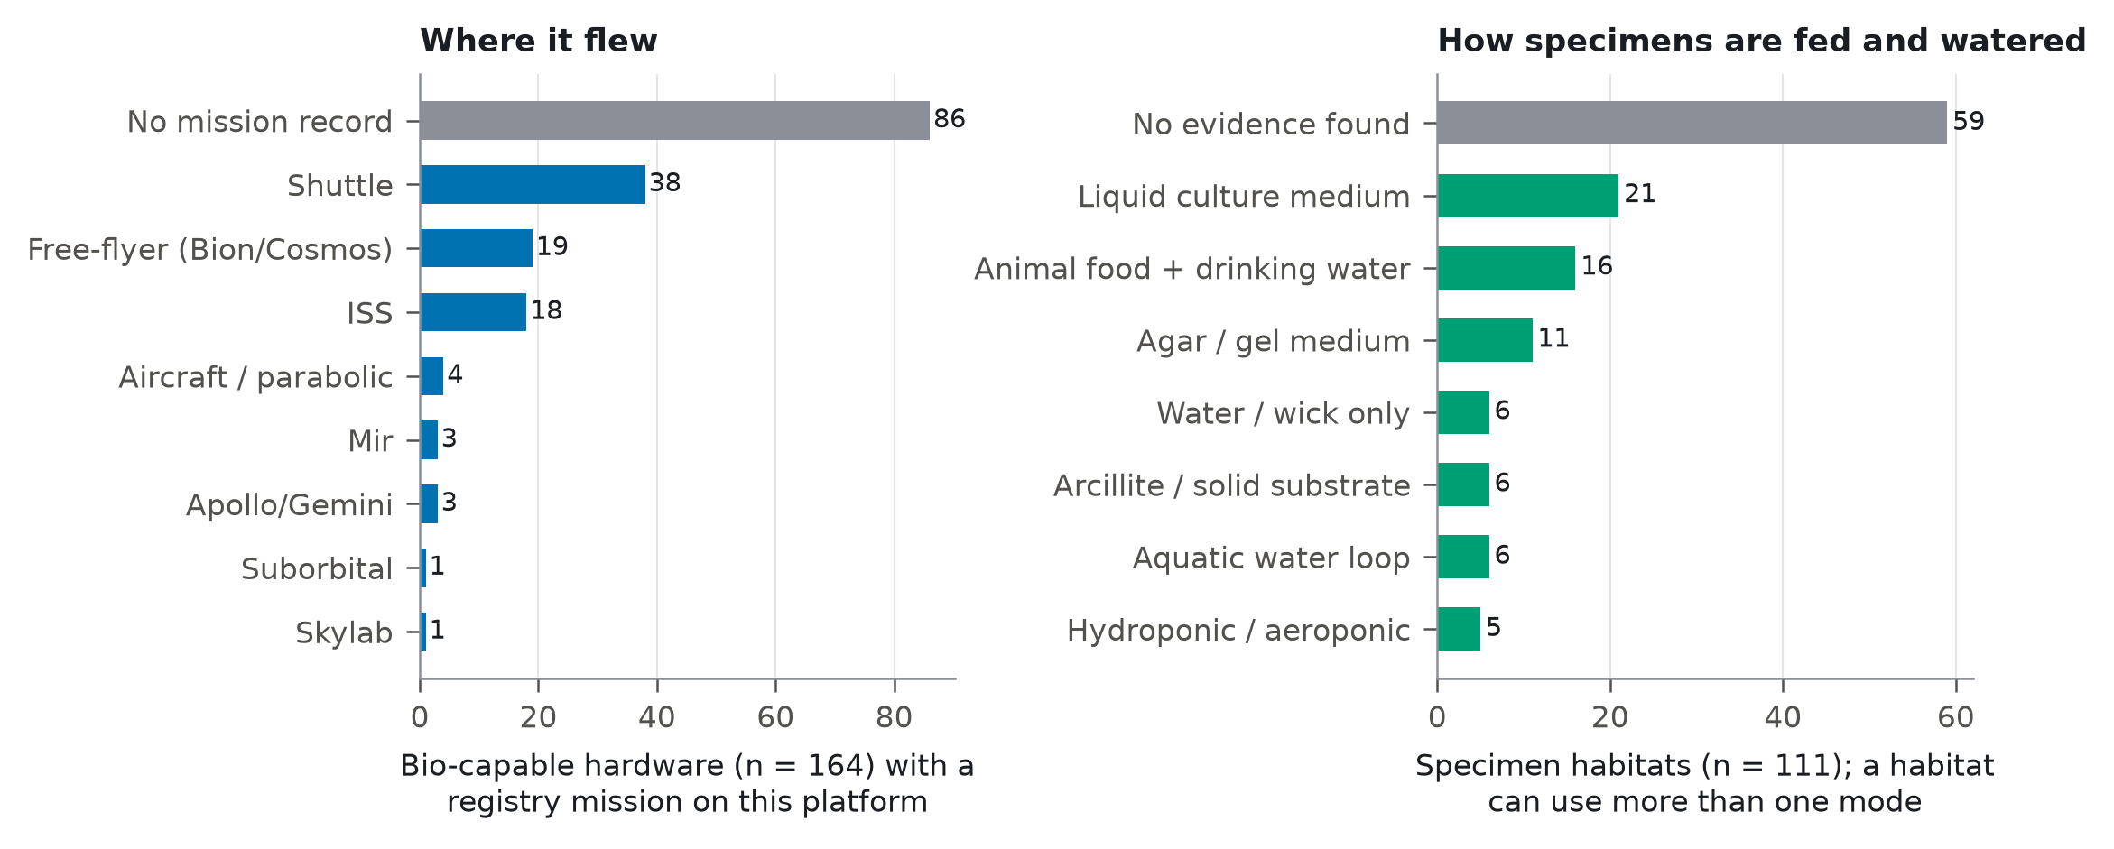
Where space-biology hardware flew, from the missions of its registry payloads, and how specimens in specimen habitats are fed and watered, from quotation-backed evidence.
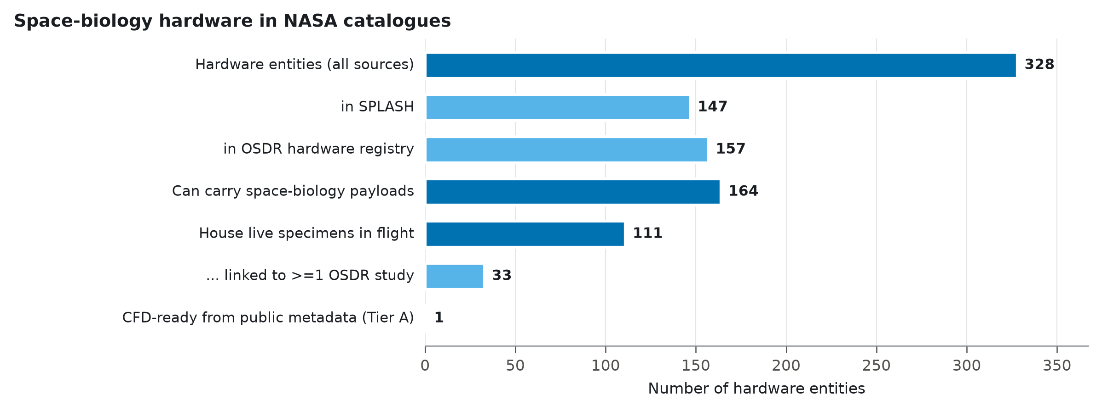
Space-biology hardware in the three NASA sources, from all entities to those whose public metadata support a CFD model.

Catalogue defects
27 SPLASH records (#121–#147) carry descriptive fields displaced from neighbouring rows: 29 fields were confirmed as misattributed on review, for example a Plant Growth Unit record whose specimen field describes an RNA thermal cycler, and a BRIC-Opti canister record carrying the crop list and CO$​_{2}$, humidity and temperature control ranges of the Advanced Plant Habitat. The sources, schematics and study_links fields are empty in every record. 310 of 641 OSDR datasets have no experiment-platform entry; the remainder use 116 free-text strings, with 9 spellings of Veggie alone.

How much of a CFD model the public record supplies
Specimen type is almost always stated (98.20% quantitative), but airflow rate (3.60%), specimen metabolic load (0.00%) and heat load (1.80%) are almost never given (Fig. 3). Median completeness was 0.30 using all public sources and 0.07 using SPLASH alone. 1 of 111 specimen-housing items reached Tier A from public metadata and 0 from SPLASH alone; waiving the airflow requirement for sealed or passive hardware raised this to 2. Blind raters agreed on 90% of 180 cells (weighted $κ=0.89$). Against the adjudicated gold standard the automated scorer never credited absent information (precision 1.00) but missed some (recall 0.69; mean completeness 0.36 versus 0.53 gold), so automated completeness is a conservative lower bound; no sampled entity was Tier A on the gold scores either.
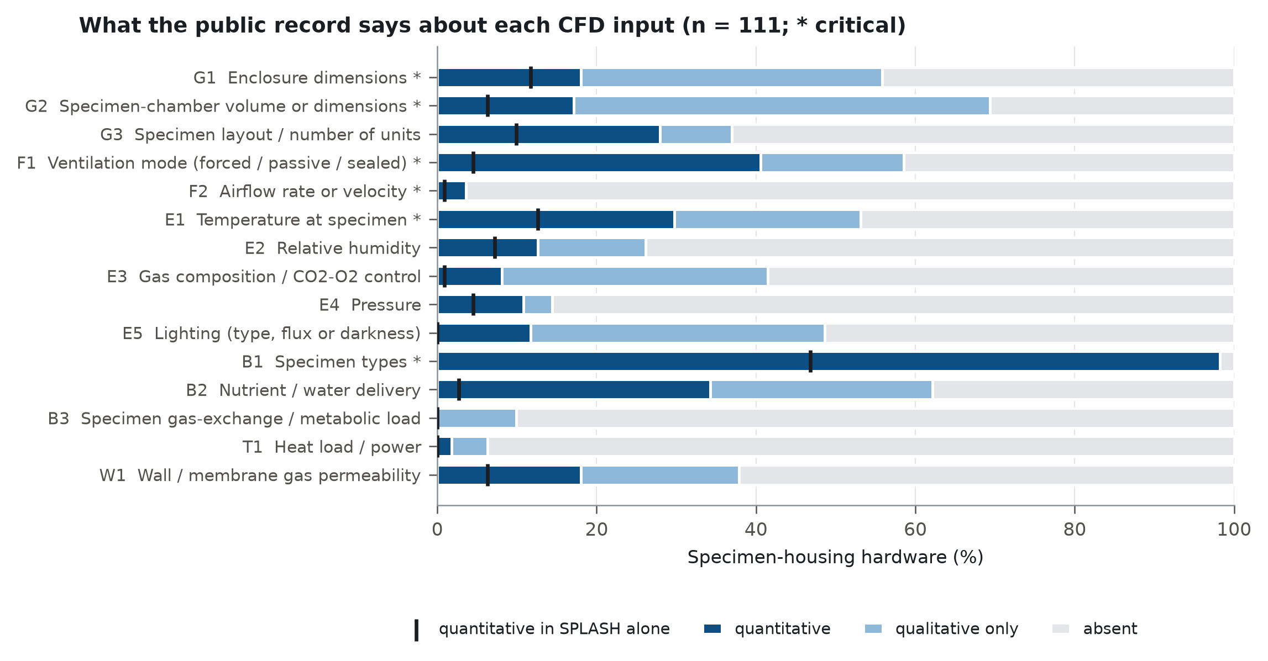
Coverage of each MI-CFD-HW item across specimen-housing hardware. Dark: quantitative; light: qualitative only; grey: absent. Ticks: quantitative in SPLASH alone.

Which hardware is under-documented
Completeness differed by hardware class (Kruskal–Wallis $p=0.00$), flight platform ($p=5.9×{10}^{−6}$) and catalogue coverage ($p=1.0×{10}^{−6}$), but not by era ($p=0.27$) or SPLASH status ($p=0.17$) (Fig. 4). Cell and microbe culture hardware was least documented and ISS hardware best. Hardware used in OSDR studies was better documented than unused hardware ($p=5.3×{10}^{−8}$; $ρ=0.54$ with the number of studies, Fig. 5), but several used items remain below the median.
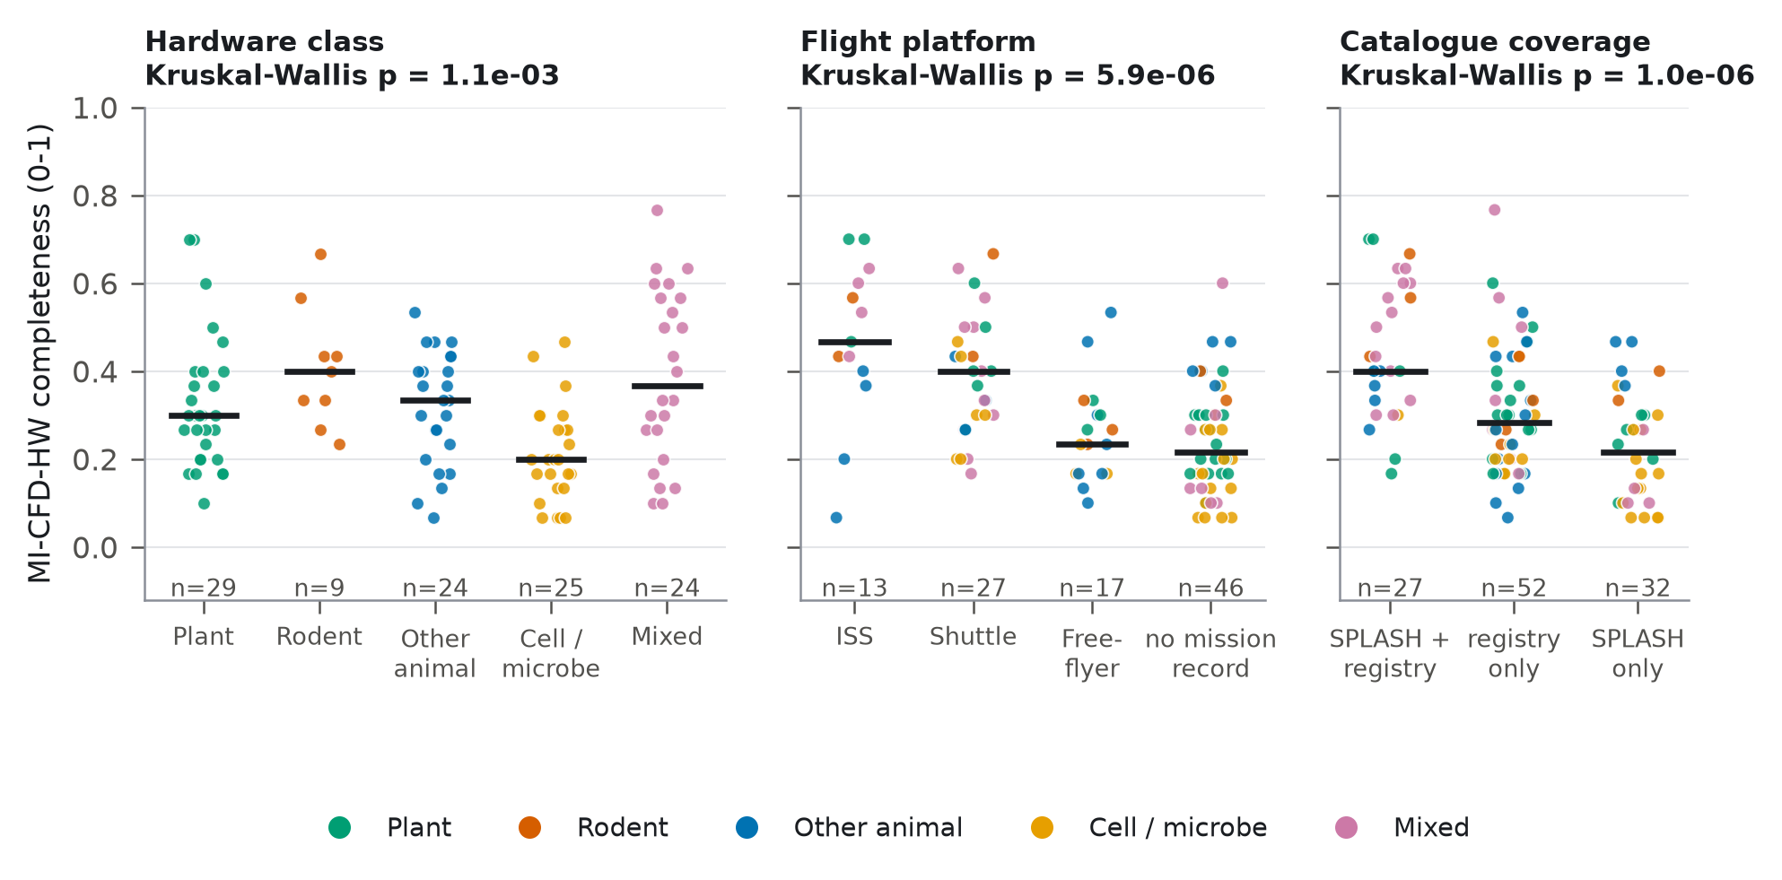
MI-CFD-HW completeness by hardware class, flight platform and catalogue coverage (bars: medians).
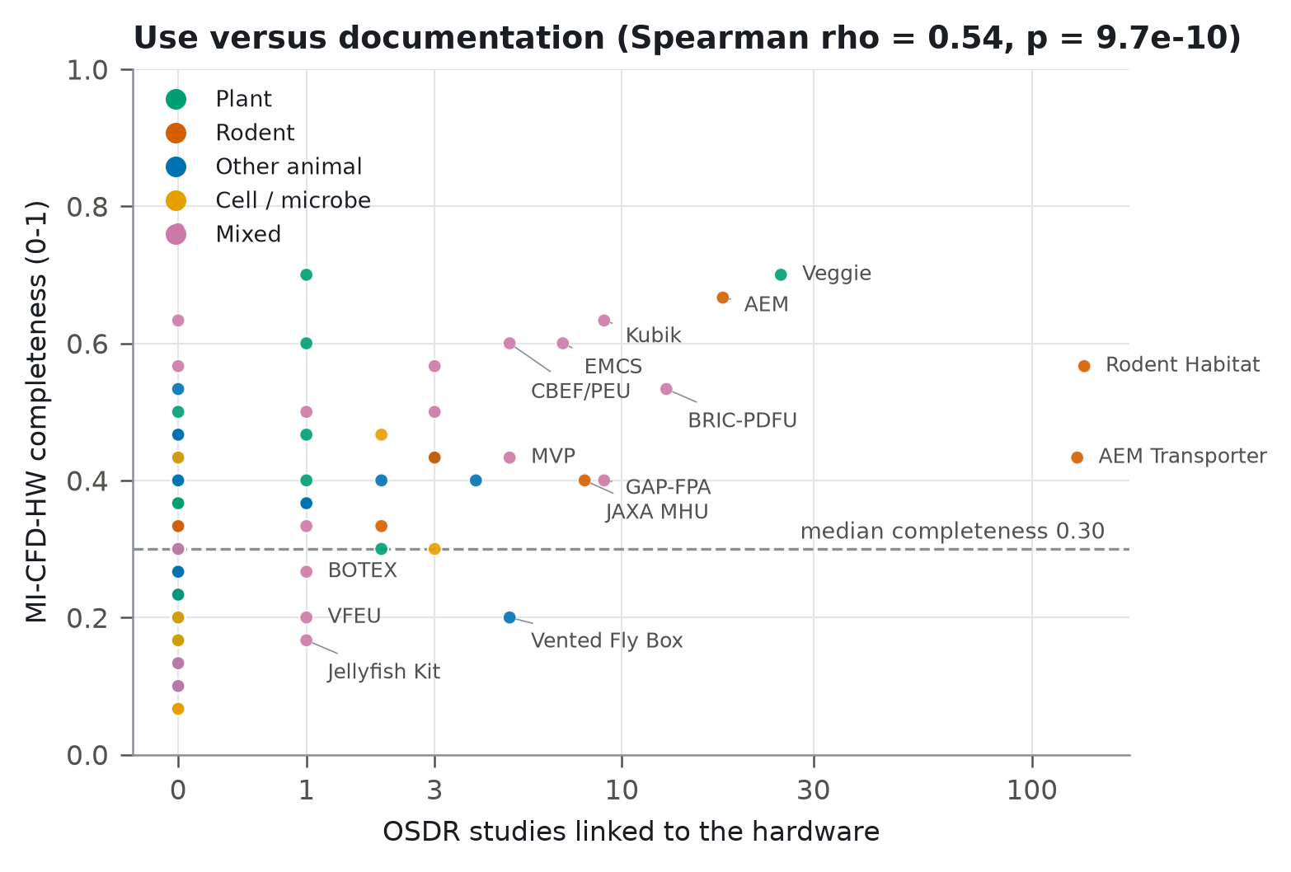
Documentation versus scientific use. Points: specimen-housing hardware.

Literature curation
Curation of 37 hardware items yielded 592 sourced parameters out of 1,081 sought (54.76%). 4 items reached Tier A (the Advanced Plant Habitat, the JAXA Aquatic Habitat, the Mice Drawer System and the Vented Fly Box), 24 remained Tier B and 9 Tier C (Fig. 6; Supplementary Note S3).
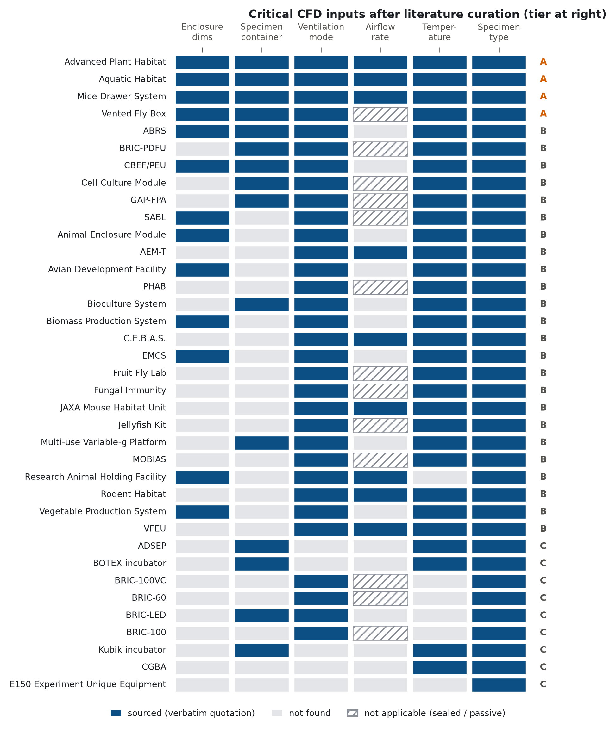
Critical CFD inputs for the 37 curated hardware items after literature curation.

Verification
The solver reproduced the reference heated-cavity Nusselt numbers with second-order convergence (observed order 2.05 and 2.15 at $Ra={10}^{5}$ and ${10}^{6}$); Richardson-extrapolated values were within 0.07% of Hortmann et al. (1990) (Table 1). One-dimensional diffusion matched the analytic solution to $4.6×{10}^{−5}$ (concentration scale 0–1), and the transient CO$​_{2}$ balance closed to within 0.68% in every hardware run.
Verification on the differentially heated cavity (Pr 0.71): mean wall Nusselt number on three meshes, observed order $p$, Richardson-extrapolated value and its error against Hortmann et al. (1990).
$Ra$​ | Nu ${64}^{2}$ | Nu ${96}^{2}$ | Nu ${128}^{2}$ | $p$​ | Nu$​_{ext}$ | Ref. | Err. (%) | Convergence
${10}^{4}$​ | 2.2447 | 2.2447 | 2.2434 | 15.84 | 2.2434 | 2.245 | -0.071 | oscillatory
${10}^{5}$​ | 4.5293 | 4.5250 | 4.5235 | 2.05 | 4.5217 | 4.522 | -0.007 | monotonic
${10}^{6}$​ | 8.8829 | 8.8496 | 8.8386 | 2.15 | 8.8257 | 8.825 | +0.008 | monotonic

Specimen environments in flight and ground control
Table 2 and Fig. 7 summarise the specimen environments at the end of each run; field slices, environment cards and animations are in the Supplementary Information.

Mice Drawer System.
With the sourced cage through-flow (0.2–0.3 m s$​^{−1}$) and organism-level loads for a 30 g mouse, the air around the mouse carried 15.58 ppm more CO$​_{2}$ than the supply, was 0.29 K warmer and had a mean age of 0.27 s. Flight and ground control differed by 0.19% in CO$​_{2}$ excess: at a Richardson number of 0.01 the forced flow dominates the mouse’s buoyant plume. The mouse-zone CO$​_{2}$ excess converged monotonically with mesh refinement (observed order 2.29, fine-mesh GCI 5.83%).

Advanced Plant Habitat.
At the PH-04 set-points the canopy drew CO$​_{2}$ down by -6.50 ppm relative to the 550 ppm supply in flight (temporal s.d. 0.46 ppm) and by -6.82 ppm in ground control (s.d. 0.28 ppm), a difference of 0.32 ppm that lies within the fluctuation of the transitional, fan-driven flow; with no sourced canopy or lamp heat load the Boussinesq model has no buoyancy source. The mean age of canopy air was 1.98 s in flight and 2.23 s in ground control, and mesh-to-mesh differences were smaller than the temporal fluctuation (Supplementary Table S5). Setting the fans to their maximum speed changed the canopy CO$​_{2}$ drawdown to -1.34 ppm and the canopy age of air to 0.44 s (laminar approximation).

Vented Fly Box.
The box exchanges gas with the cabin only through its vents, whose size is not published. With 20 mm vents the CO$​_{2}$ excess at the vial plugs reached 187.94 ppm, with 60 mm vents 40.51 ppm: the undocumented vent size alone changes the predicted specimen CO$​_{2}$ 4.64-fold and the time to reach 90% of the plateau 5.52-fold (1,150 versus 208.19 s). Because the fly load contributes no sourced heat, the model has no thermal buoyancy; the solutal Rayleigh number of the CO$​_{2}$ excess, which the model omits, was 4836.81 and 1042.56 for the two vent sizes, so density-driven exchange in a 1 $g$ ground control remains a candidate gravity effect that these metadata cannot resolve.

Aquatic Habitat.
At the sourced 0.1 L min$​^{−1}$ per aquarium, the mean age of water in the aquarium was 544.50 s against a nominal residence time of 441.00 s; a mean age above the nominal residence time indicates poorly flushed regions for the assumed port positions.
Specimen environments (medium mesh): plateau excess over the supply or initial state in the specimen zone ($±$ temporal s.d. over the last quarter of the run), mean age of air, inlet Reynolds number, Richardson number (1 $g$), solutal Rayleigh number of the CO$​_{2}$ excess (omitted by the model) and the closure of the transient CO$​_{2}$ balance. Zero entries are zero up to round-off.
Model | $g$​ | Zone | $Δ$CO$​_{2}$ (ppm) | $Δ$H$​_{2}$O (mmol/mol) | $ΔT$ (K) | Age of air (s) | Re$​_{inlet}$ | Ri | Ra$​_{CO_{2}}$ | CO$​_{2}$ bal. (%)
MDS mouse cage | 0g | mouse | 15.58 | 0.061 | 0.294 | 0.27 | 1680 | 0.01 | 316 | -0.00
MDS mouse cage | 1g | mouse | 15.61 | 0.062 | 0.295 | 0.27 | 1680 | 0.01 | 317 | -0.00
APH (PH-04 set-points) | 0g | canopy | -6.50 $±$ 0.46 | 0 | 0 | 1.98 $±$ 0.15 | 1949 | 0 | 11999 | +0.42
APH (PH-04 set-points) | 1g | canopy | -6.82 $±$ 0.28 | 0 | 0 | 2.23 $±$ 0.19 | 1949 | 0 | 12599 | +0.68
Vented Fly Box (20 mm vents) | 0g | plug | 187.94 | 0 | 0 | 469.19 | – | – | 4837 | -0.19
Vented Fly Box (60 mm vents) | 0g | plug | 40.51 | 0 | 0 | 73.07 | – | – | 1043 | -0.19
APH (fan 1.5 m/s) | 0g | canopy | -1.34 $±$ 0.10 | 0 | 0 | 0.44 $±$ 0.06 | 9746 | 0 | 2480 | +0.10
AQH aquarium (water) | 0g | domain | – | – | 0 | 544.50 $±$ 11.41 | 95 | 0 | – | –
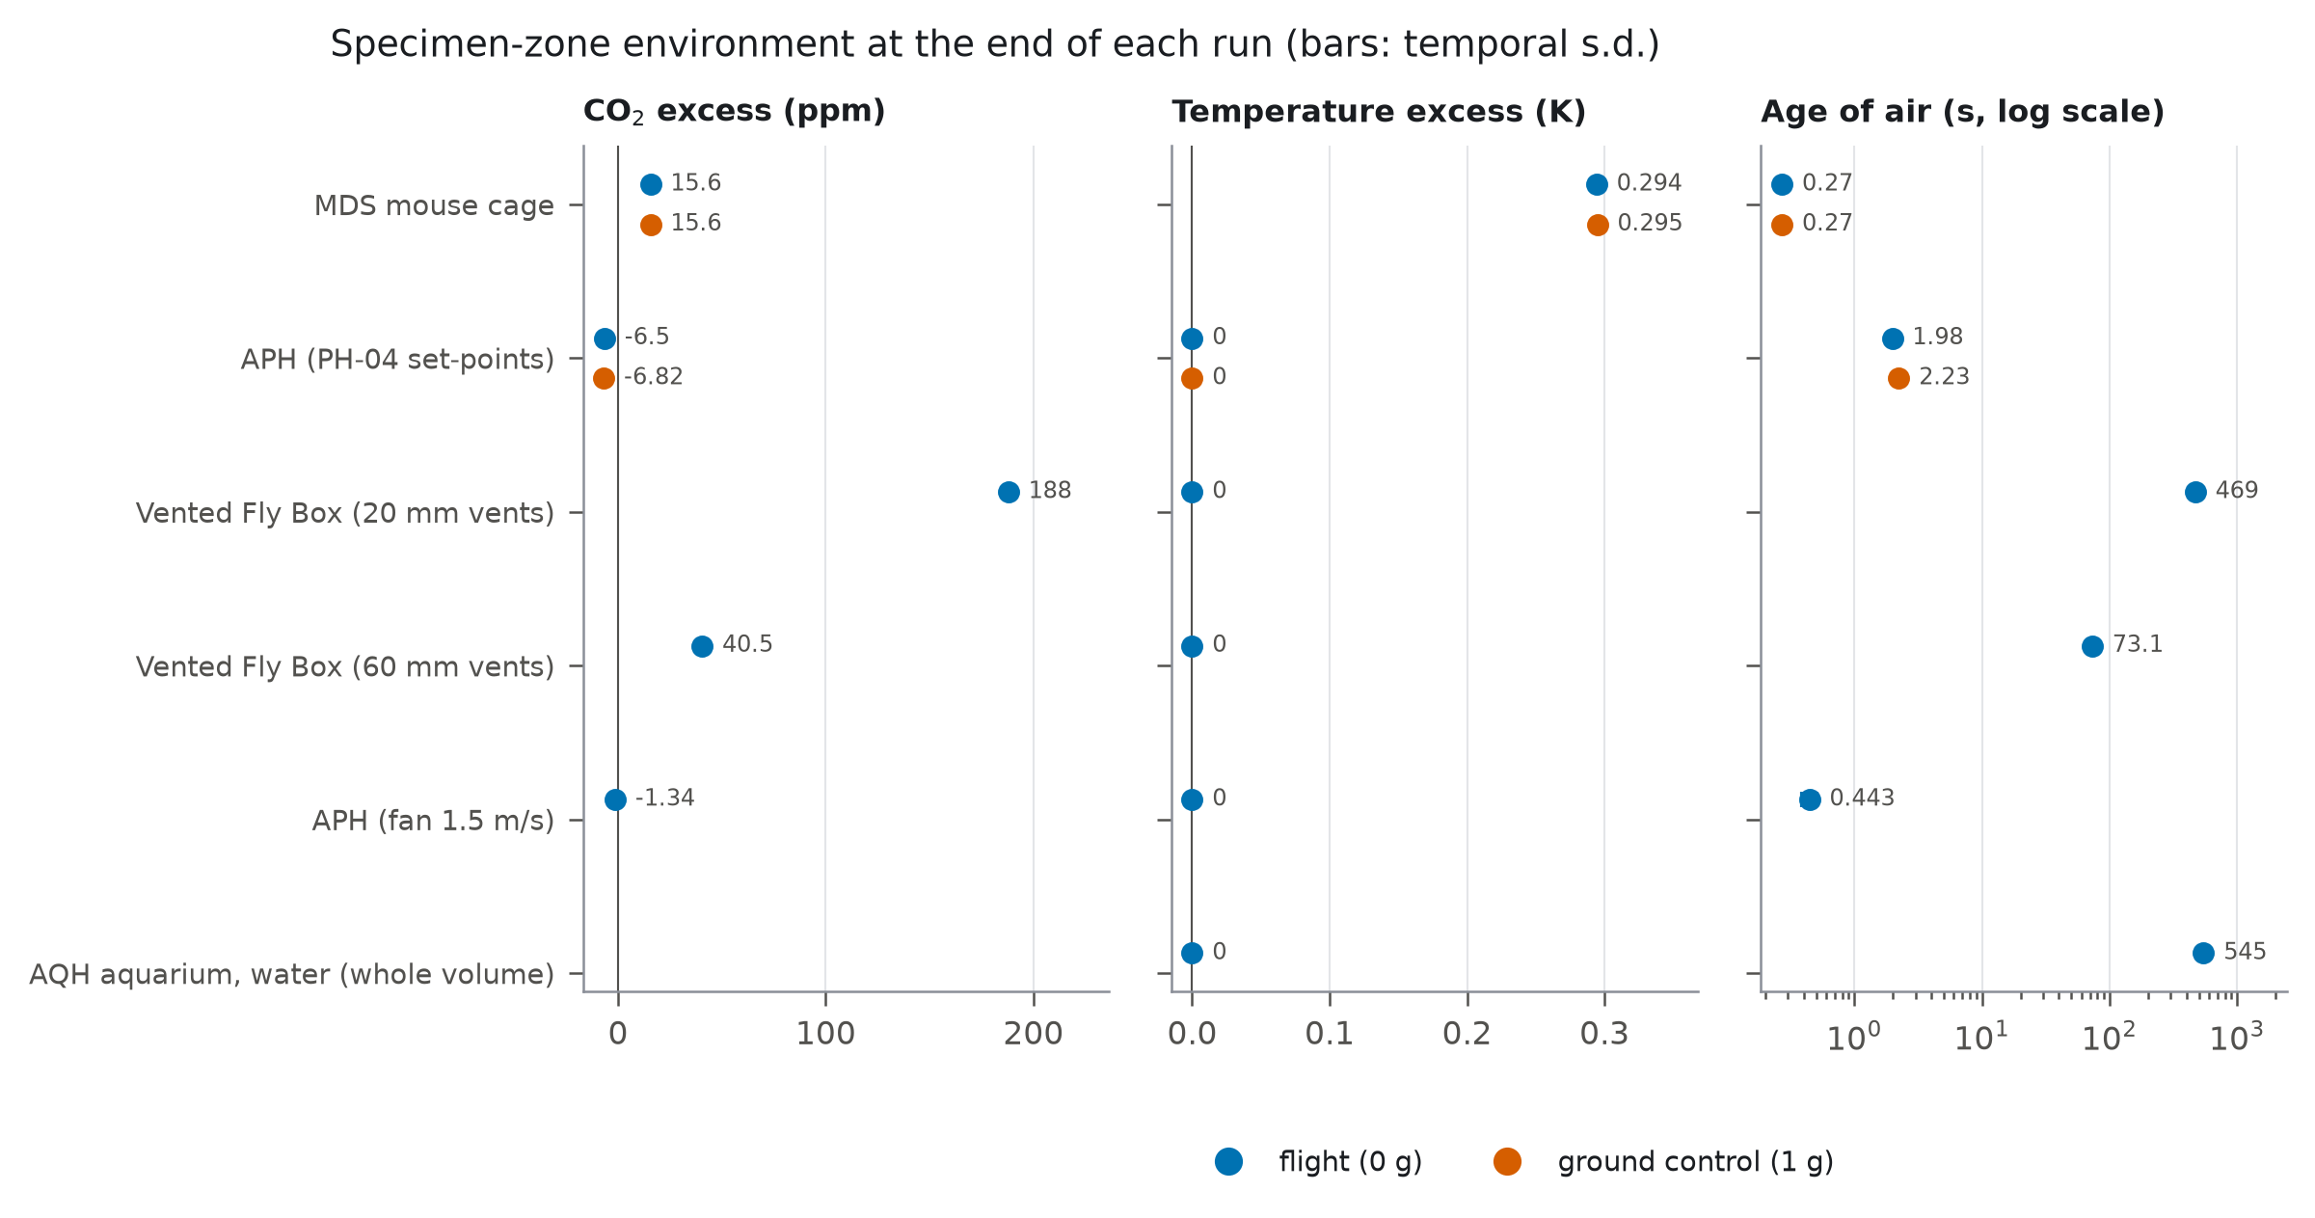
Specimen-zone CO$​_{2}$ and temperature excess and age of air in each modelled hardware item, flight (0 $g$) versus ground control (1 $g$), medium meshes.

Cabin telemetry
Of the 24 missions in the Environmental Data App, 13 Rodent Research missions have flight and ground-control series of the same variables during habitation (10 with CO$​_{2}$); all describe cabin or ground-chamber air, and none the interior of the hardware. The ground-control series tracked the cabin with a lag of at most 1 h, and median flight$−$ground differences were within 0.10 $​^{∘}$C, 1.03% relative humidity and 67.33 ppm CO$​_{2}$, except in RR-3, whose ground controls were 2.00 $​^{∘}$C warmer than the cabin (23.88 versus 21.88 $​^{∘}$C; Supplementary Note S9). The plant missions in the app return no values, and PH-04, the Advanced Plant Habitat run modelled here (OSD-772), has no telemetry in OSDR. The RR-1 cabin ranges reported by Choi et al. (2020) (CO$​_{2}$ 788–4,690 ppm) equal the extremes of the app’s ground-control series; its flight series spans 1,862–4,667 ppm.

Discussion

The specimen environment is mostly undocumented
Of 111 hardware items that house live specimens in flight, the public record supports a CFD description of 1, and SPLASH alone supports none. Targeted curation of 37 items, reading papers, technical reports and mission documentation, raised only 4 to CFD readiness. The single most common gap is the airflow that ventilates the specimens: it is missing for 15 curated items, including Veggie (whose fan is described only by its Low/High/Off settings), EMCS, ABRS and the Biomass Production System. The second is the geometry of the specimen container and of the enclosure itself. The ISS Rodent Habitat, linked to 133 OSDR studies, has no published internal cage dimensions in any source we could open, and the dimensions of its predecessor, the Animal Enclosure Module, cannot be assumed to carry over. None of the nine canister and culture items of the BRIC family, GAP-FPA, BioCell, Kubik and CGBA has published internal dimensions, although BRIC-PDFU alone is linked to 13 OSDR studies. Specimen metabolic and heat loads are almost never reported for the flight itself and had to be taken from organism-level physiology. These are not obscure parameters: they set the gas, temperature and humidity fields that flight and ground-control specimens experience, and they are exactly what is needed to judge whether a flight–ground difference is a gravity effect or a hardware effect.

What the models can and cannot say
In the four hardware items that could be modelled, the gravity contrast was small: forced ventilation dominated the mouse-cage environment, and in the plant growth chamber the flight–ground difference was within the fluctuation of the flow. This is not evidence that gravity does not matter to these environments, because the loads that would let it act – canopy and lamp heat, fly metabolic heat, the solutal buoyancy of exhaled CO$​_{2}$ – are exactly the inputs the public record does not provide. What the models do show is that the undocumented inputs can matter more than gravity: the fly-box vent size, which no source states, changed the predicted CO$​_{2}$ around the specimens 4.64-fold. For hardware of this kind, interpreting a flight–ground difference as a gravity effect requires the hardware environment to be measured or modelled, and modelling requires metadata that do not yet exist publicly. Cabin telemetry, now public for 13 rodent missions, can set the exterior of such models and shows that ground controls usually reproduced the cabin closely, with exceptions such as RR-3; it cannot test a specimen-zone prediction, which needs telemetry from inside the hardware, and none is public for PH-04.

Catalogue integrity
The defects we found are of a kind that propagates silently: displaced fields in a contiguous block of SPLASH records (a plant growth unit described by an RNA thermal cycler’s specimen list, a sealed canister carrying a growth chamber’s CO$​_{2}$ control range), an alias that merges two different bioreactors, and registry links that attach unrelated studies to hardware. Automated reuse of these catalogues – including by language models – would inherit the errors. We therefore recommend that SPLASH and the OSDR registry (i) adopt the MI-CFD-HW items as structured fields with units and provenance, (ii) populate the existing but empty sources, schematics and study_links fields, (iii) replace the free-text experiment-platform field of OSDR studies with a controlled reference to a hardware identifier, and (iv) record, per flight, the logged temperature, humidity and CO$​_{2}$ of the hardware interior.

Limitations
The automated scorer is conservative (recall 0.69) and its tiers are a lower bound; the blind gold standard, however, also contained no Tier A item. Curation was bounded by access: several sources likely to hold the missing airflow and geometry data were paywalled or unavailable and are listed in the curation notes. The CFD models are laminar and Boussinesq in temperature only; solutal buoyancy from CO$​_{2}$ and water vapour is not simulated, and we report its Rayleigh number for each run instead. Where heat loads were not sourced (plant canopies, LED arrays, flies) they were not invented, so buoyancy in the 1 $g$ cases is driven only by the sourced loads and gravity contrasts are lower bounds. Unpublished details – vent sizes and positions, canopy height, the location at which a fan’s “wind speed” is measured – are declared assumptions (Supplementary Note S4) and, where they matter, were varied.

Data and code availability
Code, the 2026-10-12 source snapshot, curated hardware specifications, model definitions, reduced CFD outputs, the Environmental Data App telemetry snapshot and this manuscript’s sources are archived on Zenodo (DOI to be assigned on deposit) under the MIT licence (code) and CC-BY-4.0 (data and figures). SPLASH data were obtained from NASA’s Space Life Sciences Archive of Scientific Hardware (NASA Ames Research Center 2026).
Bell, Ian H., Jorrit Wronski, Sylvain Quoilin, and Vincent Lemort. 2014. “Pure and Pseudo-Pure Fluid Thermophysical Property Evaluation and the Open-Source Thermophysical Property Library CoolProp.” Industrial & Engineering Chemistry Research 53: 2498–508. https://doi.org/10.1021/ie4033999.
Berrios, Daniel C., Jonathan Galazka, Kirill Grigorev, Samrawit Gebre, and Sylvain V. Costes. 2021. “NASA GeneLab: Interfaces for the Exploration of Space Omics Data.” Nucleic Acids Research 49 (D1): D1515–22. https://doi.org/10.1093/nar/gkaa887.
Celik, Ismail B., Urmila Ghia, Patrick J. Roache, and Christopher J. Freitas. 2008. “Procedure for Estimation and Reporting of Uncertainty Due to Discretization in CFD Applications.” Journal of Fluids Engineering 130: 078001. https://doi.org/10.1115/1.2960953.
Choi, Sungshin Y., Amanda Saravia-Butler, Yasaman Shirazi-Fard, et al. 2020. “Validation of a New Rodent Experimental System to Investigate Consequences of Long Duration Space Habitation.” Scientific Reports 10: 2336. https://doi.org/10.1038/s41598-020-58898-4.
Gebre, Samrawit G., Ryan T. Scott, Amanda M. Saravia-Butler, Danielle K. Lopez, Lauren M. Sanders, and Sylvain V. Costes. 2025. “NASA Open Science Data Repository: Open Science for Life in Space.” Nucleic Acids Research 53 (D1): D1697–710. https://doi.org/10.1093/nar/gkae1116.
Gjesdal, Thor, Carl Erik Wasberg, and Øyvind Andreassen. 2003. Spectral Element Simulations of Buoyancy-Driven Flow. https://arxiv.org/abs/physics/0305049.
Hortmann, M., M. Perić, and G. Scheuerer. 1990. “Finite Volume Multigrid Prediction of Laminar Natural Convection: Bench-Mark Solutions.” International Journal for Numerical Methods in Fluids 11: 189–207. https://doi.org/10.1002/fld.1650110206.
Lemmon, E. W., and R. T. Jacobsen. 2004. “Viscosity and Thermal Conductivity Equations for Nitrogen, Oxygen, Argon, and Air.” International Journal of Thermophysics 25: 21–69. https://doi.org/10.1023/B:IJOT.0000022327.04529.f3.
Lemmon, Eric W., Richard T. Jacobsen, Steven G. Penoncello, and Daniel G. Friend. 2000. “Thermodynamic Properties of Air and Mixtures of Nitrogen, Argon, and Oxygen from 60 to 2000 K at Pressures to 2000 MPa.” Journal of Physical and Chemical Reference Data 29: 331–85. https://doi.org/10.1063/1.1285884.
Monteith, John L., and Mike H. Unsworth. 2008. Principles of Environmental Physics. 3rd ed. Academic Press / Elsevier.
NASA Ames Research Center. 2026. SPLASH: Space Life Sciences Archive of Scientific Hardware. Https://visualization.osdr.nasa.gov/splash/instruments.
NASA Open Science Data Repository. 2026a. OSDR Environmental Data App (EDA). Https://visualization.osdr.nasa.gov/eda/.
NASA Open Science Data Repository. 2026b. OSDR Hardware Registry and Biological Data API (V2). Https://osdr.nasa.gov/geode-py/ws/api/hardware; https://visualization.osdr.nasa.gov/biodata/api/v2.
OpenCFD Ltd. 2026. OpenFOAM V2606. Https://www.openfoam.com.
Vahl Davis, G. de. 1983. “Natural Convection of Air in a Square Cavity: A Bench Mark Numerical Solution.” International Journal for Numerical Methods in Fluids 3: 249–64. https://doi.org/10.1002/fld.1650030305.
Weller, H. G., G. Tabor, H. Jasak, and C. Fureby. 1998. “A Tensorial Approach to Computational Continuum Mechanics Using Object-Oriented Techniques.” Computers in Physics 12: 620–31. https://doi.org/10.1063/1.168744.

ORCID 0000-0001-5681-9857. Correspondence: richard@cosecloud.com.

