Gravity, geometry and enclosure control the gas‑exchange boundary layer of *Arabidopsis*: a validated in‑browser CFD model linking spaceflight hardware to carbon gain
Richard J. Barker¹* and collaborators (author list provisional)
¹ MadWest / AstroBotany International Research Initiative (AIRI). Affiliations to be finalised. * Correspondence: admin@cosecloud.com
Manuscript draft for an npj Microgravity‑style methods + case‑study article. This document is
generated from the LunarLeaf‑CFD results package; figures (F1–F10) and tables (T1–T12) are in
`results/figures/` and `results/tables/`. A LaTeX version is in `results/manuscript/`.

Abstract
Plants grown in spaceflight display stress phenotypes whose mechanistic basis remains debated. A long‑ suspected contributor is the loss of buoyancy‑driven convection in microgravity, which should thicken the unstirred boundary layer around plant organs and steepen the O₂/CO₂/H₂O gradients that govern gas exchange. We test this quantitatively with a browser‑based lattice‑Boltzmann model that solves incompressible flow, multi‑species advection–diffusion and Boussinesq buoyancy under an adjustable gravity vector. The solver is validated against four numerical benchmarks and anchored to measured Arabidopsis thaliana whole‑plant‑ chamber gas exchange (net assimilation 3.85 µmol CO₂ m⁻² s⁻¹). Reducing gravity from 1 g to microgravity removes convective ventilation (peak flow speed ∝ √g → 0) and steepens the surface gas gaps 1.5–1.8× at every scale; denser architectures — a rosette, then a microgreen canopy — trap air and amplify the effect. The forced airflow needed to restore Earth‑equivalent boundary layers scales steeply with planting density (≈ 2.6 / 11 / 21 cm s⁻¹ for a leaf / rosette / canopy). Mapping the three ISS growth systems onto dish boundary conditions, a sealed BRIC dish both drifts toward hypoxia and, once photosynthesis is made CO₂‑ limited, fixes only ≈ 1 % of the Earth carbon over a 12 h photoperiod; a micropore‑taped CARA dish sustains ≈ 90 % and a ventilated VEGGIE system ≈ 100 %. The model, runnable entirely in a web browser, provides a mechanistic bridge from cabin‑scale transport to plant carbon gain and a quantitative design tool for space‑flight growth hardware.
Keywords: microgravity, boundary layer, gas exchange, Arabidopsis, computational fluid dynamics, lattice‑Boltzmann, spaceflight hardware, photosynthesis.

Introduction
On Earth a photosynthesising leaf warms and humidifies the thin layer of air in contact with its surface. The warmed, moistened air is less dense than the bulk atmosphere, becomes buoyant, and rises — a free‑ convection plume that continuously sweeps the leaf boundary layer, replenishing CO₂ and carrying away O₂ and water vapour. This buoyancy‑driven ventilation is invisible on Earth but does real physiological work: it sets the boundary‑layer conductance that, in series with stomatal and mesophyll conductances, limits gas exchange.
In microgravity there is no buoyancy. Density differences no longer generate motion, so in still air the only transport left is molecular diffusion. The unstirred boundary layer around a plant organ is expected to thicken, and the surface‑to‑bulk gradients of CO₂, O₂ and water vapour to steepen. This has been proposed for decades as a mechanism contributing to the altered morphology, gas exchange and stress signatures of spaceflight‑grown plants¹⁻³, and it is the stated rationale for the forced‑ventilation design of modern plant‑growth hardware. Yet the effect is difficult to measure directly: no whole‑chamber sensor resolves the sub‑millimetre boundary layer, and flight opportunities are scarce. A physically grounded, quantitative model is therefore valuable both to interpret existing results and to design hardware.
Here we build such a model and make it broadly usable — it runs entirely in a web browser with no installation. We (i) implement and validate an incompressible flow + multi‑species transport solver with a user‑controlled gravity vector; (ii) anchor it to measured Arabidopsis gas‑exchange rates; (iii) quantify how reduced gravity reshapes the boundary layer and its gas gradients across three biological scales — a single leaf, a rosette, and a dense microgreen canopy; (iv) compute the forced airflow required to counteract the microgravity penalty at each scale; (v) map the three most‑used ISS plant‑growth systems (BRIC, CARA, VEGGIE) onto solver boundary conditions; and (vi) close the loop by making photosynthesis CO₂‑ limited, translating the transport limitation into a prediction of carbon gain. Throughout we separate what the data validate (the flux magnitude and closed‑chamber transport) from what the model predicts (the spatial, gravity‑ and scale‑dependent gradients).

Results

Solver validation
Before any biology, the incompressible‑flow + advection–diffusion solver was verified against four independent benchmarks (Table 1). It reproduces the Ghia et al.⁴ lid‑driven‑cavity centreline profiles at Re 100 (L2 = 0.011), the Kármán vortex‑shedding Strouhal number of a confined cylinder (St = 0.192), the de Vahl Davis⁵ differentially‑heated‑cavity Nusselt number at Ra 10⁴ (Nu = 2.242 vs 2.238, 0.18 % error), and the analytic error‑function profile for pure diffusion (L2 ≈ 0). Gate 3 is decisive: reproducing the natural‑convection benchmark to 0.18 % confirms that the buoyancy/gravity coupling is quantitatively correct, so scaling the gravity vector to zero genuinely collapses convection to the diffusion limit certified by gate 4.
Table 1 | Numerical validation gates.
Gate | Benchmark | Reference | Model | Result
1 | Lid‑driven cavity, Re 100 | Ghia et al. (1982)⁴ | L2 = 0.011 | ✓
2 | Cylinder wake, Re 100 | St ≈ 0.16 (unconfined) | St = 0.192 (confined) | ✓
3 | Natural‑convection cavity, Ra 10⁴ | de Vahl Davis (1983)⁵ Nu = 2.238 | Nu = 2.242 | ✓
4 | Pure diffusion | ½·erfc analytic | L2 ≈ 0 | ✓

Measured gas exchange anchors the model
Two independent measurements fix the physical stomatal flux (Fig. 1; Table 2). A whole‑plant‑chamber dataset⁶ gives a net CO₂ assimilation of 1.38 µmol CO₂ h⁻¹ cm⁻² = 3.85 µmol m⁻² s⁻¹ for Col wild‑type, with dark respiration 1.18 µmol m⁻² s⁻¹ (R/A = 0.31) — textbook‑typical for Arabidopsis. An independent 4.8‑day Vernier whole‑chamber trace (Fig. 1a) shows the expected closed‑system signature: strong diel O₂ cycling (6.6–32.8 %) and humidity swings driven by photosynthesis and respiration. These fix the model's surface source/sink terms in physical units.
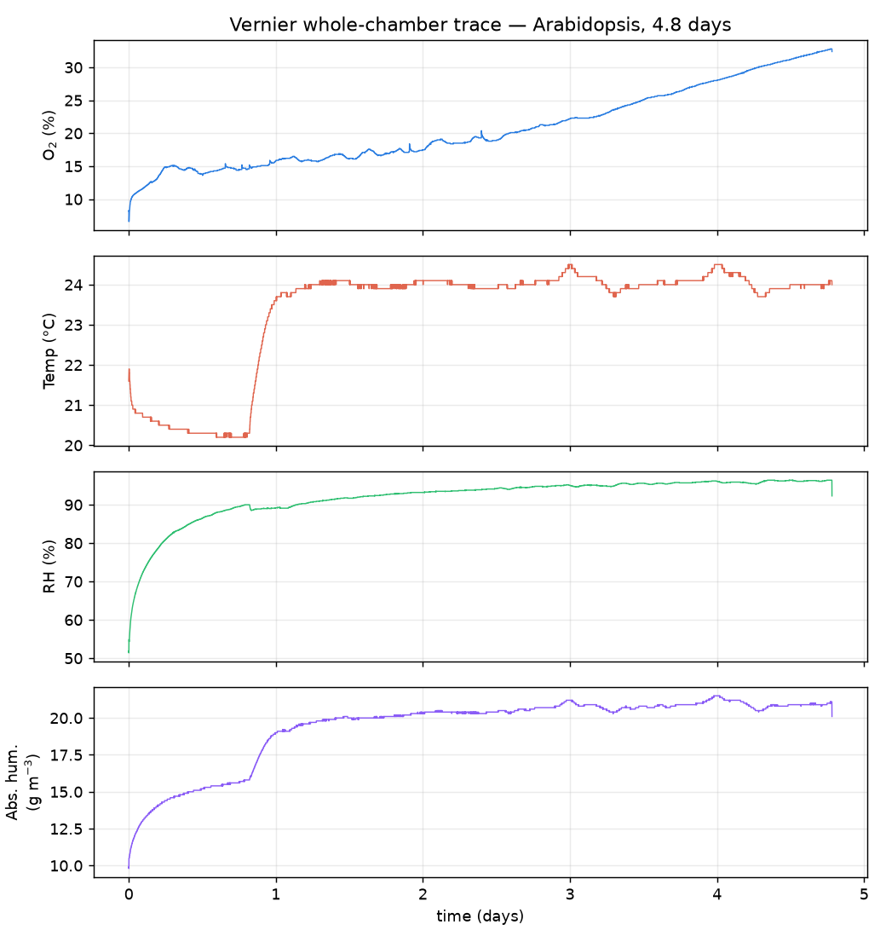
Figure 1 | Measured whole‑chamber gas exchange. Vernier closed‑chamber trace over 4.8 days: O₂, temperature, relative humidity and absolute humidity, showing diel gas cycling driven by the plant.
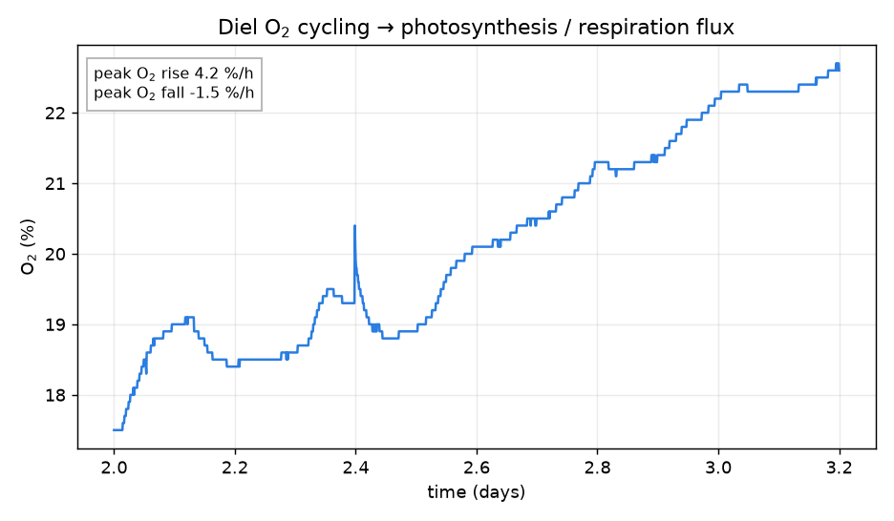
Figure 2 | One diel O₂ cycle with peak photosynthesis and respiration slopes, from which whole‑chamber gas‑exchange fluxes are derived.
Table 2 | Measured gas exchange (selected).
Quantity | Value | Units | Source
Net CO₂ assimilation A | 1.38 (3.85) | µmol h⁻¹ cm⁻² (µmol m⁻² s⁻¹) | Chamber⁶
Dark respiration R | 0.43 (1.18) | µmol h⁻¹ cm⁻² (µmol m⁻² s⁻¹) | Chamber⁶
Chamber volume / area | 339 / 26 | cm³ / cm² | Chamber⁶
Vernier O₂ diel range | 6.6–32.8 | % | Vernier

Calibration and closed‑chamber transport
Resolving the leaf at 52 lattice cells across a 1.5 cm blade maps the lattice to physical units as dx = 0.288 mm, dt = 0.173 ms, giving an Earth‑gravity convective velocity of ≈ 7.7 cm s⁻¹ near the leaf — a physically reasonable free‑convection speed (Table 3). Run as a sealed chamber with a central source, the solver reproduces monotonic gas accumulation and conserves mass to a relative error of 2 × 10⁻⁵ (Fig. 3a), matching the imposed flux exactly. A persistent surface‑to‑bulk concentration gap develops between the near‑ leaf air and the far wall (Fig. 3b): the boundary layer expressed at chamber scale, and the quantity that gravity modulates below.
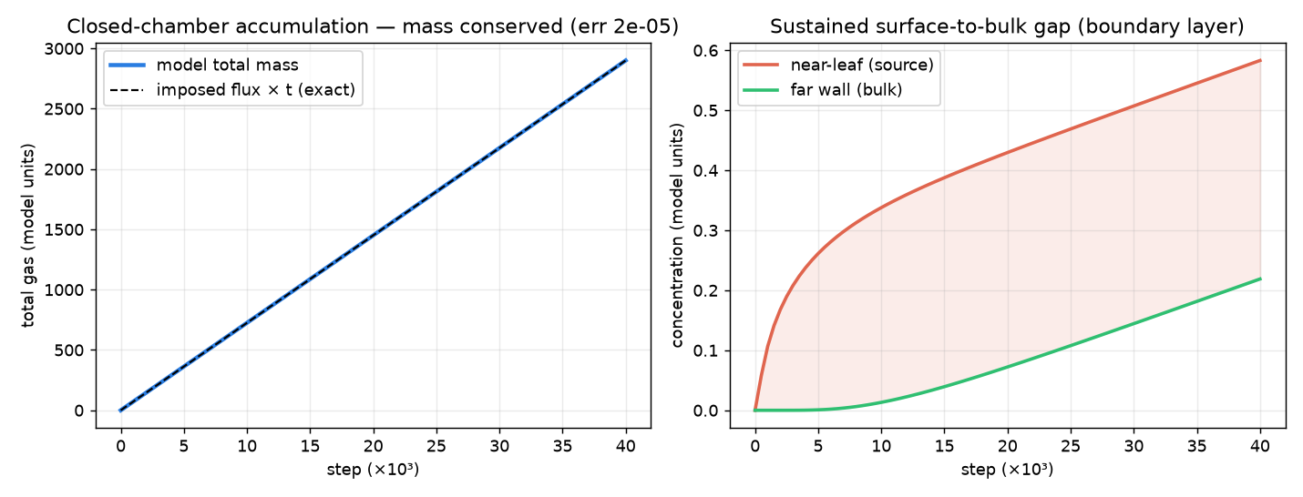
Figure 3 | Closed‑chamber transport validation. (a) Sealed‑chamber total gas matches the imposed flux exactly (mass conserved to 2 × 10⁻⁵). (b) A sustained near‑leaf vs far‑wall concentration gap — the boundary layer at chamber scale.

Gravity controls the boundary layer
Sweeping gravity from Earth through Mars (0.38 g) and the Moon (0.17 g) to microgravity, convective ventilation weakens monotonically (peak speed ∝ √g) while the surface gas gaps steepen (Fig. 4a). The field maps make the mechanism visible (Fig. 5): at 1 g a buoyant plume rises off the leaf, thinning the upper‑ surface boundary layer; in microgravity the plume is gone and a symmetric, thicker diffusive halo surrounds the blade. The surface CO₂ gap roughly doubles from Earth to microgravity for an isolated leaf.
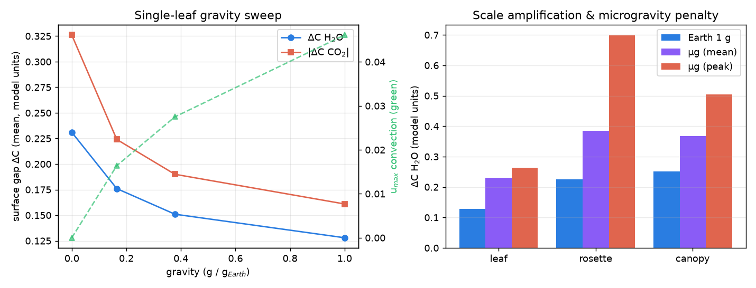
Figure 4 | Gravity and scale. (a) Single‑leaf gravity sweep: surface gaps rise and convection falls as gravity decreases. (b) Scale amplification and the microgravity penalty across leaf, rosette and canopy.
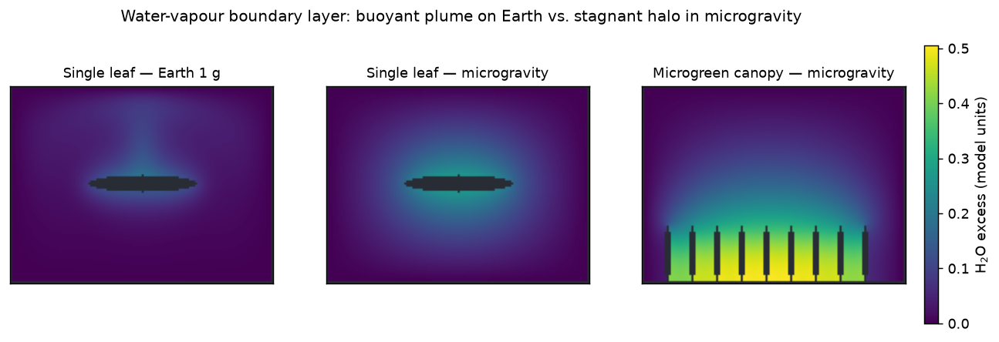
Figure 5 | Water‑vapour boundary layer. Buoyant plume (leaf, Earth), symmetric stagnant halo (leaf, microgravity), and trapped within‑canopy air (microgreen canopy, microgravity).

Scale amplifies the effect
Moving from a single leaf to a rosette to a microgreen stand compounds the gravity penalty (Fig. 4b). Over‑ lapping rosette leaves trap air in the crown, producing the steepest local gradients of any geometry; the dense canopy ventilates only at its top, so the within‑canopy air stagnates as a whole (highest mean gradient). Both effects intensify in microgravity, making a microgravity canopy the worst case.

Physical prediction of surface gas drawdown
Anchoring the model's dimensionless gradients on the measured assimilation flux and a standard still‑air leaf boundary‑layer conductance (1.0 mol m⁻² s⁻¹) yields concrete predictions (Table 4): a boundary‑layer CO₂ drawdown of ≈ 4 ppm for an isolated leaf on Earth, rising to ≈ 13 ppm for the rosette bulk in microgravity, with trapped crown pockets reaching ≈ 25 ppm. These boundary‑layer contributions add to the larger stomatal and mesophyll drops.
Table 4 | Predicted leaf‑surface CO₂ drawdown (ppm), anchored on measured flux.
Scenario | Mean | Peak
Leaf · Earth | 3.8 | 5.9
Leaf · microgravity | 7.8 | 8.9
Rosette · Earth | 7.1 | 17.1
Rosette · microgravity | 13.2 | 24.7
Canopy · Earth | 7.8 | 12.9
Canopy · microgravity | 10.6 | 14.4

Forced ventilation reverses the penalty — but the requirement scales with density
Because the microgravity penalty is transport‑limited, it is engineerable: forced airflow substitutes for the missing buoyant convection. For an isolated leaf, a fan of only ≈ 2.6 cm s⁻¹ restores Earth‑equivalent surface gradients (Fig. 6). Extending the sweep to all three scales exposes a result with direct hardware consequences (Fig. 7a): the Earth‑equivalent airflow rises steeply with planting density — ≈ 2.6, 11 and 21 cm s⁻¹ for a leaf, rosette and canopy respectively (Fig. 7b), an ~8× increase. The canopy is the hardest to ventilate: side airflow skims the top of the stand while the within‑canopy air stays comparatively stagnant, so its gradient‑vs‑speed curve flattens and only approaches the Earth level near the solver's low‑Mach limit — a hint that a real dense canopy needs vigorous, likely turbulent, through‑canopy flow.
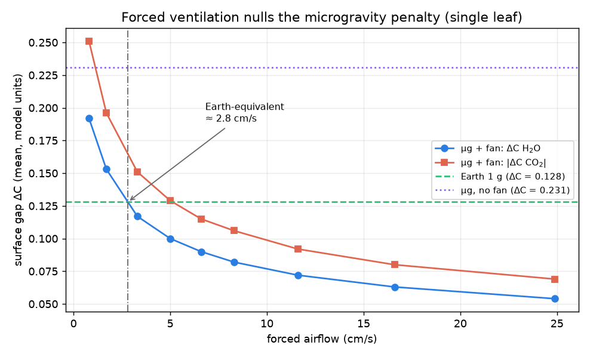
Figure 6 | Forced ventilation nulls the microgravity penalty (single leaf). Surface gap vs fan speed, with the Earth‑1 g and µg‑no‑fan references and the ≈ 2.6 cm s⁻¹ Earth‑equivalent point.
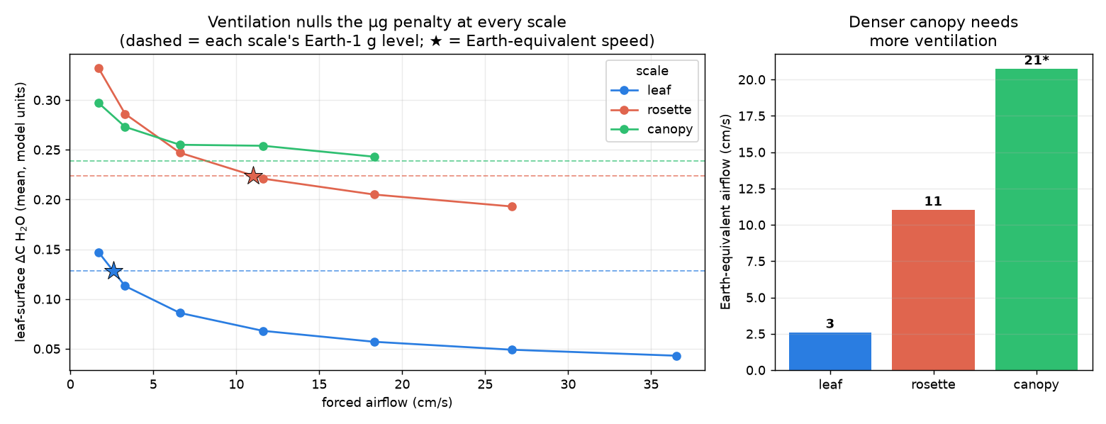
Figure 7 | Ventilation requirement scales with planting density. (a) Fan‑sweep curves for leaf/rosette/ canopy with each scale's Earth reference and crossing point. (b) Earth‑equivalent airflow ≈ 2.6 / 11 / 21 cm s⁻¹ (canopy value extrapolated; higher speeds exceeded the low‑Mach limit).

Spaceflight hardware as boundary conditions
The three most‑used ISS plant systems differ, in gas‑transport terms, only in the boundary condition they impose on the Petri dish (Fig. 8; Fig. 9). BRIC — hermetically sealed⁷ — imposes zero‑flux walls: the enclosure atmosphere drifts without bound (Fig. 8a), and a simple mass balance on the small dish reservoir (Table 5) shows the ~400 ppm of CO₂ in a 30 cm³ headspace is fixed by photosynthesis in ≈ 7 minutes (light), while in the dark CO₂ reaches a stressful 1 % in ≈ 9 hours and O₂ falls to a hypoxic 5 % in ≈ 6.5 days. BRIC also gives the steepest leaf‑surface gradient of any hardware (Fig. 8b). CARA — gas‑permeable micropore surgical tape⁸ — vents the dish to the effectively‑infinite cabin, so the dish‑mean stays a few ppm from ambient (consistent with ground measurements that surgical tape keeps plated seedlings near‑ambient while parafilm and plastic wrap deplete CO₂ and trigger thousands of stress genes⁸,⁹); but it does not fix the microgravity boundary layer, so the leaf‑surface gradient remains that of an open dish (Fig. 9). VEGGIE — light + forced airflow — vents the enclosure and thins the leaf boundary layer, cutting the surface gradient ~3× toward Earth values. Across all three scales, BRIC ≈ CARA at the leaf surface, and a single VEGGIE fan speed (~8 cm s⁻¹) that restores a leaf barely helps a rosette or canopy (Fig. 9), because 8 cm s⁻¹ is well below their 11 and 21 cm s⁻¹ requirements.
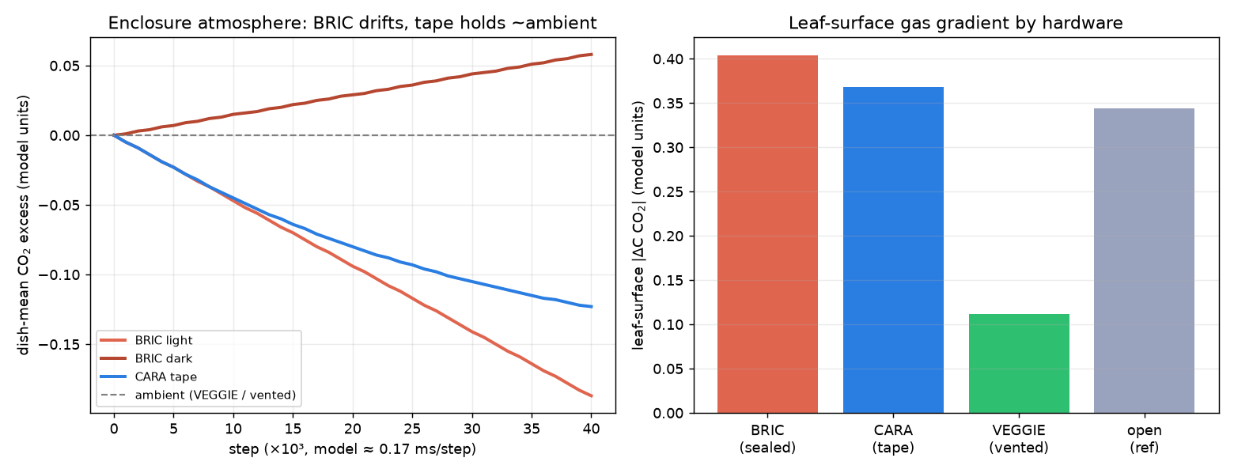
Figure 8 | Spaceflight hardware as dish boundary conditions. (a) Enclosure‑mean CO₂ drift over time — BRIC diverges (light depletes, dark accumulates) while the taped dish holds near ambient. (b) Leaf‑surface gradient by hardware.
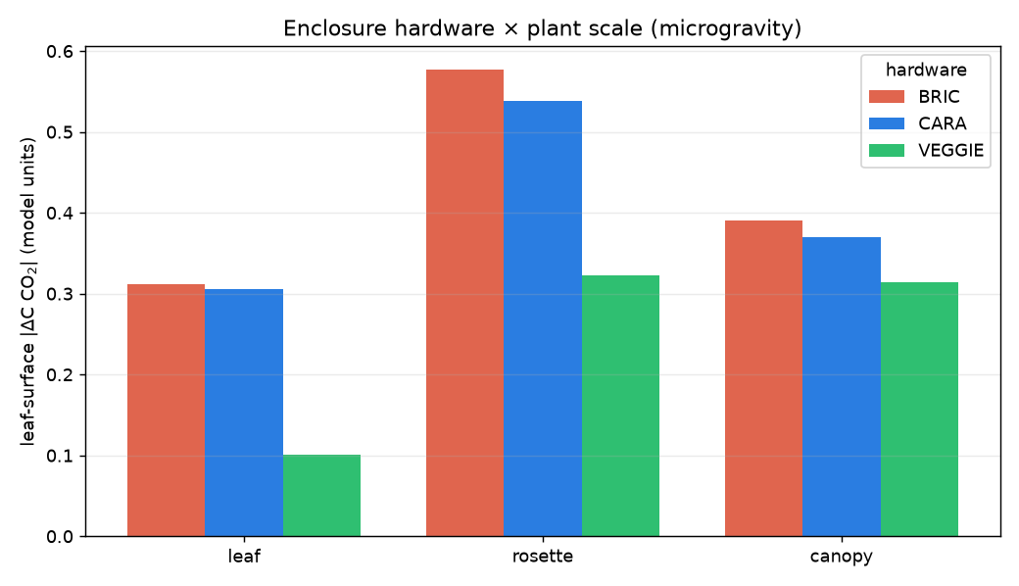
Figure 9 | Hardware × plant scale (microgravity). BRIC ≈ CARA at the leaf surface at every scale; one VEGGIE fan speed under‑serves denser stands.
Table 5 | Sealed‑dish (BRIC) atmosphere timescales (analytic, 30 cm³ dish, 3 cm² leaf).
Event | Time
Light: CO₂ 400 → ~0 ppm (photosynthesis self‑limits) | ≈ 7 min
Dark: CO₂ → 1 % (stress) | ≈ 9 h
Dark: O₂ 21 → 5 % (hypoxia) | ≈ 6.5 d

Closing the loop: CO₂‑limited photosynthesis
The analyses above impose a fixed assimilation flux. Because photosynthesis is CO₂‑limited, the depletion the boundary layer creates should feed back and suppress the flux. Making the leaf's CO₂ uptake follow a compensation‑point + saturation response of the local surface CO₂, the boundary‑layer depletion self‑ limits assimilation by ≈ 1–4 % at steady state, tracking the transport story: smallest under ventilation (VEGGIE, net A = 99.3 % of potential), larger for a bare microgravity leaf (98.0 %), and largest in the trapped rosette crown (96.5 %) (Table 6). Coupling the same response to the enclosure mass balance and the microgravity boundary‑layer conductance over a 12 h photoperiod (Fig. 10) exposes the growth consequence: in a sealed BRIC dish the surface CO₂ falls to the compensation point within minutes, photosynthesis collapses, and only ≈ 1 % of the Earth carbon is fixed; the taped CARA dish sustains ≈ 90 % and the ventilated VEGGIE system ≈ 100 %. The transport limitations are therefore not merely gradients — they throttle carbon gain, mildly where air moves and almost completely where it is sealed and still.
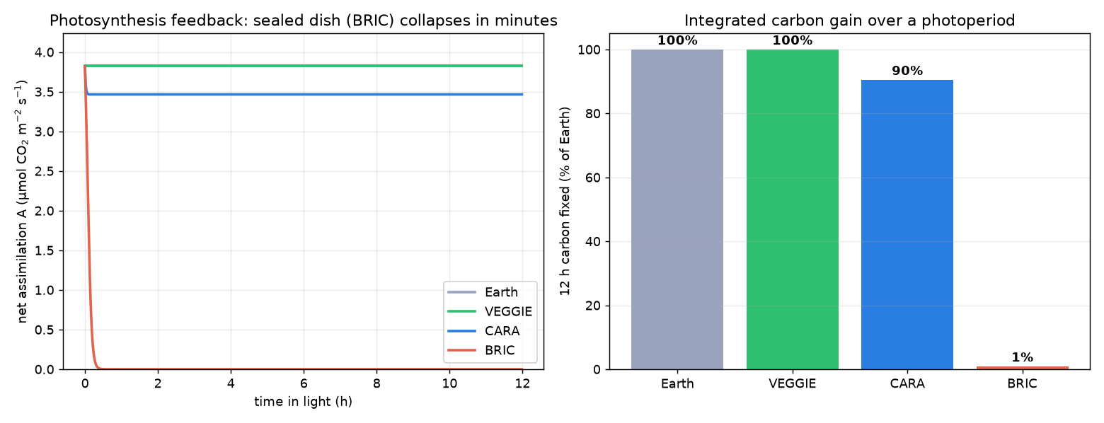
Figure 10 | Closed‑loop CO₂‑limited photosynthesis. (a) Net assimilation over a photoperiod — the sealed BRIC dish collapses within minutes. (b) Integrated 12 h carbon fixed: BRIC ≈ 1 %, CARA ≈ 90 %, VEGGIE ≈ 100 % of Earth.
Table 6 | Closed‑loop net assimilation (solver, % of light‑saturated potential).
Scenario | Net A (%)
Leaf · Earth | 98.9
Leaf · microgravity | 98.0
Rosette · microgravity (crown) | 96.5
Canopy · microgravity | 97.5
Leaf · µg · VEGGIE | 99.3

Discussion
The results give a mechanistic, quantitative account of a long‑suspected spaceflight stress: without buoyancy‑driven convection, plant organs sit in a thickened, poorly‑ventilated boundary layer that is simultaneously CO₂‑starved (suppressing photosynthesis), O₂‑enriched (promoting photorespiration) and humid (reducing transpirational cooling and nutrient transport). Crucially, this is not a fixed penalty but one that scales with both gravity and canopy architecture, and — through the CO₂ feedback — with the gas‑exchange control of the enclosure. The denser the planting and the more sealed the container, the more a still, low‑ gravity atmosphere throttles carbon gain.
Because the effect is transport‑ rather than biochemistry‑limited, it is engineerable, and the same solver that quantifies the penalty sizes the forced airflow needed to remove it. The scale dependence of that requirement (≈ 2.6 → 11 → 21 cm s⁻¹ from leaf to canopy) is a concrete design guideline: a ventilation setting or permeable seal tuned on sparse plants will under‑serve a dense stand. The hardware mapping frames the three ISS systems as a ladder of increasing gas‑exchange control — sealed (both enclosure drift and surface layer), vented seal (enclosure fixed, surface not), actively ventilated (both fixed) — and the photosynthesis feedback converts these into a growth currency: a sealed dish fixes almost no carbon over a photoperiod. This offers a parsimonious, physics‑based contributor to the reduced growth and stress transcriptomes reported for sealed‑hardware spaceflight experiments⁷,⁹, complementary to gravisensing‑ and light‑driven responses.
Limitations. The model is 2‑D and uses the Boussinesq approximation; results are kept within its validity (u_max < 0.1 lattice units, β·ΔC ≲ 0.5). Photosynthesis is CO₂‑limited through a rectangular‑ hyperbola response, but stomatal conductance is not yet dynamic (transpiration is held CO₂‑independent), and the CO₂‑response and tape‑permeance parameters are reasonable assumptions rather than fits. Absolute ΔC values are reported in lattice excess units and converted to ppm through a single literature‑anchored conductance; the microgravity boundary layer is further bounded by the finite chamber, so the reported gravity ratios are conservative lower bounds. Finally, the ground datasets validate the flux magnitude and closed‑chamber transport, not the spatial boundary layer directly — which no whole‑chamber sensor can resolve — so the gravity‑ and scale‑dependent gradients remain model predictions built on validated components.
Future work. (i) Make stomatal conductance dynamic (CO₂‑ and humidity‑responsive) so transpiration and assimilation co‑vary; (ii) enlarge the domain and move to 3‑D (WebGPU) to remove the chamber‑bound conservatism and let a dense canopy develop the turbulent through‑flow its ventilation requires; (iii) calibrate against spatially‑resolved surface‑gas imaging (e.g. planar‑optode pH/CO₂/O₂ maps) for a direct test of the predicted gradients; (iv) couple to a whole‑plant carbon‑balance model to translate per‑ photoperiod carbon deficits into growth‑rate predictions across mission durations.

Methods
Flow solver. Incompressible flow is solved with a two‑dimensional D2Q9 Bhatnagar–Gross–Krook (BGK) lattice‑Boltzmann scheme with halfway bounce‑back walls. The relaxation time τ sets the kinematic viscosity via ν = c_s²(τ − ½) with c_s² = ⅓ in lattice units. Body forces (buoyancy) are applied with the Guo forcing scheme.
Species transport. Three gas species (CO₂, O₂, H₂O) are transported by D2Q5 advection–diffusion lattices that share the flow velocity, with molecular diffusivities in the ratio 1.6 : 2.0 : 2.4 (× 10⁻⁵ m² s⁻¹). Walls are zero‑flux (bounce‑back), fixed‑concentration (anti‑bounce‑back Dirichlet) or semi‑permeable membrane as required by the scenario.
Gravity and buoyancy. Gravity enters through a Boussinesq body force f = ρ g Σₖ βₖ(cₖ − cₖ,₀), where g is a user‑set gravity vector (0 → 9.81 m s⁻²) and βₖ are signed density‑change coefficients (water vapour and warm air lighter; CO₂ heavier). Setting g = 0 removes the force, collapsing transport to diffusion.
Boundary conditions and hardware. The leaf surface imposes a stomatal source/sink (CO₂ uptake, O₂ + H₂O release; signs reversed and scaled by R/A = 0.31 in the dark). Chamber walls are ambient‑held (Dirichlet), sealed (zero‑flux, BRIC), semi‑permeable (the lid/side cells relax toward ambient each step, CARA micropore tape), or an inlet/outlet ventilation pair (VEGGIE forced airflow). The dense canopy uses a reduced per‑leaf flux to represent self‑shading.
Photosynthesis feedback. When enabled, the CO₂ uptake follows A(C) = A_max (C − Γ)/(C − Γ + K) of the local surface CO₂ (Γ compensation point, K half‑saturation), normalised to the measured flux at ambient, so boundary‑layer depletion self‑limits assimilation; O₂ release tracks A.
Validation, calibration and the 0‑D enclosure model. The solver was validated on four benchmarks (Table 1). The lattice was mapped to physical units by resolving a 1.5 cm leaf at 52 cells and matching the H₂O diffusivity. A 0‑D coupled enclosure–photosynthesis model integrates the CO₂ response, the boundary‑ layer conductance (Earth free convection vs microgravity diffusion) and the enclosure exchange over a 12 h photoperiod.
Data sources. Measured gas exchange: Vernier whole‑chamber logs and a whole‑plant‑chamber biomass/gas‑ exchange workbook⁶. All model code, the validation harness and the analysis scripts are in the LunarLeaf‑CFD repository; runs are 30 000 (or 22 000) steps to quasi‑steady state.

Data and code availability
Model source, validation harness, analysis scripts and this results package are in the LunarLeaf‑CFD repository. Measured gas‑exchange data comprise Vernier whole‑chamber logs and the whole‑plant‑chamber workbook of Chew, Y.H. & Millar, A.J.⁶; raw third‑party data are referenced by provenance and not redistributed here.

Author contributions
R.J.B. conceived the study, built the model and analysis, and wrote the manuscript. Co‑author contributions to be added.

Competing interests
The authors declare no competing interests.

Acknowledgements
Measured gas‑exchange data courtesy of Y.H. Chew and A.J. Millar (University of Edinburgh). (To be completed.)

References
Preliminary reference list — citations to be finalised.
- Kitaya, Y. et al. Gas exchange and boundary‑layer resistance of plant leaves under altered gravity and
forced convection. Adv. Space Res. (2003).
- Porterfield, D. M. The biophysical limitations in physiological transport and exchange in plants grown in
microgravity. Ann. Bot. (2002).
- Musgrave, M. E. et al. Gas exchange and plant metabolism in the spaceflight environment. Plant Physiol.
- Ghia, U., Ghia, K. N. & Shin, C. T. High‑Re solutions for incompressible flow using the Navier–Stokes
equations and a multigrid method. J. Comput. Phys. 48, 387–411 (1982).
- de Vahl Davis, G. Natural convection of air in a square cavity: a benchmark numerical solution.
Int. J. Numer. Methods Fluids 3, 249–264 (1983).
- Chew, Y. H., Millar, A. J. et al. Whole‑plant‑chamber carbon‑balance dataset for Arabidopsis thaliana.
bioRxiv (2017) and associated data workbook.
- Paul, A.‑L. et al. Organ‑specific remodeling of the Arabidopsis transcriptome in response to
spaceflight (BRIC hardware). BMC Plant Biol. (2013). PMC3750915.
- Beware of sealing film of Petri dishes! — sealing method alters the expression of a large number of
genes; surgical tape maintains near‑ambient CO₂/O₂. PMC12193506.
- Plants grown in parafilm‑wrapped Petri dishes are stressed and possess altered gene‑expression profiles.
PMC6529517.
- Light has a principal role in the Arabidopsis transcriptomic response to the spaceflight environment
(CARA). PMC11303767.

