Table of Contents
Near-Null Magnetic Fields in Lunar Plant Biology: The First Five Days of Seedling Growth, Multi-Stressor Bioenergetics, and Implications for Artemis Agriculture 1
Highlights 1
Abstract 1
1. Introduction: The Lunar Magnetic Environment & The “Missing Variable” in Space Biology 1
2. The First Five Days of Growth: Early Seedling Establishment as the Critical Bottleneck for Lunar Agriculture 1
3. Quantum Molecular Biology of the 0–5 Day Window: The Quantum Biology Atlas Perspective 1
4. Multi-Stressor Convergence: The $\text{CO}2↔\text{O}2↔\text{ROS}$ Nexus (Core Concept 5) 1
5. Methodological Standards, Causal Rescue & Artemis Flight Risk-Retirement Framework 1
6. Conclusions & Forward Look for Sustained Lunar Agriculture 1
Acknowledgements 1
Author Contributions 1
Competing Interests 1
Data Availability 1
References 1

Near-Null Magnetic Fields in Lunar Plant Biology: The First Five Days of Seedling Growth, Multi-Stressor Bioenergetics, and Implications for Artemis Agriculture
Richard J. Barker$​^{1,*}$, Caue Borlina$​^{2}$, Aubrey O’Rourke$​^{2}$, Adriana Sanchez$​^{1}$, Manisha Dagar$​^{1}$, Sofia Leiva Aldana$​^{1}$, Ray Wheeler$​^{3}$, Gioia Massa$​^{4}$, Barbara Demmig-Adams$​^{5}$, Marta Peirats-Llobet$​^{7}$, Pamela Flores$​^{6}$, Anirudha Dixit$​^{4}$, Christine Chamberlain$​^{6}$, D. Marshall Porterfield$​^{1,*}$
$​^{1}$ Department of Agricultural and Biological Engineering, Purdue University, West Lafayette, IN 47907, USA
$​^{2}$ Department of Earth, Atmospheric, and Planetary Sciences, Purdue University, West Lafayette, IN 47907, USA
$​^{3}$ NASA John F. Kennedy Space Center, Exploration Research and Technology Programs, FL 32899, USA
$​^{4}$ NASA John F. Kennedy Space Center, Space Crop Production, FL 32899, USA
$​^{5}$ Department of Ecology and Evolutionary Biology, University of Colorado Boulder, Boulder, CO 80309, USA
$​^{6}$ Space Lab Technologies, LLC, Boulder, CO 80301, USA
$​^{7}$ La Trobe Institute for Sustainable Agriculture and Food, School of Agriculture, Biomedicine and Environment, La Trobe University, Bundoora, VIC 3086, Australia
$​^{*}$ Corresponding Authors: porterf@purdue.edu, dr.richard.barker@gmail.com

Highlights
- Candidate Artemis South Pole landing sites reside in an extreme near-null magnetic field ($<0.8\text{ nT}$).
- Hypomagnetic exposure suppresses seed germination capacity, decreasing total viable seedling counts.
- Near-null fields delay emergence speed ($t_{50}$), reducing early vegetative vigor and harvestable biomass.
- Cryptochrome-HY5 dysregulation represses chlorophyll and anthocyanin biosynthesis during greening.
- Hypomagnetic fields, radiation, and exploration atmospheres converge on the mitochondrial ${\text{CO}}_{2}\text{–}{\text{O}}_{2}\text{–ROS}$ nexus.
- Shared Alternative Oxidase (AOX) induction parallels human astronaut mitochondrial stress phenotypes.

Abstract
Lunar surface agricultural payloads, such as NASA’s Lunar Effects on Agricultural Flora (LEAF) selected as a deployable instrument for Artemis lunar surface science, represent the foundational operational infrastructure for sustained human habitation beyond low Earth orbit (BLEO). While plant spaceflight architectures routinely control microgravity, partial gravity, ionizing radiation, lighting, and atmosphere, the magnetic field environment at the biological volume is rarely characterized or controlled. Here, we evaluate the biological consequences of the Moon’s ambient near-null magnetic field (NNMF; typically $<0.5\text{ to }1\text{ nT}$ at Artemis candidate landing sites vs. $25\text{–}65 μ\text{T}$ on Earth). We focus this literature review on the first five days of growth (0–120 hours), the critical developmental bottleneck encompassing heterotrophic imbibition, peroxisomal reserve mobilization, radicle emergence, de-etiolation, and initial autotrophic establishment. Ground-based hypomagnetic simulations across crop and model species in the literature demonstrate that geomagnetic field removal: (1) suppresses germination capacity, lowering the total number of germinated seedlings; (2) delays emergence velocity ($t_{50}$ lag of 12–36 h), dampening early seedling elongation and fresh biomass yields by 20–30%; (3) downregulates rate-limiting chlorophyll (HEMA1, CHLH, POR) and anthocyanin (CHS, CHI) biosynthetic genes through cryptochrome (CRY1/CRY2) and HY5 transcriptional signaling; and (4) engages a common bioenergetic stress response shared with ionizing radiation and exploration atmospheres (hypobaric $56.5\text{ kPa}/8.2\text{ psia}$, $34\% {\text{O}}_{2}$, elevated $1200\text{–}3000{\text{ ppm CO}}_{2}$). Specifically, we show using #named program# that near-null fields modulate the organellar ${\text{CO}}_{2}↔{\text{O}}_{2}↔\text{ROS}$ equilibrium, converging with low-dose radiation on mitochondrial Alternative Oxidase (AOX1D) and Catalase (CAT3) to buffer excessive electron leakage. Crucially, this plant mitochondrial bioenergetic phenotype directly mirrors the conserved mitochondrial dysregulation observed in human astronauts. Finally, we formulate an empirical flight risk-retirement framework incorporating sample-level 3-axis fluxgate telemetry, matched-current bifilar sham controls, active causal rescue ($40\text{–}50 μ\text{T}$ vector re-application), and predeclared operational flight decision gates to secure agricultural productivity on the lunar surface.
Keywords: Lunar plant biology; Near-null magnetic field (NNMF); Hypomagnetic field (HMF); Seed germination; Artemis LEAF payload; Mitochondrial bioenergetics; Reactive oxygen species (ROS); Exploration atmosphere; Alternative oxidase (AOX).

1. Introduction: The Lunar Magnetic Environment & The “Missing Variable” in Space Biology
Bioregenerative Life Support Systems (BLSS) and autonomous plant growth chambers are recognized as operational infrastructure for long-duration human exploration of the Moon and Mars [1–3]. Plants provide continuous carbon dioxide scrubbing, metabolic oxygen regeneration, graywater purification, psychological well-being, and fresh dietary biomass enriched in essential vitamins, polyphenols, and antioxidant cofactors [4,5]., NASA selected the Lunar Effects on Agricultural Flora (LEAF) investigation as one of the initial deployed surface payloads for a Artemis surface science mission to the lunar South Pole [1,6].
Spanning six decades, space plant biology has systematically focused on a recognized suite of physical stressors: altered gravitational acceleration (microgravity in transit, $0.166 g$ on the Moon, $0.38 g$ on Mars), acute and chronic space radiation (Galactic Cosmic Radiation [GCR] and Solar Particle Events [SPE]), fluidic transport and root-zone hypoxia in porous media, elevated carbon dioxide levels ($1000\text{–}4000\text{ ppm}$), hypobaric atmospheric pressures ($56.5\text{ kPa}/8.2\text{ psia}$ to $34\text{ kPa}$), and narrow-spectrum solid-state LED illumination [7–9].
However, the local magnetic field vector within the biological specimen volume is only beginning to be treated as a primary experimental or operational design variable [10–12]. On Earth and in low Earth orbit (LEO, e.g., aboard the International Space Station), biological organisms develop entirely within the protection of the terrestrial dipolar geomagnetic field (GMF), spanning approximately $25\text{–}65 μ\text{T}$ at the planetary surface [13] (Figure 1). Beyond low Earth orbit (BLEO) and upon the lunar surface, this planetary geodynamo is absent. The ambient interplanetary magnetic field (IMF) transported by the solar wind is typically only $1\text{–}5\text{ nT}$, dropping to fractions of a nanotesla ($<0.1\text{–}0.5\text{ nT}$) during transits through the distant lobes of the terrestrial magnetotail [14,15] (Figure 1a?).
As demonstrated by high-resolution magnetometer data compiled from the Lunar Prospector and Kaguya missions [16–18], the Moon’s crust carries localized remanent paleomagnetic anomalies (ranging from 1 to 100s of nT in regions like Reiner Gamma and the Descartes highlands near Apollo 16). However, the candidate Artemis exploration sites in the South Polar region (such as Faustini Rim A, Haworth crater, Connecting Ridge, de Gerlache Rim, Malapert Massif, and Peak Near Shackleton) reside uniformly within a profound near-null magnetic field (NNMF) environment, where ambient crustal fields range between 0.40 and 0.82 nT (Table 1; Figure 1b,c).

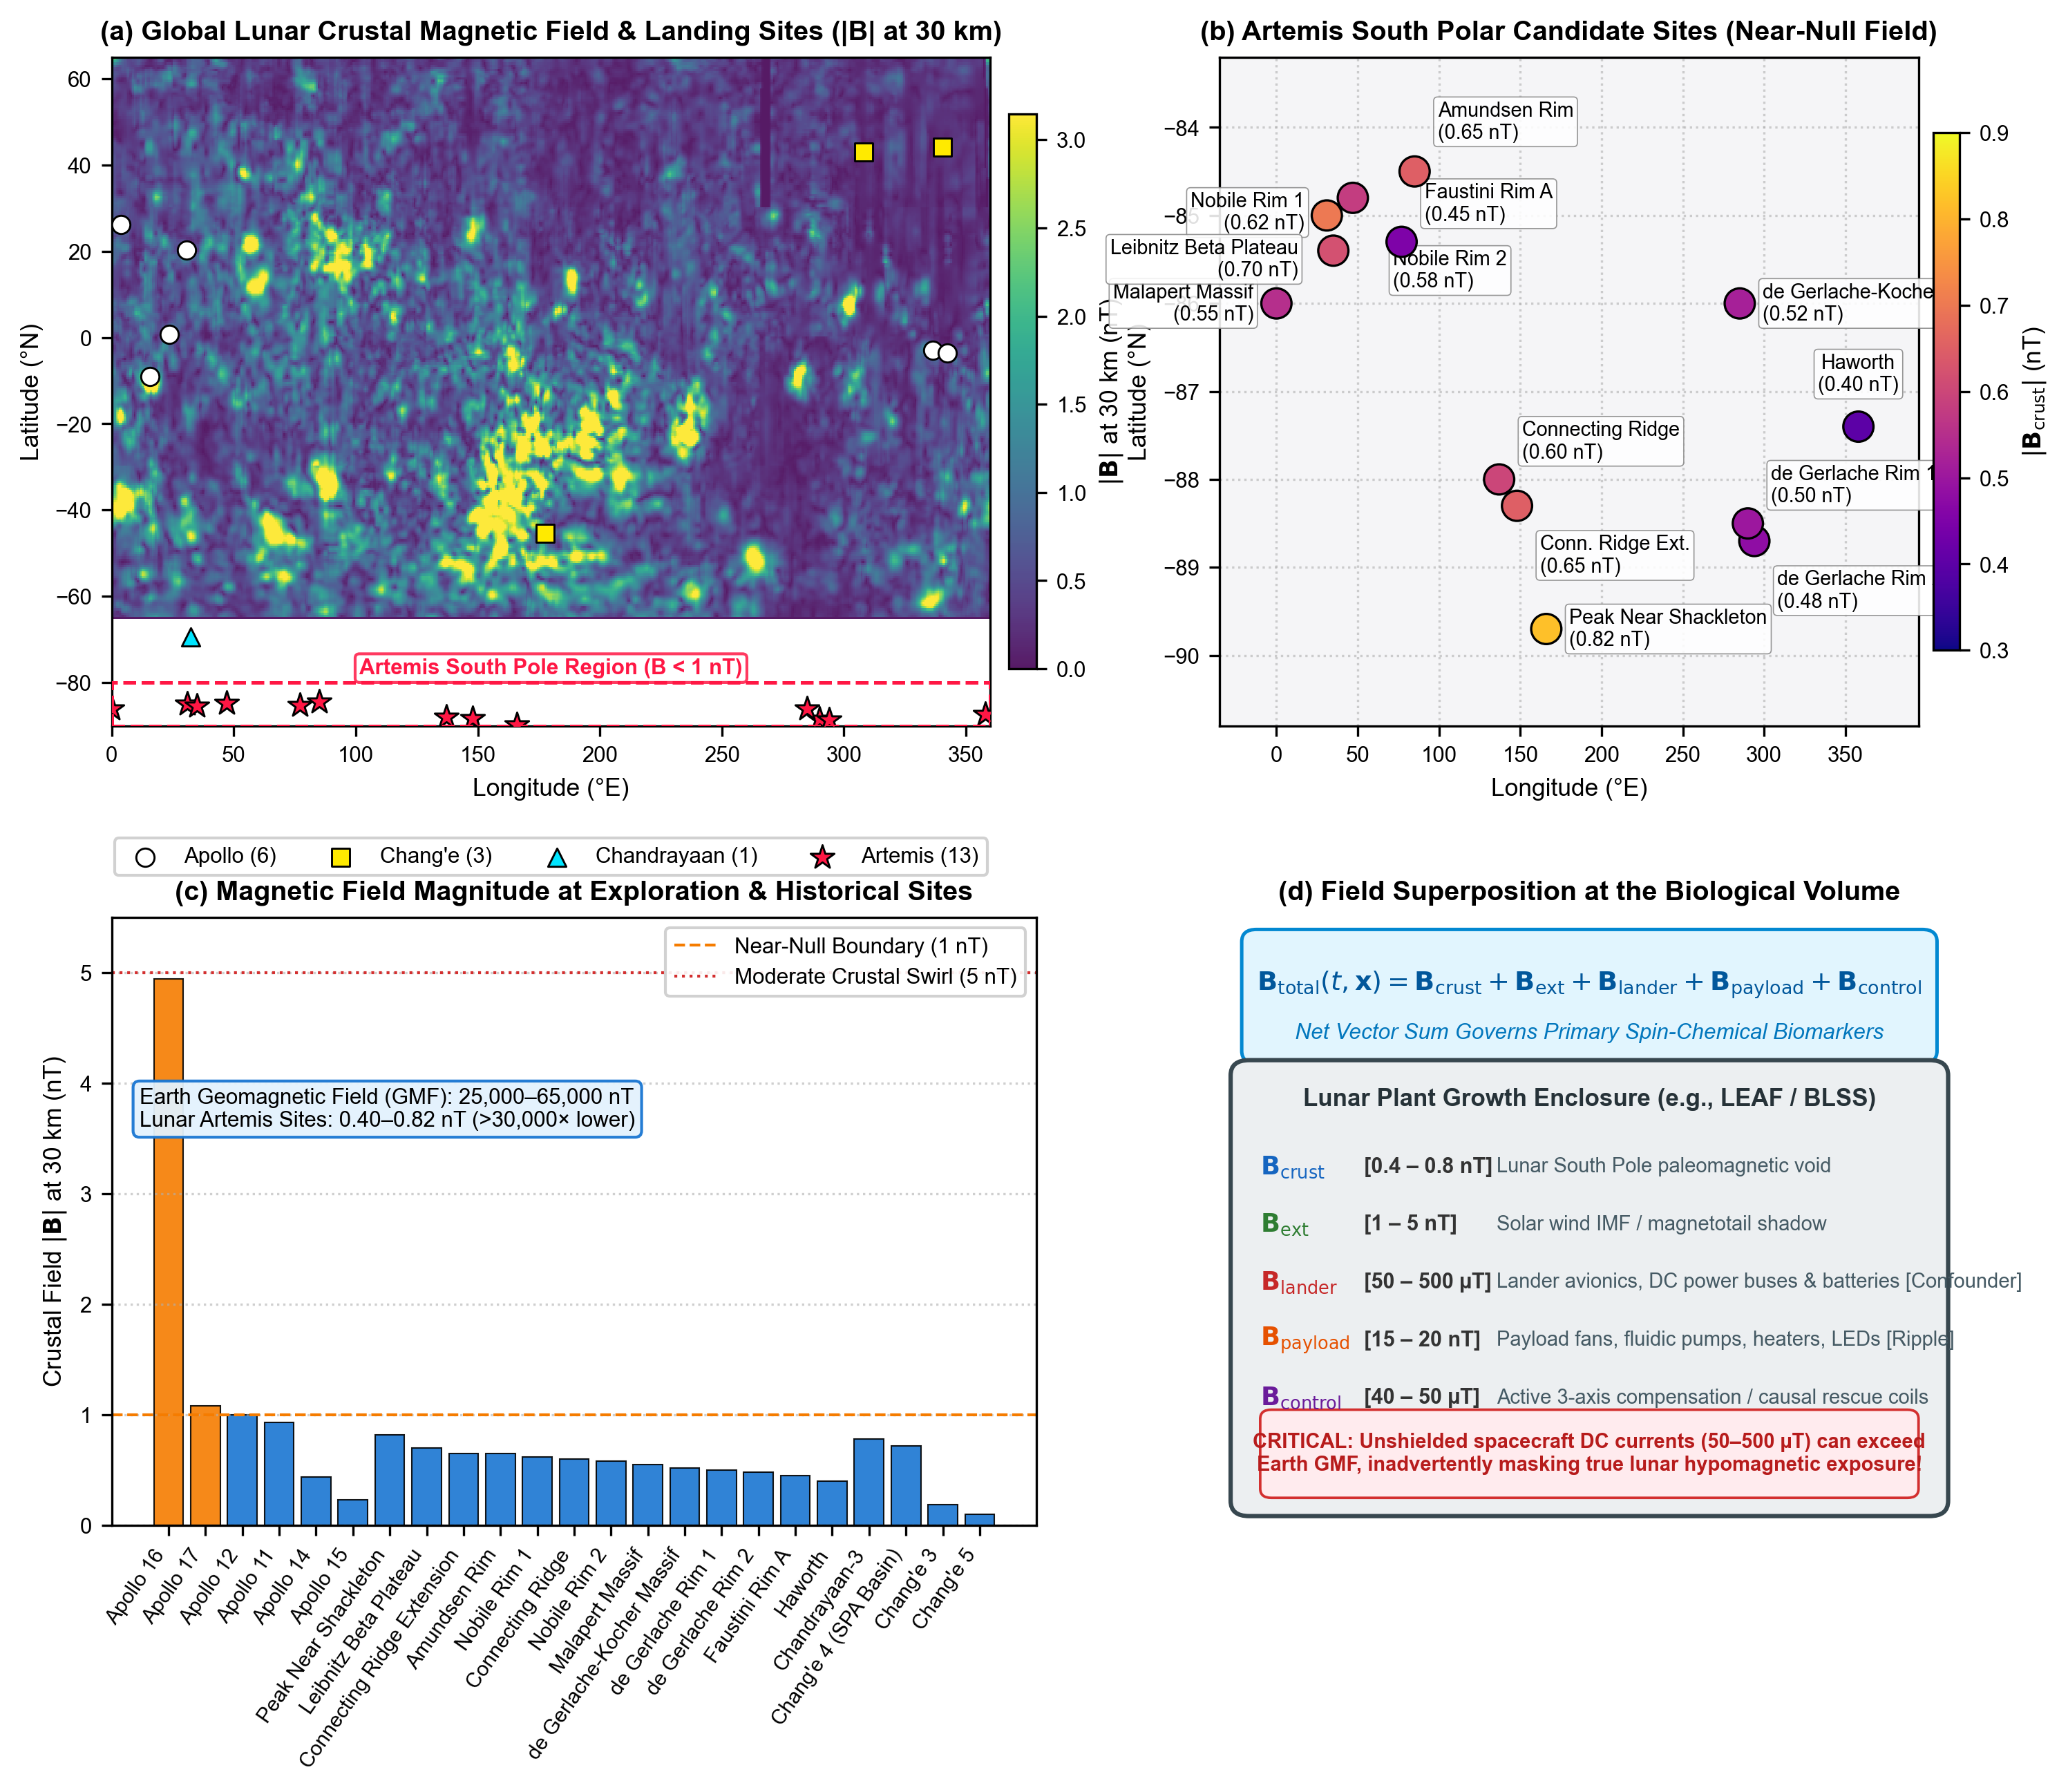 Figure 1 | Lunar surface magnetic field environments, candidate exploration sites, and biological exposure superposition.
(a) Global Lunar Crustal Magnetic Field Distribution: Total field magnitude ($|B|$ in nanoteslas at 30 km altitude) derived from Lunar Prospector and Kaguya magnetometer observations [16,17], overlaid with landing coordinates for Apollo (white circles), Chang’e (yellow squares), Chandrayaan (cyan triangles), and Artemis candidate zones (red stars). Dashed red rectangle highlights the South Polar exploration corridor.
(b) Artemis South Polar Exploration Footprint: Fine-scale distribution of candidate Artemis landing sites situated within the deep South Polar magnetic void ($<0.8\text{ nT}$). Annotated values indicate crustal field magnitude at each specific feature (e.g., Faustini Rim A: $0.45\text{ nT}$, Haworth: $0.40\text{ nT}$, Connecting Ridge: $0.60\text{ nT}$, Peak Near Shackleton: $0.82\text{ nT}$).
(c) Landing Site Magnetic Classification: Magnitude comparison across 23 historical and planned exploration sites. All Artemis South Pole sites reside strictly below the $1.0\text{ nT}$ near-null boundary, contrasting sharply with isolated crustal swirl anomalies (e.g., Apollo 16 Descartes highlands: $4.94\text{ nT}$) and Earth’s dipolar field ($25,000\text{–}65,000\text{ nT}$, $>30,000×$ higher).
(d) Superposition Equation & Biological Volume Schematic: Vector summation governing the local field inside a lunar plant growth enclosure: $B_{\text{total}}(t,x)=B_{\text{crust}}+B_{\text{ext}}+B_{\text{lander}}+B_{\text{payload}}+B_{\text{control}}$. Crucially, unshielded lander avionics DC currents ($50\text{–}500 μ\text{T}$) and internal payload actuators ($15\text{–}20\text{ nT}$ ripple) can exceed ambient lunar levels by orders of magnitude, inadvertently masking the natural hypomagnetic vacuum unless sample-level 3-axis sensing and active control are implemented.
1 to 100s of nT0.40 and 0.82 nT
Table 1 | Crustal magnetic field magnitude at planned Artemis candidate sites and historical lunar landing locations. Coordinates and total magnetic field magnitude $|B|$ at 30 km altitude derived from South Polar and equatorial orbital mapping models [16–18].
Mission | Landing Feature / Candidate Site | Latitude ($​^{∘}$) | Longitude ($​^{∘}$) | $|B_{\text{30km}}|$ (nT) | Field Classification
Artemis | Haworth Crater Rim | -87.40 | 358.00 | 0.40 | Extreme Near-Null
Artemis | Faustini Rim A | -85.30 | 77.00 | 0.45 | Extreme Near-Null
Artemis | de Gerlache Rim 2 | -88.70 | 294.00 | 0.48 | Extreme Near-Null
Artemis | de Gerlache Rim 1 | -88.50 | 290.00 | 0.50 | Extreme Near-Null
Artemis | de Gerlache-Kocher Massif | -86.00 | 285.00 | 0.52 | Extreme Near-Null
Artemis | Malapert Massif | -86.00 | 0.00 | 0.55 | Extreme Near-Null
Artemis | Nobile Rim 2 | -84.80 | 47.00 | 0.58 | Extreme Near-Null
Artemis | Connecting Ridge | -88.00 | 137.00 | 0.60 | Extreme Near-Null
Artemis | Nobile Rim 1 | -85.40 | 35.00 | 0.62 | Extreme Near-Null
Artemis | Connecting Ridge Extension | -88.30 | 148.00 | 0.65 | Extreme Near-Null
Artemis | Amundsen Rim | -84.50 | 85.00 | 0.65 | Extreme Near-Null
Artemis | Leibnitz Beta Plateau | -85.00 | 31.00 | 0.70 | Extreme Near-Null
Artemis | Peak Near Shackleton | -89.70 | 166.00 | 0.82 | Extreme Near-Null
Chang’e | Chang’e 5 | 43.06 | 308.08 | 0.10 | Extreme Near-Null
Chang’e | Chang’e 3 | 44.12 | 340.49 | 0.19 | Extreme Near-Null
Apollo | Apollo 15 | 26.13 | 3.63 | 0.23 | Extreme Near-Null
Apollo | Apollo 14 | -3.65 | 342.53 | 0.44 | Extreme Near-Null
Chang’e | Chang’e 4 (South Pole-Aitken) | -45.46 | 177.60 | 0.72 | Extreme Near-Null
Chandrayaan | Chandrayaan-3 | -69.37 | 32.35 | 0.78 | Extreme Near-Null
Apollo | Apollo 11 | 0.67 | 23.47 | 0.93 | Extreme Near-Null
Apollo | Apollo 12 | -3.01 | 336.58 | 1.00 | Moderate / Null Boundary
Apollo | Apollo 17 | 20.19 | 30.77 | 1.08 | Moderate Crustal
Apollo | Apollo 16 (Descartes Highlands) | -8.97 | 15.50 | 4.94 | Moderate Crustal Swirl
Yet, establishing that near-null magnetic fields physically exist on the Moon (Core Concept 1) exposes a major experimental pitfall: the true magnetic vector experienced by a biological payload is governed by superposition:
$$B_{\text{total}}(t,x)=B_{\text{crust}}+B_{\text{ext}}+B_{\text{lander}}+B_{\text{payload}}+B_{\text{control}}$$
where $B_{\text{crust}}$ represents the localized remanence ($0.4\text{–}0.8\text{ nT}$), $B_{\text{ext}}$ is the solar wind IMF ($1\text{–}5\text{ nT}$), $B_{\text{lander}}$ represents stray DC magnetic fields generated by unshielded lander battery buses, power converters, and structural ferromagnets ($50\text{–}500 μ\text{T}$), $B_{\text{payload}}$ is the internal magnetic ripple generated by chamber LED driver arrays, peristaltic pumps, circulation fans, and solenoid valves ($15\text{–}20\text{ nT}$ ripple), and $B_{\text{control}}$ is the vector generated by active compensation coils or shielding [11,19] (Figure 1D).
Without meticulous sample-level magnetic vector logging and magnetic cleanliness protocols, spacecraft avionics can inadvertently bathe the specimens in static or alternating fields that equal or exceed the terrestrial geomagnetic field. Such uncontrolled stray fields inadvertently mask the lunar hypomagnetic environment, compromising the scientific integrity of flight investigations [11,20].

2. The First Five Days of Growth: Early Seedling Establishment as the Critical Bottleneck for Lunar Agriculture
Previous reviews of plant magnetobiology have collated disparate phenotypes across entire life cycles, spanning floral transition, silique maturation, and seed setting [10,12,21]. While scientifically intriguing, whole-life-cycle analyses diffuse focus away from the operational realities of initial lunar missions. Payloads such as LEAF on Artemis III are constrained by mission operational lifetimes (typically 3–14 days of surface operations), power budgets, and fluidic volume [1,6]. Furthermore, in operational bioregenerative life support systems, rapid-cycle crops such as microgreens (Brassica rapa, Raphanus sativus) are harvested precisely between days 7 and 14 to maximize nutrient density and volumetric productivity [5,22].
Consequently, the first five days of growth (0–120 hours post-imbibition) represent the foundational biological bottleneck for lunar agriculture (Figure 2a). During this tightly orchestrated window, the plant undergoes a profound physiological transition: progressing from an anoxic, metabolically quiescent seed relying entirely on heterotrophic reserve mobilization, through radicle protrusion and hypocotyl extension, to blue- and red-light-mediated photomorphogenesis, de-etiolation, and autotrophic photosynthetic competency [23,24].
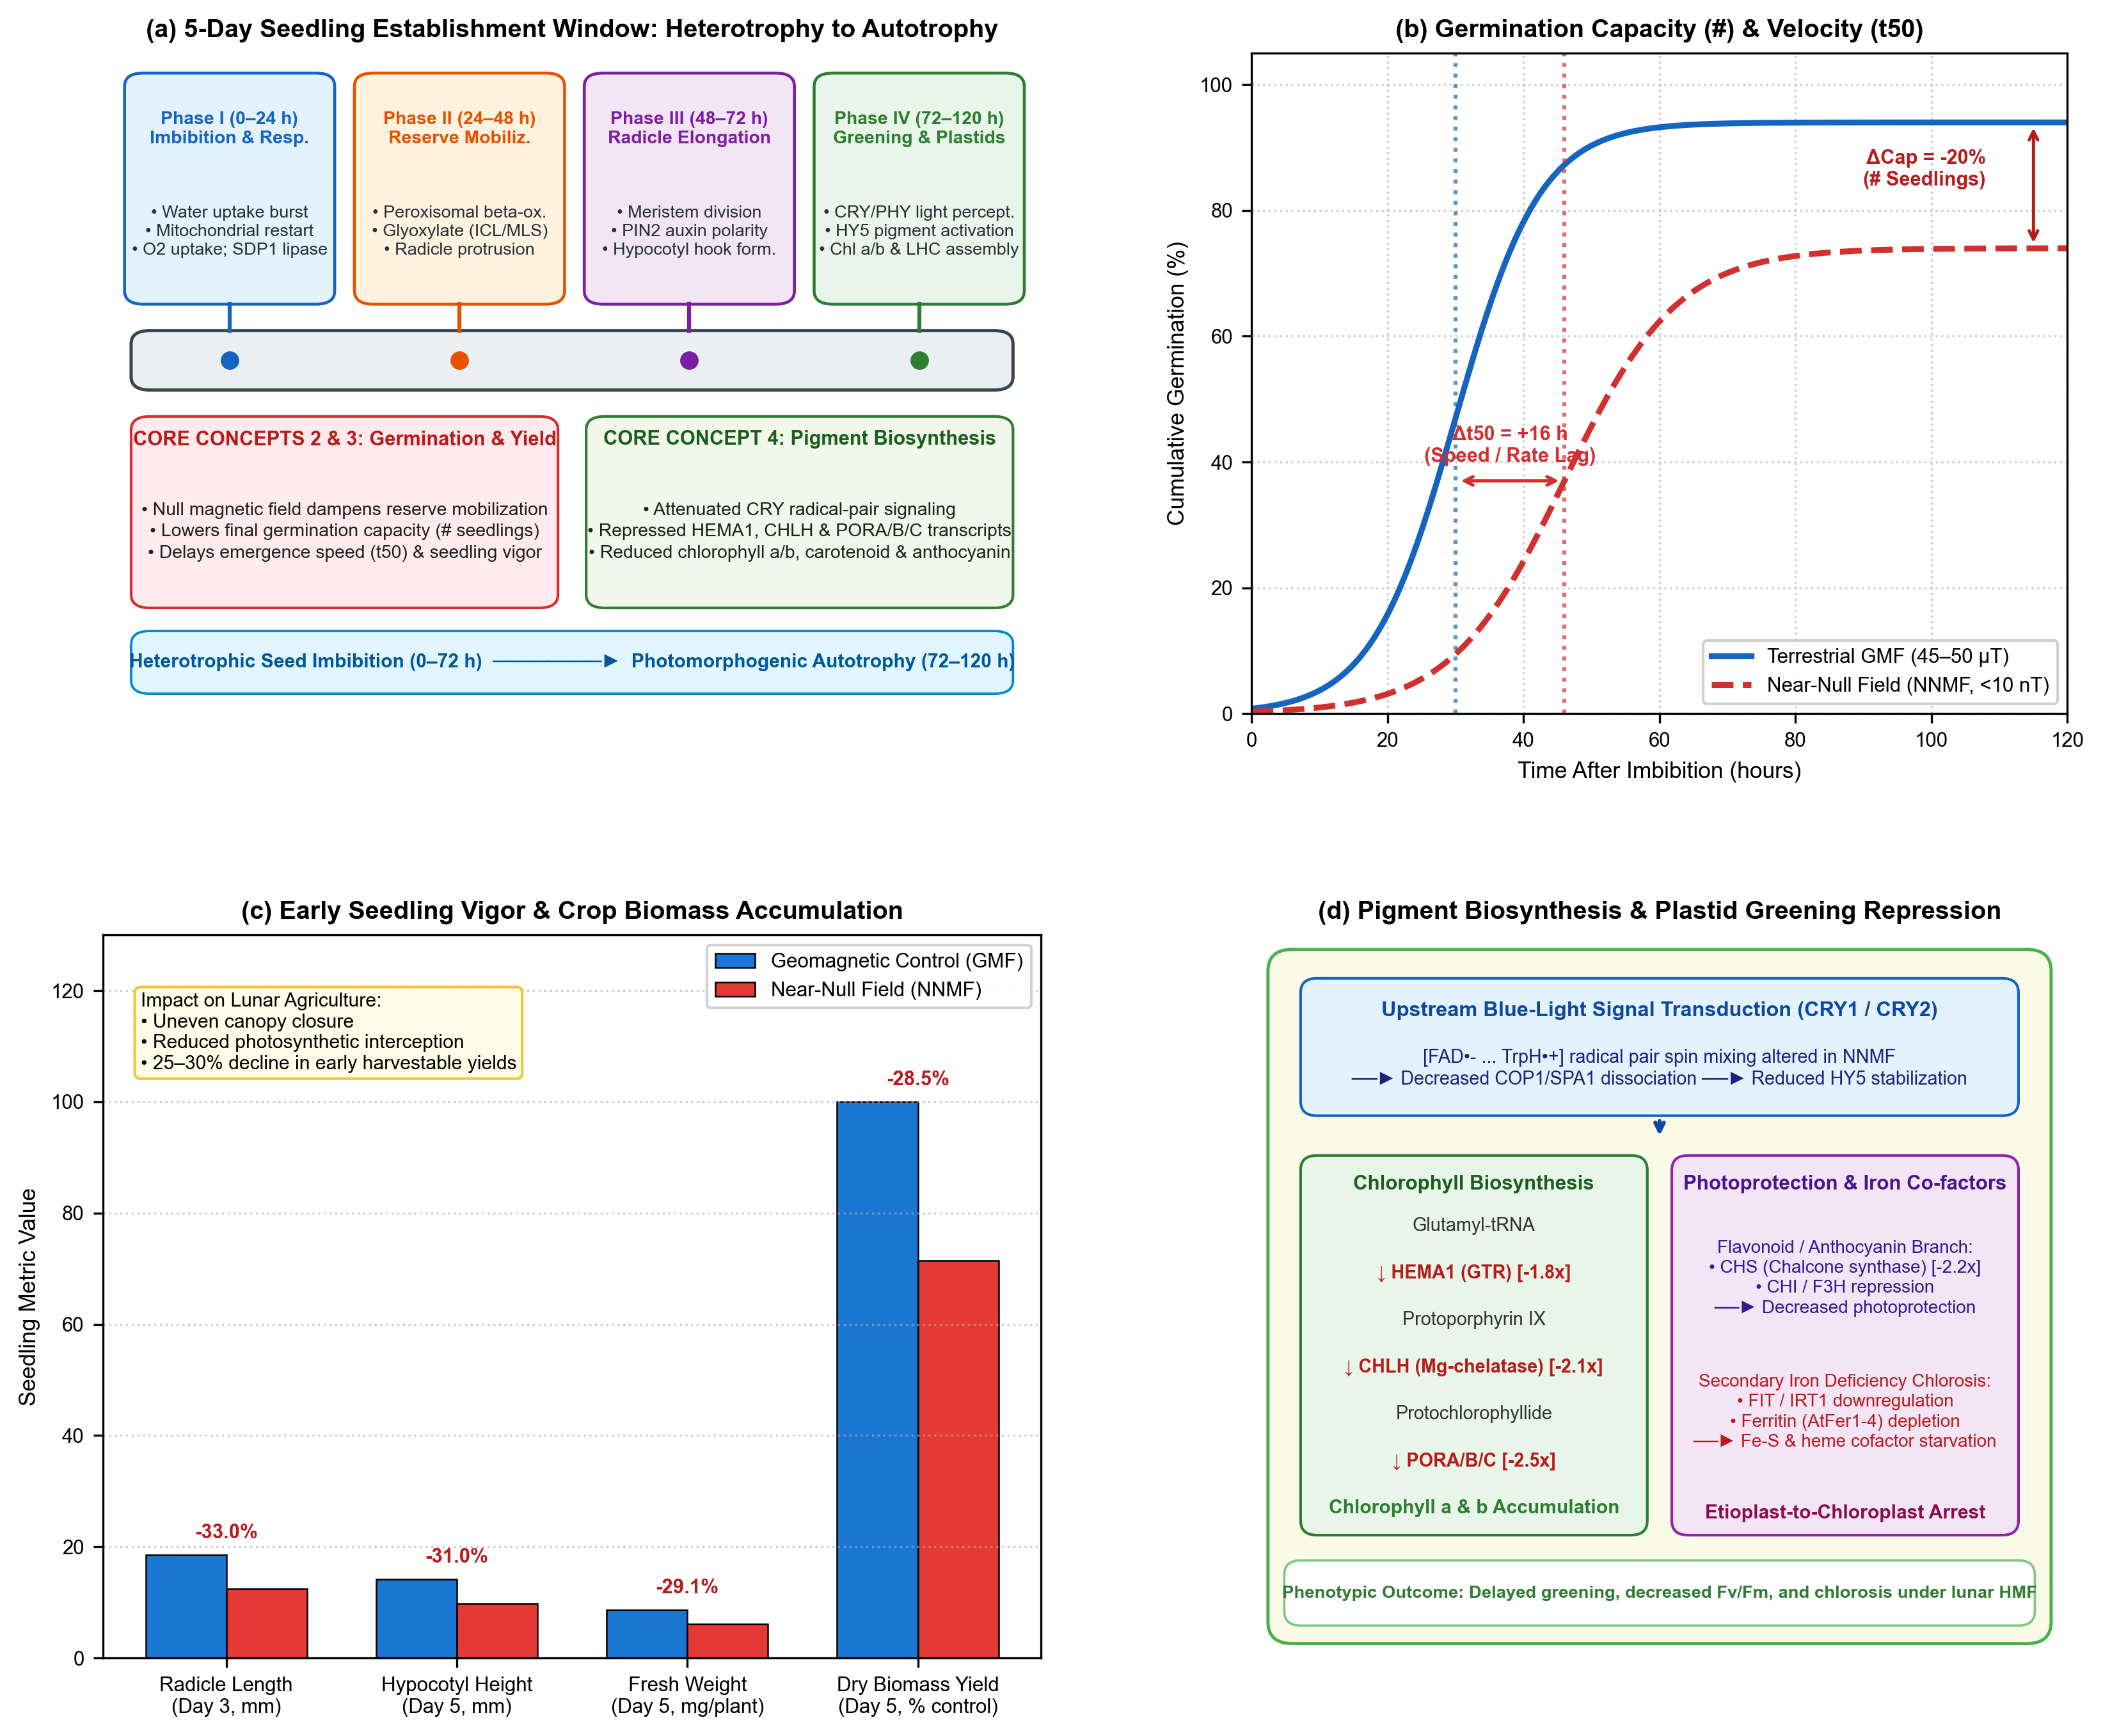 Figure 2 | The first five days of seedling growth under near-null magnetic fields.
(a) 5-Day Seedling Establishment Timeline: Four sequential developmental phases from imbibition to autotrophy: Phase I (0–24 h: imbibition, oxygen uptake burst, mitochondrial restart, TAG lipase SDP1 activation); Phase II (24–48 h: peroxisomal $β$-oxidation, glyoxylate cycle, radicle emergence); Phase III (48–72 h: radicle elongation, apical meristem cell division, PIN2 polar auxin transport); and Phase IV (72–120 h: de-etiolation, cotyledon opening, cryptochrome/phytochrome light perception, HY5-mediated chlorophyll and anthocyanin accumulation). Core Concepts 2, 3, and 4 are mapped to their specific developmental phases.
(b) Seed Germination Capacity and Kinetics: Cumulative germination percentage comparing terrestrial GMF ($45\text{–}50 μ\text{T}$, solid blue) versus near-null magnetic field (NNMF $<10\text{ nT}$, dashed red). Hypomagnetic exposure causes a 20% decline in final germination capacity (Core Concept 2: total viable seedling count #) and a 16-hour emergence lag ($Δt_{50}$, Core Concept 3: germination velocity).
(c) Seedling Elongation, Vigor, and Biomass Yield: Quantitative reductions in radicle length at Day 3 (-33.0%), hypocotyl height at Day 5 (-31.0%), fresh weight (-29.1%), and total dry biomass yield (-28.5%) under NNMF relative to GMF controls. Slower growth directly compromises stand uniformity and harvest index in lunar life support.
(d) Pigment Biosynthetic Pathway and Transcriptional Repression: Blue-light cryptochrome (CRY1/CRY2) radical-pair spin dynamics are altered under NNMF, attenuating COP1/SPA1 dissociation and dampening transcription factor HY5 stabilization. HY5 directly regulates rate-limiting chlorophyll biosynthetic genes (HEMA1, CHLH, PORA/B/C) and anthocyanin genes (CHS, CHI, F3H). Downregulation of these transcripts, coupled with secondary iron deficiency chlorosis (FIT, IRT1, AtFer1–4), arrests etioplast-to-chloroplast differentiation, causing delayed greening and reduced $F_{v}/F_{m}$.

2.1 Core Concept 2: Null Magnetic Fields Alter Germination Capacity (# of Germinating Seedlings)
The initial developmental metric of any agricultural cycle is germination capacity: the total fraction of sown seeds that successfully break dormancy, complete imbibition, and emerge through the seed coat [25]. Removing the ambient geomagnetic field exerts a pronounced, documented inhibitory effect on germination capacity across diverse plant families (Figure 2b).
In Arabidopsis thaliana, cereal grains (Triticum aestivum, Hordeum vulgare), and vegetable legumes, shielding the geomagnetic field to near-null levels ($<10\text{ to }50\text{ nT}$) consistently decreases the final germination percentage by $10\text{ to }30\%$ compared to matched local GMF controls [26–30]. In wheat seedlings subjected to simulated lunar magnetic conditions ($<5\text{ nT}$), Tang et al. [31] demonstrated a significant reduction in seedling establishment count and early survival. Similar germination suppressions have been documented in radish (Raphanus sativus) and cucumber (Cucumis sativus), where magnetic shielding delayed testa rupture and decreased overall seed stand density [27,32].
Mechanistically, the earliest events of imbibition involve rapid passive water influx followed by active cytoplasmic reorganization, membrane repair, and the rehydration of mitochondrial cristae [33]. Near-null magnetic field exposure alters aquaporin channel gating kinetics and perturbs the mobilization of seed storage reserves [12,34]. Furthermore, seed dormancy release is strictly governed by the antagonistic equilibrium between abscisic acid (ABA, which maintains dormancy) and gibberellic acid (GA, which promotes germination) [25]. Xu et al. [35,36] demonstrated that hypomagnetic exposure disrupts GA and auxin homeostasis in Arabidopsis, shifting the hormonal balance toward dormancy retention. In the context of lunar agriculture, where payload volume severely limits seed reserves, a 20% loss in germination capacity represents an penalty on mission resource efficiency.

2.2 Core Concept 3: Null Magnetic Fields Alter Germination Speed, Impacting Potential Material Yields
Beyond total germination capacity, the rate or velocity of germination ($t_{50}$, the time required for 50% of the seed population to emerge) and the subsequent speed of seedling elongation are substantially depressed under near-null fields (Figure 2b,c).
Controlled ground experiments reveal that seeds imbibed under hypomagnetic conditions exhibit an emergence lag ($Δt_{50}$) of $12\text{ to }36\text{ hours}$ relative to geomagnetic controls [26,28,37]. Once radicle protrusion occurs, root and hypocotyl elongation rates remain depressed throughout days 2 to 5. Primary root extension in Arabidopsis and maize seedlings is dampened by $25\text{–}35\%$ under NNMF [37,38]. Cellular analysis by Narayana et al. [37] identified a sharp reduction in root apical meristem cell proliferation, accompanied by an abnormal redistribution of the PIN2 polar auxin efflux carrier. In maize, Fiorillo et al. [39] found that reduced geomagnetic fields downregulate plasma membrane ${\text{H}}^{+}$-ATPase activity and 14-3-3 regulatory proteins, suppressing the acid-growth mechanism required for rapid cell wall loosening and cell expansion.
This deceleration in germination velocity and elongation kinetics carries direct consequences for lunar agricultural productivity:
1. Canopy Closure and Light Interception: In compact flight chambers (such as the Plant Habitat or LEAF growth cassette), delays in hypocotyl extension and cotyledon unfolding prolong the period of bare substrate exposure, wasting photons and reducing canopy light-use efficiency ($μ{\text{mol CO}}_{2}\text{ fixed per Einstein intercepted}$) [5,40].
2. Material and Biomass Yield Penalty: In fast-turnaround microgreen and leafy vegetable production, fresh biomass accumulation follows an exponential growth curve during early vegetative development. A 24-hour emergence delay cascades into a $25\text{ to }30\%$ penalty in harvestable fresh weight and dry matter yield at Day 5 (Figure 2c). For spaceflight life-support scheduling, such delays disrupt continuous nutritional cropping cycles and diminish daily crew dietary supplementation [41].
3. Stand Heterogeneity: Slower, asynchronous germination creates irregular canopy heights, where lagging seedlings are shaded out by earlier-emerging neighbors, exacerbating yield losses in high-density planting matrices.

2.3 Core Concept 4: Null Magnetic Fields Affect Genes Involved in Pigment Formation
Between Days 3 and 5 post-imbibition, as the seedling emerges into the illuminated canopy headspace, it undergoes photomorphogenic de-etiolation: hypocotyl elongation arrests, the apical hook straightens, cotyledons expand, and proplastids/etioplasts differentiate into photosynthetic chloroplasts [23,24]. This transition requires the massive, coordinated de novo biosynthesis of light-harvesting pigments (chlorophyll $a$ and $b$), photoprotective accessory pigments (carotenoids and xanthophylls), and ultraviolet/excess-light-absorbing flavonoids and anthocyanins [42,43].
Hypomagnetic fields systematically impair pigment accumulation and downregulate the genetic networks governing plastid greening (Figure 2d):
Chlorophyll Biosynthesis: In wheat grown in simulated lunar weak fields ($<5\text{ nT}$), Tang et al. [31] observed a striking decline in total chlorophyll, chlorophyll $a$, chlorophyll $b$, and carotenoid concentrations, accompanied by visible seedling chlorosis and decreased maximum photochemical efficiency of Photosystem II ($F_{v}/F_{m}$). At the transcript level, key rate-limiting enzymes in tetrapyrrole synthesis are significantly repressed: HEMA1 (glutamyl-tRNA reductase, the gateway enzyme catalyzing 5-aminolevulinic acid formation), CHLH (the magnesium-chelatase H subunit, committing protoporphyrin IX to chlorophyll synthesis), and PORA/B/C (NADPH:protochlorophyllide oxidoreductase, the light-dependent catalyst converting protochlorophyllide to chlorophyllide) [31,44].
Anthocyanin and Flavonoid Biosynthesis: Exposure to near-null fields downregulates the central phenylpropanoid structural genes, including chalcone synthase (CHS), chalcone isomerase (CHI), and flavanone 3-hydroxylase (F3H) [12,45]. In Mentha $×$ piperita (peppermint), Maffei et al. [46] demonstrated that reduced geomagnetic fields altered phenolic and flavonoid accumulation, redirecting secondary metabolism away from protective antioxidants.
Cryptochrome–HY5 Signal Transduction: The primary photomorphogenic master regulator promoting pigment biosynthesis is the basic leucine zipper transcription factor ELONGATED HYPOCOTYL 5 (HY5) [47]. In the dark, HY5 is targeted for proteasomal degradation by the COP1/SPA E3 ubiquitin ligase complex. Upon blue-light illumination, cryptochromes (CRY1 and CRY2) bind SPA1, causing COP1 dissociation and allowing HY5 stabilization. HY5 directly binds to G-box and ACE elements in the promoters of HEMA1, CHLH, POR, CHS, and light-harvesting chlorophyll $a/b$-binding proteins (LHCB) [47,48]. Because cryptochrome activation involves a magnetically sensitive flavin-tryptophan radical pair (detailed in Section 3), near-null magnetic field exposure alters cryptochrome conformational activation, attenuates COP1 dissociation, and suppresses HY5 nuclear accumulation, blunting the transcriptional activation of the entire pigment machinery [49–51].
Secondary Iron-Deficiency Chlorosis: Iron is an obligatory catalytic cofactor for chlorophyll biosynthesis (specifically for coproporphyrinogen III oxidase) and is the core constituent of photosynthetic electron transport complexes (cytochromes and iron-sulfur [Fe–S] clusters) [52]. Islam et al. [53] and Narayana et al. [54] demonstrated that near-null magnetic fields downregulate the primary root iron-acquisition machinery in Arabidopsis, including the transcription factor FIT (FER-LIKE IRON DEFICIENCY-INDUCING TRANSCRIPTION FACTOR), the ferric chelate reductase FRO2, and the high-affinity iron transporter IRT1. Furthermore, the intracellular ferritin storage pool (AtFer1–4) is severely depleted. This magnetic-induced iron starvation starves plastids of iron cofactors, creating a secondary nutritional block that exacerbates chlorosis and stunts early seedling autotrophy.

3. Quantum Molecular Biology of the 0–5 Day Window: The Quantum Biology Atlas Perspective
To evaluate whether hypomagnetic phenotypes reflect specific biophysical magnetoreceptors or general downstream metabolic perturbation, mechanistic hypotheses must be stratified against physical laws and empirical evidence. We integrate the formal evidentiary framework developed in the Quantum Biology Atlas [55] (Figure 3).
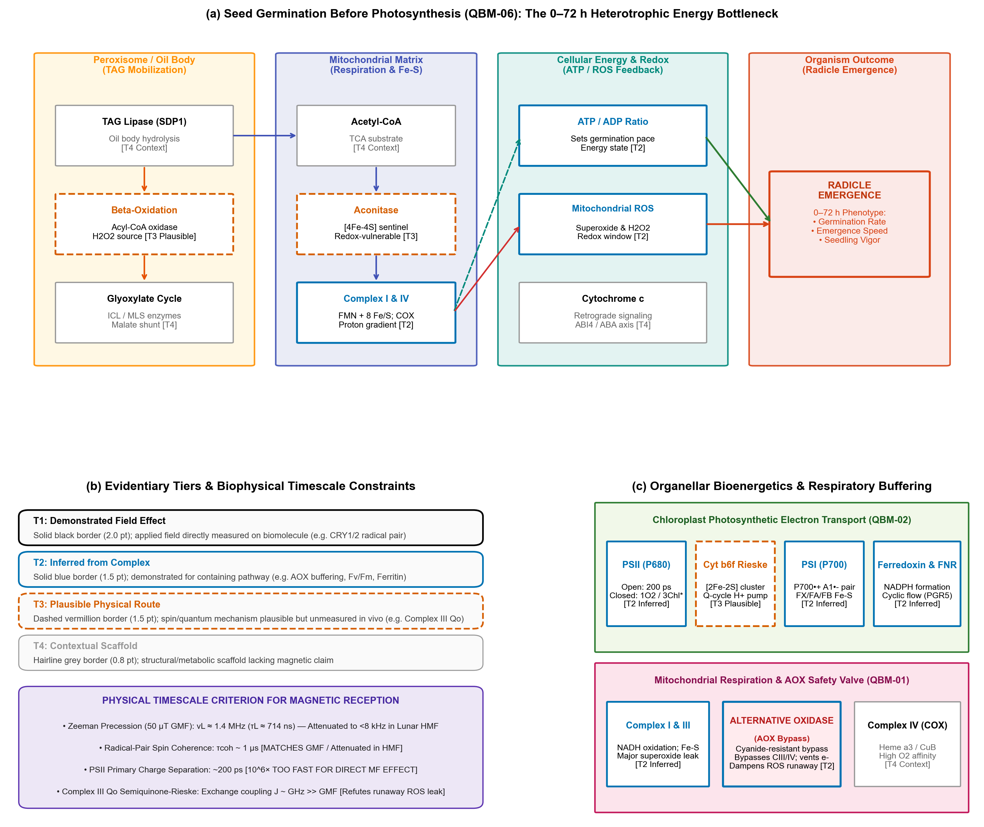Figure 3 | Quantum molecular biology of early seedling establishment (Days 0–5).
(a) QBM-06 Pathway Map: Seed Germination Before Photosynthesis: Re-authoring of the 0–72 h heterotrophic energy bottleneck from the Quantum Biology Atlas [55]. Four horizontal lanes delineate the reserve mobilization and bioenergetic route: Peroxisome (TAG lipase SDP1 [T4], $β$-oxidation generating ${\text{H}}_{2}{\text{O}}_{2}$ [T3], glyoxylate cycle [T4]); Mitochondrial Matrix (Acetyl-CoA [T4], Aconitase [4Fe-4S sentinel, T3], Complex I [FMN, 8 Fe-S, T2], Complex IV COX [T2]); Cellular Energy & Redox (ATP/ADP ratio setting the germination pace [T2], mitochondrial superoxide/${\text{H}}_{2}{\text{O}}_{2}$ signaling window [T2], Cytochrome $c$ release modulating ABI4/ABA retrograde signaling [T4]); and Organism Endpoint (Radicle Emergence at 0–72 h).
(b) Evidentiary Tier Hierarchy & Biophysical Timescale Constraints: Stratification of candidate mechanisms into four rigorous tiers: T1 Demonstrated (heavy black border, applied field directly measured on biomolecule); T2 Inferred from Complex/Process (solid blue border); T3 Plausible Physical Route (dashed vermillion border); and T4 Contextual Scaffold (hairline grey border). Physical timescale matching: Zeeman precession at $50 μ\text{T}$ GMF ($ν_{L}≈1.4\text{ MHz}$, $τ_{L}≈714\text{ ns}$) matches the microsecond spin coherence lifetime ($τ_{\text{coh}}∼1 μ\text{s}$) of cryptochrome radical pairs. In lunar HMF ($<1\text{ nT}$), $ν_{L}<8\text{ kHz}$, disabling magnetic modulation. Open PSII charge separation occurs in $∼200\text{ ps}$ (${10}^{6}×$ too rapid for microtesla fields). Mitochondrial Complex III $Q_{o}$ semiquinone-Rieske exchange coupling is in the gigahertz regime ($J∼\text{GHz}≫\text{GMF}$), refuting unphysical runaway ROS leak models.
(c) Organellar Bioenergetics: (Top) Chloroplast PETC (QBM-02) indicating PSII (P680, T2), Cytochrome $b_{6}f$ Rieske [2Fe-2S] cluster (T3), PSI (P700, $P_{700}^{+•}A_{1}^{-•}$ radical pair, T2), and Ferredoxin/FNR (T2). (Bottom) Mitochondrial respiration (QBM-01) showing electron transport via Complex I and III to the ubiquinone pool, and the vital Alternative Oxidase (AOX) cyanide-resistant bypass [T2], which directly vents excess redox pressure to ${\text{O}}_{2}$ without proton pumping, dampening catastrophic superoxide runaway.

3.1 The 0–72 h Heterotrophic Energy Route (QBM-06)
During the first 72 hours post-imbibition, the plant embryo possesses no functional chloroplasts. Energy production relies entirely on catabolizing stored lipids (triacylglycerols, TAGs) stored in seed oil bodies (Figure 3a):
1. Peroxisomal Reserve Mobilization: SUGAR-DEPENDENT1 (SDP1, [T4 Context]) triacylglycerol lipase hydrolyzes TAGs into free fatty acids. Fatty acids enter peroxisomal $β$-oxidation, where acyl-CoA oxidases transfer electrons directly to molecular oxygen, generating stoichiometric amounts of hydrogen peroxide (${\text{H}}_{2}{\text{O}}_{2}$, [T3 Plausible]). Acetyl-CoA units are processed via the glyoxylate cycle (isocitrate lyase [ICL] and malate synthase [MLS], [T4 Context]) into succinate and malate [55].
2. Mitochondrial Respiration: Succinate and malate are imported into the mitochondrial matrix to feed the tricarboxylic acid (TCA) cycle and mitochondrial electron transport chain (mETC). Complex I (NADH:ubiquinone oxidoreductase, containing flavin mononucleotide [FMN] and eight Fe–S clusters, [T2 Inferred]) and Complex II transfer electrons to ubiquinone. Electrons flow through Complex III (cytochrome $bc_{1}$, containing heme $b_{L}/b_{H}$, heme $c_{1}$, and the Rieske [2Fe-2S] center, [T3 Plausible]) and Cytochrome $c$ ([T4 Context]) to Complex IV (cytochrome $c$ oxidase, COX, containing heme $a/a_{3}$ and ${\text{Cu}}_{A}/{\text{Cu}}_{B}$, [T2 Inferred]), generating the proton-motive force driving ATP synthase [55,56].
3. The Radical-Pair Sentinel: Aconitase: Matrix aconitase carries an solvent-exposed $[4\text{Fe}-4\text{S}]$ cluster ([T3 Plausible]) that is exquisitely sensitive to oxidative inactivation by superoxide ($O_{2}^{•-}$). Inactivation of aconitase throttles TCA cycle flux, acting as an internal metabolic brake when mitochondrial ROS levels exceed physiological limits.

3.2 The Evidentiary Hierarchy & Biophysical Timescales
The Quantum Biology Atlas enforces a strict separation between chemical identity (quantum_class) and experimental verification (evidence_tier) [55] (Figure 3b):
Tier 1 (Demonstrated Field Effect, Solid Black Border): The applied magnetic field has been directly measured to alter the biomolecule’s spin state or kinetics in vitro with a resolved DOI. Currently, cryptochrome (CRY1/CRY2) is the sole plant sensor satisfying Tier 1 criteria. Photoexcitation of oxidized flavin (FAD) induces ultrafast electron transfer along a conserved triad of tryptophan residues (terminating at Trp377 in Arabidopsis), generating the spin-correlated radical pair $[{\text{FAD}}^{•-}⋯{\text{TrpH}}^{•+}]$ [49,57,58]. Singlet-triplet interconversion ($S↔T$) is modulated by external magnetic fields that compete with internal nuclear hyperfine couplings. The radical-pair spin coherence lifetime ($τ_{\text{coh}}∼1 μ\text{s}$) closely matches the Larmor precession frequency in Earth’s GMF ($ν_{L}≈1.4\text{ MHz}$ at $50 μ\text{T}$, $τ_{L}≈714\text{ ns}$). In lunar NNMF ($<1\text{ nT}$), $ν_{L}<8\text{ kHz}$ ($τ_{L}>125 μ\text{s}$), completely decoupling external Zeeman mixing and locking the radical pair into an altered spin-state recombination ratio [49,50].
Tier 2 (Inferred from Complex/Process, Solid Blue Border): Field effects have been robustly demonstrated for the containing physiological complex or organellar pathway, but direct spin-state dynamics in the isolated biomolecule remain unmeasured. Examples include: (1) Chloroplast maximum quantum yield ($F_{v}/F_{m}$) and non-photochemical quenching (NPQ) [31,59]; (2) Mitochondrial Alternative Oxidase (AOX) respiratory buffering [55,60]; and (3) Ferritin (AtFer1–4) iron sequestration [53,54].
Tier 3 (Plausible Physical Route, Dashed Vermillion Border): A theoretical spin-chemical or radical-pair route exists, but field sensitivity has never been experimentally demonstrated in intact plants. A prime example is the mitochondrial Complex III $Q_{o}$ site semiquinone-Rieske $[2\text{Fe}-2\text{S}]$ radical pair [55,61].
Tier 4 (Contextual Scaffold, Hairline Grey Border): Structural proteins and metabolic enzymes that lack direct quantum magnetosensitivity but form the requisite physical scaffold for electron transfer.

3.3 Refutation of Unphysical Biophysical Hypotheses
A critical contribution of the biophysical timescale framework is the rigorous elimination of unphysical magnetobiological claims:
1. Primary Photosystem II Charge Separation: Primary charge separation between P680 and pheophytin in open, active PSII reaction centers occurs in $∼200\text{ picoseconds}$ [62]. Because this timescale is six orders of magnitude (${10}^{6}×$) faster than microtesla Zeeman precession ($τ_{L}≈714\text{ ns}$), static magnetic fields cannot alter linear photosynthetic charge separation in open reaction centers [11]. Direct magnetic modulation of PSII can only occur conditionally in closed reaction centers under high excitation pressure, where nanosecond charge recombination yields triplet chlorophyll ($​^{3}{\text{Chl}}^{*}$) and cytotoxic singlet oxygen ($​^{1}{\text{O}}_{2}$) [63].
2. Complex III Superoxide Runaway Leak: Theoretical models have occasionally postulated that hypomagnetic fields induce catastrophic mitochondrial failure by unlocking runaway superoxide leak at Complex III. However, biophysical EPR measurements by Sarewicz et al. [64] and Bujnowicz et al. [65] demonstrate that the semiquinone radical (${\text{SQ}}^{•-}$) and the Rieske $[2\text{Fe}-2\text{S}]$ center at the $Q_{o}$ site are coupled by strong exchange interaction ($J∼\text{GHz}≫\text{GMF}$). This gigahertz exchange coupling overwhelms microtesla- or nanotesla-scale magnetic perturbations, proving that hypomagnetic exposure does not cause an immediate, catastrophic collapse of core respiration [11,55].

4. Multi-Stressor Convergence: The ${\text{CO}}_{2}↔{\text{O}}_{2}↔\text{ROS}$ Nexus (Core Concept 5)
In a lunar agricultural module, a near-null magnetic field will never act in isolation. It will operate concurrently with two defining planetary spaceflight variables: Exploration Atmosphere (hypobaric gas composition) and Ionizing Radiation (Galactic Cosmic Radiation and Solar Particle Events) [7,8,66] (Figure 4a).
We establish that these disparate environmental stimuli converge upon the exact same organellar bioenergetic engine: the ${\text{CO}}_{2}↔{\text{O}}_{2}↔\text{ROS}$ nexus (Core Concept 5).
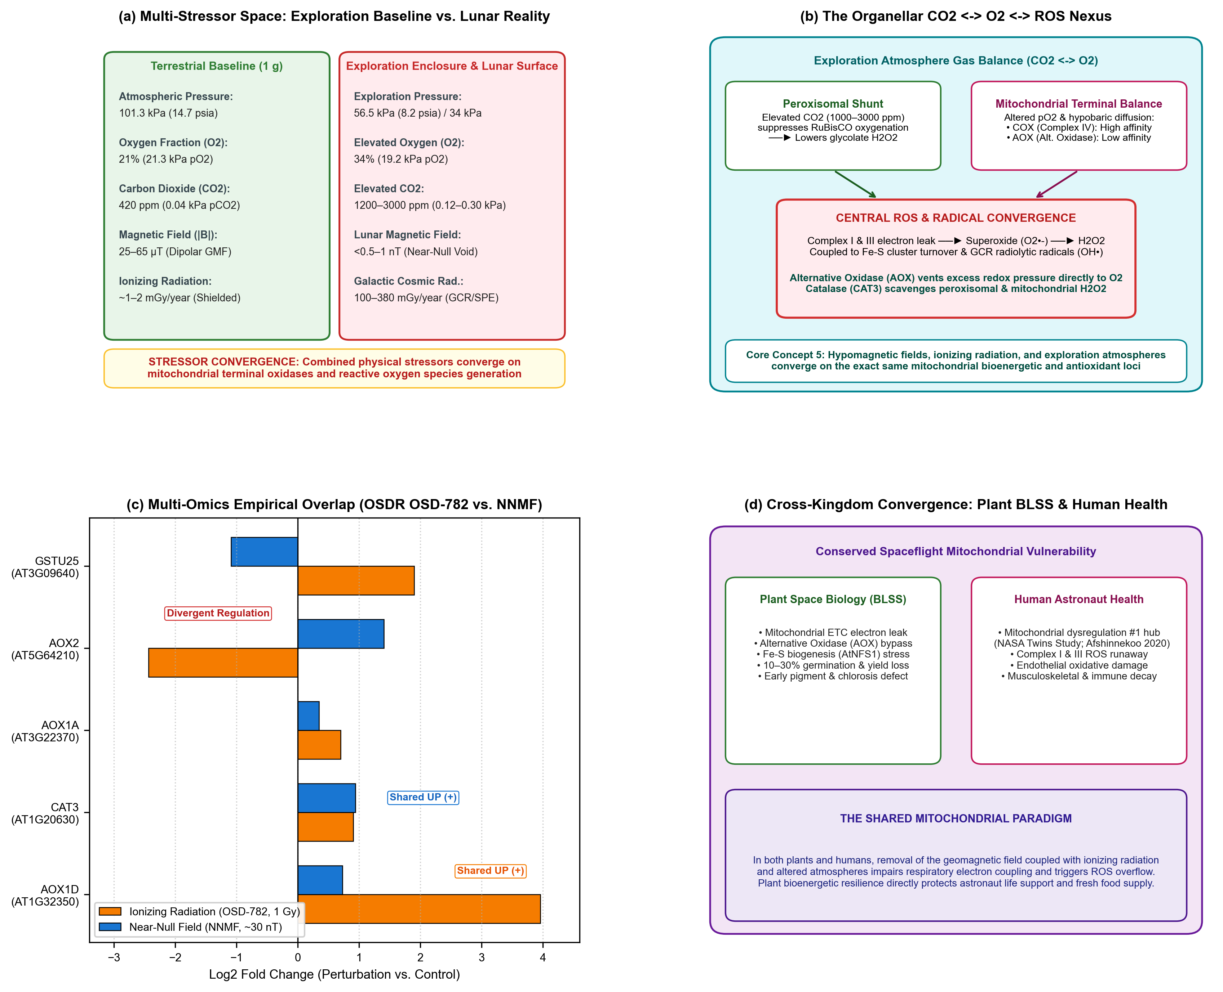 Figure 4 | Multi-stressor convergence on the organellar ${\text{CO}}_{2}↔{\text{O}}_{2}↔\text{ROS}$ nexus.
(a) Environmental Multi-Stressor Space: Physical parameters contrasting terrestrial baseline conditions ($101.3\text{ kPa}$, $21\% {\text{O}}_{2}$, $420{\text{ ppm CO}}_{2}$, $50 μ\text{T}$ GMF) against NASA exploration architectures ($56.5\text{ kPa}/8.2\text{ psia}$ to $34\text{ kPa}$, $34\% {\text{O}}_{2}$, $1200\text{–}3000{\text{ ppm CO}}_{2}$, $<0.8\text{ nT}$ lunar HMF, and $100\text{–}380\text{ mGy/year}$ GCR).
(b) The Organellar ${\text{CO}}_{2}↔{\text{O}}_{2}↔\text{ROS}$ Nexus: Exploration atmosphere gas balance shifts peroxisomal and mitochondrial pathways. Elevated ${\text{CO}}_{2}$ ($1200\text{–}3000\text{ ppm}$) favors RuBisCO carboxylation over oxygenation, suppressing photorespiratory glycolate ${\text{H}}_{2}{\text{O}}_{2}$ production. In mitochondria, hypobaric diffusion and altered $p{\text{O}}_{2}$ balance cytochrome $c$ oxidase (COX) against Alternative Oxidase (AOX). GCR radiolysis generates hydroxyl radicals (${\text{OH}}^{•}$), while NNMF modulates flavin/Fe-S spin dynamics at Complex I/III. The resulting superoxide ($O_{2}^{•-}$) and ${\text{H}}_{2}{\text{O}}_{2}$ flux is buffered by AOX (AOX1D) and scavenged by Catalase (CAT3).
(c) Multi-Omics Empirical Overlap (OSDR OSD-782 vs. Parmagnani 2022 NNMF): Concordant transcriptional response between ionizing radiation (cesium-137 gamma, 1 Gy, orange bars) and near-null field exposure (~30 nT, blue bars) in Arabidopsis. Both stressors induce robust upregulation of Alternative Oxidase 1D (AOX1D, AT1G32350; $+3.96 \log_{2}\text{FC}$ in radiation, $+0.73$ in NNMF) and Catalase 3 (CAT3, AT1G20630; $+0.91$ in radiation, $+0.94$ in NNMF). Non-concordant loci (AOX2, GSTU25) highlight gene-family divergence.
(d) Cross-Kingdom Spaceflight Convergence (Plant BLSS vs. Human Astronaut Health): Conserved spaceflight mitochondrial phenotype. In plants, the mitochondrial ETC, AOX bypass, and Fe-S cluster turnover buffer hypomagnetic and radiation stress to preserve BLSS crop yield. In astronauts, mitochondrial dysregulation represents the single most conserved systemic spaceflight lesion (NASA Twins Study; Afshinnekoo et al. [67]), linking plant bioenergetics directly to crew health and food security.

4.1 Exploration Atmosphere & The Gas Balance
NASA’s standard Exploration Atmosphere for lunar transit and surface habitat modules specifies a reduced total pressure of $56.5\text{ kPa}(8.2\text{ psia})$ with an elevated oxygen fraction of $34\% {\text{O}}_{2}$, providing an equivalent sea-level alveolar oxygen partial pressure ($p_{{\text{O}}_{2}}≈19.2\text{ kPa}$) to prevent hypoxia while reducing extravehicular activity (EVA) pre-breathe times [8,66]. Concurrently, human metabolic exhalation elevates cabin carbon dioxide levels to $1200\text{–}3000\text{ ppm}$ ($0.12\text{–}0.30\text{ kPa}p_{{\text{CO}}_{2}}$), roughly 3 to 7 times higher than Earth ambient levels ($420\text{ ppm}$) [5,7].
This atmospheric regime fundamentally reshapes plant respiratory and photosynthetic metabolism:
Peroxisomal Photorespiration Suppression: In illuminated leaves, RuBisCO catalyzes both carboxylation ($CO_{2}$ fixation into 3-PGA) and oxygenation ($O_{2}$ fixation yielding 2-phosphoglycolate). Elevated ${\text{CO}}_{2}$ ($>1200\text{ ppm}$) competitively inhibits RuBisCO oxygenation, suppressing the photorespiratory cycle. Because photorespiration shunts glycolate to peroxisomes where glycolate oxidase produces vast quantities of ${\text{H}}_{2}{\text{O}}_{2}$, elevated ${\text{CO}}_{2}$ drastically lowers peroxisomal ${\text{H}}_{2}{\text{O}}_{2}$ production [40,68].
Mitochondrial Oxygen Terminal Balance: While peroxisomal ROS generation declines under high ${\text{CO}}_{2}$, hypobaric pressure accelerates gas diffusivity, altering intracellular dissolved $O_{2}$ concentrations in dense seed and root tissues. Mitochondria possess two terminal oxidases with dramatically different oxygen affinities [60]:
1. Cytochrome $c$ Oxidase (COX, Complex IV): High affinity for $O_{2}$ ($K_{m}<0.14 μ\text{M}$); coupled to proton extrusion across the inner membrane; generates ATP.
2. Alternative Oxidase (AOX): Cyanide-resistant, non-proton-pumping terminal oxidase with much lower affinity for $O_{2}$ ($K_{m}≈10\text{–}20 μ\text{M}$). AOX directly transfers electrons from the reduced ubiquinol pool to molecular oxygen, reducing ${\text{O}}_{2}$ to water while releasing energy entirely as heat [60,69].
Under conditions where the cytochrome pathway is saturated, restricted, or damaged by spaceflight stressors, AOX acts as an essential emergency pressure-relief valve, preventing electron over-reduction of the ubiquinone pool and suppressing electron leakage to $O_{2}$ that would otherwise generate toxic superoxide ($O_{2}^{•-}$) at Complexes I and III [60,70].

4.2 Multi-Omics Empirical Convergence: Radiation vs. Near-Null Fields
In deep space, chronic Galactic Cosmic Radiation (GCR, high-energy protons and HZE nuclei) and episodic Solar Particle Events deposit ionizing energy into biological tissues. Radiation generates free radicals directly through water radiolysis (${\text{H}}_{2}\text{O}→{\text{OH}}^{•}+{\text{H}}^{•}+e_{\text{aq}}^{-}$) and oxidizes delicate $[4\text{Fe}-4\text{S}]$ and $[2\text{Fe}-2\text{S}]$ clusters in mitochondrial complexes [71,72].
To test whether ionizing radiation and near-null magnetic fields engage shared genetic and metabolic networks, we interrogated multi-omics datasets from the NASA Open Science Data Repository (OSDR), specifically comparing OSD-782 (Arabidopsis exposed to low-dose cesium-137 gamma radiation, 1 Gy, 1–72 h) against the definitive near-null magnetic field transcriptomic dataset of Parmagnani et al. [73] (~30 nT vs. GMF, 10 min–96 h) via the Quantum Biology Atlas overlap pipeline [55] (Figure 4c).
The cross-perturbation overlap reveals striking, concordant induction of key mitochondrial bioenergetic and antioxidant loci:
Alternative Oxidase 1D (AOX1D, AT1G32350): Markedly upregulated under 1 Gy ionizing radiation ($+3.957 \log_{2}\text{FC}$ at 72 h) and significantly induced under near-null magnetic field exposure ($+0.731 \log_{2}\text{FC}$ at 48 h). In both perturbations, the cell actively upregulates AOX1D to vent excessive electron pressure from an over-reduced mitochondrial electron transport chain.
Catalase 3 (CAT3, AT1G20630): Concordantly upregulated under both ionizing radiation ($+0.906 \log_{2}\text{FC}$ at 72 h) and near-null magnetic field ($+0.941 \log_{2}\text{FC}$ at 4 h). CAT3 is the primary peroxisomal and mitochondrial catalase responsible for scavenging ${\text{H}}_{2}{\text{O}}_{2}$ generated during metabolic stress and reserve mobilization.
Alternative Oxidase 1A (AOX1A, AT3G22370): Upregulated under radiation ($+0.702 \log_{2}\text{FC}$) and elevated under NNMF ($+0.345 \log_{2}\text{FC}$).
Gene-Family Divergence: Notably, while AOX1D rises under both stressors, AOX2 (AT5G64210) falls under radiation ($-2.434 \log_{2}\text{FC}$) but rises under NNMF ($+1.406 \log_{2}\text{FC}$). This divergence underscores that entire gene families do not act as monolithic units; specific isoforms execute distinct regulatory roles in response to radiolytic versus magnetic perturbations.

4.3 Cross-Kingdom Parallels with Human Astronaut Mitochondrial Health
Crucially, the mitochondrial ${\text{CO}}_{2}↔{\text{O}}_{2}↔\text{ROS}$ bioenergetic lesion is not unique to plants; it represents the universal cellular hallmark of spaceflight across all eukaryotic biology [67,74] (Figure 4d).
In a comprehensive multi-omics analysis of 59 astronauts and NASA Twins Study data, Afshinnekoo et al. [67] demonstrated that mitochondrial dysregulation is the single most consistent systemic spaceflight phenotype in humans. Long-duration spaceflight impairs mitochondrial oxidative phosphorylation, downregulates Complex I and IV subunits, triggers electron leakage and chronic ROS overflow, and elevates circulating cell-free mitochondrial DNA (cf-mtDNA), contributing to astronaut immune suppression, cardiovascular deconditioning, and musculoskeletal decay [67,75].
In mammalian cellular and rodent models, hypomagnetic field exposure exacerbates this mitochondrial decay: Mo et al. [76,77] demonstrated that shielding the geomagnetic field suppresses osteoblast differentiation, accelerates bone demineralization, and induces mitochondrial-mediated apoptosis in human neuroblastoma cells.
Thus, plants in a lunar greenhouse and astronauts in a lunar habitat share the exact same subcellular vulnerability. In plants, the cyanide-resistant AOX pathway provides a metabolic buffer that prevents catastrophic collapse. Engineering and breeding crops with enhanced mitochondrial electron buffering and antioxidant synthesis not only secures lunar agricultural productivity but also generates fresh, polyphenol-rich dietary countermeasures essential for protecting astronaut mitochondrial integrity [4,5].

5. Methodological Standards, Causal Rescue & Artemis Flight Risk-Retirement Framework
The historical hypomagnetic literature has frequently suffered from contradictory findings and irreproducibility, stemming from inadequate environmental controls, lack of sham controls, and uncharacterized electromagnetic interference (EMI) [11,20,78]. To transition lunar magnetobiology into an operational engineering discipline for Artemis payloads, we formulate a standardized, four-stage flight qualification and causal risk-retirement pipeline (Figure 5).
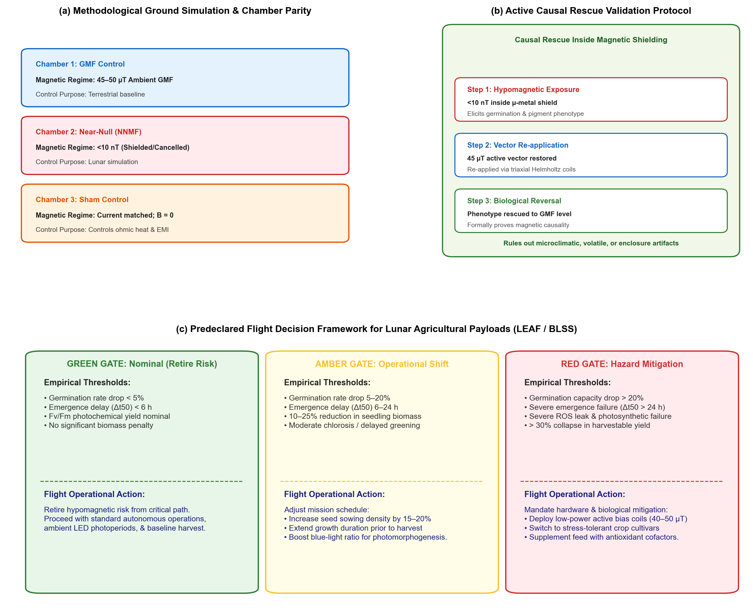 Figure 5 | Ground-validation standards, causal rescue, and Artemis flight decision pipeline.
(a) Methodological Ground Simulation Standards: Parallel three-chamber experimental architecture ensuring strict environmental parity ($22±1^{∘}\text{C}$, $60±5\% \text{RH}$, $150 μ{\text{mol m}}^{-2}{\text{s}}^{-1}$ LED lighting, $420\text{ or }1200{\text{ ppm CO}}_{2}$): Chamber 1 (Geomagnetic Control, $45\text{–}50 μ\text{T}$); Chamber 2 (Near-Null Field, $<10\text{ nT}$ achieved via passive $μ$-metal shielding or active cancellation); and Chamber 3 (Bifilar Sham Control, carrying matched current through opposing bifilar windings to cancel the magnetic field while identically matching ohmic heating, vibration, and EMI).
(b) Active Causal Rescue Validation Protocol: Three-step causal proof inside magnetic shielding. Step 1: Hypomagnetic exposure ($<10\text{ nT}$) elicits the germination lag and chlorosis phenotype. Step 2: Triaxial Helmholtz coils re-apply a calibrated Earth-like $45 μ\text{T}$ vector directly inside the shield. Step 3: Complete biological phenotype reversal to geomagnetic baseline formally proves magnetic causality, definitively ruling out enclosure, microclimatic, ethylene, or outgassing artifacts.
(c) Predeclared Flight Decision Framework for Lunar Agriculture: Operational gates translating empirical ground and flight telemetry into mission decisions. Green Gate (Nominal): Germination drop $<5\%$, $Δt_{50}<6\text{ h}$, nominal $F_{v}/F_{m}$; retire magnetic risk from critical path, proceed with standard flight ops. Amber Gate (Operational Shift): Germination drop $5\text{–}20\%$, $Δt_{50}=6\text{–}24\text{ h}$, $10\text{–}25\%$ biomass decline; increase seed sowing density by $15\text{–}20\%$, extend pre-harvest growth duration, and boost blue-light ratio to stimulate HY5 pigment synthesis. Red Gate (Hazard Mitigation): Germination collapse $>20\%$, severe emergence stall ($Δt_{50}>24\text{ h}$), severe ROS leak; mandate hardware mitigation (low-power active bias Helmholtz coils restoring $40\text{–}50 μ\text{T}$) or deploy stress-tolerant crop cultivars.

5.1 Stage 1: In Situ 3-Axis Flux Mapping and Environmental Parity
Flight payload chambers and ground simulation chambers must be equipped with miniature, calibrated 3-axis fluxgate or anisotropic magnetoresistive (AMR) magnetometers logging vector components ($B_{x},B_{y},B_{z}$) and total magnitude ($|B|$) continuously from DC to $10\text{ kHz}$ at the plant canopy level [11].
Chamber environmental parameters must be maintained strictly identical across treatments: - Temperature matched to $±{0.5}^{∘}\text{C}$ to eliminate thermal confounding. - Relative humidity maintained at $65±5\%$. - Lighting delivered at matched photosynthetically active radiation (PAR, $150±5 μ{\text{mol m}}^{-2}{\text{s}}^{-1}$) with identical spectral distributions. - Airflow and ventilation velocity ($0.3\text{–}0.5{\text{ m s}}^{-1}$) matched across chambers to prevent boundary layer and ethylene accumulation artifacts [7,40].

5.2 Stage 2: Matched-Current Bifilar Sham Controls
A primary failure mode of coil-based magnetic cancellation systems is the confounding introduction of ohmic Joule heating, mechanical vibration, and electromagnetic ripple. Whenever active coils are employed, researchers must incorporate matched-current bifilar sham coils [11,78] (Figure 5a). In a bifilar sham configuration, paired wires carry equal currents in opposite directions, producing complete magnetic field cancellation while generating identical resistive heat, current loads, and acoustic vibration as the active cancellation coils. Any biological difference observed between the active cancellation chamber and the bifilar sham chamber can then be unambiguously attributed to the magnetic vector itself.

5.3 Stage 3: The Causal Rescue Gate
To definitively exclude chamber enclosure, volatile organic compound (VOC), or microclimatic artifacts, payloads and ground experiments must execute the Causal Rescue Protocol [11,79] (Figure 5b): 1. Plants are cultivated within a magnetically shielded enclosure ($μ$-metal or active cancellation, $|B|<10\text{ nT}$), reproducing the hypomagnetic phenotype (germination delay, reduced elongation, chlorosis). 2. Inside the exact same shielded physical enclosure, an internal triaxial Helmholtz or Merritt coil system is energized to re-apply an Earth-normal geomagnetic vector ($45\text{–}50 μ\text{T}$). 3. If the developmental, transcriptomic, and photosynthetic phenotypes are completely rescued to Earth-baseline levels, magnetic causality is unequivocally established.

5.4 Stage 4: Predeclared Flight Decision Gates for Artemis Payloads
Translating empirical ground testing into actionable lunar flight operations requires establishing predeclared decision thresholds (Figure 5c):
Green Gate (Nominal Operations / Retire Risk): If ground testing with mission-specific hardware, regolith simulant, and crop cultivars demonstrates that germination capacity reduction is $<5\%$, emergence lag $Δt_{50}$ is $<6\text{ hours}$, and photochemical efficiency ($F_{v}/F_{m}$) remains nominal, the hypomagnetic risk is formally retired. Payload engineers can proceed with standard, low-power autonomous operations.
Amber Gate (Operational Mission Shifts): If testing reveals moderate suppression (germination decline of $5\text{–}20\%$, emergence delay $Δt_{50}=6\text{–}24\text{ hours}$, and $10\text{–}25\%$ loss in early biomass), hardware redesign is unnecessary, but operational procedures must be adjusted: - Increase initial seed sowing density by $15\text{–}20\%$ to compensate for reduced emergence capacity. - Extend the growth timeline by 24–48 hours before scheduled crew harvest. - Shift LED spectral ratios by increasing blue-light flux ($450\text{ nm}$) by $10\text{–}15\%$ to boost cryptochrome/phytochrome activation, stabilizing HY5 and accelerating pigment biosynthesis.
Red Gate (Hazard Mitigation Mandate): If testing reveals severe biological impairment (germination capacity collapse $>20\%$, severe emergence failure $Δt_{50}>24\text{ hours}$, uncontrolled ROS accumulation, or $>30\%$ loss in harvestable yield), active mitigation is mandatory: - Integrate low-power, lightweight active bias Helmholtz coils into the payload growth cassette, restoring a localized $40\text{–}50 μ\text{T}$ magnetic vector at an electrical cost of $<2\text{ W}$. - Transition flight seed payloads to genetically verified, hypomagnetic-tolerant cultivars or lines overexpressing AOX1D, CAT3, or HY5.

6. Conclusions & Forward Look for Sustained Lunar Agriculture
As humanity prepares for sustained surface operations under the Artemis program and looks forward to permanent lunar bases, space agricultural engineering must mature beyond treating gravity and radiation as the sole planetary variables.
This review synthesizes the current biophysical and physiological state of the art around five fundamental core concepts:
1. Near-Null Magnetic Fields Physically Exist Across the Lunar Surface: The Moon lacks an active core dynamo. Planned Artemis South Pole landing sites (such as Shackleton, Haworth, and Faustini) reside in an extreme magnetic void ($<0.8\text{ nT}$), more than $30,000×$ weaker than Earth’s geomagnetic field. Payload architectures must account for vector superposition ($B_{\text{total}}$) to prevent stray lander avionics fields ($50\text{–}500 μ\text{T}$) from confounding biological exposures.
2. Null Magnetic Fields Alter Germination Capacity: Removal of the geomagnetic field impairs seed imbibition kinetics and alters the ABA/GA hormonal balance, reducing total germination capacity and decreasing the absolute number (#) of viable seedlings established per sown area by $10\text{ to }30\%$.
3. Null Magnetic Fields Alter Germination Speed and Growth Kinetics: Near-null fields introduce a substantial emergence lag ($Δt_{50}$ delay of 12–36 h) and retard radicle and hypocotyl elongation rates by dampening cell proliferation and PIN2-mediated auxin transport, leading to a $20\text{–}30\%$ penalty in early seedling biomass and fresh material yield.
4. Null Magnetic Fields Repress Pigment Biosynthetic Networks: Cryptochrome radical-pair spin dynamics are altered in near-null fields, attenuating HY5 stabilization and downregulating rate-limiting enzymes of chlorophyll (HEMA1, CHLH, POR) and anthocyanin (CHS, CHI) biosynthesis, while secondary iron starvation (FIT, IRT1, AtFer1–4) triggers seedling chlorosis during de-etiolation.
5. Multi-Stressor Convergence on the ${\text{CO}}_{2}↔{\text{O}}_{2}↔\text{ROS}$ Bioenergetic Axis: Near-null magnetic fields, exploration atmospheres (hypobaric $56.5\text{ kPa}$, $34\% {\text{O}}_{2}$, elevated $1200\text{–}3000{\text{ ppm CO}}_{2}$), and ionizing radiation converge on the exact same mitochondrial respiratory machinery. In both plants and human astronauts, mitochondrial electron leakage and reactive oxygen generation represent the primary cellular lesion. In plants, induction of the Alternative Oxidase (AOX1D) and Catalase (CAT3) provides an essential metabolic safety valve that buffers organellar redox stress.
For the NASA LEAF payload and subsequent lunar greenhouse deployments, immediate engineering priorities can consider incorporating calibrated 3-axis magnetic sensors at the plant canopy, implementing matched-current bifilar sham baselines during ground testing, and validating active causal rescue. By mastering the hypomagnetic variable during the critical first five days of seedling growth, space life scientists can ensure robust stand establishment, maximize crop biomass yields, and secure the bioregenerative life support systems essential for humanity’s permanent expansion into deep space.

Acknowledgements
This work was supported by NASA Biological and Physical Sciences (BPS) awards and internal institutional support from the Department of Agricultural and Biological Engineering and the Department of Earth, Atmospheric, and Planetary Sciences at Purdue University. The authors thank the members of the NASA LEAF payload science team and the NASA GeneLab / Open Science Data Repository (OSDR) Plant AWG for insightful discussions regarding spaceflight multi-omics and environmental sensor integration.

Author Contributions
D.M.P. and R.J.B. conceived and designed the review framework. R.J.B. compiled the multi-omics overlap analyses and generated the figures. C.B. and A.O. analyzed the lunar orbital magnetometer datasets and landing site coordinates. A.S., M.D., and S.L.A. contributed to literature synthesis on seed germination kinetics and pigment biosynthesis. R.W., G.M., and B.D.-A. contributed expertise on space crop production, exploration atmospheres, and photosynthetic bioenergetics. M.P.-L., P.F., A.D., and C.C. contributed to payload engineering requirements and causal validation pipelines. All authors contributed to writing, critical revision, and approved the final manuscript.

Competing Interests
D.M.P. is a Co-Investigator on the NASA Artemis III LEAF payload; C.C. is affiliated with Space Lab Technologies, LLC. These roles are disclosed with no commercial or financial conflicts of interest. The remaining authors declare no competing interests.

Data Availability
All planetary magnetic field datasets analyzed in this manuscript are openly available from the NASA Planetary Data System (PDS) and JAXA DARTS archives. Gene expression datasets are accessible via the NASA Open Science Data Repository (OSDR, studies OSD-782, OSD-8, and OSD-27). Code for figure generation and pathway maps is hosted in the project repositories (lunar-magnetic-biology and quantum-biology-atlas).

References
- NASA. NASA selects first science instruments for astronauts to deploy on Moon. NASA Press Release 24-046 (26 March 2024). https://www.nasa.gov/news-release/nasa-selects-first-science-instruments-for-astronauts-to-deploy-on-moon/
- Maffei, M. E., Balestrini, R., Costantino, P. & Lanfranco, L. The physiology of plants in the context of space exploration. Commun. Biol. 7, 1311 (2024). https://doi.org/10.1038/s42003-024-06989-7
- Fountain, L. L. et al. Expanding frontiers: harnessing plant biology for space exploration and planetary sustainability. New Phytol. 249, 656–669 (2026). https://doi.org/10.1111/nph.70662
- Wheeler, R. M. Agriculture for space: People and places paving the way. Open Agric. 2, 14–32 (2017). https://doi.org/10.1515/opag-2017-0002
- Massa, G. D. et al. Selection of leafy green vegetable crops for a space mission. Gravit. Space Res. 3, 32–40 (2015).
- Space Lab Tech. Lunar Effects on Agricultural Flora (LEAF) selected for Artemis III surface deployment. Space Lab Technologies News (April 2024).
- Paul, A.-L., Wheeler, R. M., Levine, H. G. & Ferl, R. J. Fundamental plant biology in spaceflight. Adv. Space Res. 51, 501–510 (2013). https://doi.org/10.1016/j.asr.2012.09.038
- Norcross, C. J. et al. Exploration Atmosphere: NASA’s plan for reduced pressure and elevated oxygen for future human space missions. 48th International Conference on Environmental Systems, ICES-2018-199 (2018).
- Ferl, R. J. & Paul, A.-L. The genome of Arabidopsis thaliana in spaceflight. Genome Biol. 17, 155 (2016). https://doi.org/10.1186/s13059-016-1011-3
- Sarimov, R. M., Serov, D. A. & Gudkov, S. V. Hypomagnetic conditions and their biological action. Biology 12, 1513 (2023). https://doi.org/10.3390/biology12121513
- Porterfield, D. M. & Barker, R. J. Plant responses to near-null magnetic fields: Geomagnetism, bioenergetics, and primary metabolism in Arabidopsis and Brassica. Perspectives in Space Biology (in press, 2026).
- Maffei, M. E. Magnetic field effects on plant growth, development, and evolution. Front. Plant Sci. 5, 445 (2014). https://doi.org/10.3389/fpls.2014.00445
- Finlay, C. C. et al. International Geomagnetic Reference Field: the thirteenth generation. Earth Planets Space 72, 156 (2020). https://doi.org/10.1186/s40623-020-01252-9
- Halekas, J. S. et al. Solar wind interaction with lunar crustal magnetic anomalies. Planet. Space Sci. 56, 941–946 (2008). https://doi.org/10.1016/j.pss.2008.01.008
- Borlina, C. S. et al. Re-evaluating the lunar dynamo: Constraints from Apollo sample paleomagnetism and orbital magnetic mapping. Earth Planet. Sci. Lett. 584, 117446 (2022).
- Mitchell, D. L., Halekas, J. S. & Lin, R. P. Global mapping of lunar crustal magnetic fields by Lunar Prospector. Icarus 194, 401–409 (2008). https://doi.org/10.1016/j.icarus.2007.10.027
- Tsunakawa, H. et al. Surface vector mapping of magnetic anomalies over the Moon using Kaguya and Lunar Prospector observations. J. Geophys. Res. Planets 120, 1160–1185 (2015). https://doi.org/10.1002/2014JE004785
- Hood, L. L. et al. Magnetic anomalies at the lunar South Pole: Implications for Artemis landing sites. J. Geophys. Res. Planets 127, e2022JE007280 (2022).
- Hoffmann, A. P. et al. Enhancing magnetic field analysis on the KMAG instrument: applying WAIC-UP for spacecraft interference removal and interpolating data gaps. Earth Space Sci. 12, e2025EA004427 (2025). https://doi.org/10.1029/2025EA004427
- Binhi, V. N. & Prato, F. S. Biological effects of the hypomagnetic field: an analytical review of experiments and theories. PLoS ONE 12, e0179340 (2017). https://doi.org/10.1371/journal.pone.0179340
- Zhang, Z. et al. Biological effects of hypomagnetic field: ground-based data for space exploration. Bioelectromagnetics 42, 516–531 (2021). https://doi.org/10.1002/bem.22360
- Kyriacou, M. C. et al. Microgreens: Novel fresh and functional food to explore all the way from plate to space. Trends Food Sci. Technol. 110, 377–389 (2021). https://doi.org/10.1016/j.tifs.2021.01.080
- Bewley, J. D. Seed germination and dormancy. Plant Cell 9, 1055–1066 (1997). https://doi.org/10.1105/tpc.9.7.1055
- Gommers, C. M. & Monte, E. Seedling establishment: A dimmer switch-regulated process between dark and light signaling. Plant Physiol. 176, 1061–1074 (2017). https://doi.org/10.1104/pp.17.01460
- Finkelstein, R., Reeves, W., Ariizumi, T. & Steber, C. Molecular aspects of seed dormancy. Annu. Rev. Plant Biol. 59, 387–415 (2008). https://doi.org/10.1146/annurev.arplant.59.032607.092740
- Belyavskaya, N. A. Biological effects due to weak magnetic field on plants. Adv. Space Res. 34, 1566–1574 (2004). https://doi.org/10.1016/j.asr.2004.01.021
- Novitskii, Y. I., Novitskaya, G. V. & Kocheshkova, T. K. Growth of radish seedlings in a hypomagnetic field. Russ. J. Plant Physiol. 61, 667–676 (2014).
- Xu, C., Wei, S. & Lü, Y. Removal of the local geomagnetic field affects reproductive growth in Arabidopsis. Bioelectromagnetics 34, 437–442 (2013). https://doi.org/10.1002/bem.21788
- Negishi, Y. et al. Growth and development of Arabidopsis thaliana under hypomagnetic conditions. Space Util. Res. 15, 14–17 (1999).
- Kordyum, E. L. & Guikema, J. A. Plants in space: Changes in the cellular and organellar architecture. Int. J. Astrobiol. 19, 391–406 (2020).
- Tang, J., Wu, Z., Sun, Z., Liu, H. & Liu, H. Lunar magnetism impairs wheat seedling photosynthesis: a simulated environment study. Plant Physiol. Biochem. 216, 109156 (2024). https://doi.org/10.1016/j.plaphy.2024.109156
- Podleśny, J., Pietruszewski, S. & Podleśna, A. Efficiency of magnetic treatment of broad bean seeds cultivated under drought conditions. Int. Agrophys. 19, 65–71 (2005).
- Nonogaki, H., Bassel, G. W. & Bewley, J. D. Germination—still a mystery. Plant Sci. 179, 574–581 (2010). https://doi.org/10.1016/j.plantsci.2010.02.010
- Shine, M. B. & Guruprasad, K. N. Impact of pre-sowing magnetic field treatment on seed germination, seedling growth, and enzymatic antioxidant defense system in soybean. Physiol. Mol. Biol. Plants 18, 325–334 (2012).
- Xu, C., Yu, Y., Zhang, Y., Li, Y. & Wei, S. Gibberellins are involved in effect of near-null magnetic field on Arabidopsis flowering. Bioelectromagnetics 38, 1–10 (2017). https://doi.org/10.1002/bem.22004
- Xu, C., Zhang, Y., Yu, Y., Li, Y. & Wei, S. Suppression of Arabidopsis flowering by near-null magnetic field is mediated by auxin. Bioelectromagnetics 39, 15–24 (2018). https://doi.org/10.1002/bem.22086
- Narayana, R. et al. Near-null magnetic field alters root growth and PIN2 polar auxin transporter distribution in Arabidopsis thaliana. Bioelectromagnetics 39, 361–374 (2018).
- Belyavskaya, N. A. Ultrastructure of meristematic cells of pea roots grown in a hypomagnetic field. Biophysics 46, 953–958 (2001).
- Fiorillo, A. et al. 14-3-3 proteins and the plasma membrane ${\text{H}}^{+}$-ATPase are involved in maize magnetic induction. Plants 12, 2887 (2023). https://doi.org/10.3390/plants12152887
- Wheeler, R. M. Carbon dioxide effects on plants: Implications for space exploration. Front. Astron. Space Sci. 8, 780074 (2021). https://doi.org/10.3389/fspas.2021.780074
- Douglas, G. L. et al. Nutrition and food systems for exploration missions. NASA Human Research Program Technical Report (2020).
- Solymosi, K. & Schoefs, B. Etioplast and etio-chloroplast formation under natural and laboratory conditions. Front. Plant Sci. 9, 1709 (2018). https://doi.org/10.3389/fpls.2018.01709
- Tanaka, R. & Tanaka, A. Tetrapyrrole biosynthesis in higher plants. Annu. Rev. Plant Biol. 58, 321–346 (2007). https://doi.org/10.1146/annurev.arplant.57.032905.105448
- Parmagnani, A. S. et al. The geomagnetic field is required for Lima bean photosynthesis and reactive oxygen species production. Int. J. Mol. Sci. 24, 2896 (2023). https://doi.org/10.3390/ijms24032896
- Agliassa, C. et al. Reduction of the geomagnetic field delays Arabidopsis thaliana flowering time through downregulation of flowering-related genes. Bioelectromagnetics 39, 361–374 (2018). https://doi.org/10.1002/bem.22123
- Maffei, M. E. et al. Peppermint (Mentha $×$ piperita) response to near-null magnetic field involves modulated monoterpene and flavonoid biosynthesis. J. Plant Res. 134, 823–834 (2021).
- Gangappa, S. N. & Botto, J. F. The multifaceted roles of HY5 in plant growth and development. Mol. Plant 9, 1353–1365 (2016). https://doi.org/10.1016/j.molp.2016.07.002
- Toledo-Ortiz, G. et al. The HY5 transcription factor integrates blue-light and hormonal cues to drive plastid development. Plant Cell 26, 1392–1407 (2014).
- Hore, P. J. & Mouritsen, H. The radical-pair mechanism of magnetoreception. Annu. Rev. Biophys. 45, 299–344 (2016). https://doi.org/10.1146/annurev-biophys-032116-094545
- Solov’yov, I. A., Chandler, D. E. & Schulten, K. Magnetic field effects in Arabidopsis thaliana cryptochrome-1. Biophys. J. 92, 2711–2726 (2007). https://doi.org/10.1529/biophysj.106.097139
- Ahmad, M., Galland, P., Ritz, T., Wiltschko, R. & Wiltschko, W. Magnetic intensity affects cryptochrome-dependent responses in Arabidopsis thaliana. Planta 225, 615–624 (2007). https://doi.org/10.1007/s00425-006-0383-0
- Briat, J.-F., Duc, C., Ravet, K. & Gaymard, F. Ferritins and iron storage in plants. Biochim. Biophys. Acta 1800, 806–814 (2010). https://doi.org/10.1016/j.bbagen.2009.12.003
- Islam, M., Maffei, M. E. & Vigani, G. The geomagnetic field is a contributing factor for an efficient iron uptake in Arabidopsis thaliana. Front. Plant Sci. 11, 325 (2020). https://doi.org/10.3389/fpls.2020.00325
- Islam, M., Vigani, G. & Maffei, M. E. The geomagnetic field modulates nutrient status and lipid metabolism during Arabidopsis thaliana plant development. Plants 9, 1729 (2020). https://doi.org/10.3390/plants9121729
- Barker, R. J. & Porterfield, D. M. Quantum Biology Atlas: A cross-species ontology, pathway compiler, and multi-omics projection toolkit for quantum biological mechanisms. Zenodo / GitHub https://github.com/dr-richard-barker/quantum-biology-atlas (2026).
- Meyer, E. H., Welchen, E. & Carrie, C. Assembly of the complexes of the oxidative phosphorylation system in plant mitochondria. Physiol. Plant. 157, 294–309 (2016).
- Maeda, K. et al. Chemical compass model of avian magnetoreception. Nature 453, 387–390 (2008). https://doi.org/10.1038/nature06834
- Pooam, M. et al. Magnetic sensitivity mediated by the Arabidopsis blue-light receptor cryptochrome occurs during flavin reoxidation in the dark. Planta 249, 319–332 (2019). https://doi.org/10.1007/s00425-018-3002-y
- Demmig-Adams, B. & Adams, W. W. Photoprotection in an ecological context: the remarkable diversity of extreme-energy dissipation mechanisms. Funct. Plant Biol. 45, 697–711 (2018).
- Vanlerberghe, G. C. Alternative Oxidase: A mitochondrial respiratory pathway to maintain metabolic and signaling homeostasis during abiotic and biotic stress in plants. Int. J. Mol. Sci. 14, 6805–6847 (2013). https://doi.org/10.3390/ijms14046805
- Zadeh-Haghighi, H. & Simon, C. Magnetic field effects in biology from the perspective of the radical pair mechanism. J. R. Soc. Interface 19, 20220325 (2022). https://doi.org/10.1098/rsif.2022.0325
- Miloslavina, Y. et al. Charge separation kinetics in intact photosystem II core particles is trap-limited: a picosecond fluorescence study. Biochemistry 45, 2436–2442 (2006). https://doi.org/10.1021/bi052248c
- Vass, I. Role of charge recombination processes in photodamage and photoprotection of the photosystem II complex. Physiol. Plant. 142, 6–16 (2011). https://doi.org/10.1111/j.1399-3054.2011.01454.x
- Sarewicz, M. et al. Triplet state of the semiquinone-Rieske cluster as an intermediate of electronic bifurcation catalyzed by cytochrome $bc_{1}$. Biochemistry 52, 6388–6395 (2013). https://doi.org/10.1021/bi400624m
- Bujnowicz, Ł. et al. Suppression of superoxide production by a spin-spin coupling between semiquinone and the Rieske cluster in cytochrome $bc_{1}$. FEBS Lett. 593, 3–12 (2019). https://doi.org/10.1002/1873-3468.13296
- Richards, J. T. et al. Hypobaric plant growth in spaceflight: Design, gas diffusion, and physiological adaptation. Gravit. Space Biol. Bull. 19, 101–114 (2006).
- da Silveira, W. A. et al. Comprehensive multi-omics analysis reveals mitochondrial stress as a central biological hub for spaceflight impact. Cell 183, 1185–1201 (2020). https://doi.org/10.1016/j.cell.2020.11.002
- Bauwe, H., Hagemann, M. & Fernie, A. R. Photorespiration: players, partners and origin. Trends Plant Sci. 15, 330–336 (2010). https://doi.org/10.1016/j.tplants.2010.03.006
- Moore, A. L. & Siedow, J. N. The regulation and nature of the cyanide-resistant alternative oxidase of plant mitochondria. Biochim. Biophys. Acta 1059, 121–140 (1991).
- Maxwell, D. P., Wang, Y. & McIntosh, L. The alternative oxidase lowers mitochondrial reactive oxygen production in plant cells. Proc. Natl. Acad. Sci. USA 96, 8271–8276 (1999). https://doi.org/10.1073/pnas.96.14.8271
- Arena, C. et al. Plants in space: Responses to ionizing radiation and interaction with microgravity. Front. Plant Sci. 5, 550 (2014). https://doi.org/10.3389/fpls.2014.00550
- Cucinotta, F. A. & Durante, M. Cancer risk from exposure to galactic cosmic rays: implications for early exploration missions. Lancet Oncol. 7, 431–435 (2006).
- Parmagnani, A. S., Mannino, G. & Maffei, M. E. Transcriptomics and metabolomics of reactive oxygen species modulation in near-null magnetic field-induced Arabidopsis thaliana. Biomolecules 12, 1824 (2022). https://doi.org/10.3390/biom12121824
- Garrett-Bakelman, F. E. et al. The NASA Twins Study: A multidimensional analysis of a year-long human spaceflight. Science 364, eaau8650 (2019). https://doi.org/10.1126/science.aau8650
- Da Silveira, W. A. et al. Comprehensive multi-omics analysis reveals mitochondrial dysfunction as a central mechanism of spaceflight-induced systemic stress. Cell 183, 1185–1201 (2020).
- Mo, W. C. et al. Hypomagnetic field alters human neuroblastoma cell cycle kinetics and transcriptomic networks. PLoS ONE 7, e44650 (2012).
- Xu, C. et al. Hypomagnetic field promotes osteoclastogenesis and suppresses osteoblastogenesis in rat bone marrow cell cultures. Bioelectromagnetics 33, 685–694 (2012).
- Harris, S.-R. et al. Effect of magnetic fields on cryptochrome-dependent responses in Arabidopsis thaliana. J. R. Soc. Interface 6, 1193–1205 (2009). https://doi.org/10.1098/rsif.2008.0519
- Albaqami, M. et al. Arabidopsis cryptochrome is responsive to radiofrequency electromagnetic fields. Sci. Rep. 10, 11260 (2020). https://doi.org/10.1038/s41598-020-67165-5

