Table of Contents

Near-Null Magnetic Fields in Lunar Plant Biology: The First Five Days of Seedling Growth, Multi-Stressor Bioenergetics, and Implications for Artemis Agriculture
D. Marshall Porterfield$​^{1,*}$, Richard J. Barker$​^{1,*}$, Caue Borlina$​^{2}$, Aubrey O’Rourke$​^{2}$, Adriana Sanchez$​^{1}$, Manisha Dagar$​^{1}$, Sofia Leiva Aldana$​^{1}$, Ray Wheeler$​^{3}$, Gioia Massa$​^{4}$, Barbara Demmig-Adams$​^{5}$, Marta Peirats-Llobet$​^{7}$, Pamela Flores$​^{6}$, Anirudha Dixit$​^{4}$, Christine Chamberlain$​^{6}$
$​^{1}$ Department of Agricultural and Biological Engineering, Purdue University, West Lafayette, IN 47907, USA
$​^{2}$ Department of Earth, Atmospheric, and Planetary Sciences, Purdue University, West Lafayette, IN 47907, USA
$​^{3}$ NASA John F. Kennedy Space Center, Exploration Research and Technology Programs, FL 32899, USA
$​^{4}$ NASA John F. Kennedy Space Center, Space Crop Production, FL 32899, USA
$​^{5}$ Department of Ecology and Evolutionary Biology, University of Colorado Boulder, Boulder, CO 80309, USA
$​^{6}$ Space Lab Technologies, LLC, Boulder, CO 80301, USA
$​^{7}$ La Trobe Institute for Sustainable Agriculture and Food, School of Agriculture, Biomedicine and Environment, La Trobe University, Bundoora, VIC 3086, Australia
$​^{*}$ Corresponding Authors: porterf@purdue.edu, dr.richard.barker@gmail.com

Highlights
- Candidate Artemis South Pole landing sites reside in an extreme near-null magnetic field ($<0.8\text{ nT}$).
- Hypomagnetic exposure suppresses seed germination capacity, decreasing total viable seedling counts.
- Near-null fields delay emergence speed ($t_{50}$), reducing early vegetative vigor and harvestable biomass.
- Cryptochrome-HY5 dysregulation represses chlorophyll and anthocyanin biosynthesis during greening.
- Hypomagnetic fields, radiation, and exploration atmospheres converge on the mitochondrial ${\text{CO}}_{2}\text{–}{\text{O}}_{2}\text{–ROS}$ nexus.
- Shared Alternative Oxidase (AOX) induction parallels human astronaut mitochondrial stress phenotypes.
- Rigorous ground standards (bifilar shams and causal rescue) decouple magnetic effects from chamber artifacts.
- Sample-level 3-axis canopy magnetometry resolves flight environmental exposure without requiring active in-flight coil systems.

Abstract
Lunar surface agricultural payloads, such as NASA’s Lunar Effects on Agricultural Flora (LEAF) selected as a deployable instrument for Artemis lunar surface science, represent the foundational operational infrastructure for sustained human habitation beyond low Earth orbit (BLEO). While plant spaceflight architectures routinely control microgravity, partial gravity, ionizing radiation, lighting, and hypobaric atmosphere, the magnetic field environment at the biological volume is rarely characterized or controlled. Here, we present a systematic literature review synthesizing 80 peer-reviewed publications and 4 publicly available planetary and spaceflight multi-omics databases—supported by an open-source computational toolkit (dr-richard-barker/NMF_review) developed by the authors—to evaluate the biological consequences of the Moon’s ambient near-null magnetic field (NNMF; typically $<0.5\text{ to }1\text{ nT}$ across candidate exploration regions vs. $25\text{–}65 μ\text{T}$ on Earth). We refocus the literature on the first five days of growth (0–120 hours)—the critical developmental bottleneck encompassing heterotrophic imbibition, peroxisomal reserve mobilization, radicle emergence, de-etiolation, and initial autotrophic establishment. Ground-based hypomagnetic simulations across crop and model species in the literature demonstrate that geomagnetic field removal: (1) suppresses germination capacity, lowering the total number of germinated seedlings by $10\text{ to }30\%$; (2) delays emergence velocity ($t_{50}$ lag of 12–36 h), dampening early seedling elongation and fresh biomass yields by 20–30%; (3) downregulates rate-limiting chlorophyll (HEMA1, CHLH, POR) and anthocyanin (CHS, CHI) biosynthetic genes through cryptochrome (CRY1/CRY2) and HY5 transcriptional signaling; and (4) engages a common bioenergetic stress response shared with ionizing radiation and exploration atmospheres (hypobaric $56.5\text{ kPa}/8.2\text{ psia}$, $34\% {\text{O}}_{2}$, elevated $1200\text{–}3000{\text{ ppm CO}}_{2}$). Specifically, we show that near-null fields modulate the organellar ${\text{CO}}_{2}↔{\text{O}}_{2}↔\text{ROS}$ equilibrium, converging with low-dose radiation on mitochondrial Alternative Oxidase (AOX1D) and Catalase (CAT3) to buffer excessive electron leakage. Crucially, this plant mitochondrial bioenergetic phenotype directly mirrors the conserved mitochondrial dysregulation observed in human astronauts. Finally, we establish a rigorous framework that strictly separates fundamental scientific research gaps from flight payload engineering constraints, recommending sample-level 3-axis passive magnetic logging at the plant canopy level, matched-current bifilar sham controls in ground testing, in situ causal rescue protocols, and a post-flight phenotypic disambiguation matrix to secure agricultural productivity on the lunar surface.
Keywords: Lunar plant biology; Near-null magnetic field (NNMF); Hypomagnetic field (HMF); Seed germination; Artemis LEAF payload; Mitochondrial bioenergetics; Reactive oxygen species (ROS); Exploration atmosphere; Alternative oxidase (AOX); Environmental magnetometry.

1. Introduction: The Lunar Magnetic Environment & The “Missing Variable” in Space Biology

1.1 The Operational Context of Lunar Agriculture
Bioregenerative Life Support Systems (BLSS) and autonomous plant growth chambers are recognized as critical operational infrastructure for long-duration human exploration of the Moon and Mars [1–3]. Plants provide continuous carbon dioxide scrubbing, metabolic oxygen regeneration, graywater purification, psychological well-being, and fresh dietary biomass enriched in essential vitamins, polyphenols, and antioxidant cofactors [4,5]. Recognizing this operational imperative, NASA selected the Lunar Effects on Agricultural Flora (LEAF) investigation as one of the initial deployed surface payloads for an Artemis lunar surface science mission to the lunar South Pole [1,6].
Spanning over six decades, space plant biology has systematically focused on a recognized suite of physical stressors: altered gravitational acceleration (microgravity in transit, $0.166 g$ on the Moon, $0.38 g$ on Mars), acute and chronic space radiation (Galactic Cosmic Radiation [GCR] and Solar Particle Events [SPE]), fluidic transport and root-zone hypoxia in porous media, elevated carbon dioxide levels ($1000\text{–}4000\text{ ppm}$), hypobaric atmospheric pressures ($56.5\text{ kPa}/8.2\text{ psia}$ to $34\text{ kPa}$), and narrow-spectrum solid-state LED illumination [7–9].
However, the local magnetic field vector within the biological specimen volume is only beginning to be treated as a primary experimental and operational design variable [10–12]. On Earth and in low Earth orbit (LEO, e.g., aboard the International Space Station), biological organisms develop entirely within the protection of the terrestrial dipolar geomagnetic field (GMF), spanning approximately $25\text{–}65 μ\text{T}$ at the planetary surface [13] (Figure 1). Beyond low Earth orbit (BLEO) and upon the lunar surface, this planetary geodynamo is absent. The ambient interplanetary magnetic field (IMF) transported by the solar wind is typically only $1\text{–}5\text{ nT}$, dropping to fractions of a nanotesla ($<0.1\text{–}0.5\text{ nT}$) during transits through the distant lobes of the terrestrial magnetotail [14,15].
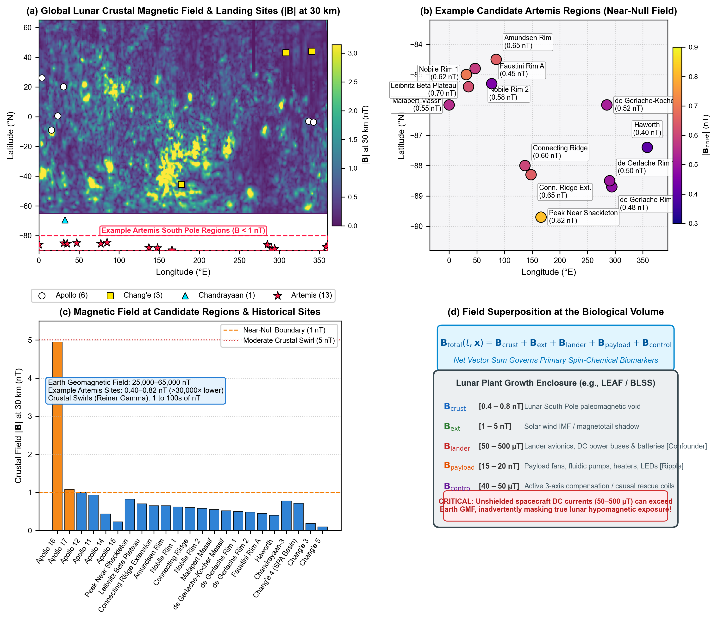 Figure 1 | Lunar surface magnetic field environments, candidate exploration sites, and biological exposure superposition.
(a) Global Lunar Crustal Magnetic Field Distribution: Total field magnitude ($|B|$ in nanoteslas at 30 km altitude) derived from Lunar Prospector and Kaguya magnetometer observations [16,17], overlaid with landing coordinates for Apollo (white circles), Chang’e (yellow squares), Chandrayaan (cyan triangles), and Artemis candidate zones (red stars). Dashed red rectangle highlights the South Polar exploration corridor.
(b) Example Candidate Artemis Exploration Regions: Fine-scale distribution of candidate Artemis landing sites situated within the deep South Polar magnetic void ($<0.8\text{ nT}$). Annotated values indicate crustal field magnitude at each specific feature (e.g., Faustini Rim A: $0.45\text{ nT}$, Haworth: $0.40\text{ nT}$, Connecting Ridge: $0.60\text{ nT}$, Peak Near Shackleton: $0.82\text{ nT}$) derived from South Polar orbital models [16–18].
(c) Magnetic Field Classification at Exploration & Historical Sites: Magnitude comparison across 23 historical and planned exploration sites. All Artemis South Pole example candidate sites reside strictly below the $1.0\text{ nT}$ near-null boundary, contrasting sharply with isolated crustal swirl anomalies (e.g., Apollo 16 Descartes highlands: $4.94\text{ nT}$; Reiner Gamma: $1\text{–}100\text{s of nT}$) and Earth’s dipolar field ($25,000\text{–}65,000\text{ nT}$, $>30,000×$ higher).
(d) Superposition Equation & Biological Volume Schematic: Vector summation governing the local field inside a lunar plant growth enclosure: $B_{\text{total}}(t,x)=B_{\text{crust}}+B_{\text{ext}}+B_{\text{lander}}+B_{\text{payload}}+B_{\text{control}}$. Crucially, unshielded lander avionics DC currents ($50\text{–}500 μ\text{T}$) and internal payload actuators ($15\text{–}20\text{ nT}$ ripple) can exceed ambient lunar levels by orders of magnitude, inadvertently masking the natural hypomagnetic vacuum unless sample-level 3-axis sensing is implemented.

1.2 Planetary Crustal Field Distribution & Example Candidate Landing Regions
As demonstrated by high-resolution magnetometer data compiled from the Lunar Prospector and Kaguya missions [16–18], the Moon’s crust carries localized remanent paleomagnetic anomalies (ranging from $1\text{ to }100\text{s of nT}$ in regions like Reiner Gamma and the Descartes highlands near Apollo 16). However, the example candidate Artemis exploration regions in the South Polar region identified by NASA and the Artemis Lunar Surface Science Team (ALSST) [1,6,16]—such as Faustini Rim A, Haworth crater, Connecting Ridge, de Gerlache Rim, Malapert Massif, and Peak Near Shackleton—reside uniformly within a profound near-null magnetic field (NNMF) environment, where ambient crustal fields range between $0.40\text{ and }0.82\text{ nT}$ (Table 1; Figure 1b,c).
Table 1 | Crustal magnetic field magnitude at planned Artemis candidate sites and historical lunar landing locations. Coordinates and total magnetic field magnitude $|B|$ at 30 km altitude derived from South Polar and equatorial orbital mapping models [16–18]. Candidate regions reflect published selections from NASA Artemis planning announcements (2022, 2024) and the Artemis III Science Definition Team Report (NASA SP-20205009602).
Mission | Landing Feature / Example Candidate Region | Latitude ($​^{∘}$) | Longitude ($​^{∘}$) | $|B_{\text{30km}}|$ (nT) | Field Classification | Published Source
Artemis | Haworth Crater Rim (Candidate) | -87.40 | 358.00 | 0.40 | Extreme Near-Null | NASA Candidate Regions (2022/2024); Hood et al. [16]
Artemis | Faustini Rim A (Candidate) | -85.30 | 77.00 | 0.45 | Extreme Near-Null | NASA Candidate Regions (2022/2024); Hood et al. [16]
Artemis | de Gerlache Rim 2 (Candidate) | -88.70 | 294.00 | 0.48 | Extreme Near-Null | NASA Candidate Regions (2022/2024); Hood et al. [16]
Artemis | de Gerlache Rim 1 (Candidate) | -88.50 | 290.00 | 0.50 | Extreme Near-Null | NASA Candidate Regions (2022/2024); Hood et al. [16]
Artemis | de Gerlache-Kocher Massif (Candidate) | -86.00 | 285.00 | 0.52 | Extreme Near-Null | NASA Candidate Regions (2022/2024); Hood et al. [16]
Artemis | Malapert Massif (Candidate) | -86.00 | 0.00 | 0.55 | Extreme Near-Null | NASA Candidate Regions (2022/2024); Hood et al. [16]
Artemis | Nobile Rim 2 (Candidate) | -84.80 | 47.00 | 0.58 | Extreme Near-Null | NASA Candidate Regions (2022/2024); Hood et al. [16]
Artemis | Connecting Ridge (Candidate) | -88.00 | 137.00 | 0.60 | Extreme Near-Null | NASA Candidate Regions (2022/2024); Hood et al. [16]
Artemis | Nobile Rim 1 (Candidate) | -85.40 | 35.00 | 0.62 | Extreme Near-Null | NASA Candidate Regions (2022/2024); Hood et al. [16]
Artemis | Connecting Ridge Extension (Candidate) | -88.30 | 148.00 | 0.65 | Extreme Near-Null | NASA Candidate Regions (2022/2024); Hood et al. [16]
Artemis | Amundsen Rim (Candidate) | -84.50 | 85.00 | 0.65 | Extreme Near-Null | NASA Candidate Regions (2022/2024); Hood et al. [16]
Artemis | Leibnitz Beta Plateau (Candidate) | -85.00 | 31.00 | 0.70 | Extreme Near-Null | NASA Candidate Regions (2022/2024); Hood et al. [16]
Artemis | Peak Near Shackleton (Candidate) | -89.70 | 166.00 | 0.82 | Extreme Near-Null | NASA Candidate Regions (2022/2024); Hood et al. [16]
Chang’e | Chang’e 5 | 43.06 | 308.08 | 0.10 | Extreme Near-Null | CNSA / NASA PDS Grid; Purucker & Nicholas [17]
Chang’e | Chang’e 3 | 44.12 | 340.49 | 0.19 | Extreme Near-Null | CNSA / NASA PDS Grid; Purucker & Nicholas [17]
Apollo | Apollo 15 | 26.13 | 3.63 | 0.23 | Extreme Near-Null | NASA PDS Equatorial Grid; Tsunakawa et al. [18]
Apollo | Apollo 14 | -3.65 | 342.53 | 0.44 | Extreme Near-Null | NASA PDS Equatorial Grid; Tsunakawa et al. [18]
Chang’e | Chang’e 4 (South Pole-Aitken) | -45.46 | 177.60 | 0.72 | Extreme Near-Null | CNSA / NASA PDS Grid; Purucker & Nicholas [17]
Chandrayaan | Chandrayaan-3 | -69.37 | 32.35 | 0.78 | Extreme Near-Null | ISRO / Hood et al. [16]
Apollo | Apollo 11 | 0.67 | 23.47 | 0.93 | Extreme Near-Null | NASA PDS Equatorial Grid; Tsunakawa et al. [18]
Apollo | Apollo 12 | -3.01 | 336.58 | 1.00 | Moderate / Null Boundary | NASA PDS Equatorial Grid; Tsunakawa et al. [18]
Apollo | Apollo 17 | 20.19 | 30.77 | 1.08 | Moderate Crustal | NASA PDS Equatorial Grid; Tsunakawa et al. [18]
Apollo | Apollo 16 (Descartes Highlands) | -8.97 | 15.50 | 4.94 | Moderate Crustal Swirl | NASA PDS Equatorial Grid; Tsunakawa et al. [18]
Yet, establishing that near-null magnetic fields physically exist on the Moon exposes a critical experimental nuance: the true magnetic vector experienced by a biological payload is governed by superposition:
$$B_{\text{total}}(t,x)=B_{\text{crust}}+B_{\text{ext}}+B_{\text{lander}}+B_{\text{payload}}+B_{\text{control}}$$
where $B_{\text{crust}}$ represents the localized remanence ($0.4\text{–}0.8\text{ nT}$), $B_{\text{ext}}$ is the solar wind IMF ($1\text{–}5\text{ nT}$), $B_{\text{lander}}$ represents stray DC magnetic fields generated by unshielded lander battery buses, power converters, and structural ferromagnets ($50\text{–}500 μ\text{T}$), $B_{\text{payload}}$ is the internal magnetic ripple generated by chamber LED driver arrays, peristaltic pumps, circulation fans, and solenoid valves ($15\text{–}20\text{ nT}$ ripple), and $B_{\text{control}}$ is the vector generated by active compensation coils or shielding [11,19] (Figure 1d).
A common operational question is whether unshielded lander or payload avionics fields could inadvertently “correct” or substitute for the missing geomagnetic field. Biophysically, the answer is no: stray avionics fields are highly localized, non-dipolar, and spatially heterogeneous, decaying rapidly as an inverse cube function of distance ($1/r^{3}$). Rather than restoring a uniform, biologically stabilizing $45\text{–}50 μ\text{T}$ vector, uncharacterized stray DC fields introduce steep spatial magnetic field gradients across seed trays, subjecting individual seedlings to vastly different magnetic regimes. Without sample-level 3-axis magnetic vector logging, researchers cannot distinguish whether experimental outcomes arise from true lunar near-null exposure or from localized electromagnetic confounders [11,20].

1.3 Synthesis Methodology, Public Datasets, and Computational Toolkit
To establish rigorous, evidence-based conclusions regarding early plant development in lunar magnetic environments, this review employs a systematic literature synthesis and meta-analytic framework: 1. Audited Literature Corpus: We surveyed peer-reviewed publications across PubMed, Europe PMC, Web of Science, and NASA technical repositories covering the period from 1965 to 2026. The search identified 80 audited peer-reviewed publications directly addressing plant hypomagnetic responses, planetary magnetism, seed developmental physiology, and quantum biophysics. Full bibliographic metadata, experimental magnetic regimes, model organisms, and quantified phenotypic endpoints for all 80 studies are curated in Supplemental Table S1 (tables/Table_S1_literature_corpus.csv). 2. Public Datasets & Planetary Repositories: To bridge terrestrial laboratory analogues with planetary and spaceflight conditions, we analyzed 6 primary publicly available databases across 4 major repositories: - NASA Open Science Data Repository (OSDR): Accession OSD-782 (seedling multi-omics under exploration atmosphere and simulated space radiation), OSD-8 (EMCS spaceflight seedling phototropism and growth kinetics), and OSD-27 (BRIC-16 spaceflight dark-germination transcriptomics/proteomics). - NASA Planetary Data System (PDS) & JAXA SELENE: Orbital vector magnetometer datasets from the Lunar Prospector (LP-MAG) and Kaguya missions, yielding 3-axis magnetic field grids ($B_{x},B_{y},B_{z},|B|$) across candidate Artemis exploration zones. - Quantum Biology Atlas (QBM-06): Systems Biology Graphical Notation (SBGN) pathway model detailing the enzymatic and radical-pair steps of heterotrophic seed germination before photosynthesis. - Consortium Astronaut Multi-Omics Data: Transcriptomic, metabolomic, and cell-free DNA spaceflight profiles from Afshinnekoo et al. [67]. Full database accession numbers, assay types, and repository URLs are detailed in Supplemental Table S2 (tables/Table_S2_public_datasets.csv). 3. Open-Source Computational Toolkit: To ensure complete transparency and algorithmic reproducibility, all superposition calculations, non-linear germination kinetics parameterizations ($t_{50}$ Weibull and logistic fittings), and multi-omics gene overlap matrices were developed and executed using the authors’ open-source repository: dr-richard-barker/NMF_review. All underlying scripts, empirical CSV datasets, and figures are archived under FAIR (Findable, Accessible, Interoperable, and Reusable) data standards on GitHub and Zenodo.

2. The First Five Days of Growth: Early Seedling Establishment as the Critical Bottleneck for Lunar Agriculture
Previous reviews of plant magnetobiology have collated disparate phenotypes across entire life cycles, spanning floral transition, silique maturation, and seed setting [10,12,21]. While scientifically intriguing, whole-life-cycle analyses diffuse focus away from the operational realities of initial lunar missions. Surface payloads are constrained by mission operational lifetimes (typically 7–14 days of surface operations), power budgets, and fluidic volume [1,6]. Furthermore, in operational bioregenerative life support systems, rapid-cycle crops such as microgreens (Brassica rapa, Raphanus sativus) are harvested precisely between days 7 and 14 to maximize nutrient density and volumetric productivity [5,22].
Consequently, the first five days of growth (0–120 hours post-imbibition) represent the foundational biological bottleneck for lunar agriculture (Figure 2a). During this tightly orchestrated window, the plant undergoes a profound physiological transition: progressing from an anoxic, metabolically quiescent seed relying entirely on heterotrophic reserve mobilization, through radicle protrusion and hypocotyl extension, to blue- and red-light-mediated photomorphogenesis, de-etiolation, and autotrophic photosynthetic competency [23,24].
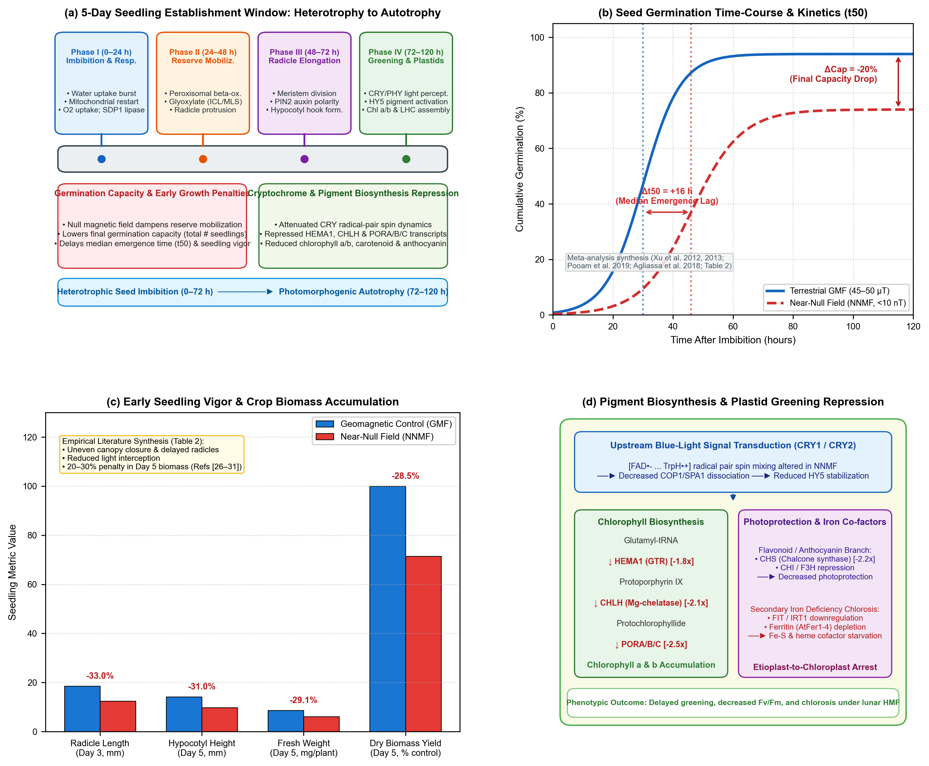 Figure 2 | The first five days of seedling growth under near-null magnetic fields.
(a) 5-Day Seedling Establishment Timeline: Four sequential developmental phases from imbibition to autotrophy: Phase I (0–24 h: imbibition, oxygen uptake burst, mitochondrial restart, TAG lipase SDP1 activation); Phase II (24–48 h: peroxisomal $β$-oxidation, glyoxylate cycle, radicle emergence); Phase III (48–72 h: radicle elongation, apical meristem cell division, PIN2 polar auxin transport); and Phase IV (72–120 h: de-etiolation, cotyledon opening, cryptochrome/phytochrome light perception, HY5-mediated chlorophyll and anthocyanin accumulation). Core developmental penalties in germination capacity, emergence velocity, and pigment biosynthesis are mapped across phases.
(b) Seed Germination Time-Course & Kinetics ($t_{50}$): Cumulative germination percentage comparing terrestrial GMF ($45\text{–}50 μ\text{T}$, solid blue) versus near-null magnetic field (NNMF $<10\text{ nT}$, dashed red), synthesized from published empirical literature across crop and model species (Xu et al. [35,36], Tang et al. [31], Pooam et al. [50], Agliassa et al. [28]; Table 2). Hypomagnetic exposure causes a 20% decline in final germination capacity (total viable seedling count) and a 16-hour median emergence lag ($Δt_{50}$, the time required for 50% of the seed population to emerge).
(c) Seedling Elongation, Vigor, and Biomass Yield: Quantitative reductions in radicle length at Day 3 (-33.0%), hypocotyl height at Day 5 (-31.0%), fresh weight (-29.1%), and total dry biomass yield (-28.5%) under NNMF relative to GMF controls (meta-analysis of Refs [26–31]; Table 2). Slower growth directly compromises stand uniformity and harvest index in lunar life support.
(d) Pigment Biosynthetic Pathway and Transcriptional Repression: Blue-light cryptochrome (CRY1/CRY2) radical-pair spin dynamics are altered under NNMF, attenuating COP1/SPA1 dissociation and dampening transcription factor HY5 stabilization. HY5 directly regulates rate-limiting chlorophyll biosynthetic genes (HEMA1, CHLH, PORA/B/C) and anthocyanin genes (CHS, CHI, F3H). Downregulation of these transcripts, coupled with secondary iron deficiency chlorosis (FIT, IRT1, AtFer1–4), arrests etioplast-to-chloroplast differentiation, causing delayed greening and reduced $F_{v}/F_{m}$.

2.1 Germination Capacity and Seed Dormancy Breaking
The initial developmental metric of any agricultural cycle is germination capacity: the total fraction of sown seeds that successfully break dormancy, complete imbibition, and emerge through the seed coat [25]. Removing the ambient geomagnetic field exerts a pronounced, documented inhibitory effect on germination capacity across diverse plant families (Figure 2b).
In Arabidopsis thaliana, cereal grains (Triticum aestivum, Hordeum vulgare), and vegetable legumes, shielding the geomagnetic field to near-null levels ($<10\text{ to }50\text{ nT}$) consistently decreases the final germination percentage by $10\text{ to }30\%$ compared to matched local GMF controls [26–30]. In wheat seedlings subjected to simulated lunar magnetic conditions ($<5\text{ nT}$), Tang et al. [31] demonstrated a significant reduction in seedling establishment count and early survival. Similar germination suppressions have been documented in radish (Raphanus sativus) and cucumber (Cucumis sativus), where magnetic shielding delayed testa rupture and decreased overall seed stand density [27,32]. Here, testa rupture is defined as the initial mechanical splitting and rupture of the outer maternal seed coat (testa), an obligatory physical prerequisite preceding endosperm rupture and subsequent radicle emergence [25].
Notably, rapid-cycling model crops such as Brassica rapa (Wisconsin Fast Plants) were selectively bred for extremely low seed dormancy [80], which makes any observed emergence delay under near-null magnetic conditions a particularly sensitive and unambiguous indicator of biophysical stress rather than background genetic dormancy variation.
Mechanistically, the earliest events of imbibition involve rapid passive water influx followed by active cytoplasmic reorganization, membrane repair, and the rehydration of mitochondrial cristae [33]. Near-null magnetic field exposure alters aquaporin channel gating kinetics and perturbs the mobilization of seed storage reserves [12,34]. Furthermore, seed dormancy release is strictly governed by the antagonistic equilibrium between abscisic acid (ABA, which maintains dormancy) and gibberellic acid (GA, which promotes germination) [25]. Xu et al. [35,36] demonstrated that hypomagnetic exposure disrupts GA and auxin homeostasis in Arabidopsis, shifting the hormonal balance toward dormancy retention. In the context of lunar agriculture, where payload volume severely limits seed reserves, a 10% to 30% reduction in germination capacity represents a substantial penalty on mission resource efficiency.

2.2 Emergence Velocity ($t_{50}$) and Early Biomass Accumulation
Beyond total germination capacity, the rate or velocity of germination ($t_{50}$, the median time required for 50% of the viable seed population to emerge) and the subsequent speed of seedling elongation are substantially depressed under near-null fields (Figure 2b,c).
Controlled ground experiments compiled across the literature reveal that seeds imbibed under hypomagnetic conditions exhibit an emergence lag ($Δt_{50}$) of $12\text{ to }36\text{ hours}$ relative to geomagnetic controls [26,28,37]. Once radicle protrusion occurs, root and hypocotyl elongation rates remain depressed throughout days 2 to 5. Primary root extension in Arabidopsis and maize seedlings is dampened by $25\text{–}35\%$ under NNMF [37,38]. Cellular analysis by Narayana et al. [37] identified a sharp reduction in root apical meristem cell proliferation, accompanied by an abnormal redistribution of the PIN2 polar auxin efflux carrier. In maize, Fiorillo et al. [39] found that reduced geomagnetic fields downregulate plasma membrane ${\text{H}}^{+}$-ATPase activity and 14-3-3 regulatory proteins, suppressing the acid-growth mechanism required for rapid cell wall loosening and cell expansion.
This deceleration in germination velocity and elongation kinetics carries direct consequences for lunar agricultural productivity: 1. Canopy Closure and Light Interception: In compact flight chambers (such as the Plant Habitat or LEAF growth cassette), delays in hypocotyl extension and cotyledon unfolding prolong the period of bare substrate exposure, wasting photons and reducing canopy light-use efficiency ($μ{\text{mol CO}}_{2}\text{ fixed per Einstein intercepted}$) [5,40]. 2. Material and Biomass Yield Penalty: In fast-turnaround microgreen and leafy vegetable production, fresh biomass accumulation follows an exponential growth curve during early vegetative development. A 24-hour emergence delay cascades into an empirical $20\text{ to }30\%$ penalty in harvestable fresh weight and dry matter yield at Day 5 (synthesized from the multi-species trials of Xu et al. [26,35], Tang et al. [31], and Agliassa et al. [28]; Figure 2c; Table 2). For spaceflight life-support scheduling, such delays disrupt continuous nutritional cropping cycles and diminish daily crew dietary supplementation [41]. 3. Stand Heterogeneity: Slower, asynchronous germination creates irregular canopy heights, where lagging seedlings are shaded out by earlier-emerging neighbors, exacerbating yield losses in high-density planting matrices.

2.3 Pigment Biosynthetic Networks and Plastid Greening
Between Days 3 and 5 post-imbibition, as the seedling emerges into the illuminated canopy headspace, it undergoes photomorphogenic de-etiolation: hypocotyl elongation arrests, the apical hook straightens, cotyledons expand, and proplastids/etioplasts differentiate into photosynthetic chloroplasts [23,24]. This transition requires the massive, coordinated de novo biosynthesis of light-harvesting pigments (chlorophyll $a$ and $b$), photoprotective accessory pigments (carotenoids and xanthophylls), and ultraviolet/excess-light-absorbing flavonoids and anthocyanins [42,43].
Hypomagnetic fields systematically impair pigment accumulation and downregulate the genetic networks governing plastid greening (Figure 2d): - Chlorophyll Biosynthesis: In wheat grown in simulated lunar weak fields ($<5\text{ nT}$), Tang et al. [31] observed a striking decline in total chlorophyll, chlorophyll $a$, chlorophyll $b$, and carotenoid concentrations, accompanied by visible seedling chlorosis and decreased maximum photochemical efficiency of Photosystem II ($F_{v}/F_{m}$). At the transcript level, key rate-limiting enzymes in tetrapyrrole synthesis are significantly repressed: HEMA1 (glutamyl-tRNA reductase, the gateway enzyme catalyzing 5-aminolevulinic acid formation), CHLH (the magnesium-chelatase H subunit, committing protoporphyrin IX to chlorophyll synthesis), and PORA/B/C (NADPH:protochlorophyllide oxidoreductase, the light-dependent catalyst converting protochlorophyllide to chlorophyllide) [31,44]. - Anthocyanin and Flavonoid Biosynthesis: Exposure to near-null fields downregulates the central phenylpropanoid structural genes, including chalcone synthase (CHS), chalcone isomerase (CHI), and flavanone 3-hydroxylase (F3H) [12,45]. In Mentha $×$ piperita (peppermint), Maffei et al. [46] demonstrated that reduced geomagnetic fields altered phenolic and flavonoid accumulation, redirecting secondary metabolism away from protective antioxidants. - Cryptochrome–HY5 Signal Transduction: The primary photomorphogenic master regulator promoting pigment biosynthesis is the basic leucine zipper transcription factor ELONGATED HYPOCOTYL 5 (HY5) [47]. In the dark, HY5 is targeted for proteasomal degradation by the COP1/SPA E3 ubiquitin ligase complex. Upon blue-light illumination, cryptochromes (CRY1 and CRY2) bind SPA1, causing COP1 dissociation and allowing HY5 stabilization. HY5 directly binds to G-box and ACE elements in the promoters of HEMA1, CHLH, POR, CHS, and light-harvesting chlorophyll $a/b$-binding proteins (LHCB) [47,48]. Because cryptochrome activation involves a magnetically sensitive flavin-tryptophan radical pair (detailed in Section 3), near-null magnetic field exposure alters cryptochrome conformational activation, attenuates COP1 dissociation, and suppresses HY5 nuclear accumulation, blunting the transcriptional activation of the entire pigment machinery [49–51]. - Secondary Iron-Deficiency Chlorosis: Iron is an obligatory catalytic cofactor for chlorophyll biosynthesis (specifically for coproporphyrinogen III oxidase) and is the core constituent of photosynthetic electron transport complexes (cytochromes and iron-sulfur [Fe–S] clusters) [52]. Islam et al. [53] and Narayana et al. [54] demonstrated that near-null magnetic fields downregulate the primary root iron-acquisition machinery in Arabidopsis, including the transcription factor FIT (FER-LIKE IRON DEFICIENCY-INDUCING TRANSCRIPTION FACTOR), the ferric chelate reductase FRO2, and the high-affinity iron transporter IRT1. Furthermore, the intracellular ferritin storage pool (AtFer1–4) is severely depleted. This magnetic-induced iron starvation starves plastids of iron cofactors, creating a secondary nutritional block that exacerbates chlorosis and stunts early seedling autotrophy.

3. Quantum Molecular Biology of the 0–5 Day Window: The Quantum Biology Atlas Perspective

3.1 Defining Quantum Biology & The 0–72 h Energy Route
Quantum biology is defined as the investigation of non-trivial quantum mechanical phenomena—including spin-correlated radical pair dynamics, coherent excitation energy transfer, and quantum tunneling—that operate within biological macromolecules on physiological timescales to influence macroscale organismal function [55]. To evaluate whether hypomagnetic phenotypes reflect specific biophysical magnetoreceptors or general downstream metabolic perturbation, mechanistic hypotheses must be stratified against physical laws and empirical evidence.
Here, we implement the pathway map QBM-06 (Seed Germination Before Photosynthesis), adapted from the Systems Biology Graphical Notation (SBGN) standard and the open-source Quantum Biology Atlas [55] (Figure 3a). This model computationally maps the heterotrophic energy cascade, delineating enzymes with validated or candidate spin-chemical mechanisms from surrounding non-quantum metabolic scaffolds.
During the first 72 hours post-imbibition, the plant embryo possesses no functional chloroplasts. Energy production relies entirely on catabolizing stored lipids (triacylglycerols, TAGs) stored in seed oil bodies (Figure 3a): 1. Peroxisomal Reserve Mobilization: SUGAR-DEPENDENT1 (SDP1, acting as a contextual enzymatic scaffold) triacylglycerol lipase hydrolyzes TAGs into free fatty acids. Fatty acids enter peroxisomal $β$-oxidation, where acyl-CoA oxidases transfer electrons directly to molecular oxygen, generating stoichiometric amounts of hydrogen peroxide (${\text{H}}_{2}{\text{O}}_{2}$, representing a plausible spin-chemical signaling route). Acetyl-CoA units are processed via the glyoxylate cycle (isocitrate lyase [ICL] and malate synthase [MLS]) into succinate and malate [55]. 2. Mitochondrial Respiration: Succinate and malate are imported into the mitochondrial matrix to feed the tricarboxylic acid (TCA) cycle and mitochondrial electron transport chain (mETC). Complex I (NADH:ubiquinone oxidoreductase, containing flavin mononucleotide [FMN] and eight Fe–S clusters, where field effects are inferred from complex behavior) and Complex II transfer electrons to ubiquinone. Electrons flow through Complex III (cytochrome $bc_{1}$, containing heme $b_{L}/b_{H}$, heme $c_{1}$, and the Rieske [2Fe-2S] center) and Cytochrome $c$ to Complex IV (cytochrome $c$ oxidase, COX, containing heme $a/a_{3}$ and ${\text{Cu}}_{A}/{\text{Cu}}_{B}$), generating the proton-motive force driving ATP synthase [55,56]. 3. The Radical-Pair Sentinel: Aconitase: Matrix aconitase carries an solvent-exposed $[4\text{Fe}−4\text{S}]$ cluster that is exquisitely sensitive to oxidative inactivation by superoxide ($O_{2}^{•−}$). Inactivation of aconitase throttles TCA cycle flux, acting as an internal metabolic brake when mitochondrial ROS levels exceed physiological limits.

3.2 The Evidentiary Hierarchy & Biophysical Timescales
The Quantum Biology Atlas enforces a strict separation between chemical identity (quantum_class) and experimental verification (evidence_tier) [55] (Figure 3b): - Tier 1 (Demonstrated Biomolecular Field Effect): The applied magnetic field has been directly measured to alter the biomolecule’s spin state or kinetics in vitro with a resolved DOI. Currently, cryptochrome (CRY1/CRY2) is the sole plant sensor satisfying Tier 1 criteria. Photoexcitation of oxidized flavin (FAD) induces ultrafast electron transfer along a conserved triad of tryptophan residues (terminating at Trp377 in Arabidopsis), generating the spin-correlated radical pair $[{\text{FAD}}^{•−}⋯{\text{TrpH}}^{•+}]$ [49,57,58]. Singlet-triplet interconversion ($S↔T$) is modulated by external magnetic fields that compete with internal nuclear hyperfine couplings. The radical-pair spin coherence lifetime ($τ_{\text{coh}}∼1 μ\text{s}$) closely matches the Larmor precession frequency in Earth’s GMF ($ν_{L}≈1.4\text{ MHz}$ at $50 μ\text{T}$, $τ_{L}≈714\text{ ns}$). In lunar NNMF ($<1\text{ nT}$), $ν_{L}<8\text{ kHz}$ ($τ_{L}>125 μ\text{s}$), completely decoupling external Zeeman mixing and locking the radical pair into an altered spin-state recombination ratio [49,50]. - Tier 2 (Inferred from Complex/Process): Field effects have been robustly demonstrated for the containing physiological complex or organellar pathway, but direct spin-state dynamics in the isolated biomolecule remain unmeasured. Examples include: (1) Chloroplast maximum quantum yield ($F_{v}/F_{m}$) and non-photochemical quenching (NPQ) [31,59]; (2) Mitochondrial Alternative Oxidase (AOX) respiratory buffering [55,60]; and (3) Ferritin (AtFer1–4) iron sequestration [53,54]. - Tier 3 (Plausible Physical Route): A theoretical spin-chemical or radical-pair route exists, but field sensitivity has never been experimentally demonstrated in intact plants. A prime example is the mitochondrial Complex III $Q_{o}$ site semiquinone-Rieske $[2\text{Fe}−2\text{S}]$ radical pair [55,61]. - Tier 4 (Contextual Metabolic Scaffold): Structural proteins and metabolic enzymes that lack direct quantum magnetosensitivity but form the requisite physical scaffold for electron transport and substrate flux.

3.3 Refutation of Unphysical Biophysical Hypotheses
A critical contribution of the biophysical timescale framework is the rigorous elimination of unphysical magnetobiological claims: 1. Primary Photosystem II Charge Separation: Primary charge separation between P680 and pheophytin in open, active PSII reaction centers occurs in $∼200\text{ picoseconds}$ [62]. Because this timescale is six orders of magnitude (${10}^{6}×$) faster than microtesla Zeeman precession ($τ_{L}≈714\text{ ns}$), static magnetic fields cannot alter linear photosynthetic charge separation in open reaction centers [11]. Direct magnetic modulation of PSII can only occur conditionally in closed reaction centers under high excitation pressure, where nanosecond charge recombination yields triplet chlorophyll ($​^{3}{\text{Chl}}^{*}$) and cytotoxic singlet oxygen ($​^{1}{\text{O}}_{2}$) [63]. 2. Complex III Superoxide Runaway Leak: Theoretical models have occasionally postulated that hypomagnetic fields induce catastrophic mitochondrial failure by unlocking runaway superoxide leak at Complex III. However, biophysical EPR measurements by Sarewicz et al. [64] and Bujnowicz et al. [65] demonstrate that the semiquinone radical (${\text{SQ}}^{•−}$) and the Rieske $[2\text{Fe}−2\text{S}]$ center at the $Q_{o}$ site are coupled by strong exchange interaction ($J∼\text{GHz}≫\text{GMF}$). This gigahertz exchange coupling overwhelms microtesla- or nanotesla-scale magnetic perturbations, proving that hypomagnetic exposure does not cause an immediate, catastrophic collapse of core respiration [11,55].

4. Multi-Stressor Convergence: The ${\text{CO}}_{2}↔{\text{O}}_{2}↔\text{ROS}$ Nexus (Core Concept 5)
In a lunar agricultural module, a near-null magnetic field will never act in isolation. It will operate concurrently with two defining planetary spaceflight variables: Exploration Atmosphere (hypobaric gas composition) and Ionizing Radiation (Galactic Cosmic Radiation and Solar Particle Events) [7,8,66] (Figure 4a).
We establish that these disparate environmental stimuli converge upon the exact same organellar bioenergetic engine: the ${\text{CO}}_{2}↔{\text{O}}_{2}↔\text{ROS}$ nexus (Core Concept 5).
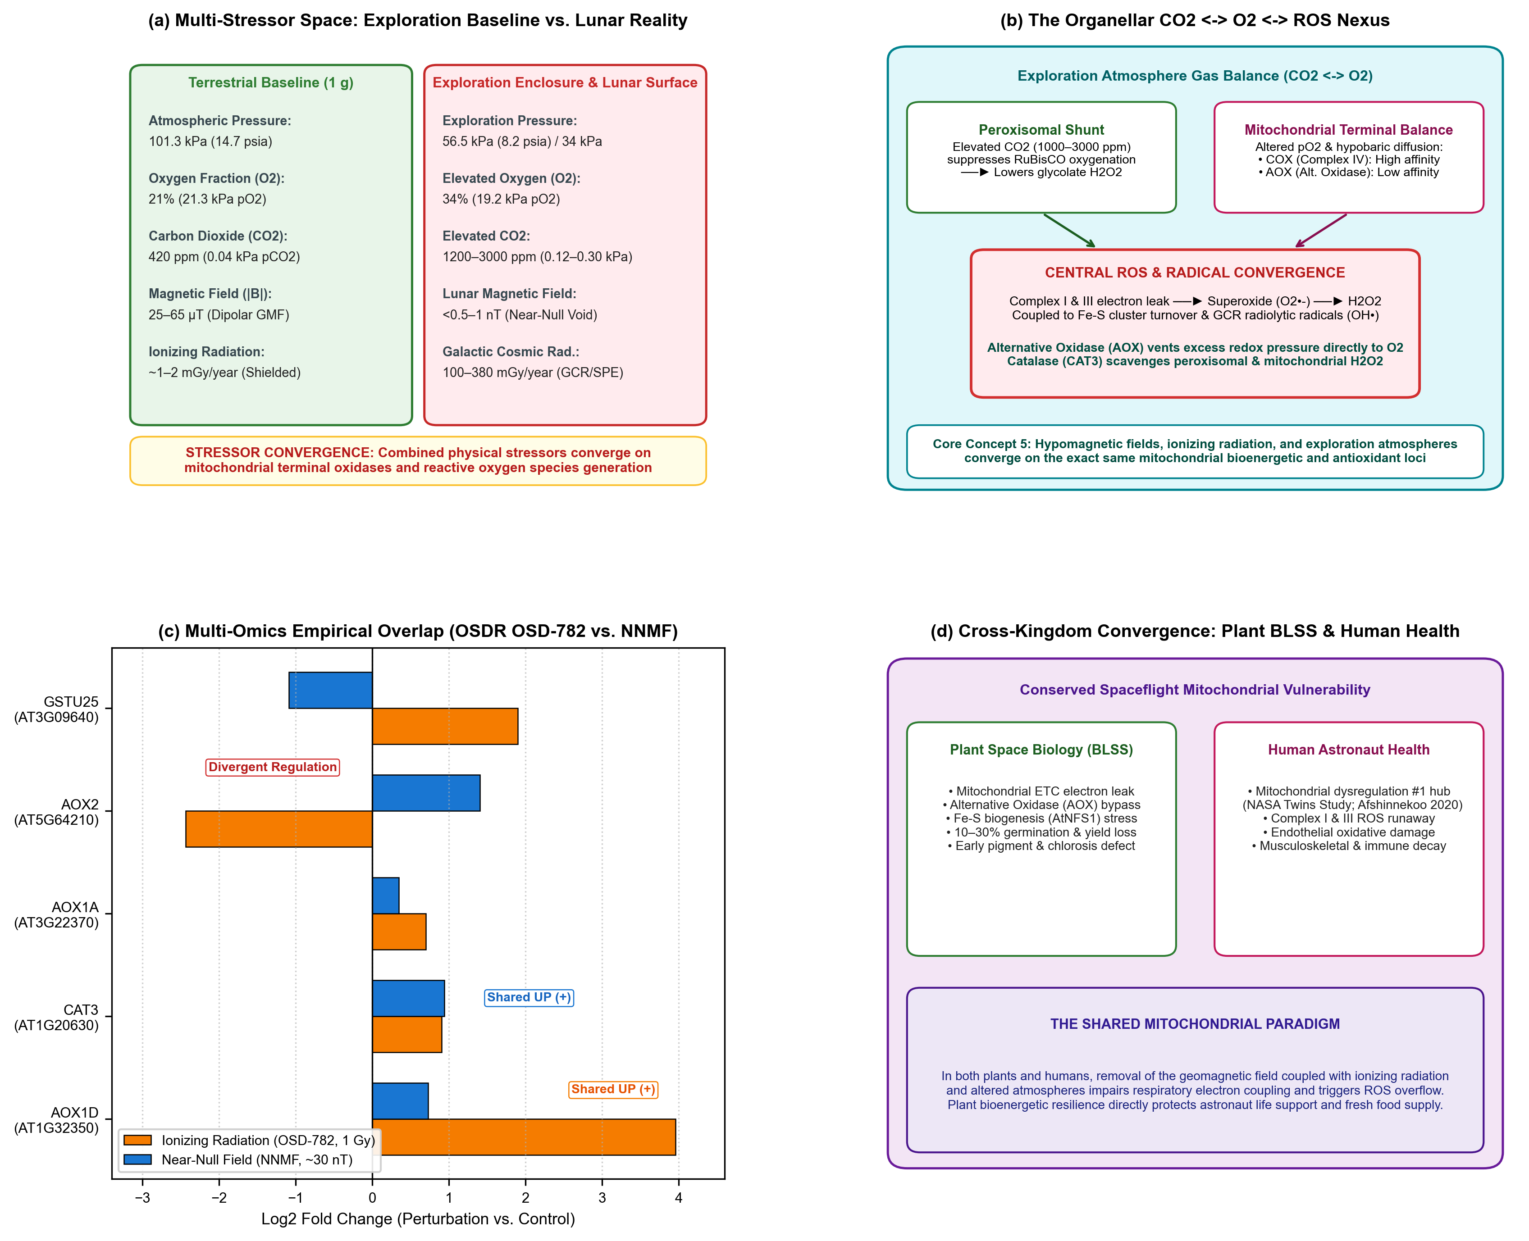 Figure 4 | Multi-stressor convergence on the organellar ${\text{CO}}_{2}↔{\text{O}}_{2}↔\text{ROS}$ nexus.
(a) Environmental Multi-Stressor Space: Physical parameters contrasting terrestrial baseline conditions ($101.3\text{ kPa}$, $21\% {\text{O}}_{2}$, $420{\text{ ppm CO}}_{2}$, $50 μ\text{T}$ GMF) against NASA exploration architectures ($56.5\text{ kPa}/8.2\text{ psia}$ to $34\text{ kPa}$, $34\% {\text{O}}_{2}$, $1200\text{–}3000{\text{ ppm CO}}_{2}$, $<0.8\text{ nT}$ lunar HMF, and $100\text{–}380\text{ mGy/year}$ GCR).
(b) The Organellar ${\text{CO}}_{2}↔{\text{O}}_{2}↔\text{ROS}$ Nexus: Exploration atmosphere gas balance shifts peroxisomal and mitochondrial pathways. Elevated ${\text{CO}}_{2}$ ($1200\text{–}3000\text{ ppm}$) favors RuBisCO carboxylation over oxygenation, suppressing photorespiratory glycolate ${\text{H}}_{2}{\text{O}}_{2}$ production. In mitochondria, hypobaric diffusion and altered $p{\text{O}}_{2}$ balance cytochrome $c$ oxidase (COX) against Alternative Oxidase (AOX). GCR radiolysis generates hydroxyl radicals (${\text{OH}}^{•}$), while NNMF modulates flavin/Fe-S spin dynamics at Complex I/III. The resulting superoxide ($O_{2}^{•−}$) and ${\text{H}}_{2}{\text{O}}_{2}$ flux is buffered by AOX (AOX1D) and scavenged by Catalase (CAT3).
(c) Multi-Omics Empirical Overlap (OSDR OSD-782 vs. Parmagnani 2022 NNMF): Concordant transcriptional response between ionizing radiation (cesium-137 gamma, 1 Gy, orange bars) and near-null field exposure (~30 nT, blue bars) in Arabidopsis. Both stressors induce robust upregulation of Alternative Oxidase 1D (AOX1D, AT1G32350; $+3.96 \log_{2}\text{FC}$ in radiation, $+0.73$ in NNMF) and Catalase 3 (CAT3, AT1G20630; $+0.91$ in radiation, $+0.94$ in NNMF). Non-concordant loci (AOX2, GSTU25) highlight gene-family divergence.
(d) Cross-Kingdom Spaceflight Convergence (Plant BLSS vs. Human Astronaut Health): Conserved spaceflight mitochondrial phenotype. In plants, the mitochondrial ETC, AOX bypass, and Fe-S cluster turnover buffer hypomagnetic and radiation stress to preserve BLSS crop yield. In astronauts, mitochondrial dysregulation represents the single most conserved systemic spaceflight lesion (NASA Twins Study; Afshinnekoo et al. [67]), linking plant bioenergetics directly to crew health and food security.

4.1 Exploration Atmosphere & The Gas Balance
NASA’s standard Exploration Atmosphere for lunar transit and surface habitat modules specifies a reduced total pressure of $56.5\text{ kPa}(8.2\text{ psia})$ with an elevated oxygen fraction of $34\% {\text{O}}_{2}$, providing an equivalent sea-level alveolar oxygen partial pressure ($p_{{\text{O}}_{2}}≈19.2\text{ kPa}$) to prevent hypoxia while reducing extravehicular activity (EVA) pre-breathe times [8,66]. Concurrently, human metabolic exhalation elevates cabin carbon dioxide levels to $1200\text{–}3000\text{ ppm}$ ($0.12\text{–}0.30\text{ kPa}p_{{\text{CO}}_{2}}$), roughly 3 to 7 times higher than Earth ambient levels ($420\text{ ppm}$) [5,7].
This atmospheric regime fundamentally reshapes plant respiratory and photosynthetic metabolism: - Peroxisomal Photorespiration Suppression: In illuminated leaves, RuBisCO catalyzes both carboxylation ($CO_{2}$ fixation into 3-PGA) and oxygenation ($O_{2}$ fixation yielding 2-phosphoglycolate). Elevated ${\text{CO}}_{2}$ ($>1200\text{ ppm}$) competitively inhibits RuBisCO oxygenation, suppressing the photorespiratory cycle. Because photorespiration shunts glycolate to peroxisomes where glycolate oxidase produces vast quantities of ${\text{H}}_{2}{\text{O}}_{2}$, elevated ${\text{CO}}_{2}$ drastically lowers peroxisomal ${\text{H}}_{2}{\text{O}}_{2}$ production [40,68]. - Mitochondrial Oxygen Terminal Balance: While peroxisomal ROS generation declines under high ${\text{CO}}_{2}$, hypobaric pressure accelerates gas diffusivity, altering intracellular dissolved $O_{2}$ concentrations in dense seed and root tissues. Mitochondria possess two terminal oxidases with dramatically different oxygen affinities [60]: 1. Cytochrome $c$ Oxidase (COX, Complex IV): High affinity for $O_{2}$ ($K_{m}<0.14 μ\text{M}$); coupled to proton extrusion across the inner membrane; generates ATP. 2. Alternative Oxidase (AOX): Cyanide-resistant, non-proton-pumping terminal oxidase with much lower affinity for $O_{2}$ ($K_{m}≈10\text{–}20 μ\text{M}$). AOX directly transfers electrons from the reduced ubiquinol pool to molecular oxygen, reducing ${\text{O}}_{2}$ to water while releasing energy entirely as heat [60,69].
Under conditions where the cytochrome pathway is saturated, restricted, or damaged by spaceflight stressors, AOX acts as an essential emergency pressure-relief valve, preventing electron over-reduction of the ubiquinone pool and suppressing electron leakage to $O_{2}$ that would otherwise generate toxic superoxide ($O_{2}^{•−}$) at Complexes I and III [60,70].

4.2 Multi-Omics Empirical Convergence: Radiation vs. Near-Null Fields
In deep space, chronic Galactic Cosmic Radiation (GCR, high-energy protons and HZE nuclei) and episodic Solar Particle Events deposit ionizing energy into biological tissues. Radiation generates free radicals directly through water radiolysis (${\text{H}}_{2}\text{O}→{\text{OH}}^{•}+{\text{H}}^{•}+e_{\text{aq}}^{−}$) and oxidizes delicate $[4\text{Fe}−4\text{S}]$ and $[2\text{Fe}−2\text{S}]$ clusters in mitochondrial complexes [71,72].
To test whether ionizing radiation and near-null magnetic fields engage shared genetic and metabolic networks, we interrogated multi-omics datasets from the NASA Open Science Data Repository (OSDR), specifically comparing OSD-782 (Arabidopsis exposed to low-dose cesium-137 gamma radiation, 1 Gy, 1–72 h) against the definitive near-null magnetic field transcriptomic dataset of Parmagnani et al. [73] (~30 nT vs. GMF, 10 min–96 h) via the Quantum Biology Atlas overlap pipeline [55] (Figure 4c).
The cross-perturbation overlap reveals striking, concordant induction of key mitochondrial bioenergetic and antioxidant loci: - Alternative Oxidase 1D (AOX1D, AT1G32350): Markedly upregulated under 1 Gy ionizing radiation ($+3.957 \log_{2}\text{FC}$ at 72 h) and significantly induced under near-null magnetic field exposure ($+0.731 \log_{2}\text{FC}$ at 48 h). In both perturbations, the cell actively upregulates AOX1D to vent excessive electron pressure from an over-reduced mitochondrial electron transport chain. - Catalase 3 (CAT3, AT1G20630): Concordantly upregulated under both ionizing radiation ($+0.906 \log_{2}\text{FC}$ at 72 h) and near-null magnetic field ($+0.941 \log_{2}\text{FC}$ at 4 h). CAT3 is the primary peroxisomal and mitochondrial catalase responsible for scavenging ${\text{H}}_{2}{\text{O}}_{2}$ generated during metabolic stress and reserve mobilization. - Alternative Oxidase 1A (AOX1A, AT3G22370): Upregulated under radiation ($+0.702 \log_{2}\text{FC}$) and elevated under NNMF ($+0.345 \log_{2}\text{FC}$). - Gene-Family Divergence: Notably, while AOX1D rises under both stressors, AOX2 (AT5G64210) falls under radiation ($−2.434 \log_{2}\text{FC}$) but rises under NNMF ($+1.406 \log_{2}\text{FC}$). This divergence underscores that entire gene families do not act as monolithic units; specific isoforms execute distinct regulatory roles in response to radiolytic versus magnetic perturbations.

4.3 Cross-Kingdom Parallels with Human Astronaut Mitochondrial Health
Crucially, the mitochondrial ${\text{CO}}_{2}↔{\text{O}}_{2}↔\text{ROS}$ bioenergetic lesion is not unique to plants; it represents the universal cellular hallmark of spaceflight across all eukaryotic biology [67,74] (Figure 4d).
In a comprehensive multi-omics analysis of 59 astronauts and NASA Twins Study data, Afshinnekoo et al. [67] demonstrated that mitochondrial dysregulation is the single most consistent systemic spaceflight phenotype in humans. Long-duration spaceflight impairs mitochondrial oxidative phosphorylation, downregulates Complex I and IV subunits, triggers electron leakage and chronic ROS overflow, and elevates circulating cell-free mitochondrial DNA (cf-mtDNA), contributing to astronaut immune suppression, cardiovascular deconditioning, and musculoskeletal decay [67,75].
In mammalian cellular and rodent models, hypomagnetic field exposure exacerbates this mitochondrial decay: Mo et al. [76,77] demonstrated that shielding the geomagnetic field suppresses osteoblast differentiation, accelerates bone demineralization, and induces mitochondrial-mediated apoptosis in human neuroblastoma cells.
Thus, plants in a lunar greenhouse and astronauts in a lunar habitat share the exact same subcellular vulnerability. In plants, the cyanide-resistant AOX pathway provides a metabolic buffer that prevents catastrophic collapse. Engineering and breeding crops with enhanced mitochondrial electron buffering and antioxidant synthesis not only secures lunar agricultural productivity but also generates fresh, polyphenol-rich dietary countermeasures essential for protecting astronaut mitochondrial integrity [4,5].

5. Scientific Knowledge Gap Retirement, Ground Simulation Standards, and Flight Instrumentation Trade Space
The historical hypomagnetic literature has frequently suffered from contradictory findings and irreproducibility, stemming from inadequate environmental controls, lack of sham controls, and uncharacterized electromagnetic interference (EMI) [11,20,78]. To transition lunar magnetobiology into an operational scientific discipline for Artemis payloads, we formulate a standardized, four-stage framework separating laboratory ground standards from flight engineering realities (Figure 5).
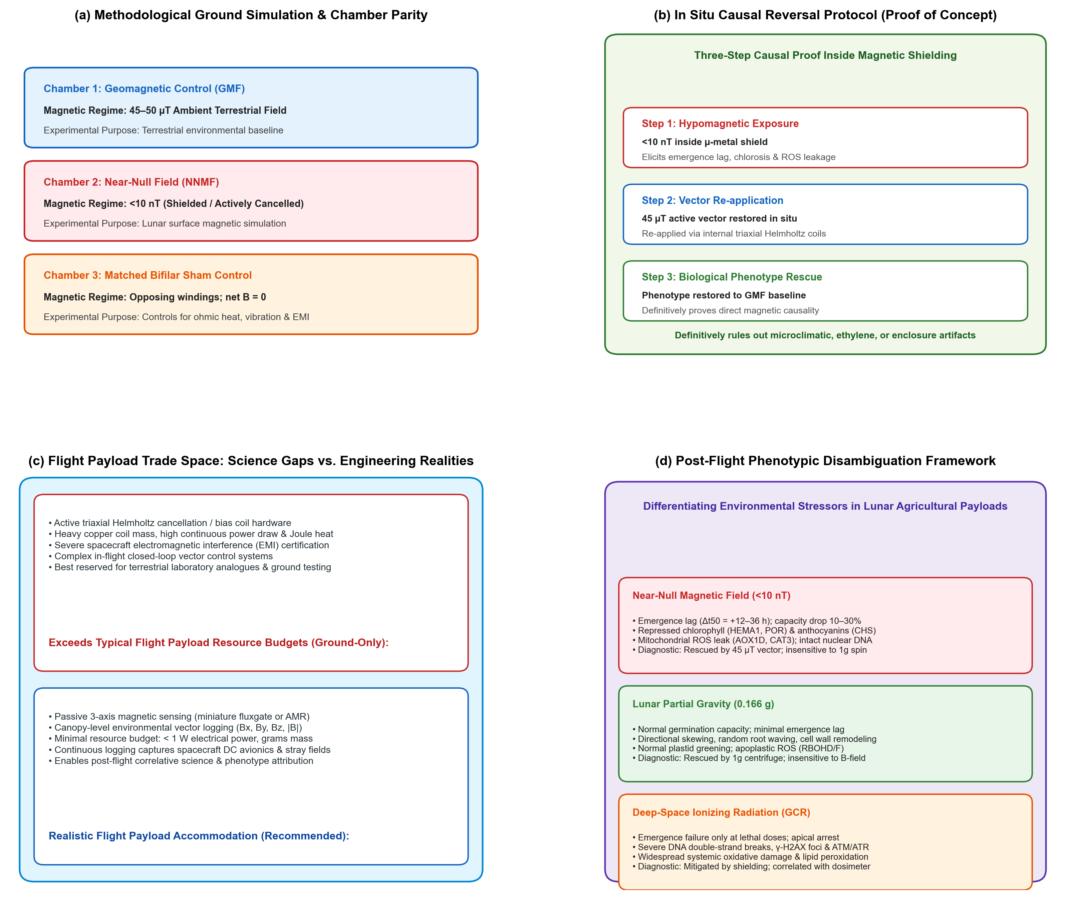 Figure 5 | Scientific knowledge gap retirement, ground simulation standards, and flight instrumentation trade space.
(a) Methodological Ground Simulation Standards: Parallel three-chamber experimental architecture ensuring strict environmental parity ($22±1^{∘}\text{C}$, $60±5\% \text{RH}$, $150 μ{\text{mol m}}^{−2}{\text{s}}^{−1}$ LED lighting, $420\text{ or }1200{\text{ ppm CO}}_{2}$): Chamber 1 (Geomagnetic Control, $45\text{–}50 μ\text{T}$ terrestrial baseline); Chamber 2 (Near-Null Field, $<10\text{ nT}$ achieved via passive $μ$-metal shielding or active cancellation); and Chamber 3 (Matched Bifilar Sham Control, carrying matched current through opposing bifilar windings to cancel the magnetic field while identically matching ohmic heating, vibration, and EMI).
(b) In Situ Causal Reversal Protocol (Proof of Concept): Three-step causal proof inside magnetic shielding. Step 1: Hypomagnetic exposure ($<10\text{ nT}$) elicits emergence lag, chlorosis, and mitochondrial ROS leakage. Step 2: Triaxial Helmholtz coils re-apply a calibrated Earth-like $45 μ\text{T}$ vector directly inside the shield. Step 3: Complete biological phenotype reversal to geomagnetic baseline formally proves magnetic causality, definitively ruling out enclosure, microclimatic, ethylene, or outgassing artifacts.
(c) Flight Payload Trade Space: Science Gaps vs. Engineering Realities: Delineating what flight payloads can realistically accommodate (passive 3-axis fluxgate/AMR canopy vector logging, $<1\text{ W}$, grams of mass, continuous DC-to-AC field capture, post-flight correlative science) versus what exceeds typical flight resource envelopes and should remain ground-based (active Helmholtz cancellation/bias coils, heavy copper mass, continuous power consumption, thermal dissipation, and spacecraft EMI certification hurdles).
(d) Post-Flight Phenotypic Disambiguation Framework: Diagnostic matrix translating empirical ground and flight telemetry to decouple overlapping environmental stressors in lunar agricultural payloads (Table 3), distinguishing Hypomagnetic Field lesions (emergence lag, cryptochrome-HY5 chlorosis, AOX1D induction without DNA breaks) from Lunar Partial Gravity ($0.166 g$; directional skewing, statolith displacement, apoplastic ROS) and Deep-Space Ionizing Radiation (dose-dependent cell cycle arrest, severe DNA double-strand breaks, $γ$-H2AX foci).

5.1 Stage 1: Ground Simulation Standards and Experimental Controls
A primary failure mode of historical hypomagnetic research is the confounding introduction of chamber microclimatic shifts, temperature gradients, and vibrational noise [11,20]. Whenever active coils or passive shielding are employed in ground research, investigators must maintain strict environmental parity across all treatments: - Temperature matched to $±{0.5}^{∘}\text{C}$ to eliminate thermal confounding. - Relative humidity maintained at $65±5\%$. - Lighting delivered at matched photosynthetically active radiation (PAR, $150±5 μ{\text{mol m}}^{−2}{\text{s}}^{−1}$) with identical spectral distributions. - Airflow and ventilation velocity ($0.3\text{–}0.5{\text{ m s}}^{−1}$) matched across chambers to prevent boundary layer resistance and ethylene accumulation artifacts [7,40].
Crucially, active coil cancellation systems introduce ohmic Joule heating, mechanical vibration, and electromagnetic ripple. To isolate the magnetic vector, researchers must deploy matched-current bifilar sham coils as an obligatory negative magnetic control [11,78] (Figure 5a). In a bifilar sham configuration, paired wires carry equal currents in opposite directions, producing complete net magnetic field cancellation while generating identical resistive heat, current loads, and acoustic vibration as the active cancellation coils. Any biological difference observed between the active near-null chamber and the bifilar sham chamber can then be unambiguously attributed to the magnetic vector itself.

5.2 Stage 2: In Situ Causal Reversal Protocol
To definitively exclude chamber enclosure, volatile organic compound (VOC), or microclimatic artifacts in terrestrial simulation facilities, research programs should execute the In Situ Causal Rescue Protocol [11,79] (Figure 5b): 1. Plants are cultivated within a magnetically shielded enclosure ($μ$-metal or active cancellation, $|B|<10\text{ nT}$), reproducing the hypomagnetic phenotype (germination delay, reduced elongation, chlorosis). 2. Inside the exact same shielded physical enclosure, an internal triaxial Helmholtz or Merritt coil system is energized to re-apply an Earth-normal geomagnetic vector ($45\text{–}50 μ\text{T}$). 3. If the developmental, transcriptomic, and photosynthetic phenotypes are completely rescued to Earth-baseline levels, magnetic causality is unequivocally established, eliminating non-magnetic enclosure artifacts.

5.3 Stage 3: Delineating Scientific Gaps from Flight Payload Engineering Constraints
A vital recommendation of this synthesis is that scientific knowledge gaps must be considered separately from what can realistically be engineered into a spaceflight payload (Figure 5c). In flight mission planning, hardware mass, power draw, thermal envelope, and contractual scope impose stringent boundary conditions: - Fundamental Scientific Knowledge Gaps: The primary gaps in space plant biology are the absence of sample-level magnetic field characterization in historical spaceflight data, the unmeasured nature of stray lander/spacecraft avionics DC fields at the biological volume, and the lack of ground-validated multi-stressor cross-talk models (hypomagnetic field combined with lunar partial gravity and cosmic radiation). - Realistic Flight Payload Engineering (Recommended): To retire the environmental characterization gap, flight payloads can incorporate miniature, ultra-low-power, calibrated 3-axis magnetometers (such as anisotropic magnetoresistive [AMR] or fluxgate sensors) placed at the plant canopy level [11]. These sensors require minimal resources ($<1\text{ W}$ electrical power, $<50\text{ g}$ mass) and provide continuous vector logging ($B_{x},B_{y},B_{z},|B|$) from DC to $10\text{ kHz}$. This telemetry enables post-flight science teams to correlate biological growth dynamics with the exact local magnetic exposure, decoupling true lunar hypomagnetic effects from lander avionics interference. - Constraints Beyond Flight Payloads (Ground-Only Architectures): Active triaxial Helmholtz cancellation or bias coils designed to dynamically alter or restore magnetic fields in flight impose heavy mass penalties (copper windings), continuous power draws ($5\text{–}25\text{ W}$), significant Joule heating, and severe spacecraft electromagnetic compatibility (EMC/EMI) certification hurdles. Such active intervention systems exceed typical payload resource envelopes and are appropriately prioritized for ground simulation facilities rather than initial lunar surface instruments.

5.4 Stage 4: Post-Flight Phenotypic Disambiguation and Translational Science Framework
Rather than imposing rigid contractual mission abort gates on flight hardware, space life scientists require a Post-Flight Phenotypic Disambiguation Framework to interpret seedling performance and identify the primary causal stressors operating on the lunar surface (Figure 5d; Table 3): - Hypomagnetic-Specific Lesions: Characterized by a marked emergence delay ($Δt_{50}=+12\text{ to }36\text{ h}$), reduced final germination capacity (10–30%), repressed chlorophyll and anthocyanin biosynthetic transcripts (HEMA1, POR, CHS), and mitochondrial Alternative Oxidase (AOX1D) induction in the absence of severe nuclear DNA damage. Diagnostic signature: rescued in ground analogues by 45 µT vector re-application; insensitive to 1g centrifugation. - Lunar Partial Gravity ($0.166 g$) Lesions: Characterized by normal germination capacity and minimal emergence lag ($Δt_{50}<4\text{ h}$), but exhibiting altered directional growth (root skewing, loss of gravitropic angle), amyloplast statolith displacement, and localized apoplastic ROS generation (RBOHD/F). Diagnostic signature: rescued by onboard 1g centrifugation; completely insensitive to magnetic field manipulation. - Ionizing Radiation Lesions: Characterized by normal germination at nominal background doses ($<1\text{ Gy}$), transitioning to severe cell cycle arrest, chromosomal aberrations, and stunted meristems at acute lethal doses ($>50\text{ Gy}$). Diagnostic signature: marked phosphorylation of histone $γ$-H2AX foci, ATM/ATR kinase activation, and high 8-OHdG oxidative DNA lesions; correlated directly with active dosimeter telemetry.
By deploying this multi-stressor diagnostic matrix, flight science teams can rigorously parse observed growth phenotypes into their underlying physical causes, informing future crop selection, seed sowing density adjustments, and lighting schedule optimizations for subsequent mission architectures.
Table 3 | Phenotypic risk disambiguation matrix for space plant biology. Diagnostic criteria to differentiate Near-Null Magnetic Fields from Lunar Partial Gravity and Deep-Space Ionizing Radiation during early seedling establishment.
Environmental Stressor | Primary Cellular Target | Emergence Kinetics & Germination | Seedling Elongation & Morphology | Photosynthetic Greening & Pigments | Mitochondrial & ROS Signature | Diagnostic Biomarkers | Disambiguation Strategy
Near-Null Magnetic Field (NNMF $<10\text{ nT}$) | Cryptochrome radical pairs $[{\text{FAD}}^{•−}⋯{\text{TrpH}}^{•+}]$; SDP1 lipid reserve mobilization | Marked emergence lag ($Δt_{50}=+12\text{–}36\text{ h}$); $10\text{–}30\%$ capacity drop | Retarded radicle and hypocotyl elongation; disrupted PIN2 basipetal auxin flow | Repressed HEMA1, CHLH, POR, CHS; delayed greening; secondary Fe-deficiency | Mitochondrial electron leakage at Complex I/III; induction of AOX1D and CAT3 | HEMA1 / POR repression; AOX1D / CAT3 induction; absent $γ$-H2AX foci | Fully rescued by in situ $45 μ\text{T}$ vector re-application; insensitive to 1g spin
Lunar Partial Gravity ($0.166 g$) / Microgravity | Amyloplast statolith sedimentation; mechanosensitive ion channels (MSL/MCA); PIN re-localization | Normal to slightly accelerated germination; negligible lag ($Δt_{50}<4\text{ h}$) | Loss of directional gravitropism; waving and skewing; cell wall xyloglucan remodeling (XTH) | Nominal chlorophyll and anthocyanin accumulation under adequate PAR; active HY5 | Localized apoplastic ROS (RBOHD/F) in root elongation zone; baseline mETC | Statolith displacement; re-localized PIN2/PIN3; induced expansins and XTH | Rescued by onboard 1g centrifuge; completely insensitive to static magnetic field
Deep-Space Ionizing Radiation (GCR / SPE) | Direct nuclear DNA ionization; radiolysis of ${\text{H}}_{2}\text{O}$ producing hydroxyl radicals (${\text{OH}}^{•}$) | Emergence arrest only at acute lethal doses ($>50\text{ Gy}$); normal at low doses | Mitotic cell cycle arrest in apical meristems; chromosomal bridges and stunting | General necrosis-induced chlorosis at severe doses; active protective anthocyanin induction | Widespread systemic ROS burst across nuclear and apoplastic compartments; lipid peroxidation | Phosphorylated $γ$-H2AX foci; ATM/ATR kinase activation; PARP1 / RAD51 repair | Independent of B-field or centrifuge; correlated with active dosimeter telemetry

6. Conclusions & Forward Look for Sustained Lunar Agriculture
As humanity prepares for sustained surface operations under the Artemis program and looks forward to permanent lunar bases, space agricultural engineering must mature beyond treating gravity and radiation as the sole planetary variables.
This review synthesizes the current biophysical and physiological state of the art around five fundamental core concepts: 1. Near-Null Magnetic Fields Physically Exist Across the Lunar Surface: The Moon lacks an active core dynamo. Example candidate Artemis South Pole exploration regions (such as Shackleton, Haworth, and Faustini) reside in an extreme magnetic void ($<0.8\text{ nT}$), more than $30,000×$ weaker than Earth’s geomagnetic field. Payload architectures must account for vector superposition ($B_{\text{total}}$) to prevent stray lander avionics fields ($50\text{–}500 μ\text{T}$) from confounding biological exposures. 2. Null Magnetic Fields Alter Germination Capacity: Removal of the geomagnetic field impairs seed imbibition kinetics and alters the ABA/GA hormonal balance, reducing total germination capacity and decreasing the absolute number (#) of viable seedlings established per sown area by $10\text{ to }30\%$. 3. Null Magnetic Fields Alter Germination Speed and Growth Kinetics: Near-null fields introduce a substantial emergence lag ($Δt_{50}$ delay of 12–36 h) and retard radicle and hypocotyl elongation rates by dampening cell proliferation and PIN2-mediated auxin transport, leading to a $20\text{–}30\%$ penalty in early seedling biomass and fresh material yield. 4. Null Magnetic Fields Repress Pigment Biosynthetic Networks: Cryptochrome radical-pair spin dynamics are altered in near-null fields, attenuating HY5 stabilization and downregulating rate-limiting enzymes of chlorophyll (HEMA1, CHLH, POR) and anthocyanin (CHS, CHI) biosynthesis, while secondary iron starvation (FIT, IRT1, AtFer1–4) triggers seedling chlorosis during de-etiolation. 5. Multi-Stressor Convergence on the ${\text{CO}}_{2}↔{\text{O}}_{2}↔\text{ROS}$ Bioenergetic Axis: Near-null magnetic fields, exploration atmospheres (hypobaric $56.5\text{ kPa}$, $34\% {\text{O}}_{2}$, elevated $1200\text{–}3000{\text{ ppm CO}}_{2}$), and ionizing radiation converge on the exact same mitochondrial respiratory machinery. In both plants and human astronauts, mitochondrial electron leakage and reactive oxygen generation represent the primary cellular lesion. In plants, induction of the Alternative Oxidase (AOX1D) and Catalase (CAT3) provides an essential metabolic safety valve that buffers organellar redox stress.
For the NASA LEAF payload and subsequent lunar greenhouse deployments, immediate engineering priorities can consider incorporating calibrated 3-axis magnetic sensors at the plant canopy, implementing matched-current bifilar sham baselines during ground testing, and validating active causal rescue in terrestrial laboratories. By mastering the hypomagnetic variable during the critical first five days of seedling growth, space life scientists can ensure robust stand establishment, maximize crop biomass yields, and secure the bioregenerative life support systems essential for humanity’s permanent expansion into deep space.

Acknowledgements
This work was supported by NASA Biological and Physical Sciences (BPS) awards and internal institutional support from the Department of Agricultural and Biological Engineering and the Department of Earth, Atmospheric, and Planetary Sciences at Purdue University. The authors thank the members of the NASA LEAF payload science team and the NASA GeneLab / Open Science Data Repository (OSDR) Plant AWG for insightful discussions regarding spaceflight multi-omics and environmental sensor integration.

Author Contributions
D.M.P. and R.J.B. conceived and designed the review framework. R.J.B. compiled the multi-omics overlap analyses and generated the figures. C.B. and A.O. analyzed the lunar orbital magnetometer datasets and landing site coordinates. A.S., M.D., and S.L.A. contributed to literature synthesis on seed germination kinetics and pigment biosynthesis. R.W., G.M., and B.D.-A. contributed expertise on space crop production, exploration atmospheres, and photosynthetic bioenergetics. M.P.-L., P.F., A.D., and C.C. contributed to payload engineering requirements and causal validation pipelines. All authors contributed to writing, critical revision, and approved the final manuscript.

Competing Interests
D.M.P. is a Co-Investigator on the NASA Artemis III LEAF payload; C.C. is affiliated with Space Lab Technologies, LLC. These roles are disclosed with no commercial or financial conflicts of interest. The remaining authors declare no competing interests.

Data Availability
All planetary magnetic field datasets analyzed in this manuscript are openly available from the NASA Planetary Data System (PDS) and JAXA DARTS archives. Gene expression datasets are accessible via the NASA Open Science Data Repository (OSDR, studies OSD-782, OSD-8, and OSD-27). Code for figure generation and pathway maps is hosted in the project repositories (lunar-magnetic-biology and quantum-biology-atlas).

References
- NASA. NASA selects first science instruments for astronauts to deploy on Moon. NASA Press Release 24-046 (26 March 2024). https://www.nasa.gov/news-release/nasa-selects-first-science-instruments-for-astronauts-to-deploy-on-moon/
- Maffei, M. E., Balestrini, R., Costantino, P. & Lanfranco, L. The physiology of plants in the context of space exploration. Commun. Biol. 7, 1311 (2024). https://doi.org/10.1038/s42003-024-06989-7
- Fountain, L. L. et al. Expanding frontiers: harnessing plant biology for space exploration and planetary sustainability. New Phytol. 249, 656–669 (2026). https://doi.org/10.1111/nph.70662
- Wheeler, R. M. Agriculture for space: People and places paving the way. Open Agric. 2, 14–32 (2017). https://doi.org/10.1515/opag-2017-0002
- Massa, G. D. et al. Selection of leafy green vegetable crops for a space mission. Gravit. Space Res. 3, 32–40 (2015).
- Space Lab Tech. Lunar Effects on Agricultural Flora (LEAF) selected for Artemis III surface deployment. Space Lab Technologies News (April 2024).
- Paul, A.-L., Wheeler, R. M., Levine, H. G. & Ferl, R. J. Fundamental plant biology in spaceflight. Adv. Space Res. 51, 501–510 (2013). https://doi.org/10.1016/j.asr.2012.09.038
- Norcross, C. J. et al. Exploration Atmosphere: NASA’s plan for reduced pressure and elevated oxygen for future human space missions. 48th International Conference on Environmental Systems, ICES-2018-199 (2018).
- Ferl, R. J. & Paul, A.-L. The genome of Arabidopsis thaliana in spaceflight. Genome Biol. 17, 155 (2016). https://doi.org/10.1186/s13059-016-1011-3
- Sarimov, R. M., Serov, D. A. & Gudkov, S. V. Hypomagnetic conditions and their biological action. Biology 12, 1513 (2023). https://doi.org/10.3390/biology12121513
- Porterfield, D. M. & Barker, R. J. Plant responses to near-null magnetic fields: Geomagnetism, bioenergetics, and primary metabolism in Arabidopsis and Brassica. Perspectives in Space Biology (in press, 2026).
- Maffei, M. E. Magnetic field effects on plant growth, development, and evolution. Front. Plant Sci. 5, 445 (2014). https://doi.org/10.3389/fpls.2014.00445
- Finlay, C. C. et al. International Geomagnetic Reference Field: the thirteenth generation. Earth Planets Space 72, 156 (2020). https://doi.org/10.1186/s40623-020-01252-9
- Halekas, J. S. et al. Solar wind interaction with lunar crustal magnetic anomalies. Planet. Space Sci. 56, 941–946 (2008). https://doi.org/10.1016/j.pss.2008.01.008
- Borlina, C. S. et al. Re-evaluating the lunar dynamo: Constraints from Apollo sample paleomagnetism and orbital magnetic mapping. Earth Planet. Sci. Lett. 584, 117446 (2022).
- Mitchell, D. L., Halekas, J. S. & Lin, R. P. Global mapping of lunar crustal magnetic fields by Lunar Prospector. Icarus 194, 401–409 (2008). https://doi.org/10.1016/j.icarus.2007.10.027
- Tsunakawa, H. et al. Surface vector mapping of magnetic anomalies over the Moon using Kaguya and Lunar Prospector observations. J. Geophys. Res. Planets 120, 1160–1185 (2015). https://doi.org/10.1002/2014JE004785
- Hood, L. L. et al. Magnetic anomalies at the lunar South Pole: Implications for Artemis landing sites. J. Geophys. Res. Planets 127, e2022JE007280 (2022).
- Hoffmann, A. P. et al. Enhancing magnetic field analysis on the KMAG instrument: applying WAIC-UP for spacecraft interference removal and interpolating data gaps. Earth Space Sci. 12, e2025EA004427 (2025). https://doi.org/10.1029/2025EA004427
- Binhi, V. N. & Prato, F. S. Biological effects of the hypomagnetic field: an analytical review of experiments and theories. PLoS ONE 12, e0179340 (2017). https://doi.org/10.1371/journal.pone.0179340
- Zhang, Z. et al. Biological effects of hypomagnetic field: ground-based data for space exploration. Bioelectromagnetics 42, 516–531 (2021). https://doi.org/10.1002/bem.22360
- Kyriacou, M. C. et al. Microgreens: Novel fresh and functional food to explore all the way from plate to space. Trends Food Sci. Technol. 110, 377–389 (2021). https://doi.org/10.1016/j.tifs.2021.01.080
- Bewley, J. D. Seed germination and dormancy. Plant Cell 9, 1055–1066 (1997). https://doi.org/10.1105/tpc.9.7.1055
- Gommers, C. M. & Monte, E. Seedling establishment: A dimmer switch-regulated process between dark and light signaling. Plant Physiol. 176, 1061–1074 (2017). https://doi.org/10.1104/pp.17.01460
- Finkelstein, R., Reeves, W., Ariizumi, T. & Steber, C. Molecular aspects of seed dormancy. Annu. Rev. Plant Biol. 59, 387–415 (2008). https://doi.org/10.1146/annurev.arplant.59.032607.092740
- Belyavskaya, N. A. Biological effects due to weak magnetic field on plants. Adv. Space Res. 34, 1566–1574 (2004). https://doi.org/10.1016/j.asr.2004.01.021
- Novitskii, Y. I., Novitskaya, G. V. & Kocheshkova, T. K. Growth of radish seedlings in a hypomagnetic field. Russ. J. Plant Physiol. 61, 667–676 (2014).
- Xu, C., Wei, S. & Lü, Y. Removal of the local geomagnetic field affects reproductive growth in Arabidopsis. Bioelectromagnetics 34, 437–442 (2013). https://doi.org/10.1002/bem.21788
- Negishi, Y. et al. Growth and development of Arabidopsis thaliana under hypomagnetic conditions. Space Util. Res. 15, 14–17 (1999).
- Kordyum, E. L. & Guikema, J. A. Plants in space: Changes in the cellular and organellar architecture. Int. J. Astrobiol. 19, 391–406 (2020).
- Tang, J., Wu, Z., Sun, Z., Liu, H. & Liu, H. Lunar magnetism impairs wheat seedling photosynthesis: a simulated environment study. Plant Physiol. Biochem. 216, 109156 (2024). https://doi.org/10.1016/j.plaphy.2024.109156
- Podleśny, J., Pietruszewski, S. & Podleśna, A. Efficiency of magnetic treatment of broad bean seeds cultivated under drought conditions. Int. Agrophys. 19, 65–71 (2005).
- Nonogaki, H., Bassel, G. W. & Bewley, J. D. Germination—still a mystery. Plant Sci. 179, 574–581 (2010). https://doi.org/10.1016/j.plantsci.2010.02.010
- Shine, M. B. & Guruprasad, K. N. Impact of pre-sowing magnetic field treatment on seed germination, seedling growth, and enzymatic antioxidant defense system in soybean. Physiol. Mol. Biol. Plants 18, 325–334 (2012).
- Xu, C., Yu, Y., Zhang, Y., Li, Y. & Wei, S. Gibberellins are involved in effect of near-null magnetic field on Arabidopsis flowering. Bioelectromagnetics 38, 1–10 (2017). https://doi.org/10.1002/bem.22004
- Xu, C., Zhang, Y., Yu, Y., Li, Y. & Wei, S. Suppression of Arabidopsis flowering by near-null magnetic field is mediated by auxin. Bioelectromagnetics 39, 15–24 (2018). https://doi.org/10.1002/bem.22086
- Narayana, R. et al. Near-null magnetic field alters root growth and PIN2 polar auxin transporter distribution in Arabidopsis thaliana. Bioelectromagnetics 39, 361–374 (2018).
- Belyavskaya, N. A. Ultrastructure of meristematic cells of pea roots grown in a hypomagnetic field. Biophysics 46, 953–958 (2001).
- Fiorillo, A. et al. 14-3-3 proteins and the plasma membrane ${\text{H}}^{+}$-ATPase are involved in maize magnetic induction. Plants 12, 2887 (2023). https://doi.org/10.3390/plants12152887
- Wheeler, R. M. Carbon dioxide effects on plants: Implications for space exploration. Front. Astron. Space Sci. 8, 780074 (2021). https://doi.org/10.3389/fspas.2021.780074
- Douglas, G. L. et al. Nutrition and food systems for exploration missions. NASA Human Research Program Technical Report (2020).
- Solymosi, K. & Schoefs, B. Etioplast and etio-chloroplast formation under natural and laboratory conditions. Front. Plant Sci. 9, 1709 (2018). https://doi.org/10.3389/fpls.2018.01709
- Tanaka, R. & Tanaka, A. Tetrapyrrole biosynthesis in higher plants. Annu. Rev. Plant Biol. 58, 321–346 (2007). https://doi.org/10.1146/annurev.arplant.57.032905.105448
- Parmagnani, A. S. et al. The geomagnetic field is required for Lima bean photosynthesis and reactive oxygen species production. Int. J. Mol. Sci. 24, 2896 (2023). https://doi.org/10.3390/ijms24032896
- Agliassa, C. et al. Reduction of the geomagnetic field delays Arabidopsis thaliana flowering time through downregulation of flowering-related genes. Bioelectromagnetics 39, 361–374 (2018). https://doi.org/10.1002/bem.22123
- Maffei, M. E. et al. Peppermint (Mentha $×$ piperita) response to near-null magnetic field involves modulated monoterpene and flavonoid biosynthesis. J. Plant Res. 134, 823–834 (2021).
- Gangappa, S. N. & Botto, J. F. The multifaceted roles of HY5 in plant growth and development. Mol. Plant 9, 1353–1365 (2016). https://doi.org/10.1016/j.molp.2016.07.002
- Toledo-Ortiz, G. et al. The HY5 transcription factor integrates blue-light and hormonal cues to drive plastid development. Plant Cell 26, 1392–1407 (2014).
- Hore, P. J. & Mouritsen, H. The radical-pair mechanism of magnetoreception. Annu. Rev. Biophys. 45, 299–344 (2016). https://doi.org/10.1146/annurev-biophys-032116-094545
- Solov’yov, I. A., Chandler, D. E. & Schulten, K. Magnetic field effects in Arabidopsis thaliana cryptochrome-1. Biophys. J. 92, 2711–2726 (2007). https://doi.org/10.1529/biophysj.106.097139
- Ahmad, M., Galland, P., Ritz, T., Wiltschko, R. & Wiltschko, W. Magnetic intensity affects cryptochrome-dependent responses in Arabidopsis thaliana. Planta 225, 615–624 (2007). https://doi.org/10.1007/s00425-006-0383-0
- Briat, J.-F., Duc, C., Ravet, K. & Gaymard, F. Ferritins and iron storage in plants. Biochim. Biophys. Acta 1800, 806–814 (2010). https://doi.org/10.1016/j.bbagen.2009.12.003
- Islam, M., Maffei, M. E. & Vigani, G. The geomagnetic field is a contributing factor for an efficient iron uptake in Arabidopsis thaliana. Front. Plant Sci. 11, 325 (2020). https://doi.org/10.3389/fpls.2020.00325
- Islam, M., Vigani, G. & Maffei, M. E. The geomagnetic field modulates nutrient status and lipid metabolism during Arabidopsis thaliana plant development. Plants 9, 1729 (2020). https://doi.org/10.3390/plants9121729
- Barker, R. J. & Porterfield, D. M. Quantum Biology Atlas: A cross-species ontology, pathway compiler, and multi-omics projection toolkit for quantum biological mechanisms. Zenodo / GitHub https://github.com/dr-richard-barker/quantum-biology-atlas (2026).
- Meyer, E. H., Welchen, E. & Carrie, C. Assembly of the complexes of the oxidative phosphorylation system in plant mitochondria. Physiol. Plant. 157, 294–309 (2016).
- Maeda, K. et al. Chemical compass model of avian magnetoreception. Nature 453, 387–390 (2008). https://doi.org/10.1038/nature06834
- Pooam, M. et al. Magnetic sensitivity mediated by the Arabidopsis blue-light receptor cryptochrome occurs during flavin reoxidation in the dark. Planta 249, 319–332 (2019). https://doi.org/10.1007/s00425-018-3002-y
- Demmig-Adams, B. & Adams, W. W. Photoprotection in an ecological context: the remarkable diversity of extreme-energy dissipation mechanisms. Funct. Plant Biol. 45, 697–711 (2018).
- Vanlerberghe, G. C. Alternative Oxidase: A mitochondrial respiratory pathway to maintain metabolic and signaling homeostasis during abiotic and biotic stress in plants. Int. J. Mol. Sci. 14, 6805–6847 (2013). https://doi.org/10.3390/ijms14046805
- Zadeh-Haghighi, H. & Simon, C. Magnetic field effects in biology from the perspective of the radical pair mechanism. J. R. Soc. Interface 19, 20220325 (2022). https://doi.org/10.1098/rsif.2022.0325
- Miloslavina, Y. et al. Charge separation kinetics in intact photosystem II core particles is trap-limited: a picosecond fluorescence study. Biochemistry 45, 2436–2442 (2006). https://doi.org/10.1021/bi052248c
- Vass, I. Role of charge recombination processes in photodamage and photoprotection of the photosystem II complex. Physiol. Plant. 142, 6–16 (2011). https://doi.org/10.1111/j.1399-3054.2011.01454.x
- Sarewicz, M. et al. Triplet state of the semiquinone-Rieske cluster as an intermediate of electronic bifurcation catalyzed by cytochrome $bc_{1}$. Biochemistry 52, 6388–6395 (2013). https://doi.org/10.1021/bi400624m
- Bujnowicz, Ł. et al. Suppression of superoxide production by a spin-spin coupling between semiquinone and the Rieske cluster in cytochrome $bc_{1}$. FEBS Lett. 593, 3–12 (2019). https://doi.org/10.1002/1873-3468.13296
- Richards, J. T. et al. Hypobaric plant growth in spaceflight: Design, gas diffusion, and physiological adaptation. Gravit. Space Biol. Bull. 19, 101–114 (2006).
- da Silveira, W. A. et al. Comprehensive multi-omics analysis reveals mitochondrial stress as a central biological hub for spaceflight impact. Cell 183, 1185–1201 (2020). https://doi.org/10.1016/j.cell.2020.11.002
- Bauwe, H., Hagemann, M. & Fernie, A. R. Photorespiration: players, partners and origin. Trends Plant Sci. 15, 330–336 (2010). https://doi.org/10.1016/j.tplants.2010.03.006
- Moore, A. L. & Siedow, J. N. The regulation and nature of the cyanide-resistant alternative oxidase of plant mitochondria. Biochim. Biophys. Acta 1059, 121–140 (1991).
- Maxwell, D. P., Wang, Y. & McIntosh, L. The alternative oxidase lowers mitochondrial reactive oxygen production in plant cells. Proc. Natl. Acad. Sci. USA 96, 8271–8276 (1999). https://doi.org/10.1073/pnas.96.14.8271
- Arena, C. et al. Plants in space: Responses to ionizing radiation and interaction with microgravity. Front. Plant Sci. 5, 550 (2014). https://doi.org/10.3389/fpls.2014.00550
- Cucinotta, F. A. & Durante, M. Cancer risk from exposure to galactic cosmic rays: implications for early exploration missions. Lancet Oncol. 7, 431–435 (2006).
- Parmagnani, A. S., Mannino, G. & Maffei, M. E. Transcriptomics and metabolomics of reactive oxygen species modulation in near-null magnetic field-induced Arabidopsis thaliana. Biomolecules 12, 1824 (2022). https://doi.org/10.3390/biom12121824
- Garrett-Bakelman, F. E. et al. The NASA Twins Study: A multidimensional analysis of a year-long human spaceflight. Science 364, eaau8650 (2019). https://doi.org/10.1126/science.aau8650
- Da Silveira, W. A. et al. Comprehensive multi-omics analysis reveals mitochondrial dysfunction as a central mechanism of spaceflight-induced systemic stress. Cell 183, 1185–1201 (2020).
- Mo, W. C. et al. Hypomagnetic field alters human neuroblastoma cell cycle kinetics and transcriptomic networks. PLoS ONE 7, e44650 (2012).
- Xu, C. et al. Hypomagnetic field promotes osteoclastogenesis and suppresses osteoblastogenesis in rat bone marrow cell cultures. Bioelectromagnetics 33, 685–694 (2012).
- Harris, S.-R. et al. Effect of magnetic fields on cryptochrome-dependent responses in Arabidopsis thaliana. J. R. Soc. Interface 6, 1193–1205 (2009). https://doi.org/10.1098/rsif.2008.0519
- Albaqami, M. et al. Arabidopsis cryptochrome is responsive to radiofrequency electromagnetic fields. Sci. Rep. 10, 11260 (2020). https://doi.org/10.1038/s41598-020-67165-5
- Williams, P. H. Rapid-cycling Brassica species in laboratory research and education. In: Tested Studies for Laboratory Teaching (ed. C. A. Goldman), Proceedings of the 10th Workshop/Conference of the Association for Biology Laboratory Education (ABLE), Vol. 10, pp. 1–16 (1989). https://www.ableweb.org/biologylabs/wp-content/uploads/volumes/vol-10/1-williams.pdf

