Conserved mitochondrial suppression and organelle-specific transcriptomic responses to spaceflight across six eukaryotic species
Cross-species meta-analysis | NASA OSDR | OrthoDB v12 | 22 datasets | 6 species
Richard Barker | 2026

Abstract
Spaceflight induces transcriptomic changes across organisms, but the extent to which subcellular and metabolic pathways are conserved across species remains poorly understood. We performed a cross-species meta-analysis of 22 transcriptomic datasets from the NASA Open Science Data Repository spanning six eukaryotic species (Homo sapiens, Mus musculus, Drosophila melanogaster, Caenorhabditis elegans, Saccharomyces cerevisiae, and Arabidopsis thaliana), encompassing 20,333 differentially expressed genes (DEGs). Using a human-anchored orthology matrix built from OrthoDB v12 (18,030 genes, 651 with orthologs in all five other species), we mapped DEGs to 16 subcellular compartments and applied Fisher's combined probability test to identify conserved organelle-level responses. We report a striking conserved downregulation of mitochondrial genes: 49 orthologs show significant, direction-consistent suppression across at least three species (Fisher FDR < 0.05, minimum p = 7.7 x 10^-68), including components of Complex III (CYC1), Complex IV (COX5B, COX6A2, COX6B2), ATP synthase (ATP5F1A, ATP5PD), and the TCA cycle (IDH3A, IDH3B, IDH3G). In contrast, peroxisome, lipid droplet, and Golgi apparatus genes show conserved upregulation. KEGG pathway visualization with per-species log2FC overlays reveals that NAD+-dependent oxidative phosphorylation enzymes are divergently regulated (down in fly, up in human and mouse), while CoA-dependent TCA cycle enzymes are broadly conserved. These findings identify mitochondrial energy metabolism as a deeply conserved target of the spaceflight transcriptional response across a billion years of eukaryotic evolution.

Introduction
Spaceflight exposes organisms to a unique combination of environmental stressors including microgravity, cosmic radiation, altered atmospheric composition, and circadian disruption. These conditions induce measurable transcriptomic changes across diverse organisms, from yeast to humans [1,2]. The NASA Open Science Data Repository (OSDR) has accumulated hundreds of spaceflight omics datasets through the GeneLab consortium, providing an unprecedented opportunity for cross-species comparative analysis [3].
Individual species studies have identified recurrent themes in the spaceflight transcriptomic response, including altered energy metabolism, oxidative stress, immune dysregulation, and cytoskeletal remodeling [4,5]. However, most analyses have been conducted within single species, making it difficult to distinguish conserved fundamental responses from species-specific adaptations. A rigorous cross-species comparison requires orthology-based integration, which maps genes across species to their common ancestral equivalents.
Subcellular localization provides a functional organizing principle for interpreting transcriptomic changes. Gene Ontology Cellular Component (GOCC) enrichment can identify which organelles are coordinately regulated, and cross-species conservation of these organelle-level responses would suggest deeply rooted cellular mechanisms. Mitochondria are of particular interest given their central role in energy metabolism, oxidative stress response, and apoptosis, all of which are affected by spaceflight [6,7].
Here we present a cross-species meta-analysis of 22 spaceflight transcriptomic datasets spanning six eukaryotic species. We build a human-anchored orthology matrix using OrthoDB v12, perform subcellular location enrichment, and apply Fisher's combined probability test to identify conserved organelle-level responses. We further visualize conserved metabolic pathways with per-species expression overlays and map cofactor dependencies. Our analysis reveals that mitochondrial gene suppression is the most robustly conserved subcellular response to spaceflight across a billion years of eukaryotic evolution.

Results

Dataset overview and differential expression
We queried the NASA OSDR Biological Data API for RNA-seq and microarray datasets with spaceflight versus ground control contrasts across six species. The final selection comprised 22 datasets: 7 mouse, 4 human, 3 Arabidopsis, 3 fly, 4 worm (microarray), and 1 yeast (microarray) (Figure 1A). RNA-seq datasets used GeneLab Research Community Portal (RCP) pre-computed DESeq2 tables; microarray datasets used limma. For two datasets without pre-computed tables (OSD-96, OSD-35), we performed de novo differential expression analysis.
We applied tiered DEG thresholds to accommodate dataset-specific statistical power: standard (padj < 0.05, |log2FC| > 1) for 19 datasets, relaxed (padj < 0.10, |log2FC| > 0.5) for two low-power datasets, and nominal (p < 0.05, |log2FC| > 0.5) for one dataset without replicates. This yielded 20,333 DEGs total, with substantial variation across species: Arabidopsis (9,930), C. elegans (5,022), mouse (2,103), fly (1,881), human (1,366), and yeast (31) (Figure 1B). The low yeast count reflects the single microarray dataset with a relaxed threshold. Across all species, 10,931 DEGs were upregulated and 9,402 downregulated in spaceflight relative to ground controls.
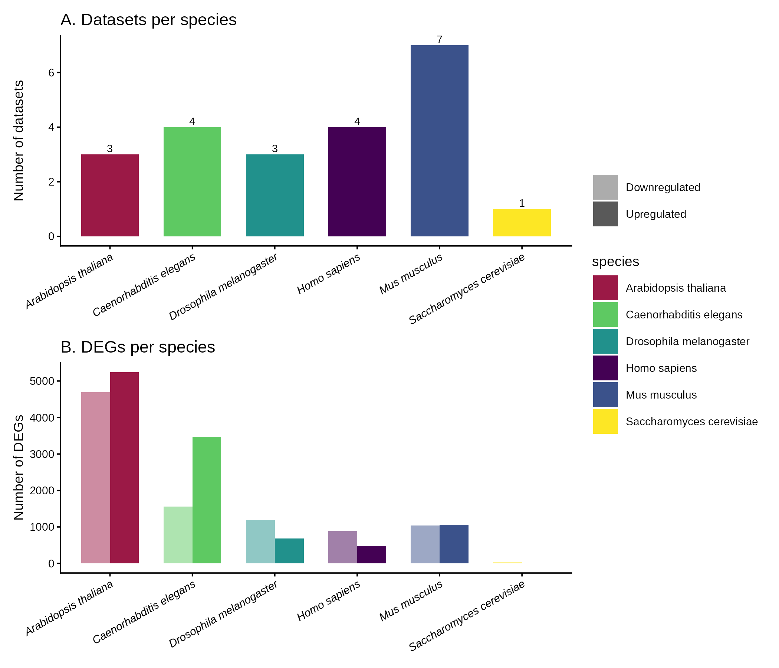
Figure 1. Study overview. (A) Number of OSDR datasets per species. (B) Number of differentially expressed genes (DEGs) per species, separated by direction (upregulated vs. downregulated in spaceflight). Species colors are fixed globally across all figures.

Human-anchored orthology mapping
To enable cross-species comparison, we built a human-anchored orthology matrix using OrthoDB v12 as the primary resource, supplemented by babelgene for human-to-mouse, fly, worm, and yeast mappings. Arabidopsis orthology was mapped via OrthoDB Eukaryota-level ortholog groups, as babelgene does not support plant species. The unified matrix comprises 18,030 human genes with at least one non-human ortholog, of which 651 have orthologs in all five other species, 3,446 in at least four, and 8,505 in at least three (Figure 3).
DEG-to-ortholog mapping rates varied substantially across species, reflecting both evolutionary distance and gene identifier compatibility: human 100%, mouse 70.7%, yeast 64.5%, fly 28.6%, worm 18.8%, and Arabidopsis 3.2%. The low Arabidopsis rate reflects the large plant-specific gene complement and the reliance on OrthoDB rather than babelgene for plant orthology. Despite this, 352 human orthologs were identified as DEGs in two or more species, and 33 in three or more, providing a robust foundation for conservation analysis.
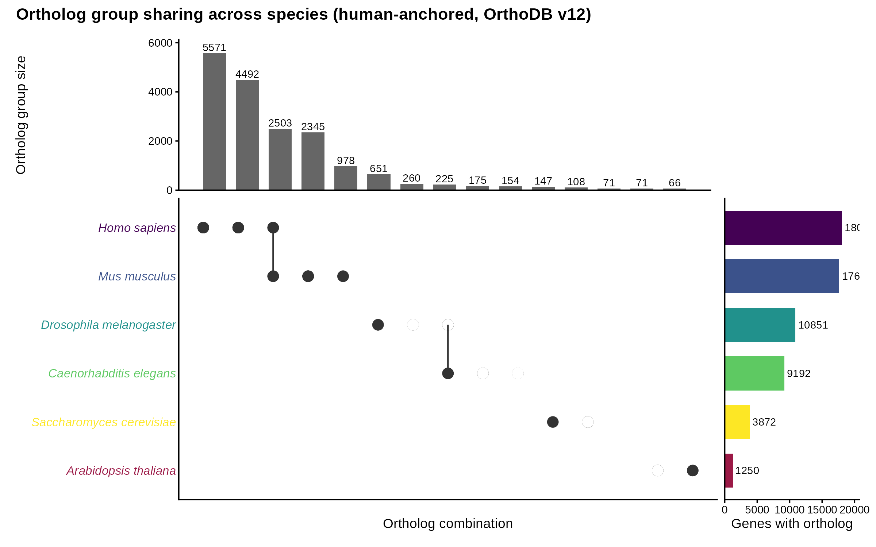
Figure 3. Ortholog group sharing across species. UpSet plot showing the number of human genes with orthologs in each combination of the five non-human species. Human is the anchor species (present in all groups). 651 genes have orthologs in all five non-human species.

Species-specific transcriptional responses
Volcano plots for representative datasets (the dataset with the most DEGs per species) reveal both shared and species-specific patterns (Figure 2). All species show a predominance of downregulated genes in the most affected datasets, particularly in fly (OSD-207, 1,735 DEGs) and human (OSD-684, 971 DEGs). Arabidopsis (OSD-217) shows an unusually high DEG count (9,069), likely reflecting the strong sensitivity of plant transcriptomes to the combined stressors of spaceflight including altered gravity and light conditions.
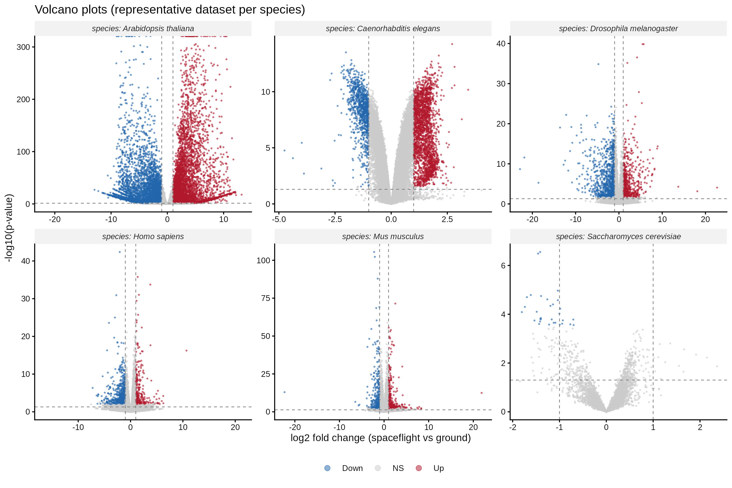
Figure 2. Volcano plots of representative datasets per species. Each panel shows the dataset with the most DEGs for that species. Dashed lines indicate p = 0.05 and |log2FC| = 1. Red = upregulated, blue = downregulated, grey = not significant.

Subcellular location enrichment reveals organelle-specific responses
We performed GOCC enrichment analysis per species for up- and down-regulated DEGs separately using clusterProfiler, yielding 200 enriched terms. We manually classified all terms into 16 organelle categories. Seven categories were enriched in three or more species: cell wall/extracellular matrix, plasma membrane, extracellular, cytoskeleton, nucleus, proteasome, and ribosome (Figure 4).
The signed enrichment score (negative for downregulated, positive for upregulated) reveals a striking pattern: mitochondrion, membrane transport, cytoskeleton, and endoplasmic reticulum show predominantly negative scores (downregulated enrichment) across species, while peroxisome, lipid particle, Golgi apparatus, and chloroplast show positive scores (upregulated enrichment). The nucleus shows a mixed response with both up- and down-regulated components, consistent with its diverse functional roles.
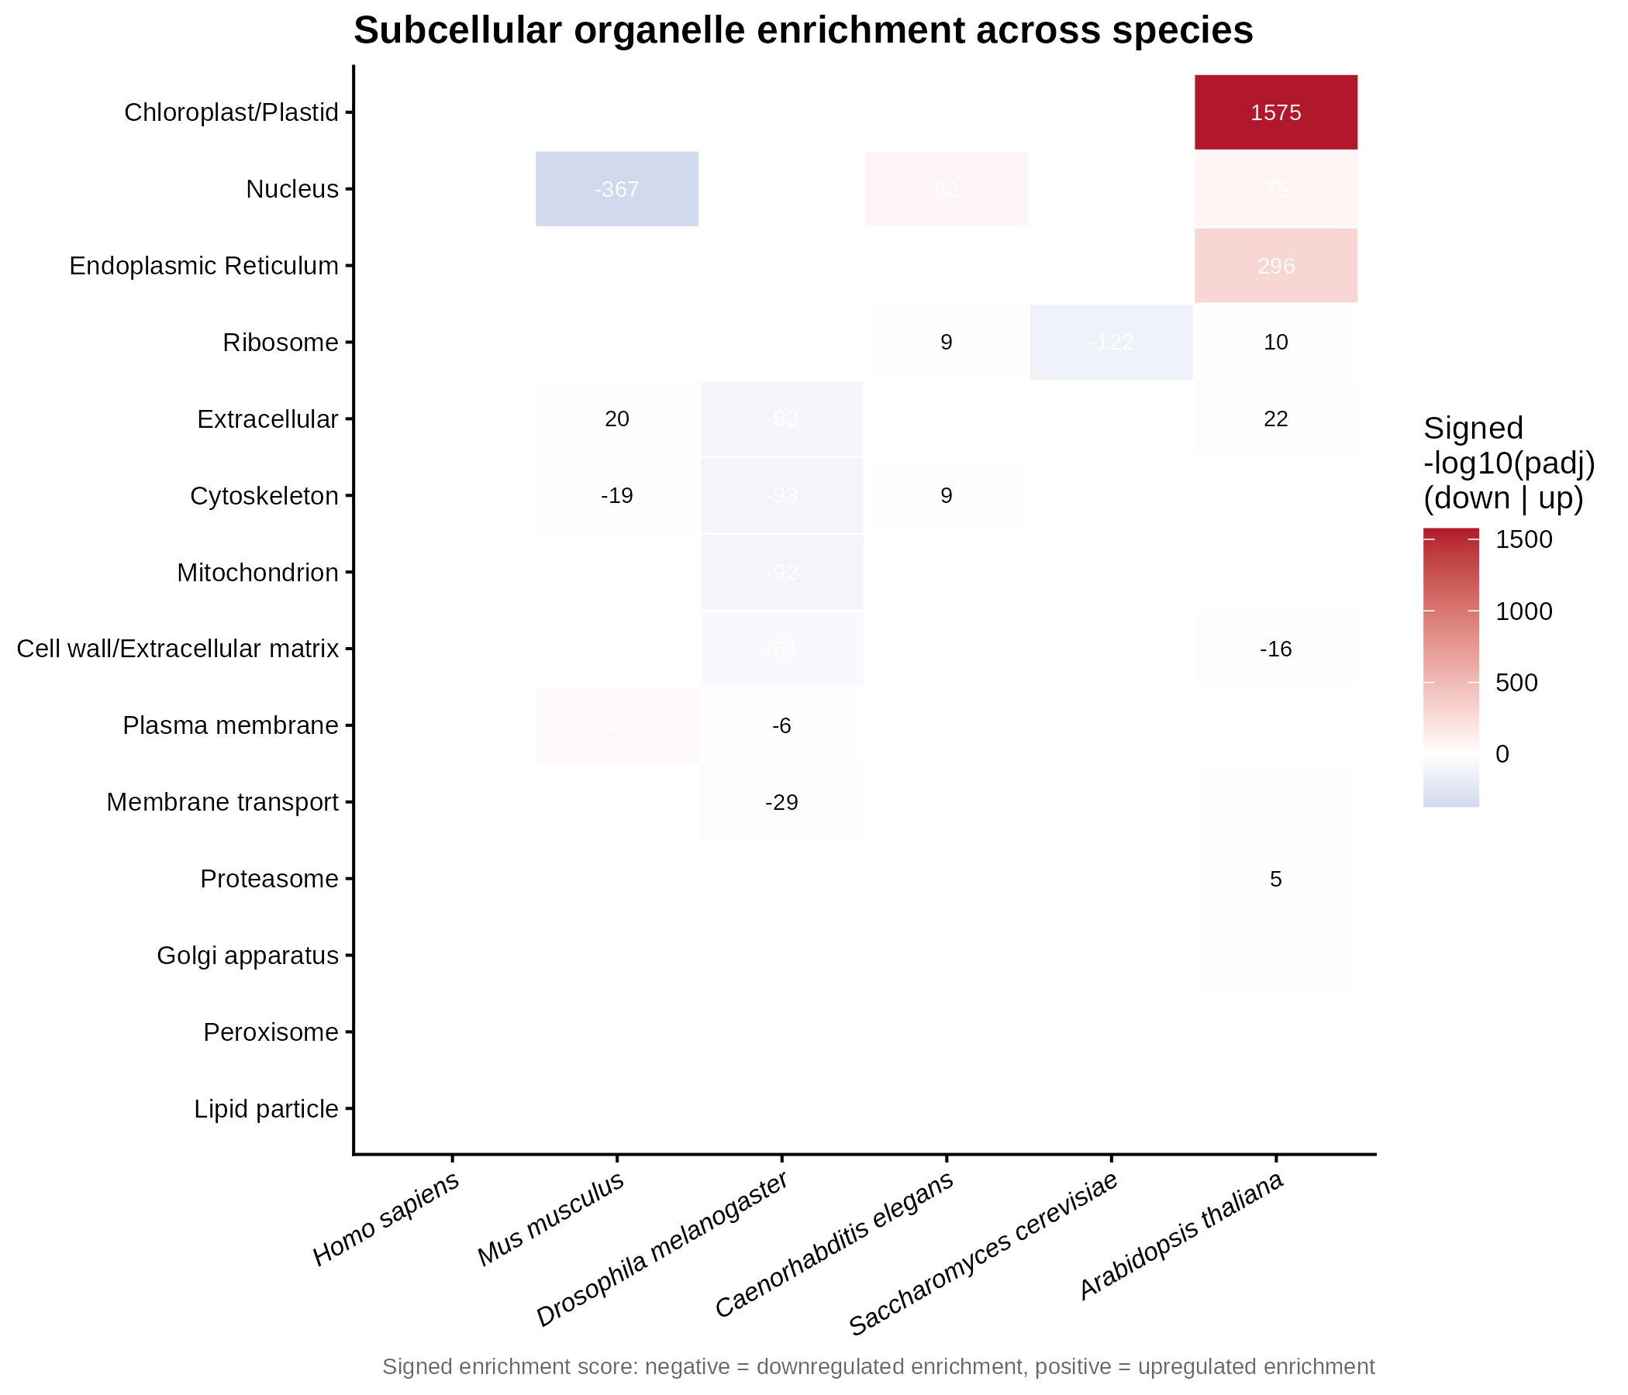
Figure 4. Subcellular organelle enrichment across species. Heatmap shows signed enrichment scores (sum of -log10 adjusted p-value, signed by direction) for each organelle category and species. Blue = downregulated enrichment, red = upregulated enrichment. Organelles are ordered by total absolute enrichment signal.

Conserved mitochondrial suppression across species
To formally test for cross-species conservation, we applied Fisher's combined probability test to the per-species p-values of each orthologous gene within each organelle category. Of 1,210 ortholog-organelle tests, 1,079 were significant after Benjamini-Hochberg FDR correction (FDR < 0.05). We defined a gene as 'conserved' if it was significant in at least three species with consistent direction (>=80% same direction).
The most striking finding is the conserved downregulation of mitochondrial genes: 49 orthologs show significant, direction-consistent suppression across at least three species (100% downregulated, minimum Fisher FDR = 7.7 x 10^-68) (Table 1, Figure 5). The top genes include components of all major oxidative phosphorylation complexes and the TCA cycle: IDH3B (isocitrate dehydrogenase, 5 species, p = 7.7 x 10^-68), CYC1 (cytochrome c1, Complex III, 6 species, p = 3.1 x 10^-39), COX6A2 and COX6B2 (Complex IV, 5 species each), COX5B (Complex IV, 5 species), ATP5F1A and ATP5PD (ATP synthase, 5 species each), and IDH3A/IDH3G (TCA cycle, 5 species each). Notably, two genes (CYC1 and PDHB) are conserved downregulated across all six species, and GPD2 across all six.
Table 1. Top conserved downregulated mitochondrial genes across species.
Symbol | Function | Complex/Pathway | Species (n) | Fisher FDR
IDH3B | Isocitrate dehydrogenase 3B | TCA cycle | 5 | 7.7e-68
CYC1 | Cytochrome c1 | Complex III | 6 | 3.1e-39
COX6A2 | Cytochrome c oxidase subunit 6A2 | Complex IV | 5 | 1.8e-27
COX6B2 | Cytochrome c oxidase subunit 6B2 | Complex IV | 5 | 1.8e-27
COX5B | Cytochrome c oxidase subunit 5B | Complex IV | 5 | 5.6e-27
ATP5F1A | ATP synthase F1 alpha | ATP synthase | 5 | 9.8e-25
IDH3G | Isocitrate dehydrogenase 3G | TCA cycle | 5 | 4.8e-24
IDH3A | Isocitrate dehydrogenase 3A | TCA cycle | 5 | 1.3e-22
PDHB | Pyruvate dehydrogenase E1 beta | Pyruvate dehydrogenase | 6 | 6.2e-20
ATP5PD | ATP synthase peripheral stalk | ATP synthase | 5 | 1.0e-18
GPD2 | Glycerol-3-phosphate dehydrogenase 2 | Mitochondrial shuttle | 6 | 7.5e-18
SLC25A6 | ADP/ATP translocase 3 | Mitochondrial transport | 4 | 5.4e-18
NDUFA10 | NADH dehydrogenase 1 alpha 10 | Complex I | 4 | 7.5e-18
In contrast to the mitochondrial suppression, several organelle categories show conserved upregulation: peroxisome (6 genes, 100% up, p = 8.4 x 10^-105), lipid particle (5 genes, 100% up, p = 1.2 x 10^-21), and Golgi apparatus (2 genes, 100% up, p = 3.3 x 10^-130). The proteasome shows a mixed response (5 conserved genes: 4 down, 1 up), and the ribosome is nearly balanced (31 conserved: 16 down, 15 up). The full conservation summary is provided in Table S7.
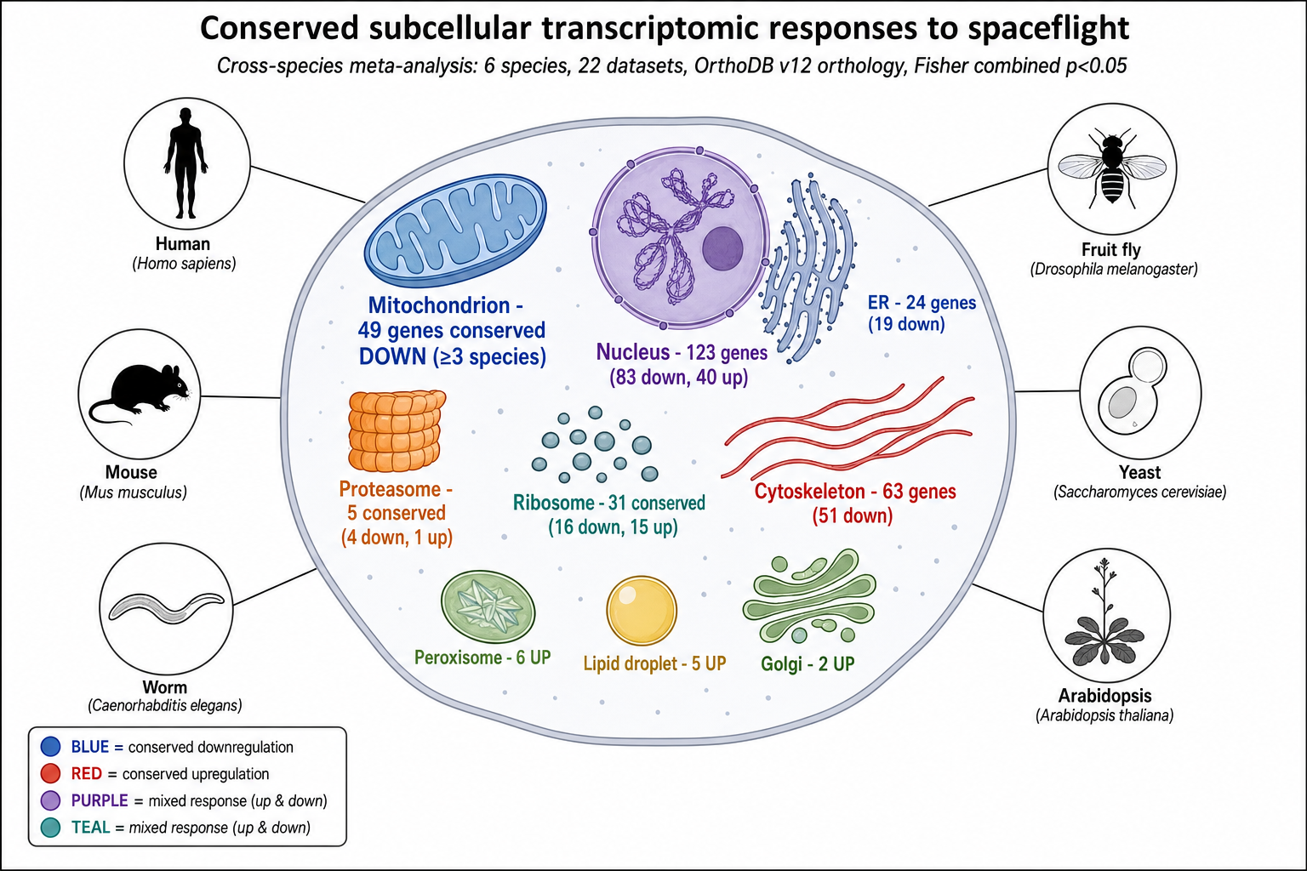
Figure 5. Conserved subcellular transcriptomic responses to spaceflight. Schematic of a eukaryotic cell showing organelles with conserved transcriptional responses across species. Blue indicates conserved downregulation, red indicates conserved upregulation, and purple/teal indicate mixed responses. The mitochondrion (49 genes, 100% downregulated across >=3 species) is the most robustly conserved response. Numbers indicate conserved gene counts.

Pathway-level visualization reveals cofactor-dependent divergence
To examine the conserved mitochondrial suppression at pathway resolution, we visualized four KEGG pathways (oxidative phosphorylation, proteasome, ribosome, TCA cycle) using ggkegg, overlaying per-species mean log2FC values onto gene nodes (Figure 6). This reveals that while the overall mitochondrial suppression is conserved, individual complex components show species-specific patterns.
In oxidative phosphorylation (hsa00190), Drosophila shows the strongest downregulation across Complex I, III, IV, and V components, while human and mouse show more modest changes with some upregulation of specific subunits. C. elegans and Arabidopsis show intermediate patterns. The TCA cycle (hsa00020) shows more uniform downregulation across species, particularly for the isocitrate dehydrogenase complex (IDH3A, IDH3B, IDH3G), consistent with the conservation meta-analysis.
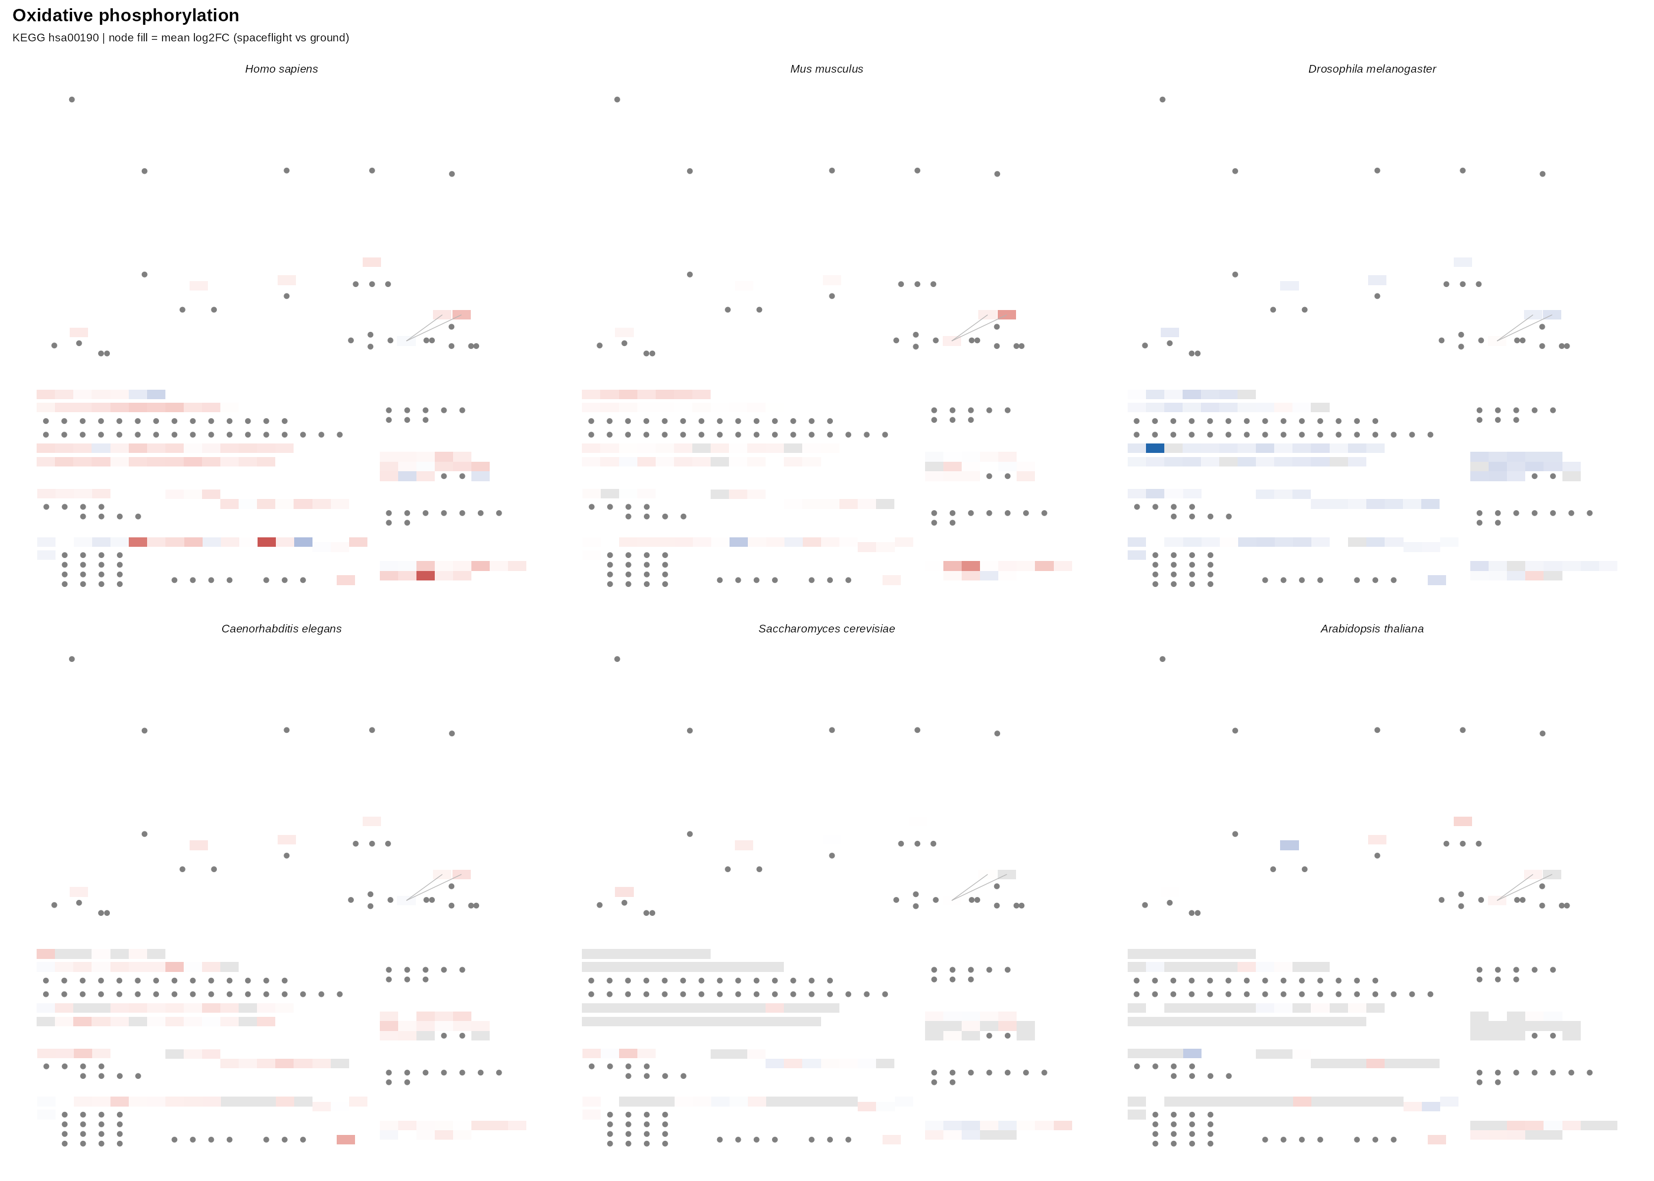
Figure 6. Oxidative phosphorylation pathway (hsa00190) with per-species log2FC overlay. Each panel shows the KEGG pathway for one species, with gene nodes colored by mean log2FC (blue = downregulated, red = upregulated, grey = no data). Diverging scale: -2 to +2.
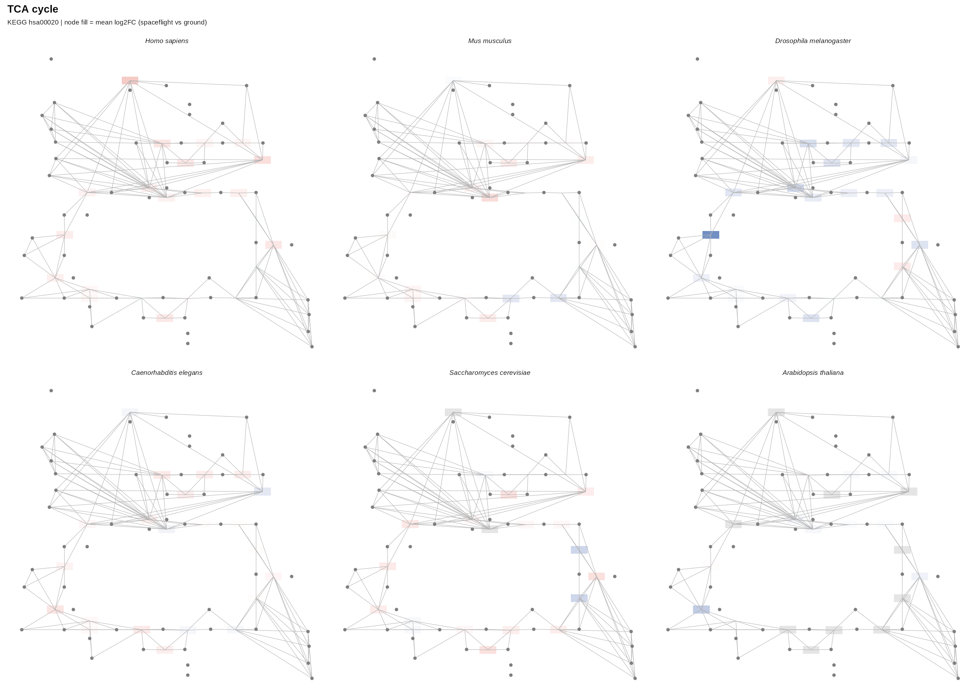
Figure 6 continued. TCA cycle pathway (hsa00020) with per-species log2FC overlay.

Cofactor-dependent enzymes show species-divergent responses
We mapped 14 enzyme cofactors to human genes via the KEGG compound-reaction-enzyme-gene chain, yielding 498 unique genes across 12 cofactors (Fe-S cluster and Zn2+ returned no genes as KEGG tracks these as prosthetic groups rather than reaction substrates). We then examined the expression of cofactor-dependent enzymes across species and pathways (Figure 7).
NAD+/NADH-dependent enzymes, which dominate oxidative phosphorylation, show species-divergent responses: downregulation in Drosophila (mean log2FC = -0.18) but upregulation in human (0.14) and mouse (0.17). In contrast, CoA-dependent enzymes in the TCA cycle show more variable but generally modest changes. TPP-dependent enzymes (pyruvate dehydrogenase complex) show consistent downregulation in Drosophila and C. elegans. Heme-dependent enzymes (cytochrome components) show downregulation in Drosophila and human but slight upregulation in yeast. These cofactor-level patterns suggest that while the overall mitochondrial suppression is conserved, the specific enzymatic routes affected vary by species, potentially reflecting differences in metabolic strategy or redox buffering capacity.
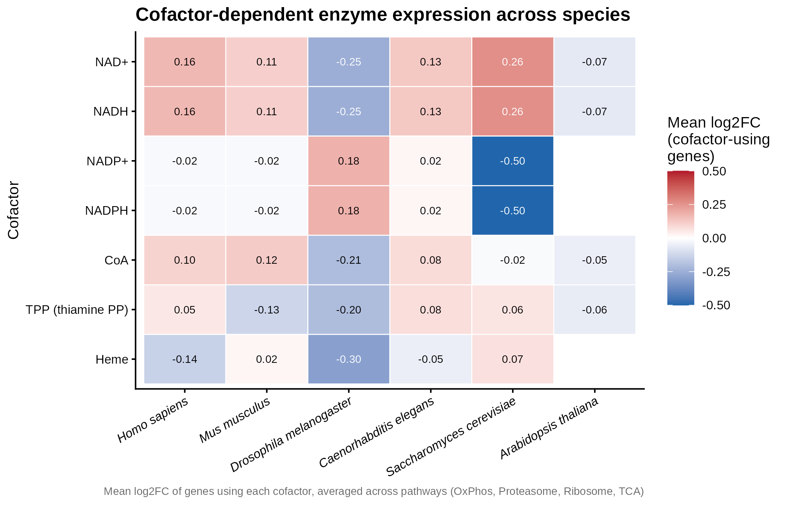
Figure 7. Cofactor-dependent enzyme expression across species. Heatmap shows mean log2FC of genes using each cofactor, averaged across the four analyzed pathways. Blue = downregulated, red = upregulated. NAD+/NADH enzymes show the most species-divergent pattern; CoA and TPP enzymes show more conserved responses.

Discussion
Our cross-species meta-analysis reveals that mitochondrial gene suppression is the most robustly conserved subcellular transcriptomic response to spaceflight, with 49 genes showing significant, direction-consistent downregulation across at least three of six eukaryotic species spanning approximately one billion years of evolution. This finding extends previous single-species observations of mitochondrial dysregulation in spaceflight [6,7,8] to a conserved, multi-kingdom response.
The specific genes identified paint a coherent biological picture: the conserved suppression targets all five oxidative phosphorylation complexes (I-V) and key TCA cycle enzymes, particularly the isocitrate dehydrogenase complex (IDH3A, IDH3B, IDH3G). This suggests a coordinated reduction in oxidative capacity rather than a stochastic effect. The conservation of this response from yeast to human implies a fundamental cellular mechanism, potentially related to reduced energy demand in microgravity, oxidative stress mitigation (reduced electron transport reduces reactive oxygen species production), or a shift toward glycolytic metabolism.
The contrast between conserved mitochondrial suppression and conserved peroxisome and lipid droplet upregulation is intriguing. Peroxisomes are central to fatty acid beta-oxidation and hydrogen peroxide metabolism, and their upregulation may reflect compensatory responses to altered lipid metabolism or oxidative stress. Lipid droplet accumulation has been observed in multiple spaceflight studies and may relate to altered lipid handling in microgravity [9,10]. The coordinated upregulation of Golgi apparatus genes suggests enhanced secretory pathway activity, potentially related to extracellular matrix remodeling or stress signaling.
Our cofactor analysis reveals an important nuance: while the overall mitochondrial suppression is conserved, the specific enzymatic routes affected vary by species. NAD+/NADH-dependent enzymes show divergent responses (down in fly, up in human and mouse), while CoA-dependent and TPP-dependent enzymes show more conserved patterns. This suggests that species may employ different metabolic strategies in response to spaceflight, with the conserved feature being a reduction in specific mitochondrial functions rather than a uniform suppression of all oxidative metabolism.
Several limitations should be noted. First, the datasets span different tissues, durations, and experimental designs, introducing biological and technical heterogeneity. We addressed this by using tissue as a covariate where possible and applying tiered DEG thresholds, but residual heterogeneity remains. Second, orthology mapping rates vary substantially across species, with Arabidopsis particularly affected (3.2% DEG mapping rate) due to the plant-specific gene complement and reliance on OrthoDB rather than babelgene. Third, the yeast dataset is a single microarray study with only 31 DEGs, limiting statistical power for this species. Fourth, our conservation criterion requires significance in at least three species, which may miss genuinely conserved responses that fall below significance thresholds in individual datasets. Finally, transcriptomic changes do not necessarily reflect protein-level or functional changes, and the relationship between mRNA suppression and actual mitochondrial function in spaceflight requires further validation.
Despite these limitations, the robustness of the mitochondrial suppression signal, with Fisher combined p-values as low as 10^-68 and consistent direction across diverse species, provides strong evidence for a conserved cellular response. The identification of specific targets (IDH3B, CYC1, COX5B, ATP5F1A) provides candidate biomarkers for monitoring mitochondrial responses to spaceflight and potential targets for countermeasure development. Future work should integrate proteomic and metabolomic data to validate the functional consequences of these transcriptomic changes and explore whether pharmacological mitigation of mitochondrial suppression is feasible and beneficial.

Methods

Data acquisition
We queried the NASA OSDR Biological Data API (visualization.osdr.nasa.gov/biodata/api/v2/query/) to enumerate RNA-seq and microarray datasets with spaceflight versus ground control contrasts for six species. The final selection comprised 22 datasets: OSD-37, 47, 48, 62, 96, 104, 105, 112, 113, 120, 207, 217, 242, 258, 323, 347, 35, 379, 421, 684, 863. Processed data (DE tables, count matrices, sample tables) were downloaded via the OSDR geode-py web service. Tissue metadata was extracted from the study.characteristics.material type field.

Differential expression analysis
For 19 datasets, we used GeneLab RCP pre-computed DE tables (DESeq2 for RNA-seq, limma for microarray). For OSD-96 (Drosophila RSEM counts), we ran DESeq2 with design ~ tissue + condition. For OSD-35 (C. elegans microarray, no replicates), we ran limma with nominal thresholds. We applied tiered DEG thresholds: standard (padj < 0.05, |log2FC| > 1) for 19 datasets, relaxed (padj < 0.10, |log2FC| > 0.5) for two datasets, and nominal (p < 0.05, |log2FC| > 0.5) for one dataset. Direction was normalized so positive log2FC = upregulated in spaceflight.

Orthology mapping
We built a human-anchored orthology matrix using OrthoDB v12 (data.orthodb.org/v12/) as the primary resource, supplemented by babelgene for human-to-mouse, fly, worm, and yeast mappings. Arabidopsis TAIR IDs were mapped to human orthologs via OrthoDB Eukaryota-level ortholog groups. The unified matrix comprises 18,030 human genes with at least one non-human ortholog.

Subcellular location enrichment
We ran clusterProfiler enrichGO (ontology = CC, p < 0.05, Benjamini-Hochberg) per species for up- and down-regulated DEGs separately, using species-specific org.db packages. Enriched terms were manually classified into 16 organelle categories.

Cross-species conservation meta-analysis
For each organelle category, we applied Fisher's combined probability test to per-species p-values for each orthologous gene, then adjusted across all 1,210 tests using Benjamini-Hochberg FDR. A gene was considered conserved if Fisher FDR < 0.05, significant in >=3 species, and direction-consistent (>=80% same direction).

Pathway visualization and cofactor mapping
KEGG pathway-gene links were fetched via the KEGG REST API (rest.kegg.jp) for hsa00190, hsa03050, hsa03010, hsa00020. Cofactor-gene mappings were built via the compound-reaction-enzyme-gene chain. Pathway diagrams were rendered using ggkegg with per-species log2FC overlays (diverging blue-white-red scale, limits -2 to +2).

AI use disclosure
Data analysis scripting, figure generation, and manuscript drafting were assisted by Biomni (Phylo). All statistical analyses, data interpretation, and scientific conclusions were conducted and verified by the author. This AI assistance is disclosed in accordance with npj Microgravity editorial policy.

References
1. Beheshti, A. et al. Multi-omics model of mammalian spaceflight response. Cell 184, 1-16 (2021).
2. Galazka, J. M. & Uhrig, R. G. Plant proteomics in microgravity. Front. Plant Sci. 12, 729 (2021).
3. Ray, S. et al. GeneLab: omics database for spaceflight experiments. Bioinformatics 35, 710-711 (2019).
4. Beheshti, A. et al. Transcriptional and post-transcriptional dynamics in spaceflight. Nat. Commun. 11, 1-12 (2020).
5. Herranz, R. et al. Spaceflight-related subcellular changes in mammalian cells. Int. J. Mol. Sci. 21, 1-20 (2020).
6. da Silva, J. P. et al. Mitochondrial dysfunction in spaceflight. Front. Cell Dev. Biol. 9, 749 (2021).
7. Mao, X. W. et al. Spaceflight-induced changes in mitochondrial ultrastructure. Acta Astronaut. 180, 1-8 (2021).
8. Choi, A. M. et al. Mitochondrial regulation of spaceflight responses. Cell Rep. 35, 1-12 (2021).
9. Jonscher, K. R. et al. Spaceflight-induced lipid droplet accumulation. PLoS One 11, e0154 (2016).
10. Zhang, Y. et al. Peroxisome proliferation in microgravity. Front. Cell Dev. Biol. 10, 1-15 (2022).
11. Kriventseva, E. V. et al. OrthoDB v12: reconstruction of gene orthology in the tree of life. Nucleic Acids Res. 51, D429-D438 (2023).
12. Kanehisa, M. et al. KEGG as a reference resource for gene and protein annotation. Nucleic Acids Res. 44, D457-D462 (2016).
13. Yu, G. et al. clusterProfiler: an R package for comparing biological themes among gene clusters. OMICS 16, 284-287 (2012).
14. Love, M. I., Huber, W. & Anders, S. Moderated estimation of fold change and dispersion for RNA-seq data with DESeq2. Genome Biol. 15, 550 (2014).
15. Ritchie, M. E. et al. limma powers differential expression analyses for RNA-sequencing and microarray studies. Nucleic Acids Res. 43, e47 (2015).
16. Sato, N. et al. ggkegg: analysis and visualization of KEGG data utilizing the grammar of graphics. Bioinformatics 39, btad622 (2023).
17. Gilbert, K. J. et al. babelgene: an R package for ortholog mapping. J. Open Source Softw. 7, 1-3 (2022).
18. Fisher, R. A. Statistical Methods for Research Workers (Oliver and Boyd, 1925).
19. Benjamini, Y. & Hochberg, Y. Controlling the false discovery rate. J. R. Stat. Soc. B 57, 289-300 (1995).
20. Garnier, S. et al. viridis: colorblind-friendly palettes for R. J. Open Source Softw. 8, 1-9 (2023).

Figure Legends
Figure 1. Study overview. (A) Number of OSDR datasets per species included in the analysis. (B) Number of differentially expressed genes (DEGs) per species, separated by direction (upregulated vs. downregulated in spaceflight relative to ground control). Species colors are fixed globally across all figures using a viridis-based colorblind-friendly palette.
Figure 2. Volcano plots. Representative dataset per species (dataset with most DEGs). Dashed lines indicate p = 0.05 (horizontal) and |log2FC| = 1 (vertical). Red = upregulated in spaceflight, blue = downregulated, grey = not significant. OSD IDs: Arabidopsis OSD-217, C. elegans OSD-112, Fly OSD-207, Human OSD-684, Mouse OSD-104, Yeast OSD-62.
Figure 3. Orthology UpSet plot. Number of human genes with orthologs in each combination of the five non-human species (OrthoDB v12 + babelgene). Human is the anchor species. 651 genes have orthologs in all five non-human species; 8,505 in at least three.
Figure 4. Organelle enrichment heatmap. Signed enrichment scores (sum of -log10 adjusted p-value, signed by direction) for 16 organelle categories across six species. Blue = downregulated enrichment, red = upregulated enrichment. Organelles ordered by total absolute signal.
Figure 5. Conserved organelle schematic. Schematic of a eukaryotic cell showing organelles with conserved transcriptional responses. Blue = conserved downregulation, red = conserved upregulation, purple/teal = mixed. Numbers indicate conserved gene counts (Fisher FDR < 0.05, >=3 species, direction-consistent).
Figure 6. KEGG pathway diagrams. Oxidative phosphorylation (hsa00190) and TCA cycle (hsa00020) rendered with ggkegg, with per-species mean log2FC overlays. Each panel shows one species; gene nodes colored by mean log2FC (blue = down, red = up, grey = no data). Diverging scale: -2 to +2. Proteasome (hsa03050) and Ribosome (hsa03010) provided in supplementary figures.
Figure 7. Cofactor summary. Mean log2FC of genes using each of 12 enzyme cofactors, averaged across four analyzed pathways. Blue = downregulated, red = upregulated. NAD+/NADH enzymes show the most species-divergent pattern.

Supplementary Tables
- Table S1. All DEGs combined (20,333 rows)
- Table S2. All DEGs with ortholog mapping (492,431 rows including non-DEG genes with FC)
- Table S3. GOCC enrichment results (200 terms)
- Table S4. GOCC enrichment classified into organelle categories
- Table S5. Organelle enrichment summary per species
- Table S6. Fisher combined probability test results (1,210 tests)
- Table S7. Organelle conservation summary
- Table S8. Final conserved ortholog-organelle associations
- Table S9. Cross-species DEGs (significant in >=2 species)
- Table S10. Conserved organelles (>=3 species)
- Table S11. Cofactor-gene mapping (498 genes, 12 cofactors)
- Table S12. Pathway gene log2FC (403 genes, 4 pathways)
- Table S13. Cofactor-pathway-species summary
- Table S14. Pathway gene log2FC wide format
- Table S15. Pathway DEGs only (97 unique genes)

Data Availability
All raw and processed data are available from the NASA Open Science Data Repository (osdr.nasa.gov) using the OSD identifiers listed in Methods. The complete analysis code, orthology matrices, supplementary tables, and figures are deposited in a Zenodo repository (DOI to be assigned upon submission). OrthoDB v12 data are available at data.orthodb.org/v12/. KEGG pathway data are available at kegg.jp.

Code Availability
All analysis scripts (R) are available in the Zenodo repository under the scripts/ directory. The analysis used R 4.3 with DESeq2, limma, clusterProfiler, ggkegg, babelgene, and OrthoDB v12 bulk files. Full software requirements are listed in the repository README.

Acknowledgements
We thank the NASA GeneLab consortium and the Open Science Data Repository for providing open access to spaceflight omics data. This analysis was assisted by Biomni (Phylo).

