Supplementary information for: A gas-transport model predicts the Arabidopsis spaceflight transcriptome, and illumination separates six flight contrasts

Supplementary figures
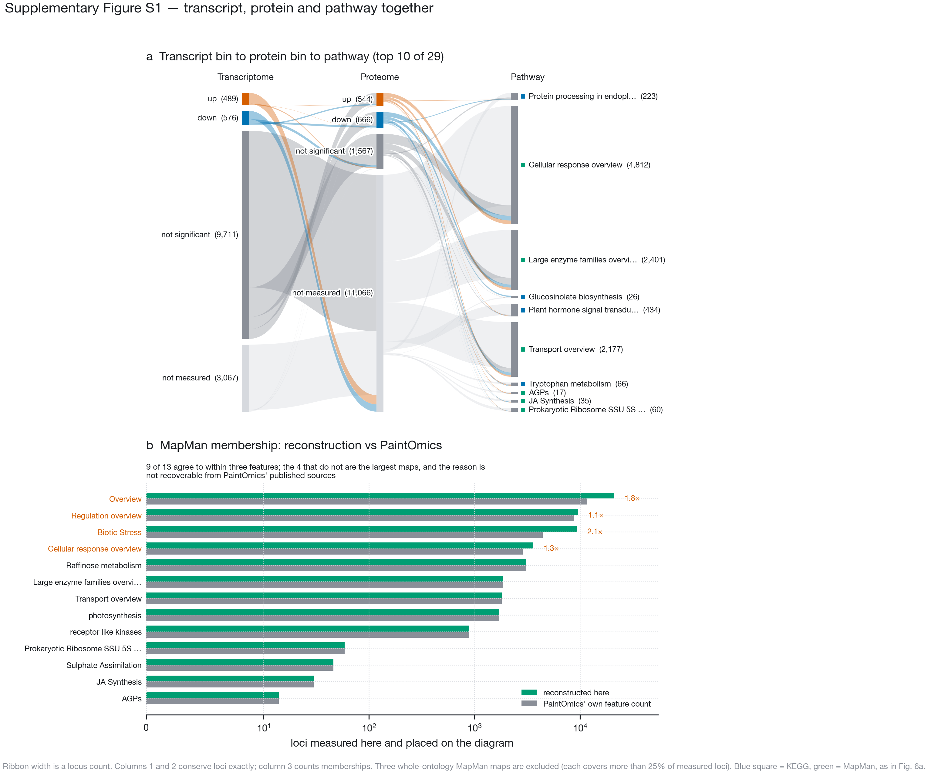
Where the loci go, and how far the MapMan half of the diagram can be trusted. a, Each locus in at least one of the 29 non-whole-ontology significant pathways is placed in one transcript bin and one protein bin, and then into the pathways it belongs to. Ribbon width is a locus count. The transcript and protein columns conserve loci exactly; the pathway column counts memberships, so a locus in more than one pathway is counted more than once. The pathway column draws the ten most significant; a square gives each pathway’s database in the colours of Fig. 6a. Three whole-ontology MapMan diagrams are excluded — Overview lists all 36 top-level bins and so covers 99.8 % of measured loci, and Regulation overview and Biotic Stress cover 45 % and 44 %; the next largest covers 17 %. A map holding nearly every measured locus cannot say where anything goes, because its ribbons reproduce the marginal distribution. b, PaintOmics reports enrichment but not the gene lists behind it, and MapMan has no equivalent of the KEGG REST API, so MapMan membership is reconstructed from GoMapMan’s Araport11 gene-to-bin mapping and the MapMan diagram layouts, by PaintOmics’ own inclusion rules. Reconstructed membership is compared against the feature count PaintOmics itself reported for each diagram (log scale). Nine of the thirteen agree to within three features. Significance throughout is PaintOmics’ uncorrected combined $p<0.05$. The four that do not are the largest maps, are marked in vermilion with the ratio between the two counts, and the reason for the difference is not recoverable from PaintOmics’ published sources; both counts are reported rather than one.

