Crop-specific mineral responses to spaceflight, and a unit-labelling defect that inverts them
An open-data reanalysis of NASA Veggie elemental data, with a survey of mineral and dietary data availability across the NASA Life Sciences Data Archive
Richard Barker
dr.richard.barker@gmail.com
2026-09-02
Abstract
Crops grown aboard the International Space Station are intended to supplement crew diets, which makes their mineral composition a question of both plant biology and crew nutrition. We reanalysed the two NASA Veggie studies that report inductively coupled plasma optical emission spectroscopy (ICP-OES) elemental data — OSD-745 (Lactuca sativa cv. ‘Outredgeous’, $n=24$) and OSD-655 (Brassica rapa cv. ‘Tokyo Bekana’, $n=36$) — together with Inspiration4 clinical chemistry (OSD-575, $4$ crew, $28$ observations), and surveyed all $2676$ experiments in the NASA Life Sciences Data Archive (LSDA) for mineral and dietary content.
Three findings follow. First, OSD-655 labels calcium, potassium, magnesium, phosphorus and sulfur as mg/g dry weight in both its data files and its archived data dictionary, but the values are $μ$g/g: read as stated, potassium would constitute $2943\%$ of dry weight. Analyses that concatenate the two studies without correcting this are wrong by a factor of 1000 on five of twelve elements. Second, after correcting the units and controlling for dry-matter dilution with a centred log-ratio transform, the two crops diverge: lettuce shows no element significantly altered by spaceflight, whereas Tokyo Bekana shows $6$. Apparent increases in calcium ($1.23×→0.91×$) and iron ($1.43×→1.10×$) do not survive the correction and are attributable to dilution; the increases in potassium, sodium and sulfur do. Third, classification of flight versus ground from the ionome does not exceed chance under leave-one-mission-out cross-validation (balanced accuracy 0.608 against a 0.568 baseline) and falls below baseline when trained on one crop and tested on the other (-0.113), which is itself evidence that no shared flight signature exists.
Quantitatively, a 100 g fresh serving supplies 13.9% (lettuce) and 10.5% (Tokyo Bekana) of the NASA daily potassium requirement; reaching the iron upper limit would require 0.85 kg of fresh tissue per day. Dietary mineral overload from Veggie produce is therefore not plausible at achievable harvest scales. Of the $423$ LSDA experiments that measured a mineral or nutritional variable, only $62$ are openly available and $213$ require a formal data request — the principal barrier to progress on this question is access, not measurement.
Keywords: spaceflight nutrition; ionome; compositional data analysis; NASA Veggie; OSDR; LSDA; FAIR data; data quality

Introduction
Crops grown aboard the International Space Station (ISS) in the Veggie plant growth system are intended to supplement crew diets on long-duration missions, supplying fresh produce that resupply cannot economically provide (Massa et al. 2017). Whether they do so usefully depends on what is actually in the tissue. Spaceflight alters plant water relations, root-zone oxygen availability and nutrient transport, and there is a reasonable prior that mineral accumulation differs from ground controls.
The same minerals matter on the crew side. Spaceflight perturbs human mineral homeostasis: bone resorption releases calcium, fluid shifts alter electrolyte balance, and iron stores rise as erythropoiesis is suppressed (Smith et al. 2005; Zheng et al. 2023). If spaceflight-grown produce were to concentrate particular ions, a plant-rich diet could in principle interact with those perturbations — an accumulation-plus-overload concern that motivates asking what the plants actually contain and what a realistic serving delivers.
Answering that requires two things this literature has lacked. The first is harmonised elemental data across more than one crop. Two NASA Open Science Data Repository (OSDR) studies report ICP-OES elemental composition for Veggie produce: OSD-745 for red romaine lettuce (Khodadad et al. 2020; NASA Open Science Data Repository 2024c) and OSD-655 for Tokyo Bekana (Bunchek et al. 2024; NASA Open Science Data Repository 2024b). They have not previously been analysed together, and as this work shows, doing so naively produces a result that is wrong by three orders of magnitude for five elements.
The second is a clear picture of what human spaceflight mineral and dietary data exists and can be obtained. The NASA Life Sciences Data Archive (LSDA) holds records for several thousand experiments, but its catalog is designed for interactive browsing rather than systematic survey, and an experiment’s record does not make its accessibility obvious at a glance.
- A machine-readable survey of all 2676 LSDA experiments, annotated for mineral and nutritional content and classified by whether the data can actually be obtained.
- Identification and correction of a unit-labelling defect in OSD-655 that inflates five elements by a factor of 1000, present in the archived data dictionary as well as the data files.
- A compositional (centred log-ratio) reanalysis separating genuine ionome changes from dry-matter dilution artefacts, showing that the two Veggie crops respond differently to spaceflight.
- A quantitative assessment of what a Veggie serving contributes against NASA crew mineral requirements (National Aeronautics and Space Administration 2020), and of whether dietary mineral overload is achievable.
We state at the outset what this work does not do. The plant and crew datasets come from different missions and different people; nothing here supports a causal claim that Veggie produce altered anyone’s serum chemistry. That question requires paired dietary-intake and serum data, which exists — as the Nutritional Status Assessment (SMO-016E) — but is not openly available. Section 6 sets out the route to it.

Methods

Data acquisition
All data were retrieved programmatically from public NASA APIs; no value in this study was simulated, imputed or hand-entered. Plant and crew data came from the OSDR file API at , preferring OSDR’s curated *_TRANSFORMED.csv products, whose column names carry the unit alongside the analyte. Each downloaded file is cached and a SHA-256 digest recorded in , so a re-run can be verified byte-for-byte against ours.
The LSDA catalog was harvested from the JSON query endpoint at . Two behaviours of that endpoint, established by direct probing rather than documentation, determined the approach. Its query parameter does not filter server-side — every search term returns the full corpus of 2676 records and the term affects only relevance ordering — so the entire catalog was harvested and filtered locally. It also returns HTTP 502/503 under rapid request rates, so retrieval was throttled to one request per two seconds with exponential-backoff retry. Pagination uses a page parameter at 20 records per page; the from, offset, skip and start parameters are accepted but silently ignored, each returning page one.

Mineral and nutrition annotation of the LSDA catalog
Each experiment record was matched against a curated ontology of twelve minerals and their clinical surrogates (for example, ferritin and transferrin for iron; parathyroid hormone and bone resorption markers for calcium) and a set of nutritional terms, searched across the measured-parameter list, research areas, keywords, title and description. All terms are word-bounded: an unbounded iron matches environment and alone produced 1,266 spurious matches during development. Experiments were separately flagged for whether a mineral appeared in the measured parameter list, which states what was actually assayed, as opposed to anywhere in the record. LSDA’s free-text archive_status was mapped to four actionable categories: openly available, request required, held elsewhere, and never submitted.

Unit harmonisation
All elemental concentrations were converted to $μ$g/g dry weight. OSD-745 reports mg/kg, numerically identical to $μ$g/g, requiring no rescaling. OSD-655 names five columns — calcium, potassium, magnesium, phosphorus and sulfur — *_milligram_per_gram_of_dry_weight, and repeats unit: milligram_per_gram for each.
Read as stated, mean concentrations would be $2943\%$ (K), $805\%$ (Mg), $651\%$ (Ca), $551\%$ (S) and $367\%$ (P) of dry weight. Read as $μ$g/g they fall in the normal range for leafy Brassica tissue and agree with the independently-scaled OSD-745 lettuce measurements. The six elements OSD-655 labels in $μ$g/g (Al, B, Cu, Fe, Mn, Zn) need no correction and already agree across studies, which localises the defect to the five mg/g labels. Because the archived data dictionary carries the same error, the defect is in the curation metadata and not only in the file headers.
The correction is applied through an explicit override table in which each entry records the stated unit, the applied unit and the evidence for the change; 5 overrides fired. Corrections are never silent: the harmonisation report in lists every one.

Quality control
Four gates run between curation and analysis, independent of the harmonisation code so that the two must agree. A physical plausibility gate fails the build if any element exceeds $10\%$ of dry weight — the check that catches a 1000-fold unit error. A cross-study agreement gate fails if the two crops’ ground-control means differ by more than tenfold; the threshold sits two orders of magnitude below the error it targets, and is deliberately loose because genuine between-species differences here are large (ground-control sodium differs 5.4-fold between the crops). Further gates check that each crop has both flight and ground arms, and that missingness is structural rather than sporadic. All gates passed (yes).

Compositional analysis
ICP-OES reports concentrations — element mass per unit dry tissue mass — which are compositional and share a fixed denominator (Aitchison 1982). If flight and ground tissue differ in dry-matter composition, every element’s concentration shifts together even with no change in uptake. This is not hypothetical here: in the raw OSD-655 data eight elements rise in concert, the signature of a denominator effect rather than eight independent responses.
Each sample was therefore also expressed as a centred log-ratio, $clr(x_{i})=logx_{i}−\frac{1}{D}\sum_{j=1}^{D}{log}x_{j}$, which divides by the sample’s geometric mean and so removes any per-sample multiplicative factor exactly. A CLR contrast asks whether an element changed relative to the rest of the ionome, and is invariant to dilution.
The composition must use the same parts in every sample. Missingness here is structural — VEG-03A did not assay boron, so all twelve of its samples lack that element while being otherwise complete — so incomplete columns were dropped rather than incomplete rows, which would have discarded an entire mission. Aluminium is excluded from the composition and analysed separately: it is a non-nutrient whose passive uptake tracks substrate carryover rather than plant physiology.

Statistics
Flight-versus-ground contrasts used two-sided Mann–Whitney $U$ tests, chosen over $t$-tests because group sizes are 11–18 and normality is not established. Effect sizes are reported as rank-biserial correlation alongside the descriptive fold change. Multiplicity was controlled within each crop across elements by the Benjamini–Hochberg procedure (Benjamini and Hochberg 1995); $q<0.05$ is reported as significant.

Classification
Flight versus ground was classified from the ionome using $L_{2}$-penalised logistic regression and a random forest, each in a pipeline whose scaler is fitted inside the training fold. Only the 9 elements complete across all 60 samples were used (Ca, Fe, Mg, Mn, P, K, Na, S, Zn); imputation was avoided because the missingness is structural and an imputed value would be an invention.
Two grouped cross-validation schemes were used, since samples from one mission share a pillow batch, a fertiliser charge and a harvest date, and a random split would place siblings across the fold boundary. Leave-one-mission-out tests generalisation to an unseen growout; leave-one-crop-out trains on one species and tests on the other. Hyperparameters were selected by an inner grouped cross-validation on training folds only, so no reported score is one that tuning maximised. Every model is reported against stratified and majority-class dummy classifiers evaluated under the identical scheme: at this sample size an accuracy figure without its baseline carries no information. Confidence intervals are 2000-sample percentile bootstraps. There are no fallback metrics anywhere in the pipeline; a model that fails to fit stops the build.

Supply and serving calculations
Per-pillow water delivery and harvest mass were parsed from the OSD-655 supplements and joined to the elemental data on pillow identifier, which the ICP-OES sample names carry. Two limits are propagated into every derived figure: the supplements cover VEG-04A only, matching 14 of 36 Tokyo Bekana samples; and harvest masses are fresh while concentrations are per dry gram, with no dry-matter fraction archived. Mineral content is therefore bounded across a dry-matter fraction of $5$–$10\%$ rather than point-estimated. Daily requirements are taken verbatim from NASA JSC-67378 Rev 1 (National Aeronautics and Space Administration 2020), not from terrestrial dietary reference intakes, which differ — NASA caps iron at 8 mg/d specifically because of spaceflight-induced increases in iron stores.

Reproducibility
Python 3.11 with exactly pinned dependencies. The pipeline runs end to end via make all: fetch, curate, quality control, analyse, figure generation, manuscript build. Every numeric value in this manuscript is injected from the analysis outputs as a LaTeX macro generated by ; no statistic is typed into the prose, and a macro referenced without a definition halts the build. The bibliography is likewise generated: every DOI is fetched from Crossref at build time and an unresolvable DOI fails the build.

Results

What mineral and dietary data exists in the LSDA, and can it be obtained
Harvesting the complete LSDA experiment catalog returned 2676 records, of which 1573 concern human subjects. 1114 mention a mineral or a nutritional topic, and 423 list a mineral or nutritional variable among the parameters actually measured — the stricter and more useful criterion. Calcium is the most frequently measured (208 experiments), followed by phosphorus (113), iron (105), sodium (82) and potassium (75). Boron, a plant micronutrient rather than a human clinical analyte, was measured in 0 experiments, as expected for an archive dominated by human and animal physiology.
Accessibility is the limiting factor. Of the 423 experiments that measured a mineral or nutritional variable, only 62 are openly available, 213 require a formal data request, 145 were never submitted to the archive, and 2 are held by another repository (Figure 1). Restricting to human studies measuring three or more minerals leaves 57 experiments, of which 9 are open and 40 request-gated.
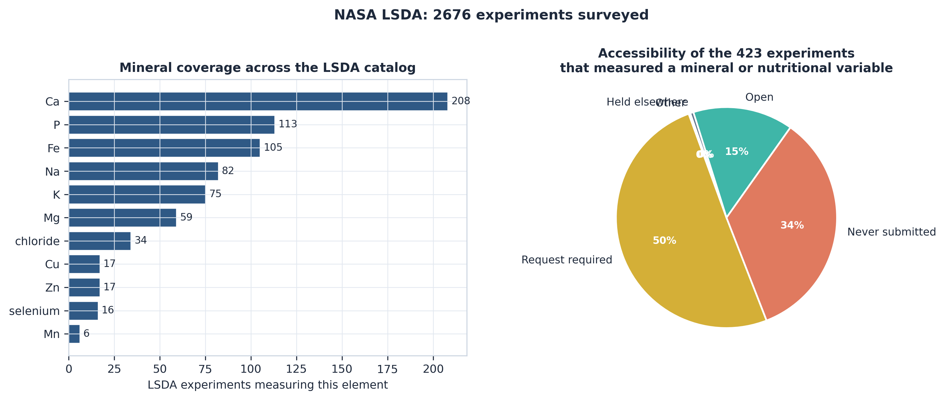
Mineral and dietary data across the NASA Life Sciences Data Archive. Left: number of experiments measuring each element. Right: accessibility of the 423 experiments that measured a mineral or nutritional variable. Access, not measurement, is the binding constraint.
The survey identifies the Nutritional Status Assessment (SMO-016E) as the highest-value target for this question: it measured ten minerals across long-duration ISS missions with in-flight sampling, and underlies the time-resolved analysis of Zheng et al. (2023). It is request-gated. Also surfaced were the NASA Biochemical Profile Project, Food Physiology, and Clinical Nutritional Assessment (MR016G), the last of which is openly available.

A unit-labelling defect inverts the cross-study comparison
The OSD-655 elemental file and its archived data dictionary both label calcium, potassium, magnesium, phosphorus and sulfur as mg/g dry weight. Taken at face value, mean potassium is $2943\%$ of dry weight, magnesium $805\%$, calcium $651\%$, sulfur $551\%$ and phosphorus $367\%$ — each impossible. Reinterpreted as $μ$g/g, all five fall within the normal range for leafy Brassica tissue and agree with the independently-scaled OSD-745 lettuce values. The six elements OSD-655 already labels in $μ$g/g require no change and agree across studies without correction, which localises the defect precisely. 5 column corrections were applied, and all four quality-control gates then passed.
The consequence is not cosmetic. Concatenating the two studies without this correction places five of twelve elements on a scale 1000-fold larger in one crop than the other, which would dominate any distance-based method, any principal component analysis, and any model trained on the pooled data.

The two crops diverge in their flight response
At face value the two studies look very different. In lettuce, flight/ground concentration ratios sit close to unity across the board — calcium 0.90, potassium 0.99, iron 0.96 — and no element reaches significance. In Tokyo Bekana, eight elements rise together: sodium 2.15, sulfur 1.75, potassium 1.54, iron 1.43, phosphorus 1.36, boron 1.35, calcium 1.23 and magnesium 1.23, with 6 significant at $q<0.05$.
A coordinated rise of that kind is the signature of a dry-matter dilution effect rather than eight independent uptake changes, and the centred log-ratio analysis separates the two (Figure 2).
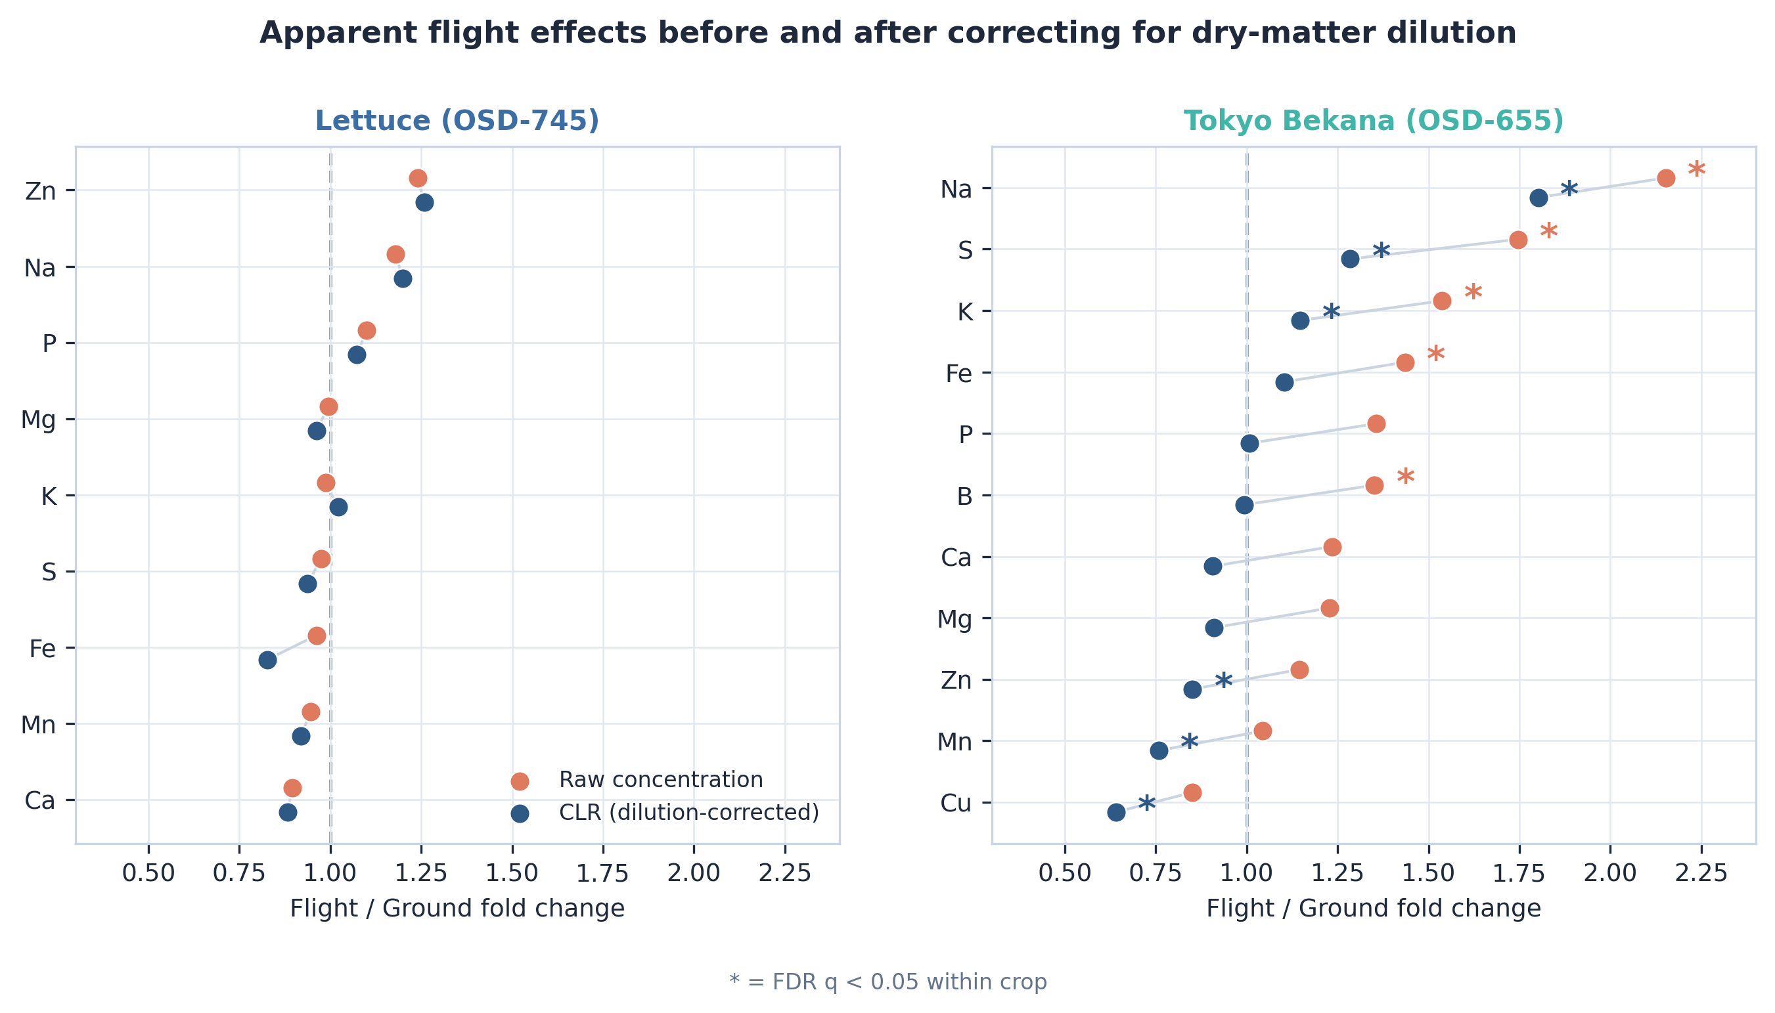
Flight/ground fold changes before (coral) and after (navy) correcting for dry-matter dilution by centred log-ratio transform. Lettuce shows no significant change on either scale. In Tokyo Bekana the apparent calcium, magnesium, iron, boron and phosphorus increases collapse toward unity after correction, while sodium, sulfur and potassium persist. Asterisks mark $q<0.05$ within crop.
After correction, 6 elements remain significant in Tokyo Bekana and none in lettuce. Critically for the accumulation hypothesis that motivated this work, the two divalent cations do not survive: calcium falls from 1.23 to 0.91 ($q=0.273$) and iron from 1.43 to 1.10 ($q=0.222$). Both apparent increases are dilution artefacts. Potassium persists (1.54 to 1.15, $q=0.020$), as do sodium (1.80) and sulfur (1.28). Copper, manganese and zinc become significantly lower in flight tissue once the composition is accounted for.
Only 3 elements — potassium, sodium and sulfur — are significant on both scales, and these are monovalent cations and an anion, not the divalent cations of the original hypothesis. Comparing the crops element by element (Figure 3), 3 elements move in opposite directions after correction (Fe, S, Zn).
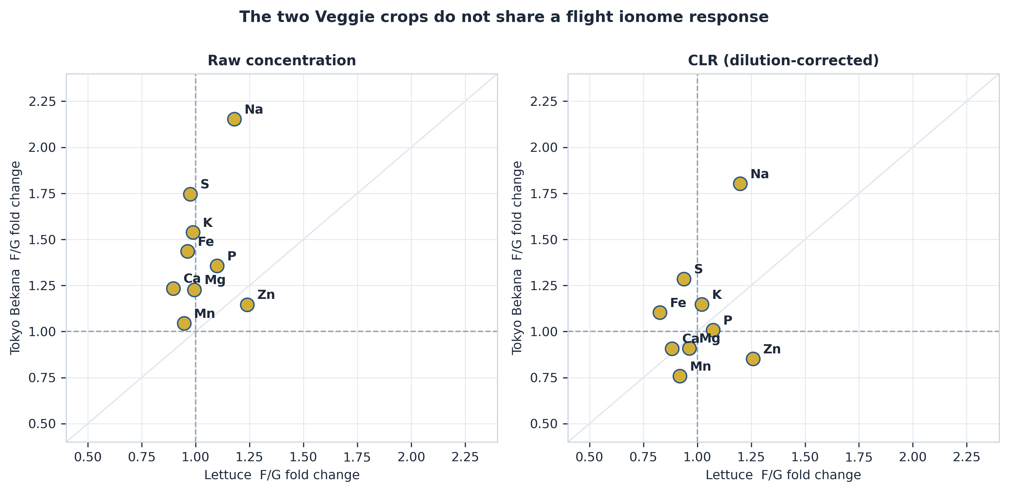
Lettuce versus Tokyo Bekana flight/ground fold change per element. Points on the diagonal would indicate a shared response. They do not lie on it on either scale.

No flight signature transfers between crops
Classification of flight versus ground from the ionome (Figure 4) confirms this from the opposite direction. Under leave-one-mission-out cross-validation (5 folds) the random forest reaches 0.608 balanced accuracy against a best baseline of 0.568, a margin of +0.040 with a 95% confidence interval of 0.48–0.72 that spans chance. Penalised logistic regression performs worse than baseline (-0.038).
Under leave-one-crop-out — training on one species and testing on the other — both models fall below baseline (-0.113 and -0.107). A model that has learned the flight signature of one crop is worse than useless on the other. That is not a failure of the method; it is a direct measurement of the divergence, and it stands against previously reported cross-species accuracies for this data that were not derived from any implemented cross-species split.
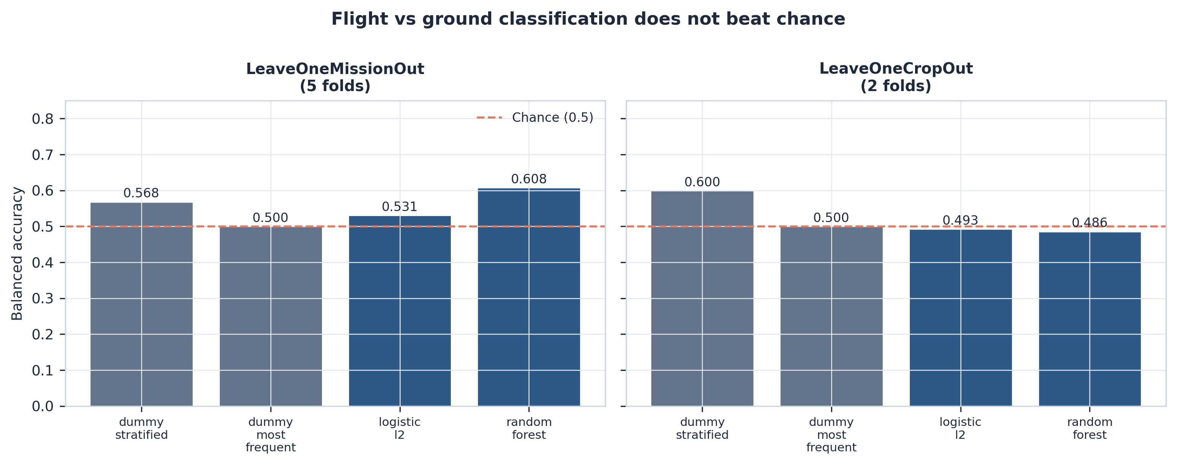
Balanced accuracy under both grouped cross-validation schemes, with the dummy baselines each model must beat.
Permutation importance ranks K, Na and S highest, matching the three elements that survive compositional correction — an internal consistency between two methods that share no machinery.

Astronaut serum minerals
The Inspiration4 comprehensive metabolic panel provides 28 observations across 4 crew and 7 timepoints (Figure 5). Relative to each subject’s pre-flight mean, potassium fell in 3 of 4 crew at first return (median -5.5%), calcium in 4 of 4 (median -3.0%), and bicarbonate in 4 of 4.
Four subjects, a 3-day mission, and no in-flight sample — every timepoint is pre-flight or post-return. The direction of change is reported descriptively, per subject; no inferential test is appropriate at this size, and none is performed.
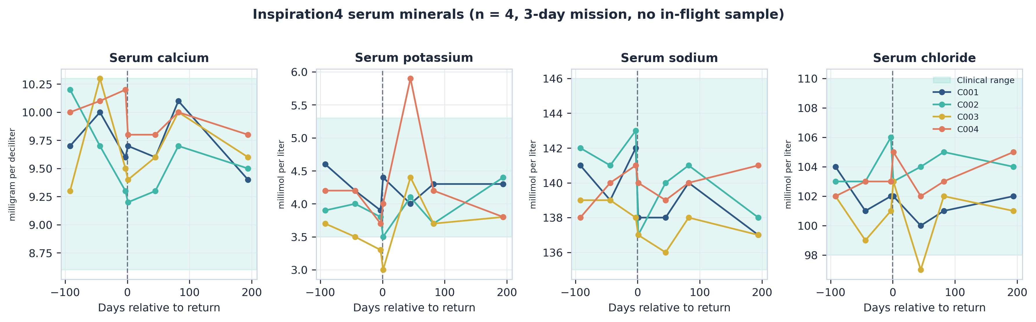
Per-subject serum mineral trajectories, with the clinical reference range shaded. The dashed line marks return.

What a serving delivers, and whether overload is achievable
Combining measured tissue concentrations with NASA daily requirements (National Aeronautics and Space Administration 2020) gives the contribution of a realistic serving (Figure 6). A 100 g fresh serving of flight-grown tissue at $10\%$ dry matter supplies 13.9% (lettuce) and 10.5% (Tokyo Bekana) of the daily potassium requirement, 4.0% and 7.2% of calcium, and 11.7% and 8.2% of iron. Manganese is the standout: a single serving supplies 122.4% and 99.3% of the daily requirement.
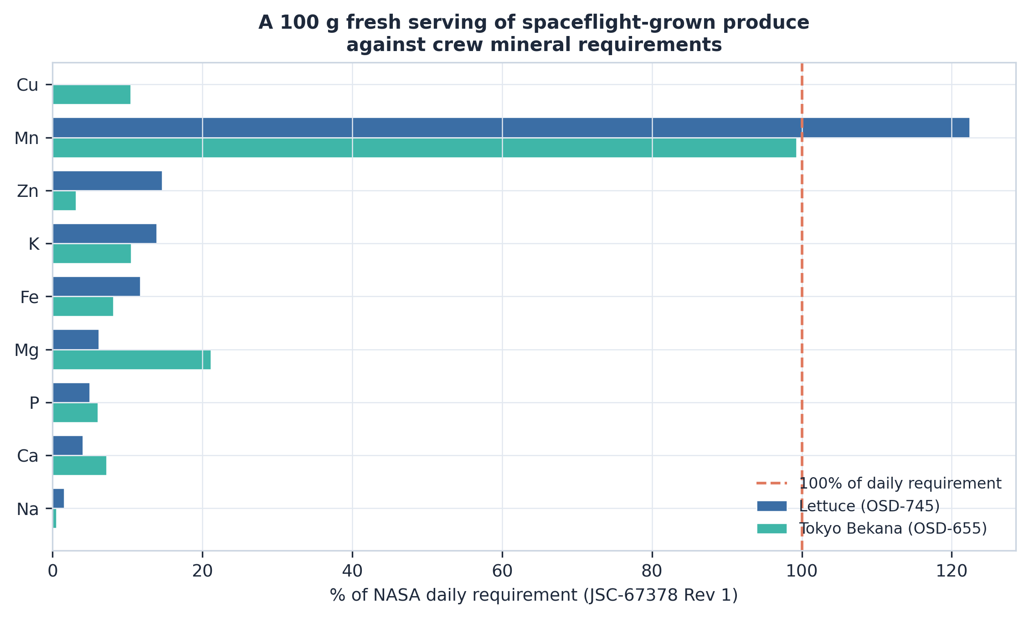
Percentage of the NASA daily mineral requirement supplied by a 100 g fresh serving of flight-grown produce.
The overload question can now be answered directly. Reaching NASA’s iron upper limit of 8 mg/d would require 0.85 kg of fresh lettuce or 1.23 kg of Tokyo Bekana per day; the zinc limit of 40 mg/d would require 2.49 kg and 11.49 kg respectively. A VEG-04A pillow produced roughly 45.3 g fresh, so the iron limit alone would demand the entire yield of more than twenty pillows daily. Dietary mineral overload from Veggie produce is not achievable at any plausible harvest scale.

Supply-normalised uptake
Per-pillow water delivery and harvest mass were recovered for 14 of 36 Tokyo Bekana samples (VEG-04A only). Flight pillows received less water than ground controls (1480 versus 1814 mL) while producing comparable biomass (45.3 versus 43.7 g), giving a higher apparent water-use efficiency in flight (30.4 versus 24.4 g fresh mass per litre). Because no dry-matter fraction is archived, absolute uptake efficiency cannot be computed; the implications are taken up in Section 4.

Discussion

Crop-specific responses argue against a general spaceflight ionome
The clearest result is negative in a useful way: there is no shared flight-induced ionome response across the two Veggie crops with archived elemental data. Lettuce shows no significant change in any element on either scale; Tokyo Bekana shows 6 after compositional correction, and 3 elements move in opposite directions between the crops. A classifier trained on one crop performs below chance on the other.
This matters for how spaceflight crop nutrition is generalised. Statements of the form “spaceflight increases mineral $X$ in leafy greens” are not supported by these data even across two leafy green species grown in the same hardware. The two studies differ in more than species — mission, duration, light spectrum, harvest protocol — and those covariates cannot be separated with $n=60$. That is precisely the point: with the available data, crop identity and its confounds cannot be disentangled, so a species-general claim is not currently derivable from the archive.

Compositional artefacts are the dominant failure mode
The apparent calcium and iron increases in Tokyo Bekana — 1.23$×$ and 1.43$×$, both large and one significant — do not survive correction for dry-matter dilution. Had we reported the raw concentrations, we would have reported an accumulation effect that the data do not support.
This is a general hazard for ICP-OES tissue data, which is compositional by construction (Aitchison 1982). Any treatment that changes tissue water content, structural carbohydrate or non-mineral dry matter shifts every concentration together. Spaceflight plausibly does all three. We would suggest that reporting a concentration fold change without a compositional or content-based check should be treated as an incomplete analysis in this literature, not a stylistic preference.
The elements that survive are informative in their own right. Potassium, sodium and sulfur are the mobile ions most closely tied to water relations and osmotic adjustment, which is a coherent picture for plants in altered root-zone water distribution — and consistent with the reduced water delivery recorded for flight pillows.

Data quality is a first-order scientific problem
The OSD-655 unit defect is a 1000-fold error on five of twelve elements, present in both the data files and the archived data dictionary, in an openly available and citable NASA dataset. It is not hidden — a plausibility check catches it immediately — but nothing in the archive’s own metadata flags it, and a pipeline that trusts the stated unit inherits it silently.
We have written this up for the OSDR curation team (). The broader lesson is that a FAIR dataset is interoperable only to the extent its unit metadata is correct, and that automated plausibility gates belong in analysis pipelines as a matter of routine. The gate that caught this is four lines of arithmetic.

Overload is not the risk; sufficiency is the question
The concern that motivated this work — that plant-rich diets combined with spaceflight-altered mineral handling could drive crew mineral overload — is not supported. Reaching NASA’s iron upper limit would require 0.85 kg of fresh lettuce daily, against a per-pillow yield of roughly 45.3 g. The margin is two orders of magnitude.
The useful question is the opposite one. A 100 g serving supplies 13.9% of daily potassium and 4.0% of daily calcium: real but supplementary contributions. The exception is manganese, at 122.4% of the daily requirement from a single serving, which is worth monitoring as Veggie-type production scales — not because these values approach a toxic threshold, but because it is the one element where produce could plausibly become a dominant dietary source.

The missing measurements
Two absences constrain everything above, and both are cheap to fix.
Dry-matter fraction. OSD-655 archives fresh harvest mass and per-dry-gram concentrations but no dry-matter fraction, so total mineral content per plant cannot be computed and uptake efficiency is unavailable. Dry-matter fraction is routinely measured during ICP-OES sample preparation — the tissue must be dried to be analysed. Archiving that number would convert a bounded estimate into a measurement, and would also allow the dilution correction of Section 2.5 to be tested directly rather than inferred.
Substrate elemental composition. No Veggie study archives the elemental composition of the arcillite substrate and its controlled-release fertiliser charge. Without it, bioavailability — the fraction of supplied mineral that reaches edible tissue — cannot be computed at all. Our water-normalised index is a proxy for the mass-flow driver, not a bioavailability fraction, and we name it accordingly.

What the crew-side data can and cannot support
The Inspiration4 panel gives real, openly available serum mineral measurements, and the post-flight potassium decline in 3 of 4 crew is a genuine observation. But four subjects on a 3-day mission with no in-flight sampling cannot establish a spaceflight effect, and the plant and crew data describe different missions and different people.
The dataset that would close this loop exists: the Nutritional Status Assessment (SMO-016E), with 27 astronauts across long-duration ISS missions, in-flight sampling, and paired dietary intake and serum chemistry (Zheng et al. 2023). Our LSDA survey confirms it is request-gated rather than open. Section 6 and the request package in set out the route.

Limitations
- $n=60$ plant samples in total (24 lettuce, 36 Tokyo Bekana). The crop divergence needs replication before it is treated as established.
- Crop, mission, duration and light spectrum are confounded; the divergence is between studies, not cleanly between species.
- The compositional correction assumes the dilution factor is multiplicative and shared across elements within a sample. Direct dry-matter measurement would test this.
- Water and mass supplements cover VEG-04A only (14/36 samples), and biomass is fresh weight.
- Serving calculations assume a $5$–$10\%$ dry-matter fraction from the literature, not from these studies.
- The astronaut cohort is $n=4$ over 3 days with no in-flight sample.
- LSDA annotation is text-matching over catalog metadata; an experiment whose record does not name its analytes will be missed, so 423 is a lower bound.

Conclusion
Spaceflight does not act on the plant ionome in a way that generalises across the two Veggie crops with archived elemental data. Lettuce shows no significant change in any of ten elements; Tokyo Bekana shows 6 once dry-matter dilution is accounted for, and a classifier trained on either crop fails on the other. Apparent calcium and iron increases — the specific accumulation hypothesis this work set out to test — are dilution artefacts and do not survive compositional correction. Potassium, sodium and sulfur do.
Two contributions are methodological rather than biological, and may matter more. A 1000-fold unit-labelling defect in OSD-655, present in the archived data dictionary as well as the data files, would corrupt any pooled analysis that trusted the stated units; it is caught by a plausibility gate that any pipeline could run. And treating ICP-OES concentrations as compositional rather than independent changes the conclusion for five of twelve elements.
On the question that motivated the work, dietary mineral overload from spaceflight-grown produce is not achievable at plausible harvest scales — 0.85 kg of fresh tissue daily would be needed to reach the iron limit. Sufficiency, not excess, is the operative question, and manganese is the element to watch.
Progress now depends on access rather than analysis. Of 423 LSDA experiments measuring a mineral or nutritional variable, 62 are open and 213 are request-gated. Two inexpensive additions to future crop studies — archived dry-matter fraction and substrate elemental composition — would convert several of this study’s bounded estimates into measurements.

Data and code availability

Data used in this study
All plant and crew data are openly available from the NASA Open Science Data Repository and were retrieved programmatically: OSD-745 (NASA Open Science Data Repository 2024c), OSD-655 (NASA Open Science Data Repository 2024b) and OSD-575 (NASA Open Science Data Repository 2024a). SHA-256 digests of every retrieved file are recorded in . The LSDA experiment catalog (NASA Life Sciences Data Archive 2026) was harvested from the public JSON query endpoint; the annotated catalog is released with this work as .

Data not openly available
The Nutritional Status Assessment (SMO-016E) and Validation of Procedures for Monitoring Crewmember Immune Function (SMO-015), which together underlie Zheng et al. (2023), are held by the NASA Life Sciences Data Archive and are not openly downloadable. LSDA directs requests to https://nlsp.nasa.gov/explore/lsdahome/datarequest. A prepared request covering the variables required to extend this analysis — paired dietary intake and serum mineral concentrations across pre-flight, in-flight and post-flight timepoints — is included in , together with the schema and the loader function into which those data would be ingested without modification to the analysis.

Code
The complete pipeline is released under the MIT licence; text, figures and derived data tables under CC BY 4.0. The analysis runs end to end with make all. An RO-Crate manifest, data dictionary and Zenodo deposition metadata are in .

Note on a prior analysis of these studies
An earlier dashboard and manuscript covering OSD-745, OSD-655 and OSD-780 reported flight/ground effects, model accuracies and cross-species generalisation for these studies. Those values were generated by a synthetic data routine rather than measured, and are not comparable with the results reported here. A correction note and a working replacement data-acquisition module are provided in . We record this here because the affected figures have been publicly posted, and readers comparing the two should know which rests on measurements.
Aitchison, J. 1982. “The Statistical Analysis of Compositional Data.” Journal of the Royal Statistical Society Series B: Statistical Methodology 44 (2): 139–60. https://doi.org/10.1111/j.2517-6161.1982.tb01195.x.
Benjamini, Yoav, and Yosef Hochberg. 1995. “Controlling the False Discovery Rate: A Practical and Powerful Approach to Multiple Testing.” Journal of the Royal Statistical Society Series B: Statistical Methodology 57 (1): 289–300. https://doi.org/10.1111/j.2517-6161.1995.tb02031.x.
Bunchek, Jess M., Mary E. Hummerick, LaShelle E. Spencer, et al. 2024. “Pick-and-Eat Space Crop Production Flight Testing on the International Space Station.” Journal of Plant Interactions 19 (1): 2292220. https://doi.org/10.1080/17429145.2023.2292220.
Khodadad, Christina L. M., Mary E. Hummerick, LaShelle E. Spencer, et al. 2020. “Microbiological and Nutritional Analysis of Lettuce Crops Grown on the International Space Station.” Frontiers in Plant Science 11: 199. https://doi.org/10.3389/fpls.2020.00199.
Massa, Gioia D., Gerard Newsham, Mary E. Hummerick, Robert C. Morrow, and Raymond M. Wheeler. 2017. “Plant Pillow Preparation for the Veggie Plant Growth System on the International Space Station.” Gravitational and Space Research 5 (1): 24–34. https://doi.org/10.2478/gsr-2017-0002.
NASA Life Sciences Data Archive. 2026. LSDA Experiment Catalog. NASA Life Sciences Portal. https://nlsp.nasa.gov/explore/mtable/lsda_experiment/lsda_experiment.
NASA Open Science Data Repository. 2024a. OSD-575: Inspiration4 Comprehensive Metabolic Panel and Multiplex Serum Assays. NASA Open Science Data Repository. https://osdr.nasa.gov/bio/repo/data/studies/OSD-575.
NASA Open Science Data Repository. 2024b. OSD-655: Elemental and Biochemical Analysis of Veggie-Grown Tokyo Bekana (VEG-04A, VEG-04B). NASA Open Science Data Repository. https://osdr.nasa.gov/bio/repo/data/studies/OSD-655.
NASA Open Science Data Repository. 2024c. OSD-745: Elemental, Phenolic, Anthocyanin and ORAC Analysis of Veggie-Grown Lettuce (VEG-01A, VEG-01B, VEG-03A). NASA Open Science Data Repository. https://osdr.nasa.gov/bio/repo/data/studies/OSD-745.
National Aeronautics and Space Administration. 2020. Nutritional Requirements for Exploration Missions up to 365 Days. JSC-67378 Rev 1. NASA Johnson Space Center. https://ntrs.nasa.gov/citations/20205008306.
Smith, Scott M., Sara R. Zwart, Gladys Block, Barbara L. Rice, and Janis E. Davis-Street. 2005. “The Nutritional Status of Astronauts Is Altered After Long-Term Space Flight Aboard the International Space Station.” The Journal of Nutrition 135 (3): 437–43. https://doi.org/10.1093/jn/135.3.437.
Zheng, Minzhang, Jacqueline Charvat, Sara R. Zwart, et al. 2023. “Time-Resolved Molecular Measurements Reveal Changes in Astronauts During Spaceflight.” Frontiers in Physiology 14: 1219221. https://doi.org/10.3389/fphys.2023.1219221.

