A gas-transport model predicts the Arabidopsis spaceflight transcriptome, and illumination separates six flight contrasts

Introduction
Interpreting a plant spaceflight experiment means attributing a molecular difference to microgravity. That attribution rests on an assumption that is almost never tested: that the flight and ground arms differ in gravity and in nothing else that matters to metabolism.
Plants flown on the International Space Station are grown inside enclosures — sealed Petri Dish Fixation Units in BRIC canisters, Petri plates on the cabin wall in CARA, actively ventilated chambers in VEGGIE and the Advanced Plant Habitat. These enclosures differ by orders of magnitude in how freely they exchange gas with the cabin, and to our knowledge no BRIC-class flight has logged the CO$​_{2}$ concentration its plants actually experienced.
The quantity that matters is not the cabin atmosphere but the CO$​_{2}$ mole fraction reaching Rubisco, $C_{c}$, which sits at the end of a chain of conductances: from bulk air across the leaf boundary layer ($g_{bl}$), through the stomata ($g_{s}$), and through the mesophyll ($g_{m}$). Only the first of those is gravity-dependent, through buoyancy-driven convection. Rubisco partitions between carboxylation and oxygenation as $V_{o}/V_{c}=2Γ^{*}/C_{c}$ (Farquhar et al. 1980), so anything that lowers $C_{c}$ raises photorespiration.
Here we ask a question about the enclosure rather than about gravity, and we ask it of the model before we ask it of any data.

Results

An illuminated sealed canister is a CO$​_{2}$-starvation chamber
Boundary-layer conductance was taken from LunarLeaf-CFD (Barker, n.d.), a lattice-Boltzmann solver validated against four analytical and empirical gates. The enclosure dynamics come from zero-dimensional (0-D) mass-balance models parameterized by geometry (Table S1). A headspace mass balance (30 mL air over 3 cm$​^{2}$ leaf; well-mixed assumption) draws a lit BRIC canister from 400 ppm to near zero in approximately seven minutes; dynamic photosynthesis-feedback puts 12 h carbon gain at 1 % of an unenclosed 1 $g$ control, against 90 % for CARA plates sealed with micropore tape (permeance $0.006{\text{ mol m}}^{−2}{\text{ s}}^{−1}$) and 100 % when ventilated (Fig. 1). Sensitivity analysis demonstrates that rapid starvation holds across a wide envelope of leaf area (1–10 cm$​^{2}$) and headspace (15–60 mL; Table S5).
Because drawdown is an enclosure mass balance, under symmetric thermal and sealing conditions it occurs in the ground control as much as in flight, canceling out of the published contrast.

What that does to Rubisco, and what gravity does not do
Feeding $g_{bl}$ into a Farquhar–von Caemmerer–Berry model (Farquhar et al. 1980) with in-vivo kinetics (Bernacchi et al. 2001, 2003) at experimental irradiance (60 μmol m$​^{−2}$ s$​^{−1}$, OSD-522) moves the leaf along its CO$​_{2}$ response curve: oxygenation fraction $φ=V_{o}/(V_{o}+V_{c})$ rises from 18.0 % in ventilated hardware at ambient CO$​_{2}$ to 46.2 % in a drawn-down canister (at an assumed 100 ppm; Table 1, Fig. 2a). At saturating light (1,000 μmol m$​^{−2}$ s$​^{−1}$), $φ$ rises from 28.5 % to 53.7 %.
Contrary to our initial hypothesis, CO$​_{2}$ starvation does not amplify the microgravity boundary-layer penalty (Fig. 2b). As assimilation falls, flux across the boundary layer ($A/g_{bl}$) vanishes and the gravities converge. What survives is an assimilation deficit of $<3 \%$ at leaf and rosette scale (up to 11 % in a dense canopy) at 60 μmol m$​^{−2}$ s$​^{−1}$, and 5–9 % (26–29 % in canopy) at saturating light (Fig. 2c). The sealed-versus-ventilated hardware effect on metabolite pools is 22 times the flight-versus-ground effect (Fig. 2d).

A metabolite layer that does not exist
Pathway-level integration needs a metabolome. An exhaustive census of all 567 OSDR studies revealed that 12 are metabolite profiling, and all 12 are mouse, human, rat or microbial (Table S3). No plant study in OSDR has a metabolome.
We therefore predicted a 21-compound layer as a falsifiable hypothesis scaffold (Fig. 3, Table S4), propagating fluxes under quasi-steady state: $\log_{2}(P_{\text{flight}}/P_{\text{ground}})=\log_{2}(J_{\text{flight}}/J_{\text{ground}})$.

The model called eight of nine transcriptome gene sets
OSD-522 (Integrative Transcriptomics and Proteomics Profiling of Arabidopsis Thaliana Elucidates Novel Mechanisms Underlying Spaceflight Adaptation 2024) grew Arabidopsis in BRIC-LED hardware under 60 μmol m$​^{−2}$ s$​^{−1}$ light (6 flight vs 6 ground shoot libraries). Differential expression with PyDESeq2 (Muzellec et al. 2023) yielded 1,795 DEGs at FDR $<0.05$ from 19,325 tested (1,658 had NA adjusted $p$ due to standard DESeq2 independent filtering on low base counts; Fig. 4). Deposited proteomics provided ratios for 5,160 proteins.
Scoring against KEGG gene sets (Fig. 5), predictions held for eight of nine transcriptome sets: photosystems fell ($−0.238$, $p=3.8×{10}^{−6}$; proteome $−0.820$, $p=5.0×{10}^{−4}$), Rubisco fell ($−0.403$, $p=4.5×{10}^{−3}$), carbon fixation and starch/sucrose fell, DIN carbon-starvation markers rose ($+0.685$, $p=2.6×{10}^{−3}$), and photorespiratory enzymes were not induced. In set-versus-set contrasts immune to global depression, photorespiratory enzymes sat above Rubisco in transcriptome ($+0.239$, $p=6.8×{10}^{−3}$) and proteome ($+0.285$, $p=4.9×{10}^{−2}$).

Pathway integration puts photorespiration in the bottom 8 %
In PaintOmics (Liu et al. 2022) (Fig. 6), 32 of 232 pathways reached uncorrected $p<0.05$, led by ER protein processing (UPR, $p=8.6×{10}^{−9}$). Photosynthesis was enriched ($p=0.008$), while Glyoxylate and dicarboxylate metabolism (photorespiration) ranked 214th of 232 ($p=0.994$, bottom 8 %). An integration control excluding predicted metabolites confirmed that these pathway rankings and the UPR dominance are fully invariant to the metabolite layer (Table S6). Independent enrichment analysis outside PaintOmics confirmed identical significance for photosynthesis and Calvin cycle repression (Table S7). In the metabolite hub analysis, 7 of 15 compounds reached FDR $<0.05$, all carbon-starvation or supply nodes.

Illumination separates six contrasts; the enclosure gradient does not
Across six flight-versus-ground contrasts from five studies (Proteomics and Transcriptomics Analysis of Arabidopsis Seedlings in Microgravity 2015; Relevance of Unfolded Protein Response to Spaceflight-Induced Transcriptional Reprogramming in Arabidopsis 2021; Light Has a Principal Role in the Arabidopsis Transcriptomic Response to the Spaceflight Environment 2023; Characterizing Epigenetic Changes in Methylation Mutants (Elp2-5 and Met1-7) in Response to Spaceflight [RNA-Seq] 2021) (Fig. 7, Table 2), illumination separated them completely: all three illuminated contrasts were positive on starvation over photosynthesis ($+0.41,+0.92,+2.58$) and all three dark ones negative ($−0.39,−1.95,−3.22$; one-sided descriptive Mann–Whitney $p=0.05$). The predicted gradient across enclosure classes did not hold ($ρ=−0.50,p=0.67$), indicating that illumination driving drawdown, rather than enclosure sealing alone, dominates.

Discussion
The strongest signal in OSD-522 is unfolded protein response (UPR) in the ER, which gas transport does not explain. However, in an illuminated enclosure the hardware sets an unmeasured, extreme carbon-starvation baseline. Hardware cancellation between flight and ground is a baseline hypothesis that holds when gas exchange and thermal regimes are symmetric; any flight-ground asymmetry in leakage or temperature would expose hardware effects in the contrast.

Limitations
The cross-study comparison is descriptive and subject to platform and tissue variation. FvCB parameters reflect literature values rather than flight fits. Headspace drawdown was evaluated with 0-D mass balances; while verified across broad parameter sweeps, in-situ sensor logging remains essential.

What would settle it
First, log CO$​_{2}$ and O$​_{2}$ inside flight canisters. Second, profile a targeted 20-compound metabolite panel on archived material. Third, implement a three-arm design (flight sealed, ground sealed, ground vented) to separate main effects of hardware and gravity (Fig. 8), or a complete $2×2$ factorial design (adding flight vented) to evaluate gravity $×$ enclosure interactions.

Methods
Gas transport. Conductances $g_{bl}$ were obtained from LunarLeaf-CFD (Barker, n.d.) steady-state exports across leaf, rosette, and canopy scales. Enclosure drawdown kinetics were calculated using 0-D mass balance models (Table S1). Upscaling from leaf to rosette accounts for 8 overlapping blades with crown sheltering; canopy scaling models dense upright shoots ($3.5\text{ mm}$ spacing) where boundary layers merge in parallel.
Photosynthesis model. The FvCB C$​_{3}$ model was solved for supply-equals-demand fixed points across $C_{a}$ grids and irradiances (Table S2). Oxygenation fraction is defined as $φ=V_{o}/(V_{o}+V_{c})$. Surface O$​_{2}$ excess from CFD ($ΔO_{2}∼5$–$12\text{ ppm}$) was propagated into local $Γ^{*}$.
Differential expression. OSD-522 was processed with PyDESeq2 (Muzellec et al. 2023) using design ~ condition and Cook’s distance refitting. Transcripts with NA adjusted $p$-values reflect standard independent filtering on low base counts.
Gene sets and pathways. KEGG pathway membership was retrieved live (Kanehisa and Goto 2000; KEGG, n.d.). PaintOmics 4 (Liu et al. 2022) was executed on KEGG and MapMan databases.

Use of AI tools
Analysis scripts, figures, and manuscript drafts were developed with AI coding assistants (Claude Code, Anthropic; Google Antigravity) under the author’s direction. The author verified all data, derivations, and references, and takes full responsibility.
Supplementary Tables S1–S7 and Supplementary Figure S1 accompany this paper.
Primary data are available in NASA OSDR (Gebre et al. 2025) (OSD-522, OSD-38, OSD-321, OSD-678, OSD-427). Derived tables are in the repository.
Analysis code is available at https://github.com/dr-richard-barker/Photorespiration_multiomics_microgravity.
The author thanks the NASA Open Science Data Repository team and the spaceflight plant biology community.
R.B. conceived the study, conducted modeling and multi-omics analysis, and wrote the manuscript.
This study received no external funding.
The author declares no competing financial or non-financial interests.
Modelled operating points at experimental (60 μmol m$​^{−2}$ s$​^{−1}$) and saturating (1000 μmol m$​^{−2}$ s$​^{−1}$) light. $g_{bl}$ in mol m$​^{−2}$ s$​^{−1}$ (two-sided leaf basis); $C_{a},C_{c}$ in μmol mol$​^{−1}$; $A$ in μmol m$​^{−2}$ s$​^{−1}$; $φ=V_{o}/(V_{o}+V_{c})$ in %. Rosette scale.
Arm | Irradiance ($Q$) | $g_{bl}$​ | $C_{a}$​ | $C_{c}$​ | $φ$ (%) | $A$​
Ground control (sealed) | 60 | 0.540 | 100 | 88.2 | 45.8 | 0.94
Flight (sealed) | 60 | 0.272 | 100 | 87.2 | 46.2 | 0.88
Ventilated (ambient) | 60 | 0.272 | 400 | 334.6 | 18.0 | 4.90
Ground control (sealed) | 1000 | 0.540 | 100 | 75.5 | 53.1 | 2.40
Flight (sealed) | 1000 | 0.272 | 100 | 73.6 | 53.7 | 2.20
Ventilated (ambient) | 1000 | 0.272 | 400 | 215.0 | 28.5 | 15.40

The five OSDR studies analysed (six flight-vs-ground contrasts), with complete experimental metadata and confounders, and the six excluded studies.
Study | Hardware | Class | Tissue | Genotype | Duration | Light | Status
OSD-522 | BRIC-LED | sealed | shoots | Col-0 WT | 11 d | lit (60 $μ$mol) | Included
OSD-38 | BRIC-PDFU | sealed | whole seedlings | Col-0 WT | 8 d | dark | Included
OSD-321 | BRIC-PDFU | sealed | seedlings | WT | 14 d | dark | Included
OSD-678 | CARA square dish | tape | leaves | Col-0 WT | 12 d | lit (cabin) | Included
OSD-678 | CARA square dish | tape | leaves | Col-0 WT | 12 d | dark | Included
OSD-427 | VEGGIE (VPS) | vented | leaf | WT | 21 d | lit (120 $μ$mol) | Included
OSD-120 | CARA square dish | tape | root tips | Col-0 | 12 d | lit/dark | Excluded (roots)
OSD-193 | APH/APEX | vented | roots | Col-0, Sku6 | 14 d | lit | Excluded (roots)
OSD-281 | APH/APEX | vented | roots | WS, Sku5 | 14 d | lit | Excluded (roots)
OSD-218 | APH/APEX | vented | unstated | Col-0, WS | 14 d | lit | Excluded (tissue unstated)
OSD-16 | APEX-TAGES | vented | leaf/stem | WT | 12 d | lit | Excluded (no processed files)
OSD-7 | TAGES | vented | whole | WT | 12 d | lit | Excluded (microarray)
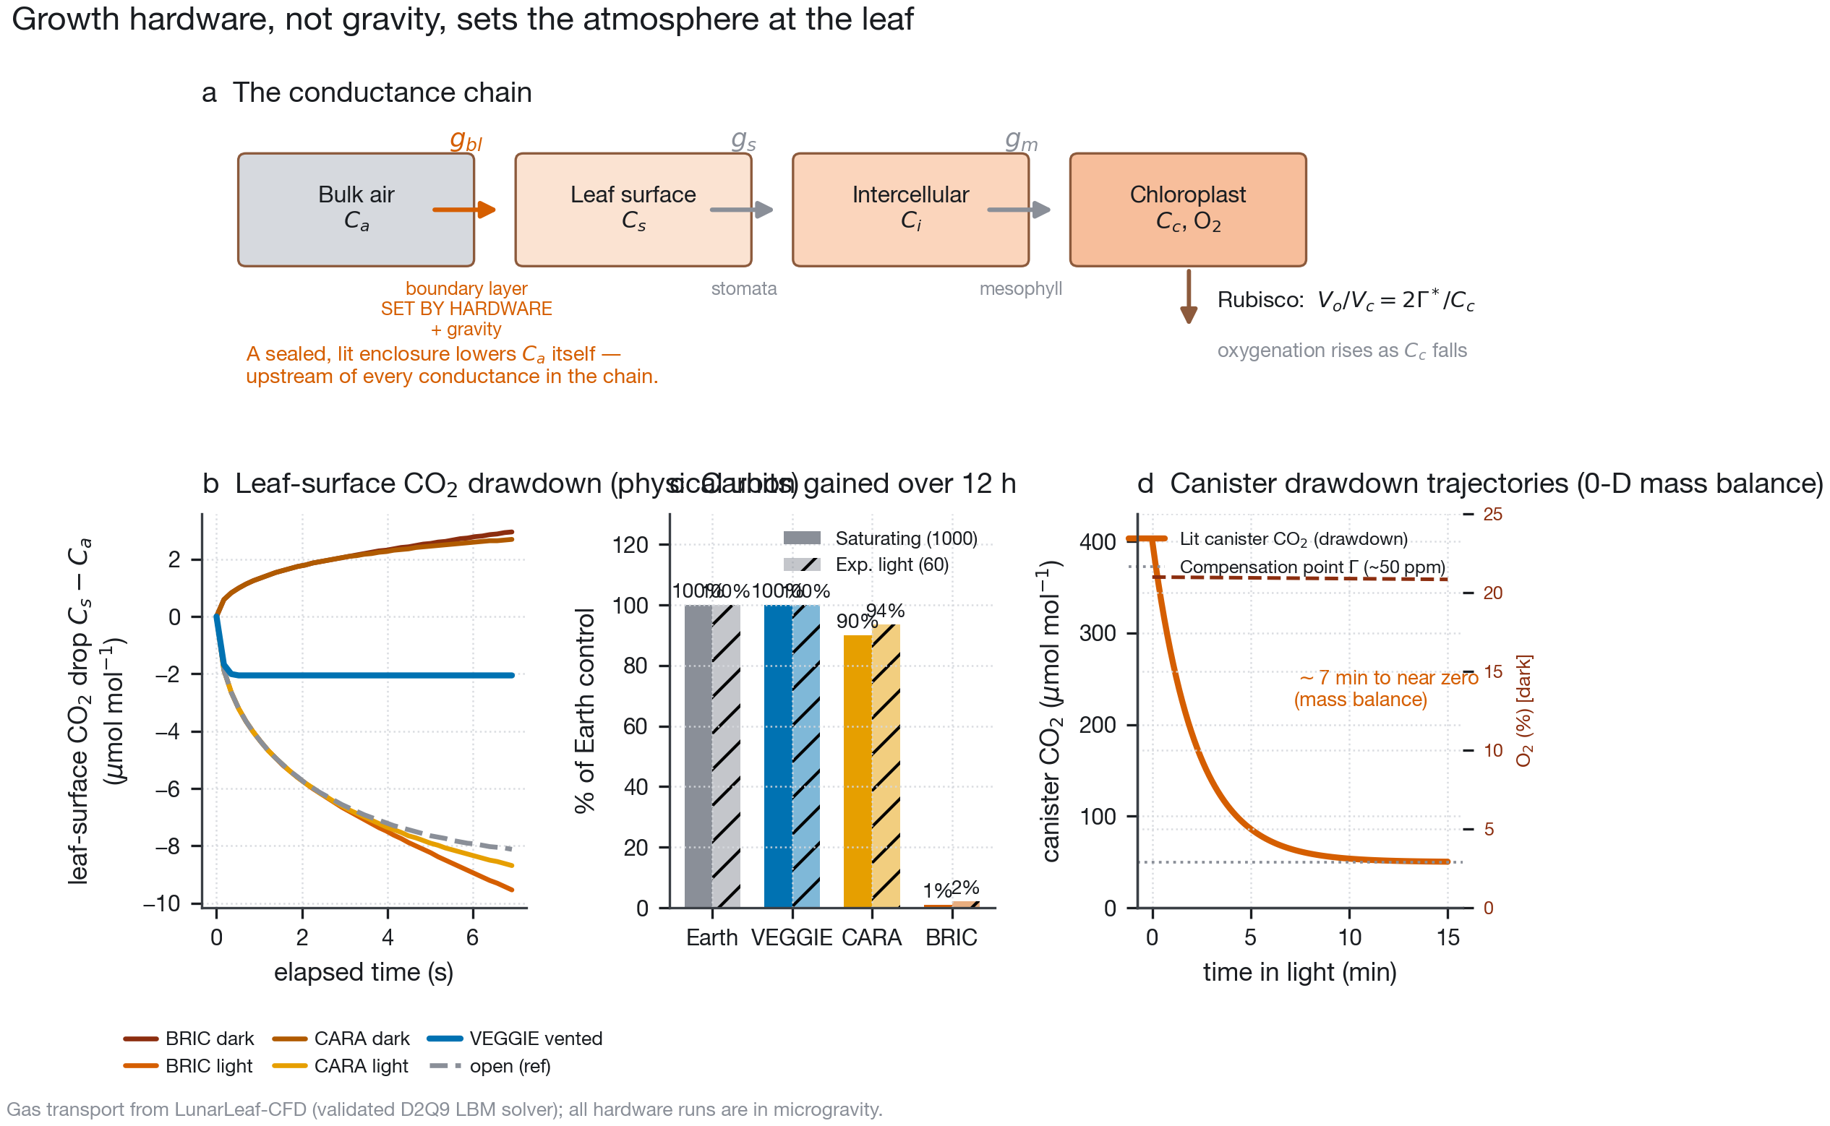
Growth hardware, not gravity, sets the atmosphere at the leaf. a, The conductance chain. b, Simulated leaf-surface CO$​_{2}$ difference ($C_{s}−C_{a}$, $μ$mol mol$​^{−1}$) over elapsed physical time ($dt=0.173\text{ ms}$). c, Integrated 12 h carbon gain (% of Earth control) comparing saturating light (1000 μmol m$​^{−2}$ s$​^{−1}$) and experimental light (60 μmol m$​^{−2}$ s$​^{−1}$). d, Dynamic 0-D canister mass-balance trajectories showing rapid CO$​_{2}$ drawdown to compensation point in lit canisters and gradual O$​_{2}$ depletion in dark canisters.
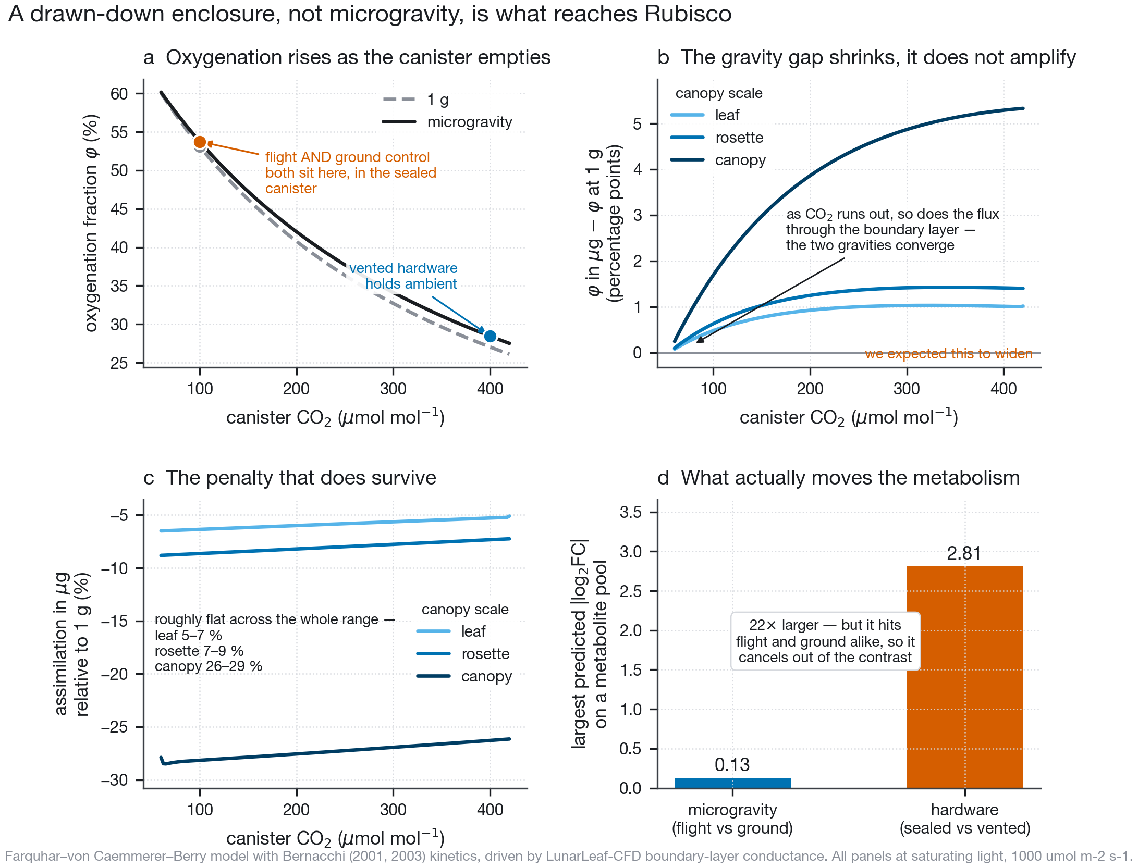
A drawn-down enclosure, not microgravity, is what reaches Rubisco. a, Oxygenation fraction $φ=V_{o}/(V_{o}+V_{c})$ at experimental light ($60 μ{\text{mol m}}^{−2}{\text{ s}}^{−1}$, solid) and saturating light ($1000$, dotted). b, The gravity gap in oxygenation shrinks toward zero as CO$​_{2}$ falls. c, Proportional assimilation deficit ($<3\%$ at rosette scale under 60 $μ$mol m$​^{−2}$ s$​^{−1}$; 7–9% at saturating light). d, The 22-fold dominance of the enclosure effect over the microgravity effect.
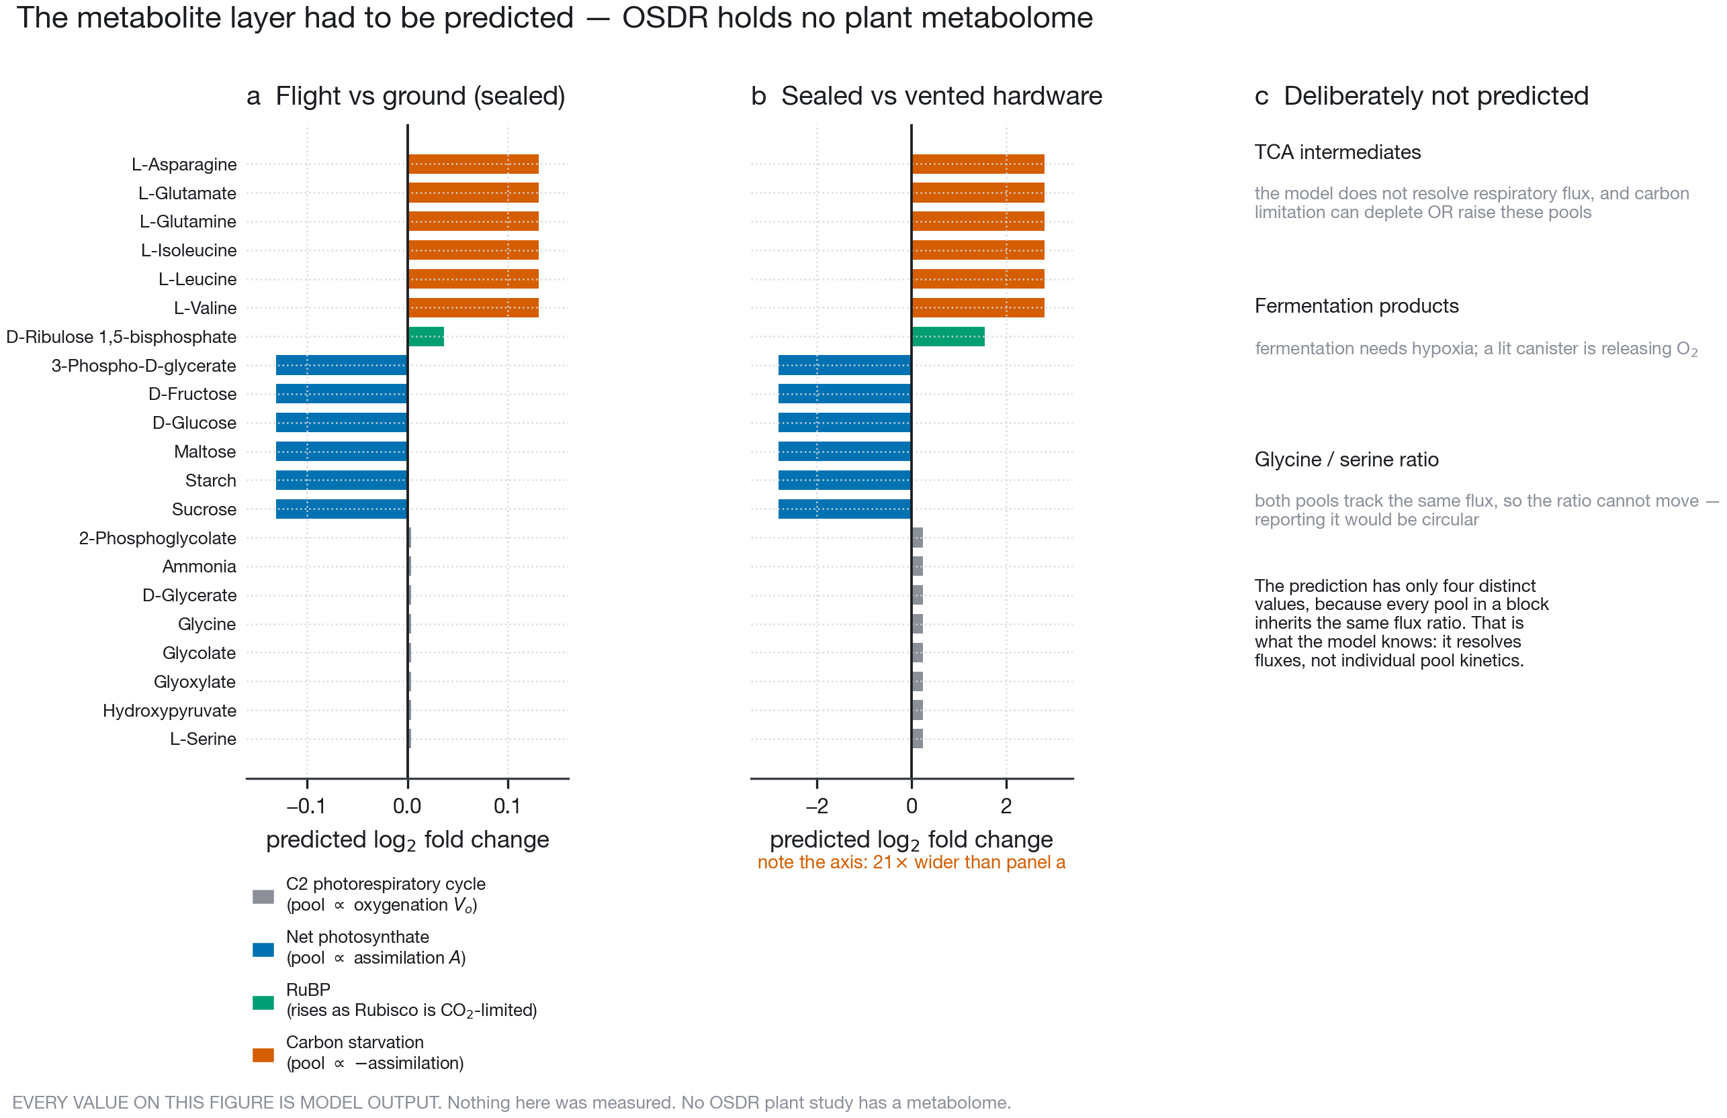
The predicted metabolite layer. Formulated as a transparent hypothesis scaffold driven by modelled fluxes ($V_{o},A,−C_{c},−A$). Every value is model output.
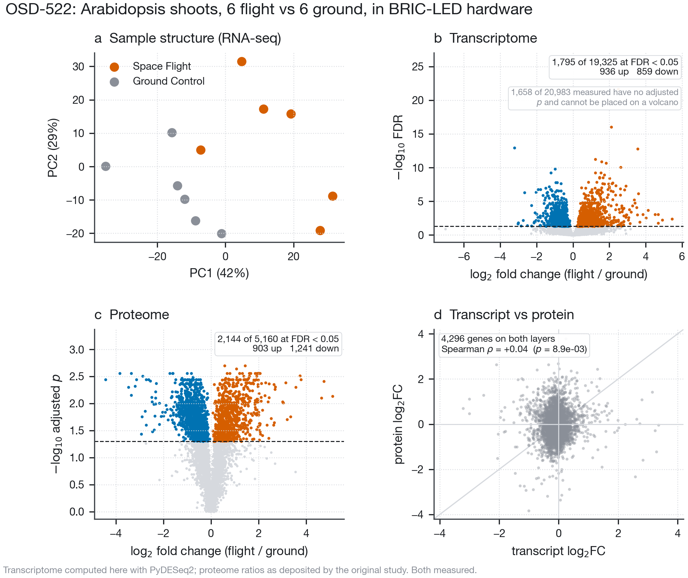
OSD-522 omics profiling: 6 flight vs 6 ground shoot samples in BRIC-LED hardware. a, PCA of RNA-seq libraries. b, Transcriptome volcano (PyDESeq2; 1,658 transcripts with NA adjusted $p$ due to independent filtering). c, Proteome volcano. d, Transcript vs protein correlation for 4,296 co-measured genes.
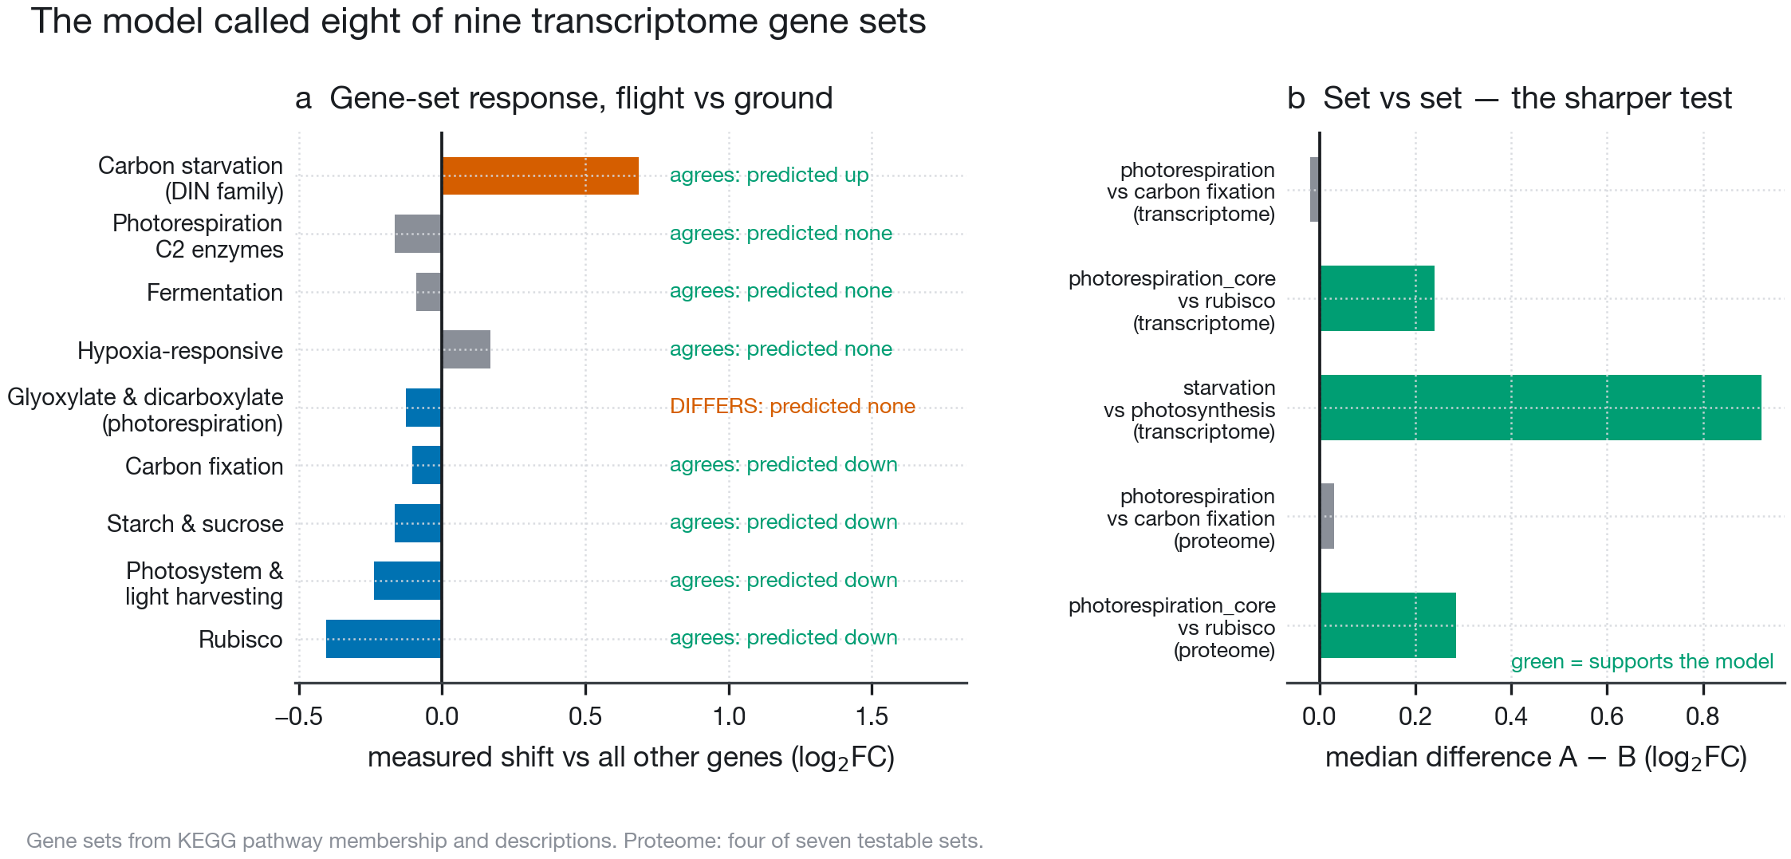
The model’s blind predictions against OSD-522 measurements. a, Directional calls across nine transcriptome sets. b, Set-versus-set contrasts demonstrating photorespiratory maintenance over photosynthetic apparatus.
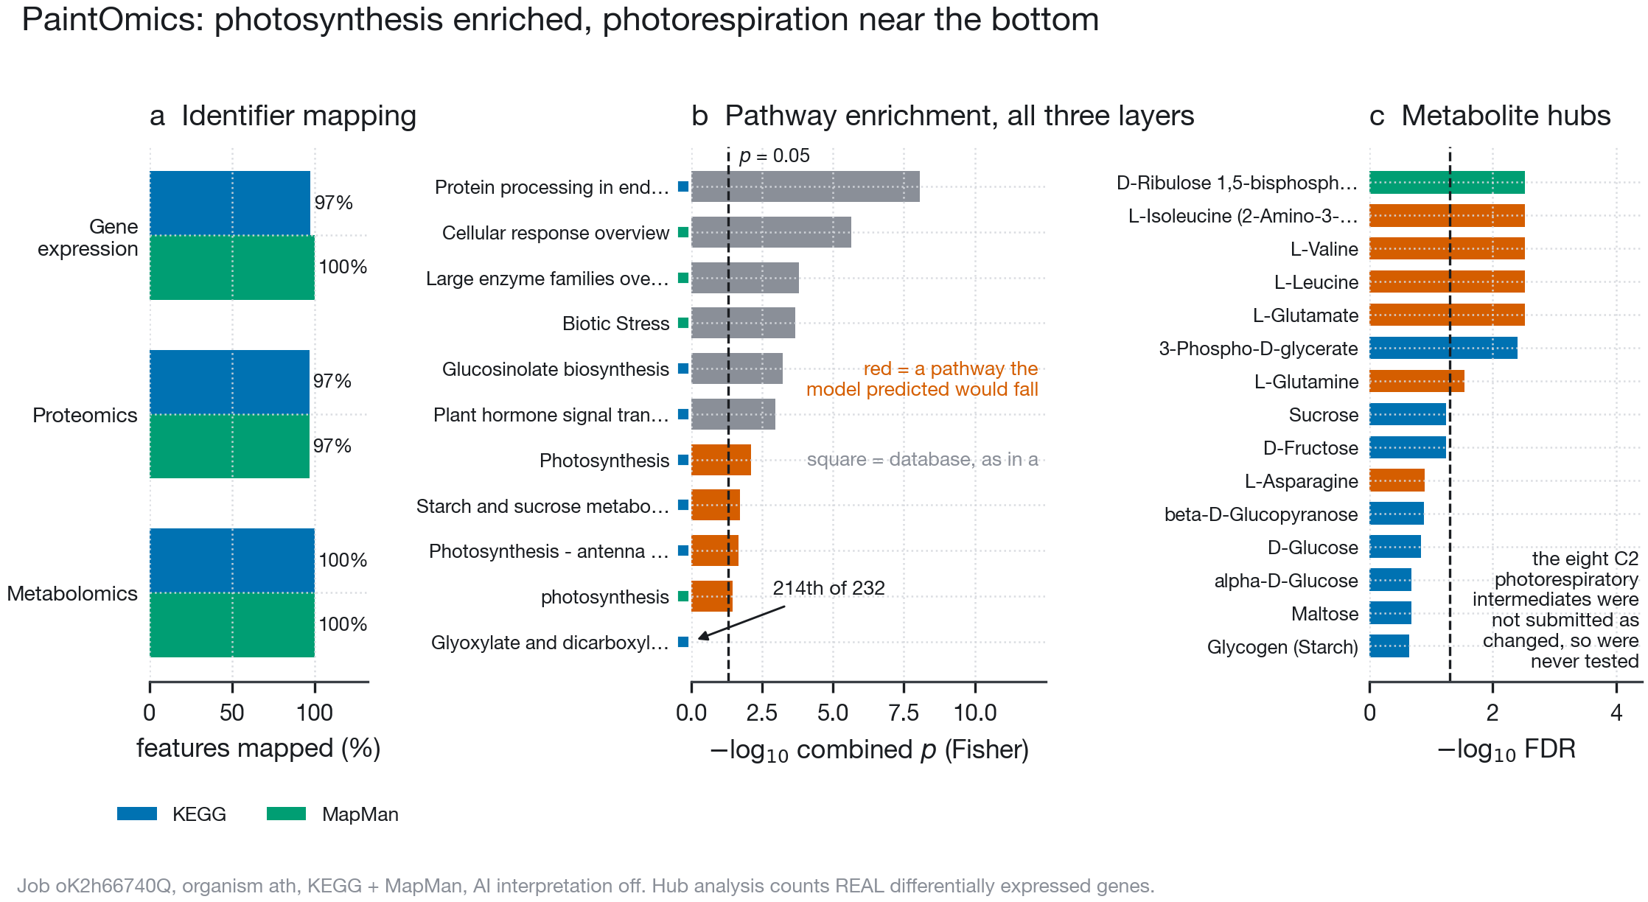
PaintOmics multi-omics pathway integration. a, Feature mapping across databases. b, Pathway enrichment ranking: ER protein processing (UPR) dominates; photorespiration ranks in the bottom 8% (214th of 232). c, Metabolite hub analysis ranking predicted compounds by measured DEG neighbours.
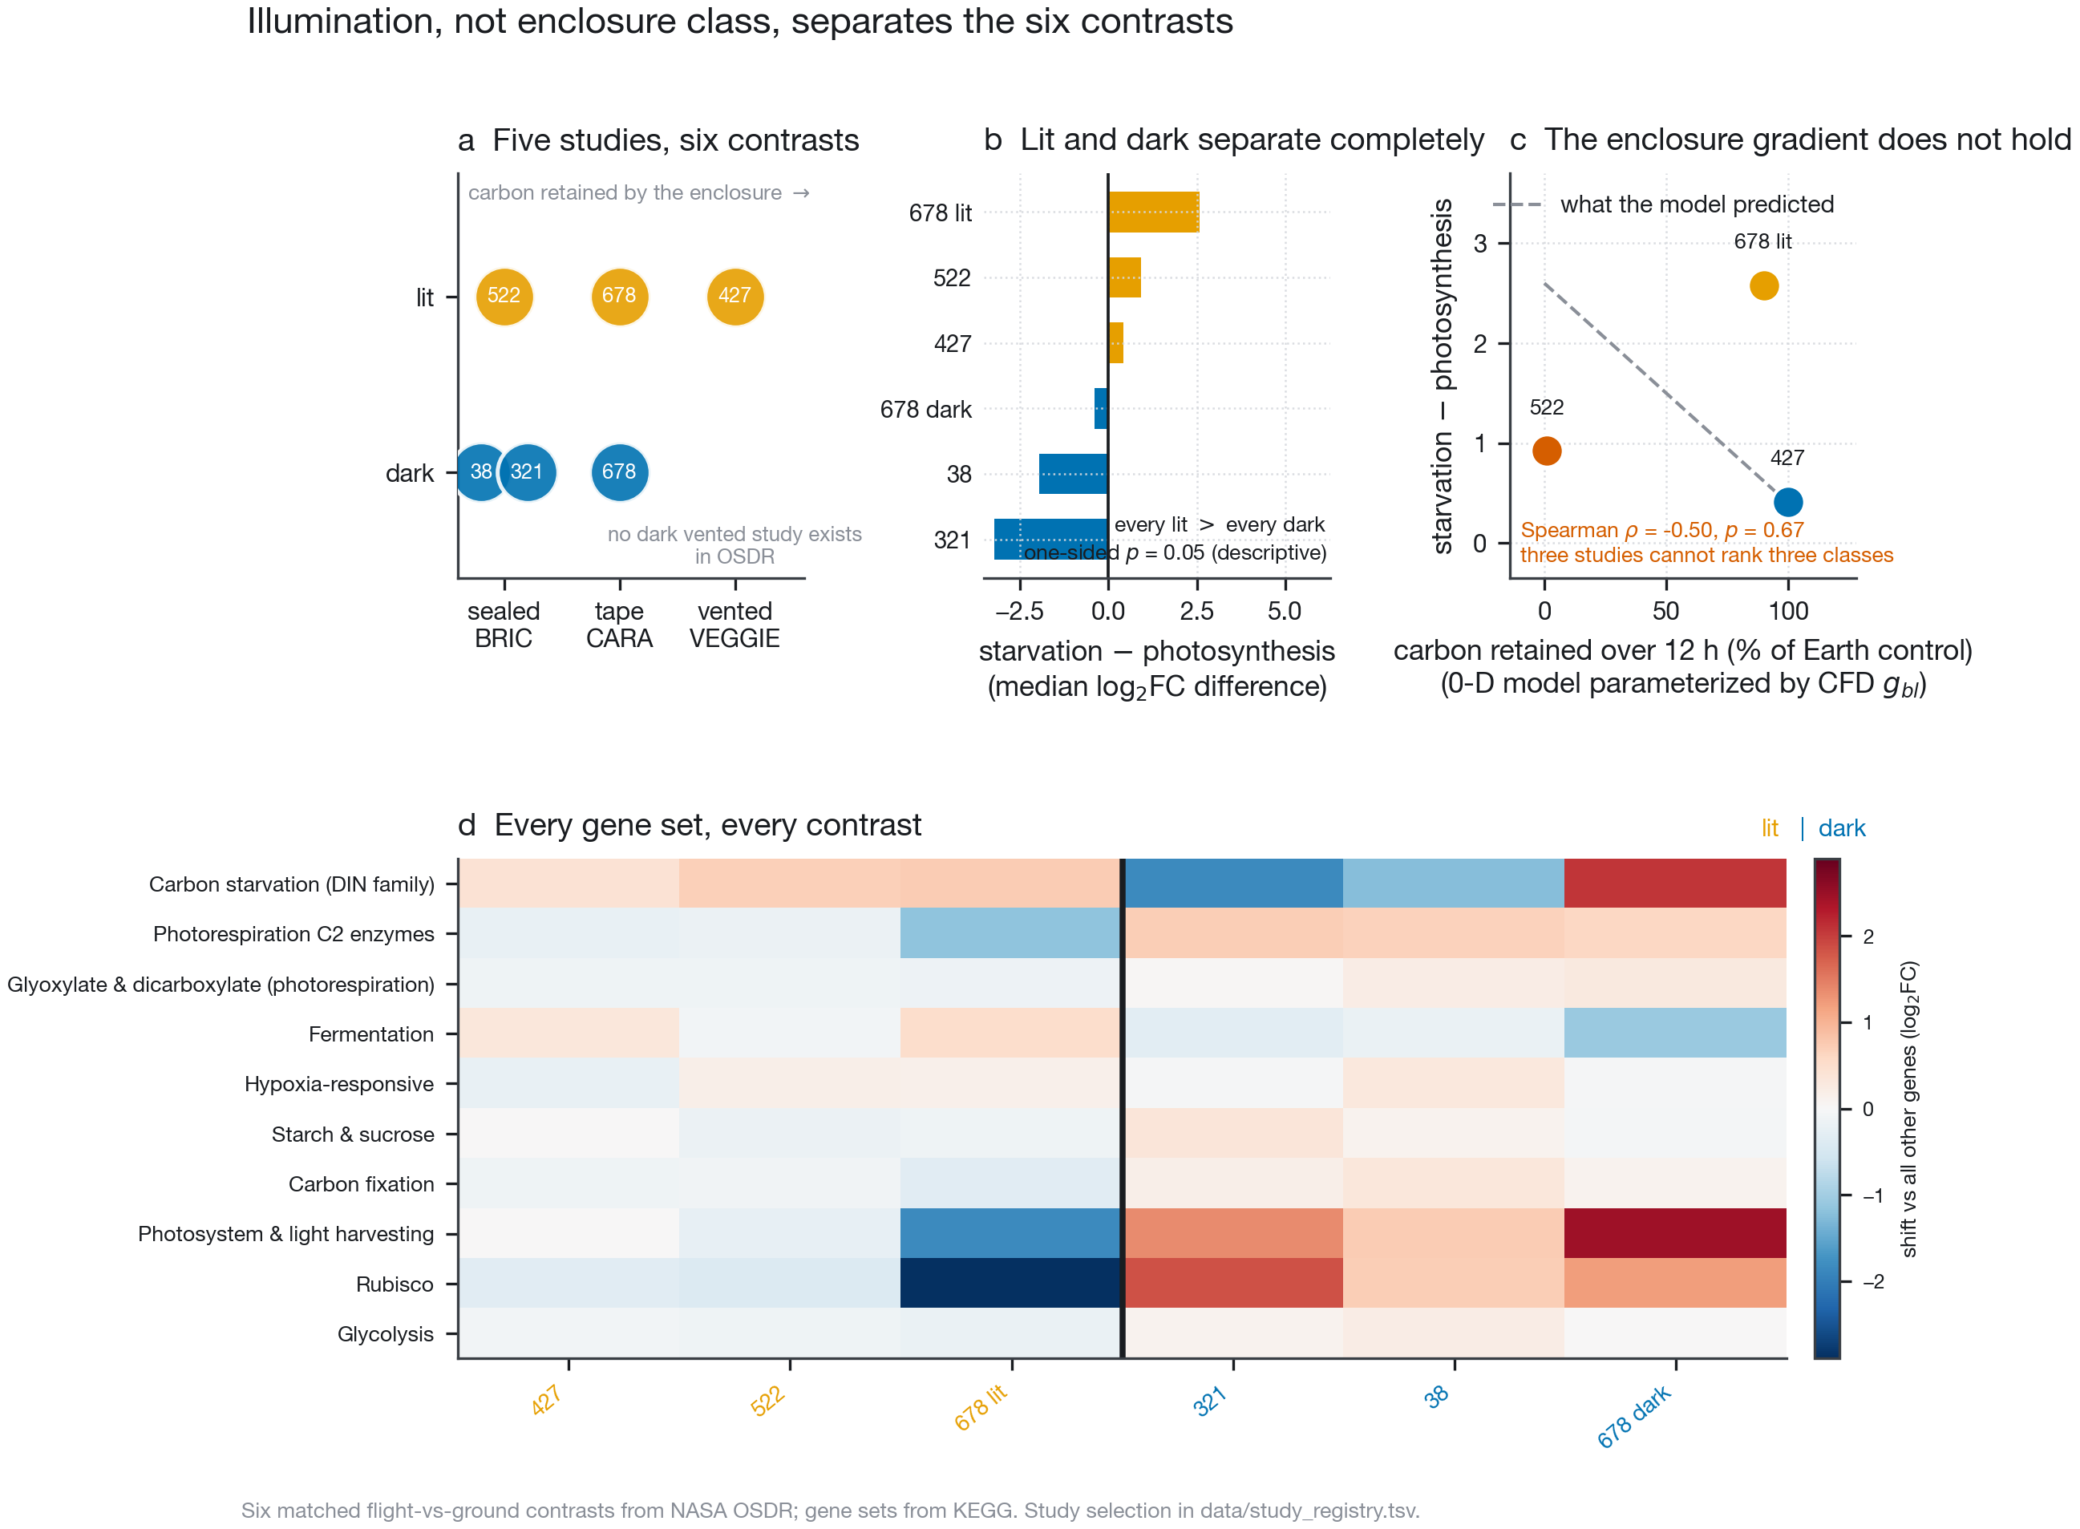
Cross-study evaluation of the hardware ladder. a, Grid of six contrasts across five studies. b, Illumination separates all lit from all dark contrasts on starvation over photosynthesis. c, The predicted enclosure gradient does not hold (0-D model parameterized by CFD $g_{bl}$). d, Response matrix across all ten evaluated gene sets.
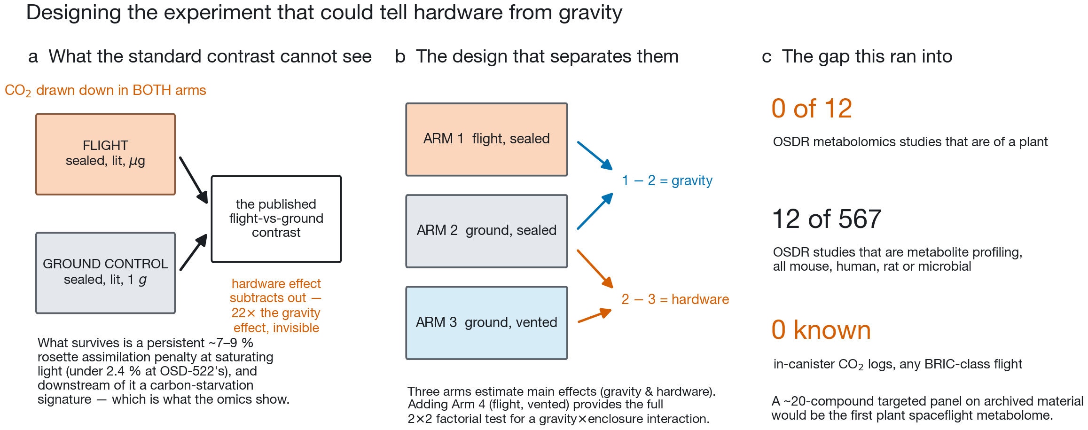
Experimental designs to resolve growth hardware from microgravity. a, The published contrast cancels hardware effects. b, Proposed three-arm design separates main effects of hardware and microgravity; adding a flight-vented arm forms a complete $2×2$ factorial test for interaction. c, The archive gap in OSDR plant metabolomics and in-canister logging.
Barker, Richard. n.d. LunarLeaf-CFD: A Validated Lattice-Boltzmann Solver for Leaf Boundary-Layer Gas Transport Under Variable Gravity. Https://github.com/dr-richard-barker/LunarLeaf-CFD.
Bernacchi, C. J., C. Pimentel, and S. P. Long. 2003. “In Vivo Temperature Response Functions of Parameters Required to Model RuBP-Limited Photosynthesis.” Plant, Cell and Environment 26 (9): 1419–30. https://doi.org/10.1046/j.0016-8025.2003.01050.x.
Bernacchi, C. J., E. L. Singsaas, C. Pimentel, A. R. Portis Jr., and S. P. Long. 2001. “Improved Temperature Response Functions for Models of Rubisco-Limited Photosynthesis.” Plant, Cell and Environment 24 (2): 253–59. https://doi.org/10.1046/j.1365-3040.2001.00668.x.
Characterizing Epigenetic Changes in Methylation Mutants (Elp2-5 and Met1-7) in Response to Spaceflight [RNA-Seq]. 2021. NASA Open Science Data Repository, OSD-427 (APEX-04).
Farquhar, G. D., S. von Caemmerer, and J. A. Berry. 1980. “A Biochemical Model of Photosynthetic CO$​_{2}$ Assimilation in Leaves of C$​_{3}$ Species.” Planta 149 (1): 78–90. https://doi.org/10.1007/BF00386231.
Gebre, Samrawit G, Ryan T Scott, Amanda M Saravia-Butler, Danielle K Lopez, Lauren M Sanders, and Sylvain V Costes. 2025. “NASA Open Science Data Repository: Open Science for Life in Space.” Nucleic Acids Research 53 (D1): D1697–710. https://doi.org/10.1093/nar/gkae1116.
Integrative Transcriptomics and Proteomics Profiling of Arabidopsis Thaliana Elucidates Novel Mechanisms Underlying Spaceflight Adaptation. 2024. NASA Open Science Data Repository, OSD-522 (BRIC-LED-001).
Kanehisa, M., and S. Goto. 2000. “KEGG: Kyoto Encyclopedia of Genes and Genomes.” Nucleic Acids Research 28 (1): 27–30. https://doi.org/10.1093/nar/28.1.27.
KEGG: Kyoto Encyclopedia of Genes and Genomes. n.d. Https://www.kegg.jp/.
Light Has a Principal Role in the Arabidopsis Transcriptomic Response to the Spaceflight Environment. 2023. NASA Open Science Data Repository, OSD-678 (CARA).
Liu, Tianyuan, Pedro Salguero, Marko Petek, et al. 2022. “PaintOmics 4: New Tools for the Integrative Analysis of Multi-Omics Datasets Supported by Multiple Pathway Databases.” Nucleic Acids Research 50 (W1): W551–59. https://doi.org/10.1093/nar/gkac352.
Muzellec, Boris, Maria Teleńczuk, Vincent Cabeli, and Mathieu Andreux. 2023. “PyDESeq2: A Python Package for Bulk RNA-Seq Differential Expression Analysis.” Bioinformatics 39 (9): btad547. https://doi.org/10.1093/bioinformatics/btad547.
Proteomics and Transcriptomics Analysis of Arabidopsis Seedlings in Microgravity. 2015. NASA Open Science Data Repository, OSD-38 (BRIC-20).
Relevance of Unfolded Protein Response to Spaceflight-Induced Transcriptional Reprogramming in Arabidopsis. 2021. NASA Open Science Data Repository, OSD-321 (BRIC-22).

