Supplementary information for: A gas-transport model predicts the Arabidopsis spaceflight transcriptome, and illumination separates six flight contrasts

Supplementary Tables
Zero-dimensional (0-D) enclosure model specifications across hardware classes. Parameters governing dynamic mass balance, boundary-layer drawdown, and 12 h carbon gain.
Parameter | BRIC (Sealed) | CARA (Tape) | VEGGIE (Vented)
Headspace volume $V$ | 30 mL ($30×{10}^{−6}{\text{ m}}^{3}$) | 30 mL ($30×{10}^{−6}{\text{ m}}^{3}$) | $∞$ (open/circulated)
Leaf area $A_{\text{leaf}}$ | 3 cm$​^{2}$ ($3×{10}^{−4}{\text{ m}}^{2}$) | 3 cm$​^{2}$ ($3×{10}^{−4}{\text{ m}}^{2}$) | 3 cm$​^{2}$
Enclosure surface $A_{\text{dish}}$ | 28 cm$​^{2}$ ($2.8×{10}^{−3}{\text{ m}}^{2}$) | 28 cm$​^{2}$ (venting lid/sides) | N/A
Tape / vent permeance | 0.0 mol m$​^{−2}$ s$​^{−1}$ (sealed) | 0.006 mol m$​^{−2}$ s$​^{−1}$ | Vented to cabin
Air density $ρ_{\text{air}}$ (25 $​^{∘}$C) | 41.6 mol m$​^{−3}$ | 41.6 mol m$​^{−3}$ | 41.6 mol m$​^{−3}$
Initial $C_{a}$ (CO$​_{2}$) | 400 $μ$mol mol$​^{−1}$ (ppm) | 400 $μ$mol mol$​^{−1}$ | 400 $μ$mol mol$​^{−1}$
Initial $O_{2}$ | 210 mmol mol$​^{−1}$ (21 %) | 210 mmol mol$​^{−1}$ | 210 mmol mol$​^{−1}$
Boundary air condition | Zero flux ($∂C/∂n=0$) | Relaxed to cabin | Pinned at cabin air
Boundary-layer $g_{bl}$ ($μg$) | 0.272 mol m$​^{−2}$ s$​^{−1}$ (rosette) | 0.272 mol m$​^{−2}$ s$​^{−1}$ | 0.272 mol m$​^{−2}$ s$​^{−1}$
Mixing assumption | Well-mixed headspace | Well-mixed headspace | Actively swept
12 h photoperiod gain | 1 % of Earth | 90 % of Earth | 100 % of Earth

Farquhar–von Caemmerer–Berry (FvCB) C$​_{3}$ model parameterization at 25 $​^{∘}$C. Kinetic constants and activation energies from in-vivo Bernacchi et al. (2001, 2003); photosynthetic capacities are Arabidopsis mid-range values.
Symbol | Quantity | Value (25 $​^{∘}$C) | Units / Source
$V_{cmax,25}$​ | Maximum carboxylation capacity | 90.0 | $μ$mol m$​^{−2}$ s$​^{−1}$
$J_{max,25}$​ | Maximum electron transport rate | 153.0 | $μ$mol m$​^{−2}$ s$​^{−1}$ ($∼1.7×V_{cmax}$)
$R_{d,25}$​ | Day respiration | 1.35 | $μ$mol m$​^{−2}$ s$​^{−1}$
$K_{c,25}$​ | Michaelis constant for CO$​_{2}$ | 404.9 | $μ$mol mol$​^{−1}$ (Bernacchi 2001)
$K_{o,25}$​ | Michaelis constant for O$​_{2}$ | 278.4 | mmol mol$​^{−1}$ (Bernacchi 2001)
$Γ_{25}^{*}$​ | CO$​_{2}$ compensation point w/o $R_{d}$ | 42.75 | $μ$mol mol$​^{−1}$ at 210 mmol mol$​^{−1}$ O$​_{2}$
$S_{c/o,25}$​ | Rubisco specificity | 2456.1 | mol mol$​^{−1}$ ($0.5×O_{\text{ref}}/Γ_{25}^{*}$)
$g_{s}$​ | Stomatal conductance to CO$​_{2}$ | 0.20 | mol m$​^{−2}$ s$​^{−1}$
$g_{m}$​ | Mesophyll conductance to CO$​_{2}$ | 0.30 | mol m$​^{−2}$ s$​^{−1}$
$θ$​ | Curvature of light response | 0.70 | Dimensionless
$α$​ | Quantum yield of electron transport | 0.30 | mol e$​^{−}$ / mol photon
$E_{a}(V_{cmax})$​ | Activation energy $V_{cmax}$ | 65.33 | kJ mol$​^{−1}$
$E_{a}(J_{max})$​ | Activation energy $J_{max}$ | 43.90 | kJ mol$​^{−1}$
$E_{a}(R_{d})$​ | Activation energy $R_{d}$ | 46.39 | kJ mol$​^{−1}$
$E_{a}(K_{c})$​ | Activation energy $K_{c}$ | 79.43 | kJ mol$​^{−1}$
$E_{a}(K_{o})$​ | Activation energy $K_{o}$ | 36.38 | kJ mol$​^{−1}$
$E_{a}(Γ^{*})$​ | Activation energy $Γ^{*}$ | 37.83 | kJ mol$​^{−1}$

NASA OSDR metabolomics census: all twelve metabolite-profiling studies. Queried 2026-09-08 across all 567 OSDR accessions. Demonstrates that 0 of 12 are plant studies.
Accession | Organism | Study Title / Focus
OSD-108 | Mus musculus | Muscle atrophy and metabolic alteration in spaceflight
OSD-116 | Mus musculus | Spaceflight-induced changes in liver metabolism
OSD-138 | Mus musculus | Multi-omics of rodent eye and retina following flight
OSD-145 | Homo sapiens | Human astronaut serum metabolomics (Twin Study)
OSD-343 | Mus musculus | Cecal metabolome and microbiome in microgravity
OSD-360 | Rattus norvegicus | Rat musculoskeletal metabolomics
OSD-417 | Mus musculus | Rodent spleen and bone marrow metabolic profiles
OSD-571 | Microbial | ISS environmental microbiome and metabolome
OSD-734 | Mus musculus | Murine cardiovascular and plasma metabolomics
OSD-832 | Homo sapiens | Commercial astronaut plasma metabolomic profiling
OSD-833 | Homo sapiens | Spaceflight urine metabolomics time series
OSD-834 | Homo sapiens | Astronaut peripheral blood mononuclear cell metabolome

Specification and physiological rationale for the 21 predicted metabolite pools. $P_{\text{flt}}/P_{\text{gc}}=J_{\text{flt}}/J_{\text{gc}}$ under quasi-steady state. Log$​_{2}$FC values are model predictions.
Compound | KEGG | Driver | Tier | Physiological Basis / Rationale
2-Phosphoglycolate | C00988 | $V_{o}$​ | 1 | Primary product of Rubisco oxygenase activity
Glycolate | C00160 | $V_{o}$​ | 1 | Dephosphorylated 2-PG exported to peroxisome
Glyoxylate | C00048 | $V_{o}$​ | 1 | Peroxisomal oxidation of glycolate by GOX
Glycine | C00037 | $V_{o}$​ | 1 | Transamination product; mitochondrial GDC substrate
L-Serine | C00065 | $V_{o}$​ | 1 | Mitochondrial condensation product of 2 Gly by SHMT
Hydroxypyruvate | C00168 | $V_{o}$​ | 1 | Peroxisomal transamination product of Serine
D-Glycerate | C00258 | $V_{o}$​ | 1 | Reduced hydroxypyruvate; chloroplast kinase substrate
Ammonia | C00014 | $V_{o}$​ | 1 | Stoichiometric release from GDC reaction in C$​_{2}$ cycle
3-Phosphoglycerate | C00197 | $A$​ | 1 | Stable product of Rubisco carboxylation
Sucrose | C00089 | $A$​ | 1 | Primary transport carbohydrate synthesized from triose-P
D-Glucose | C00031 | $A$​ | 1 | Free hexose pool downstream of sucrose cleavage
D-Fructose | C00095 | $A$​ | 1 | Free hexose pool downstream of invertase activity
Maltose | C00208 | $A$​ | 1 | Starch breakdown and export intermediate
Starch | C00369 | $A$​ | 1 | Chloroplastic insoluble reserve from surplus assimilation
RuBP | C01182 | $−C_{c}$​ | 2 | Accumulates upstream of CO$​_{2}$-limited Rubisco
L-Asparagine | C00152 | $−A$​ | 2 | Carbon starvation marker (ASN1/DIN6 induction)
L-Valine | C00183 | $−A$​ | 2 | Branched-chain amino acid mobilized during starvation
L-Leucine | C00123 | $−A$​ | 2 | Branched-chain amino acid catabolized for energy
L-Isoleucine | C00407 | $−A$​ | 2 | Branched-chain amino acid catabolized for energy
L-Glutamine | C00064 | $−A$​ | 2 | Nitrogen remobilization hub during carbon deficit
L-Glutamate | C00025 | $−A$​ | 2 | Amino donor for transamination and GS/GOGAT hub

Supplementary Figures
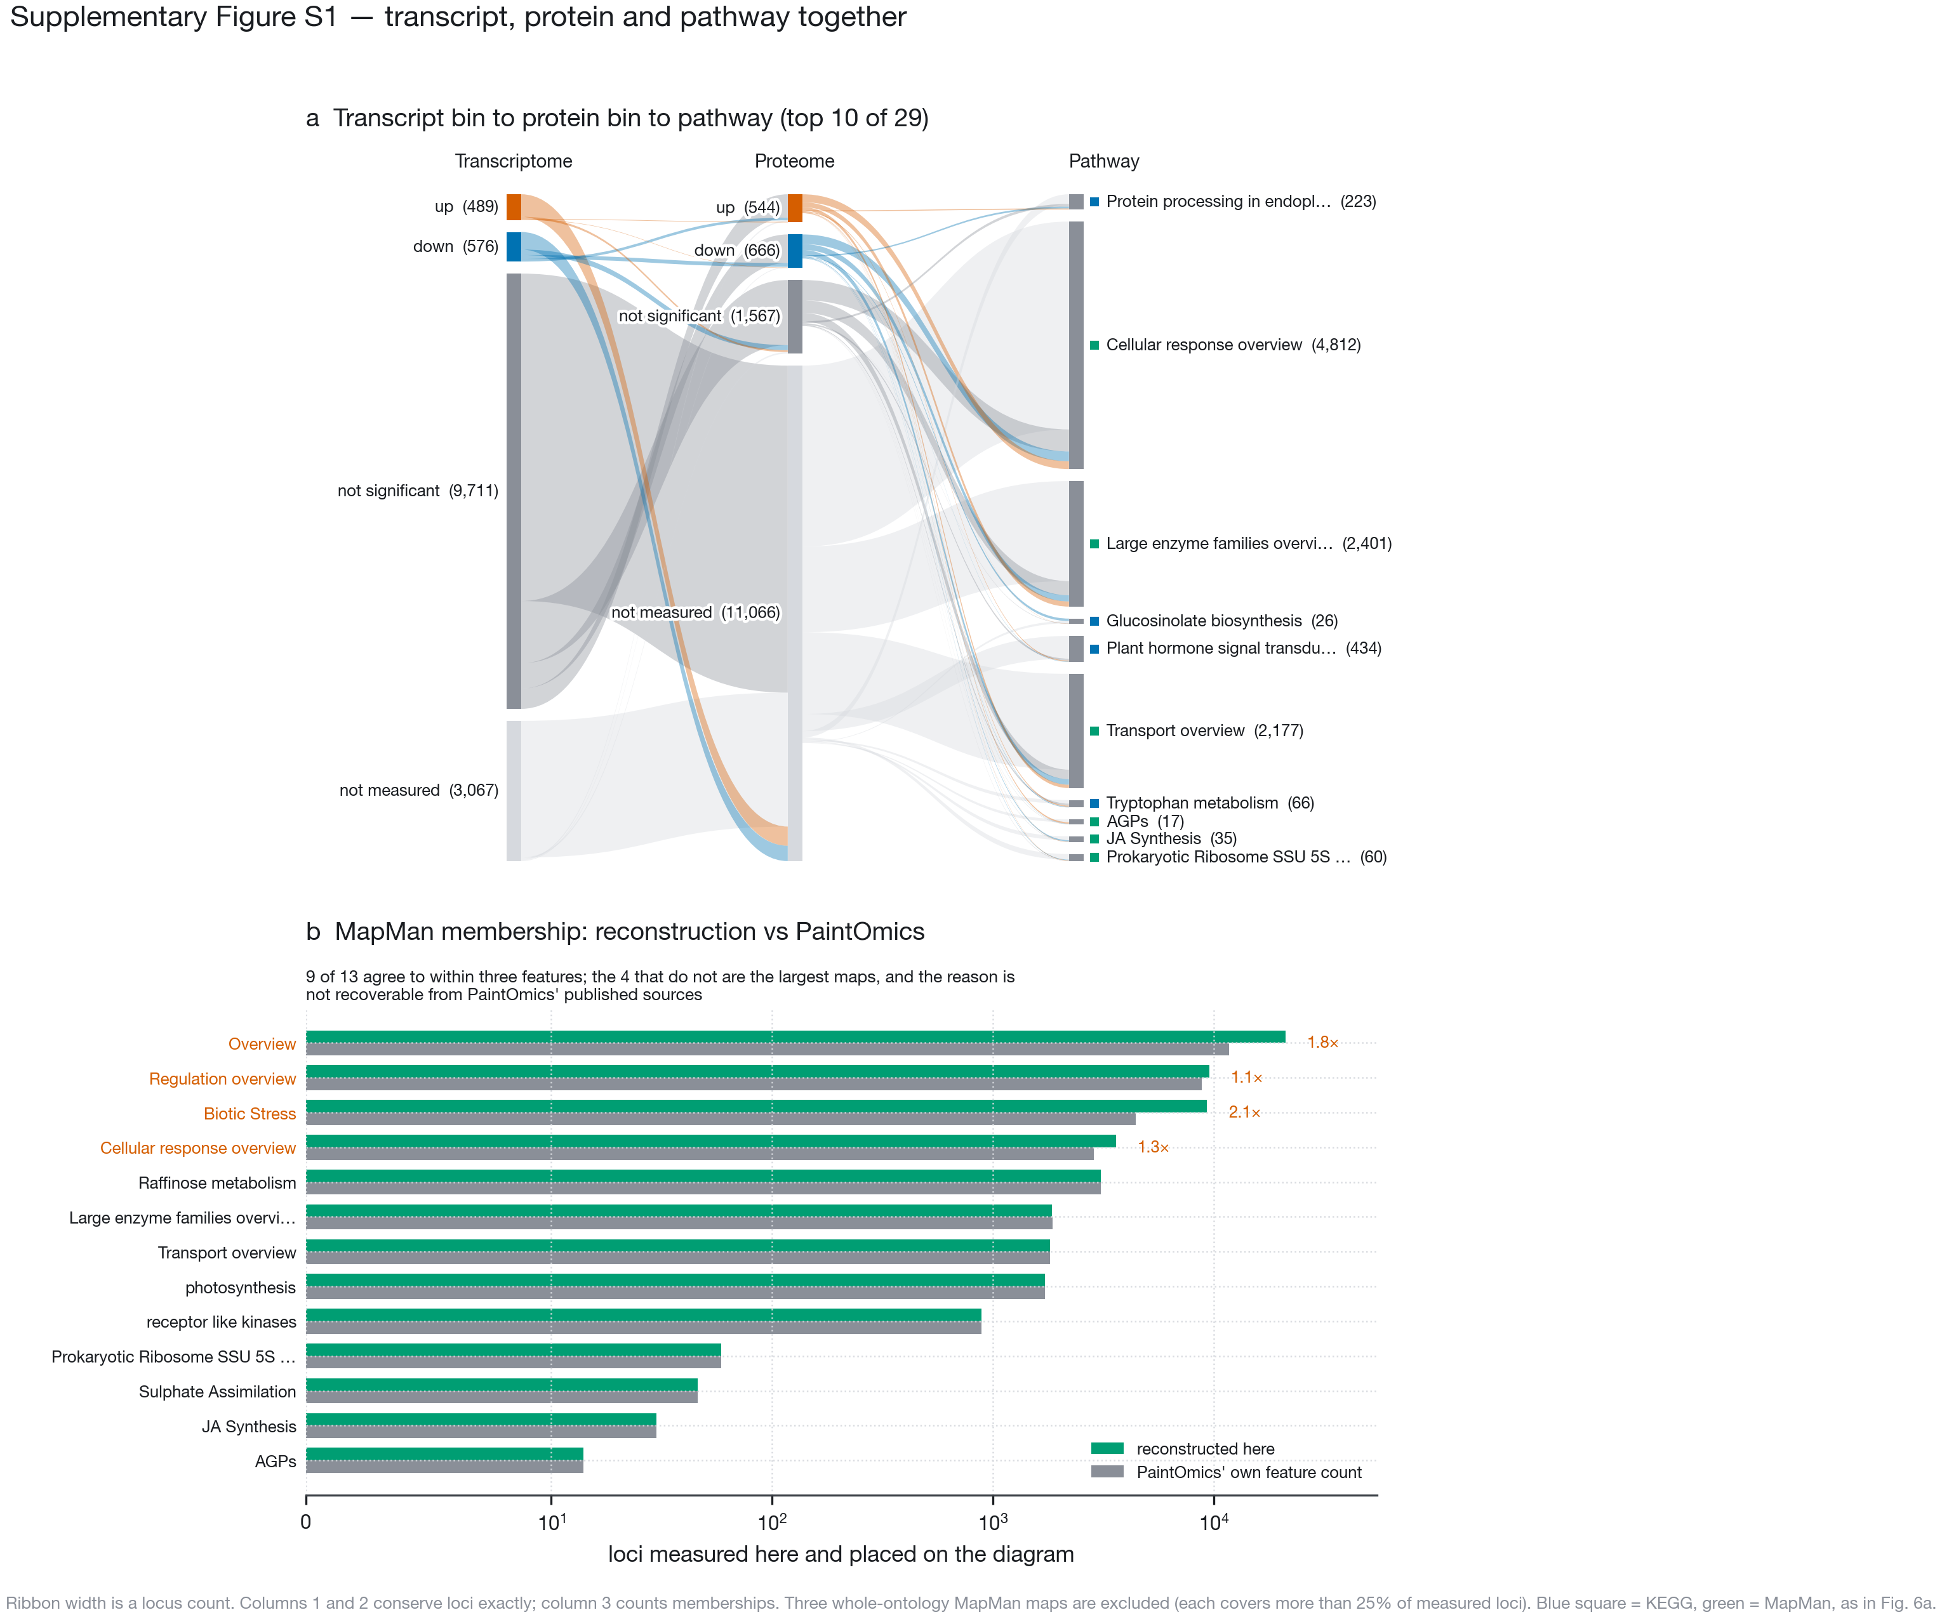
Where the loci go, and how far the MapMan half of the diagram can be trusted. a, Each locus in at least one of the 29 non-whole-ontology significant pathways is placed in one transcript bin and one protein bin, and then into the pathways it belongs to. Ribbon width is a locus count. The transcript and protein columns conserve loci exactly; the pathway column counts memberships, so a locus in more than one pathway is counted more than once. The pathway column draws the ten most significant; a square gives each pathway’s database in the colours of Fig. 6a. Three whole-ontology MapMan diagrams are excluded — Overview lists all 36 top-level bins and so covers 99.8 % of measured loci, and Regulation overview and Biotic Stress cover 45 % and 44 %; the next largest covers 17 %. A map holding nearly every measured locus cannot say where anything goes, because its ribbons reproduce the marginal distribution. b, PaintOmics reports enrichment but not the gene lists behind it, and MapMan has no equivalent of the KEGG REST API, so MapMan membership is reconstructed from GoMapMan’s Araport11 gene-to-bin mapping and the MapMan diagram layouts, by PaintOmics’ own inclusion rules. Reconstructed membership is compared against the feature count PaintOmics itself reported for each diagram (log scale). Nine of the thirteen agree to within three features. Significance throughout is PaintOmics’ uncorrected combined $p<0.05$. The four that do not are the largest maps, are marked in vermilion with the ratio between the two counts, and the reason for the difference is not recoverable from PaintOmics’ published sources; both counts are reported rather than one.

