Supplementary Information for: From microgravity boundary-layer biophysics to the spaceflight multi-ome: a coupled lattice-Boltzmann and Farquhar–von Caemmerer–Berry model of Arabidopsis gas exchange and enclosure carbon starvation
Richard J. Barker
Abstract
This document contains Supplementary Tables S1–S11 and Supplementary Figures S1–S8 supporting the main manuscript. It reports: (i) zero-dimensional enclosure and Farquhar–von Caemmerer–Berry (FvCB) model parameterizations (Tables [tab:s_enclosure_params]–[tab:s_fvcb_params]); (ii) lattice-Boltzmann grid convergence index (GCI), stationarity verification, density-matched pressure-outlet throughput checks, leaf-shape/curl sensitivity, surface $CO_{2}$ distribution percentiles, chamber domain-size sensitivity, and real BRIC/CARA Petri-dish cross-section simulations including humidity-limited transpiration and wet-agar stability bounds (Tables [tab:s_gci]–[tab:s_real_dish], Figs. [fig:s_diel_flux]–[fig:s_dish_feedback]); and (iii) enclosure drawdown sensitivity sweeps, the complete NASA OSDR metabolomics census, the 21-compound predicted metabolite specification, PaintOmics locus-to-pathway Sankey conservation and MapMan reconstruction verification, and metabolite-free pathway enrichment controls (Tables [tab:s_enclosure_sens]–[tab:s_indep_pathways], Fig. [fig:s_sankey]).

Supplementary Tables

Supplementary Figures
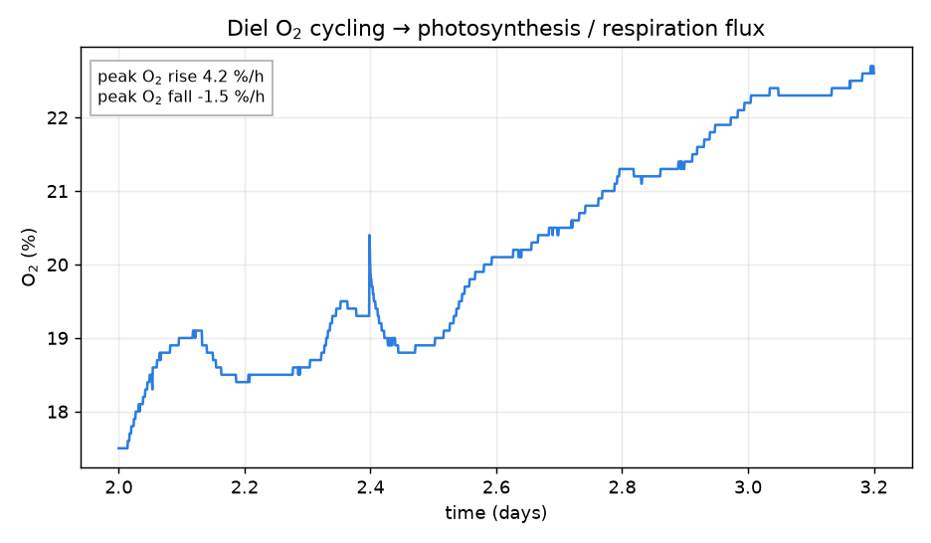
Single diel $O_{2}$ cycle and whole-chamber flux extraction. Expanded $24 h$ window from the $4.8 d$ Vernier closed-chamber trace (F2_diel_flux.png) showing linear regression slopes for peak light-phase net $O_{2}$ evolution ($+4.2\% h^{−1}$) and dark-phase respiratory $O_{2}$ uptake ($−1.5\% h^{−1}$).
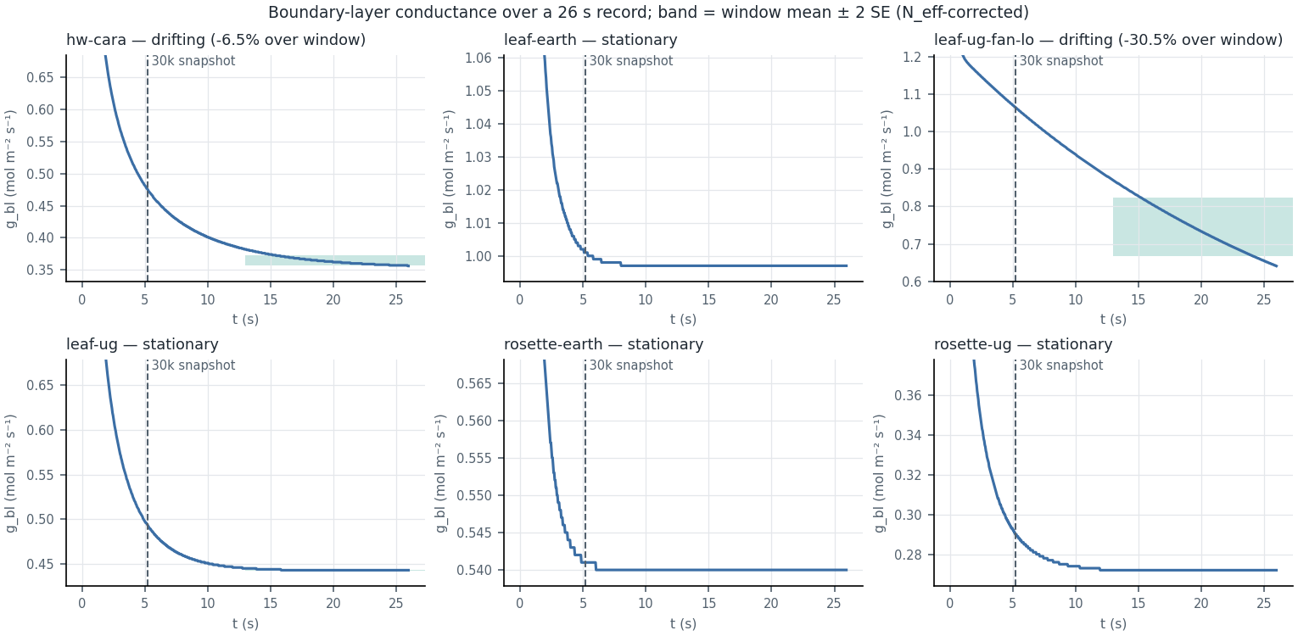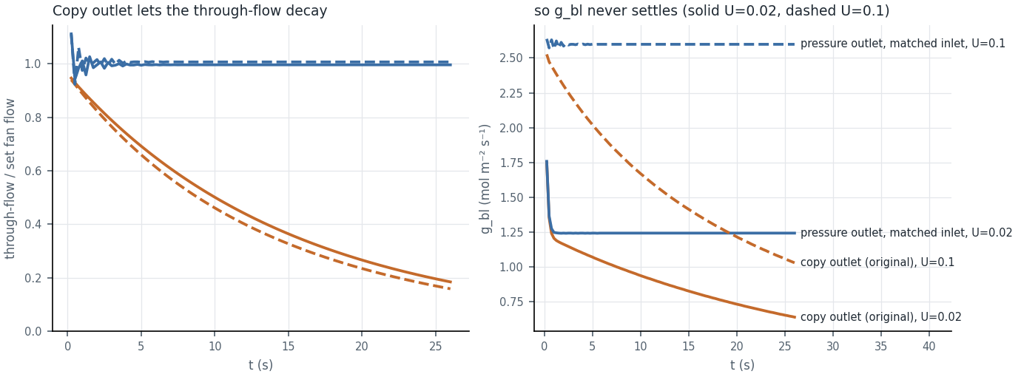
Temporal stationarity verification and density-matched pressure-outlet validation. a, Time evolution of boundary-layer conductance $g_{bl}(t)$ over $26 s$ ($150 k$ steps; F11_stationarity.png) across six representative scenarios. The vertical dashed line marks the legacy $30 k$-step ($5.2 s$) snapshot, which caught the $0 g$ pure-diffusion runs prior to full relaxation. b, Forced-airflow outlet throughput ($Q_{out}/Q_{set}$) and $g_{bl}(t)$ comparing the legacy zero-gradient copy outlet against the pressure-pinned outlet ($ρ=1$) paired with a density-matched velocity inlet (F12_outlet_bc.png), which delivers $99.6\text{–}100.9\%$ of the set flow.
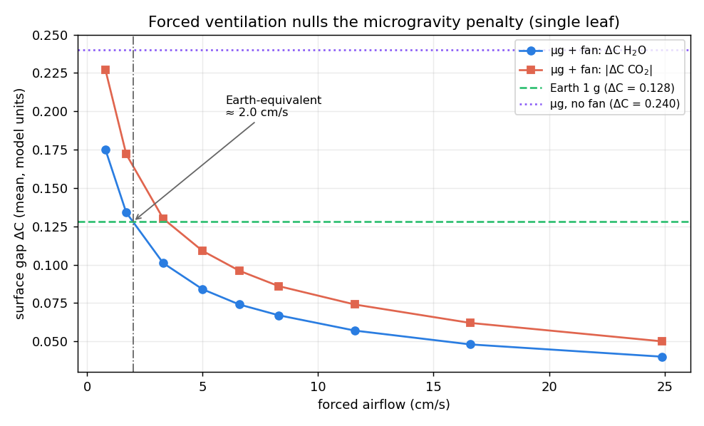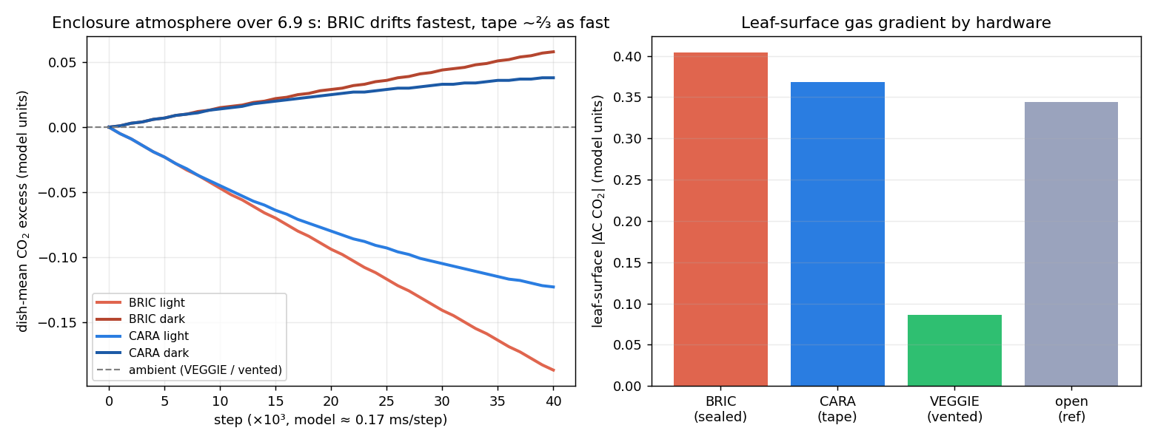
Single-leaf forced-airflow sweep and spaceflight hardware enclosure comparison. a, Steady-state surface $H_{2}O$ and $|CO_{2}|$ concentration gaps versus fan speed for an isolated microgravity leaf (F6_forced_airflow.png), crossing the $1 g$ free-convection reference at $≈2.0\text{–}2.1 cm s^{−1}$. b, Short-window ($6.9 s$) lattice-Boltzmann enclosure-mean $CO_{2}$ drift and leaf-surface concentration gradient across BRIC (sealed), CARA (micropore tape), and VEGGIE (ventilated) boundary conditions (F7_hardware_compare.png).
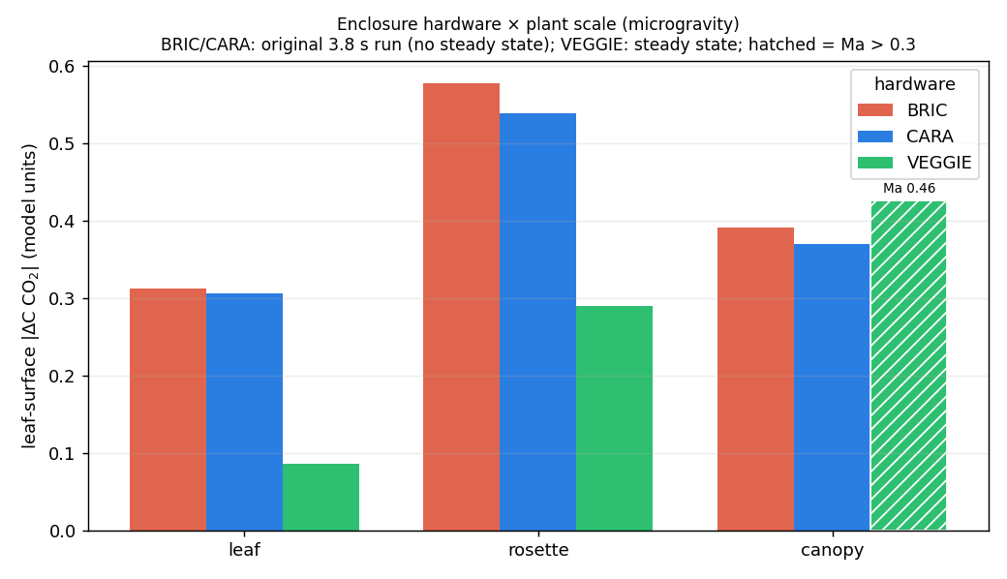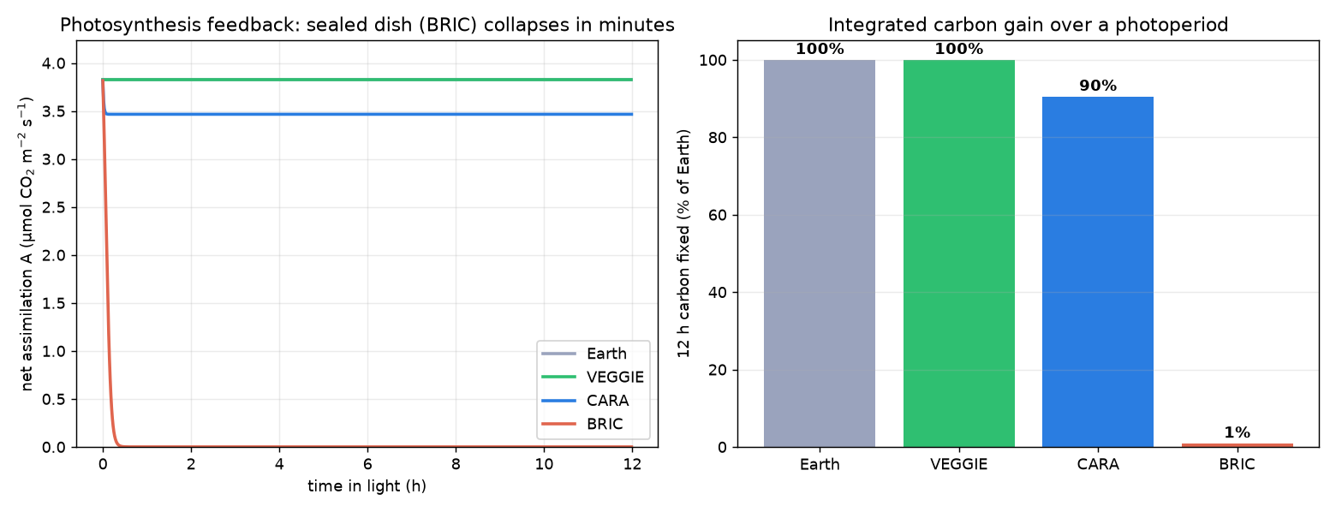
Hardware boundary conditions across plant scales and closed-loop $CO_{2}$-limited photosynthesis. a, Leaf-surface concentration gaps across BRIC, CARA, and VEGGIE for single leaf, rosette, and microgreen canopy scales in microgravity (F9_hardware_by_scale.png). BRIC and CARA have nearly identical surface boundary layers at every scale; one VEGGIE fan speed ($∼8 cm s^{−1}$) restores the leaf and rosette mean but exceeds the low-Mach limit in the dense canopy (hatched bar, $Ma=0.46$). b, Coupled 0-D enclosure mass balance and $CO_{2}$-limited photosynthesis over a $12 h$ photoperiod (F10_photosynthesis_feedback.png), showing collapse of net assimilation within minutes in sealed BRIC ($1\%$ of Earth carbon gain) versus $90\%$ in taped CARA and $100\%$ in ventilated VEGGIE.
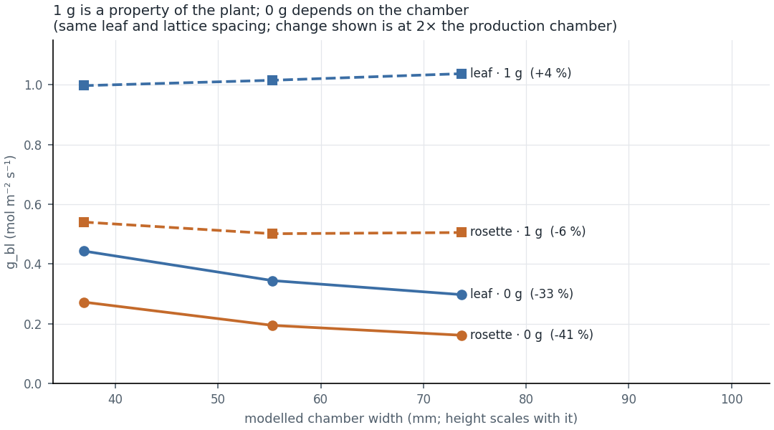
Chamber domain-size sensitivity at $1 g$ and $0 g$. Boundary-layer conductance $g_{bl}$ across $1×$, $1.5×$, and $2×$ domain sizes for an isolated leaf and a rosette (F13_domain_size.png, Table [tab:s_domain]). At $1 g$, buoyant convection localizes the boundary layer and $g_{bl}$ changes by $≤7\%$; at $0 g$, 2-D pure diffusion spans the chamber to the ambient walls, so larger domains yield even lower $0 g$ conductances ($−33\%$ leaf, $−41\%$ rosette at $2×$).
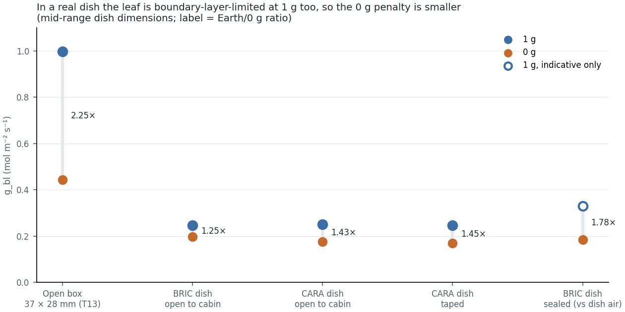
Leaf boundary-layer conductance inside real BRIC ($60 mm$ round) and CARA ($120 mm$ square) Petri-dish cross-sections. Simulated $g_{bl}$ at $1 g$ and $0 g$ for a leaf positioned $1 mm$ above the agar floor inside actual dish geometries (F14_dish_hardware.png, Table [tab:s_real_dish]A) compared against the generic open chamber. Because the shallow $7.4\text{–}9.8 mm$ headspace restricts vertical plume development even at $1 g$, dish $g_{bl}(1 g)$ is $≈0.25 mol m^{−2} s^{−1}$ and the $1 g/0 g$ ratio inside the dish is $1.25\text{–}1.8×$.
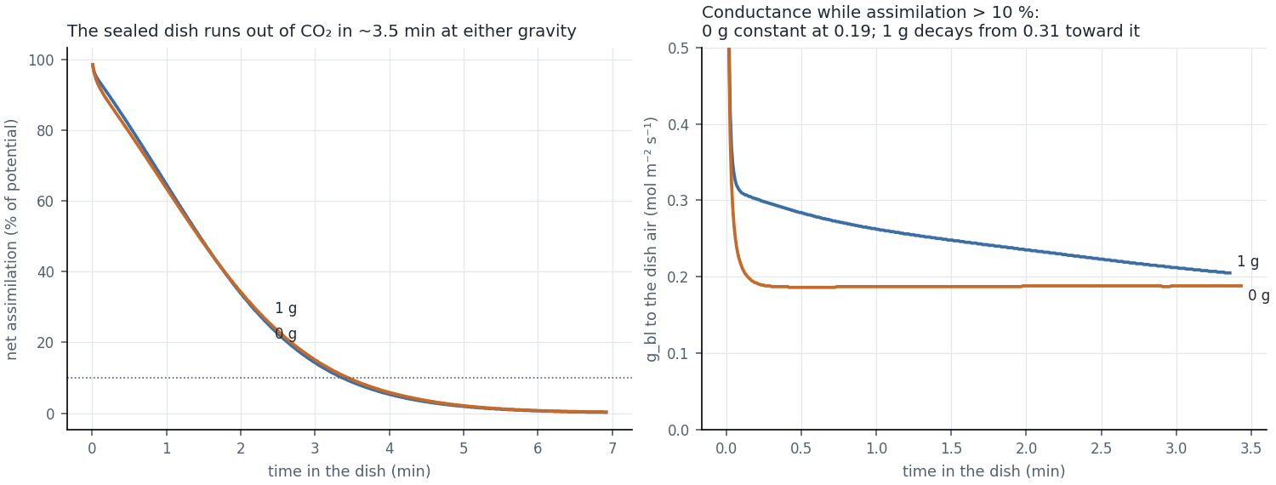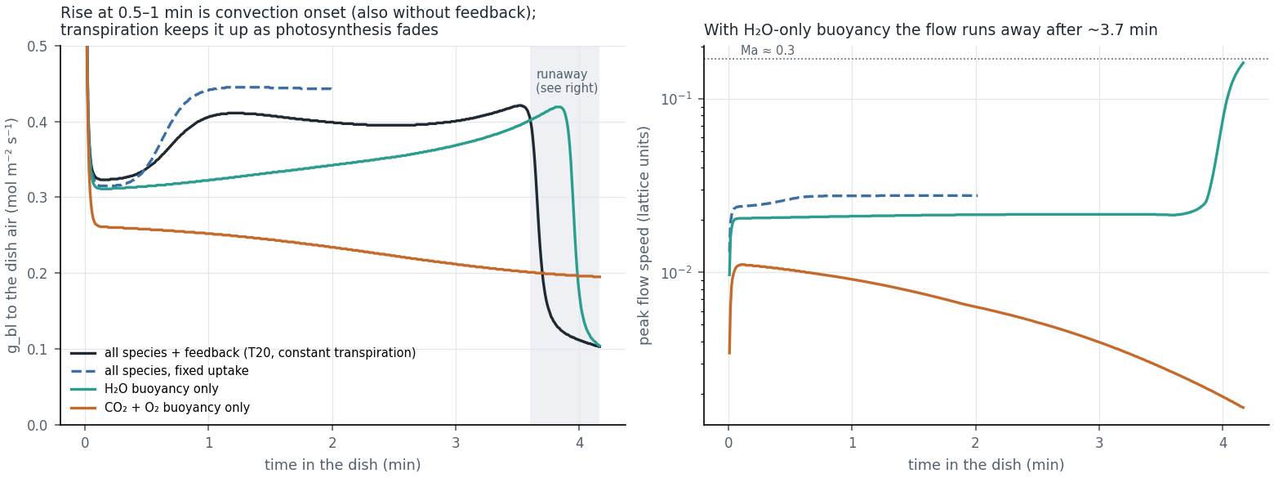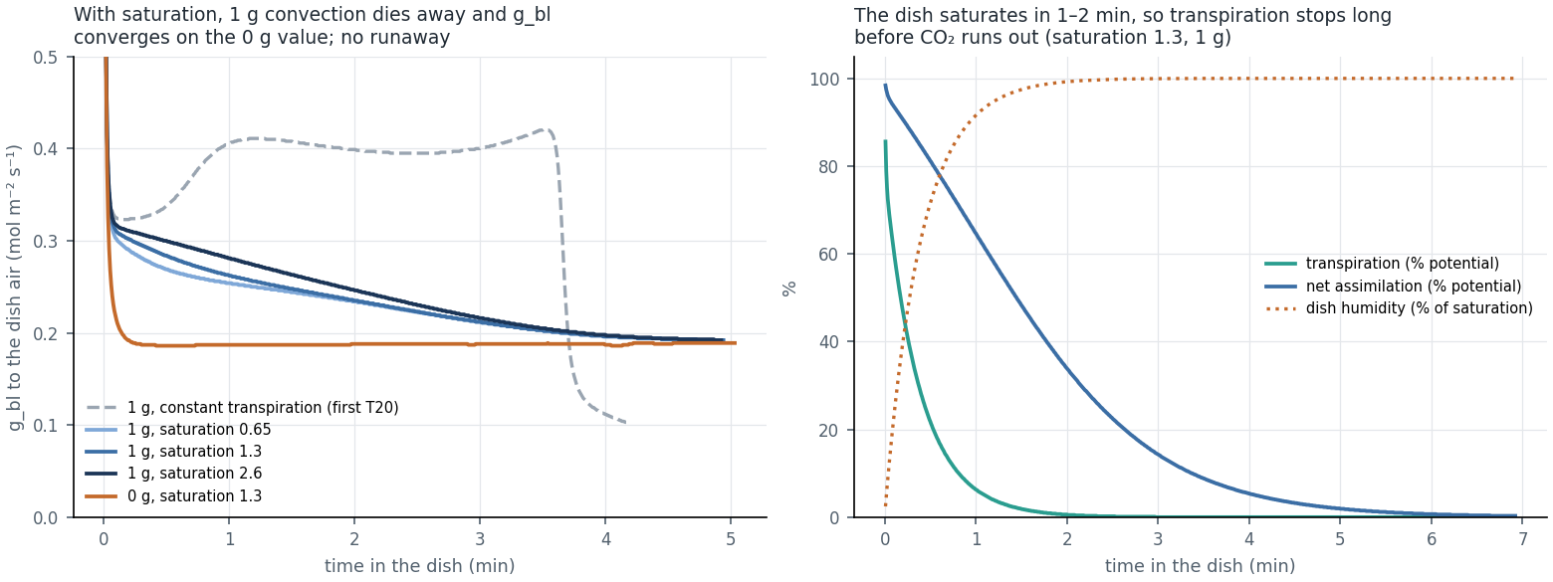
Transient $CO_{2}$ feedback, solutal buoyancy decomposition, and humidity-limited transpiration inside a sealed BRIC Petri dish. Top left (F15_dish_feedback.png), Net assimilation ($\%$ of potential) and leaf-to-dish $g_{bl}$ over $415 s$ in a sealed BRIC dish at $1 g$ and $0 g$ (T20_dish_feedback.csv): $CO_{2}$ is exhausted in $∼3.5 min$ ($A<10\%$ at $≈205 s$) at both gravities. Top right (F16_dish_buoyancy_diag.png), Buoyancy species decomposition at $1 g$ (T21_dish_buoyancy_diag.csv), showing that unbounded constant transpiration in a sealed dish causes late-time humidity runaway after $∼3.7 min$. Bottom (F17_dish_humidity.png), Coupling transpiration to headspace humidity saturation (T22_dish_humidity.csv, h2oSatExcess $=0.65,1.3,2.6$) eliminates the runaway: as the dish air saturates within $1\text{–}2 min$, transpiration ceases, $1 g$ solutal convection dies out, and the $1 g$ and $0 g$ boundary-layer conductances converge.
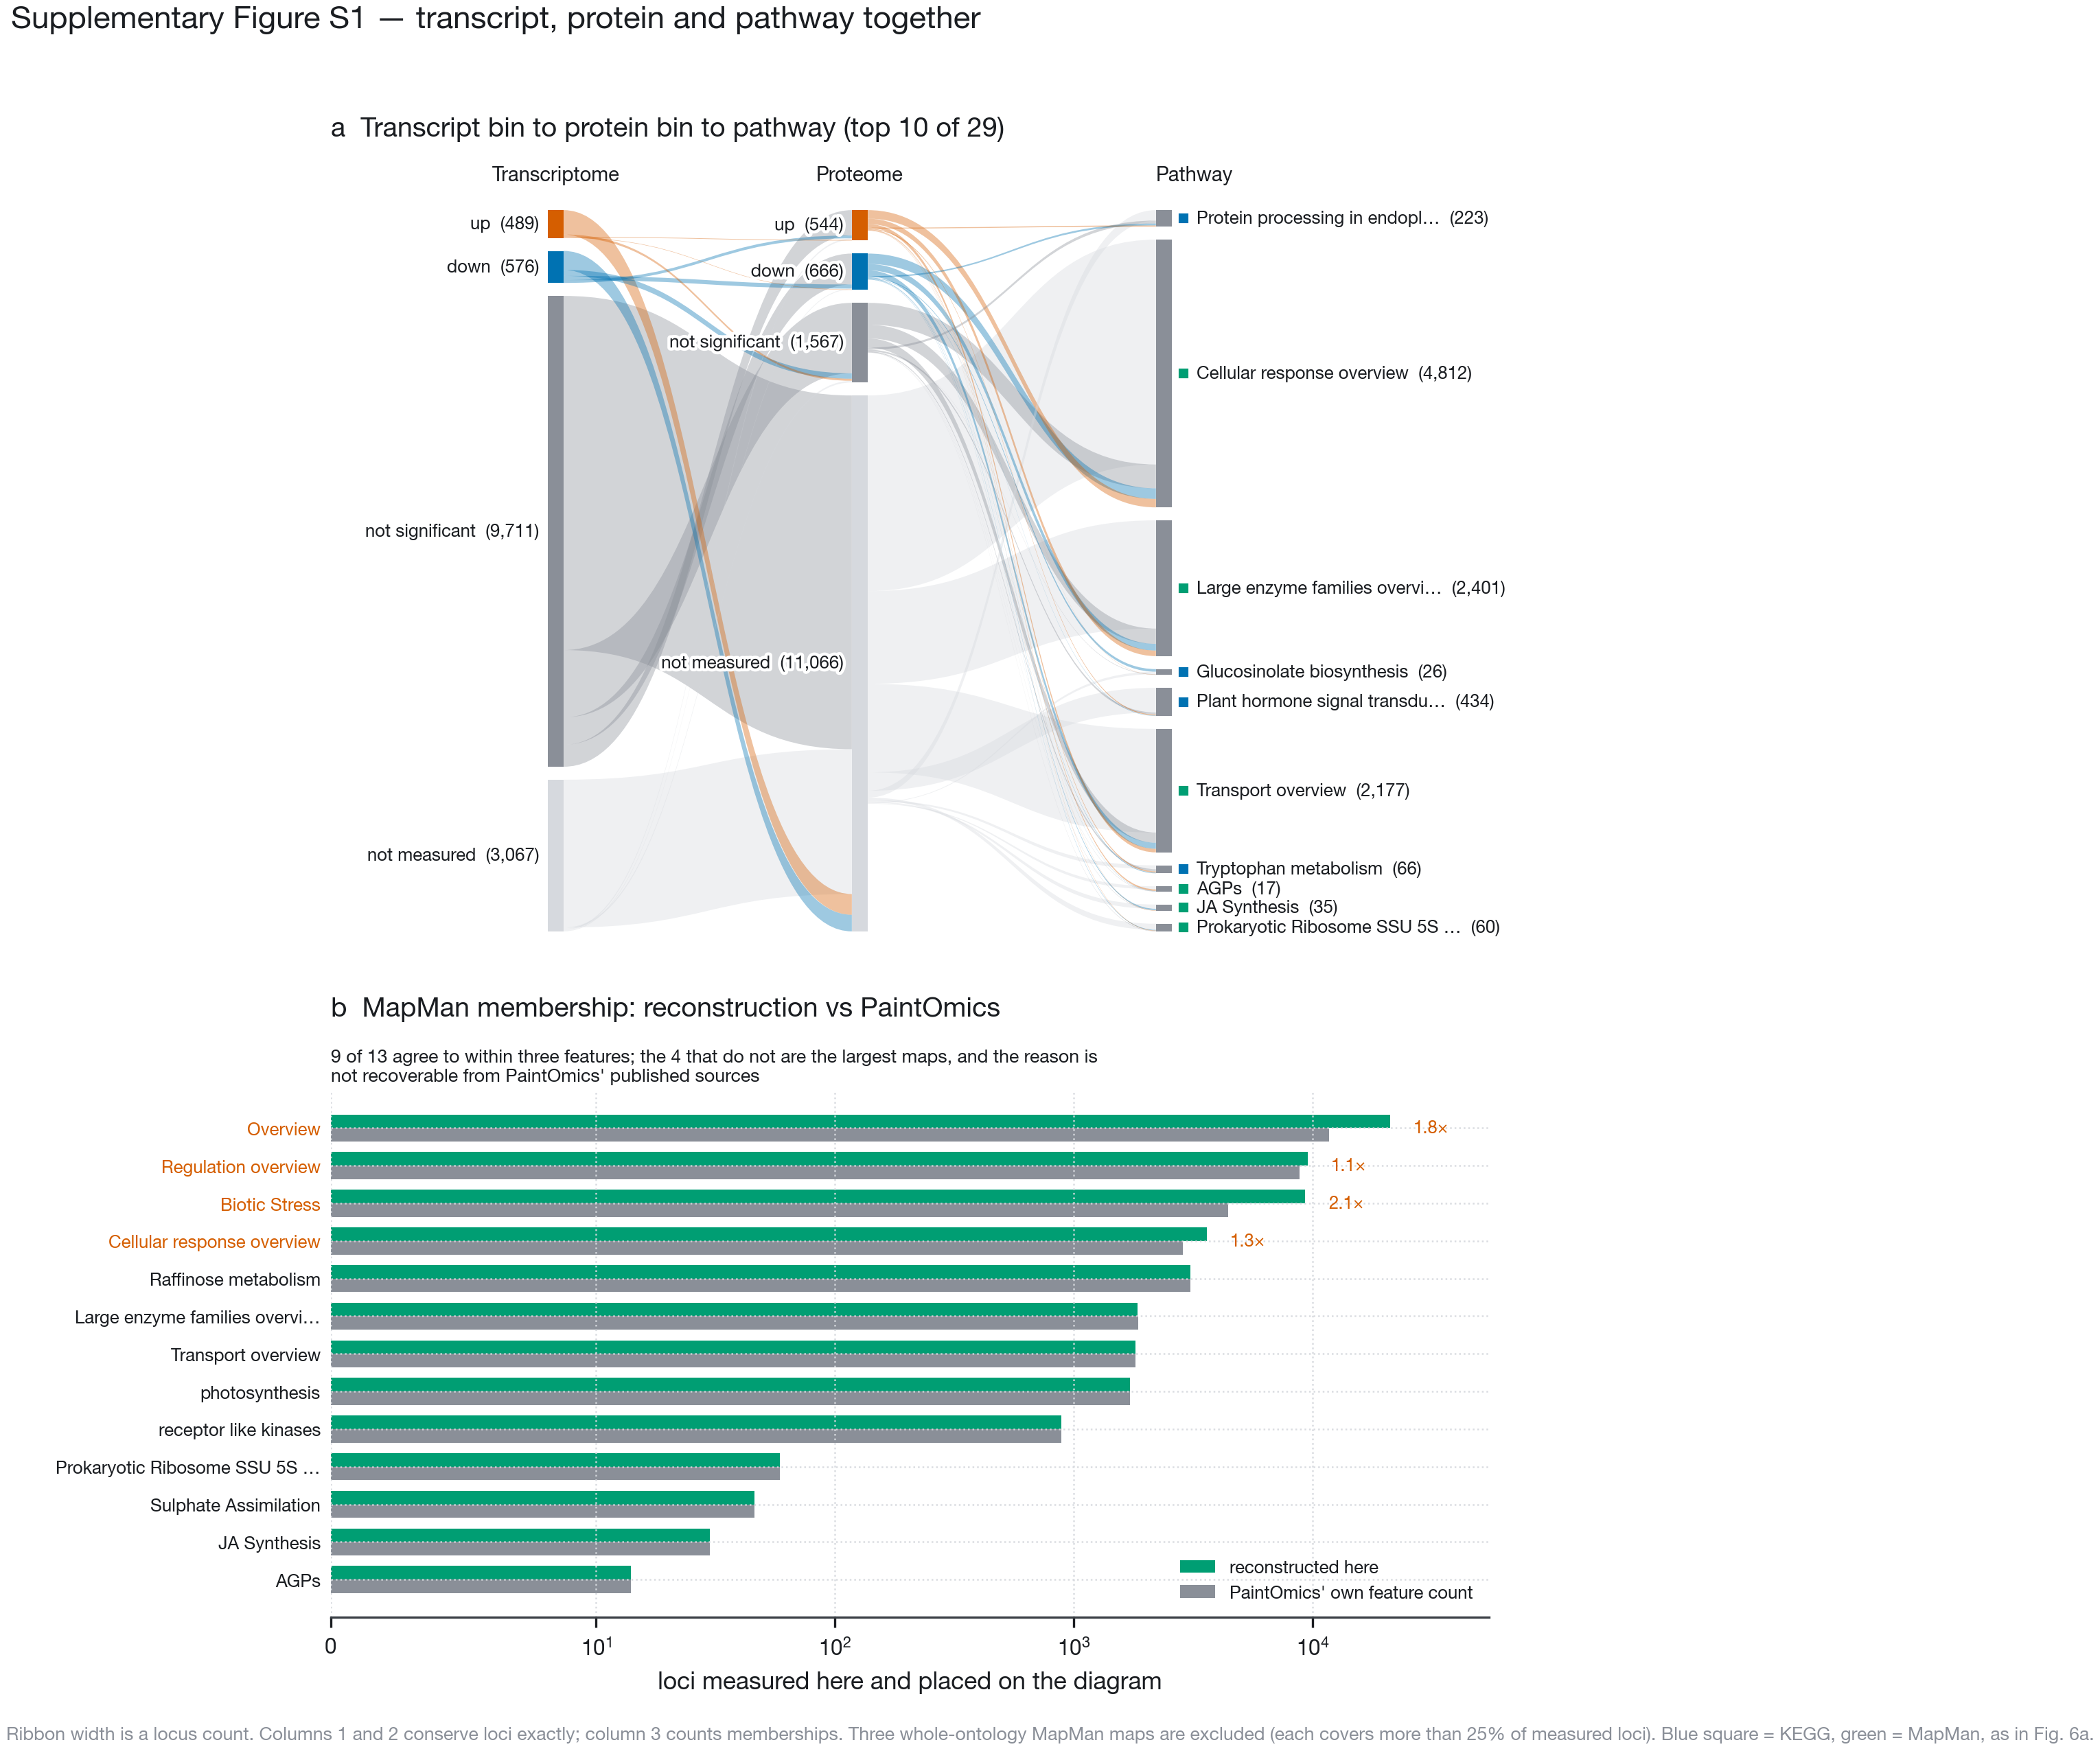
Multi-omics locus conservation across significant pathways and deterministic MapMan reconstruction verification. a, Sankey diagram (figS1_sankey.pdf) tracing every measured Arabidopsis locus in the 29 non-broad significant pathways ($p<0.05$) from its OSD-522 transcript bin (column 1) to its protein bin (column 2) and into the top ten enriched KEGG and MapMan pathways (column 3). Columns 1 and 2 conserve gene counts exactly ($13,843$ loci); column 3 counts pathway memberships ($22,147$). b, Verification of reconstructed MapMan pathway feature counts (scripts/mapman.py, built from GoMapMan Araport11 mappings and MapManStore diagram XMLs) against the feature counts reported by the PaintOmics 4 server: 9 of 13 pathways agree within $≤3$ features.

