Engineering for stress does not exempt it: root-architecture and transcriptomic response of AVP-OX cotton to spaceflight
Authors: [AUTHOR LIST — incl. R. Barker; ORCIDs] Affiliations: [Gilroy Life Science Lab, University of Wisconsin–Madison; …] Corresponding author: [name, email] Funding: CASIS UA-2018-276.

Abstract
(structured, ~150–200 words — write last, from final results) Background: roots drive cotton yield and stress resilience; AVP1-overexpressing (AVP-OX) lines show enhanced salt/drought tolerance and larger root systems, but how this engineering behaves in microgravity is unknown. We flew wild-type and two AVP-OX cotton lines (A68, D130) on the ISS with matched ground controls, and profiled root architecture (time-series imaging → RSML tracing) and the root + shoot transcriptome (RNA-seq, full Treatment × Genotype × Tissue design). Spaceflight roots proliferated lateral roots, and both AVP-OX lines mounted a larger primary-root spaceflight response than wild type (P ≤ 0.04). The transcriptomic response was strongly tissue-specific (Treatment × Tissue the dominant interaction; root ≫ shoot), and in wild-type roots comprised a canonical hypoxia/wounding induction with translational suppression. Across three independent methods — differential-expression interaction tests, ortholog-mapped GO/KEGG, and PhysioSpace stress-pattern decoding — the AVP-OX engineering attenuated rather than amplified the spaceflight defence/stress programme (suppressed jasmonate/wounding signalling; lower osmotic/wounding PhysioScores). Co-expression analysis tied a signalling/isoprenoid-metabolism module to the root-growth phenotype and a defence module to the AVP-OX effect. Thus AVP-OX cotton appears to experience microgravity as less stressful while sustaining stronger root growth — a favourable trait for space agriculture, pending image-calibration and replication checks. These results have implications for engineering crops for spaceflight environments.

Introduction
Root systems determine how efficiently a crop captures water and nutrients, and their architecture is shaped by gravity through auxin-directed growth of the primary and lateral roots. In cotton — a globally important but water-demanding fibre crop — improving root vigour and stress resilience is a long-standing breeding goal. Overexpression of the Arabidopsis vacuolar H⁺-pyrophosphatase gene AVP1 enhances auxin transport and root proliferation and confers drought and salt tolerance; in cotton it increases fibre yield by more than 20% under field stress conditions (Pasapula et al. 2011¹; AVP1 function first established in Arabidopsis, Park et al. 2005²). AVP-OX cotton is therefore an attractive line for environments where water is scarce — including, potentially, spaceflight.
Spaceflight imposes a distinctive combination of stresses on plants: microgravity removes the gravity vector that normally guides root growth, and alters water and gas movement around roots, while also perturbing cytoskeletal organisation and cell-wall remodelling [spaceflight-root-biology refs to add]. These conditions reshape root architecture and elicit broad transcriptional reprogramming. Yet whether a crop engineered for terrestrial stress tolerance behaves differently under spaceflight — retaining a benefit, or being overwhelmed by the novel stress — has not been tested at the intersection of root architecture and the transcriptome.
Here we address that gap using the TIC-TOC experiment, in which wild-type cotton and two independent AVP-OX lines (A68, D130) were grown aboard the ISS alongside matched ground controls. We pair time-series root-architecture imaging (days 3–6, traced as RSML) with root and shoot RNA-seq in a full Treatment × Genotype × Tissue design, and decode the transcriptome into stress programmes using ortholog-mapped GO/KEGG enrichment, PhysioSpace stress-pattern analysis, and co-expression network analysis — asking specifically how the AVP-OX engineering modulates the cotton spaceflight response.

Results

R1. Experimental design and dataset overview → Fig 1, Table 1
Wild-type cotton and two independent AVP1-overexpressing lines (A68, D130) were grown aboard the ISS (SpaceX CRS-22) alongside matched ground controls, in a full factorial Treatment (Flight/Ground) × Genotype (WT/A68/D130) × Tissue (root/shoot) design with four replicates per group (48 RNA-seq libraries; Table 1). Root systems were imaged daily on days 3–6 and traced (SmartRoot → RSML), yielding 198 curated tracings from 53 plants, 44 with the complete four-day series (Fig 1; ../Data/RSML_QC_summary.md). Transcriptomes were quantified against the G. hirsutum UTX-TM1 v2.1 assembly (59,918 expressed genes). Together these provide paired root-architecture and transcriptomic readouts of the spaceflight response across genotypes and tissues.

R2. Root architecture over days 3–6 → Fig 2, Table S?
(PRELIMINARY — from executed RSML analysis; total-length magnitude pending image-calibration check.) Linear mixed models of root length (plant random effect; days 3–6) revealed a genotype-dependent spaceflight response. Both AVP-OX lines mounted a larger primary-root spaceflight response than wild type (condition × genotype on primary-root length: A68 ×1.84, P = 0.040; D130 ×1.84, P = 0.017) — an effect measured on the primary root, which is equally resolved in flight and ground images and is therefore robust to image artifacts. Total traced root length increased far more under spaceflight (day × condition ≈ 1.65×/day), driven by lateral-root proliferation: flight plants developed many laterals by day 6 while ground plants remained largely single-primary (Fig 2). Notably, primary-root elongation itself was not accelerated in flight (day × condition ×0.95, P = 0.009), localising the spaceflight length gain to lateral roots. [The magnitude of the lateral effect is reported pending verification of Flight/Ground image scale and lateral-detection thresholds; see ../morphometrics/README.md.]

R3. Transcriptome landscape of the spaceflight response → Fig 3, Table 2
(From the executed DESeq2 model over all 12 groups; DEGs at P.adj < 0.05, |log₂FC| ≥ 1, ashr-shrunk.) The spaceflight (Flight vs Ground) response was markedly stronger in root than shoot across all genotypes. In roots, wild type showed 2,503 up / 578 down DEGs and the AVP-OX line A68 the largest response of all (2,806 up / 3,610 down), whereas D130 roots responded more modestly (420 / 299). Shoot responses were smaller and skewed toward down-regulation (e.g. D130 shoot 327 up / 890 down; A68 shoot 79 / 419). The genotype × treatment interaction contrasts — the AVP-OX flight response relative to wild type — were consistently down-biased (A68-vs-WT root 55 down / 2 up; D130-vs-WT root 20 down / 0 up), i.e. the engineered lines attenuate rather than amplify the wild-type spaceflight transcriptional programme (Table 2), consistent with the dampened defence/stress signatures in R5–R6.
Principal-component analysis placed tissue as the dominant transcriptomic axis (PC1, 92.5% of variance, associated with tissue at P = 2.9×10⁻⁹) and spaceflight as the second (PC2, associated with treatment at P = 6.3×10⁻⁶; Fig 3a). A full factorial model (Treatment × Genotype × Tissue) confirmed that the spaceflight response is overwhelmingly tissue-specific: the Treatment × Tissue interaction comprised 3,374 DEGs — far larger than the Treatment × Genotype (AVP-OX) interactions (A68 62, D130 20; both down-biased) or the negligible genotype × tissue and three-way terms. Total read depth differed by tissue (P ≈ 0) but not by treatment (P = 0.41), so the Flight-vs-Ground comparisons are not depth-confounded. [Fig 3: PCA + DEG-count barplot; per-contrast tables in ../deseq2/contrasts/, factorial model in ../deseq2/v4/.]

R4. Co-expression modules link the spaceflight transcriptome to root architecture → Fig 4
(From the executed root WGCNA; module eigengenes vs treatment/genotype/RSML traits. Trait correlations are group-level — see caveat.) Weighted co-expression network analysis of root samples resolved six modules, named here by their GO enrichment (BP/MF/CC): *turquoise — signalling & isoprenoid metabolism* (1,963 genes), blue — translation & ribosome biogenesis (1,767), brown — defence & ubiquitin signalling (1,046), yellow — metal transport & phenylpropanoid metabolism (68), green — photosynthesis (light reactions) (38) and an unassigned grey module. Two formed a flight-responsive, growth-coupled axis: turquoise was strongly induced by spaceflight and positively correlated with a larger, more-branched root system (module-eigengene r with Flight/total-length/lateral-count = +0.89/+0.86/+0.83), and blue was its suppressed mirror (Flight r = −0.83). Critically, the defence & ubiquitin (brown) module was flight-induced yet down-regulated in the AVP-OX lines** (r = −0.43), providing a module-level transcriptomic correlate of the attenuated defence/stress response seen independently by enrichment (R5) and PhysioSpace (R6). Thus a single, interpretable co-expression structure ties the spaceflight response, the engineered-genotype effect, and the root-architecture phenotype together (Fig 4).

R5. Functional enrichment of the spaceflight response → Fig 5, Table 3
(From the executed clusterProfiler run over all 10 DESeq2 contrasts; Arabidopsis-mapped, expressed-gene universe.) In wild-type roots, spaceflight up-regulated a canonical low-oxygen/mechanical-stress programme — cellular response to hypoxia / decreased oxygen (P.adj = 7.3×10⁻²⁰) and response to wounding — while down-regulating translation (P.adj = 1.5×10⁻²²), ribosome biogenesis, and rRNA processing, indicating suppression of growth-associated protein synthesis. The AVP-OX line A68 shifted this response toward defence/immunity (up-regulated defence response to bacterium, immune response), and D130 showed the same themes more weakly. Directly contrasting each AVP-OX line's flight response with wild type (interaction), the genes specifically down-regulated in AVP-OX were enriched for jasmonic-acid biosynthesis/metabolism and response to wounding (A68-vs-WT root P.adj = 3.8×10⁻⁴; KEGG α-linolenic-acid metabolism, plant–pathogen interaction), with up-regulation of negative regulators of defence. Thus, against a shared hypoxia/wounding spaceflight signature, the engineered lines attenuate the jasmonate/ defence arm — converging with the independent PhysioSpace result (R6).

R6. PhysioSpace stress-pattern decoding → Fig 6, Table 4
(PRELIMINARY — from executed PhysioSpace run; VST group-mean input, `STATICResponse` scoring.) Projecting the Flight−Ground contrasts onto the Arabidopsis stress reference spaces (Plant PhysioSpace; 13,367 shared orthologs) showed that spaceflight roots of all three genotypes engage a coordinated abiotic-stress / defence programme — most strongly osmotic, drought, far-red/shade, genotoxic, and wounding axes — whereas the shoot response was weaker and more heterogeneous. Notably, the two *AVP-OX lines showed attenuated root stress-programme activation relative to wild type* (e.g. osmotic axis WT > A68 > D130; wounding axis WT 0.72 vs D130 0.44), a transcriptomic signature consistent with the engineered stress tolerance operating under spaceflight. [Descriptive; formal genotype contrast on PhysioScores + the frozen-model input pending. Root scores saturate under signed-p scoring — the bounded STATICResponse statistic is reported; see ../physiospace/README.md.]

R7. Integrative model → Fig 7
Across four independent analyses a single, consistent model emerges. Spaceflight elicits a strongly tissue-specific transcriptional response (Treatment × Tissue ≫ all other interactions; R3), which in roots is a canonical hypoxia/wounding induction with translational suppression (R5) that maps onto a coordinated osmotic/drought/wounding stress programme (R6) and a growth-coupled co-expression module (turquoise; R4). Against this shared wild-type response, the AVP-OX engineering acts as an attenuator, not an amplifier, of stress signalling: the genotype × treatment interaction is small and down-biased (R3), specifically suppressing the jasmonate/defence arm (R5), lowering PhysioSpace stress-programme activation (R6), and down-regulating the flight-induced brown module (R4). Yet at the organ level the AVP-OX lines mount a larger primary-root spaceflight response (R2). The coherent interpretation: AVP-OX cotton experiences microgravity as less of a stress — mounting a calmer defence/stress transcriptional programme while sustaining stronger root growth — a favourable phenotype for space agriculture, pending the calibration and full-replication checks noted throughout. [Fig 7: schematic integrating root-trait ↔ module ↔ stress-programme layers.]
To connect expression to the growth phenotype explicitly, we correlated module eigengenes and genes with root-architecture traits (group level) and ranked genes by module membership and gene significance for total root length. The growth phenotype co-occurred with induction of the signalling & isoprenoid-metabolism (turquoise) module and suppression of the translation & ribosome (blue) module (1,678 and 1,444 hub-and-growth genes). Because isoprenoid/terpenoid metabolism supplies precursors for growth hormones (gibberellins, brassinosteroids, strigolactones), this nominates hormone-precursor metabolism as a testable candidate route from the spaceflight signal to altered root growth. Statistical limitation: RNA-seq libraries are not individually paired to imaged plants, so the integration is group-level (n = 6), and across those groups spaceflight and traced root growth are collinear — it identifies pathways consistent with driving growth but cannot separate growth-driving from flight-responsive effects. A causal model (paired multi-omics/DIABLO or Treatment→expression→trait mediation) is proposed for follow-up (see ../integration/README.md).

Discussion
Spaceflight remodelled the cotton root far more than the shoot, and in wild-type roots the response was a recognisable low-oxygen/mechanical-stress programme — induction of hypoxia and wounding genes with concomitant suppression of translation and ribosome biogenesis. A hypoxic root signature is a recurrent feature of spaceflight plant biology and is consistent with altered water and gas movement around roots in microgravity; its pairing here with translational shutdown suggests a shift away from growth-associated biosynthesis. That the response is overwhelmingly tissue-specific (the Treatment × Tissue interaction dominated all others) argues that spaceflight acts on organs through their distinct physiologies rather than as a single systemic stress, and cautions against pooling tissues in spaceflight transcriptomics.
The central result is that engineering cotton for terrestrial stress tolerance did not simply amplify or blunt this response uniformly: the AVP-OX lines attenuated the defence/stress arm specifically — a small, down-biased genotype × treatment interaction that GO resolved as suppressed jasmonate/wounding signalling, PhysioSpace read as lower osmotic/wounding stress activation, and WGCNA localised to a down-regulated defence-and-ubiquitin module — while mounting a larger primary-root spaceflight response than wild type. The coherent interpretation across four methods is that AVP-OX cotton experiences microgravity as less of a stress while sustaining more root growth. Mechanistically, AVP1 (a vacuolar H⁺-pyrophosphatase) increases auxin transport and root proliferation on Earth, which plausibly underlies the enhanced primary-root response; how that intersects with the dampened defence programme in microgravity is an open and testable question.
- Named co-expression modules (turquoise = signalling & isoprenoid metabolism; blue = translation &
ribosome; brown = defence & ubiquitin; yellow = metal/phenylpropanoid; green = photosynthesis) give an interpretable middle layer linking the spaceflight signal to root growth; isoprenoid → growth-hormone precursor metabolism is the leading mechanistic hypothesis.
- Limitations: best-hit orthology (approximate); unbalanced morphometric design; single mission;
RNA-seq and imaging are not individually paired, so transcriptome↔architecture integration is group-level (n=6) and Flight/growth are collinear — correlational, not causal. A paired multi-omics design (or mediation model) is needed to test the isoprenoid-hormone route directly.
- Implications for engineering crops for spaceflight agriculture.

Methods
(Concrete — fill bracketed hardware/version specifics.)
Plant material & spaceflight. Cotton (Gossypium hirsutum): wild type and two independent AVP1-overexpressing lines (A68, D130; AVP1 confers drought/salt tolerance and increased fibre yield¹). Plants were grown aboard the ISS (SpaceX CRS-22, launched 3 June 2021; Expedition 65) in the Vegetable Production System (Veggie) facility, in custom-designed Target Veggie Chambers (≈10 × 3 in, clear plastic with a translucent gel substrate in place of soil so roots were visible for imaging). Fifteen seed samples were launched and twelve grown; crew captured high-resolution images over the ≈6-day experiment (days 3–6 analysed here). Matched ground controls were grown in identical Veggie hardware at NASA Kennedy Space Center within the ISS Environmental Simulator (matched temperature, CO₂ and O₂), on a 48-h offset. Sponsored by the ISS National Laboratory (CASIS UA-2018-276) with support from the Target Corporation.
Root imaging & morphometrics. Time-series photographs (grayscale, 300 dpi; flight frames clarity-enhanced) were traced in SmartRoot and exported as RSML. Traits (root length, diameter, angle, insertion; see ../DATA_DICTIONARY.md §7) were extracted per plant/day with a stdlib parser (../morphometrics/extract_rsml_traits.py). Curated set: 198 tracings, 53 plants (44 with the full day-3–6 series). Because the design is unbalanced across genotype × condition, log-transformed total and primary root length were modelled with linear mixed models (statsmodels; random intercept per plant; fixed effects condition × genotype + day + day:condition, Ground/WT references). A primary-root sensitivity analysis (immune to lateral-tracing depth) tested robustness of the genotype × condition effects. [Growth medium, planting density, harvest day, and image spatial calibration to add from the flight protocol.]
RNA-seq & differential expression. Root and shoot RNA-seq, WT/A68/D130 × Flight/Ground, 4 replicates. Reads [quality-trimming, aligner and quantifier to add from the run-1 processing pipeline — the exact tools/versions are needed from the sequencing/bioinformatics collaborators or the OSDR processed-data record], quantified against the G. hirsutum accession TM-1 UTX-TM1 v2.1 reference genome³ (CottonGen/Phytozome Ghirsutum_527_v2.1; Gohir IDs). Filtered counts (~59.9k genes × 48) analysed with DESeq2 using a Treatment × Genotype × Tissue model (references Ground/WT/Root; ashr LFC shrinkage). Both per-group Flight−Ground contrasts (deseq2/contrasts/) and the factorial interaction model (deseq2/v4/) were fit. Read depth differed by tissue but not treatment, so size-factor normalisation is not confounded with the spaceflight comparison. Package versions in ENVIRONMENT.txt.
Ortholog mapping. Gohir genes mapped to Arabidopsis thaliana by CottonGen BLASTP best-hit (../crosswalk/; 92.3% of expressed genes mapped).
Functional enrichment. GO (BP/MF/CC) and KEGG (ath) enrichment in Arabidopsis space with clusterProfiler, against the universe of AT loci reachable from expressed cotton genes (../go_analysis/).
Co-expression & integration. Signed WGCNA on the top 5,000 variable root genes (soft power 12, minModuleSize 30) gave six modules, named by GO (BP/MF/CC) enrichment. Module eigengenes were correlated with Flight, genotype and group-level day-6 RSML root traits; within growth-associated modules, genes were ranked by module membership and gene significance for total root length (integration/). Because RNA-seq libraries are not individually paired to imaged plants, expression–trait correlations are computed on the six genotype × treatment group means (hypothesis-generating; Flight and traced growth are collinear at this level).
PhysioSpace. Per-(genotype × tissue) Flight−Ground VST fold changes were re-indexed to Arabidopsis Entrez and projected onto the Arabidopsis stress reference spaces with PhysioSpaceMethods (calculatePhysioMap, GenesRatio = 0.05, TTEST = FALSE, ImputationMethod = "PCA") using the PlantPhysioSpace data package (../physiospace/). Refs: Lenz et al. 2013; Hadizadeh Esfahani et al. 2021.
Statistics. DEGs: BH-adjusted P < 0.05 and |log₂FC| ≥ 1 (ashr-shrunk). GO/KEGG: BH q < 0.05 against the expressed-gene universe. PC–factor and module–trait associations: Kruskal–Wallis / Pearson. Morphometrics: linear mixed models (above). Exact package versions in ../ENVIRONMENT.txt.

Figure & table legends
Figure 1. Experimental design and analysis workflow. Wild-type and two AVP1-overexpressing cotton lines (A68, D130) were grown aboard the ISS (SpaceX CRS-22) with matched ground controls in a full factorial Treatment × Genotype × Tissue design (4 replicates/group; 48 RNA-seq libraries). Root systems were imaged on days 3–6 and traced (SmartRoot → RSML); root and shoot were profiled by RNA-seq. The analysis pipeline (DESeq2 → Gohir→Arabidopsis crosswalk → GO/KEGG → PhysioSpace → WGCNA → integration) is shown.
Figure 2. Root architecture over days 3–6. Group mean ± SE of total root length (top) and primary root length (bottom) for Flight (orange) vs Ground (blue), per genotype (native RSML units; day-6 n per group in Table 1). Total length diverges strongly under spaceflight whereas primary-root length differs little, localising the flight effect to lateral roots. Absolute magnitude pending Flight/Ground image-scale calibration.
Figure 3. Transcriptomic landscape. (a) PCA of VST-transformed counts — PC1 (92.5% variance) separates tissue, PC2 separates treatment. (b) Differentially expressed genes per Flight-vs-Ground contrast (P.adj < 0.05, |log₂FC| ≥ 1), up in Flight (orange) vs down (blue), by genotype × tissue.
Figure 4. Root co-expression modules linked to Flight, genotype and root architecture. Correlations between WGCNA module eigengenes (rows, named by GO enrichment) and Flight, AVP-OX and day-6 RSML root traits (columns), at group level (n = 6). Turquoise (signalling & isoprenoid) tracks Flight and root growth; brown (defence & ubiquitin) is down-regulated in AVP-OX.
Figure 5. Functional enrichment. GO/KEGG dot-/bar-plots of spaceflight-responsive gene sets, ortholog-mapped to Arabidopsis, per contrast (../go_analysis/results_full/).
Figure 6. PhysioSpace stress-pattern decoding. PhysioScores (bounded STATICResponse) for each genotype × tissue Flight−Ground contrast across Arabidopsis stress axes; AVP-OX roots show attenuated osmotic/wounding activation vs WT.
Figure 7. Integrative model. Spaceflight elicits a tissue-specific hypoxia/wounding response with translational suppression; AVP-OX attenuates the defence/stress arm while sustaining stronger root growth.
Table 1. Sample/design summary. Table 2. DEG counts per contrast (up/down). Table 3. Top enriched GO/KEGG terms per contrast. Table 4. PhysioScores per genotype × tissue × stress axis. See Supplementary_index.md for all supplementary items.

Data & code availability
Raw reads, count matrices, root images, and RSML tracings: NASA OSDR/GeneLab OSD-XXX (released on publication). Analysis code and derived tables: Zenodo DOI 10.5281/zenodo.XXXXXXX (v1.0.0 release) and https://github.com/dr-richard-barker/TICTOC. Data under CC0-1.0; analysis code under MIT.

Author contributions / Acknowledgements / Competing interests
[Author contributions per CRediT — to complete.] Supported by CASIS UA-2018-276; conducted in the Gilroy Life Science Lab, University of Wisconsin–Madison. The authors declare no competing interests. [Confirm.]

References
(Method/anchor citations — verified where noted; confirm exact page numbers in your reference manager, and add spaceflight-plant-biology background refs for the Introduction/Discussion.)
1. Pasapula V, Shen G, Kuppu S, et al. Expression of an Arabidopsis vacuolar H⁺-pyrophosphatase gene (AVP1) in cotton improves drought- and salt tolerance and increases fibre yield in the field. Plant Biotechnol J. 2011;9(1):88–99. doi:10.1111/j.1467-7652.2010.00535.x (cotton AVP1 — verified) 2. Park S, Li J, Pittman JK, et al. Up-regulation of a H⁺-pyrophosphatase (AVP1) as a strategy to engineer drought-resistant crop plants. Proc Natl Acad Sci USA. 2005;102(52):18830–18835. 3. Hu Y, Chen J, Fang L, et al. Gossypium barbadense and Gossypium hirsutum genomes provide insights into the origin and evolution of allotetraploid cotton. Nat Genet. 2019;51(4):739–748. (TM-1 UTX reference genome — verified) 4. Yu J, Jung S, Cheng CH, et al. CottonGen: a genomics, genetics and breeding database for cotton research. Nucleic Acids Res. 2014;42(D1):D1229–D1236. 5. Love MI, Huber W, Anders S. Moderated estimation of fold change and dispersion for RNA-seq data with DESeq2. Genome Biol. 2014;15(12):550. 6. Stephens M. False discovery rates: a new deal. Biostatistics. 2017;18(2):275–294. (ashr) 7. Wu T, Hu E, Xu S, et al. clusterProfiler 4.0: a universal enrichment tool for interpreting omics data. Innovation (Camb). 2021;2(3):100141. 8. Langfelder P, Horvath S. WGCNA: an R package for weighted correlation network analysis. BMC Bioinformatics. 2008;9:559. 9. Lenz M, Müller FJ, Zenke M, Schuppert A. PhysioSpace: relating gene expression experiments from heterogeneous sources using shared physiological processes. PLoS ONE. 2013;8(10):e77627. 10. Hadizadeh Esfahani A, et al. Plant PhysioSpace: a robust tool to compare stress response across plant species. Plant Physiol. 2021;187(3):1795–1809. 11. Lobet G, Pagès L, Draye X. A novel image-analysis toolbox enabling quantitative analysis of root system architecture. Plant Physiol. 2011;157(1):29–39. (SmartRoot) 12. Lobet G, Pound MP, Diener J, et al. Root System Markup Language: toward a unified root architecture description language. Plant Physiol. 2015;167(3):617–627. (RSML) 13. Massa GD, Dufour NF, Crabb VA, et al. VEG-01: Veggie hardware validation testing on the International Space Station. Open Agric. 2017;2(1):33–41. (Veggie facility)

Table 2. DEG counts per contrast
DESeq2, P.adj < 0.05, |log2FC| >= 1 (ashr-shrunk). Root responds far more than shoot; AVP-OX interaction contrasts down-biased.
contrast | type | up | down
WT_Root_FlightVsGround | spaceflight | 2503 | 578
WT_Shoot_FlightVsGround | spaceflight | 335 | 259
A68_Root_FlightVsGround | spaceflight | 2806 | 3610
A68_Shoot_FlightVsGround | spaceflight | 79 | 419
D130_Root_FlightVsGround | spaceflight | 420 | 299
D130_Shoot_FlightVsGround | spaceflight | 327 | 890
A68vsWT_Root_FlightInteraction | interaction | 2 | 55
A68vsWT_Shoot_FlightInteraction | interaction | 2 | 3
D130vsWT_Root_FlightInteraction | interaction | 0 | 20
D130vsWT_Shoot_FlightInteraction | interaction | 40 | 155

Figures
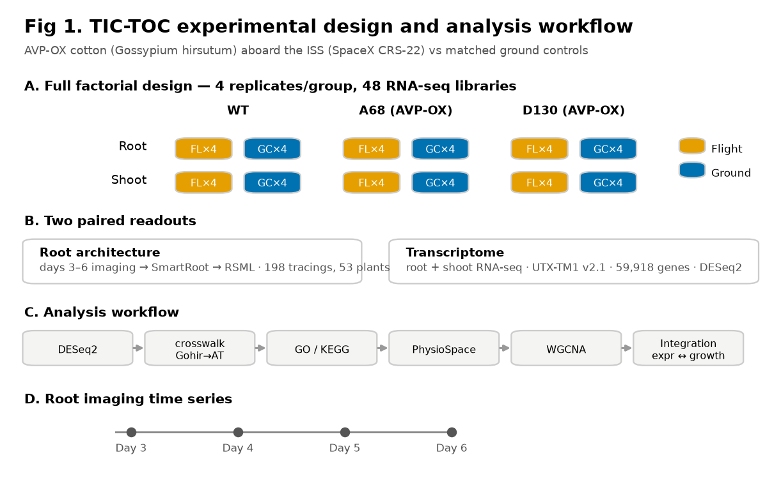
Figure 1. Experimental design and analysis workflow.
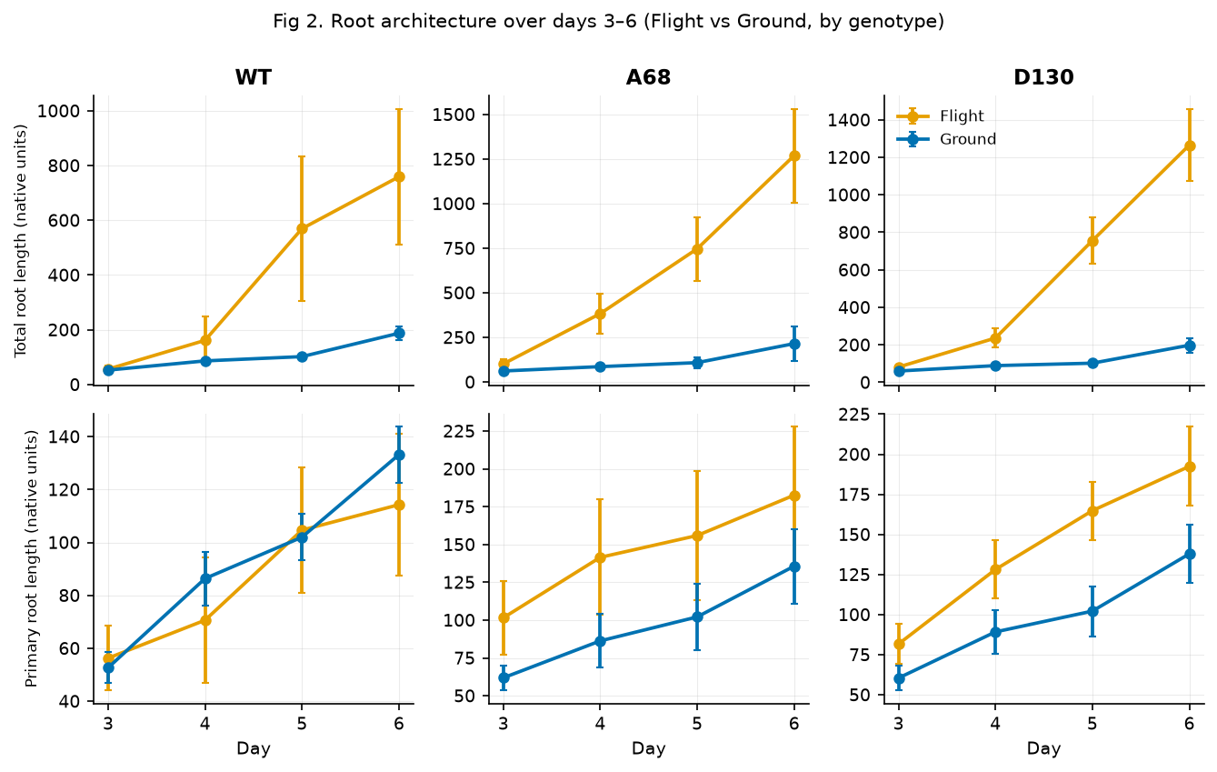
Figure 2. Root architecture over days 3–6 (Flight vs Ground by genotype).
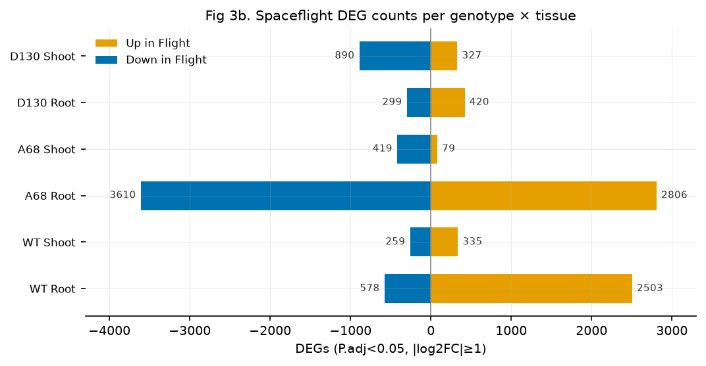
Figure 3. Spaceflight DEG counts per genotype × tissue (up/down).
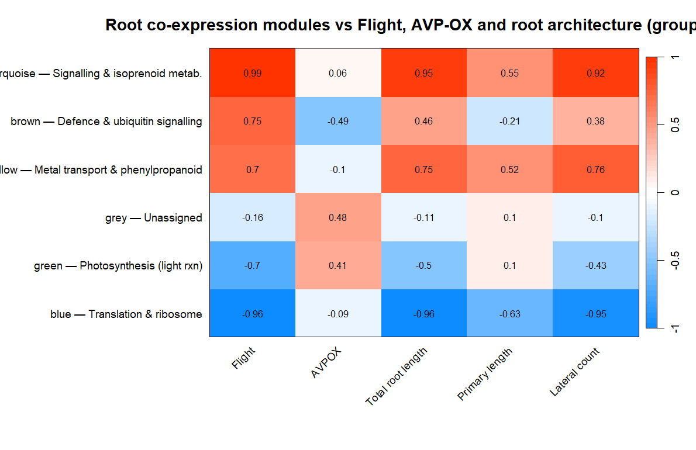
Figure 4. Root co-expression module–trait correlations (group-level).
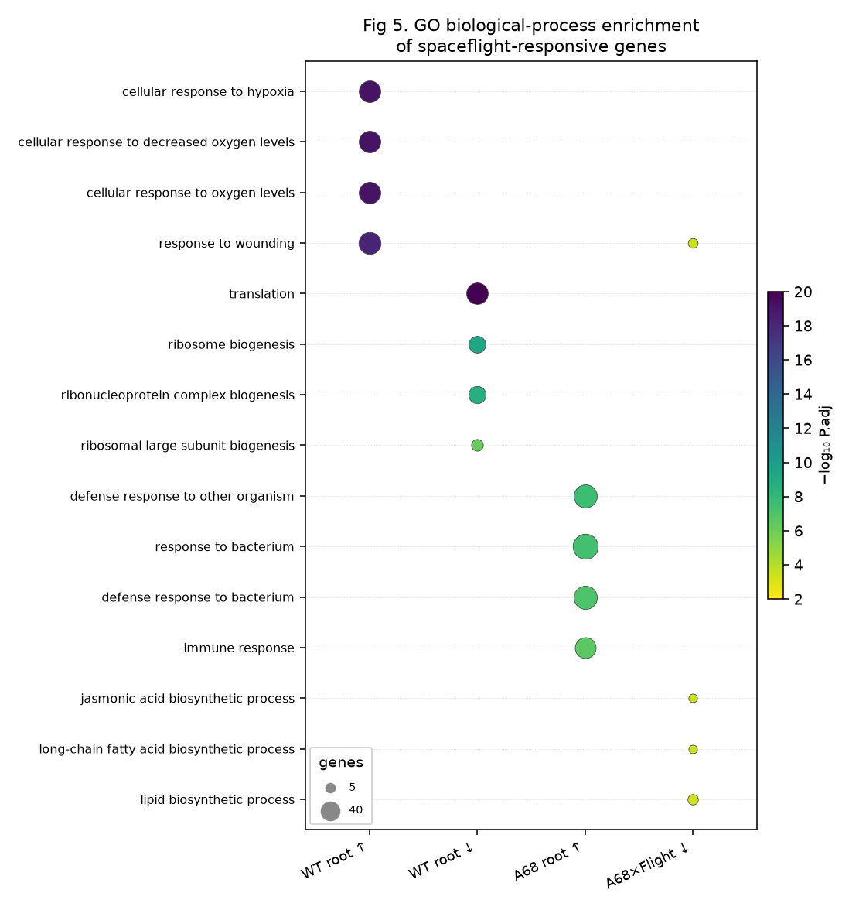
Figure 5. GO biological-process enrichment across key contrasts.
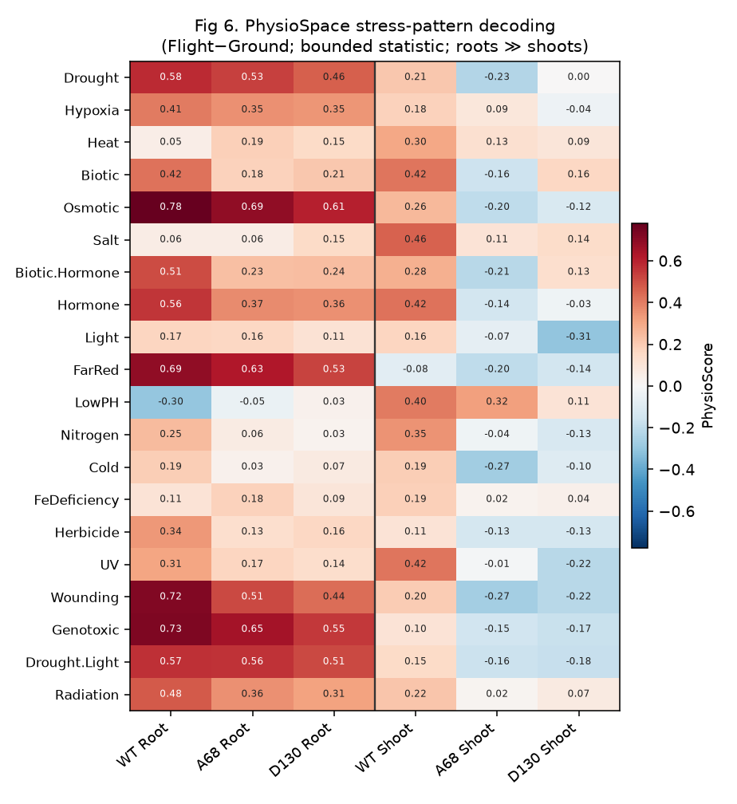
Figure 6. PhysioSpace stress-pattern decoding (stress axis × genotype × tissue).
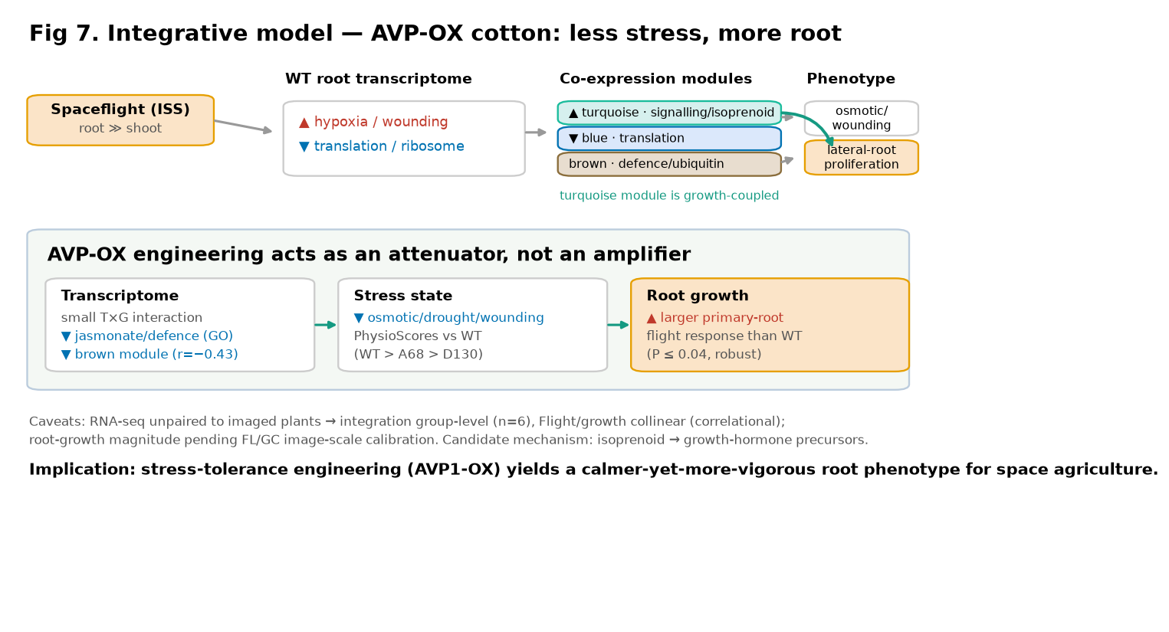
Figure 7. Integrative model — AVP-OX as a stress attenuator.

