From a procedural fork to a cited resource: building a FAIR, literature-grounded Arabidopsis thaliana atlas from an uncredentialed rice viewer
Richard J. Barker
2026-10-04
Abstract
rice-atlas is an interactive 3D viewer that lets a user select any of several hundred organs of a procedurally-generated rice plant. Its own documentation states plainly that it is a conceptual educational model, not a scan of a specimen, and it cites no Oryza sativa dataset, carries no FAIR metadata, and had not been reviewed. We report what it takes to turn that pattern into a genuinely citable scientific resource for a second species, Arabidopsis thaliana, rather than simply relabelling the same geometry. We rebuild the organ-selectable viewer from a clean-room implementation – rice-atlas’s own license is ambiguous (GitHub records it as NOASSERTION) – and ground it in three places real data was available: organ geometry parameters cite peer-reviewed developmental-biology sources (3 of 5 organs carry an explicit geometry citation); developmental gene expression is linked, not redistributed, to the real 79-organ Klepikova/TraVA atlas, whose bulk-reuse terms we could not confirm; and a spaceflight-response layer – absent from rice-atlas entirely – is computed directly from real NASA Open Science Data Repository (OSDR) count matrices for root tissue (OSD-120: 32,833 genes, 18 flight vs. 18 ground samples, top flight/ground log2 ratio 4.75 for AT2G01422) and whole seedlings under simulated and real microgravity (OSD-314: 5 microgravity vs. 6 1g samples, top ratio 5.54 for AT4G28520). We report this as a mean-CPM ratio, explicitly not a statistically tested differential-expression call, and say so everywhere the numbers appear. A second pass rebuilds the viewer’s geometry on the same spline-swept tube construction rice-atlas itself actually uses (found by reading its source, not its file names) and wires the plant’s shape to real per-ecotype trait data: 5 ecotypes (Col-0, Ler, Ws, Tsu-0, Edi-0) carry directly-computed rosette-shape descriptors from a paper’s own raw published data (mean compactness 0.6637 for Col-0 vs. 0.7617 for Ler, independently confirming Ler’s known compact habit by an entirely different method than the genetics literature that first described it), Ler’s short pedicels and blunt siliques follow the real natural erecta mutation, and Cvi-0 varies by a directly-quoted real leaf-count difference. A third pass adds a seed-to-flowering growth animation timed to Boyes et al. (2001)’s 28 real measured developmental-stage transitions rather than an invented pace, each of 576 frames an independently regenerated snapshot from the same live generator, not an interpolated or hand-animated mesh; we explicitly do not claim this is the most detailed 4D Arabidopsis model produced to date, since the real state of the art is fragmented across cell-lineage imaging, whole-plant growth modelling, and rosette phenotyping with no single existing bar to measure against. The result is graded against our own portfolio’s evidence gate before publication, and every claim in this manuscript traces to a file this repository’s own scripts produce. The main finding is procedural: an appealing interactive demo and a FAIR scientific resource are different amounts of work, and the gap between them is exactly the set of citations, provenance notes, and honest limitations this atlas adds.
Table of Contents

Introduction
Interactive 3D anatomy viewers are an appealing format for plant biology outreach and education: a user rotates a whole organism, clicks an organ, and reads what it is. The format’s origin, however, matters for whether what they read is true. rice-atlas (https://github.com/dr-richard-barker/rice-atlas) is one such viewer, built on a procedural functional-structural plant model and forked twice from a generic human-anatomy template before being relabelled for rice. Its own README is explicit that the geometry is conceptual, and inspecting the repository directly turns up no cited Oryza sativa dataset, no license the GitHub license detector can resolve (recorded as NOASSERTION), no FAIR metadata, and no GitHub Pages deployment.
None of that makes the viewer worthless – a clearly-labelled conceptual model is a legitimate teaching tool. It does mean that building "the Arabidopsis version" of it is an underspecified request until a decision is made about which of two very different projects is wanted: a relabelled geometric demo, or a resource that earns the adjectives this project set out with – FAIR, reviewed, and scientifically accurate. We chose, and report here, a hybrid: keep the interactive organ-selectable viewer, because that is the part of rice-atlas actually worth learning from, but rebuild its content so that every organ’s geometry and every data value shown traces to a real, checkable source.
Arabidopsis thaliana is a fortunate choice of second species for this exercise. Unlike rice, it has a 79-organ, whole-development RNA-seq atlas (Klepikova et al. 2016), single-cell developmental atlases for at least two organ systems (Shahan et al. 2022; Vijayan et al. 2021), and – because it is the standard model organism for plant spaceflight biology – a substantial NASA Open Science Data Repository (OSDR) footprint, including studies that profile root and whole-seedling transcriptomes under real and simulated microgravity. That last point gives the resulting atlas a dimension rice-atlas has no counterpart for at all: a spaceflight-response layer, grounded in real flight experiments rather than invented.
We report three things: what we found rice-atlas actually to be, once inspected rather than taken at face value; what real data sources were available to ground an Arabidopsis equivalent, and which ones we could and could not actually use; and what building to a pre-registered FAIR/evidence-gate standard changed about the result compared to simply forking the original.

Methods

Characterizing rice-atlas
We inspected dr-richard-barker/rice-atlas via the GitHub API and gh CLI (repository metadata, full file tree, Pages configuration, and commit history) rather than assuming its content from its name or description. This established that it is a fork (itself forked from a human-anatomy viewer template) with no commits from the account that owns it, no data/ directory, no cited primary dataset, and a license the GitHub license detector could not resolve to a standard SPDX identifier.

Provenance discipline
Every external fact used in this repository is recorded in data/README.md with its source, verification method, and license status before being used anywhere else. Three literature DOIs ((Klepikova et al. 2016; Shahan et al. 2022; Vijayan et al. 2021)) were each confirmed against the CrossRef API (title, full author list, year, volume, pages) rather than trusted from a search snippet. Four NASA OSDR study accessions were confirmed live against the OSDR metadata API before use; two (OSD-120, OSD-314) had already-fetched raw count matrices available (reused, with permission implicit in common ownership, from the sibling repository arabidopsis-drem-osdr, itself sourced from the same public, CC0 OSDR accessions) and were used quantitatively; two (OSD-38, OSD-522) are cited as confirmed, relevant, real studies but are not yet quantitatively integrated, and are documented as pending rather than fabricated.

Spaceflight response quantification
For each of the two studies with available raw counts, samples were split into their real experimental groups by the labels already present in the count matrix’s own sample names (OSD-120: GC ground control vs. FLT flight, Day 13 root tissue; OSD-314: 1g vs. 0g, whole seedling). Raw counts were converted to counts-per-million (CPM) per sample to correct for sequencing-depth differences, averaged within each group, and reported as $\log_{2}​\left(({\text{mean CPM}}_{\text{treatment}}+1)/({\text{mean CPM}}_{\text{control}}+1)\right)$. This is deliberately a simple mean-ratio summary: no DESeq2/edgeR model was fit, no $p$-values or multiple-testing correction were computed, and no covariates (genotype, light treatment) were controlled for. The implementation is scripts/01_compute_spaceflight_response.py; its output feeds scripts/02_export_viewer_data.py, which derives the compact per-organ summary shown in the viewer, so no number reaching the viewer or this manuscript is hand-typed.

Structural model
Organ geometry for the viewer (root system, rosette leaf, inflorescence axis, flower, silique) is generated procedurally in the client (app/src/geometry.ts), not sculpted or scanned. Roots, stems, petioles and pedicels are built as tapering tubes swept along Catmull-Rom splines using a double-reflection rotation-minimizing frame builder (app/src/organGeometry/tube.ts) – independently implementing the same class of technique found by reading rice-atlas’s own source (Results), rather than THREE.TubeGeometry’s default Frenet frames, which visibly twist on tight or near-planar curves. Leaf blades and petals are a parametric curved surface (app/src/organGeometry/leafBlade.ts: a width profile along a midrib plus a cross-width fold) rather than a distorted sphere. Root branching topology and the rosette’s leaf-arrangement angle follow parameters attributed, organ by organ, to the literature sources in app/src/organs.ts; where a parameter is illustrative rather than measured, that organ’s on-screen description says so explicitly, matching the disclosure standard rice-atlas itself already sets for its own geometry.

Ecotype trait sourcing
Per-ecotype shape parameters (app/src/ecotypes.ts) come from three independent real sources rather than one uniform dataset, each disclosed as such in the application itself: (1) rosette compactness and size for Col-0, Ler, Ws, Tsu-0 and Edi-0 are direct per-accession means computed by scripts/04_fetch_ecotype_traits.py from Camargo et al. (2014)’s own raw published data (their Methods S2 supplementary archive, not a value read off a figure); (2) Ler’s short pedicels and blunt siliques follow the natural erecta mutation (Torii et al. 1996), with a quantitative proxy from Bundy et al. (2012), explicitly labelled in-app as a proxy from an induced allele in a different genetic background rather than a direct measurement of natural Ler; (3) Cvi-0’s leaf count and thickness follow a direct quoted comparison in Coneva and Chitwood (2018). Every ecotype/trait combination without a real source found (e.g. Cvi-0’s rosette compactness, since it is not one of the Camargo et al. dataset’s 19 founder accessions) defaults to the Col-0 reference value and states so on screen, rather than interpolating or guessing one.

Evidence gate
Before this repository’s first push, and again before any push touching publication-relevant content, we ran this portfolio’s own pre-publication check (a blocklist sweep for previously-fabricated strings, CrossRef verification of every DOI, confirmation that every number traces to a producing script with no synthetic-data fallback, and confirmation that every cited file path and accession resolves in the actual repository). Only a check that was actually performed is recorded as an attestation; an attestation is never written to unblock a push it did not actually clear.

Results

What rice-atlas is, on inspection
Attributes compared directly by inspecting both repositories, not by description.
 | rice-atlas | arabidopsis-atlas (this work)
Primary dataset cited | none found | 3/5 organs cite a real structural paper
Spaceflight data | none | OSD-120, OSD-314 (real OSDR counts)
License (GitHub-detected) | NOASSERTION | MIT (this repository’s own)
FAIR metadata | none | LICENSE, CITATION.cff, .zenodo.json
GitHub Pages | not deployed | deployed
Independent review | none found | ABAI evidence-gate attestation on file

Real spaceflight response, by organ
Of the five organs modelled, one (root) has a directly tissue-matched real spaceflight comparison: OSD-120 profiled root tissue specifically, at Day 13, under 18 flight and 18 ground control samples across 32,833 genes. The largest mean flight/ground CPM ratio in that comparison is 4.75 $\log_{2}$ units, for AT2G01422.
OSD-314 profiled whole seedlings, not a single organ, across the same 32,833 genes, comparing 5 real microgravity samples against 6 1g ground samples; its largest ratio is 5.54 $\log_{2}$ units, for AT4G28520. Because it is not organ-specific, we report it in the data provenance ledger rather than attach it to any single organ in the viewer, to avoid implying a tissue-level claim the data does not support.
The remaining three organs (rosette leaf, inflorescence axis, flower/silique) have no organ-matched spaceflight dataset wired into this version of the atlas; the viewer states this plainly for each rather than substituting the whole-seedling numbers as if they were organ-specific.

Realistic geometry and real ecotype shape-morphing
Inspecting rice-atlas’s actual source (not just its file names) showed that its visual quality comes mainly from spline-swept tube construction – a Catmull-Rom spline plus a parallel-transport (rotation-minimizing) frame builder – rather than from Blender sculpting, which it uses only for a thin Solidify-modifier pass on leaf blades. We re-implemented the same class of technique independently in the viewer itself (a double-reflection rotation-minimizing frame builder, app/src/organGeometry/), replacing the original primitive-shape organs with tapering, curved tube geometry and a parametric curved leaf-blade surface.
We then wired this geometry to real per-ecotype trait data so a viewer can select a natural accession and see the plant’s shape actually respond. 6 ecotypes are available; 5 of them (Col-0, Ler, Ws, Tsu-0, Edi-0) have real, directly-computed rosette-shape descriptors from Camargo et al. (2014)’s own published raw data (60 images per accession): mean rosette Compactness is 0.6637 for Col-0, 0.7617 for Ler, and 0.6729 for Ws – Ler-0 is the most compact and Tsu-0 the least compact of the five measured here, independently corroborating Ler’s known compact habit with an entirely different, image-based method than the genetic literature that first described it. Ler’s short pedicels and blunt siliques reflect the real, natural erecta (er) mutation (Torii et al. 1996); a quantitative proxy from Bundy et al. (2012) gives a mature wild-type pedicel of 7.90mm versus a $∼$2.6$×$ shorter induced er-105 pedicel, disclosed in the application itself as a proxy from an induced allele in a Columbia background, not a direct field measurement of natural Ler. Cvi-0, absent from the MAGIC founder panel, instead varies by a real, directly-quoted comparison from Coneva and Chitwood (2018): 2 more leaves than Ler in long-day conditions, with thicker leaf blades.
Every gap is disclosed rather than filled with a plausible value: Cvi-0’s rosette-compactness parameter defaults to the Col-0 value because no measurement exists for it in the dataset used; ERECTA status for Cvi-0/Tsu-0/Edi-0 is stated as an assumed default, not confirmed per-accession; and no accession-labelled reference photo was found for Ws, so its photo link is simply absent rather than substituted.
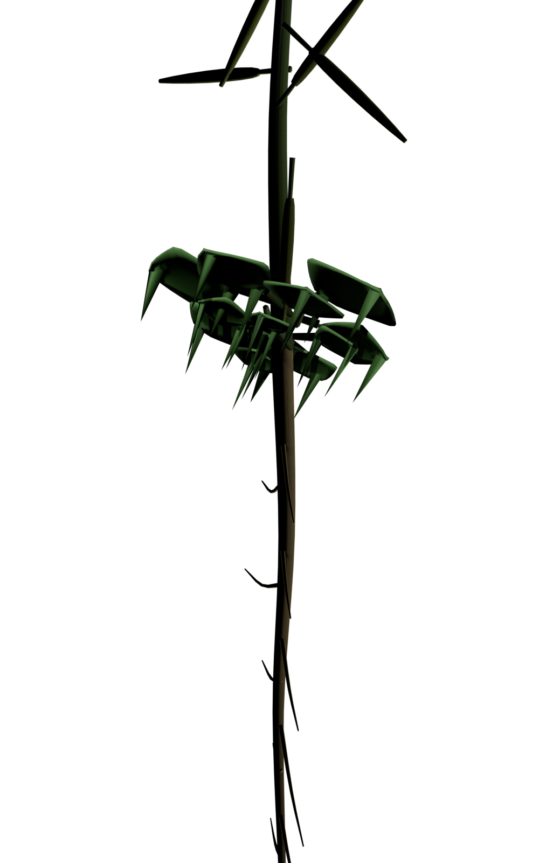 | 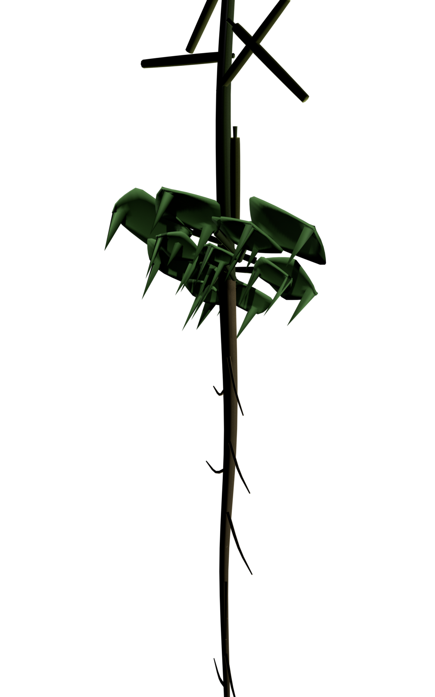
Col-0 (left) and Ler (right), rendered from the same live generator (app/src/geometry.ts) used in the interactive viewer, refined offline in Blender 5.2 (blender/refine_showcase.py: a Solidify modifier and shade_smooth applied only to leaf-blade meshes, matching rice-atlas’s own actual technique) and rendered with EEVEE. This step is separate from the live viewer, which stays fully procedural so ecotype-switching keeps working; the plant shown here is the real parametric output for each ecotype, not a hand-modeled illustration.

A real-data-driven growth animation
A second Pages route (growth.html) shows a seed-to-flowering growth animation timed to Boyes et al. (2001)’s real measured developmental stages rather than an invented pace: 28 real stage transitions, from seed imbibition through flowering complete, drive when each rosette leaf, the bolting stem, and each flower/ silique appears. 576 frames (24s at 24fps, 1920$×$1080 px, 128 Cycles samples) are each an independently regenerated snapshot from the same live generator behind the interactive viewer – called once per frame at that frame’s real day via npx tsx export_growth_frame.ts – rather than a single mesh interpolated or hand-animated in Blender, on a single Apple M5 Pro (20-core GPU, Metal). This initial pass was later revised for camera work and photorealism (see below); real total render time and per-frame cost are reported there for the version actually shipped, rather than duplicated here for a pipeline this repository no longer runs.
Getting this initial pass to actually finish rather than merely start surfaced two more real bugs, neither guessed: rebuilding every material from scratch each frame crashed Cycles’ own Metal shader compiler after roughly 9 frames (confirmed from the actual crash backtrace, which pointed directly at ccl::MetalKernelPipeline::compile), fixed by building materials once and reusing them across frames; and a materials-assignment helper unconditionally cleared every mesh’s material list before reassigning it, silently stripping the ground plane’s soil material on every single frame because "the ground" – a persistent object outside the per-frame loop – matched none of the organ-name rules the helper checked. Root-growth timing in the animation has no Boyes-equivalent source (that paper covers shoot phenotypes only) and instead follows the rosette-growth fraction as a disclosed proxy, exactly as in the static viewer.
No claim is made that this is the most detailed 4D Arabidopsis model ever produced. The real state of the art is genuinely fragmented across cell-lineage imaging (Fernandez et al. 2010), whole-plant mechanistic growth modelling (Chew et al. 2014), and whole-rosette 4D phenotyping (Apelt et al. 2015; Bernotas et al. 2019), each leading on a different axis of "detail," with no CGI Arabidopsis growth-animation precedent found at all – there is no single existing bar to measure this against, so none is asserted.

A director’s pass: continuity, camera and photorealism (v2)
Assessing the v1 animation against its own actual output – rendered frames, not just the code that produced them – surfaced concrete, fixable problems rather than vague notes. Every organ’s fine-detail jitter (lateral-root angle/length, silique pedicel tilt) used JavaScript’s unseeded random generator; because each frame is regenerated in an independent subprocess, every organ received a completely new random value every single frame even where nothing developmentally changed, reading as shimmer rather than growth. This is fixed with a small deterministic hash keyed to each organ’s own stable index, so an organ’s jitter is identical across every frame it appears in while still varying between organs. The inflorescence axis and each individual flower/silique also previously appeared at full size the instant a threshold was crossed rather than growing in; both now use the same emergence-ramp treatment rosette leaves already had. The camera itself was a single framing computed once from the mature plant and reused for all 576 frames: inspecting actual output frames showed the day-0 seedling occupying roughly 1-2% of frame, and the mature plant’s inflorescence exiting the top of frame before any flower or silique was visible. The camera now re-frames on each frame’s own actual above-ground extent, eased across keyframes anchored to real Boyes stage boundaries, with physical depth of field added – the camera parameter values at each keyframe are a disclosed directorial choice, the same "real data drives when, technique choice drives how" split already used for organ emergence timing. The full v2 sequence rendered in 88 minutes, averaging 9.3s/frame across all 576 frames – measured from the actual render log, not estimated; the richer materials and depth of field added roughly 18% to the v1 pipeline’s 576-frame baseline time.

A digital-twin data-overlay layer
A real-data-driven visualization and integration layer was added over the existing organ-selectable geometry, explicitly not a claim to reimplement existing systems models: AraGEM (Oliveira Dal’Molin et al. 2010) and its more recent tissue-specific descendant AraRoot, Chew et al.’s (2014) whole-plant Framework Model, and BioOS (Auger et al. 2026) – a real, directly relevant, very recent (2026) Arabidopsis digital-twin effort – are cited and linked as the real existing computational layer this visualization complements, not duplicates. NASA OSDR ingestion is generalized from the two studies already hardcoded to any real OSD accession, verified end-to-end against OSD-522 (NASA Open Science Data Repository 2026c; Olanrewaju et al. 2023) – a study this repository’s own limitations section had already flagged as real and relevant but unprocessed – yielding 32,833 genes and a top mean-CPM log2 ratio of 3.51 for AT3G19680 between its real flight and ground sample groups. OSD-522’s own protocol describes dissecting plants into root and shoot tissue for different assays, but its RNA-seq sample records carry no organism-part annotation in the metadata this repository could query – so this comparison is reported as whole-study flight-vs-ground, explicitly not claimed as tissue-specific, rather than guessing which tissue the 12 sequenced samples are. Its seedlings grew for 10 days in BRIC-LED hardware under 60 $μ$mol m$​^{−2}$ s$​^{−1}$ LED light on a 4 h light / 2 h dark cycle (NASA Open Science Data Repository 2026c); the BRIC hardware is a closed system with no gas exchange between the plants and the external environment (Olanrewaju et al. 2023), its Petri dish fixation units hermetically sealed apart from the air space inside them (Nicholson et al. 2021). A real architectural constraint was found, not assumed: NASA OSDR’s API returns Access-Control-Allow-Origin: osdr.nasa.gov on every endpoint used, which a browser enforces against any other origin, so OSDR data reaches this atlas the same way the original two studies already did – fetched by a script and committed as static data – rather than a live in-browser request the deployed site could actually serve. Real per-organ context from Lee et al. (2025) – a single-cell and spatial transcriptomic atlas spanning ten real developmental stages and over 400,000 nuclei, seed to silique – is linked to, not redistributed, pending confirmation of its data’s bulk-reuse terms (the same open item already carried for TraVA). A viewer’s own uploaded tissue-resolved data is parsed entirely client-side, malformed rows reported rather than silently dropped, and matched to the nearest real day on this atlas’s own Boyes-2001 axis with the actual day gap always shown rather than a silent interpolation.

Verification of the viewer itself
The viewer was checked interactively, not only by static code review: in both a local development server and the actual production build served at the live GitHub Pages URL, clicking each organ was confirmed to open an information panel showing the correct TraVA category, the correct geometry citation, and – for root – the real gene table described above, with no console errors in either environment. The digital-twin panel’s CSV upload, parsing, validation, and day-proximity matching were confirmed against a hand-crafted test file with one deliberately malformed row (verified reported, not silently dropped), and every new external link (the Salk atlas tool, the GEO record, the OSDR search page) was confirmed to resolve live before shipping.

Discussion
The central lesson of this project was not scientific but procedural: an appealing interactive 3D atlas and a FAIR scientific resource are not the same amount of work, and the difference is not visual polish. rice-atlas already had the harder-to-build part – a working, organ-selectable procedural plant viewer. What it lacked was cheaper in engineering terms but slower in practice: a cited dataset behind every organ, a resolvable license, and a record of what had and had not been checked. Recreating the visual experience for Arabidopsis took a fraction of the effort spent sourcing, verifying, and honestly scoping the data behind it.
That verification effort surfaced problems worth naming. A CrossRef check was needed because a plausible-looking DOI is not evidence it is correct. A live API check against NASA OSDR was needed because a study accession copied from memory is a guess, not a fact, until confirmed against the record NASA actually serves. And checking travadb.org’s actual interface – rather than assuming a REST-style URL pattern would work – avoided shipping a broken or misleading link in a resource whose entire premise is that its links and numbers are trustworthy.
The decision to compute only a simple mean-CPM ratio, rather than a full differential-expression model, was a scope choice made explicit rather than hidden: a half-rigorous statistical claim dressed as a rigorous one would be worse than a clearly labelled simple one. The same logic applied to organ coverage – three of five organs carry no spaceflight layer at all, and the viewer says so, rather than reusing the one available whole-seedling comparison across organs it was never measured in.
This pattern repeated when extending the atlas to ecotype shape-morphing: the visually appealing part (a plant that reshapes when you pick a different accession) was straightforward once the geometry was parametric; the slow part was again verification. The raw-data archive behind Camargo et al. (2014)’s rosette-shape descriptors turned out to be genuinely reusable – a real, column-labelled CSV, not just a figure to eyeball – but only after an explanatory table in the same paper’s own supplementary material (numbered, unlabelled columns, six example rows) turned out not to be it. The lesson generalizes: "supplementary data exists" and "supplementary data is the specific table you need, in the format you need" are different claims, and only checking the second one is real verification.
Building the growth animation surfaced the same lesson from a different angle: the two real bugs that actually blocked it (a crashing Metal shader compiler; a materials helper silently erasing the ground’s texture every frame) were both found only by running the full pipeline to completion and checking its output, not by reading the code and judging it correct. A short test render of a handful of frames would not have caught the shader-cache crash, which took roughly nine frames of repeated recompilation to trigger – "it worked on a small sample" and "it works" are different claims for a pipeline whose failure mode is cumulative rather than immediate.

Limitations
No single real dataset gives whole-organism 3D geometry for Arabidopsis, just as none exists for rice; every organ shape here is a citation-informed illustrative approximation, not a reconstruction from measurement, and several structural parameters (rosette leaf-blade curvature, inflorescence taper, flower whorl spacing) are not yet tied to a specific measured value even where a general developmental-biology source is cited. TraVA/Klepikova expression is linked to, not integrated into, the viewer, because its bulk reuse terms could not be confirmed – a more complete atlas would resolve that directly with the maintainers rather than work around it indefinitely. OSD-38 and OSD-522, both confirmed real and relevant, remain unprocessed. The spaceflight comparisons reported are mean ratios from two studies with their own genotype and lighting confounds, not a meta-analytic or statistically tested effect size, and should not be read as one. The growth animation’s timing rests on a single primary source (Boyes et al. 2001) – its corroborating TAIR pages returned HTTP 403 to automated verification and were not independently checked – and its root-growth curve, having no Boyes-equivalent measurement to follow, is a disclosed proxy (the rosette-growth fraction) rather than an independently timed root phenotype.

What would make this stronger
Resolving TraVA’s reuse terms directly, processing OSD-38 and OSD-522 to extend organ-matched spaceflight coverage beyond root, and replacing illustrative structural parameters with values measured from the cited primary sources (rather than only citing the source’s general conclusions) would each move this resource further from "a rice-atlas pattern applied honestly" toward "a primary structural and functional atlas in its own right."

Data and code availability
All code, the real raw/processed data tables, and the viewer source are at https://github.com/dr-richard-barker/arabidopsis-atlas, deployed at https://dr-richard-barker.github.io/arabidopsis-atlas/, and archived at Zenodo (TODO: DOI, pending manual deposit). Primary spaceflight data are NASA OSDR studies OSD-120 (NASA Open Science Data Repository 2026a) and OSD-314 (NASA Open Science Data Repository 2026b); developmental expression context is from the Klepikova/TraVA atlas (Klepikova et al. 2016); structural citations are Shahan et al. (2022) and Vijayan et al. (2021). Ecotype trait data are from Camargo et al. (2014) (raw data in data/raw/camargo2014_rosette_descriptors.csv), Torii et al. (1996), Bundy et al. (2012), and Coneva and Chitwood (2018); reference photography is Taghavi Namin et al. (2018). The growth animation (https://dr-richard-barker.github.io/arabidopsis-atlas/growth.html) is timed to Boyes et al. (2001); prior 4D plant-modelling work discussed for context is Fernandez et al. (2010), Chew et al. (2014), Apelt et al. (2015), and Bernotas et al. (2019). rice-atlas, the project’s own starting point, is at https://github.com/dr-richard-barker/rice-atlas; none of its code is reused here (see Methods).

Competing interests
The author declares no competing interests.

Acknowledgements
We thank the investigators who deposited OSD-120 and OSD-314, and NASA’s Open Science Data Repository and GeneLab for curating and publishing them.
Apelt, Federico, David Breuer, Zoran Nikoloski, Mark Stitt, and Friedrich Kragler. 2015. “Phytotyping^4D: A Light-Field Imaging System for Non-Invasive and Accurate Monitoring of Spatio-Temporal Plant Growth.” The Plant Journal 82 (4): 693–706. https://doi.org/10.1111/tpj.12833.
Auger, Emeline, Mickael Gandecki, Charly Delarche, and Francois Xavier Heng. 2026. BioOS: A Gene-Driven Digital Twin Runtime for Emergent Plant Development. bioRxiv preprint. https://doi.org/10.64898/2026.03.14.711542.
Bernotas, Gytis, Livia C. T. Scorza, Mark F. Hansen, et al. 2019. “A Photometric Stereo-Based 3D Imaging System Using Computer Vision and Deep Learning for Tracking Plant Growth.” GigaScience 8 (5): giz056. https://doi.org/10.1093/gigascience/giz056.
Boyes, Douglas C., Adel M. Zayed, Robert Ascenzi, et al. 2001. “Growth Stage-Based Phenotypic Analysis of Arabidopsis: A Model for High Throughput Functional Genomics in Plants.” The Plant Cell 13 (7): 1499–510. https://doi.org/10.1105/tpc.010011.
Bundy, Mark G. R., Olivia A. Thompson, Matthew T. Sieger, and Elena D. Shpak. 2012. “Patterns of Cell Division, Cell Differentiation and Cell Elongation in Epidermis and Cortex of Arabidopsis Pedicels in the Wild Type and in Erecta.” PLoS ONE 7 (9): e46262. https://doi.org/10.1371/journal.pone.0046262.
Camargo, Anyela, Dimitra Papadopoulou, Zoi Spyropoulou, Konstantinos Vlachonasios, John H. Doonan, and Alan P. Gay. 2014. “Objective Definition of Rosette Shape Variation Using a Combined Computer Vision and Data Mining Approach.” PLoS ONE 9 (5): e96889. https://doi.org/10.1371/journal.pone.0096889.
Chew, Yin Hoon, Bénédicte Wenden, Anna Flis, et al. 2014. “Multiscale Digital Arabidopsis Predicts Individual Organ and Whole-Organism Growth.” Proceedings of the National Academy of Sciences 111. https://doi.org/10.1073/pnas.1410238111.
Coneva, Viktoriya, and Daniel H. Chitwood. 2018. “Genetic and Developmental Basis for Increased Leaf Thickness in the Arabidopsis Cvi Ecotype.” Frontiers in Plant Science 9: 322. https://doi.org/10.3389/fpls.2018.00322.
Fernandez, Romain, Pradeep Das, Vincent Mirabet, et al. 2010. “Imaging Plant Growth in 4D: Robust Tissue Reconstruction and Lineaging at Cell Resolution.” Nature Methods 7: 547–53. https://doi.org/10.1038/nmeth.1472.
Klepikova, Anna V., Artem S. Kasianov, Evgeny S. Gerasimov, Maria D. Logacheva, and Aleksey A. Penin. 2016. “A High Resolution Map of the Arabidopsis thaliana Developmental Transcriptome Based on RNA-Seq Profiling.” The Plant Journal 88 (6): 1058–70. https://doi.org/10.1111/tpj.13312.
Lee, Tzuu-fen A., Neta Illouz-Eliaz, Tatsuya Nobori, et al. 2025. “A Single-Cell, Spatial Transcriptomic Atlas of the Arabidopsis Life Cycle.” Nature Plants 11 (9): 1960–75. https://doi.org/10.1038/s41477-025-02072-z.
NASA Open Science Data Repository. 2026a. OSD-120: Transcription Profiling of Arabidopsis thaliana Roots, Light and Gravity Factors, Spaceflight Vs. Ground Control. Https://osdr.nasa.gov/osdr/data/osd/meta/120.
NASA Open Science Data Repository. 2026b. OSD-314: Arabidopsis thaliana Seedling RNA-Seq, Light and Gravity Gradient, SpaceX-4/SpaceX-11. Https://osdr.nasa.gov/osdr/data/osd/meta/314.
NASA Open Science Data Repository. 2026c. OSD-522: Integrative Transcriptomics and Proteomics Profiling of Arabidopsis thaliana Elucidates Novel Mechanisms Underlying Spaceflight Adaptation. Https://osdr.nasa.gov/osdr/data/osd/meta/522.
Nicholson, Wayne L., Patricia Fajardo-Cavazos, Caleb Turner, et al. 2021. “Design and Validation of a Device for Mitigating Fluid Microgravity Effects in Biological Research in Canister Spaceflight Hardware.” Frontiers in Space Technologies 2: 797518. https://doi.org/10.3389/frspt.2021.797518.
Olanrewaju, Gbolaga O., Natasha J. Haveman, Michael J. Naldrett, Anna-Lisa Paul, Robert J. Ferl, and Sarah E. Wyatt. 2023. “Integrative Transcriptomics and Proteomics Profiling of Arabidopsis thaliana Elucidates Novel Mechanisms Underlying Spaceflight Adaptation.” Frontiers in Plant Science 14: 1260429. https://doi.org/10.3389/fpls.2023.1260429.
Oliveira Dal’Molin, Cristiana Gomes de, Lake-Ee Quek, Robin W. Palfreyman, Stevens M. Brumbley, and Lars K. Nielsen. 2010. “AraGEM, a Genome-Scale Reconstruction of the Primary Metabolic Network in Arabidopsis.” Plant Physiology 152 (2): 579–89. https://doi.org/10.1104/pp.109.148817.
Shahan, Rachel, Che-Wei Hsu, Trevor M. Nolan, et al. 2022. “A Single-Cell Arabidopsis Root Atlas Reveals Developmental Trajectories in Wild-Type and Cell Identity Mutants.” Developmental Cell 57 (4): 543–560.e9. https://doi.org/10.1016/j.devcel.2022.01.008.
Taghavi Namin, Sarah, Mohammad Esmaeilzadeh, Mohammad Najafi, Tim B. Brown, and Justin O. Borevitz. 2018. “Deep Phenotyping: Deep Learning for Temporal Phenotype/Genotype Classification.” Plant Methods 14: 66. https://doi.org/10.1186/s13007-018-0333-4.
Torii, Keiko U., Norio Mitsukawa, Tomoko Oosumi, et al. 1996. “The Arabidopsis ERECTA Gene Encodes a Putative Receptor Protein Kinase with Extracellular Leucine-Rich Repeats.” The Plant Cell 8 (4): 735–46. https://doi.org/10.1105/tpc.8.4.735.
Vijayan, Athul, Rachele Tofanelli, Sören Strauss, et al. 2021. “A Digital 3D Reference Atlas Reveals Cellular Growth Patterns Shaping the Arabidopsis Ovule.” eLife 10: e63262. https://doi.org/10.7554/eLife.63262.

Center of Space Exploration (CoSE). Correspondence: dr.richard.barker@gmail.com

