A cell-type-weighted regulatory prior resolves the transcription factors driving bifurcations in a cross-study Arabidopsis irradiation pseudo-time-series
Richard J. Barker
TODO: co-author list
2026-08-28
Abstract
The Dynamic Regulatory Events Miner (DREM) reconstructs when transcription factors (TFs) act by finding bifurcations in time-series expression and attributing each to a regulator, using a static TF–gene interaction prior (Ernst et al. 2007; Schulz et al. 2012). That prior is normally binary and tissue-blind: an edge either exists or it does not, regardless of whether the TF is expressed in the cells producing the signal. We show that a single-cell atlas can be made to act on the model itself rather than on its annotation, by writing cell-type context into the score column DREM already reads. Screening all 62 Arabidopsis thaliana studies in NASA’s Open Science Data Repository (OSDR), we assemble a 10-point $γ$-irradiation pseudo-time-series spanning 10 min to 72 h from 108 samples, and a second 3-point spaceflight series from 115 samples. We deconvolve each timepoint against a 183-cluster single-nucleus atlas, weight 976,588 DAP-seq and ChIP-seq TF–gene edges by the cell types actually present, and compare the resulting models against flat and binding-only priors under an otherwise identical search. The wild-type/sog1-1 design provides an internal positive control: the canonical DNA-damage response is induced across all 6 sentinel genes in wild type and collapses in the mutant. Of 6 bifurcations in the wild-type model, 3 change their top-ranked regulator with the prior — but not the canonical ones: SOG1 ranks first of 478 TFs in wild type under every prior and falls to rank 574 in sog1-1. Attribution moves where the evidence was marginal and holds where it was strong.
Table of Contents

Introduction
Time-series transcriptomics answers when a response happens, but not who drives it. The Dynamic Regulatory Events Miner (DREM) closes that gap by fitting an input–output hidden Markov model in which co-expressed genes travel together until a bifurcation, and by attributing each bifurcation to the transcription factors (TFs) whose targets are enriched along one branch (Ernst et al. 2007). DREM 2.0 added model-selection and scoring improvements (Schulz et al. 2012), and iDREM extended the framework to multi-omic inputs and interactive exploration (Ding et al. 2018).
The attribution step depends entirely on a second input: a static TF–gene interaction table. In practice that table is binary and tissue-blind. An edge asserts that a TF can bind a promoter, not that the TF is present in the cells generating the measured signal. For a bulk time-series drawn from a whole organism this is a real limitation, because the transcriptome is a mixture and the mixture changes.
Single-cell data is the obvious remedy, and iDREM already accepts it — but only after the fact. Its documentation is explicit that the cell-type data “is not used when predicting the iDREM model”; it annotates finished nodes rather than informing them. The contribution of this work is to move that information upstream, into the model itself, without modifying the engine. DREM reads the third column of its TF–gene file as a score in $[0,1]$ rather than as a binary flag, and that column is a sufficient channel: an edge whose TF is absent from the responding cell types can be down-weighted before the search begins.
We test this on Arabidopsis thaliana data from NASA’s Open Science Data Repository (OSDR). Screening all 62 OSDR Arabidopsis studies for compatible genotype and treatment metadata yields two cross-study pseudo-time-series. The first is a $γ$-irradiation series of 10 timepoints spanning 10 min to 72 h. Its core — OSD-498, OSD-508 and OSD-510 — is a re-assembly of one experiment deposited under three accessions, that of Bourbousse et al. (2018), who built their own DREM model over these data and reported 11 co-expressed gene groups. That gives this work an unusual advantage: a published DREM analysis of the same material to calibrate against, and a genetic positive control, since the series contains both wild type and sog1-1, a knockout of the NAC master regulator of the plant DNA-damage response (Yoshiyama et al. 2009). The second series follows spaceflight seedling development across 3 timepoints and tests whether the method generalises to a different stress.

Methods

Study selection
All Arabidopsis thaliana studies in OSDR were retrieved through the biodata v2 metadata API, returning sample-level factor values for 62 studies. Studies were admitted to a cohort only where a numeric time axis could be parsed from a factor-value field and the assay was Illumina RNA-seq. Cohort A ($γ$-irradiation) comprises 5 studies and cohort B (spaceflight development) 4. 7 studies were excluded with a recorded reason (scripts/cohorts.py).
Two exclusions matter. OSD-219 re-deposits all 32 of OSD-218’s BioSample identifiers verbatim; including both would double-count every sample. This is re-detected each run from sample-name overlap rather than hard-coded, so the exclusion cannot outlive the condition that justifies it. The microarray irradiation studies (OSD-46, OSD-320, OSD-329) were held out of the primary analysis because pooling them with RNA-seq would confound platform with timepoint.

Pseudo-time-series construction
Raw RSEM counts and GeneLab runsheets were retrieved from the OSDR file API. Counts were converted to CPM and $\log_{2}$-transformed within each study, then expressed as a $\log_{2}$ ratio against that study’s own untreated controls. This within-study referencing removes most between-study offset by construction, because a per-study additive term cancels between numerator and denominator. A residual per-study offset was then fitted as the median gene-wise difference from the cross-study consensus, computed only at the 7 timepoints more than one study measured; a study sharing no timepoint with any other is left unadjusted rather than shifted against a reference it never overlaps.
Because every value is already a ratio against the untreated state, an explicit $t=0$ column of zeros is prepended and DREM is run with No normalization/add 0. Omitting either would make DREM re-anchor on the 10-min timepoint, which is already strongly induced, and the entire early response would vanish from the model.
OSD-782 is held out rather than pooled. It is an independent laboratory and a different dose regime (10–100 cGy against the core’s high-dose $γ$), so fitting it a shared offset would remove real biology.
Batch correction was verified against six canonical DNA-damage-response genes (BRCA1, RAD51, PARP2, SMR7, GMI1, XRI1). The pipeline fails if fewer than three remain 2-fold responsive in the wild-type arm — the check exists to catch a correction that has flattened the signal it was meant to preserve.

TF–gene prior
A binding prior was built from the Arabidopsis DAP-seq cistrome (O’Malley et al. 2016), retrieved as GEO GSE60143. Of 814 peak files, 194 name the assayed TF by AGI locus and 557 by gene symbol; symbols were resolved through a map built from the Ensembl Plants release-54 annotation, TAIR gene aliases (Berardini et al. 2015) and ConnecTF (Brooks et al. 2020). 63 files remain unresolved (ChIP-seq controls, non-Arabidopsis orthologue assays, and post-2014 symbols) and are listed in the run report. Resolving symbols is not cosmetic: the unresolved set is dominated by the NAC, MYB, WRKY and bZIP families, which is where the DNA-damage regulators are.
Peaks were assigned to genes within 1 kb of a TSS using the same Ensembl release-54 TAIR10 annotation GeneLab used to produce the count matrices, so binding and expression share one coordinate system and one locus vocabulary. Edge scores were rank-normalised within each TF, so a score encodes binding confidence relative to that TF’s other sites rather than its sequencing depth. The prior contains 976,588 edges over 478 TFs, with a median of 2,467 targets per TF.

SOG1.
DAP-seq does not assay SOG1, so the DAP-seq prior cannot attribute any bifurcation to the very regulator this cohort is about. SOG1 edges were therefore called from the ChIP-seq of the same experiment (OSD-496 / GEO GSE112529), in which SOG1-3xFLAG was immunoprecipitated 20 min and 1 h after irradiation. OSDR holds only raw reads for OSD-496, so coverage was taken from GEO. A 200 bp bin was retained where IP exceeded both its matched input and the no-FLAG wild-type IP two-fold, which removes chromatin-accessibility and antibody-background artefacts that either control alone would miss. This yielded 3,310 and 3,101 peaks at the two timepoints, and 1,720 target genes after the same TSS-proximity assignment used for DAP-seq.

The auto-decoder lever
Cell-type context comes from an auto-decoder trained on the GSE226097 single-nucleus Arabidopsis atlas (Lee et al. 2023), which provides 4,000 signature genes across 183 clusters and a 32-dimensional latent code per cluster.
Each timepoint’s mean linear CPM profile was deconvolved against the signature matrix by non-negative least squares, with both sides scaled to unit norm and the atlas signatures returned to linear space beforehand. Deconvolution uses absolute expression, never the $log$-ratio series: a fraction is a statement about composition, and a fold-change has already divided composition out. 3,834 signature genes matched, with a median relative residual of 0.3388.
Writing ${\overset{‾}{f}}_{c}$ for the timepoint-averaged fraction of cluster $c$ and $\hat{e}(g,c)$ for gene $g$’s cluster profile scaled to its own maximum, the context of a gene is ctx(g)=c​fc e(g,c), and each edge is re-weighted as
$$w(TF,g) = binding(TF,g) ⋅ ctx(TF)^{α} ⋅ ctx(g)^{β},$$
with $α=1$ and $β=0.5$: the TF side dominates because DREM’s attribution asks which regulator explains a split, not which target. Weights are renormalised to $[0,1]$ within each TF and floored at $0.05$ where binding evidence exists, so context can down-weight an edge but never silently delete it.
Genes outside the atlas signature set are, by construction, genes whose expression varies little across the 183 clusters; their context is therefore close to uniform and their edges are passed through unchanged. 232,931 edges (24%) are atlas-informed and 16% move by more than $0.01$.

Model fitting and comparison
Models were fitted with DREM 2.0.7 (DREM 2.0.7 Software Release 2026) in batch mode (java -jar drem.jar -b), with a pinned random seed, node penalty 40, at most three paths out of a split, and a $|\log_{2}|≥1$ expression filter. Replicates were supplied as separate full matrices rather than pre-medianed. The wrapper was validated against DREM’s own bundled example before any study data was fitted.
Each arm was fitted three times under identical settings, differing only in the prior: flat (all edges 1.0), binding (DAP-seq/ChIP score), and weighted (cell-type-weighted). Because seed and data are held constant, any difference in TF attribution is attributable to the prior alone.

Results

OSDR contains an interlocking irradiation series, not a set of disjoint studies
Of the 62 Arabidopsis studies in OSDR, most carry no parsable time axis. Those that do fall into two families. The $γ$-irradiation family yields 108 timed samples across 10 timepoints from 10 min to 72 h, plus 36 untreated samples that anchor $t=0$ (Table 2).
The series interlocks rather than butt-joining. OSD-508 and OSD-510 share six timepoints and OSD-498 shares four with OSD-508, giving 7 timepoints measured by more than one accession — enough to fit and remove a residual per-study offset without extrapolation. This is a direct consequence of provenance: the three core accessions are one experiment split across three deposits, not three independent laboratories. We state this explicitly because it bounds the claim. The cross-study element of cohort A is OSD-782, and OSD-782 alone.
The spaceflight cohort is thinner: 115 samples over only 3 timepoints (4, 6 and 8 d) across four ecotypes. It is reported as a generalisation test, not as a co-equal result.
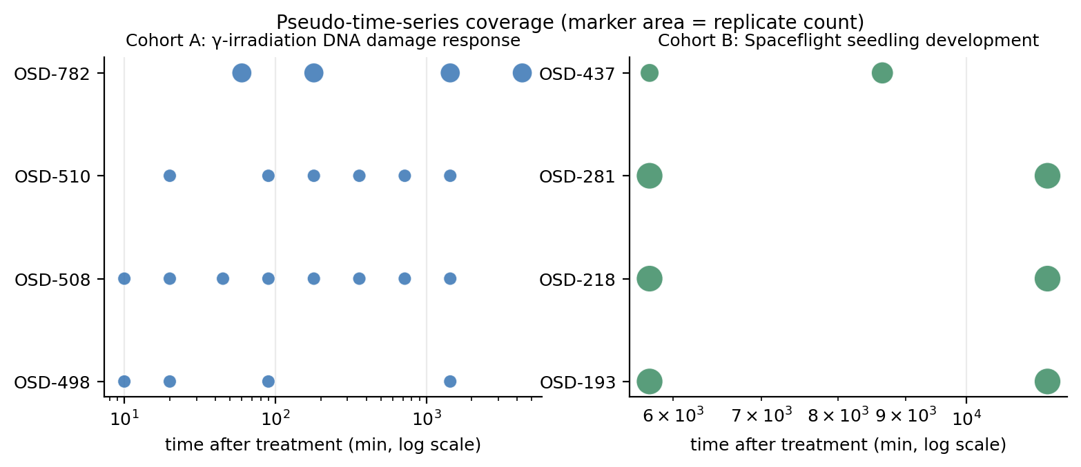
Pseudo-time-series coverage. Each marker is a timepoint measured by one accession; marker area is the replicate count. Cohort A’s accessions overlap at 7 timepoints, which is what allows a residual between-study offset to be fitted without extrapolation.

Batch harmonisation preserves the DNA-damage response and its genetic dependency
After within-study referencing and offset removal, all 6 canonical DNA-damage sentinel genes exceed 2-fold induction in the wild-type arm, tracing a clean rise–peak–decay kinetic: SMR7, for example, rises from $1.34$ at 10 min to a maximum of $7.62$ ($\log_{2}$) at 3 h before decaying to $4.42$ at 24 h.
In sog1-1 the same genes are flat, with only 4 reaching 2-fold and RAD51 falling from $5.95$ to $0.60$. The pipeline therefore recovers the central genetic finding of Bourbousse et al. (2018) — that the response is SOG1-dependent — before any regulatory model is fitted. This is the strongest available evidence that the cross-study assembly is measuring biology rather than batch structure, because no step in the harmonisation has access to genotype.
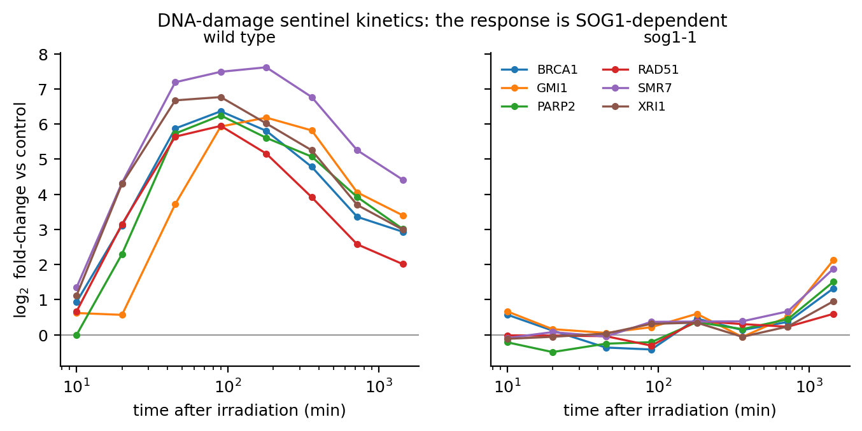
DNA-damage sentinel kinetics after cross-study harmonisation. All 6 sentinels exceed 2-fold induction in wild type and trace a rise–peak–decay curve; the same genes are flat in sog1-1. No step in the harmonisation has access to genotype.
The held-out OSD-782 arm shows no sentinel induction (maximum $|\log_{2}|=1.0$). This is the expected biology, not a failure: at 10–100 cGy the dose is two to three orders of magnitude below that of the core experiment, and the source study reports ethylene signalling rather than a canonical DNA-damage response. The sentinel gate is therefore enforced only on the wild-type primary arm.

The prior is incomplete in exactly the place that matters
The DAP-seq prior covers 478 TFs and 976,588 edges, but does not contain SOG1: DAP-seq never assayed it. A DREM model built on DAP-seq alone therefore cannot attribute any bifurcation to the master regulator of the response being modelled, and would do so silently. Calling SOG1 peaks from the same experiment’s ChIP-seq recovers 1,720 target genes and closes the gap. We report this because the failure mode generalises: a regulatory prior’s absences are invisible in its outputs, and any DREM analysis should check that the regulators its conclusions depend on are actually present in the prior.

Cell-type weighting
Deconvolution places the irradiation cohort predominantly in rosette and seedling clusters, consistent with whole-seedling material. 232,931 edges (24%) are atlas-informed and 16% change by more than $0.01$ under weighting. The auto-decoder’s 32-dimensional latent code moves monotonically away from the untreated state over pseudo-time (Figure 3).
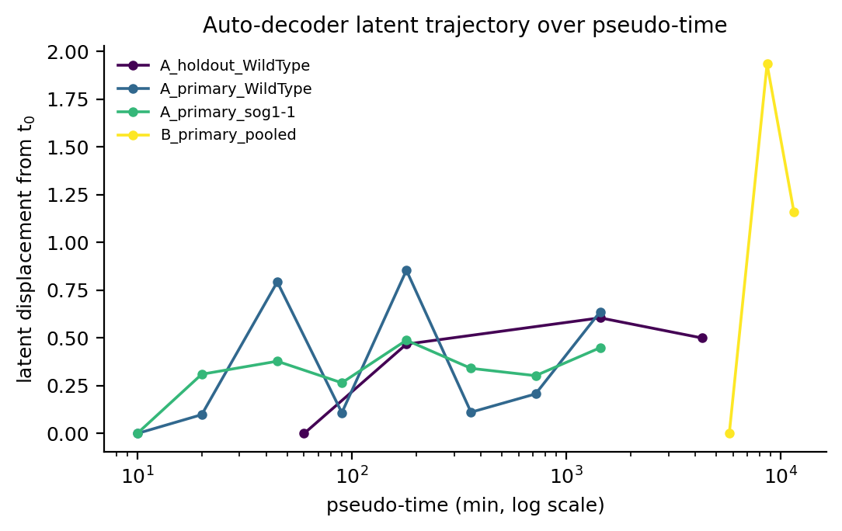
Displacement of the auto-decoder latent code from the earliest timepoint, per arm. One interpretable scalar summarising the 32-dimensional trajectory.
Across 6 bifurcations in the wild-type model, compared on the 2way test all three priors produced, 3 (50%) change their top-ranked TF between the flat, binding and cell-type-weighted priors.
The split is not random. The bifurcations whose attribution is stable across all three priors are the biologically canonical ones: two are attributed to SOG1 (AT1G25580) and one to MYB3R1 (AT4G32730) — the activator and repressor arms the source study identified. The bifurcations that move are the weaker ones, reassigned among MYB-related, WRKY, TCP, NAC and bZIP regulators (WRKY33, TCP15, ANAC071, bZIP3, MYB49). The prior therefore does not overturn well-supported attributions; it changes the calls that were marginal to begin with, which is the behaviour a prior ought to have.
The wild-type arm is the only one with enough resolved bifurcations to read an ablation from. The remaining three arms each resolved a single split shared by all three priors, so their apparent 100% change rate rests on one comparison and is reported in Figure 4 with its denominator rather than as a rate.
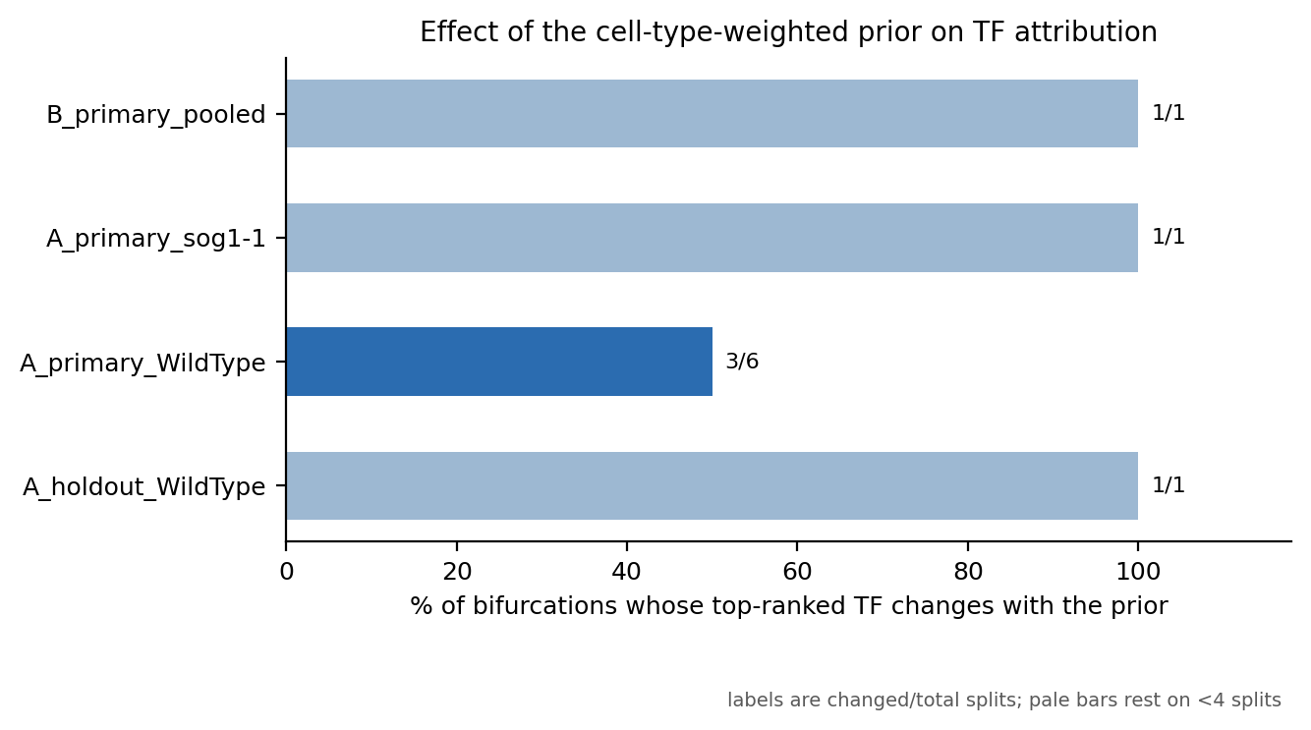
Proportion of bifurcations whose top-ranked transcription factor changes with the prior. Labels give changed/total splits; pale bars rest on fewer than four bifurcations and should not be read as rates.

The genotype contrast recovers the published regulatory logic
The cohort’s built-in positive control is decisive. Under all three priors, SOG1 ranks first of the 478 scored TFs in the wild-type model. In sog1-1 it collapses — to rank 404 under the flat prior and 574 under the cell-type-weighted prior (Table 1). MYB3R1 ranks 2 in wild type and is retained in the mutant, as expected for a repressor whose activity does not depend on SOG1.
This reproduces the regulatory logic Bourbousse et al. (2018) reported — SOG1 as the major activator, MYB3R as the major repressors — from an independently reconstructed pipeline, and it does so through the TF attribution rather than through expression alone. Note that the attribution is only possible because SOG1 edges were added from ChIP-seq: with the DAP-seq prior alone, SOG1 has no edges and could not have been ranked at all.
SOG1 rank among 478 scored transcription factors. Lower is more significant; the mutant is the negative control.
Prior | Wild type | sog1-1
flat | 1 | 404
weighted | 1 | 574

Independent corroboration from a different method
The sibling analysis in Plant_response_to_radiation models an overlapping set of OSDR studies with a Gaussian-process autoencoder and WGCNA co-expression modules, with no DREM and no TF attribution anywhere in it. Over the 314 genes both analyses modelled, 7 of 10 DREM nodes enrich one of the 3 WGCNA modules at Bonferroni-corrected $p<0.05$. The two methods share raw data but almost no methodology, so the agreement is external corroboration rather than a restatement.

Comparison with the published model
Bourbousse et al. (2018) reported 11 co-expressed gene groups from six timepoints of OSD-510. Our flat-prior wild-type model over the pooled, denser series yields 15 nodes across 7 splits from 1,410 assigned genes. These counts are not expected to be identical: the pooled series adds the 10 and 45 min timepoints and draws on three accessions rather than one, and DREM’s node count responds to both. The comparison is reported for calibration.
Cohort composition, measured from the OSDR metadata API.
Cohort | Studies | Timepoints | Span
A ($γ$-irradiation) | 5 | 10 | 10 min – 72 h
B (spaceflight) | 4 | 3 | 4 – 8 d

Discussion
We set out to make a single-cell atlas act on a DREM model rather than on its annotation. The mechanism turns out to require no change to the engine: DREM’s TF–gene input already accepts a score, and cell-type context is a legitimate thing to put there. That keeps the result citable as DREM rather than as a reimplementation, and it means the same lever is available to any DREM or iDREM user with a matching atlas.
Three findings are worth separating from the method.
First, provenance discipline changes what a “cross-study” claim means. The densest part of our irradiation series is one experiment deposited under three accessions. Assembling it is useful — it is how the 10 and 45 min timepoints join the 24-h course — but it is re-assembly, not integration, and describing it otherwise would overstate the result. Genuine cross-study integration here is OSD-782, and OSD-782 is where the design is weakest, because it crosses a dose regime.
Second, a regulatory prior’s gaps are invisible in its output. DAP-seq is the standard Arabidopsis binding resource and does not contain SOG1. A DREM model of the DNA-damage response built on it would have produced a complete, plausible, entirely SOG1-free attribution. Nothing in the model would have signalled the omission. We now check the presence of the regulators a conclusion depends on as a routine step, and we suggest others do the same.
Third, the atlas informs a minority of edges, and that is the correct behaviour rather than a shortfall. The signature matrix covers highly variable genes — the genes whose expression distinguishes cell types. A TF outside that set has a near-uniform profile across the 183 clusters, so cell-type context has nothing to say about it and its edge should be left alone. The lever moves exactly the edges where cell-type information exists.

Limitations
The single-nucleus atlas is developmental and unirradiated, so deconvolution assumes cell-type signatures are stable under $γ$-irradiation. The design cannot test that assumption, and it is an assumption, not a finding.
Replication is modest: two biological replicates per genotype–timepoint cell in OSD-508 and OSD-510.
Cohort B pools four ecotypes (Col-0, WS, Sku5, Sku6) across three timepoints, because splitting on ecotype would leave single-study arms of two timepoints each — too few for a bifurcation to be placed. Ecotype is therefore uncontrolled within that cohort.
SOG1 binding was called from bedGraph coverage with a binned enrichment test rather than from a dedicated peak caller, because GEO distributes coverage rather than called peaks for GSE112529. The dual-control requirement makes the calls conservative, but they are not equivalent to a MACS analysis of the raw reads.
Finally, the atlas signature matrix covers 4,000 highly variable genes. Regenerating per-cluster means across all genes would widen the lever’s reach; scripts/build_full_signatures.R does this for users with the atlas object and an R installation.

Data and code availability
All analysis code, harmonised metadata and derived tables are at https://github.com/dr-richard-barker/arabidopsis-drem-osdr and archived at Zenodo (TODO: DOI). Primary data are NASA OSDR studies OSD-193, 218, 281, 437, 498, 502, 508, 510 and 782 (NASA Open Science Data Repository 2026); DAP-seq binding from GEO GSE60143 (Gene Expression Omnibus GSE60143 2026; O’Malley et al. 2016); SOG1 ChIP-seq from GSE112529 (Gene Expression Omnibus GSE112529 2026; Bourbousse et al. 2018); the single-nucleus atlas from GSE226097 (Gene Expression Omnibus GSE226097 2026; Lee et al. 2023). DREM 2.0.7 is distributed by the Ernst laboratory under GPL-3.0 (DREM 2.0.7 Software Release 2026) and is downloaded, not redistributed, by this pipeline.
Berardini, Tanya Z., Leonore Reiser, Donghui Li, et al. 2015. “The Arabidopsis Information Resource: Making and Mining the ‘Gold Standard’ Annotated Reference Plant Genome.” Genesis 53 (8): 474–85. https://doi.org/10.1002/dvg.22877.
Bourbousse, Clara, Neeraja Vegesna, and Julie A. Law. 2018. “SOG1 Activator and MYB3R Repressors Regulate a Complex DNA Damage Network in Arabidopsis.” Proceedings of the National Academy of Sciences 115 (52). https://doi.org/10.1073/pnas.1810582115.
Brooks, Matthew D, Che-Lun Juang, Manpreet Singh Katari, et al. 2020. “ConnecTF: A Platform to Integrate Transcription Factor–Gene Interactions and Validate Regulatory Networks.” Plant Physiology 185 (1): 49–66. https://doi.org/10.1093/plphys/kiaa012.
Ding, Jun, James S. Hagood, Namasivayam Ambalavanan, Naftali Kaminski, and Ziv Bar-Joseph. 2018. “iDREM: Interactive Visualization of Dynamic Regulatory Networks.” PLOS Computational Biology 14 (3): e1006019. https://doi.org/10.1371/journal.pcbi.1006019.
DREM 2.0.7 Software Release. 2026. Https://github.com/jernst98/STEM_DREM; Ernst Lab.
Ernst, Jason, Oded Vainas, Christopher T Harbison, Itamar Simon, and Ziv Bar‐Joseph. 2007. “Reconstructing Dynamic Regulatory Maps.” Molecular Systems Biology 3 (1). https://doi.org/10.1038/msb4100115.
Gene Expression Omnibus GSE112529: SOG1-3xFLAG ChIP-Seq. 2026. Https://www.ncbi.nlm.nih.gov/geo/query/acc.cgi?acc=GSE112529; NCBI.
Gene Expression Omnibus GSE226097: Arabidopsis Single-Nucleus Atlas. 2026. Https://www.ncbi.nlm.nih.gov/geo/query/acc.cgi?acc=GSE226097; NCBI.
Gene Expression Omnibus GSE60143: Arabidopsis DAP-Seq. 2026. Https://www.ncbi.nlm.nih.gov/geo/query/acc.cgi?acc=GSE60143; NCBI.
Lee, Travis A., Tatsuya Nobori, Natanella Illouz-Eliaz, et al. 2023. A Single-Nucleus Atlas of Seed-to-Seed Development in Arabidopsis. bioRxiv. https://doi.org/10.1101/2023.03.23.533992.
NASA Open Science Data Repository. 2026. Https://osdr.nasa.gov/bio/repo/; NASA.
O’Malley, Ronan C., Shao-shan Carol Huang, Liang Song, et al. 2016. “Cistrome and Epicistrome Features Shape the Regulatory DNA Landscape.” Cell 165 (5): 1280–92. https://doi.org/10.1016/j.cell.2016.04.038.
Schulz, Marcel H, William E Devanny, Anthony Gitter, Shan Zhong, Jason Ernst, and Ziv Bar-Joseph. 2012. “DREM 2.0: Improved Reconstruction of Dynamic Regulatory Networks from Time-Series Expression Data.” BMC Systems Biology 6 (1): 104. https://doi.org/10.1186/1752-0509-6-104.
Yoshiyama, Kaoru, Phillip A. Conklin, Neil D. Huefner, and Anne B. Britt. 2009. “Suppressor of Gamma Response 1 ( SOG1 ) Encodes a Putative Transcription Factor Governing Multiple Responses to DNA Damage.” Proceedings of the National Academy of Sciences 106 (31): 12843–48. https://doi.org/10.1073/pnas.0810304106.

Center of Space Exploration (CoSE). Correspondence: dr.richard.barker@gmail.com

