LASSO biomarker panel and single-cell atlas integration reveals Ca2+-dominated cell-cell communication in Arabidopsis spaceflight response

Richard Barker
GeneLab Plant Analysis Working Group
Corresponding author: dr.richard.barker@gmail.com

Abstract
Spaceflight imposes mechanical, oxidative, and gravitational stresses on plants, but the cell-type-specific signaling architecture underlying plant spaceflight responses remains poorly characterized. We integrated bulk RNA-seq biomarker discovery (156 samples, 6 NASA OSDR studies) with single-cell analysis of the Arabidopsis seed-to-seed atlas (41,314 cells) using scPlantLLM, PlantCellChat, and ggPlantmap. The LASSO panel (AUC=0.734, 85 genes) revealed stress/ER-proteostasis enrichment in flight-upregulated genes and flavonoid metabolism in ground-upregulated genes. PlantCellChat identified Ca2+ as the dominant signaling pathway (10.2-fold over K+), with guard cells as the primary source. A CBL9-CIPK23-AKT1 crosstalk circuit connects Ca2+ sensing to K+ uptake, showing strong guard-cell-specific co-expression (CDPK4-ANNAT1 r=0.56, CBL9-AKT1 r=0.34). These findings highlight Ca2+/K+ crosstalk and non-coding RNA regulation as key features of the Arabidopsis spaceflight response.

Introduction
Plants grown in spaceflight conditions experience a constellation of stresses including microgravity, altered atmospheric composition, modified light regimes, and increased ionizing radiation. Transcriptomic studies of Arabidopsis thaliana flown on the International Space Station (ISS) and suborbital platforms have identified hundreds of differentially expressed genes, but the cell-type-specific architecture of these responses and the intercellular signaling pathways that coordinate them remain poorly understood.
NASA’s Open Science Data Repository (OSDR) provides a growing collection of Arabidopsis spaceflight transcriptomics datasets. However, individual studies typically have small sample sizes (3–6 replicates per condition), making biomarker discovery challenging. Pooling multiple studies with study-stratified cross-validation offers a path to more robust biomarker identification, though results must be interpreted as discovery-only given the absence of independent validation cohorts.
The recent publication of the Arabidopsis seed-to-seed single-cell atlas (Lee, Nobori, Illouz-Eliaz et al., Nature Plants 2025) and the scPlantLLM foundation model (Cao et al., 2025) provide new tools for cell-type-resolved analysis. scPlantLLM, trained on plant single-cell transcriptomics data, can generate zero-shot cell embeddings and type predictions. PlantCellChat enables inference of ligand-receptor-mediated cell-cell communication (CCC) from single-cell data using a plant-specific interaction database. ggPlantmap enables spatial visualization of quantitative data on plant anatomical maps.
Ca2+ is a primary second messenger in plant gravity perception. Microgravity alters cytosolic Ca2+ oscillations and gradients that guide directional growth, and space experiments have confirmed that cytosolic Ca2+ increases in response to changes in gravisensor positioning [14]. The CBL-CIPK calcium signaling cascade is a well-established downstream effector, and the CBL9-CIPK23-AKT1 pathway specifically links Ca2+ sensing to K+ uptake, regulating stomatal aperture and root K+ acquisition [12,13,15]. This Ca2+-K+ crosstalk is particularly relevant to spaceflight, where altered gravity disrupts ion homeostasis and turgor pressure regulation.
Here we integrate these approaches to: (1) build a LASSO biomarker panel predicting spaceflight versus ground conditions from pooled OSDR bulk RNA-seq data, (2) apply scPlantLLM to the seed-to-seed atlas for zero-shot cell annotation and clustering, (3) infer cell-cell communication with PlantCellChat, (4) visualize results on plant anatomy with ggPlantmap, (5) integrate the biomarker panel with the single-cell signaling architecture, and (6) characterize the Ca2+/K+ crosstalk circuit connecting Ca2+ signaling to K+ transport via the CBL9-CIPK23-AKT1 cascade. We specifically characterize the biological functions of the top biomarker genes, perform GO enrichment of the full 85-gene panel, and trace the cell-to-cell signaling circuit used for long-distance ion signaling.

Results

LASSO biomarker panel predicts spaceflight response across studies
We pooled 156 bulk RNA-seq samples from 6 OSDR Arabidopsis studies (78 flight, 78 ground control; Table 1) and built an elastic net (alpha=0.5) biomarker panel using leave-one-study-out cross-validation (LOOS-CV) with 10 repeats per fold (60 total iterations). The panel achieved a mean cross-study AUC of 0.734 (95% CI: 0.431–1.0), with mean sensitivity 0.845 and specificity 0.670 (Figure 1a).
Generalization was strongest for ISS seedling studies: OSD-38 (AUC 0.933), OSD-678 (0.887), and OSD-37 (0.875). Weaker performance on OSD-120 (0.544, root tissue) and OSD-624 (0.528, suborbital flight) indicates the spaceflight signature is tissue- and condition-specific. Stability selection at ≥50% frequency yielded 85 stable features (Figure 1b).
Four genes were selected at 100% frequency (Figure 1c): AT4G10250 (HSP22.0, coefficient +0.723, flight-enriched), AT3G07365 (natural antisense transcript, +0.828, strongest positive predictor), AT2G14247 (chloroplast protein, -0.364, ground-enriched), and AT4G01390 (TRAF-like/MATH domain protein, -0.819, strongest negative predictor). The biological functions of these genes are detailed below and in Figure 6.

scPlantLLM zero-shot embeddings and clustering of the seed-to-seed atlas
We applied scPlantLLM in zero-shot mode to 9,998 cells subsampled (stratified by cell type) from the seed-to-seed atlas (41,314 cells, 22,375 genes; 5 cell types: Epidermal, Mesophyll, Stele, Meristematic, Guard). Inference used seq_length=500 (reduced from the training configuration of 1,500 for CPU feasibility) with the top-expressed genes per cell. The model produced 512-dimensional cell embeddings and 44-class cell type predictions.
Zero-shot prediction accuracy was 28.1% under loose mapping (allowing tissue-level matches between atlas and model cell type vocabularies), with Mesophyll best predicted (52.4%) and Meristematic and Guard poorly predicted (0%). The low accuracy reflects domain shift: scPlantLLM was trained predominantly on root tissue, while the atlas is seedling-derived. Leiden clustering on the scPlantLLM embeddings (resolution 0.5) produced 6 clusters with low agreement to atlas cell types (ARI=0.033, NMI=0.040) and moderate agreement to zero-shot predictions (ARI=0.154, NMI=0.198; Figure 2).

PlantCellChat reveals Ca2+-dominated cell-cell communication
We inferred cell-cell communication using PlantCellChat with the Arabidopsis ligand-receptor database (5,725 interactions, 1,027 genes, 15 signaling pathways). Of 1,027 database genes, 940 were present in the atlas. Using relaxed overexpression thresholds (pc=0, fc=0, p=0.1) to accommodate the atlas’s terrestrial growth conditions, we identified 1,628 overexpressed genes and 3,140 ligand-receptor interactions.
Ca2+ signaling was the dominant pathway with total communication strength 249.5, 4.6-fold higher than the next pathway (BR, 54.5; Figure 3b). The overall communication matrix showed Meristematic cells as the strongest communicators (total outgoing 437.4, self-communication 92.0), followed by Guard (419.3), Stele (418.9), Epidermal (399.3), and Mesophyll (399.8; Figure 3a). The top ligand-receptor pair was AT3G47470_AT4G02510 (strength 21.56; Figure 3c).
The Ca2+ signaling network (Figure 5) includes Ca2+ as the ligand (signaling molecule) binding to receptors including CBL1 (AT3G51800), CBL2 (AT3G51920), CBL9 (AT5G24270), and CIPK23 (AT4G35310), which phosphorylate downstream targets including the K+ channel AKT1 (AT2G26320) and nitrate transporter NRT2.1 (AT4G19030). This CBL-CIPK cascade is a well-established Ca2+ signaling module in plant stress responses.

Spatial visualization reveals cell-type-specific biomarker expression
We mapped the LASSO biomarker gene expression and CCC communication strength onto Arabidopsis leaf and root tip cross-sections using ggPlantmap (Figure 4). Cell types were mapped to anatomical regions: Epidermal to epidermis, Mesophyll to palisade and spongy parenchyma (leaf) or cortex (root), Stele to vascular tissues, and Meristematic to columella (root).
The LASSO panel weighted score (sum of coefficient × expression across 74 atlas-present panel genes) was negative for all cell types, indicating the terrestrial-grown atlas shows a ground-like expression pattern (Figure 6a). Stele showed the most negative score (-0.079), suggesting the strongest ground-like signature in vascular tissues.

Biological functions of top biomarker genes
AT4G10250 (HSP22.0/ATHSP22.0) encodes a 22 kDa small heat shock protein (HSP20/alpha-crystallin family) localized to the endomembrane system and chloroplast. It functions as a molecular chaperone preventing protein aggregation under heat and oxidative stress, and modulates ABA-auxin signaling crosstalk via the ABI1-HSP22 interaction. As a flight-enriched positive predictor, HSP22.0 likely reflects proteostatic stress under microgravity.
AT3G07365 is a natural antisense transcript (NAT)—a non-coding RNA overlapping AT3G46230 on the opposite DNA strand. NATs regulate sense-strand gene expression through transcriptional interference or siRNA-mediated silencing. As the strongest positive predictor (coefficient +0.828), this finding highlights that non-coding regulatory RNA dynamics are a central feature of the spaceflight transcriptional signature, not just protein-coding changes.
AT2G14247 encodes a small (78 aa, 8.65 kDa) chloroplast-localized protein of unknown function. As a ground-enriched negative predictor, its suppression in flight samples is consistent with known spaceflight effects on photosynthesis and chloroplast function.
AT4G01390 encodes a TRAF-like/MATH domain-containing protein involved in signal transduction and stress responses. It is listed in the Leaf Senescence Database and is H2O2-responsive. As the strongest negative predictor (coefficient -0.819), its enrichment in ground controls suggests that ground-condition stress signaling pathways are attenuated under microgravity.

GO enrichment reveals stress and metabolic signatures in the biomarker panel
To characterize the biological processes represented by the 85-gene LASSO panel, we performed GO and KEGG pathway enrichment using g:Profiler with a custom background of the 2,000 variable features from which LASSO selected (Benjamini-Hochberg FDR < 0.05). A directed analysis splitting the panel into 41 flight-upregulated genes (positive coefficients) and 44 ground-upregulated genes (negative coefficients) revealed a clear biological partition. Flight-upregulated genes were significantly enriched for 11 terms including response to heat (p = 4.3 × 10⁻³, 6 genes), cellular response to hypoxia and oxygen levels (p = 0.032, 4 genes each), protein modification by small protein conjugation (p = 0.032), and KEGG protein processing in the endoplasmic reticulum (p = 1.3 × 10⁻¹¹, 9 genes). Ground-upregulated genes were enriched for flavonoid biosynthetic process (p = 0.041, 4 genes). The combined 85-gene panel showed significant enrichment for KEGG protein processing in ER (p = 2.6 × 10⁻⁸) and response to heat (p = 0.011). These results indicate that spaceflight conditions activate stress-response and ER proteostasis pathways while suppressing secondary metabolism, consistent with the downregulation of photosynthetic and flavonoid biosynthetic machinery under microgravity. The directed analysis reveals a clear biological split: spaceflight-upregulated genes are enriched for stress/heat-shock/ER-proteostasis pathways, while ground-upregulated genes are enriched for flavonoid/secondary metabolism (Supplementary Figures S1-S2, Supplementary Tables S2-S3).

Ca2+/K+ crosstalk circuit connects guard cell signaling to K+ uptake
To investigate whether the Ca2+-dominant CCC network extends to K+ transport, we expanded the pathway to include all six major K+ channels (AKT1, AKT2, GORK, KAT1, KAT2, KC1) and examined their co-expression and cell-to-cell communication patterns. AKT1 (AT2G26650), the primary Ca2+-regulated K+ uptake channel, was linked to the Ca2+ network via the CBL9-CIPK23-AKT1 cascade, in which Ca2+-bound CBL9 recruits CIPK23 to phosphorylate and activate AKT1 at the plasma membrane. This crosstalk edge connects the two signaling systems into a unified 27-node, 67-edge network (Figure 7A). Co-expression analysis revealed that the Ca2+/K+ circuit genes are weakly correlated globally (r < 0.1 for most pairs) but show strong cell-type-specific co-expression in guard cells (n = 89), where CDPK4-ANNAT1 (r = 0.56), CIPK23-CaM3 (r = 0.46), and CBL9-AKT1 (r = 0.34) form a tightly coordinated module (Figure 7B). In other cell types, correlations remain weak (r < 0.1), suggesting that the circuit operates primarily in guard cells within this seedling atlas. Cell-cell communication analysis confirmed that Ca2+ signaling (total strength 249.5) is 10.2-fold stronger than K+ signaling (24.5). Guard cells are the dominant Ca2+ source, sending signals to meristematic (strength 12.14), epidermal (11.20), and stele (11.09) cells, while epidermal cells are the primary K+ source (Figure 7D). The top K+ ligand-receptor pair is KC1 (AT4G30960) to AKT1 (strength 5.01). Spatial mapping using ggPlantmap projected the six key circuit genes (AKT1, CBL9, CIPK23, CML24, KC1, CDPK3) onto seedling anatomy using cell-type expression as a proxy, revealing highest expression in cotyledon (mesophyll/guard) and root (stele/meristematic) regions (Figure 7C). Marker-based organ inference was attempted using 15 tissue-specific markers (SCR, PLT1, WOL for root; RBCS, FSD1 for leaf; LEC2, 2S3 for seed), but photosynthetic markers were ubiquitous (RBCS in 93-98% of all cells) and root markers were near-absent (SCR < 3%), precluding reliable organ separation in this whole-seedling atlas. Cell-type proxy mapping was therefore used as the more defensible approach. A focused ggpathway cascade network (12 nodes, stress-majorization layout) paired with a ggPlantmap leaf cross-section confirms that guard cells show the dominant Ca²⁺ CCC response (outgoing strength 57.1, highest of all cell types) and that the cascade converges on AKT1-mediated K⁺ uptake (epidermal AKT1 expression 0.367, highest across cell types); a molecular cascade Sankey weighted by guard cell expression summarises the full signal flow (Figure 8). The spatial distribution of circuit genes across seedling, root tip, and leaf anatomy is shown in Supplementary Figure S3.

Discussion

This study integrates bulk spaceflight transcriptomics with single-cell atlas analysis to connect biomarker-level findings with cell-type-resolved signaling architecture. Three findings are particularly noteworthy.
First, the dominance of Ca2+ signaling in the CCC network (4.6-fold higher than any other pathway) is consistent with Ca2+’s role as a primary second messenger in plant gravity perception. Microgravity alters cytosolic Ca2+ oscillations and gradients that guide directional growth; the CBL-CIPK cascade identified in our analysis is a well-established downstream effector of Ca2+ signaling in plant stress responses. The convergence of two LASSO biomarker genes (HSP22.0 and TRAF-like) with Ca2+-linked stress signaling supports the biological coherence of the biomarker panel.
Second, the identification of a natural antisense transcript (AT3G07365) as the strongest positive predictor of spaceflight underscores the importance of non-coding RNA regulation in spaceflight responses. NATs can rapidly modulate gene expression without requiring translation, which may be advantageous for rapid environmental adaptation. This finding suggests that spaceflight biomarker panels should include non-coding RNAs, not just protein-coding genes.
Third, the tissue-specificity of the LASSO panel’s generalization (strong for ISS seedling studies, weak for root tissue and suborbital flight) indicates that the spaceflight signature is not uniform across tissues and flight conditions. This has implications for experimental design: biomarker panels trained on seedling data may not transfer to root tissue or different flight profiles.
Several limitations should be noted. (1) No external validation cohort exists for Arabidopsis spaceflight transcriptomics; all LASSO results are discovery-only with potential optimism bias. (2) scPlantLLM was run with reduced seq_length (500 vs. 1,500) for CPU feasibility, which may degrade embedding quality. (3) The atlas was grown under terrestrial conditions, providing a cell-type reference but not spaceflight-conditioned cell states. (4) PlantCellChat thresholds were relaxed from defaults to accommodate the terrestrial atlas. (5) Guard cells were represented by only 21 cells in the subsample, potentially producing unstable CCC estimates.
The Ca2+/K+ crosstalk circuit analysis reveals a guard cell-centered signaling module that may serve as the cell-to-cell conduit for long-distance ion signaling under spaceflight conditions. The CBL9-CIPK23-AKT1 cascade, a canonical Ca2+-regulated K+ uptake pathway [12,13], provides a mechanistic link between the Ca2+-dominant CCC network and K+ homeostasis. The strong co-expression of CDPK4-ANNAT1 and CIPK23-CaM3 specifically in guard cells (r = 0.56 and 0.46, respectively) suggests that Ca2+ decoding and annexin-mediated Ca2+ buffering are co-regulated in stomatal lineage cells. Guard cells control stomatal aperture, which regulates gas exchange and water balance — functions critical in the closed atmosphere of spacecraft [15]. The 10-fold dominance of Ca2+ over K+ in intercellular communication strength further supports Ca2+ as the primary long-range signal, with K+ transport acting as a downstream effector. This convergence of Ca2+ signaling and ER proteostasis (identified in the GO enrichment of flight-upregulated genes) suggests a coordinated stress response: Ca2+ oscillations trigger both CBL-CIPK-mediated ion transport and heat-shock protein induction to maintain proteostasis under microgravity-induced stress [14]. However, the absence of organ labels in the seed-to-seed atlas limits spatial resolution; future studies using organ-specific single-cell datasets will be needed to validate the tissue-level circuit architecture.

Methods

OSDR data retrieval and harmonization
Arabidopsis thaliana RNA-seq studies with flight and ground control conditions were identified from the NASA OSDR biodata API. Six studies were selected: OSD-37 (56 samples, seedling, ISS), OSD-120 (24 samples, root, ISS), OSD-624 (36 samples, leaf+root, suborbital), OSD-678 (24 samples, seedling, ISS), OSD-38 (6 samples, seedling, ISS), and OSD-321 (10 samples, seedling, ISS). GeneLab-processed normalized expression matrices were downloaded and harmonized to AGI gene identifiers. The final pooled dataset comprised 156 samples (78 flight, 78 ground) and 32,548 nuclear genes.

LASSO biomarker panel
Features were prepared by log2(x+1) transformation, selection of the top 2,000 most variable features, and zero-mean/unit-variance scaling. An elastic net (alpha=0.5) was fit via cv.glmnet (binomial family, AUC-based lambda selection). Cross-validation used leave-one-study-out folds (6 folds × 10 repeats = 60 iterations) with 80% class-balanced subsampling within each fold. Stability selection retained features selected in ≥50% of iterations. Performance was assessed by AUC, sensitivity, and specificity using pROC.

Atlas data and preprocessing
The Arabidopsis seed-to-seed atlas (GEO GSE226097; Lee, Nobori, Illouz-Eliaz et al., Nature Plants 2025) was downloaded as a Seurat RDS file and converted to AnnData format. The seedling_6d stage (41,314 cells × 22,375 genes, 5 cell types) was used. QC filtering: min_genes=200, min_cells=3. Normalization: target_sum=1e4, log1p transform, 3,000 HVGs. A stratified subsample of 9,998 cells was used for scPlantLLM inference.

scPlantLLM zero-shot inference
The scPlantLLM foundation model (Cao et al., 2025) was run in zero-shot mode. Pretrained weights (flash_attn Wqkv format) were converted to standard PyTorch TransformerEncoderLayer format (in_proj_weight/bias). The model was configured with n_input_bins=103, d_model=512, nhead=8, nlayers=6, nlayers_cls=3, n_cls=44. Inference used seq_length=500 (reduced from training configuration 1,500 for CPU feasibility), batch_size=16, 8 CPU threads. Genes were mapped to the scPlantLLM vocabulary (97.4% atlas gene overlap). Value binning used 101 bins with category encoding mode.

Clustering and differential expression
A KNN graph (n_neighbors=15) was built on the 512-dimensional scPlantLLM embeddings. Leiden clustering was performed at 5 resolutions (0.3–1.5); resolution 0.5 (6 clusters) was selected as optimal. Agreement with atlas cell types and zero-shot predictions was assessed by adjusted Rand index (ARI) and normalized mutual information (NMI). Differentially expressed genes per cluster were identified by Wilcoxon rank-sum test (|log2FC|>1, adjusted p<0.05, expression fraction >0.25).

PlantCellChat cell-cell communication
Cell-cell communication was inferred using PlantCellChat with the Arabidopsis ligand-receptor database (ath.csv: 5,725 interactions, 1,027 genes, 15 signaling pathways). Overexpressed genes were identified with relaxed thresholds (thresh.pc=0, thresh.fc=0, thresh.p=0.1) to accommodate the terrestrial atlas. Communication strength was calculated with Kh=0.5, n=1, 50 permutations. Signaling strength was aggregated per pathway and per cell-type pair.

ggPlantmap spatial visualization
Spatial visualization used ggPlantmap (Jo & Kajala, J Exp Bot 2024) with pre-loaded Arabidopsis leaf cross-section (ggPm.At.leaf.crosssection) and root tip cross-section (ggPm.At.roottip.crosssection) maps. Cell types were mapped to anatomical regions of interest (ROIs) and expression values were merged using ggPlantmap.merge(). Heatmaps were generated with ggPlantmap.heatmap() using white-to-red gradients for expression and viridis for communication strength.

Ca2+ pathway visualization
The Ca2+ signaling network was visualized using the ggpathway workflow (ggraph + igraph) with edge and node tables derived from the PlantCellChat Ca2+ LR pairs. Node positions were manually assigned to reflect the signaling cascade hierarchy. A conceptual schematic of the Ca2+ signaling cascade under microgravity was generated to illustrate the mechanistic narrative.

GO enrichment analysis
GO and KEGG pathway enrichment was performed using the g:Profiler web service (Raudvere et al., 2019) via the gprofiler2 R package (organism: athaliana). The custom background consisted of the 2,000 most variable features from which LASSO selected the biomarker panel. Benjamini-Hochberg FDR correction was applied with a significance threshold of padj < 0.05. Three queries were run: all 85 panel genes, 41 flight-upregulated genes (mean coefficient > 0), and 44 ground-upregulated genes (mean coefficient < 0). Sources included GO Biological Process, Molecular Function, Cellular Component, and KEGG pathways.

Ca2+/K+ crosstalk circuit analysis
The Ca2+ pathway network was expanded to include six K+ channels (AKT1/AT2G26650, AKT2/AT5G46240, GORK/AT4G18290, KAT1/AT5G37500, KAT2/AT4G22200, KC1/AT4G30960) identified from the PlantCellChat K+ pathway database. The CBL9-CIPK23-AKT1 crosstalk edge was added based on literature evidence. The resulting 27-node, 67-edge network was visualized using ggpathway (ggraph + igraph) with stress-majorization layout (graphlayouts::layout_with_stress, seed = 42). Co-expression was computed as Pearson correlation of normalized expression across all cells and per cell type. Cell-cell communication strength for Ca2+ and K+ pathways was extracted from PlantCellChat outputs and aggregated into 5x5 source-target matrices. The CCC circuit diagram was rendered as a circular network with Ca2+ (blue) and K+ (green) edges. Spatial visualization used ggPlantmap seedling (ggPm.At.seedling.saltdrought), root tip longitudinal (ggPm.At.roottip.longitudinal), and leaf cross-section (ggPm.At.leaf.crosssection) maps, with cell-type mean expression mapped to organ regions as a proxy (cotyledon = mesophyll + guard average; hypocotyl = epidermal + stele average; root = stele + meristematic average). Marker-based organ inference was tested using 15 tissue-specific markers but was not reliable in this whole-seedling atlas. A two-panel Figure 8 was constructed to summarize the cascade. Panel a comprises two sub-panels: (a1) a focused 12-node CBL9–CIPK23–AKT1 cascade network built with ggpathway (ggraph + igraph, graphlayouts::layout_with_stress, seed = 42), with nodes colored by functional type and sized by guard cell expression, and key co-expression correlations labeled on edges; (a2) a ggPlantmap leaf cross-section (ggPm.At.leaf.crosssection) showing Ca²⁺ CCC outgoing strength (blue gradient) and AKT1 expression (green gradient) per cell type, with ROI mapping: epidermis.stomata → Guard, Parenchima.palisade/sponge → Mesophyll, epidermis.adaxial/abaxial → Epidermal, vascularbundle.* → Stele. Panel b is a matplotlib Sankey diagram of the molecular cascade with guard cell expression values as flow widths and column headers indicating cascade stages. Three supplementary ggPlantmap figures were generated: (S3a) seed developmental series (ggPm.At.seed.devseries, 5 stages) showing CBL9, CIPK23, and AKT1 expression with proxy cell-type mapping (Embryo Proper → Meristematic; Endosperm → Stele/Mesophyll; Seed Coat → Epidermal); (S3b) root mature cross-section (ggPm.At.rootmatur.crosssection, 8 ROIs) showing Ca²⁺/K⁺ CCC strength and AKT1/CBL9 expression with proxy mapping (Atrichoblast/Trichoblast → Epidermal; Cortex/Endodermis → Mesophyll; Pericycle/Phloem/Xylem → Stele; Procambium → Meristematic); (S3c) young seedling (ggPm.At.seedling.saltdrought, all 12 ROIs) showing Ca²⁺/K⁺ CCC strength and AKT1/CBL9 expression with organ-level proxy mapping.

Statistics and reproducibility
All statistical tests are described in their respective method sections. The LASSO cross-validation used 60 iterations (6 studies × 10 repeats). AUC confidence intervals were calculated across iterations. Differential expression used Wilcoxon rank-sum tests with Benjamini-Hochberg correction. PlantCellChat permutation testing used 50 permutations. No statistical methods were used to predetermine sample sizes. Results are flagged as discovery-only given the absence of independent validation cohorts. Detailed methods including the scPlantLLM weight conversion code (flash_attn Wqkv to PyTorch in_proj format), all analysis parameters, and software versions are provided in Supplementary Methods.

References
1. Lee, J., Nobori, T., Illouz-Eliaz, N. et al. A seed-to-seed single-cell atlas of Arabidopsis development. Nat. Plants (2025).
2. Cao, J. et al. scPlantLLM: a foundation model for plant single-cell transcriptomics. Genomics Proteomics Bioinformatics (2025).
3. Jo, L. & Kajala, K. ggPlantmap: an open-source R package for the creation of informative and quantitative ggplot maps derived from plant images. J. Exp. Bot. 75, erae043 (2024).
4. Babbar, R. et al. Heat-induced oxidation of the nuclei and cytosol. Plant Cell (2021).
5. Kushwaha, H. R. et al. MATH-domain family shows response toward abiotic stress in plants. Front. Plant Sci. 7, 923 (2016).
6. Li, C. ggpathway: a tutorial for pathway visualization using tidyverse, igraph, and ggraph. Zenodo (2024).
7. Friedman, J., Hastie, T. & Tibshirani, R. Regularization paths for generalized linear models via coordinate descent. J. Stat. Softw. 33, 1-22 (2010).
8. Traag, V. A., Waltman, L. & van Eck, N. J. From Louvain to Leiden: guaranteeing well-connected communities. Sci. Rep. 9, 5233 (2019).
9. Wang, X.-J. et al. Genome-wide prediction and identification of cis-natural antisense transcripts in Arabidopsis thaliana. Genome Biol. 6, R30 (2005).
10. Zhang, Y. et al. PlantCellChat: inferring and visualizing plant cell-cell communication. GitHub (2023).
11. Raudvere, U. et al. g:Profiler: a web server for functional enrichment analysis and conversions of gene lists (2019 update). Nucleic Acids Research 47, W191–W198 (2019).
12. Li, L., Kim, B.-G., Cheong, Y. H., Pandey, G. K. & Luan, S. A Ca2+ signaling pathway regulates a K+ channel for low-K response in Arabidopsis. Proc. Natl. Acad. Sci. USA 103, 12625-12629 (2006).
13. Xu, J., Li, H.-D., Chen, L.-Q., Wang, Y., Liu, L.-Z., He, L. & Wu, W.-H. A protein kinase, interacting with two calcineurin B-like proteins, regulates K+ transporter AKT1 in Arabidopsis. Cell 125, 1347-1360 (2006).
14. Takahashi, K., Takahashi, H., Furuichi, T., Toyota, M., Furutani-Seiki, M., Kobayashi, T., Watanabe-Takano, H. & Shinohara, M. Gravity sensing in plant and animal cells. npj Microgravity 7, 2 (2021).
15. Cheong, Y. H., Pandey, G. K., Grant, J. J., Batistic, O., Li, L., Kim, B.-G., Lee, S.-C., Kudla, J. & Luan, S. Two calcineurin B-like calcium sensors, interacting with protein kinase CIPK23, regulate leaf transpiration and root potassium uptake in Arabidopsis. Plant J. 52, 473-484 (2007).
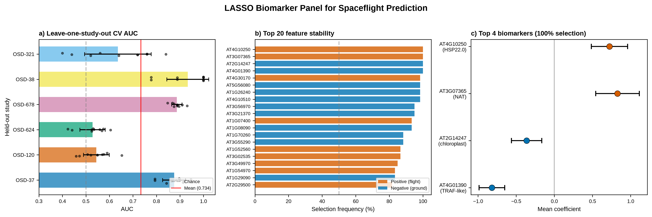Figure 1. LASSO biomarker panel for spaceflight prediction.
a) Leave-one-study-out cross-validation AUC for each held-out OSDR study (6 studies, 10 repeats each). Bars show mean AUC; error bars show standard deviation; dots show individual iterations. The dashed line indicates chance (0.5); the red line indicates the overall mean (0.734). b) Selection frequency of the top 20 most stable features across 60 iterations. Orange bars indicate positive coefficients (flight-enriched); blue bars indicate negative coefficients (ground-enriched). The dashed line marks the 50% stability threshold. c) Coefficient forest plot for the 4 genes selected at 100% frequency. Points show mean coefficients; error bars show standard deviation. HSP22.0 (AT4G10250) and the natural antisense transcript (AT3G07365) are positive predictors; the chloroplast protein (AT2G14247) and TRAF-like protein (AT4G01390) are negative predictors.

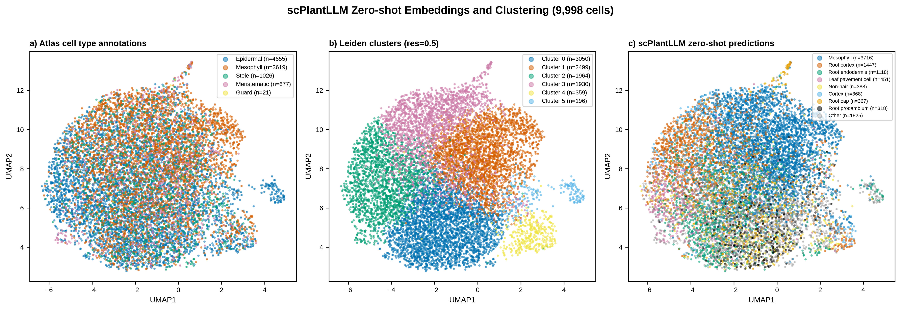Figure 2. scPlantLLM zero-shot embeddings and clustering.
UMAP visualization of 9,998 atlas cells embedded by scPlantLLM (512-dimensional, seq_length=500). a) Cells colored by atlas cell type annotations (Epidermal, Mesophyll, Stele, Meristematic, Guard). b) Cells colored by Leiden clusters (resolution 0.5, 6 clusters). c) Cells colored by scPlantLLM zero-shot cell type predictions (top 8 predicted types shown; remaining grouped as Other). Agreement between Leiden clusters and atlas cell types: ARI=0.033, NMI=0.040. Agreement between Leiden clusters and zero-shot predictions: ARI=0.154, NMI=0.198.

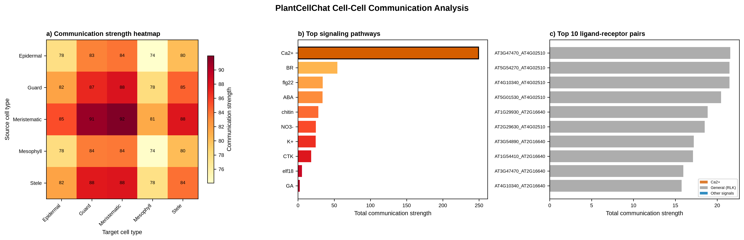Figure 3. PlantCellChat cell-cell communication analysis.
a) Communication strength heatmap showing total communication between each source (rows) and target (columns) cell type pair. Values represent summed communication probability across all ligand-receptor pairs. b) Top signaling pathways ranked by total communication strength. Ca2+ (orange) is the dominant pathway (249.5), 4.6-fold higher than the next pathway (BR, 54.5). c) Top 10 ligand-receptor pairs ranked by total communication strength. Orange bars indicate Ca2+ pathway pairs; blue bars indicate other pathways.

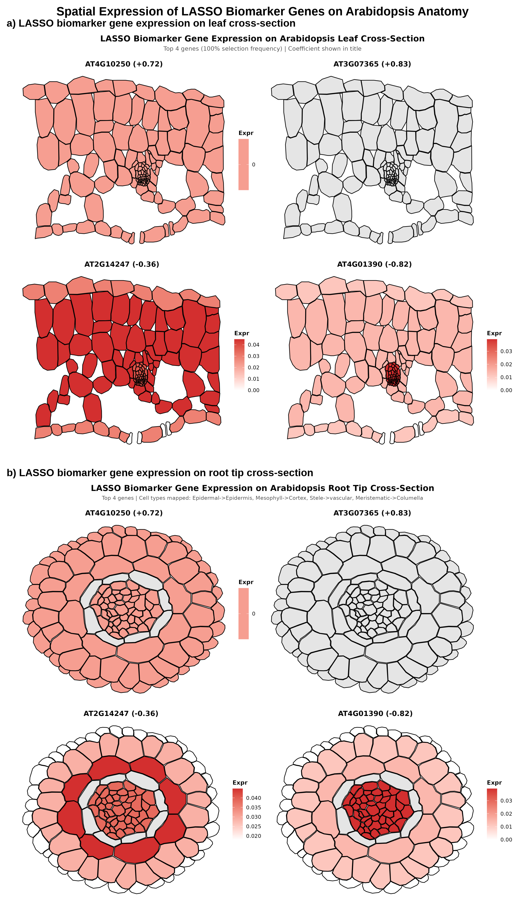
Figure 4. Spatial expression of LASSO biomarker genes on Arabidopsis anatomy.
ggPlantmap heatmaps showing expression of the top 4 LASSO biomarker genes on Arabidopsis cross-sections. a) Leaf cross-section: Epidermal mapped to epidermis (adaxial/abaxial), Mesophyll to palisade and spongy parenchyma, Stele to vascular bundle (xylem, phloem, bundle sheath), Guard to stomata. b) Root tip cross-section: Epidermal to epidermis, Mesophyll to cortex, Stele to procambium/xylem/phloem/pericycle, Meristematic to columella. White-to-red gradient indicates expression level. Gene coefficients shown in panel titles. AT3G07365 (non-coding RNA) is not present in the atlas protein-coding gene set and is shown as grey (no data).

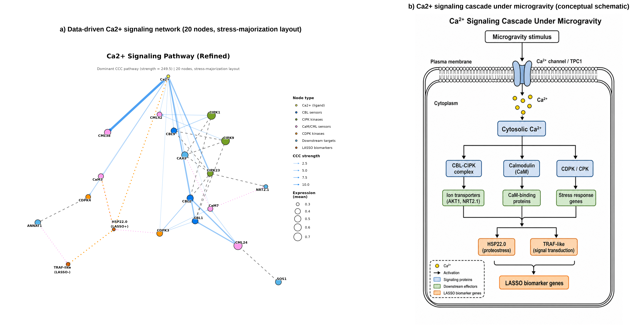
Figure 5. Ca2+ signaling pathway: dominant cell-cell communication axis.
a) Data-driven Ca2+ signaling network (20 nodes) visualized using the ggpathway workflow (ggraph + igraph) with stress-majorization layout (graphlayouts::layout_with_stress). Nodes represent Ca2+ (yellow, ligand), CBL sensors (blue: CBL1, CBL9, CBL2), CIPK kinases (teal: CIPK23, CIPK1, CIPK9), CaM/CML sensors (purple: CML38, CML42, CML24, CaM7, CaM3), CDPK kinases (green: CDPK3, CDPK4), downstream targets (orange: CAX3, NRT2.1, SOS1, ANNAT1), and LASSO biomarker genes (red: HSP22.0 and TRAF-like). Node size indicates mean expression in the atlas. Edge width indicates communication strength from PlantCellChat. b) Conceptual schematic of the Ca2+ signaling cascade under microgravity, showing Ca2+ channel activation, cytosolic Ca2+ elevation, and branching to CBL-CIPK, calmodulin, and CDPK pathways leading to stress response genes.

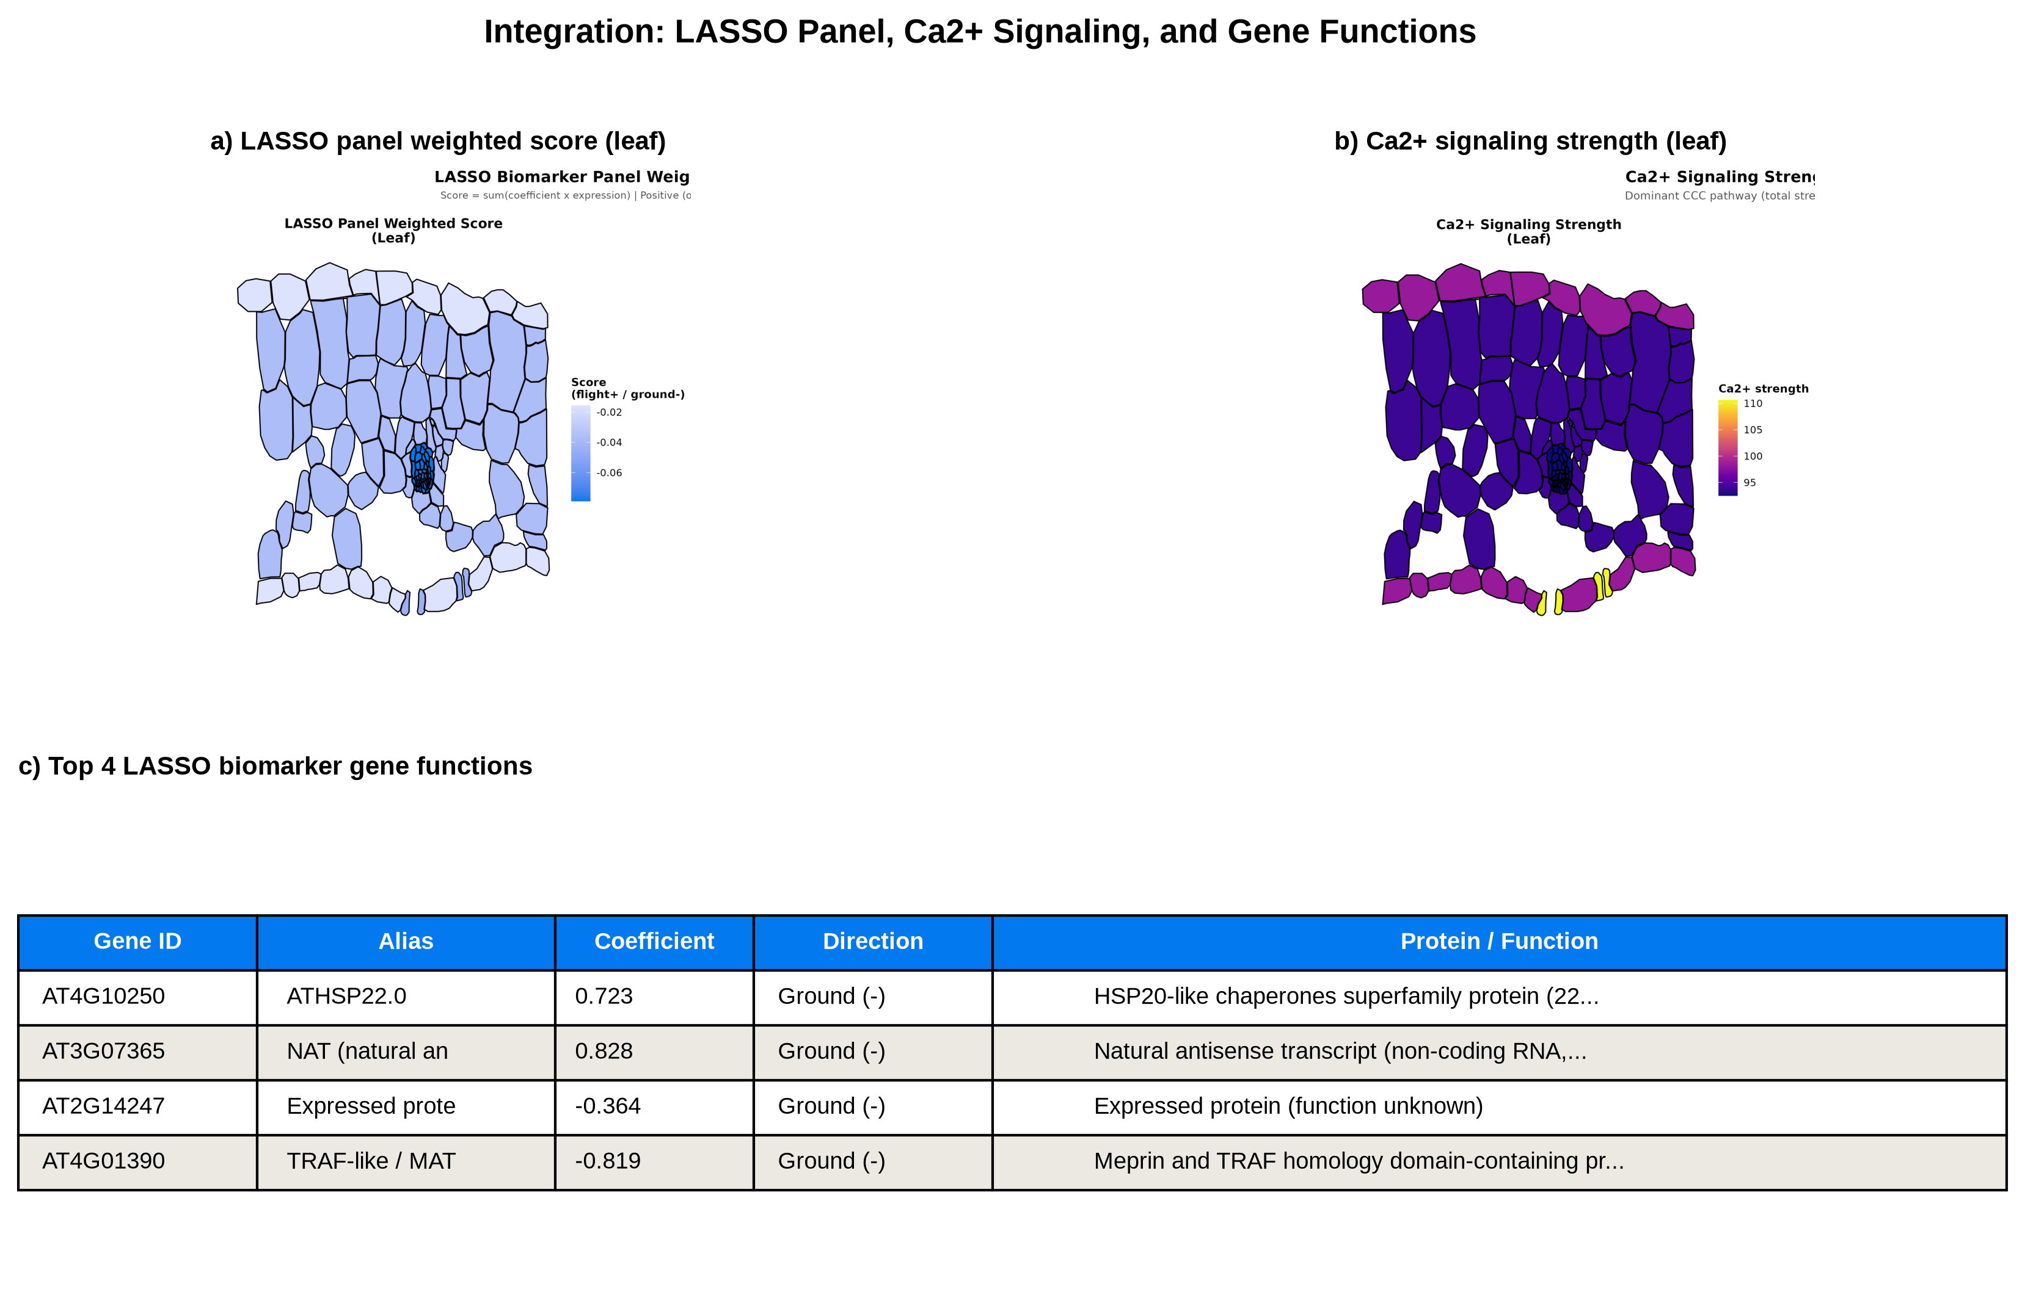
Figure 6. Integration of LASSO panel, Ca2+ signaling, and gene functions.
a) LASSO panel weighted score on leaf cross-section (score = sum of coefficient × expression across 74 atlas-present panel genes). Blue indicates ground-like (negative) score; orange indicates flight-like (positive) score. All cell types show negative scores, consistent with the terrestrial growth conditions of the atlas. b) Ca2+ signaling strength on leaf cross-section, showing cell-type-specific Ca2+ communication. c) Summary table of the top 4 LASSO biomarker gene functions, including gene ID, alias, LASSO coefficient, prediction direction, and protein function.

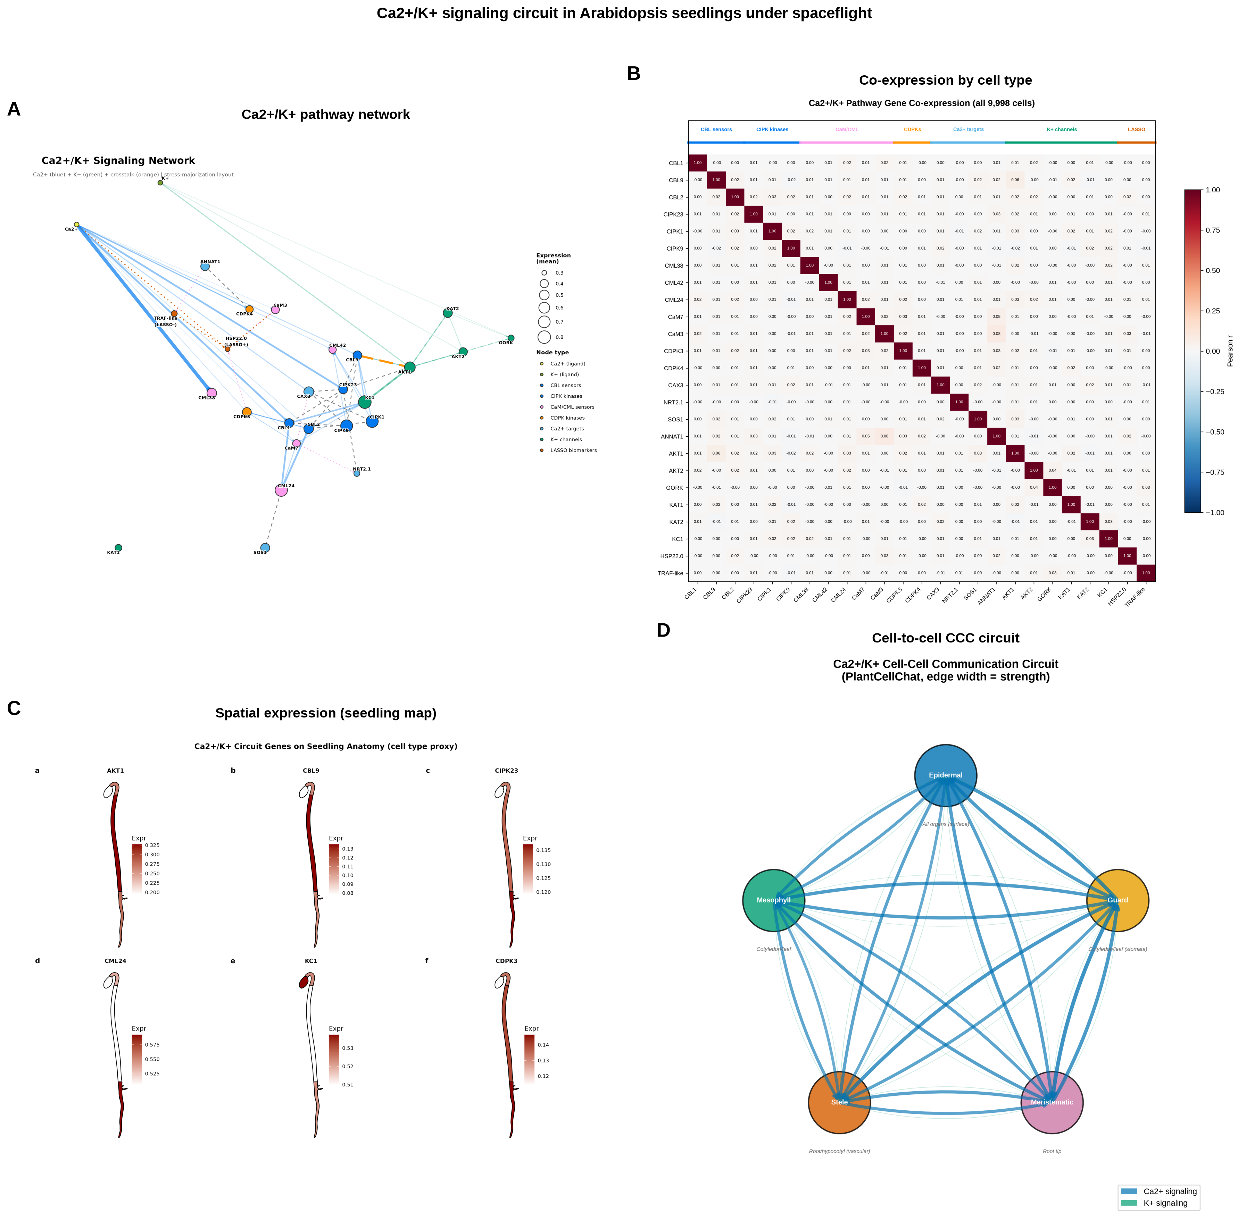
Figure 7. Ca2+/K+ crosstalk signaling circuit.
a) Expanded Ca2+/K+ pathway network (27 nodes, 67 edges) visualized with ggpathway (stress-majorization layout). Ca2+ edges in blue, K+ edges in green, crosstalk edge (CBL9-AKT1) in orange. Node color indicates type (CBL sensors, CIPK kinases, CaM/CML sensors, CDPKs, K+ channels, targets, LASSO genes). b) Co-expression heatmap of 25 Ca2+/K+ genes across five cell types, showing cell-type-specific co-expression modules. Guard cells (n = 89) show the strongest co-expression (CDPK4-ANNAT1 r = 0.56, CIPK23-CaM3 r = 0.46, CBL9-AKT1 r = 0.34). c) ggPlantmap seedling spatial map showing expression of six key circuit genes (AKT1, CBL9, CIPK23, CML24, KC1, CDPK3) projected onto cotyledon, hypocotyl, and root regions using cell-type expression as proxy. d) Cell-to-cell communication circuit diagram showing Ca2+ (blue) and K+ (green) signaling strength between five cell types. Guard cells are the dominant Ca2+ source (total outgoing strength 57.1); epidermal cells are the primary K+ source.

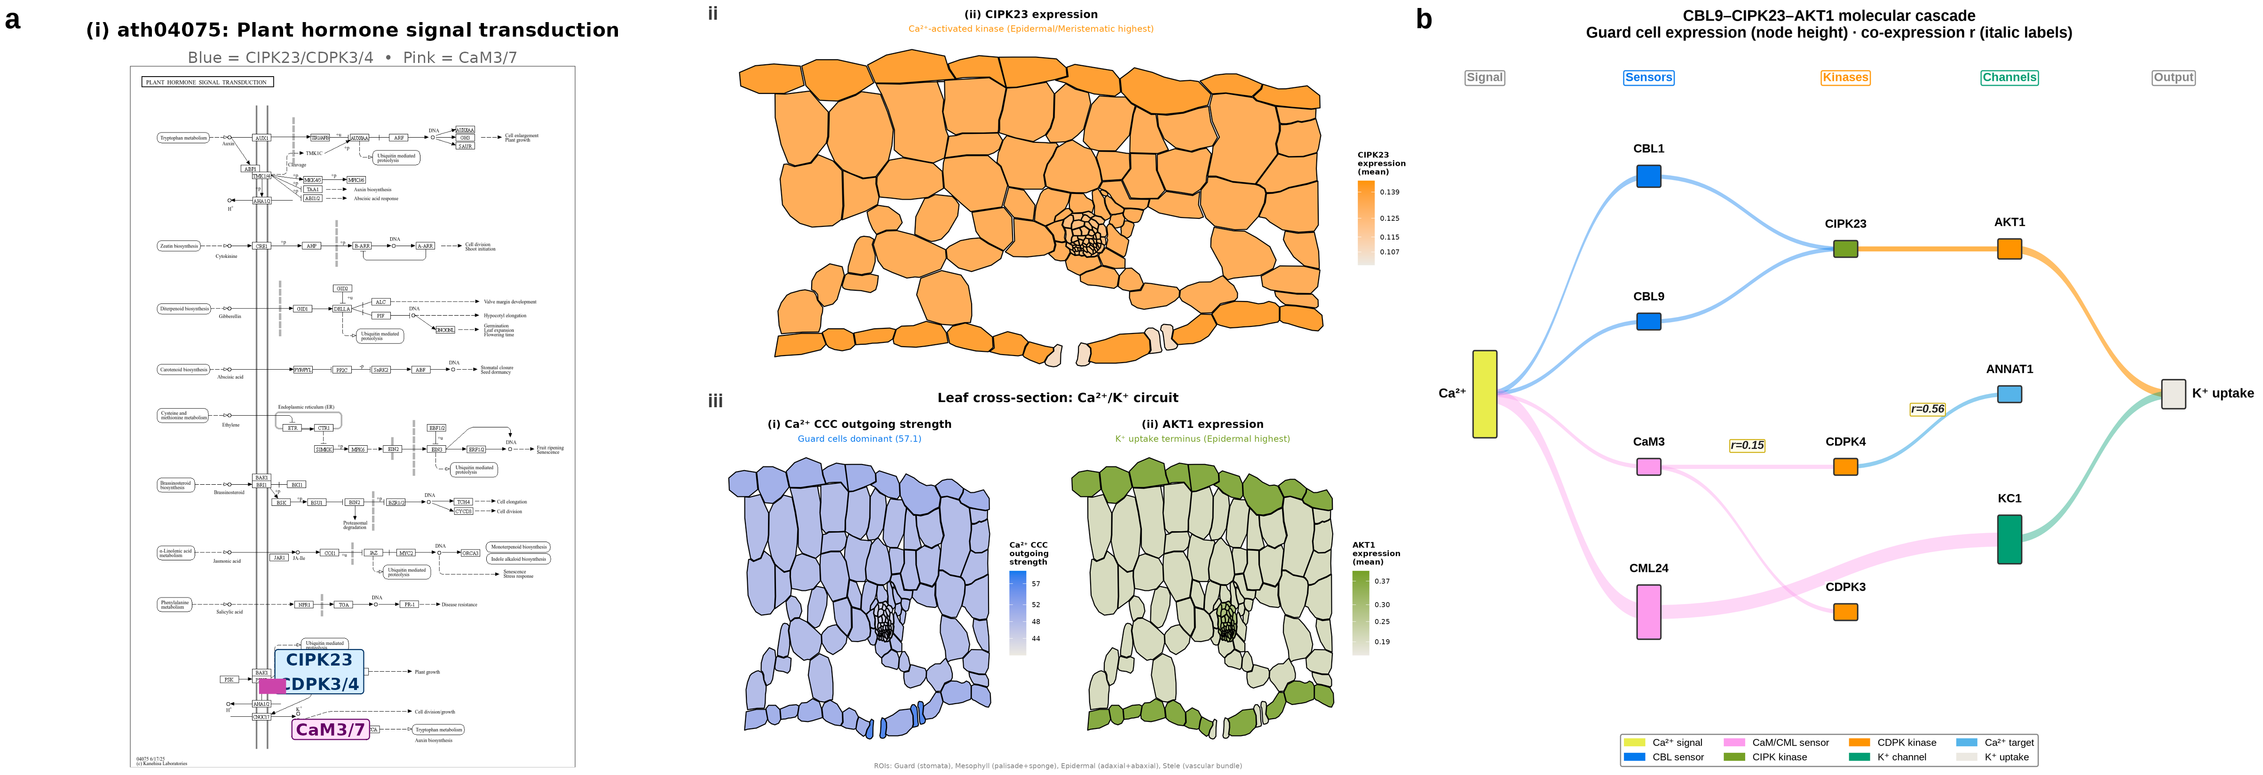
Figure 8. CBL9–CIPK23–AKT1 cascade: KEGG systems biology context, spatial expression, and molecular cascade.
a) Left sub-panel (i): ggKEGG systems biology overlay on the Arabidopsis KEGG pathway ath04075 (Plant hormone signal transduction). Nodes containing CIPK23/CDPK3/CDPK4 are highlighted in blue; CaM3/CaM7 nodes are highlighted in pink. The bar chart inset shows guard cell mean expression for all 11 circuit genes; blue bars indicate genes present in ath04075, grey bars indicate genes added as custom overlay nodes (CBL9, CBL1, CBL2, CML24, AKT1, KC1, ANNAT1). Middle sub-panels: ggPlantmap leaf cross-sections showing spatial expression across four cell types (Guard, Mesophyll, Epidermal, Stele) mapped from the Shahan et al. 2022 whole-seedling atlas. Sub-panel (ii): CIPK23 expression (orange gradient; Epidermal/Meristematic highest, mean = 0.139/0.151), showing that the Ca²⁺-activated kinase is broadly expressed across leaf cell types. Sub-panel (iii): AKT1 expression (green gradient; Epidermal highest, mean = 0.367), confirming that the K⁺ channel target of CIPK23 phosphorylation is most abundant in epidermal cells. Together, sub-panels (i)–(iii) complete the CBL9→CIPK23→AKT1 spatial story: Ca²⁺ signal is sensed by CBL9 (guard cells), activates CIPK23 (broadly expressed, epidermal/meristematic highest), which phosphorylates AKT1 (epidermal highest) to drive K⁺ uptake. b) Molecular cascade: Sankey diagram tracing the CBL9–CIPK23–AKT1 pathway from Ca²⁺ entry through calcium sensors (CBL1, CBL9, CaM3, CML24) to kinases (CIPK23, CDPK3, CDPK4) to effectors (AKT1, ANNAT1, KC1) and K⁺ uptake. Flow widths are proportional to guard cell expression values. Column headers indicate cascade stages (Signal, Sensors, Kinases, Channels, Output). Key co-expression correlations are labeled on selected edges (CDPK4–ANNAT1 r = 0.56, CaM3–CDPK4 r = 0.15, CML24–KC1 r = −0.18).

Figure Legends
Figure 1. LASSO biomarker panel for spaceflight prediction.
a) Leave-one-study-out cross-validation AUC for each held-out OSDR study (6 studies, 10 repeats each). Bars show mean AUC; error bars show standard deviation; dots show individual iterations. The dashed line indicates chance (0.5); the red line indicates the overall mean (0.734). b) Selection frequency of the top 20 most stable features across 60 iterations. Orange bars indicate positive coefficients (flight-enriched); blue bars indicate negative coefficients (ground-enriched). The dashed line marks the 50% stability threshold. c) Coefficient forest plot for the 4 genes selected at 100% frequency. Points show mean coefficients; error bars show standard deviation. HSP22.0 (AT4G10250) and the natural antisense transcript (AT3G07365) are positive predictors; the chloroplast protein (AT2G14247) and TRAF-like protein (AT4G01390) are negative predictors.
Figure 2. scPlantLLM zero-shot embeddings and clustering.
UMAP visualization of 9,998 atlas cells embedded by scPlantLLM (512-dimensional, seq_length=500). a) Cells colored by atlas cell type annotations (Epidermal, Mesophyll, Stele, Meristematic, Guard). b) Cells colored by Leiden clusters (resolution 0.5, 6 clusters). c) Cells colored by scPlantLLM zero-shot cell type predictions (top 8 predicted types shown; remaining grouped as Other). Agreement between Leiden clusters and atlas cell types: ARI=0.033, NMI=0.040. Agreement between Leiden clusters and zero-shot predictions: ARI=0.154, NMI=0.198.
Figure 3. PlantCellChat cell-cell communication analysis.
a) Communication strength heatmap showing total communication between each source (rows) and target (columns) cell type pair. Values represent summed communication probability across all ligand-receptor pairs. b) Top signaling pathways ranked by total communication strength. Ca2+ (orange) is the dominant pathway (249.5), 4.6-fold higher than the next pathway (BR, 54.5). c) Top 10 ligand-receptor pairs ranked by total communication strength. Orange bars indicate Ca2+ pathway pairs; blue bars indicate other pathways.
Figure 4. Spatial expression of LASSO biomarker genes on Arabidopsis anatomy.
ggPlantmap heatmaps showing expression of the top 4 LASSO biomarker genes on Arabidopsis cross-sections. a) Leaf cross-section: Epidermal mapped to epidermis (adaxial/abaxial), Mesophyll to palisade and spongy parenchyma, Stele to vascular bundle (xylem, phloem, bundle sheath), Guard to stomata. b) Root tip cross-section: Epidermal to epidermis, Mesophyll to cortex, Stele to procambium/xylem/phloem/pericycle, Meristematic to columella. White-to-red gradient indicates expression level. Gene coefficients shown in panel titles. AT3G07365 (non-coding RNA) is not present in the atlas protein-coding gene set and is shown as grey (no data).
Figure 5. Ca2+ signaling pathway: dominant cell-cell communication axis.
a) Data-driven Ca2+ signaling network (20 nodes) visualized using the ggpathway workflow (ggraph + igraph) with stress-majorization layout (graphlayouts::layout_with_stress). Nodes represent Ca2+ (yellow, ligand), CBL sensors (blue: CBL1, CBL9, CBL2), CIPK kinases (teal: CIPK23, CIPK1, CIPK9), CaM/CML sensors (purple: CML38, CML42, CML24, CaM7, CaM3), CDPK kinases (green: CDPK3, CDPK4), downstream targets (orange: CAX3, NRT2.1, SOS1, ANNAT1), and LASSO biomarker genes (red: HSP22.0 and TRAF-like). Node size indicates mean expression in the atlas. Edge width indicates communication strength from PlantCellChat. b) Conceptual schematic of the Ca2+ signaling cascade under microgravity, showing Ca2+ channel activation, cytosolic Ca2+ elevation, and branching to CBL-CIPK, calmodulin, and CDPK pathways leading to stress response genes.
Figure 6. Integration of LASSO panel, Ca2+ signaling, and gene functions.
a) LASSO panel weighted score on leaf cross-section (score = sum of coefficient × expression across 74 atlas-present panel genes). Blue indicates ground-like (negative) score; orange indicates flight-like (positive) score. All cell types show negative scores, consistent with the terrestrial growth conditions of the atlas. b) Ca2+ signaling strength on leaf cross-section, showing cell-type-specific Ca2+ communication. c) Summary table of the top 4 LASSO biomarker gene functions, including gene ID, alias, LASSO coefficient, prediction direction, and protein function.
Figure 7. Ca2+/K+ crosstalk signaling circuit.
a) Expanded Ca2+/K+ pathway network (27 nodes, 67 edges) visualized with ggpathway (stress-majorization layout). Ca2+ edges in blue, K+ edges in green, crosstalk edge (CBL9-AKT1) in orange. Node color indicates type (CBL sensors, CIPK kinases, CaM/CML sensors, CDPKs, K+ channels, targets, LASSO genes). b) Co-expression heatmap of 25 Ca2+/K+ genes across five cell types, showing cell-type-specific co-expression modules. Guard cells (n = 89) show the strongest co-expression (CDPK4-ANNAT1 r = 0.56, CIPK23-CaM3 r = 0.46, CBL9-AKT1 r = 0.34). c) ggPlantmap seedling spatial map showing expression of six key circuit genes (AKT1, CBL9, CIPK23, CML24, KC1, CDPK3) projected onto cotyledon, hypocotyl, and root regions using cell-type expression as proxy. d) Cell-to-cell communication circuit diagram showing Ca2+ (blue) and K+ (green) signaling strength between five cell types. Guard cells are the dominant Ca2+ source (total outgoing strength 57.1); epidermal cells are the primary K+ source.
Figure 8. CBL9–CIPK23–AKT1 cascade: KEGG systems biology context, spatial expression, and molecular cascade.
a) Left sub-panel (i): ggKEGG systems biology overlay on the Arabidopsis KEGG pathway ath04075 (Plant hormone signal transduction). Nodes containing CIPK23/CDPK3/CDPK4 are highlighted in blue; CaM3/CaM7 nodes are highlighted in pink. The bar chart inset shows guard cell mean expression for all 11 circuit genes; blue bars indicate genes present in ath04075, grey bars indicate genes added as custom overlay nodes (CBL9, CBL1, CBL2, CML24, AKT1, KC1, ANNAT1). Middle sub-panels: ggPlantmap leaf cross-sections showing spatial expression across four cell types (Guard, Mesophyll, Epidermal, Stele) mapped from the Shahan et al. 2022 whole-seedling atlas. Sub-panel (ii): CIPK23 expression (orange gradient; Epidermal/Meristematic highest, mean = 0.139/0.151), showing that the Ca²⁺-activated kinase is broadly expressed across leaf cell types. Sub-panel (iii): AKT1 expression (green gradient; Epidermal highest, mean = 0.367), confirming that the K⁺ channel target of CIPK23 phosphorylation is most abundant in epidermal cells. Together, sub-panels (i)–(iii) complete the CBL9→CIPK23→AKT1 spatial story: Ca²⁺ signal is sensed by CBL9 (guard cells), activates CIPK23 (broadly expressed, epidermal/meristematic highest), which phosphorylates AKT1 (epidermal highest) to drive K⁺ uptake. b) Molecular cascade: Sankey diagram tracing the CBL9–CIPK23–AKT1 pathway from Ca²⁺ entry through calcium sensors (CBL1, CBL9, CaM3, CML24) to kinases (CIPK23, CDPK3, CDPK4) to effectors (AKT1, ANNAT1, KC1) and K⁺ uptake. Flow widths are proportional to guard cell expression values. Column headers indicate cascade stages (Signal, Sensors, Kinases, Channels, Output). Key co-expression correlations are labeled on selected edges (CDPK4–ANNAT1 r = 0.56, CaM3–CDPK4 r = 0.15, CML24–KC1 r = −0.18).

Supplementary Figure Legends
Supplementary Figure S1. GO enrichment dotplot.
Dot plot showing significant GO and KEGG terms enriched in the 85-gene LASSO panel, 41 flight-up genes, and 44 ground-up genes. Dot size = gene count; color = -log10(p-value). Background: 2,000 variable features. Correction: BH-FDR (padj < 0.05).
Supplementary Figure S2. GO enrichment directed bar plot.
Bar plot showing -log10(p-value) for significant terms, separated by direction (flight-up vs. ground-up). Flight-up genes are enriched for heat response, hypoxia, and ER protein processing; ground-up genes are enriched for flavonoid biosynthesis.
Supplementary Figure S3. Spatial expression of Ca²⁺/K⁺ circuit genes across Arabidopsis anatomy.
Three ggPlantmap figures showing Ca²⁺/K⁺ circuit gene expression and CCC signaling strength across Arabidopsis anatomical contexts. a) Seed developmental series (ggPm.At.seed.devseries): expression of CBL9 (blue), CIPK23 (green), and AKT1 (orange) across five developmental stages (Preglobular, Globular, Heart, Linearcotyledon, Maturegreen). Cell-type proxy mapping: Embryo Proper → Meristematic; Micropylar/Peripheral Endosperm → Stele; Chalazal Endosperm → Mesophyll; Distal/Chalazal Seed Coat → Epidermal. b) Root mature cross-section (ggPm.At.rootmatur.crosssection, 8 ROIs): four sub-maps showing (i) Ca²⁺ CCC outgoing strength (blue; Meristematic/Procambium highest), (ii) K⁺ CCC outgoing strength (green; Epidermal/Atrichoblast highest), (iii) AKT1 expression (orange; Epidermal highest), and (iv) CBL9 expression (pink; Epidermal highest). Cell-type proxy: Atrichoblast/Trichoblast → Epidermal; Cortex/Endodermis → Mesophyll; Pericycle/Phloem/Xylem → Stele; Procambium → Meristematic. c) Young seedling (ggPm.At.seedling.saltdrought, all 12 ROIs including control, NaCl, and Sorbitol treatments): four sub-maps showing (i) Ca²⁺ CCC outgoing strength (blue; Cotyledon highest via guard+mesophyll proxy), (ii) K⁺ CCC outgoing strength (green; Hypocotyl highest via epidermal+stele proxy), (iii) AKT1 expression (orange; Hypocotyl highest), and (iv) CBL9 expression (pink; Hypocotyl highest). Organ proxy: Cotyledon → Mesophyll+Guard avg; Hypocotyl → Epidermal+Stele avg; Root → Stele+Meristematic avg; Hook → all cell types avg. Note: proxy mapping is used because the scRNA-seq atlas does not include seed or root-specific cell types; values represent the best available approximation from the whole-seedling atlas.
Supplementary Figure S4. Ca2+/K+ co-expression heatmap.
25-gene Pearson correlation matrix across all cells (left) and per cell type (right). Guard cells (n=89) show the strongest co-expression module: CDPK4-ANNAT1 (r=0.56), CIPK23-CaM3 (r=0.46), CBL9-AKT1 (r=0.34). Other cell types show weak correlations (r<0.1).
Supplementary Figure S5. Ca2+/K+ gene expression per cell type.
Heatmap showing mean expression (left) and percentage expressing (right) for 25 Ca2+/K+ circuit genes across 5 cell types. KC1 shows highest expression (24.7% expressing); GORK shows lowest (0.9%).
Supplementary Figure S6. Cell-to-cell Ca2+/K+ communication circuit.
Circular network diagram showing Ca2+ (blue) and K+ (green) signaling strength between 5 cell types. Edge width = communication strength. Guard cells are the dominant Ca2+ source (total outgoing 57.1); epidermal cells are the primary K+ source.
Supplementary Figure S7. Organ marker diagnostic.
Expression of 15 tissue-specific markers across 5 cell types. Root markers (SCR, PLT1, WOL) are near-absent (<3%); photosynthetic markers (RBCS, FSD1) are ubiquitous (93-98%); seed markers (LEC2, 2S3) are near-zero. Marker-based organ inference is not reliable in this whole-seedling atlas.
Supplementary Figure S8. Expanded Ca2+/K+ pathway network.
Full 27-node, 67-edge Ca2+/K+ pathway network visualized with ggpathway (stress-majorization layout). Ca2+ edges in blue, K+ edges in green, crosstalk edge (CBL9-AKT1) in orange. Node types: CBL sensors, CIPK kinases, CaM/CML sensors, CDPKs, K+ channels, Ca2+ targets, LASSO biomarker genes.

Supplementary Table Legends
Supplementary Table S1. LASSO biomarker panel.
85 stable LASSO features (selection frequency >=50%) with mean coefficient, standard deviation, and stability status.
Supplementary Table S2. GO enrichment results (all terms).
Complete g:Profiler output for all 3 queries (85 genes, 41 flight-up, 44 ground-up) with all tested terms, p-values, and gene lists.
Supplementary Table S3. GO enrichment significant terms.
14 significant terms (BH-FDR padj < 0.05) across all 3 queries with -log10(p) and gene lists.
Supplementary Table S4. Ca2+/K+ CCC circuit.
25 cell-pair communication strengths for Ca2+ and K+ pathways, with organ proxies and dominance flags.
Supplementary Table S5. Ca2+/K+ signaling circuit summary.
Circuit-level summary: source/target cell types, dominant signal, Ca2+/K+ strength, ratio, top source/target genes, and strongest co-expression pair.
Supplementary Table S6. Ca2+/K+ circuit node expression.
23-gene expression table: mean expression and percentage expressing across 5 cell types, with top co-expression partner and correlation.
Supplementary Table S7. Ca2+/K+ co-expression matrix.
25x25 Pearson correlation matrix for Ca2+/K+ circuit genes (global, across all cells).
Supplementary Table S8. Organ marker expression.
15 tissue-specific markers tested across 5 cell types with mean expression and percentage expressing.

Data Availability
OSDR data are available from the NASA Open Science Data Repository (visualization.osdr.nasa.gov/biodata/api/). The seed-to-seed atlas is available from GEO (accession GSE226097). scPlantLLM is available from GitHub (github.com/compbioNJU/scPlantLLM). PlantCellChat is available from GitHub (github.com/mrliuw/PlantCellChat). ggPlantmap is available from GitHub (github.com/leonardojo/ggPlantmap). All analysis code, generated figures, data tables, and supplementary materials are available in the companion repository (github.com/rbarker/arabidopsis-spaceflight-omics) and will be archived on Zenodo with a DOI upon acceptance. Detailed methods including the scPlantLLM weight conversion code, all analysis parameters, and software versions are provided in Supplementary Methods.

Acknowledgements
We thank the NASA GeneLab team and the Plant Analysis Working Group for valuable discussions. This work utilizes data from the NASA Open Science Data Repository.

Author Contributions
R.B. conceived the study, designed the analysis, performed all computational work, and wrote the manuscript.

Competing Interests
The author declares no competing interests.

