A cell-type-resolved atlas of deep-space stress susceptibility in the dry and germinating Arabidopsis seed
Richard Barker¹ ²
¹ Purdue University, West Lafayette, IN, USA
² The Collaborative Science Environment, PBC (public benefit corporation)
*Correspondence: Richard Barker — admin@cosecloud.com
Target journal: npj Microgravity (Article). Status: draft v1 (2026-06-27).

Abstract
Seeds are the most practical propagule for off-world agriculture, yet how the spectrum of deep-space
stressors — microgravity, ionizing radiation, altered magnetic fields, and the gas and gravitropic
environment of spaceflight hardware — impinges on the dormant and germinating seed remains largely
uncharacterized, because spaceflight experiments measure later developmental stages rather than seeds.
We address this gap with two reusable tools and a single-cell reference. The **DeepSpace
Stress-Recognition System (DSRS)** recognizes which space stressor a transcriptomic signature resembles,
and the Germinating-Seed AutoDecoder (GSAD) projects bulk transcriptomes onto a 122-panel
single-cell seed reference (developmental and germination atlases) to predict cell-type-level effects.
Validating the framework, the decoder independently recovers textbook embryo→seedling lineages
(protoderm→epidermis; hypophysis→radicle apical meristem; vascular primordium→provasculature). Applying
it to a 21-contrast model spanning five stressor families, we build a **DeepSpace seed-susceptibility
atlas. Its central result: the radicle/root apical tip is the convergence hotspot**, significantly
targeted by four of five independent stressor families, with null-magnetic-field-responsive genes most
sharply localized there. Early germination (12 h) is the most vulnerable developmental window. We frame
all predictions as testable hypotheses with falsification experiments and release the tools, panels, and
atlas as a FAIR resource. The root tip emerges as a priority target for protecting seed performance in
deep space.

Introduction
Establishing plant-based bioregenerative life support beyond low-Earth orbit depends on seeds that can be
stored dry, transported, and germinated reliably under conditions that differ profoundly from Earth.
Deep-space environments combine microgravity (or fractional gravity), chronic **ionizing/galactic
cosmic radiation, a near-absent or altered magnetic field**, and the confined gas environment of
flight hardware that can impose hypoxia/anoxia; the loss of a stable gravity vector also removes the
gravitropic set-point that organizes seedling establishment. Each of these has documented effects on
adult plant transcriptomes, but the consequences for the dry/dormant and germinating seed — the stage
that determines whether a crop establishes at all — are poorly resolved.
A core obstacle is that the relevant experiments rarely sample seeds at single-cell resolution: spaceflight
datasets profile seedlings or organs, while the richest single-cell seed atlases are ground-based.
Bridging adult-tissue or developmental signatures to seed cell types is therefore a cross-stage inference
problem. Recent single-cell resources make it tractable: a developmental atlas of early Arabidopsis seed
(embryo, endosperm, seed coat) and a germinating-embryo atlas spanning the imbibition time-course together
define the cell types and states of the dry→germinating seed.
Here we operationalize this bridge as two tools and use them to ask a concrete question of direct
relevance to space agriculture: **which seed cell types and developmental stages are most susceptible to
deep-space stressors, and do any stressors converge on the same cellular targets?** We integrate
genome-wide signatures from microgravity, radiation, low-oxygen, and tropism experiments, add a
null-magnetic-field signal, and project them onto a single-cell seed reference to produce a
susceptibility atlas with an explicit, falsifiable headline.

Results

A two-tool framework for plant space-biology stress decoding (Fig. 1)
We distilled the analysis into two reusable, FAIR tools (Fig. 1). DSRS takes any plant transcriptomic
perturbation signature (ranked log2 fold-changes, AGI/TAIR identifiers) and recognizes which space
stressor it most resembles, by comparing its seed-program fingerprint — its enrichment across the seed
reference panels — to a curated reference library spanning five stressor families. GSAD takes a bulk
transcriptome and models its predicted effect on the dry/germinating seed, returning a per cell-type,
tissue, and stage susceptibility profile. Both share one projection engine (rank-based gene-set
enrichment onto the seed panels). As an internal check, DSRS correctly recognizes a held-in submergence
signature as belonging to the low-oxygen family.

A validated single-cell seed reference (Fig. 3)
We built a 122-panel reference of seed cell-type and state marker sets from the developmental seed atlas
(snRNA-seq, 3/5/7 days after pollination) and the germination atlas (scRNA-seq, 12/24/48 h post-imbibition),
spanning embryo, endosperm, seed-coat, and germinating-embryo cell types as well as the dry→germinating
state axis. Panels reproduced canonical markers (oleosins and cruciferin for embryo; BANYULS for the
inner-integument endothelium), confirming fidelity.
As a stringent positive control, we restricted the decoder's input to embryo cells only and asked which
germinating-seed cell type each developing-embryo state maps onto. The decoder independently recovers
established developmental lineages from transcriptomes alone (Fig. 3): protoderm → epidermis,
hypophysis → radicle apical meristem, vascular primordium → provasculature, **inner cotyledon →
cotyledon mesophyll, and cortical initials → hypocotyl cortex**. Recovering ground-truth lineage
relationships validates the projection machinery and, notably, places the embryonic hypophysis as the
developmental origin of the radicle apical meristem — a point we return to below.

Recognizing deep-space stress signatures (Fig. 2)
We assembled a 21-contrast stress reference library spanning five families: gravity (spaceflight
microgravity, root and leaf), radiation (galactic-cosmic-radiation-relevant low-dose and acute γ),
low-oxygen (hypoxia, anoxia, submergence), tropism (gravitropism, phototropism), and
magnetic/null-magnetic-field (Fig. 2). Genome-wide signatures were projected onto the seed panels;
the null-magnetic-field (NMF) response, available only as a small curated gene panel, was handled by
expression-localization rather than enrichment (see Methods). Across families, a recurrent theme emerged:
stressed adult/vegetative tissue transcriptionally resembles the early-germination (12 h) state,
suggesting a shared stress-engaged transcriptional program at the onset of germination.

Decoding stress onto germinating-seed cell types (Fig. 4)
GSAD projection resolved stressor effects to individual germinating-seed cell types (Fig. 4). Microgravity
showed strong light-dependence (sign inversions between dark and light in embryo/endosperm/seed-coat
programs), acute radiation induced embryo provascular/founder programs, and low-oxygen and gravitropism
each engaged root-pole identities. Null-magnetic-field-responsive genes localized most sharply to the
radicle apical meristem (localization z = +7.96), far above any marker-panel overlap expected by
chance.

The DeepSpace seed-susceptibility atlas (Fig. 5)
To integrate across stressors, we scored each germinating-seed cell type by how many of the five stressor
families significantly target it — a family-level convergence metric that prevents any single
data-rich family from dominating (Fig. 5). The result is unambiguous: the **radicle/root apical tip is the
multi-stressor convergence hotspot. The radicle apical meristem is targeted by four of five families**
(gravity, tropism, radiation, and magnetic/NMF); the columella/root cap is likewise 4/5, and the radicle
epidermis 3/5 — all three root-tip cell types rank at the top. The principal non-root hotspot is the
cotyledon mesophyll (4/5), reflecting convergent effects on the photosynthetic program. ("Unassigned"
germination clusters score highly but lack a defined identity; the radicle apical meristem is therefore the
top biologically-defined hotspot.)

Stage and tissue resolution
At the germination-stage level, **early germination (12 h) is the most multi-stressor-susceptible
window** (4/5 families), consistent with the cross-family "12 h" convergence; the truly dry/0 h pole is
under-sampled by current single-cell data. At the broad developing-tissue level the signal is diffuse
and weighted by small maternal tissues, indicating that cell-type × stage, not gross tissue, is the
informative resolution.

A convergent model centred on the radicle growth-point (Fig. 6)
Four independent lines converge on the radicle growth-point (Fig. 6): (i) NMF-responsive genes localize
there (z = +7.96); (ii) microgravity modulates the radicle-meristem program in a light-gated manner;
(iii) gravitropism — itself a root-tip phenomenon — engages the same program; and (iv) the structure is
developmentally founded by the embryonic hypophysis, which our lineage analysis maps directly onto the
radicle apical meristem. We therefore propose the radicle apical meristem as a priority cellular target
for deep-space seed performance, and state two high-confidence, falsifiable predictions: H1 — growth
under a near-null magnetic field induces radicle-apical-meristem markers and alters radicle emergence, with
the effect abolished in cry1 cry2; H2 — microgravity suppresses radicle proliferative programs in a
light-gated manner.

Discussion
Reading the deep-space stress spectrum through a single-cell seed lens reveals that these stressors do not
act diffusely: they re-tune specific seed programs, and they converge on the radicle/root apical tip.
That convergence is biologically coherent — the radicle is the first organ to resume growth at germination,
a hub of auxin and gravity signalling, and the developmental product of the hypophysis — and it is
recovered independently by chemically and physically distinct stressors, which argues against a single
shared artefact. The cross-family "early-germination (12 h)" signal further suggests that the onset of
germination is a window of heightened environmental sensitivity.
Our predictions are explicitly concordance, not causation: GSAD performs signature transfer across
tissue and developmental stage, so each claim carries an evidence tier (direct data / atlas projection /
literature / hypothesis) and a falsification test. The framework's recovery of textbook embryo lineages
(Fig. 3) provides confidence that the projections reflect real cell-type biology rather than artefact.
Key limitations define the next experiments. Genome-wide null-magnetic-field transcriptomes are not yet
publicly deposited, so the NMF arm relies on a curated panel via localization; the dry/0 h seed pole is
under-sampled at single-cell resolution; tropism transcriptomes are sparse (gravitropism RNA-seq;
phototropism microarray) and sustained hypergravity lacks a clean public dataset; and several contrasts
are microarray- or translatome-tier. None of these undermines the central, multiply-supported result, and
each is addressable as data accrue. The tools are organism-agnostic in design and can incorporate new
stressors (e.g., desiccation, ethylene/CO₂, partial gravity) as reference panels.

Methods
Seed single-cell reference. Developmental seed atlas (snRNA-seq, 3/5/7 DAP) and germination atlas
(scRNA-seq, 12/24/48 h). Cell-type/state marker panels (top 50 genes/group, ≥20 cells, Wilcoxon) were
compiled into a 122-panel library (exported as GMT). Germination clusters were annotated from the source
publication and confirmed against canonical markers.
Stressor signatures. Genome-wide differential expression was obtained from NASA OSDR (microgravity:
OSD-120, OSD-678; radiation: OSD-658, OSD-498, OSD-502, OSD-508, OSD-510, OSD-782) and GEO (low-oxygen:
GSE315308, GSE182724; gravitropism: GSE199142; phototropism: GSE3847). Wild-type, treatment-vs-control
contrasts were used. Gene identifiers were harmonized to AGI/TAIR (Entrez and Affymetrix ATH1/GPL198 maps
provided). The null-magnetic-field panel derives from Maffei-group time-course microarrays (curated
oxidative/polyphenol gene set).
Projection (DSRS/GSAD). Each signature was ranked by log2FC and projected onto the panels by
pre-ranked gene-set enrichment (gseapy; 200 permutations; seed 42), yielding a normalized enrichment score
(NES) and FDR per panel. DSRS scores query-to-reference similarity of seed-program fingerprints (rank
correlation). The NMF panel (≤7-gene overlap with marker panels) was instead localized onto cell-type
expression specificity (mean specificity vs 1,000 random gene sets → z).
Atlas/convergence. A cell type was deemed susceptible to a family if any contrast in that family had
|NES| ≥ 1.5 and FDR < 0.25 (or NMF localization |z| ≥ 2). Convergence = number of the five families meeting
this threshold. Bridge/lineage analyses used pseudobulk and ssGSEA with within-source scaling.
Software. deepspace Python package (DSRS, GSAD, CLI). Determinism via fixed seeds; full pipeline in
numbered scripts (see Code availability).

Data availability
All inputs are public (provenance and accessions in the repository data/data_inventory.csv):
developmental seed atlas GSE295007; germination atlas GSE182331 (mirror of ArrayExpress
E-MTAB-12532); microgravity/radiation OSD-120/678/658/498/502/508/510/782 (NASA OSDR); low-oxygen
GSE315308, GSE182724; gravitropism GSE199142; phototropism GSE3847 (GPL198). Genome-wide
null-magnetic-field arrays (Parmagnani/Maffei 2022; Agliassa/Maffei 2021) are not publicly deposited and
were requested from the authors; the curated panel is included.

Code availability
Tools and pipeline are released under the MIT license with a Zenodo DOI [to be minted on deposit]: the
deepspace package (DSRS + GSAD + CLI), the panel library (GMT), numbered reproduction scripts, and a
REPRODUCE.md guide. Figures F1–F6 are regenerated by scripts/20_manuscript_figures.py.

Selected references
- Martin, Cogdill, Pusey, … Gehring. Transcriptional atlas of early Arabidopsis seed development. npj? — Nat. Plants (2026). doi:10.1038/s41477-026-02295-8 (GSE295007).
- Liew, …, Lewsey. Establishment of single-cell transcriptional states during seed germination. Nat. Plants (2024). doi:10.1038/s41477-024-01771-3 (E-MTAB-12532 / GSE182331).
- Parmagnani, Mannino, Maffei. Transcriptomics and metabolomics of ROS modulation in near-null magnetic field Arabidopsis. Biomolecules (2022). doi:10.3390/biom12121824.
- Agliassa, Maffei. Differential root and shoot magnetoresponses in Arabidopsis. Sci. Rep. (2021). doi:10.1038/s41598-021-88695-6.
- Jin et al. Static magnetic field regulates Arabidopsis root growth via auxin signaling. Sci. Rep. (2019). doi:10.1038/s41598-019-50970-y.
- Esmon et al. A gradient of auxin and auxin-dependent transcription precedes tropic growth. PNAS (2006) (GSE3847).
- NASA GeneLab/OSDR plant spaceflight datasets (OSD-120/678/658/498/502/508/510/782).
- Subramanian et al. Gene set enrichment analysis. PNAS (2005).

Author contributions / Competing interests / Acknowledgements
[To complete.] The authors declare no competing interests. We thank the data-generating consortia (Gehring
and Lewsey labs; NASA GeneLab/OSDR; the Maffei group) whose public/shared data enabled this work.
*Figures: F1 concept workflow; F2 DSRS stress library; F3 seed reference + embryo-lineage validation;
F4 GSAD susceptibility; F5 DeepSpace atlas (headline); F6 convergence model. Files in report/figures_npj/.*

Figures
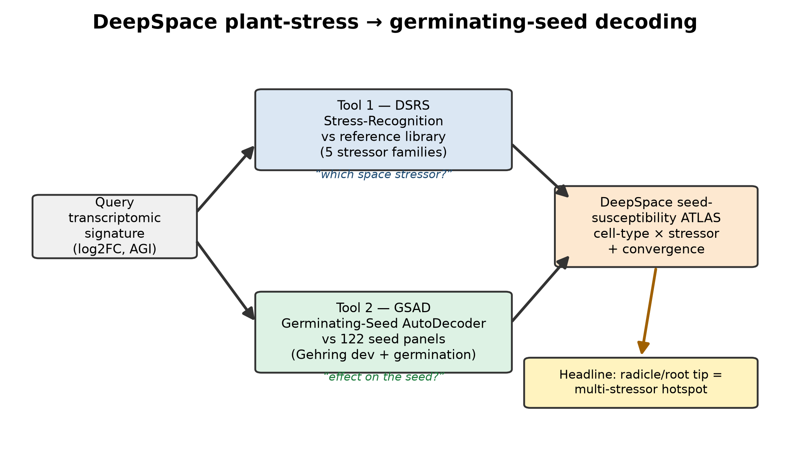
Figure 1. Two-tool framework: signature → DSRS / GSAD → DeepSpace atlas.
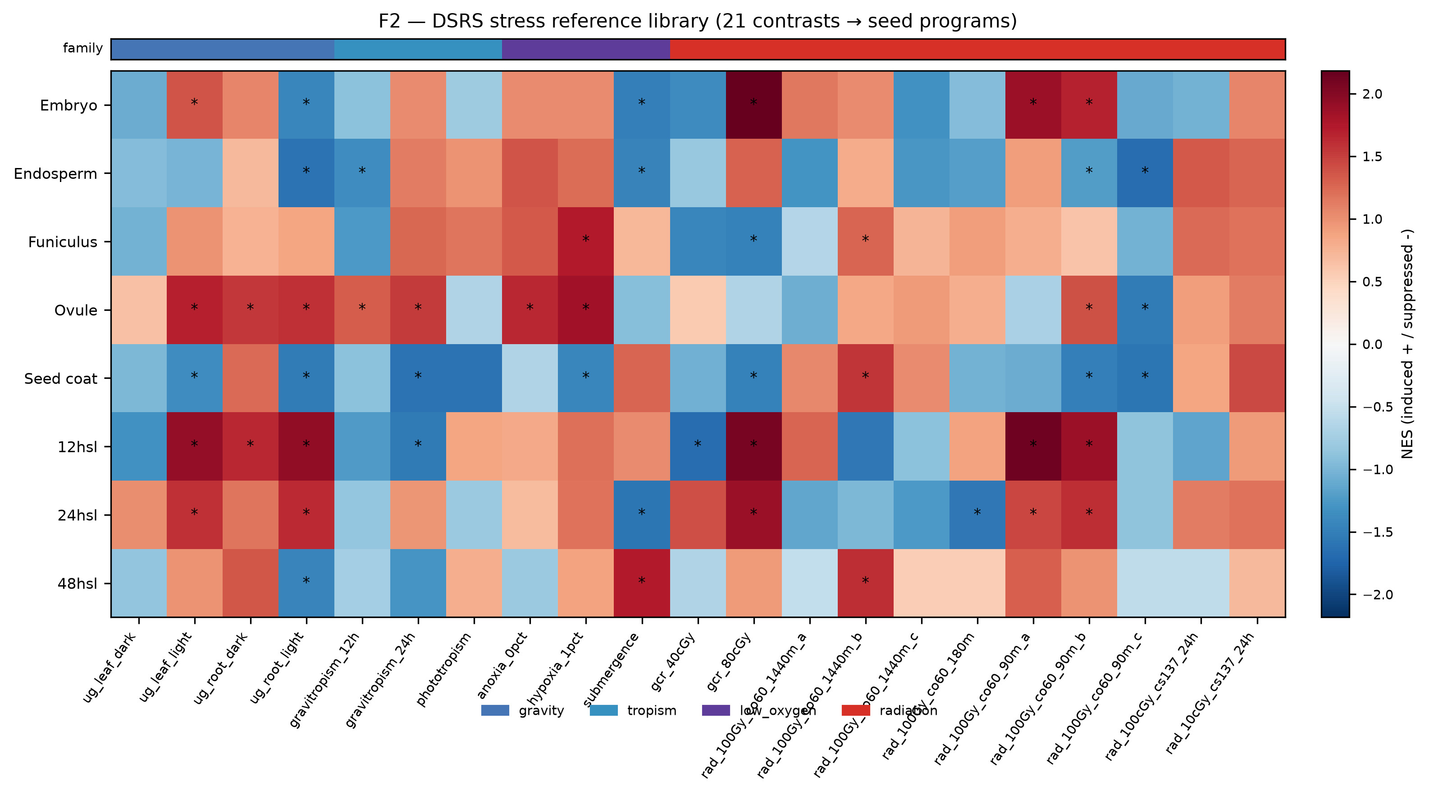
Figure 2. DSRS stress reference library — 21 contrasts (5 families) → seed programs.
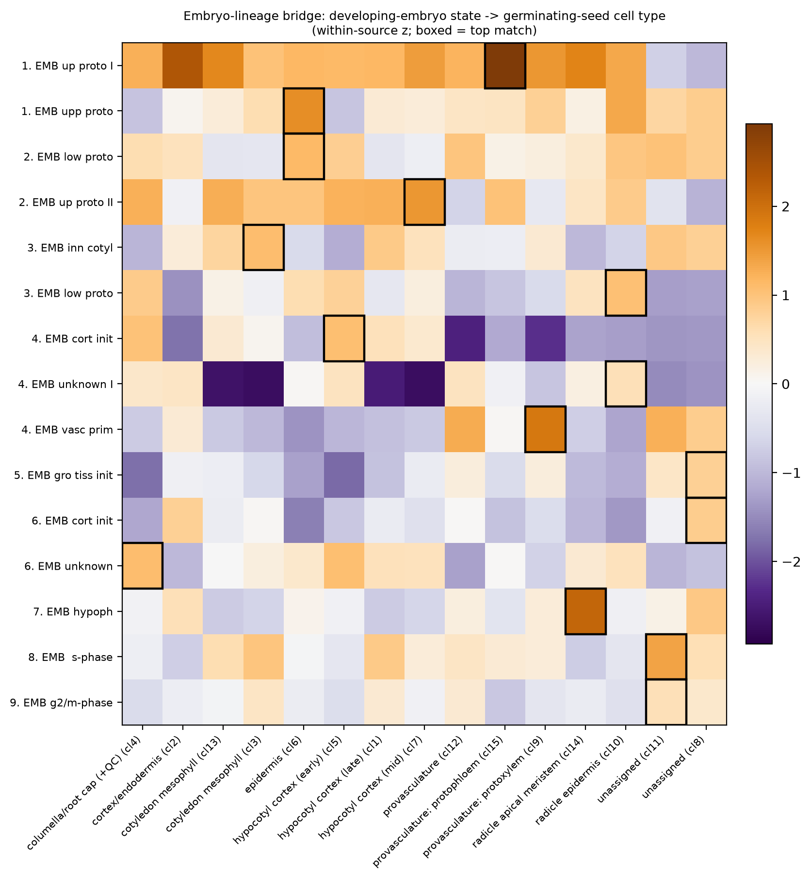
Figure 3. Seed reference validation — developing-embryo state → germinating cell type recovers textbook lineages.
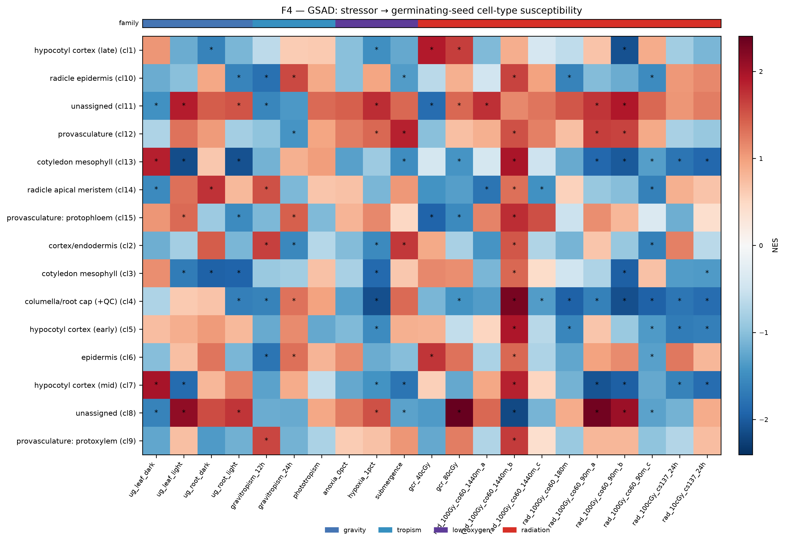
Figure 4. GSAD — stressor → germinating-seed cell-type susceptibility.
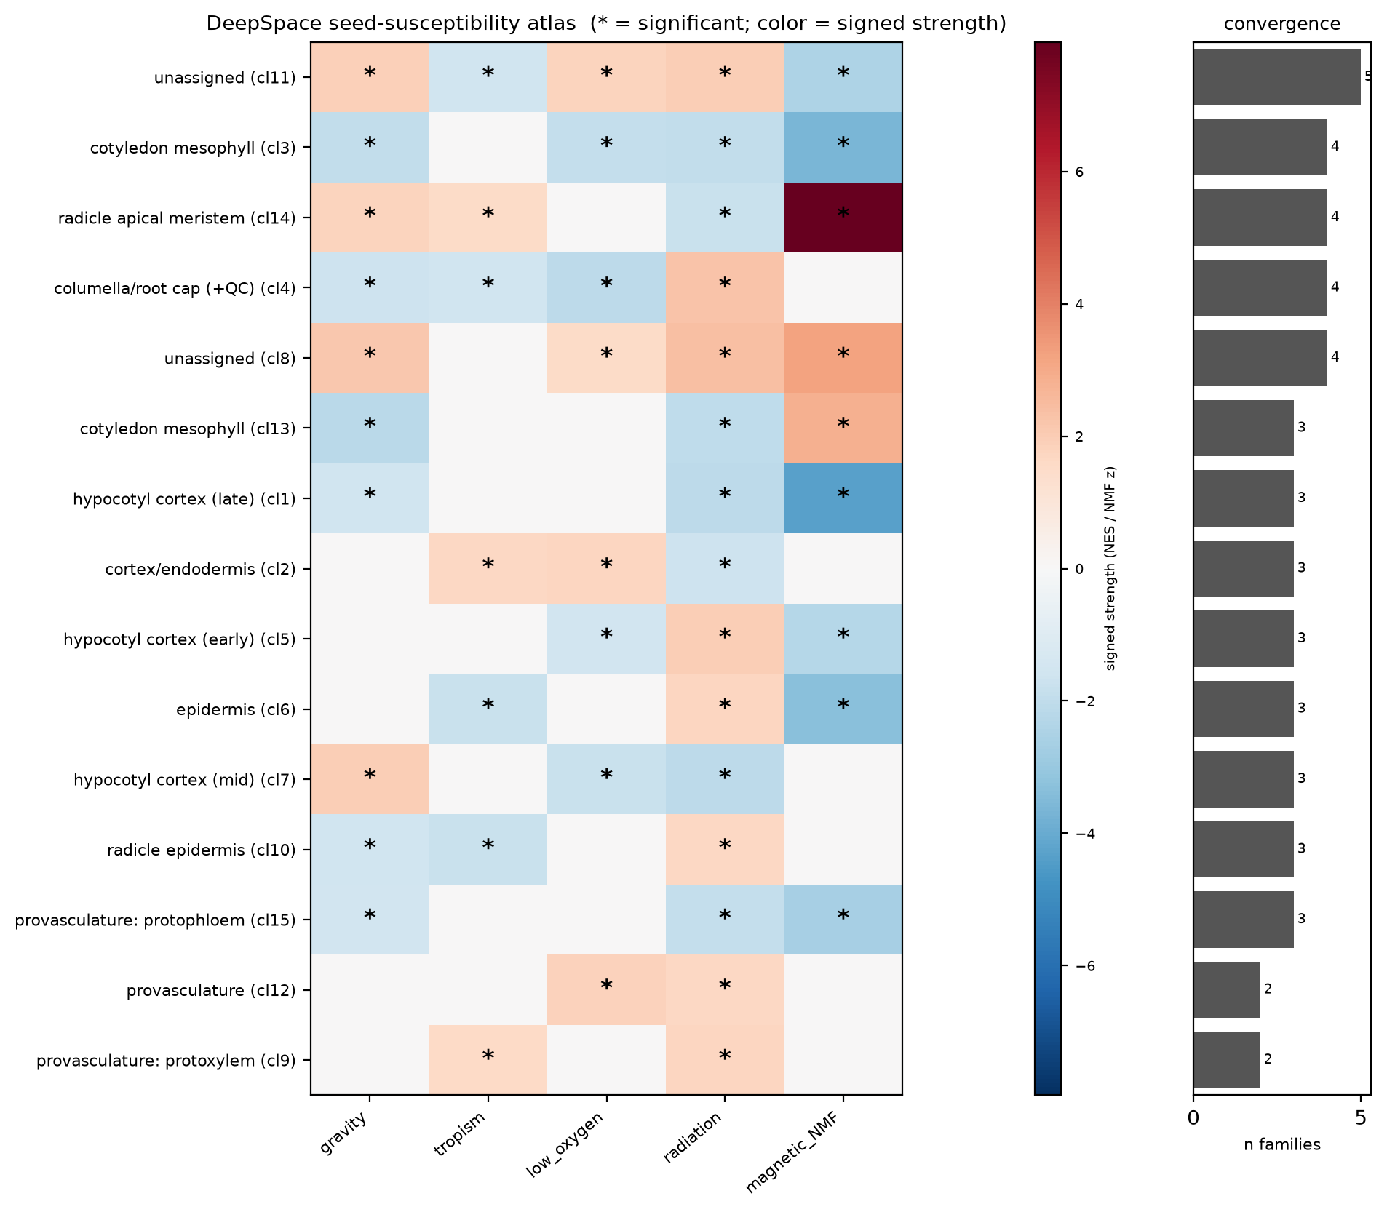
Figure 5. DeepSpace seed-susceptibility atlas — cell-type × stressor family + convergence (radicle-tip hotspot).
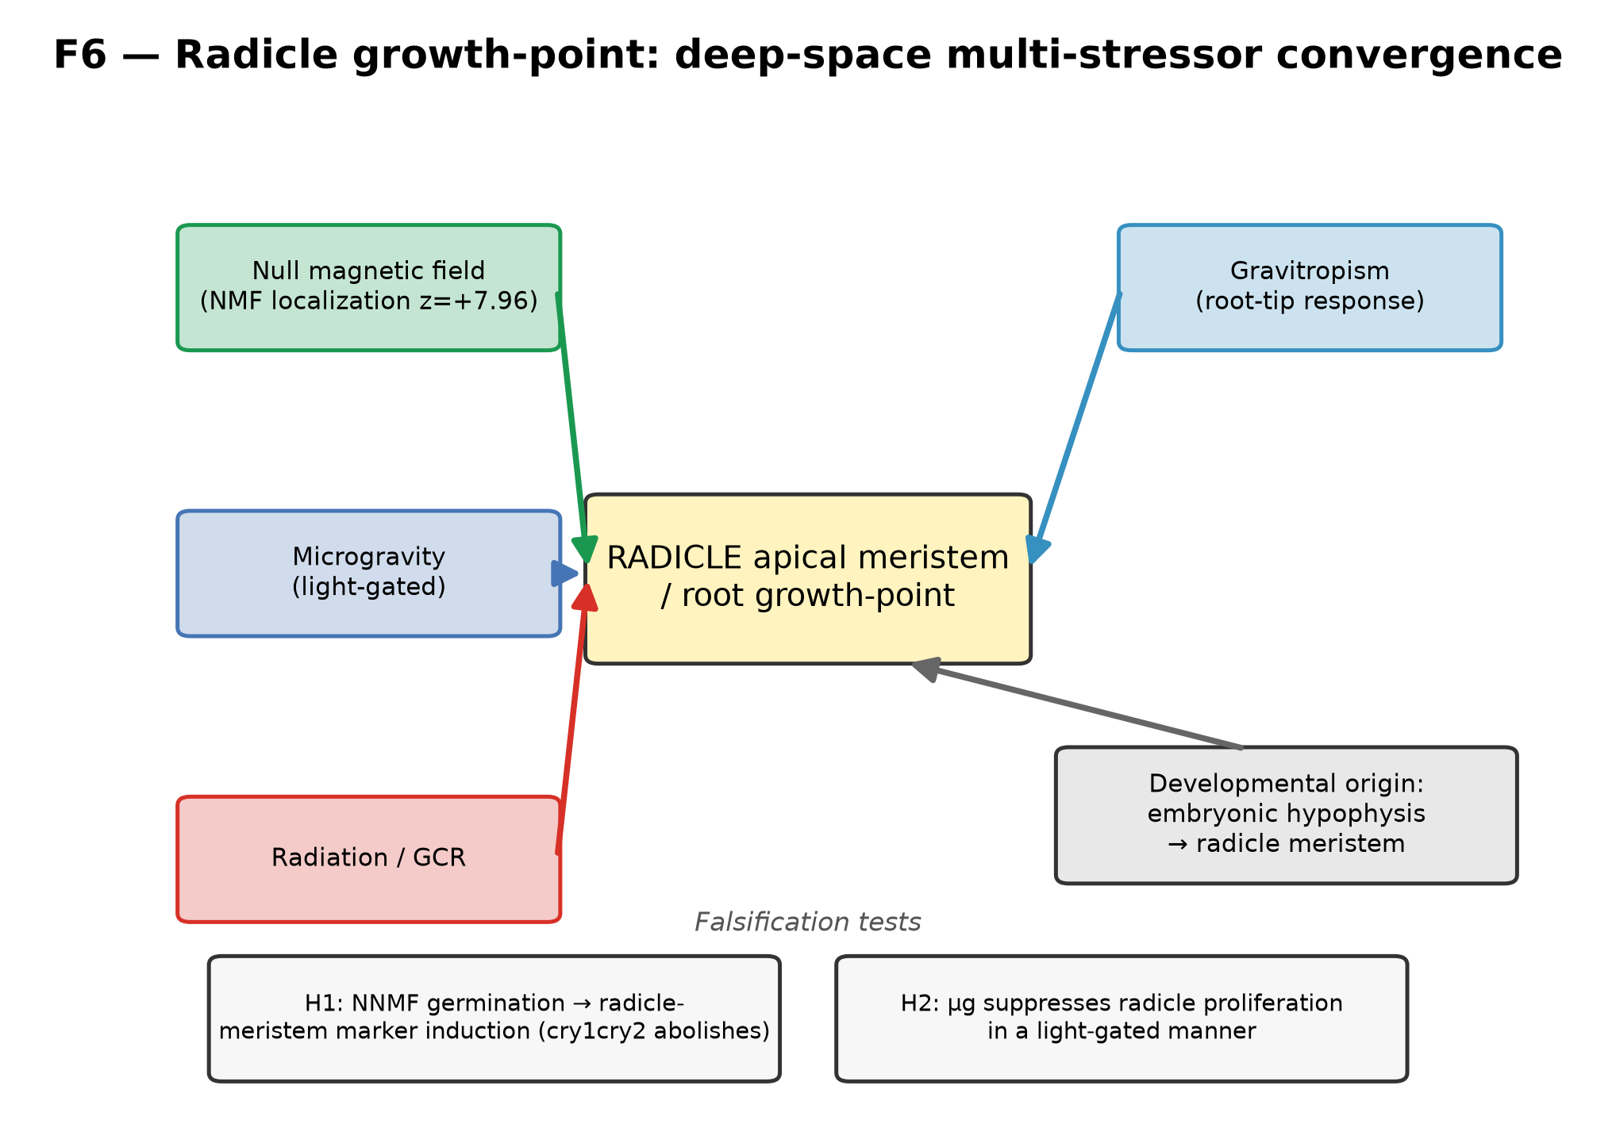
Figure 6. Radicle growth-point: deep-space multi-stressor convergence model + falsification tests.

