Natural variation in Arabidopsis darkness metabolism tests a carbon starvation model of spaceflight transcriptomes

Abstract
A gas-transport model of the BRIC-LED-001 flight (OSD-522) predicted that microgravity lowers net carbon assimilation in lit plants, so only lit spaceflight transcriptomes should show carbon starvation. We tested it with extended-darkness metabolomes from two natural-variation panels (259 and 301 Arabidopsis accessions), a light/dark time course, six flight transcriptomes and one flight proteome. Darkness raised leucine and isoleucine in every accession. Of the 6 model predictions with measured darkness directions, 5 agreed; the exception, glutamate, rested on 32 °C dark stress alone. Of 36 pre-registered gene-set outcomes, 18 matched, but no lit flight showed a significant starvation signal, whereas three dark flights showed the strongest. In a dark flight proteome, carbon-pathway transcripts rose while their membrane proteins fell. A carbon-starvation-like signal is present in spaceflight transcriptomes, but it is not specific to light, its sign differs between experiments, and where proteins were measured, carbon metabolism moved against its transcripts.

Introduction
A companion study (Barker 2026a) asked what the sealed, illuminated BRIC-LED canister of OSD-522 (Integrative Transcriptomics and Proteomics Profiling of Arabidopsis thaliana Elucidates Novel Mechanisms Underlying Spaceflight Adaptation 2024) does to the CO$​_{2}$ that reaches Rubisco, the enzyme that fixes carbon in photosynthesis. It coupled a lattice-Boltzmann simulation of gas movement in the thin layer of air over the leaf (the boundary layer) to the Farquhar–von Caemmerer–Berry model, the standard biochemical model of leaf photosynthesis. On Earth, air warmed by the leaf rises and is replaced, a buoyant convection that renews the boundary layer; in microgravity this flow is absent. The model therefore predicted a persistent deficit in net assimilation, the carbon a leaf fixes less what it releases again by respiration and photorespiration, whenever the plants photosynthesise, and so a mild carbon-starvation response in the flight transcriptome. Because there is no assimilation to lose in the dark, the same model predicts no such response in dark-grown flight experiments.
That study left four questions open, and this one takes them up. Its metabolite predictions could not be tested, because the NASA Open Science Data Repository (Gebre et al. 2025) contains no plant metabolome; it submitted them to PaintOmics (Liu et al. 2022) as a predicted third layer instead. Its “starvation amino acids” (asparagine, valine, leucine, isoleucine, glutamine and glutamate) were given one shared fold change with a gain fixed at 1, never fitted. Its gene-set tests were Mann–Whitney comparisons, which ignore the correlation between genes. And across six flight contrasts the carbon-starvation marker genes moved significantly in dark experiments, where the model predicts nothing, an observation it recorded as unexplained.
Natural variation offers a measured answer to the first two questions and a new test of the third. Zhu and colleagues profiled the leaf metabolome of natural accessions before and after six days of extended darkness (Zhu et al. 2022, 2024); 259 have both timepoints in the published per-accession values. Wu and colleagues profiled accessions under control conditions and after 1,280 min of darkness at 32 °C, and mapped metabolite GWAS loci in each (Wu et al. 2018); 301 have paired values here. Their supplement also includes LC-MS profiles from the Caldana time course, in which Col-0 plants grown at 21 °C in the light were kept there or moved to darkness (Caldana et al. 2011; Wu et al. 2018).
None of these is a mild carbon deficit in the light. Hours to days of darkness remove the supply of photosynthate, which is what they share with the deficit the model proposes, but they also start senescence, proteolysis, nitrogen remobilisation and redox changes that a small shortfall in assimilation need not cause, and the Wu stress adds heat. We therefore use them as an extended-darkness, direction-of-change reference: they say which way carbon limitation moves a compound, not how far a 9 % assimilation deficit would move it, and we keep magnitudes out of every comparison with the model. Because the Wu stress combines darkness with 32 °C, we also keep it apart from the darkness-only sources wherever a call depends on it.
We use them in four ways: to score the model’s compound predictions; to replace its predicted metabolite layer with a measured one and resubmit to PaintOmics; to test the model’s light/dark prediction on six flight contrasts with gene sets built from that natural variation, under nulls that respect gene correlation and with predictions committed before any test ran; and to ask how many plants a targeted metabolite panel on flight material would need. Finally, because OSD-38 (Proteomics and Transcriptomics analysis of Arabidopsis Seedlings in Microgravity 2015) grew dark seedlings in the same sealed BRIC hardware with a proteome (Kruse et al. 2020) and a ground control outside the hardware (Basu et al. 2017), we ask whether the dark signal reaches the proteins and whether the hardware alone produces it. In short, the measured darkness data agree with 5 of the 6 compound directions they can test, but the starvation signal it predicts for lit flight appears most strongly in dark flights, and in the one dark flight with a proteome, carbon-pathway proteins move against their transcripts.

Results

An extended-darkness reference
From the three sources (Table 1) we built a per-compound reference (Methods). Zhu’s and Wu’s responses were taken per accession, as 6 d minus 0 d of darkness and as stress minus control respectively, and a source counted for a compound when at least 75 % of accessions moved the same way; the Caldana response, 21 °C dark minus light at the timepoints from 6 h, counted at Welch $p<0.05$. Of 161 source-compound responses, 123 could be assigned a KEGG compound through the KEGG REST API (Kanehisa and Goto 2000; KEGG REST API, n.d.), giving 96 compounds. Of these, 45 had a robust consensus (at least two sources agreeing, or one with at least 90 % of accessions), 22 a single qualifying source, 28 none and 1 conflicting sources; 24 rose in darkness and 43 fell.
The branched-chain amino acids gave the largest and most consistent responses. Leucine rose by 4.92 log$​_{2}$ units after six days of darkness and by 4.74 under the darkness stress, in every accession of both panels, and by 2.40 in the Caldana time course; isoleucine rose by 3.15 and 4.42. Caldana et al. attributed this response to protein degradation followed by amino acid catabolism, which becomes the main energy supply once photosynthesis stops (Caldana et al. 2011). It is the reference’s clearest sign of carbon starvation, and the response the model’s starvation block predicts.
Because the Wu stress is darkness at 32 °C, we rebuilt the consensus within two strata (post hoc; Supplementary Table S2, Fig. S1): darkness only (Zhu and Caldana) and dark+heat (Wu). No compound changed direction between the full and the darkness-only consensus, but 23 of the 67 directional calls rest on the 32 °C source alone, because the other sources did not measure the compound or did not qualify. Glutamate is one of them: Zhu did not measure it, and in the Caldana time course at 21 °C it did not move ($0.08$ log$​_{2}$, $p=0.34$). We then varied the thresholds, accession agreement from 60 to 90 % and the Caldana window from 1, 3 or 6 h onwards (Supplementary Table S3). The rise of leucine, isoleucine and valine and the fall of malate and 2-oxoglutarate held in all 30 combinations of threshold and stratum; the robust class held 43–47 compounds with all three sources and 26–27 with darkness only.
Which compounds enter the reference also depends on name matching. Of 112 measured names, 48 returned no KEGG candidate, 21 one and 43 several; 62 matched a KEGG synonym exactly, and reviewed overrides rescued 16 and corrected 6 (Supplementary Table S4). Primary metabolites mapped completely (Wu’s amino acids 10 of 10, organic acids 7 of 7) and specialised ones poorly (glucosinolates 14 of 27, flavonoids 1 of 6), so the reference under-represents secondary metabolism.
The three darkness sources. Every entry is taken from the cited paper or data deposit; “not stated” marks what the sources do not report. Supplementary Table S1 gives where each entry is stated.
 | Zhu et al. (Zhu et al. 2024, 2022) | Wu et al. (Wu et al. 2018) | Caldana et al. (Caldana et al. 2011), via Wu
Material | Leaf, one plant per accession per timepoint and season | Rosettes, three plants pooled per sample | Col-0 rosettes (Transcription profiling by array of Arabidopsis after exposure to different temperatures and light levels 2011)
Age, growth | 35 d after germination; short days (8 h, 250 $μ$E, 20/16 °C, given in (Zhu et al. 2022)) | 42 d; control 16 h light, 150 $μ$E, 20/16 °C | 4 wk short days, 2 wk long days; 21 °C, 150 $μ$E
Contrast used | 6 d darkness minus 0 d; temperature in darkness not stated | 1,280 min darkness at 32 °C minus control | 21 °C darkness minus 21 °C light, 360–1,280 min
Sampling | 10:00 (GMT+2) | Control 4 h into the light period | Time course
Platform | UPLC–Orbitrap, negative mode | UPLC–Exactive, both modes, one used per metabolite | LC–MS (Wu re-profiling)
Values | BLUPs over two seasons | Day- and sample-median-normalised intensities | Normalised intensities
$n$ used | 259 accessions | 79–301 accessions per compound | 14–18 values per compound

The model’s compound predictions against measured darkness
Under a rule fixed before the comparison was run (the reference itself had been inspected; the rule is quoted in Methods), we compared the 12 predictions the model derives from a carbon deficit, its photosynthate and starvation blocks, with the reference (Fig. 1a). Its photorespiratory (C$​_{2}$ cycle) and RuBP predictions, 9 of the 21, were not scored, because darkness stops carboxylation and oxygenation together and so cannot test them. Those are the predictions that carry the gas-transport mechanism, so this comparison checks a downstream subset of the model’s metabolite directions, not the mechanism itself. Coverage is limited in both directions: 6 of the 21 predictions have a measured direction, and the model covers 4 of the 45 robust darkness responses.
Of the 6, 5 agreed in direction: maltose fell, and asparagine, valine, leucine and isoleucine rose. One disagreed. Glutamate, which the model raises with the other starvation amino acids, fell under the 32 °C darkness stress ($−0.50​$ log$​_{2}$, 97 % of accessions), but that call is dark+heat only: at 21 °C it did not move from 6 h of darkness, and it rose (single source) when the Caldana window began at 1 or 3 h (10 of the 15 darkness-only settings; Supplementary Table S3). Glutamine, also predicted to rise, was measured, by Wu only, but had no directional response ($−0.02​$ log$​_{2}$, 50 % of accessions in either direction). We separate this case, “no direction”, from the 5 predictions that no source measured (3-phosphoglycerate, sucrose, glucose, fructose and starch); both count as untested under the rule. Magnitudes were far from uniform: the model gives all six starvation amino acids the same fold change, but leucine’s standardised darkness response was 2.8 times valine’s and 2.7 times asparagine’s.
The reference also shows what the model leaves out (Fig. 1b): it did not predict 41 robust darkness responses (40–43 across the threshold settings). They include malate ($−1.19​$ log$​_{2}$) and 2-oxoglutarate ($−1.68​$), both TCA-cycle intermediates that the model excluded because their direction under carbon limitation seemed uncertain; the reference says both fall. Also missing were the flavin and nicotinamide cofactors (FAD, FMN, riboflavin, NAD$​^{+}$), adenosine and guanosine, glutathione and ascorbate, all of which fell, and aromatic amino acids, arginine, allantoate and purine, which rose. The model thus gets the direction of most of what it predicts right, but it predicts only a small part of what darkness changes.
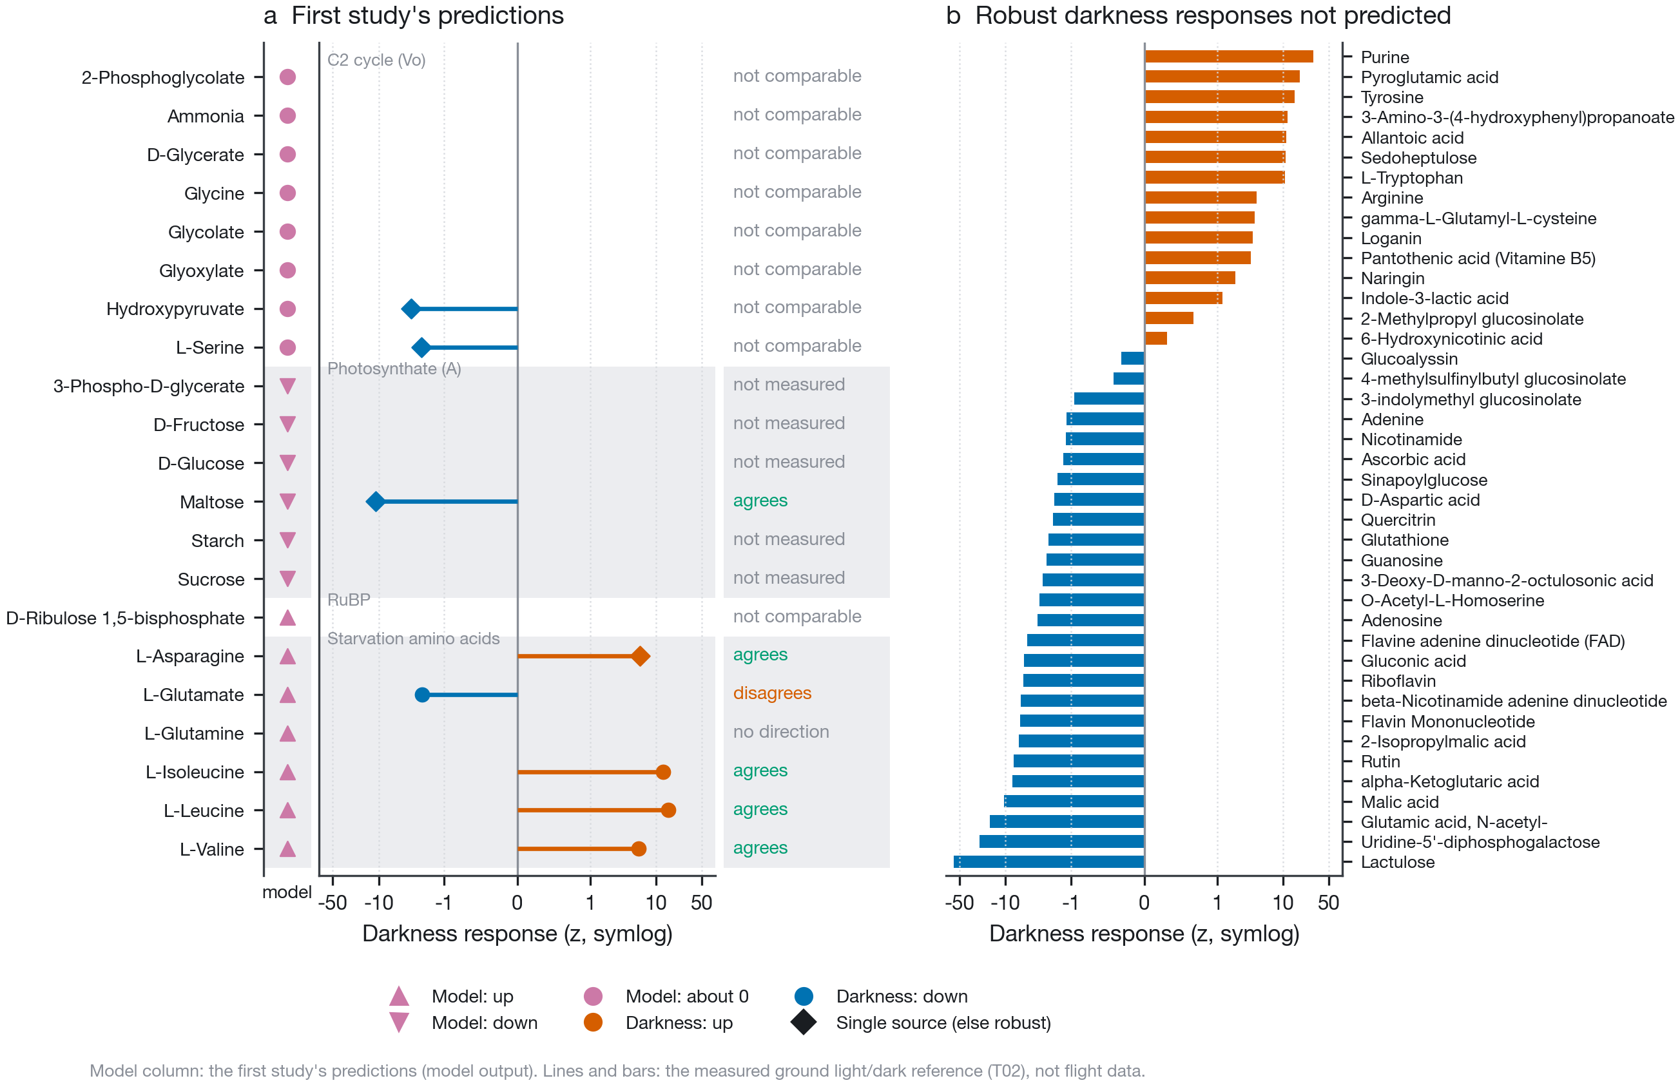
The first study’s metabolite predictions set against measured darkness. a, The 21 predicted compounds, grouped by the model’s driver. The model column gives the predicted direction in OSD-522 (model output); lines give the measured light/dark response as a standardised effect (T02; circles robust, diamonds single source). Verdicts follow the pre-registered rule (Methods); C$​_{2}$-cycle and RuBP predictions cannot be tested by darkness. “Not measured” and “no direction” are both untested: the first has no reference row, the second was measured without a directional response. The glutamate call rests on the 32 °C source only (Supplementary Table S2). b, Robust darkness responses the model did not predict.

A measured metabolite layer leaves the pathway result unchanged
We replaced the first study’s metabolite layer in PaintOmics with the reference: all 96 compounds, each valued at the model’s own carbon-deficit magnitude (0.13 log$​_{2}$) in its measured direction (0 for compounds without one), with the 45 robust compounds marked as changed. PaintOmics takes a metabolite layer as two files, a table of compound name and value and a list of “relevant” compounds. Its hub analysis tests each relevant compound with a binomial test of whether the share of differentially expressed genes linked to it in the KEGG network, directly or through up to three intermediate nodes (steps 1–4), exceeds the share in the whole dataset (Liu et al. 2022); the compound’s own value does not enter the test. The gene and protein files were byte-identical to the first study’s job, and the database, organism and settings unchanged (Methods). The layer is a ground reference, not a flight measurement: it says what carbon starvation does to these compounds, which is what the model claims lit flight is.
The pathway result did not move (Fig. 2a). The same 6 of 232 pathways passed a Benjamini–Hochberg false discovery rate (Benjamini and Hochberg 1995) of 0.05 in both jobs, led in both by protein processing in the endoplasmic reticulum (combined $p=8.65×{10}^{−9}$). The rank correlation of all combined $p$-values was 0.95. Glyoxylate and dicarboxylate metabolism, where the C$​_{2}$ cycle sits, moved from rank 214 to 193, still far from significance. Which pathways PaintOmics calls therefore did not depend on the first study’s unmeasured metabolite predictions.
The metabolite hubs changed only where the compound list changed (Fig. 2b). Leucine, valine, isoleucine and glutamate remained hubs, and malate, 2-oxoglutarate, glutathione, ascorbate, glucobrassicin, $γ$-glutamylcysteine and 2-isopropylmalate joined them (11 hubs from 32 compounds, against 7 from 15). The pre-registered check held: for every compound and step the two jobs share, the raw hub $p$-value was identical (16 compound-steps). PaintOmics returned a hub result for 32 of the 45 relevant compounds; the other 13, among them glucosinolates, flavonoids, purine and sedoheptulose, got none (listed in Supplementary Table S10).
Two post hoc control jobs test how far this goes (Supplementary Table S10). Without any metabolite layer (job E, K3ju047ZWB) the same 6 pathways passed (rank correlation 0.95). With each compound valued at its own measured effect size, rescaled to the same median (job F, L46ds55AiY), the pathway ranks did not change ($ρ=1.00$), the same 11 hubs passed, and every raw hub $p$-value was identical (128 compound-steps). Across pathways the combined $p$ followed the gene $p$ ($ρ=0.71$) more closely than the protein ($0.59$) or metabolite $p$ ($0.39$; 80 pathways have one). Hub status, by contrast, needed both gene-product layers: with genes alone (job G) or proteins alone (job H) and the same layer, none of job A’s 11 hubs remained. In this integration the gene-product layers decide the outcome, and the metabolite layer contributes its list of relevant compounds, not their values, as the design of the hub test implies. Because that test is judged against the dataset-wide share of differentially expressed genes, hub calls also depend on how many genes a contrast supplies, which the next section tests.
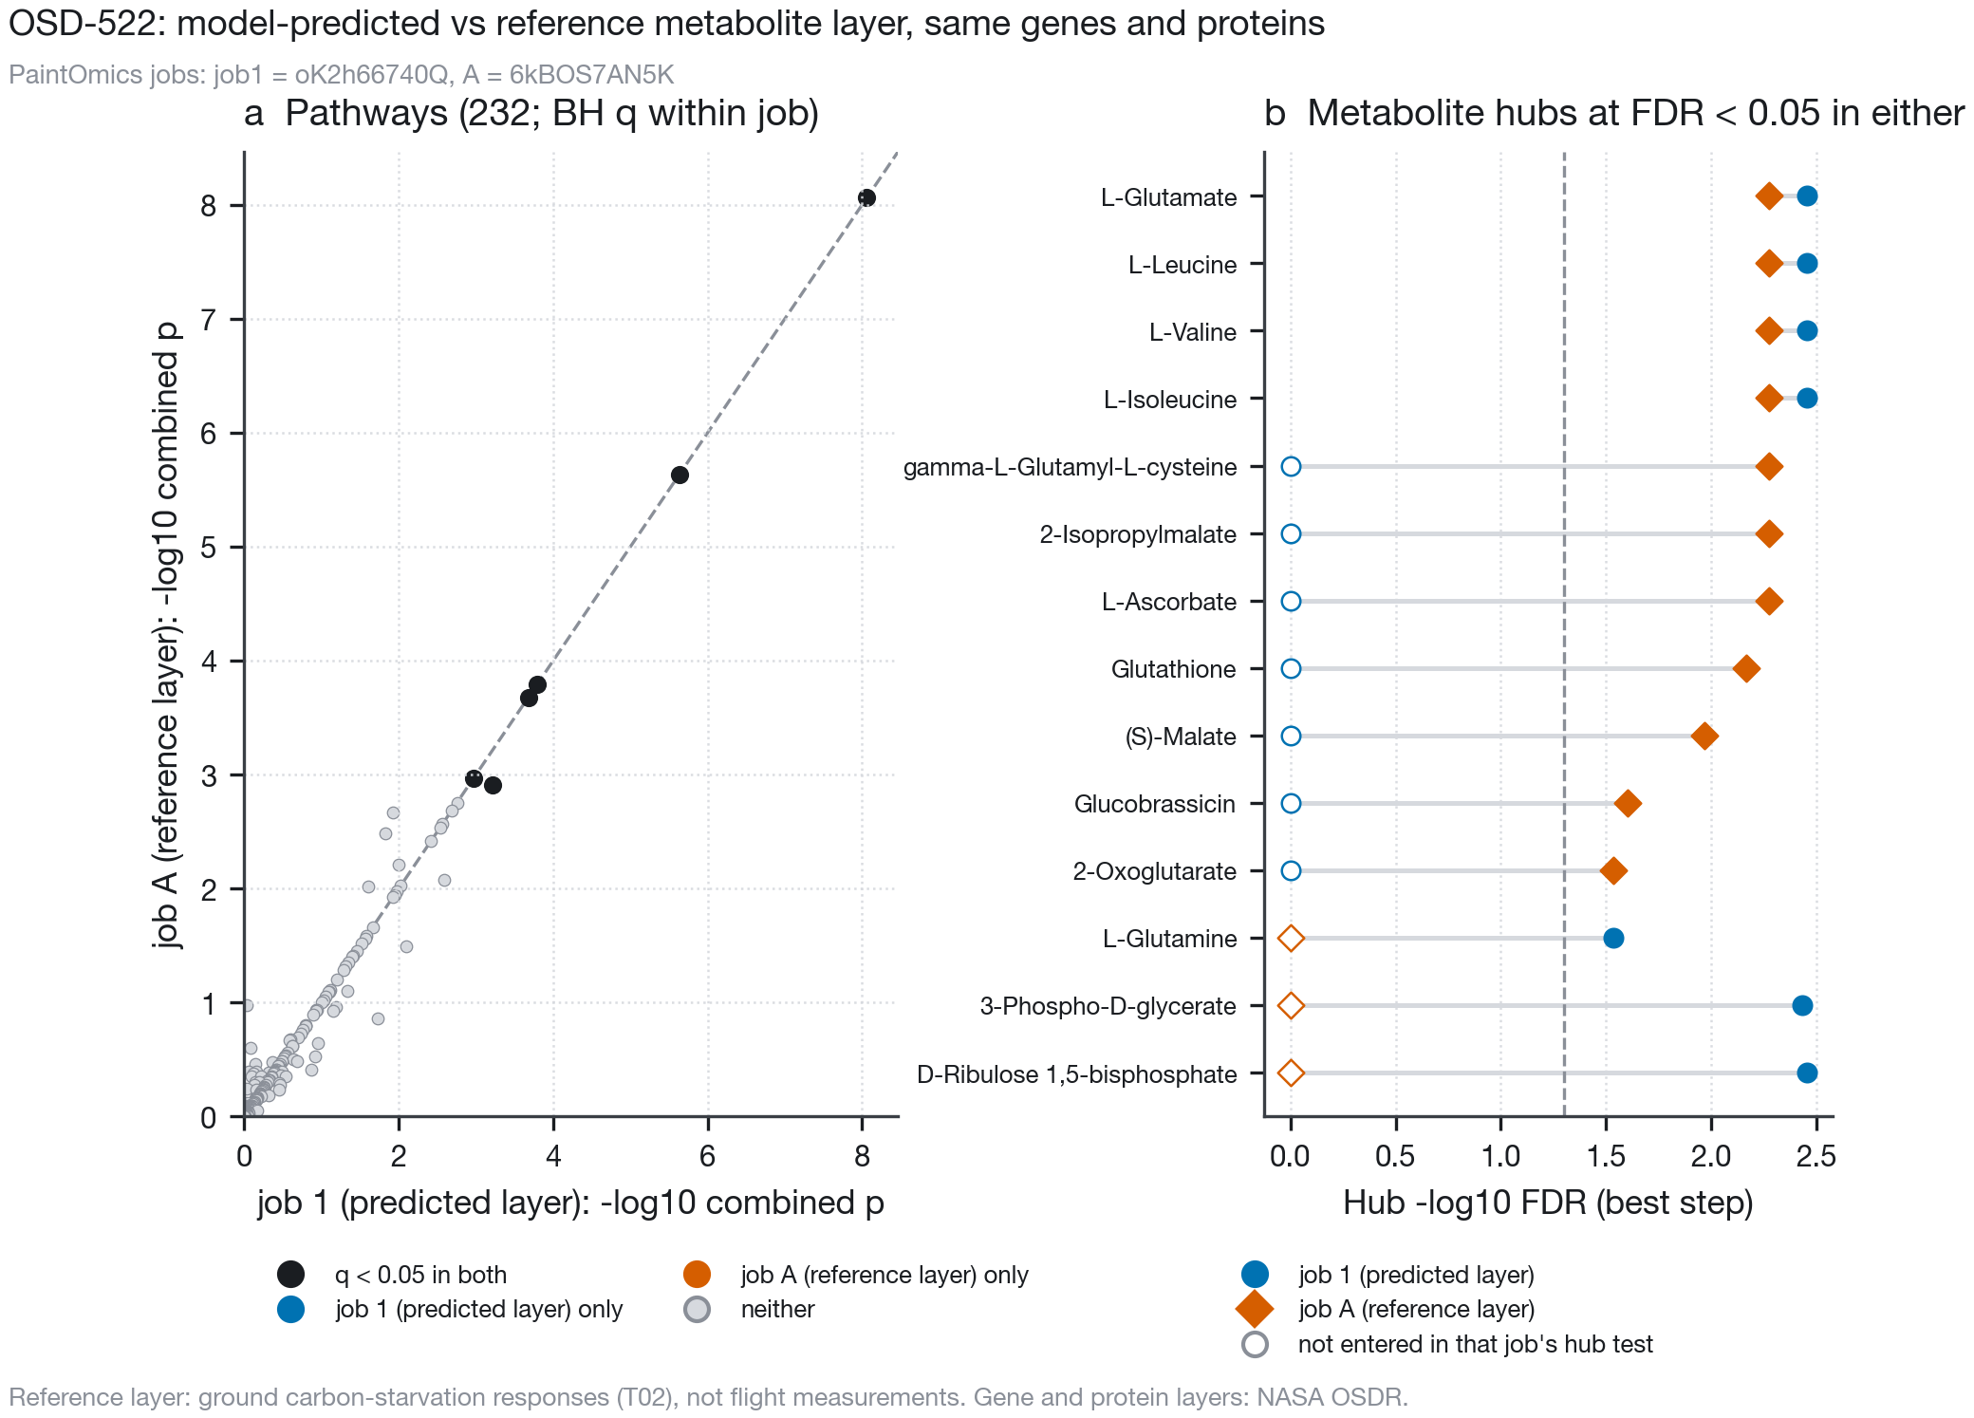
Replacing the predicted metabolite layer with the measured reference. OSD-522 genes and proteins are identical in both jobs (first study oK2h66740Q, job A 6kBOS7AN5K). a, Combined Fisher $p$ for all 232 pathways; colours mark BH $q<0.05$. b, Metabolite hubs at FDR $<0.05$ in either job; open symbols mark compounds not entered in that job’s hub test.

Light and dark flight in the same hardware
OSD-678 (Light has a principal role in the Arabidopsis transcriptomic response to the spaceflight environment 2023) grew Col-0 seedlings in the same CARA plates on the same flight, either in the ambient light of the station’s cabin wall (4–6 $μ$mol m$​^{−2}$ s$​^{−1}$) or wrapped in black-out cloth from germination, which makes it the one place where light can be compared without changing hardware, genotype or mission. We submitted both of its gene layers with the same reference metabolite layer (Fig. 3; jobs B, JfVZ1L37PY, and C, wgT3IPi7U2). The light contrast had more differentially expressed genes than the dark one (7,790 against 2,112 at an adjusted $p<0.05$) and more significant pathways (24 against 10); the two contrasts’ pathway rankings were only moderately related (rank correlation 0.51). Photosynthesis was the most significant pathway in the dark contrast ($p=1.03×{10}^{−12}$) and did not pass correction in the light one ($q=0.131$). Valine, leucine and isoleucine degradation was nominally significant in the dark ($p=0.00506$) and not in the light ($p=0.0854$).
In the light contrast 17 metabolite hubs reached FDR $<0.05$, against 5 in the dark. The branched-chain amino acids, glutamate and 2-oxoglutarate were hubs only in the light, which is the direction the model expects, but every light hub sat at the same adjusted value (0.044) just inside the threshold. That is the Benjamini–Hochberg step-up at work: it gives one adjusted value to raw $p$-values from $7.86×{10}^{−4}$ to $0.00729$ (Supplementary Table S11). The five shared hubs (malate, FAD, FMN, NAD$​^{+}$ and 2-isopropylmalate) were stronger in the dark.
The light contrast also had 3.7 times as many differentially expressed genes to place around its hubs, so we cut its relevant genes at random to the dark contrast’s number (post hoc, two draws, jobs K1 Y0V56yFW12 and K2 7725j3CkOp). No hub survived in either draw, and 1 and 0 pathways passed, against 5 hubs and 10 pathways in the dark: the light contrast’s extra hubs come from its extra genes. To compare the flight effect between light regimes without two separate thresholds, we fitted one model to the twelve Col-0 samples (edgeR TMM and limma-voom (Robinson and Oshlack 2010; Law et al. 2014; Ritchie et al. 2015), flight $×$ light; post hoc; Supplementary Table S9) and tested the interaction statistic with the rotation null. The model expects the starvation sets to respond more to flight in light. They did not: the interaction was null for the DIN set ($z=0.0$) and for branched-chain catabolism ($z=0.1$). It was large for the photosystem and light-harvesting set ($z=−11.5$, $q=5.50×{10}^{−4}$) and for the four KEGG carbon pathways ($z$ from $−5.6$ to $−2.4$), because flight raised photosynthesis genes in darkness ($z=12.5$) and lowered them in light ($z=−6.5$).
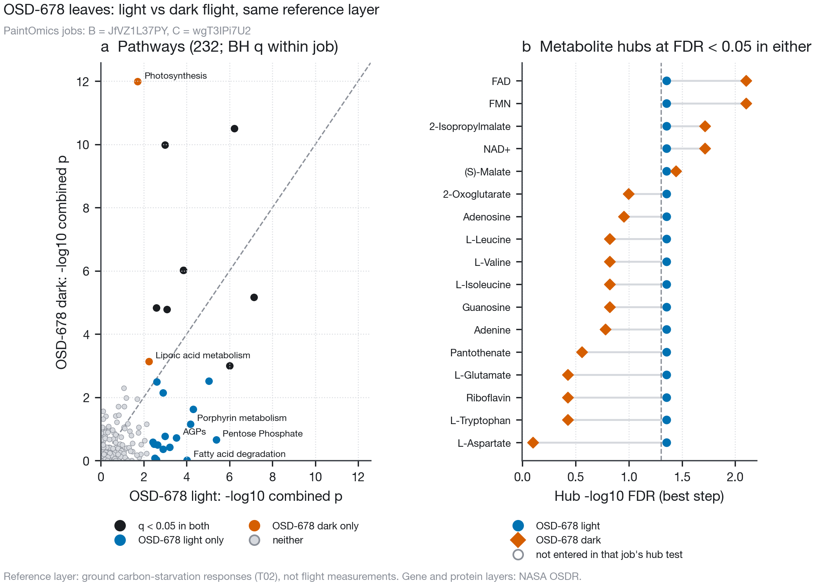
OSD-678 light and dark flight contrasts with the same reference layer. PaintOmics jobs B (JfVZ1L37PY, light) and C (wgT3IPi7U2, dark). a, Combined Fisher $p$ for all pathways; the four most separated single-contrast pathways on each side are named. b, Metabolite hubs at FDR $<0.05$ in either contrast; the light hubs share one Benjamini–Hochberg value (raw $p$ in Supplementary Table S11).

Pre-registered light/dark gene-set tests
Before any gene-set statistic was computed on a flight contrast, we committed six gene sets, the predicted outcome for each in lit and dark flight contrasts, and every test setting (prereg/PREDICTIONS.md; Table 2). Two sets are signed: the first study’s carbon-starvation (DIN) set, re-tested here, and KEGG’s valine, leucine and isoleucine degradation pathway (ath00280, 53 genes (Kanehisa and Goto 2000; KEGG REST API, n.d.)), the catabolic route of the strongest darkness response. Four come from the Wu GWAS: genes in loci found only under control, only under the darkness stress, under both, and in the loci of metabolites with a directional darkness response. For OSD-522 the null was every one of the 924 ways to relabel its twelve samples. The other five contrasts were tested on GeneLab’s published statistics, with too few replicates for a useful sample permutation (three per arm in OSD-38 and OSD-678) or samples that could not be assigned to an arm from their names, so their null was a genomic rotation that moves a set along the genome and keeps its size and clustering (Methods).
Of the 36 outcomes, 18 matched (Fig. 4), but the matches are not where the model needs them. In the lit contrasts none of the predicted signals passed correction: 5 of 18 lit outcomes matched, all of them comparator sets predicted to stay flat. The DIN set leaned upward in all three lit contrasts (OSD-522 $p=0.0281$, OSD-678 light $p=0.089$, OSD-427 $p=0.0318$; $q≥=0.127$ throughout), and so did branched-chain catabolism in OSD-678 light ($p=0.0397$, $q=0.143$). For OSD-522 the first study had reported the DIN set at $p=0.0026$ by Mann–Whitney, and the same test here reproduces that value; under the sample permutation, which keeps the correlation between genes, it weakens to $p=0.0281$.
The dark contrasts carried the strongest signals of all, where the model predicts none. The DIN set fell in both BRIC-PDFU experiments (OSD-38 (Proteomics and Transcriptomics analysis of Arabidopsis Seedlings in Microgravity 2015), $q=0.0108$; OSD-321 (Relevance of Unfolded Protein Response to Spaceflight-Induced Transcriptional Reprogramming in Arabidopsis 2021), $q=0.0018$) and rose in the leaves of dark-grown CARA seedlings (OSD-678 dark, $q=0.0048$). Branched-chain catabolism followed it, down in OSD-321 ($q=0.0018$) and up in OSD-678 dark ($q=0.009$). The natural-variation GWAS sets gave nothing light-specific: the stress-only and darkness-metabolite loci were never enriched after correction, and the one significant enrichment, of shared loci in OSD-678 light ($q=0.0114$), was in a comparator set the model makes no claim about.
Post hoc diagnostics qualify these calls (Supplementary Tables S5–S8, Figs S2 and S3). The rotation null is calibrated: on 12,000 random gene sets and contiguous genomic blocks of 5 to 2,000 genes across the six contrasts it rejected a median 0.045 of random sets and 0.045 of blocks at $α=0.05$ (range 0.010–0.090), while a naive random-gene null rejected up to 0.205 of blocks, the inflation that gene clustering causes. Sample permutation cannot confirm the 3-versus-3 contrasts: with 20 labellings its smallest $p$ is 0.1, which the DIN set reached in OSD-38 ($p=0.1$) but not in OSD-678 dark ($p=0.4$), where one of the three flight samples carries the rise (Supplementary Table S8). No single DIN gene drives the set: leaving out each in turn kept it significant in OSD-38, OSD-321 and OSD-678 dark (largest $p=0.04$). Mixing pipelines does not explain the dark results either: PyDESeq2 run on OSD-38’s raw counts, as for OSD-522, agreed with GeneLab’s statistics (Spearman 0.988 over 27,309 genes), and the DIN fall strengthened ($p=5.00×{10}^{−4}$).
Pre-registered gene sets and predictions. Statistic: signed sets test the mean gene statistic, unsigned sets the mean absolute statistic, each against the rest of the genome. Lit contrasts: OSD-522, OSD-678 light, OSD-427. Dark: OSD-38, OSD-321, OSD-678 dark. Members are in prereg/gene_sets.tsv; all 36 results, with set statistic, $z$, $p$ and $q$, are in Supplementary Table S5.
Set | Genes | Definition | Statistic | Lit | Dark
DIN (first study) | 5 | KEGG gene descriptions matching DIN$n$, the first study’s rule | signed | up | none
BCAA degradation | 53 | KEGG ath00280 | signed | up | none
Wu stress-only | 491 | Genes of GWAS regions found only under 32 °C darkness | unsigned | enriched | none
Wu darkness metabolites | 540 | Loci of metabolites with a directional darkness response | unsigned | enriched | none
Wu control-only | 301 | Genes of GWAS regions found only under control | unsigned | none | none
Wu shared | 1,954 | Genes of GWAS regions found under both | unsigned | none | none
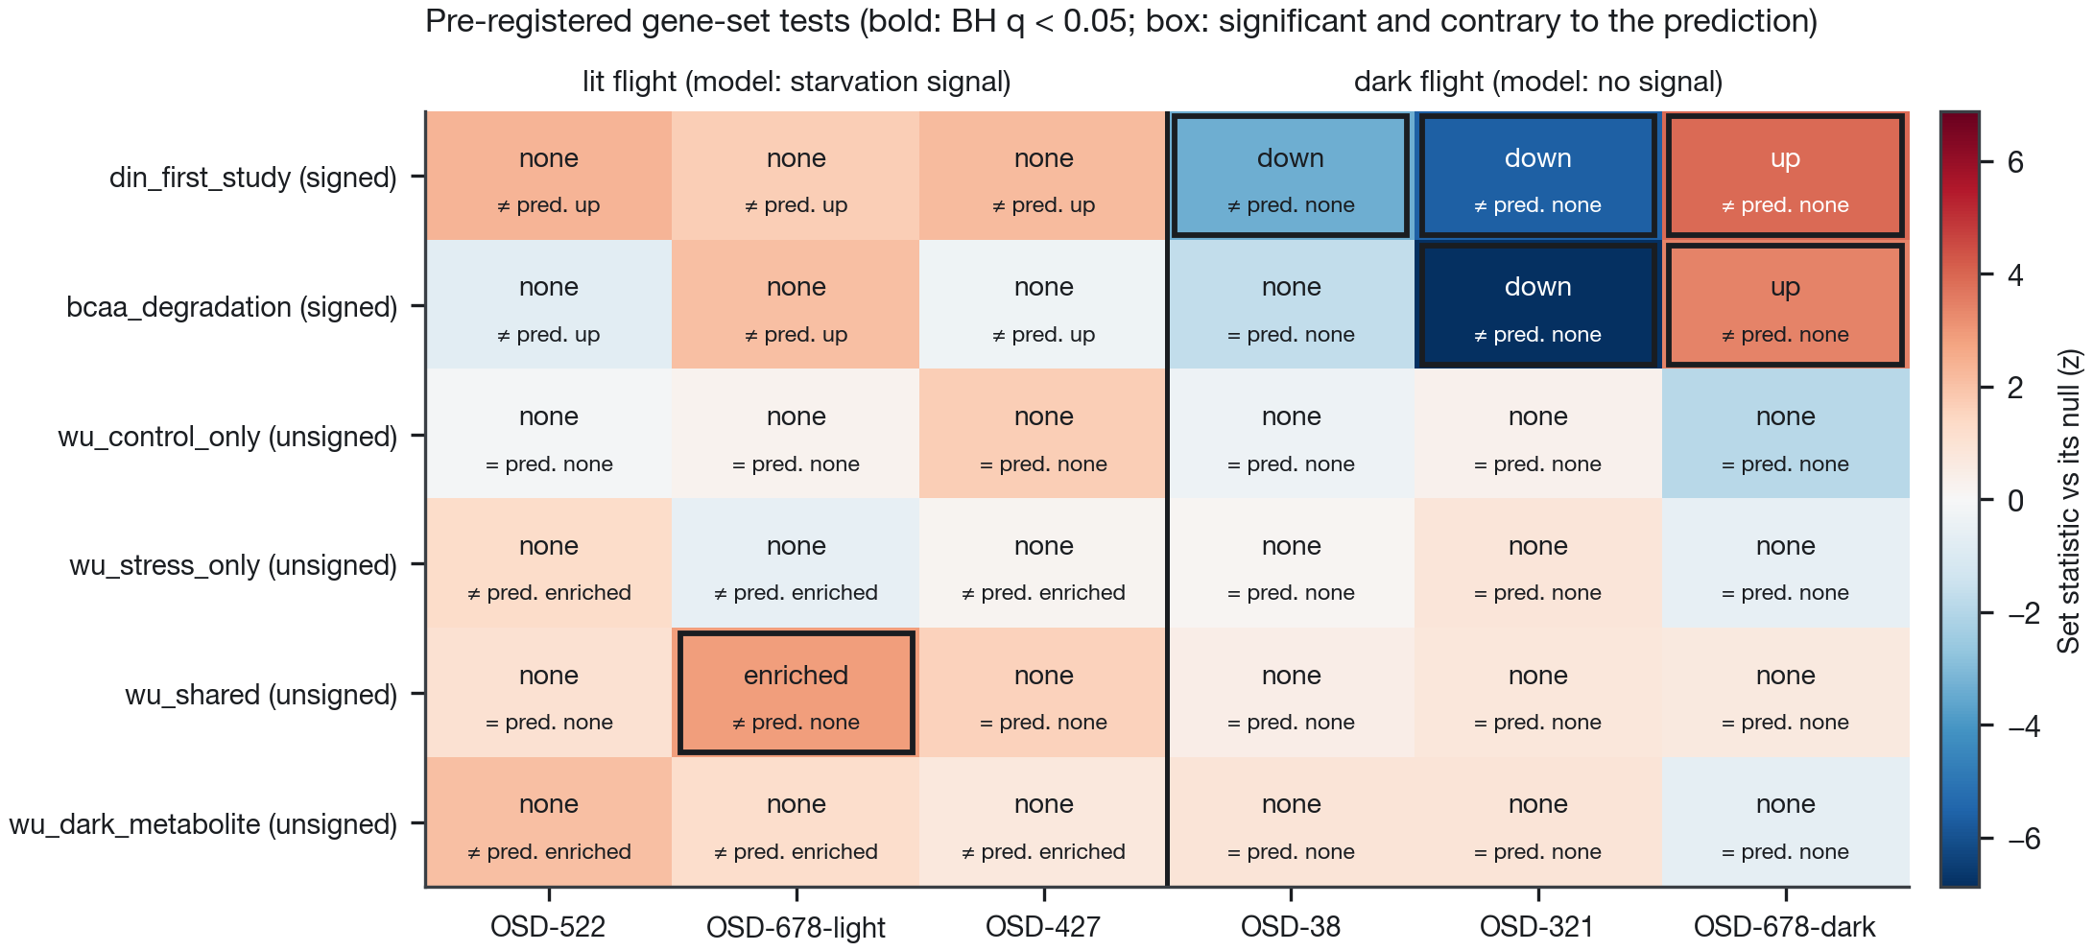
Pre-registered light/dark gene-set tests. Colour: the set statistic against its null as a $z$-score (OSD-522, sample permutation; others, genomic rotation). Each cell gives the observed outcome (bold where BH $q<0.05$ over the 36 tests) and whether it equals ($=$) or contradicts ($≠$) the prediction; boxes mark significant contradictions.

What a targeted GC-MS panel would need
To ask whether the predicted metabolite shifts could be measured on archived flight material, we estimated per-compound replicate variance from Col-0 wild-type control groups in MetaboLights GC-MS studies (Yurekten et al. 2024): 19 groups in 6 studies (Sanchez et al. 2008; Abraham et al. 2016; Fàbregas et al. 2018; Zhang and Fernie 2022), 29 compounds from the model’s predictions and the reference (Fig. 5). The median within-group standard deviation of log$​_{2}$ intensity ran from 0.31 (sucrose) to 1.21 (isoleucine).
With six plants per arm, OSD-522’s RNA-seq design, the smallest change detectable at 80 % power was 0.56 log$​_{2}$ (1.48-fold), for sucrose. The model’s predicted 0.13 log$​_{2}$ shift would need 92 to 1,342 plants per arm, and its 0.035 log$​_{2}$ shift at OSD-522’s own growth light at least 1,293. A two-fold change, the scale of the measured darkness responses, would need at most 24. A panel tests many compounds at once; with Bonferroni correction over the 29 compounds the smallest detectable change at six per arm rose to 0.96 log$​_{2}$ (1.94-fold), 0.13 log$​_{2}$ would need 186 to 2,702 plants per arm, and a two-fold change at most 49 (Fig. 5, open symbols). The variance sources are listed in Supplementary Table S14. One of them, MTBLS363, is the deposit of a CAM study in Agave (Abraham et al. 2016) that also profiled an untreated Arabidopsis Col-0 day–night series; only that Arabidopsis assay (8 timepoints, 24 rosettes) was used.
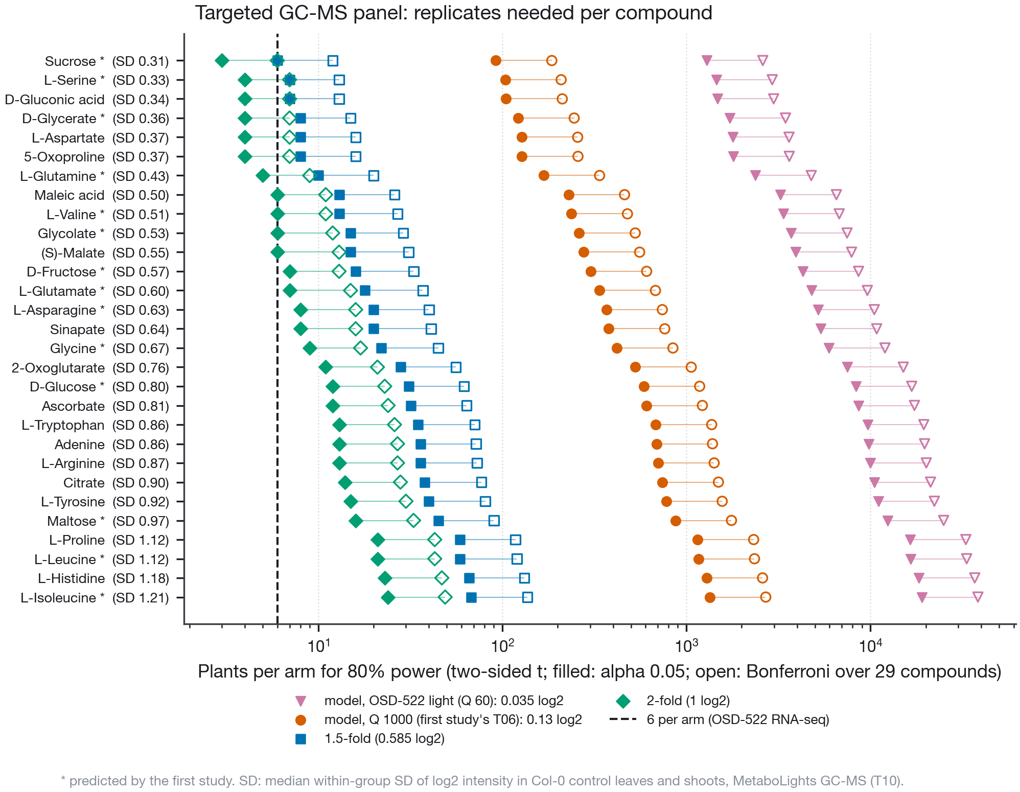
Plants per arm for a targeted GC-MS panel. Two-sided two-sample $t$-test, 80 % power; filled symbols $α=0.05$ unadjusted, open symbols Bonferroni over the 29 compounds. Effects: the model’s OSD-522 shift (0.035 log$​_{2}$) and its 0.13 log$​_{2}$, 1.5-fold (0.585 log$​_{2}$) and two-fold. Variance from Col-0 control groups in MetaboLights GC-MS studies (Supplementary Table S14). Asterisks mark compounds the first study predicted.

A dark sealed BRIC with a proteome
OSD-38 (BRIC-20) grew Col-0 seedlings for about three days in darkness on 0.5x MS with 1 % sucrose, in sealed BRIC-PDFU canisters on the station and on the ground, and measured their transcriptome and the iTRAQ proteomes of a membrane and a soluble fraction (Proteomics and Transcriptomics analysis of Arabidopsis Seedlings in Microgravity 2015; Kruse et al. 2020). The same study holds a GeneLab ground comparator: on the ground, 22 plates were sealed in PDFUs inside BRIC canisters at Kennedy Space Center and 22 were wrapped in foil in opaque, air-tight plastic containers at Ohio University; both sets were held cold for 4 days, grown for 76 h in darkness and fixed in RNAlater, and GeneLab’s contrast compares three samples of each (Proteomics and Transcriptomics analysis of Arabidopsis Seedlings in Microgravity 2015; Basu et al. 2017). The two arms differ in hardware, site and handling, so we read it as a comparator, not as an isolated hardware effect. We added both under a second pre-registration, committed before any OSD-38 protein or hardware statistic was computed (prereg/osd38/). It covers nine gene sets in four layers; the first study’s model predicts no signal for any of them in dark flight.
OSDR’s processed protein tables are truncated. Both the CSV and the spreadsheet copies stop at 65,535 data rows, the old spreadsheet row limit, and OSDR lists one version of each, from 2017 (Supplementary Table S12). The membrane table holds two acquisitions in sequence; the first (2,828 protein groups, numbered up to 2,948) ends before the cut and was used whole, giving 2,000 quantified proteins. The soluble table stops inside its 438th protein group, so only groups 1–437 could be used, as a secondary layer; they hold 433 loci, because 4 loci occur in two groups, and no locus was lost to the filters. Quantified by the paper’s rules, the membrane layer gave 97 proteins at the paper’s threshold, against the 103 the paper reports (Kruse et al. 2020).
In OSD-38, transcripts and proteins of carbon metabolism moved in opposite directions (Fig. 6). All four KEGG carbon pathways rose in the transcriptome (glyoxylate and dicarboxylate, carbon fixation, starch and sucrose, glycolysis; $q≤0.00128$), as did the photosystem and light-harvesting set ($z=4.6$), while the DIN set fell ($z=−3.4$); these transcript rows re-test what the first study reported. In the membrane proteome the same four pathways fell in the membrane fraction ($z$ from $−2.6$ to $−4.2$, $q$ from $4.60×{10}^{−4}$ to $0.0144$). This held against random protein sets matched for abundance (PSM count; $p$ from $2.00×{10}^{−4}$ to $0.0094$), the protein statistic was unrelated to abundance ($ρ=−0.04$), and a moderated (limma) $t$ gave the same verdicts ($q$ from $5.00×{10}^{−4}$ to $0.0145$; post hoc, Supplementary Table S12). Whether this reflects how much of each enzyme the seedlings made, or how it partitioned into the 100,000 $g$ membrane pellet, these tables cannot say: for the 366 proteins quantified in both fractions, membrane and soluble fold changes were unrelated ($ρ=−0.08$), and carbon-pathway members in the soluble subset were not lower in flight (mean log$​_{2}$ fold change 0.03 to 0.12). The protein result therefore applies to the membrane fraction. Branched-chain amino acid degradation, the catabolic route of the strongest darkness response, did not move in either layer ($z=−1.7$ for transcripts and $−0.4$ for 17 membrane proteins). The DIN, fermentation, hypoxia and photosystem sets had too few measured proteins to test. Across all proteins, protein and transcript changes were only weakly correlated ($ρ=0.18$ for the membrane fraction, $0.11$ for the soluble subset; $0.04$ over 4,266 proteins in OSD-522). The truncated soluble subset showed no significant set.
In the ground comparator, the pre-registered hypoxia and fermentation sets did not rise in the BRIC-PDFU against the air-tight container ($z=−0.3$ and $0.9$), the outcome derived from the first study’s enclosure mass balance. Carbon fixation and glyoxylate and dicarboxylate metabolism rose in the BRIC ($q=4.60×{10}^{−4}$ and $=0.0161$) and starch and sucrose fell ($q=8.62×{10}^{−4}$). Of the 23 testable primary OSD-38 outcomes, 8 matched the predictions.
A positive control shows that this null is partly uninformative (post hoc; Supplementary Table S13). In three independent hypoxia datasets, Ws roots at low oxygen under hypobaria (Dissecting Low Atmospheric Pressure Stress: Transcriptome Responses to the Components of Hypobaria in Arabidopsis [Experiment 2] 2017; Zhou et al. 2017) and Col-0 shoots and roots after 2 h of hypoxia (Mustroph et al. 2009; Immunopurified mRNA-ribosome complexes expose cell-type specific plasticity in response to hypoxia in Arabidopsis 2009), the fermentation set rose strongly ($z=9.6$, $8.6$ and $6.8$), but the hypoxia-responsive set, defined by gene annotation and with 2 of its 3 genes on the array, did not respond to hypoxia at all, so its null in the comparator says nothing. The fermentation set’s null, in turn, hides its strongest member: pyruvate decarboxylase PDC1 rose 6.3-fold in the BRIC ($q=2.76×{10}^{−5}$) while the set’s other genes did not, and alcohol dehydrogenase ADH1, which is not in the set, rose 6.8-fold. We therefore added, after seeing these results, a signature from independent data (an addendum to the revision plan, committed before it ran): the 111 genes up more than two-fold in both GSE14502 tissues. It rose in OSD-136 ($z=22.2$) and rose strongly in the BRIC-PDFU against the container ($z=13.0$, $q=3.00×{10}^{−4}$), while the matching down signature fell ($z=−2.9$). On the ground, seedlings in the sealed BRIC-PDFU carry the transcript signature of low oxygen relative to the air-tight container. In flight against ground, both in BRIC-PDFU, the signature was slightly lower in flight ($z=−3.2$, $q=0.002$). Across all genes, the flight effect was weakly anti-correlated with the comparator effect ($ρ=−0.15$; exploratory).
Submitted to PaintOmics with the same reference layer (job D), OSD-38’s genes and membrane proteins gave 25 pathways at FDR $<0.05$, against 6 for OSD-522’s lit canister (job A). Only 1 pathway was shared, and the rank correlation was $0.21$ (Fig. 7). Of the metabolite hubs, 6 were shared by the lit and the dark canister: leucine, isoleucine, glutamate, malate, 2-oxoglutarate and 2-isopropylmalate. The first study read these hubs as signs of lit-canister starvation; they appear in the dark too. The overlap is no larger than chance, however (post hoc; Supplementary Table S11). Two hub sets of these sizes drawn from the same 32 tested compounds share 7.2 on average (hypergeometric $P(≥6)=0.91$), or 7.3 with hub labels shuffled within tertiles of KEGG reaction count ($P=0.93$), and in no job did hubs differ significantly from other tested compounds in KEGG reaction count (Mann–Whitney $p≥0.10$). Job D’s hubs largely survived with genes alone (16 of 21, job I) and vanished with membrane proteins alone (job J). Hub calls therefore do not separate the lit from the dark canister.
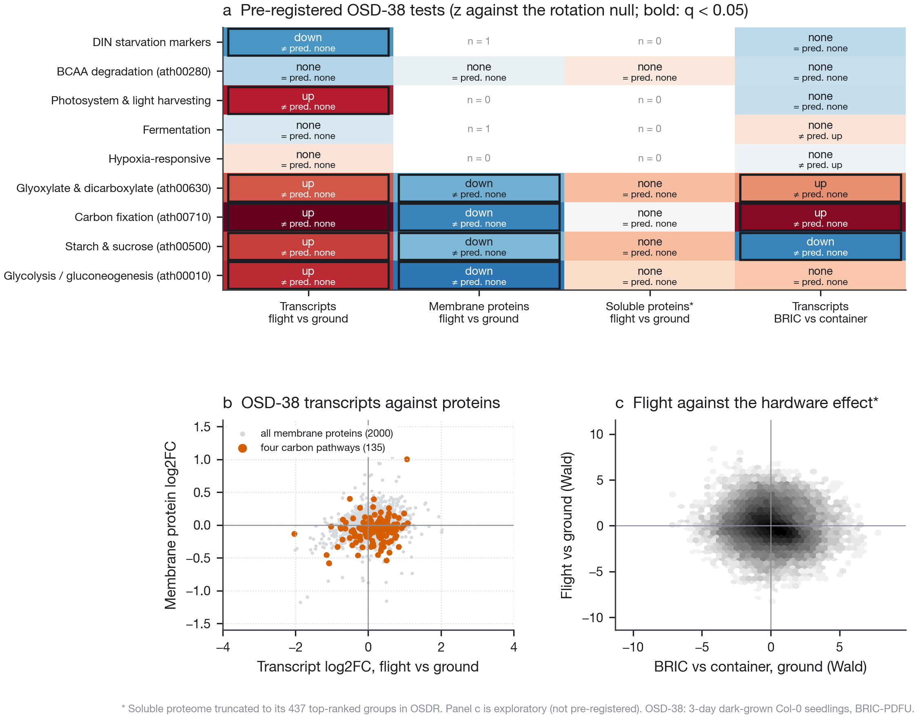
OSD-38: a dark sealed BRIC with a proteome. a, Pre-registered gene-set tests in four layers ($z$ against the rotation null; bold where BH $q<0.05$; boxes mark significant contradictions of the prediction; $n$ = measured members where fewer than three). The soluble proteome is the 437 top-ranked groups left in OSDR’s truncated table. b, Transcript against membrane-protein log$​_{2}$ fold change, flight vs ground; red, members of the four KEGG carbon pathways. c, Exploratory: the flight effect against the GeneLab ground comparator (BRIC-PDFU vs air-tight container), all genes.
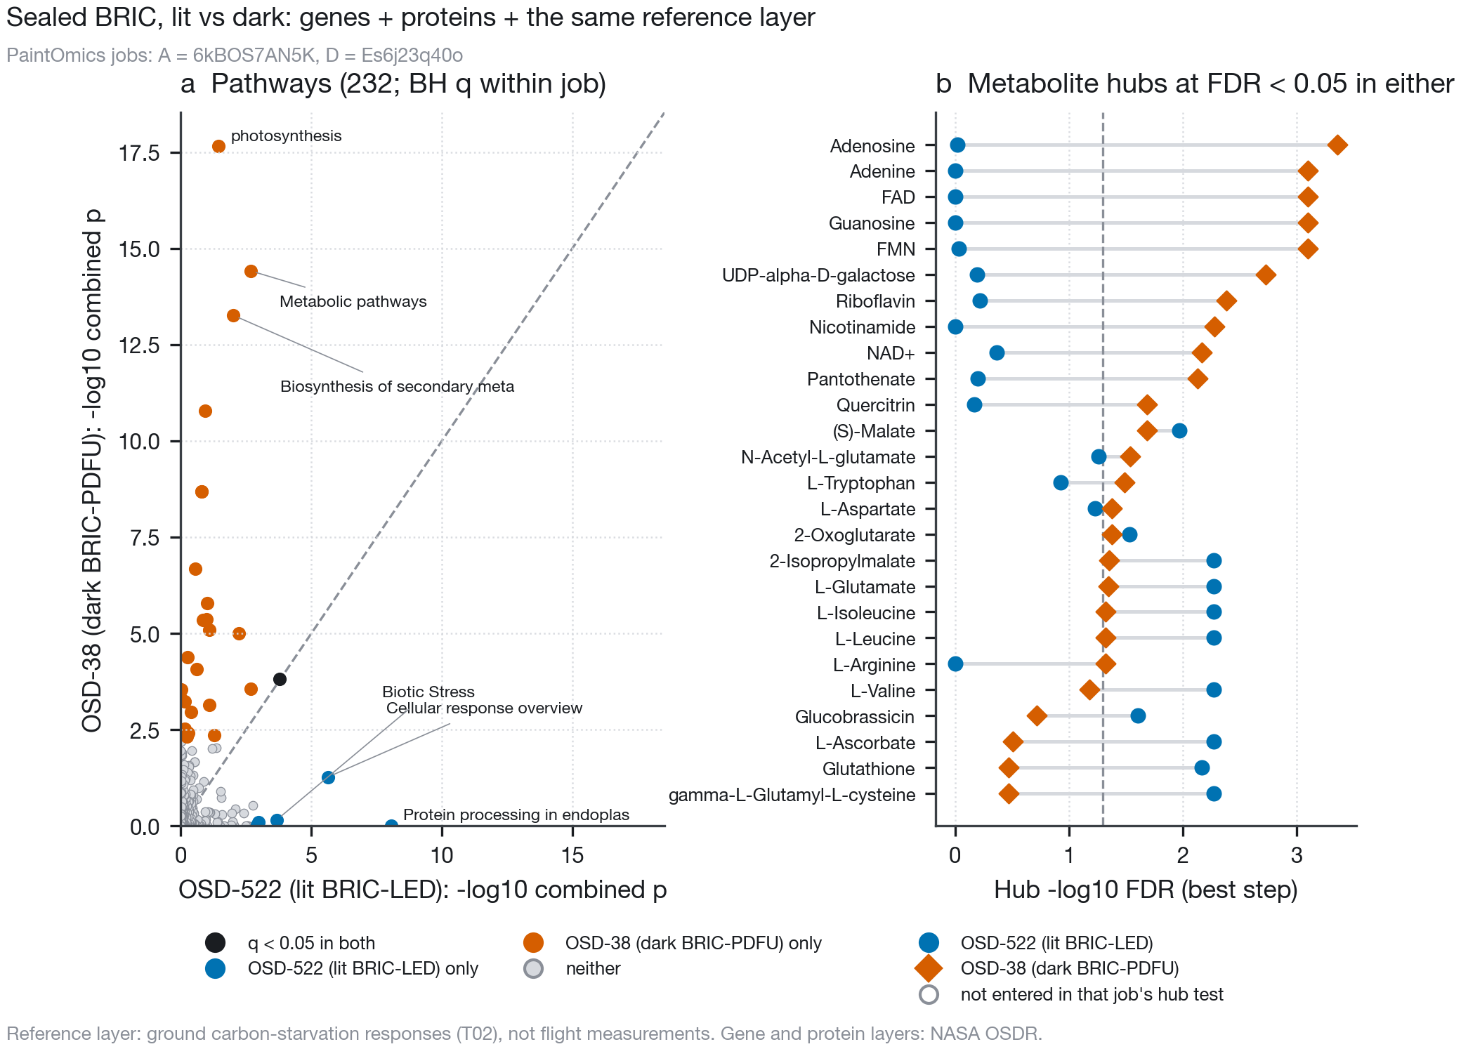
Sealed BRIC, lit (OSD-522, job A 6kBOS7AN5K) against dark (OSD-38, job D Es6j23q40o). Both jobs carry genes, proteins and the same ground reference metabolite layer. The 6 shared hubs are no more than two hub sets of these sizes share by chance (Supplementary Table S11). a, Combined Fisher $p$ for all pathways. b, Metabolite hubs at FDR $<0.05$ in either job.

Discussion
Table 3 sets the two studies side by side. Under extended darkness, the measured data show the branched-chain amino acids and asparagine rising and maltose falling, as the model predicted (Barker 2026a), at every threshold we tried. They also correct the model in detail. Glutamine does not move, the starvation amino acids differ several-fold in how strongly they respond, and the TCA-cycle acids the model declined to predict fall consistently. Glutamate falls only in the 32 °C source, so whether it contradicts the model is open. None of this tests the gas-transport mechanism itself: darkness cannot score the C$​_{2}$-cycle and RuBP predictions that carry it.
The light/dark prediction fares worse. Because the model’s mechanism runs through photosynthesis, its signature is predicted to appear in light and vanish in the dark (Barker 2026a). With nulls that respect gene correlation and predictions fixed in advance, no lit contrast produced a significant starvation signal, while three dark contrasts produced the strongest ones in the dataset, and a single model of OSD-678 showed no larger starvation response to flight in light than in darkness. The first study reported that the difference between its starvation and photosynthesis gene sets separated lit from dark experiments (Barker 2026a). Testing the starvation set on its own shows why that ordering is not a light effect: the starvation genes themselves move most in darkness, in opposite directions in BRIC-PDFU seedlings and in CARA leaves.
The first study and this one, claim by claim.
Claim | First study (Barker 2026a) | This study
Starvation amino acids rise together | Predicted together, one shared gain of 1, unfitted | Leu, Ile, Val, Asn rise; Glu falls in the 32 °C source only; Gln has no direction; Leu responds 2.7–2.8 times as strongly as Val or Asn
TCA-cycle acids | Not predicted (direction uncertain) | Malate and 2-oxoglutarate fall robustly, each in two sources
Metabolite layer in PaintOmics | 21 predicted compounds | 96 measured compounds, no layer or rescaled values: pathways unchanged; job A’s hubs need genes and proteins together
Lit flight shows a starvation signal | DIN up in OSD-522 ($p=0.0026$, Mann–Whitney) | Leans up in all three lit contrasts; none significant after correction under gene-correlation-aware nulls
Dark flight shows none | Predicted none; dark inversions unexplained | Strongest signals are in dark-grown seedlings (gene-level null; too few plants for sample permutation); sign differs between BRIC canisters and CARA plates
Metabolite shifts are measurable | Proposed a 20–30 compound panel on archived material | Needs 92–1,342 plants per arm for 0.13 log$​_{2}$
Transcripts stand in for metabolism | Read pathways and hubs from transcripts | In dark BRIC flight (OSD-38) carbon-pathway transcripts rise while the same enzymes fall in the membrane fraction
Starvation hubs mark the lit canister | Seven hubs at FDR $<0.05$, all starvation or supply nodes | Six of them are hubs in the dark BRIC too, an overlap no larger than chance; hub calls follow gene counts
Enclosure atmosphere matters | Mass balance: a dark BRIC loses O$​_{2}$ over days | Ground comparator: pre-registered sets null, but an independent low-oxygen signature rises strongly in the BRIC-PDFU (post hoc)
Both the first study’s starvation reading (Barker 2026a) and every PaintOmics integration here read metabolism from gene products, mostly transcripts. OSD-38 is the one dark sealed-BRIC flight with a proteome, and there the carbon pathways’ transcripts rose while their proteins fell in the membrane fraction; the soluble subset did not follow, so the result may reflect how these enzymes partition between fractions as much as how much of them was made. Kruse et al. saw the same decoupling gene by gene: nearly 30 % of the 17 genes that changed at both levels moved in opposite directions, and they pointed to post-transcriptional regulation (Kruse et al. 2020). At the pathway level it means a transcript signature is not a reliable proxy for the enzyme complement, and still less for metabolite pools, as broader surveys of mRNA and protein levels (Liu et al. 2016) and diurnal profiling of Arabidopsis rosettes, in which enzyme activities change more slowly than their transcripts after transfer to darkness (Gibon et al. 2006), also show. For spaceflight studies that infer metabolism from transcriptomes alone, including the first study, pathway calls are best read as statements about gene expression, not about enzyme or metabolite levels. The hub result points the same way. The branched-chain amino acid and glutamate hubs that the first study attributed to a lit-canister carbon deficit appear in a dark canister with no assimilation to lose, at an overlap no larger than chance, and in OSD-678 the light contrast’s hubs disappeared when its gene list was cut to the dark contrast’s length. Hub status reflects how many genes change around a compound in the network, not why they change.
Why the dark contrasts carry the signal we cannot say from these data, and we offer possibilities to test rather than conclusions. In all three dark contrasts both arms are seedlings grown in darkness from germination (Proteomics and Transcriptomics analysis of Arabidopsis Seedlings in Microgravity 2015; Relevance of Unfolded Protein Response to Spaceflight-Induced Transcriptional Reprogramming in Arabidopsis 2021; Light has a principal role in the Arabidopsis transcriptomic response to the spaceflight environment 2023), so the flight-versus-ground contrast compares two starved states, and a difference in the starvation programme means the flight seedlings were starved more, less or differently than their ground controls. The direction is not consistent: the programme is lower in flight in the two BRIC-PDFU canister experiments and higher in the CARA plates, which differ in hardware (a sealed canister against a plate on the cabin wall) and in what was sequenced (whole seedlings against dissected leaves). Either way, a carbon-starvation programme may respond to spaceflight conditions other than those the boundary-layer mechanism addresses, because in the dark there is no assimilation for it to reduce. OSD-38’s seedlings also grew on 1 % sucrose (OSDR protocol), which makes classical carbon starvation unlikely in either of its arms and leaves the cause of its DIN fall open. One candidate is oxygen. On the ground, seedlings in the sealed BRIC-PDFU carried a low-oxygen transcript signature relative to an air-tight container, and in flight that signature was slightly weaker than in the ground BRIC. The DIN set itself rose under hypoxia in the GSE14502 roots ($z=2.9$), so the dark contrasts may compare two oxygen states as well as two carbon states. These signals also rest on gene-level nulls: with three plants per arm, sample permutation cannot confirm them, and in the OSD-678 dark contrast one flight sample carries the DIN rise.
This study has limitations. The reference is ground darkness, a far larger perturbation than a 9 % assimilation deficit and one that also starts senescence and nitrogen remobilisation, so it fixes directions rather than flight magnitudes, and its use as a stand-in for flight rests on the first study’s hypothesis. The sources differ in age, tissue, photoperiod, sampling time and platform (Table 1), Zhu’s papers do not state the temperature in darkness, and Wu’s time-course columns are labelled 20 and 30 where its text gives 21 and 32 °C. The Caldana plants are Col-0 according to the authors’ deposit (Transcription profiling by array of Arabidopsis after exposure to different temperatures and light levels 2011) and Wu et al. (Wu et al. 2018); we could not read the Caldana paper itself. The reference covers secondary metabolism poorly, because specialised metabolites map to KEGG poorly. Gene-set tests on GWAS regions include many genes that do not cause the association, which dilutes any signal.
The five contrasts other than OSD-522 were tested with a rotation null; it is calibrated on random sets and genomic blocks, but it treats genes, not plants, as the unit, and OSD-38 and OSD-678 have three replicates per arm, too few for a sample permutation to reach significance. OSD-678’s light arm was the cabin’s ambient light of 4–6 $μ$mol m$​^{−2}$ s$​^{−1}$ (Light has a principal role in the Arabidopsis transcriptomic response to the spaceflight environment 2023), well below OSD-522’s 60, where the model’s deficit is smaller still, so its light/dark comparison is a weak test of the model’s light dependence. PaintOmics hub counts rise with the number of differentially expressed genes, which differs 3.7-fold between the two OSD-678 contrasts; at equal numbers the light contrast had no hubs. The GC-MS variance pools leaf and shoot studies from different laboratories and timepoints.
OSDR’s OSD-38 protein tables are truncated, so the soluble layer is a top-ranked subset and the membrane layer one of two acquisitions; re-searching the raw iTRAQ files, which OSDR holds, would recover the rest and is left for future work. iTRAQ compresses ratios, which shrinks protein fold changes but should not reverse them. The membrane fraction is a 100,000 $g$ pellet rather than total protein, and the two fractions disagree, so the protein result is a statement about that fraction. The GeneLab ground comparator differs in site (Kennedy Space Center against Ohio University) and in handling as well as in enclosure, and the container’s gas volume is not reported (Proteomics and Transcriptomics analysis of Arabidopsis Seedlings in Microgravity 2015; Basu et al. 2017); its hypoxia signature locates the difference in oxygen but not its cause. The pre-registration was written by the same analyst on the same day as the tests, after the reference had been built; its value lies in the commit order, which shows that no prediction or setting was changed after a flight result was seen. The revision analyses are post hoc: their plan was committed before they ran, but after the pre-registered results were known, and the hypoxia signature was added after the positive control had been seen.

Methods
Inputs and provenance. Every input is vendored with its source and SHA-256 in data/*/PROVENANCE.md. Derived natural-variation tables (Zhu per-accession darkness responses, Wu leaf metabolomes with one ion mode per metabolite, Wu GWAS loci and condition regions) and the OSD-522 raw counts are read from the Arabidopsis Atlas at commit 69b21c6 (Barker 2026b). The first study’s PaintOmics upload, job record, predictions and study registry are read from its repository at commit 515226d (Barker 2026a). Per-contrast GeneLab differential-expression statistics for OSD-38, OSD-321, OSD-678 light and dark and OSD-427 (Proteomics and Transcriptomics analysis of Arabidopsis Seedlings in Microgravity 2015; Relevance of Unfolded Protein Response to Spaceflight-Induced Transcriptional Reprogramming in Arabidopsis 2021; Light has a principal role in the Arabidopsis transcriptomic response to the spaceflight environment 2023; Characterizing Epigenetic Changes in Methylation Mutants (elp2-5 and met1-7) in Response to Spaceflight [RNA-Seq] 2021) keep only the matched flight-versus-ground columns named in that registry. The Wu supplementary tables 7 and 8 are fetched to a git-ignored cache and only derived values are committed. Files added for the revision (OSDR OSD-38, OSD-136 and OSD-678 counts and tables; GEO GSE14502 and GPL198) are fetched the same way, with their SHA-256 recorded in data/reference/revision1_sources.tsv.
Light/dark reference. Zhu: per-accession 6 d minus 0 d of the published BLUPs, which have no missing or zero values, so every accession with both timepoints contributes (259). Wu: stress minus control per accession, one ion mode per metabolite (a mode measured in both conditions where one exists); metabolites with no mode shared by the two conditions, or listed on two rows of Wu’s identification table, are excluded, and accessions missing either value are dropped (median 2.6 % of the 309 accessions, at most 68 %; 79–301 accessions per compound). Caldana (Wu supplementary table 7, whose column labels 20-D and 20-L we read as the 21 °C dark and light conditions of the text): mean dark minus light over the timepoints at or after 360 min, three replicates each, values missing in an arm dropped and at least three per arm required (14–18 values per compound), Welch $t$-test, peaks restricted to those Wu named with a KEGG identifier and, where several peaks share one, the most intense kept. The script stops if any source has two rows for one KEGG compound. Per-compound $n$ and missingness are in Supplementary Table S2. A Zhu or Wu response qualified when its median was non-zero, at least 75 % of at least 20 accessions moved in its direction; a Caldana response qualified at $p<0.05$. Consensus: conflicting if qualifying sources disagreed, robust if at least two agreed or one had at least 90 % of accessions, single otherwise. The reference value is the mean standardised effect of the qualifying sources (response divided by the source’s SD across accessions or light replicates). Compound names were matched to KEGG by the REST API, a name counting only when it equals a KEGG synonym after case, punctuation and an L-/D- prefix are ignored; every candidate is recorded and every correction is listed with the KEGG name that confirms it (data/reference/kegg_overrides.tsv). Amino acids take their L-forms, since LC-MS does not resolve enantiomers. The same overrides correct 1 and exclude 1 of the KEGG identifiers Wu gave the Caldana peaks.
Compound rule. Quoted from prereg/settings.json (compound_rule, commit 858ca21): “a T06 prediction whose driver is net assimilation (A) or carbon starvation is compared with the T02 consensus direction: agrees if the signs match, disagrees if they differ, untested if T02 has no directional status for that KEGG ID”; and “Vo- and RuBP-driven predictions: darkness stops oxygenation and carboxylation together, so a darkness reference cannot test them” (not comparable). A directional status is robust or single. T03 adds verdict_detail, which splits untested into not measured (no T02 row) and no direction (status none or conflicting) without changing the verdict.
Pre-registration. scripts/11_prereg.py wrote the gene sets, genome order, settings and predictions to prereg/, committed alone (commit 858ca21) before any test script existed; the test script reads those files and will not run without them. The DIN set was flagged as a re-test, since the first study had already reported it in all six contrasts. Wu GWAS sets: Wu’s supplementary table 5 lists, for each locus with a SNP at $p<{10}^{−8}$ (LOD above 8), the genes assigned to it; we take those gene lists as given (Wu do not state the window they used). The 261 condition-by-mode loci were merged across conditions and ion modes into 113 regions wherever their base-pair spans overlapped, a region’s genes are the union of its loci’s genes, and a region is control-only, stress-only or shared by the conditions in which its loci were found. KEGG gene lists and pathway memberships were retrieved on 30 October 2026 and frozen in prereg/gene_sets.tsv.
Gene-set tests. OSD-522 Wald statistics were recomputed from raw counts with PyDESeq2 (Muzellec et al. 2023; Love et al. 2014), six flight against six ground shoots, genes with a total count of at least 10; the log$​_{2}$ fold changes match the first study’s upload to within ${10}^{−6}$. Its permutation null used a Welch $t$ on log$​_{2}$(median-of-ratios normalised count + 1) under all 924 labellings, the observed labelling included. The rotation null shifted each set’s positions in the KEGG genome order by 10,000 random offsets (seed 20261030). Two-sided $p$-values for signed sets, upper-tail for unsigned; BH correction over the 36 primary tests. Before testing, the script plants a shift into 60 genes and leaves 60 control genes untouched, and stops unless both nulls find the first and not the second.
PaintOmics. Jobs were submitted to paintomics.org with organism ath, KEGG and MapMan, and AI interpretation off, by the multipart request the web form makes; the matching step was run in a browser, and the full job records were recovered and vendored. On each compound card, matches were reduced to the intended KEGG identifier (PaintOmics also selected CMP-KDO, neoglucobrassicin, sugar anomers and a non-KEGG NADP$​^{+}$ identifier); one residual, (S)-allantoin on a compound of value 0, is recorded. Uploads: a gene or protein table (identifier, log$​_{2}$ fold change) with a relevant list (adjusted $p<0.05$ for genes); for metabolites, a table of KEGG name and value and a relevant list of the robust compounds. Hub results are each compound’s best (lowest) adjusted $p$ over PaintOmics’ steps. Job identifiers: first study oK2h66740Q; A 6kBOS7AN5K; B JfVZ1L37PY; C wgT3IPi7U2; D Es6j23q40o; revision controls E K3ju047ZWB, F L46ds55AiY, G Y72ky4006o, H N2XgxyWlJn, I sD7V1nZ4t4, J C3kVBAm3N5, K1 Y0V56yFW12, K2 7725j3CkOp.
OSD-38. The processed iTRAQ tables (soluble and membrane, OSDR) were fetched with their SHA-256 recorded. Membrane: rows of the first block only (groups 1–2,948); soluble: groups 1–437. Peptide-spectrum matches with score above 20 and all six reporter intensities positive were kept, and loci with at least two distinct peptides, as in the paper (Kruse et al. 2020). Each channel was centred on its median, each match on its own mean, and a protein’s channel value was the median over its matches. Flight minus ground gives the log$​_{2}$ fold change, tested with a two-sided Student’s $t$ (three against three). The pre-registration addendum (scripts/21_prereg_osd38.py) fixed this method, the nine sets (DIN, BCAA degradation, the first study’s photosystem, fermentation and hypoxia rules, and KEGG ath00630, ath00710, ath00500 and ath00010), the minimum of three measured members, the rotation null over measured features and the predictions before any OSD-38 protein or hardware statistic existed. BH correction ran over the testable primary rows (flight transcripts, membrane proteins, hardware transcripts). The hardware contrast is GeneLab’s ground BRIC-PDFU against closed-container plates, both fixed in RNAlater. A planted-signal check on the membrane proteins precedes the tests. Abundance robustness, not pre-registered, compares each membrane set with 5,000 random sets matched on PSM-count decile. PaintOmics job D carried the OSD-38 genes (relevant at adjusted $p<0.05$), membrane proteins (relevant at $p≤0.05$ and $|\log_{2}FC|>0.2$, the paper’s rule) and the reference layer.
Power. Col-0 control groups: the 0 mM salt group of MTBLS22, 41 and 42; Col-0 well-watered shoots of MTBLS2289 per timepoint; the wild-type group of MTBLS4066; the Col-0 time course of MTBLS363 per timepoint. MTBLS8105 was excluded because its values carry commas whose decimal convention cannot be determined, and the single-leaf series MTBLS7, 11, 12 and 13 because leaf position is not recorded. Compounds were matched by KEGG’s ChEBI conversion or by KEGG synonym. Per compound, the median over groups of the within-group SD of log$​_{2}$ intensity (zeros missing, at least three values) set the required $n$ per arm for a two-sided two-sample $t$-test by the noncentral $t$ distribution, at $α=0.05$ and with Bonferroni correction over the 29-compound panel. The Golm salt-series values are percentages of each compound’s maximum in the study, a per-compound rescaling that leaves log$​_{2}$ SDs unchanged.
Revision analyses (post hoc). Written in prereg/revision1/ (commit 90ff4b8, with an addendum for the hypoxia signature in 8d6a9ae) before they ran, after the pre-registered results were known; they add tables and do not change T02, T08, T12 or the T03 verdicts, which the scripts check. Reference strata and sensitivity (scripts/23): the consensus rule within all three sources, darkness only (Zhu, Caldana) and dark+heat (Wu), and over accession agreement of 60, 70, 75, 80 and 90 % crossed with Caldana windows from 60, 180 and 360 min. Gene-set diagnostics (scripts/25): 200 random gene sets and 200 contiguous genomic blocks at each of five sizes per contrast, each tested against 999 rotation offsets and a naive random-gene null (seed 20261102); exact permutation over the 20 labellings of the 3-versus-3 contrasts, Welch $t$ on log$​_{2}$(GeneLab normalised count + 1); PyDESeq2 on OSD-38’s raw RSEM counts with OSD-522’s settings; DIN gene by gene and with each gene left out. OSD-678 interaction (scripts/24): GLDS-612 rRNA-removed RSEM counts of the twelve Col-0 samples, genes with a total count of at least 10, edgeR TMM (Robinson and Oshlack 2010) and limma-voom (Law et al. 2014; Ritchie et al. 2015) on the four flight-by-light groups, the interaction contrast tested with the rotation null and BH over eleven sets. Hypoxia positive control (scripts/26): GeneLab’s OSD-136 limma $t$ for 50 kPa without against with oxygen restored to 21 kPa (Dissecting Low Atmospheric Pressure Stress: Transcriptome Responses to the Components of Hypobaria in Arabidopsis [Experiment 2] 2017; Zhou et al. 2017); GSE14502 total-mRNA arrays, limma on the authors’ RMA values for shoots (3 hypoxia, 3 control) and roots (3, 4) (Mustroph et al. 2009; Immunopurified mRNA-ribosome complexes expose cell-type specific plasticity in response to hypoxia in Arabidopsis 2009), probes naming exactly one AGI in GEO’s GPL198 annotation and, per AGI, the most highly expressed probe; a set passed if it rose at $q<0.05$ in either GSE14502 tissue. The addendum’s signature is the genes up more than two-fold at $q<0.05$ in both tissues (and the matching down set). OSD-38 proteome (scripts/27): limma on the membrane protein-by-channel matrix, the partition check on proteins quantified in both fractions, and OSDR’s file listing. PaintOmics controls (scripts/28): jobs E–K2 as above, with the same settings and compound-card cleanup; the hub overlap of jobs A and D against a hypergeometric null over the compounds both jobs tested, and against 10,000 shuffles of hub labels within tertiles of KEGG reaction count (REST link/reaction).
Reproducibility. run_all.sh regenerates every table, figure and the numbers in this text from the vendored inputs; the PaintOmics step reads the vendored job records.
Use of AI tools. [TODO — the analysis code and the first draft of this text were prepared with an AI assistant (Claude); state its use as the journal requires. npj Microgravity asks for LLM use to be documented in Methods.]
All derived data are in the repository (https://github.com/dr-richard-barker/spaceflight-metabolism-natural-variation). [TODO — Zenodo DOI.] Source data: NASA OSDR (OSD-522, OSD-38, OSD-321, OSD-678, OSD-427, OSD-136), GEO GSE14502, ArrayExpress E-MTAB-375, the Zhu and Wu natural-variation datasets as cited, and MetaboLights MTBLS22, 41, 42, 363, 2289 and 4066. OSDR’s processed OSD-38 protein tables stop at 65,535 rows; the protein values used here are in results/tables/T11_osd38_proteome.tsv.
Scripts are in the same repository under the MIT licence.
[TODO — acknowledgements and funding; npj Microgravity places funding here and permits no separate funding statement.]
[TODO]
[TODO]
Abraham, Paul E., Hengfu Yin, Anne M. Borland, et al. 2016. “Transcript, protein and metabolite temporal dynamics in the CAM plant Agave.” Nature Plants 2 (12): 16178. https://doi.org/10.1038/nplants.2016.178.
Barker, Richard. 2026a. A gas-transport model predicts the Arabidopsis spaceflight transcriptome, and illumination separates six flight contrasts. Https://github.com/dr-richard-barker/Photorespiration_multiomics_microgravity.
Barker, Richard. 2026b. Arabidopsis Atlas. Https://github.com/dr-richard-barker/arabidopsis-atlas.
Basu, Proma, Colin P. S. Kruse, Darron R. Luesse, and Sarah E. Wyatt. 2017. “Growth in spaceflight hardware results in alterations to the transcriptome and proteome.” Life Sciences in Space Research 15: 88–96. https://doi.org/10.1016/j.lssr.2017.09.001.
Benjamini, Yoav, and Yosef Hochberg. 1995. “Controlling the False Discovery Rate: A Practical and Powerful Approach to Multiple Testing.” Journal of the Royal Statistical Society Series B: Statistical Methodology 57 (1): 289–300. https://doi.org/10.1111/j.2517-6161.1995.tb02031.x.
Caldana, Camila, Thomas Degenkolbe, Alvaro Cuadros-Inostroza, et al. 2011. “High-density kinetic analysis of the metabolomic and transcriptomic response of Arabidopsis to eight environmental conditions.” The Plant Journal 67 (5): 869–84. https://doi.org/10.1111/j.1365-313x.2011.04640.x.
Characterizing Epigenetic Changes in Methylation Mutants (elp2-5 and met1-7) in Response to Spaceflight [RNA-Seq]. 2021. NASA Open Science Data Repository, OSD-427 (APEX-04).
Dissecting Low Atmospheric Pressure Stress: Transcriptome Responses to the Components of Hypobaria in Arabidopsis [Experiment 2]. 2017. NASA Open Science Data Repository, OSD-136 (GEO GSE87868).
Fàbregas, Norma, Fidel Lozano-Elena, David Blasco-Escámez, et al. 2018. “Overexpression of the vascular brassinosteroid receptor BRL3 confers drought resistance without penalizing plant growth.” Nature Communications 9 (1): 4680. https://doi.org/10.1038/s41467-018-06861-3.
Gebre, Samrawit G, Ryan T Scott, Amanda M Saravia-Butler, Danielle K Lopez, Lauren M Sanders, and Sylvain V Costes. 2025. “NASA open science data repository: open science for life in space.” Nucleic Acids Research 53 (D1): D1697–710. https://doi.org/10.1093/nar/gkae1116.
Gibon, Yves, Bjoern Usadel, Oliver E Blaesing, et al. 2006. “Integration of metabolite with transcript and enzyme activity profiling during diurnal cycles in Arabidopsis rosettes.” Genome Biology 7 (8): R76. https://doi.org/10.1186/gb-2006-7-8-r76.
Immunopurified mRNA-ribosome complexes expose cell-type specific plasticity in response to hypoxia in Arabidopsis. 2009. NCBI Gene Expression Omnibus, GSE14502.
Integrative Transcriptomics and Proteomics Profiling of Arabidopsis thaliana Elucidates Novel Mechanisms Underlying Spaceflight Adaptation. 2024. NASA Open Science Data Repository, OSD-522 (BRIC-LED-001).
Kanehisa, M., and S. Goto. 2000. “KEGG: Kyoto Encyclopedia of Genes and Genomes.” Nucleic Acids Research 28 (1): 27–30. https://doi.org/10.1093/nar/28.1.27.
KEGG REST API. n.d. Https://rest.kegg.jp/.
Kruse, Colin P. S., Alexander D. Meyers, Proma Basu, Sarahann Hutchinson, Darron R. Luesse, and Sarah E. Wyatt. 2020. “Spaceflight induces novel regulatory responses in Arabidopsis seedling as revealed by combined proteomic and transcriptomic analyses.” BMC Plant Biology 20 (1): 237. https://doi.org/10.1186/s12870-020-02392-6.
Law, Charity W, Yunshun Chen, Wei Shi, and Gordon K Smyth. 2014. “voom: precision weights unlock linear model analysis tools for RNA-seq read counts.” Genome Biology 15 (2): R29. https://doi.org/10.1186/gb-2014-15-2-r29.
Light has a principal role in the Arabidopsis transcriptomic response to the spaceflight environment. 2023. NASA Open Science Data Repository, OSD-678 (CARA).
Liu, Tianyuan, Pedro Salguero, Marko Petek, et al. 2022. “PaintOmics 4: new tools for the integrative analysis of multi-omics datasets supported by multiple pathway databases.” Nucleic Acids Research 50 (W1): W551–59. https://doi.org/10.1093/nar/gkac352.
Liu, Yansheng, Andreas Beyer, and Ruedi Aebersold. 2016. “On the Dependency of Cellular Protein Levels on mRNA Abundance.” Cell 165 (3): 535–50. https://doi.org/10.1016/j.cell.2016.03.014.
Love, Michael I, Wolfgang Huber, and Simon Anders. 2014. “Moderated estimation of fold change and dispersion for RNA-seq data with DESeq2.” Genome Biology 15 (12): 550. https://doi.org/10.1186/s13059-014-0550-8.
Mustroph, Angelika, M. Eugenia Zanetti, Charles J. H. Jang, et al. 2009. “Profiling translatomes of discrete cell populations resolves altered cellular priorities during hypoxia in Arabidopsis.” Proceedings of the National Academy of Sciences 106 (44): 18843–48. https://doi.org/10.1073/pnas.0906131106.
Muzellec, Boris, Maria Teleńczuk, Vincent Cabeli, and Mathieu Andreux. 2023. “PyDESeq2: a python package for bulk RNA-seq differential expression analysis.” Bioinformatics 39 (9): btad547. https://doi.org/10.1093/bioinformatics/btad547.
Proteomics and Transcriptomics analysis of Arabidopsis Seedlings in Microgravity. 2015. NASA Open Science Data Repository, OSD-38 (BRIC-20).
Relevance of Unfolded Protein Response to Spaceflight-Induced Transcriptional Reprogramming in Arabidopsis. 2021. NASA Open Science Data Repository, OSD-321 (BRIC-22).
Ritchie, Matthew E., Belinda Phipson, Di Wu, et al. 2015. “limma powers differential expression analyses for RNA-sequencing and microarray studies.” Nucleic Acids Research 43 (7): e47. https://doi.org/10.1093/nar/gkv007.
Robinson, Mark D, and Alicia Oshlack. 2010. “A scaling normalization method for differential expression analysis of RNA-seq data.” Genome Biology 11 (3): R25. https://doi.org/10.1186/gb-2010-11-3-r25.
Sanchez, Diego H., Mohammad R. Siahpoosh, Ute Roessner, Michael Udvardi, and Joachim Kopka. 2008. “Plant metabolomics reveals conserved and divergent metabolic responses to salinity.” Physiologia Plantarum 132 (2): 209–19. https://doi.org/10.1111/j.1399-3054.2007.00993.x.
Transcription profiling by array of Arabidopsis after exposure to different temperatures and light levels. 2011. ArrayExpress, E-MTAB-375.
Wu, Si, Takayuki Tohge, Álvaro Cuadros-Inostroza, et al. 2018. “Mapping the Arabidopsis Metabolic Landscape by Untargeted Metabolomics at Different Environmental Conditions.” Molecular Plant 11 (1): 118–34. https://doi.org/10.1016/j.molp.2017.08.012.
Yurekten, Ozgur, Thomas Payne, Noemi Tejera, et al. 2024. “MetaboLights: open data repository for metabolomics.” Nucleic Acids Research 52 (D1): D640–46. https://doi.org/10.1093/nar/gkad1045.
Zhang, Youjun, and Alisdair R. Fernie. 2022. “Metabolite profiling of Arabidopsis mutants of lower glycolysis.” Scientific Data 9 (1): 614. https://doi.org/10.1038/s41597-022-01673-z.
Zhou, Mingqi, Jordan B. Callaham, Matthew Reyes, et al. 2017. “Dissecting Low Atmospheric Pressure Stress: Transcriptome Responses to the Components of Hypobaria in Arabidopsis.” Frontiers in Plant Science 8: 528. https://doi.org/10.3389/fpls.2017.00528.
Zhu, Feng, Micha Wijesingha Ahchige, Weiwei Wen, Yunjiang Cheng, Saleh Alseekh, and Alisdair R. Fernie. 2024. “The natural variance of Arabidopsis secondary metabolism on extended darkness.” Scientific Data 11 (1): 841. https://doi.org/10.1038/s41597-024-03694-2.
Zhu, Feng, Saleh Alseekh, Kaan Koper, et al. 2022. “Genome-wide association of the metabolic shifts underpinning dark-induced senescence in Arabidopsis.” The Plant Cell 34 (1): 557–78. https://doi.org/10.1093/plcell/koab251.

