Community detected in graph

Community detection via the Louvain method
One powerful tool included in the GDS Library is the ability to run Louvain clustering on in-memory graphs.
CALL gds.graph.create.cypher(
'full_graph',
'MATCH (n) RETURN id(n) AS id',
'MATCH (n)-[e]-(m) RETURN id(n) AS source, e.weight AS weight, id(m) AS target'
)

CALL gds.louvain.write('full_graph',
{relationshipWeightProperty: 'weight',
writeProperty: 'full_community_id'
})

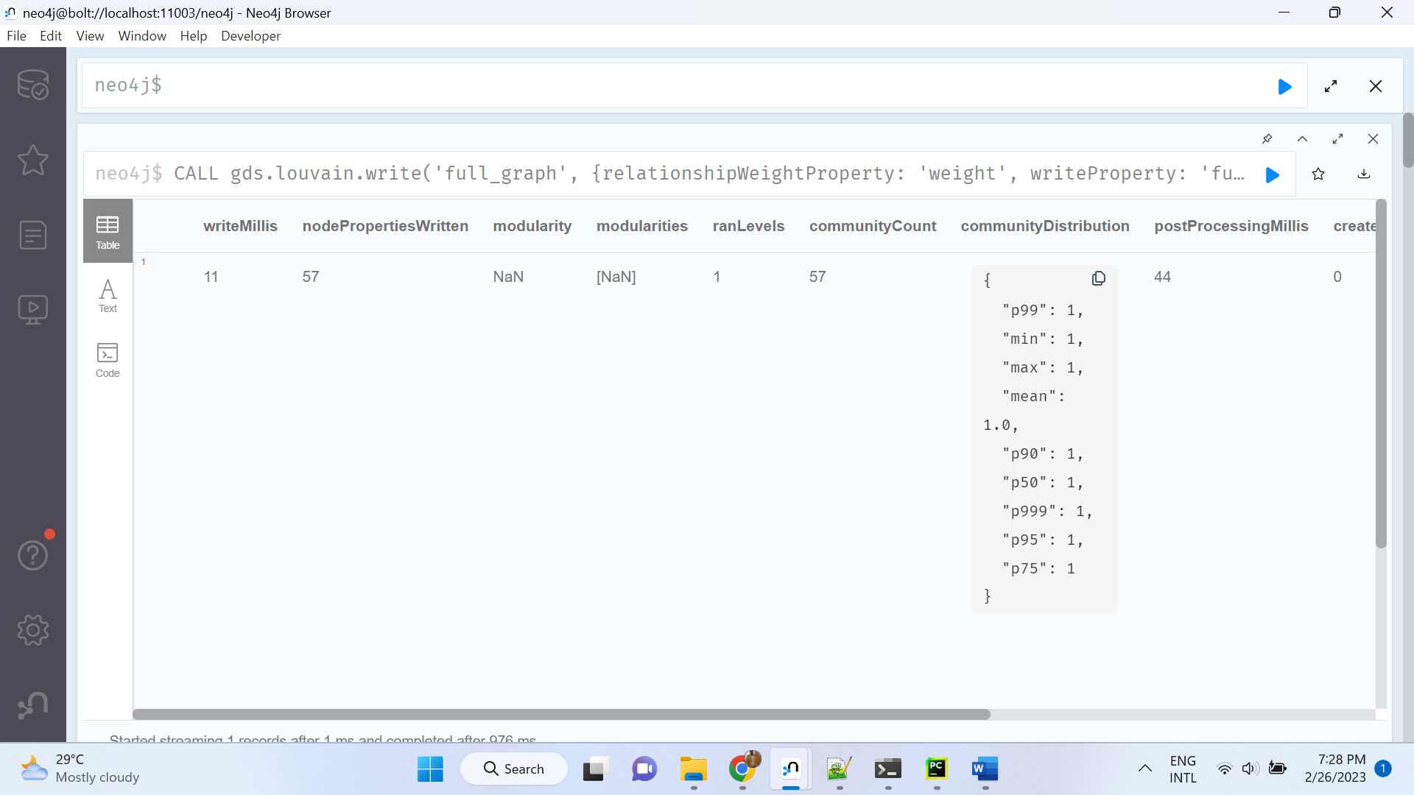

CALL gds.graph.create.cypher(
'full_graph',
'MATCH (n) RETURN id(n) AS id',
'MATCH (n)-[e]-(m) RETURN id(n) AS source, e.weight AS we

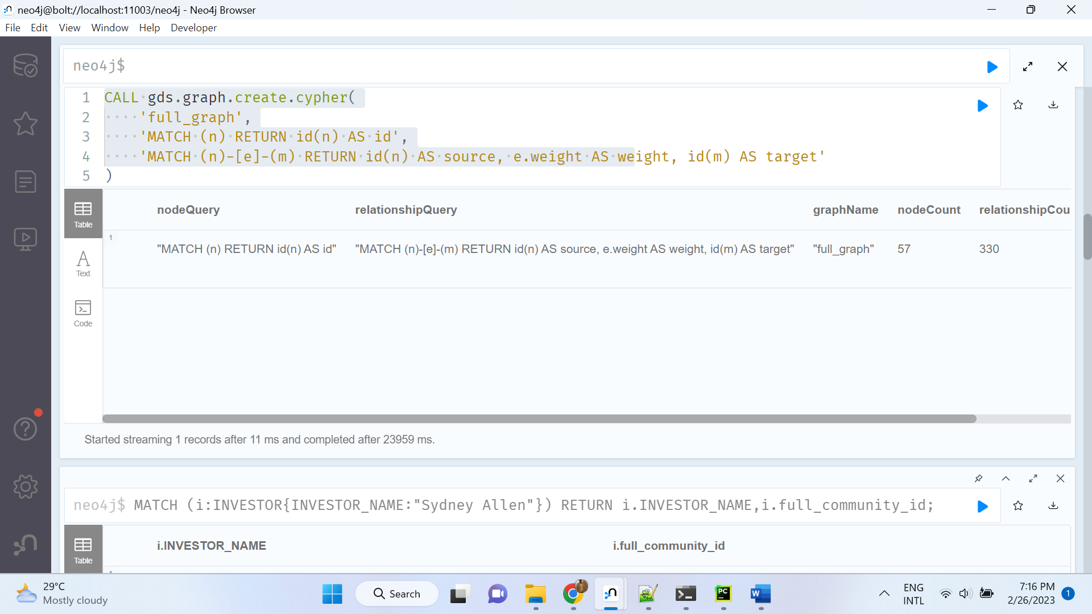

MATCH (i:INVESTOR{INVESTOR_NAME:"Sydney Allen"}) RETURN i.INVESTOR_NAME,i.full_community_id;

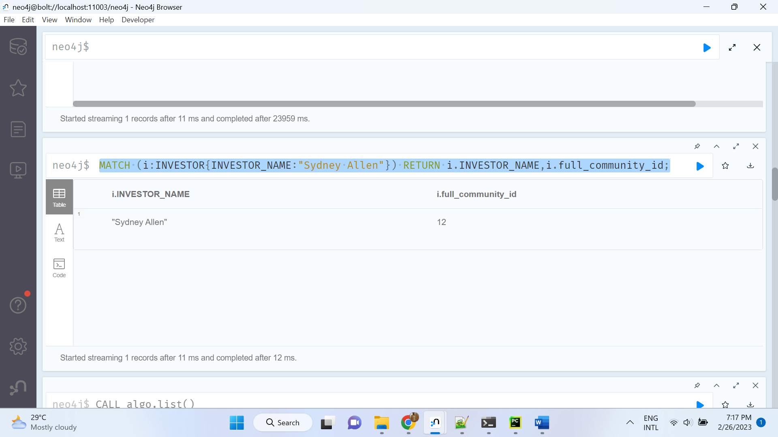
CALL gds.pageRank.write('full_graph', {
maxIterations: 20,
dampingFactor: 0.85,
relationshipWeightProperty: 'weight',
writeProperty: 'full_pagerank'})
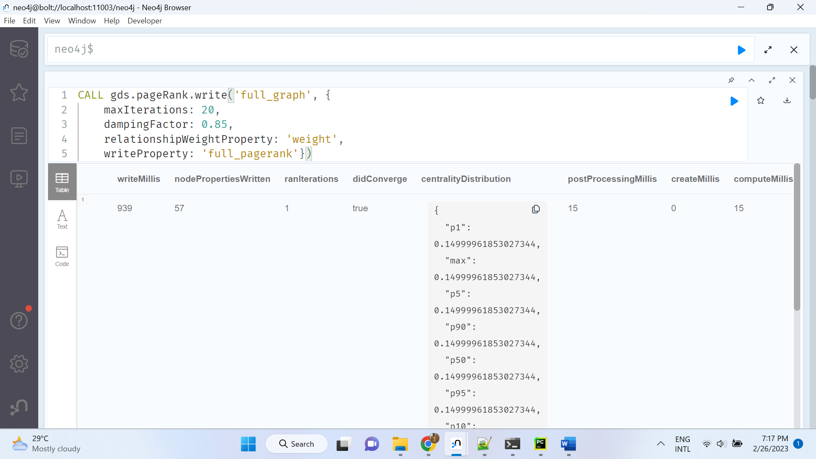

Display schema of graph
CALL db.schema.visualization() YIELD nodes, relationships
UNWIND nodes as node
with node, relationships
WHERE apoc.node.labels(node) <> ["Bloom_Perspective"]
RETURN collect(node) AS nodes, relationships

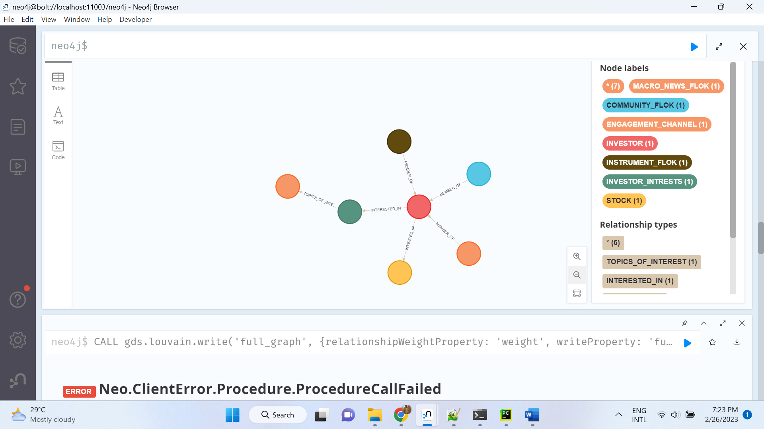

Similarity
MATCH (i1:INVESTOR {INVESTOR_NAME: "Sydney Allen"})-[:INVESTED_IN]->(stock1)
WITH i1, collect(id(stock1)) AS i1Cuisine
MATCH (i2:INVESTOR)-[:INVESTED_IN]->(stock2) WHERE i1 <> i2
WITH i1, i1Cuisine, i2, collect(id(stock2)) AS i2Cuisine
RETURN i1.INVESTOR_NAME AS from, i2.INVESTOR_NAME AS to,
gds.alpha.similarity.jaccard(i1Cuisine, i2Cuisine) AS jaccard;

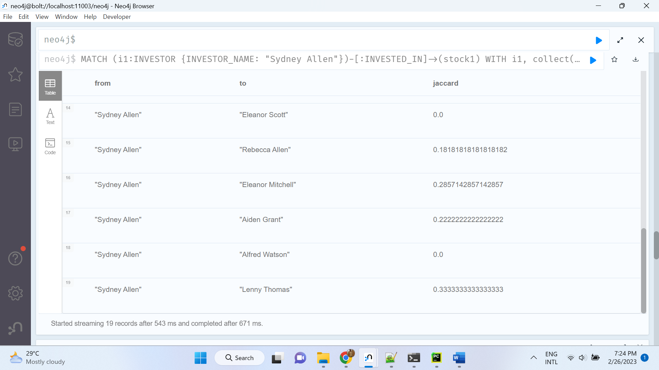

Metrics
MATCH (n)
WITH n,
["ANNUAL_INCOME","LIQUIDITY", "SAVING", "TOTAL_AUM" ] AS metrics
UNWIND metrics as metric
WITH metric, n[metric] AS value
RETURN metric, min(value) AS minValue,
percentileCont(value, 0.25) AS percentile25,
percentileCont(value, 0.50) AS percentile50,
percentileCont(value, 0.75) AS percentile75,
max(value) AS maxValue

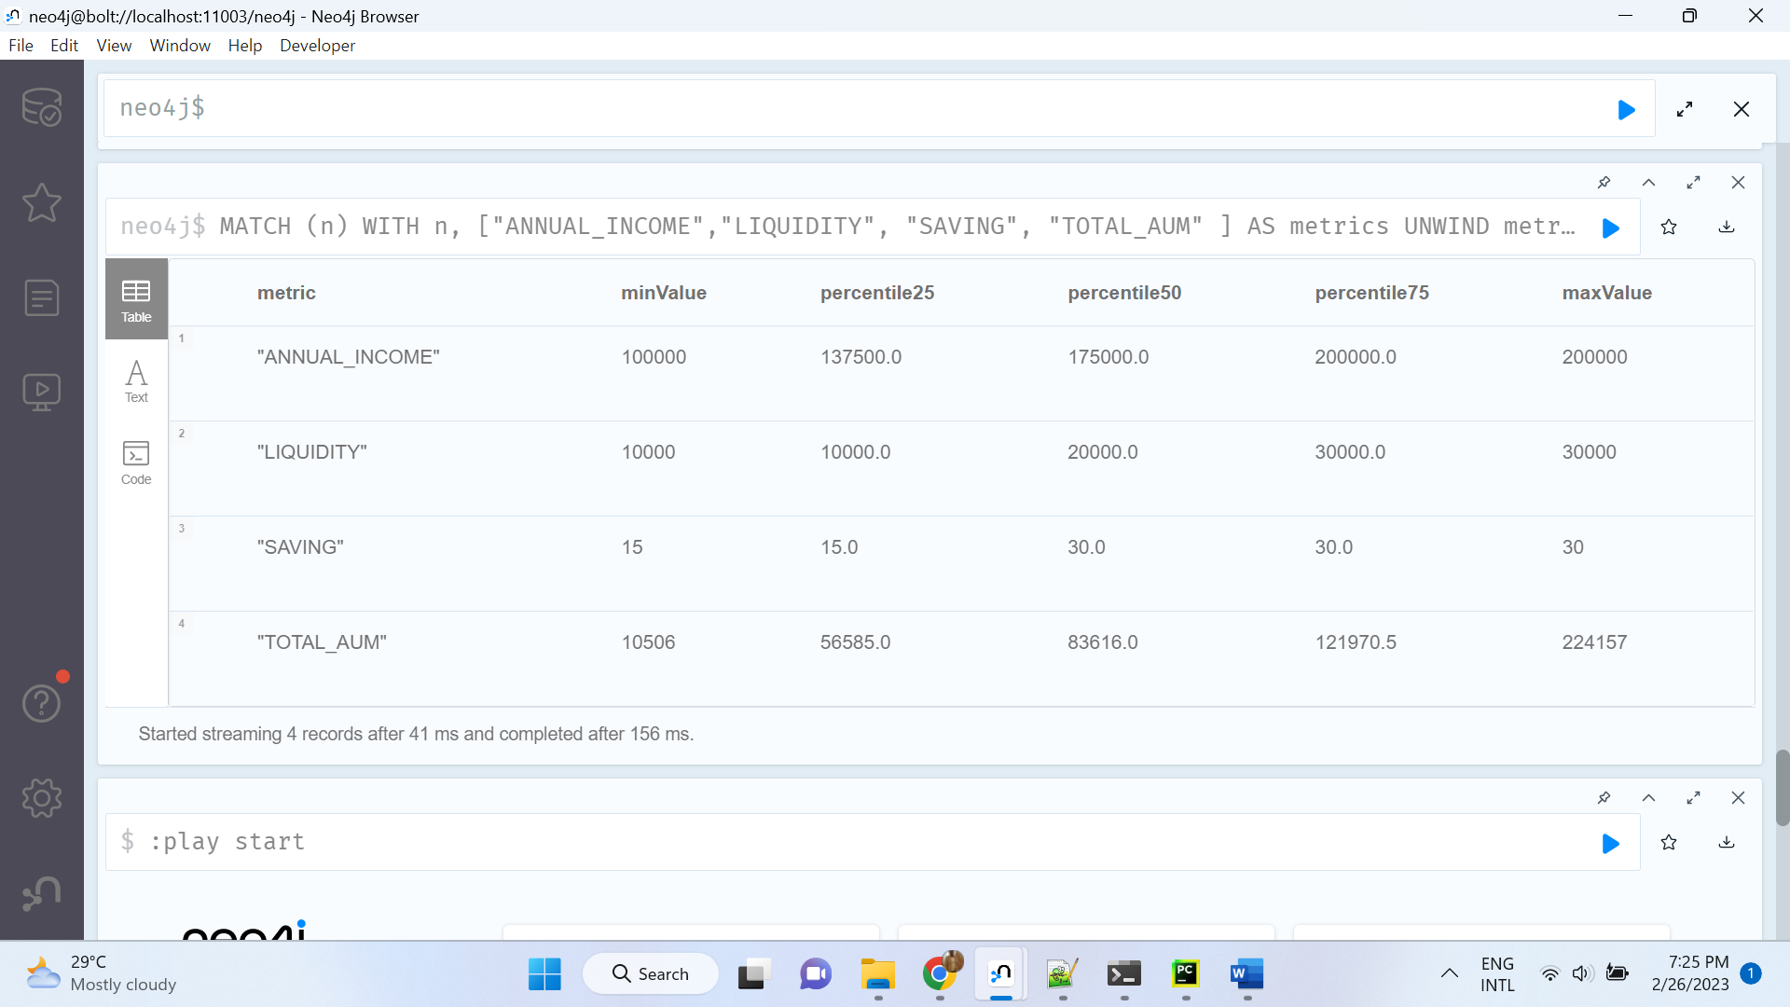

Clustering:

https://towardsdatascience.com/hdbscan-clustering-with-neo4j-57e0cec57560

CALL gds.graph.create(
'gotGraph',
'INVESTOR',
{INTERACTS:
{
type: 'INVESTED_IN',
orientation: 'UNDIRECTED',
aggregation:'SUM',
properties:{
weight:{property:'ANNUAL_INCOME'}
}
}
}) YIELD graphName, nodeCount, relationshipCount

CALL gds.nodeSimilarity.write('gotGraph',
{
writeRelationshipType: 'SIMILAR_TO',
writeProperty: 'similarity',
topK:50
})
YIELD nodesCompared, relationshipsWritten

=============

=============
MATCH (:INVESTOR)-[rel:SIMILAR_TO]->(:INVESTOR)
SET rel.distance = 1 - rel.similarity

MATCH (p1:INVESTOR)-[s:SIMILAR_TO]-(p2:INVESTOR)
WHERE id(p1) < id(p2)
RETURN round(s.distance*10)/10.0 AS roundedDistance,
count(*) as pairs
ORDER BY roundedDistance

call apoc.custom.asFunction('getLastCluster',
"MATCH (n) where id(n) = id($n)
WITH n MATCH clustPath = (n)-[:IN_CLUSTER*0..]->(c)
WITH clustPath order by length(clustPath) desc
LIMIT 1
RETURN nodes(clustPath)[-1] as lastCluster",
"NODE",
[["n","NODE"]],
false,
"Starting from a given node, get the node at the end of the longest path of IN_CLUSTER relationships")

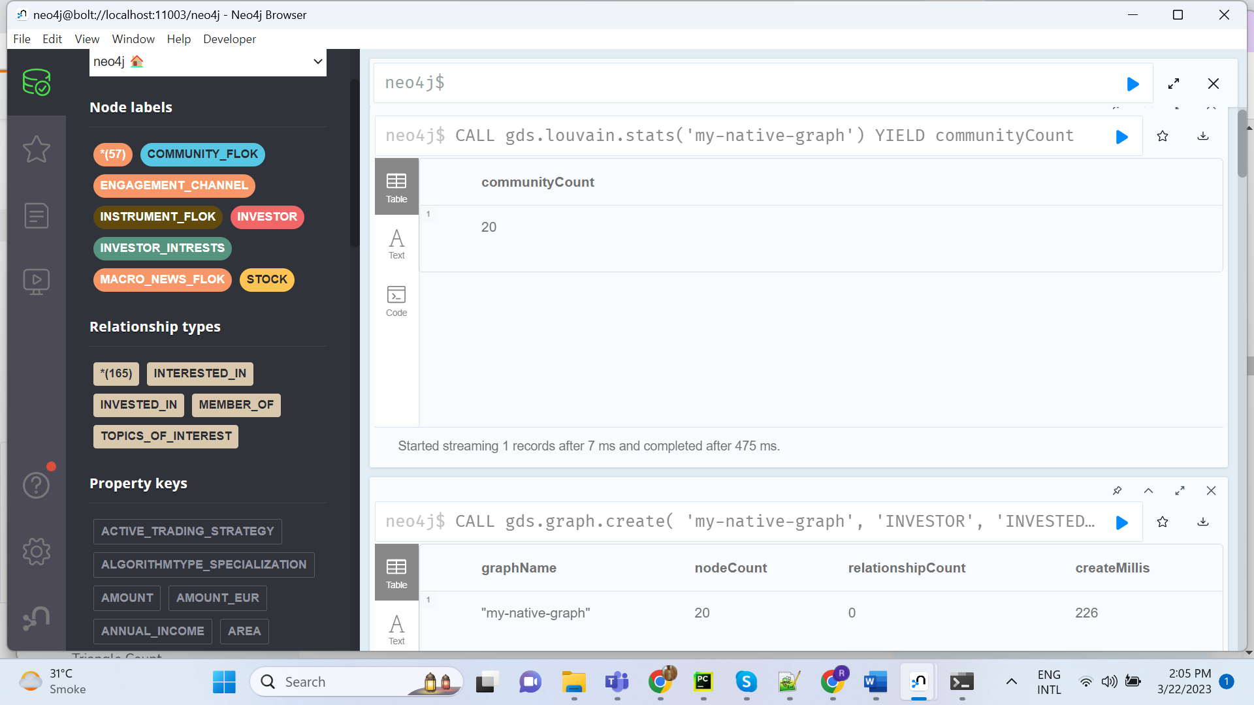

CALL gds.graph.create( 'my-native-graph', 'INVESTOR', 'INVESTED_IN' ) YIELD graphName, nodeCount, relationshipCount, createMillis;

CALL gds.louvain.stats('my-native-graph')
YIELD communityCount

CALL gds.louvain.stream('my-native-graph')
YIELD nodeId, communityId, intermediateCommunityIds
RETURN gds.util.asNode(nodeId).INVESTOR_NAME AS name, communityId
ORDER BY name ASC

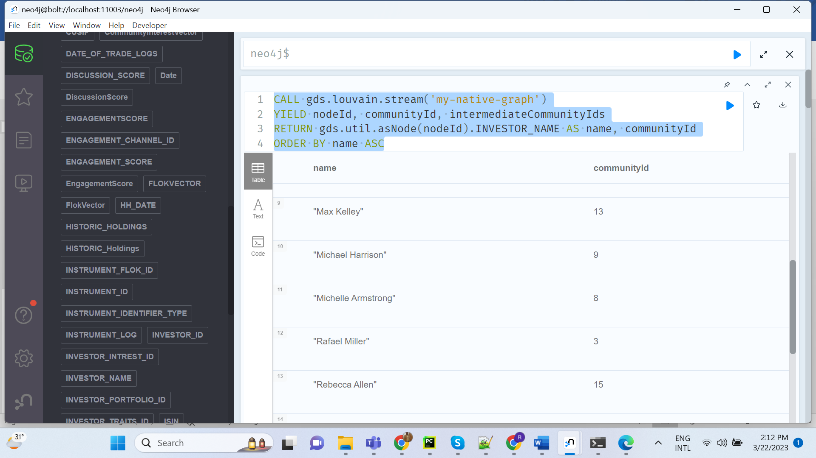

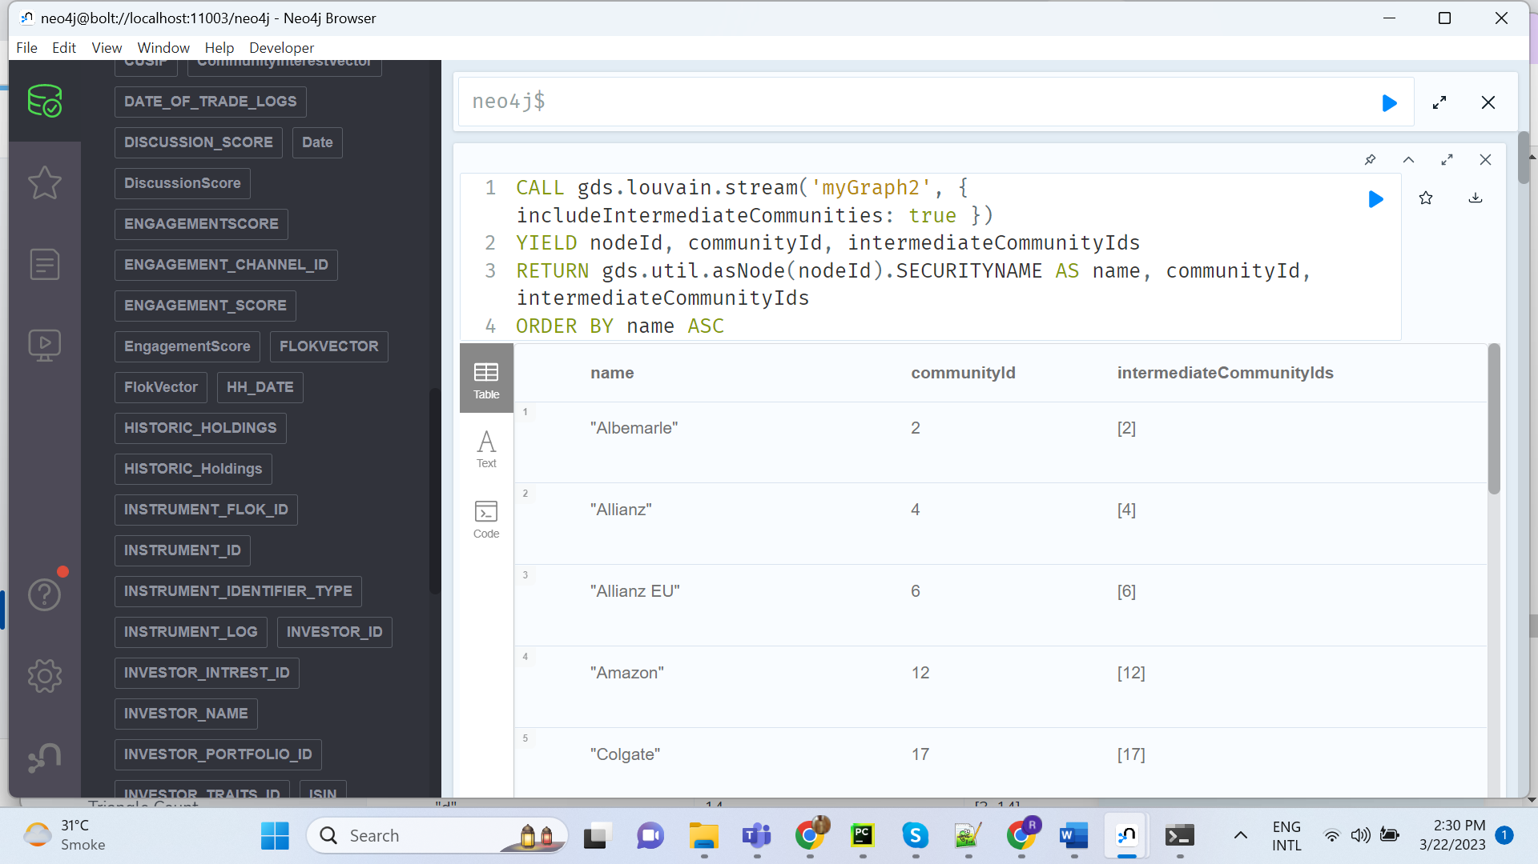

CALL gds.graph.create(
'myGraph2',
'STOCK',
{
INVESTED_IN: {
orientation: 'undirected',
aggregation: 'NONE'
}
}
)

CALL gds.louvain.stream('myGraph2', { includeIntermediateCommunities: true })
YIELD nodeId, communityId, intermediateCommunityIds
RETURN gds.util.asNode(nodeId).SECURITYNAME AS name, communityId, intermediateCommunityIds
ORDER BY name ASC

CALL gds.graph.create(
'myGraph3',
'INVESTOR',
'INVESTED_IN',
{
nodeProperties: 'ANNUAL_INCOME',
relationshipProperties: 'TRADE_LOG_PURCHASE_OR_SALE'
}
)

CALL gds.labelPropagation.write.estimate('myGraph3', { writeProperty: 'community' })
YIELD nodeCount, relationshipCount, bytesMin, bytesMax, requiredMemory

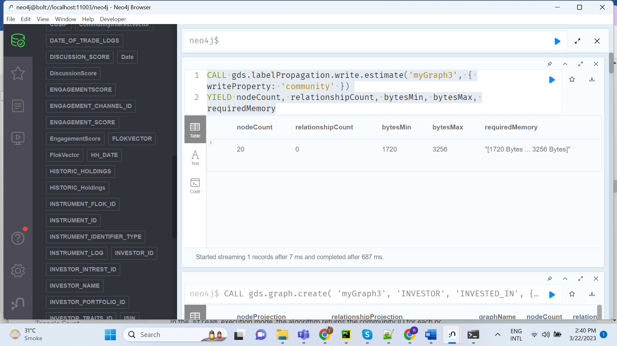

CALL gds.louvain.stream('myGraph3')
YIELD nodeId, communityId, intermediateCommunityIds
RETURN gds.util.asNode(nodeId).INVESTOR_NAME AS name, communityId
ORDER BY name ASC

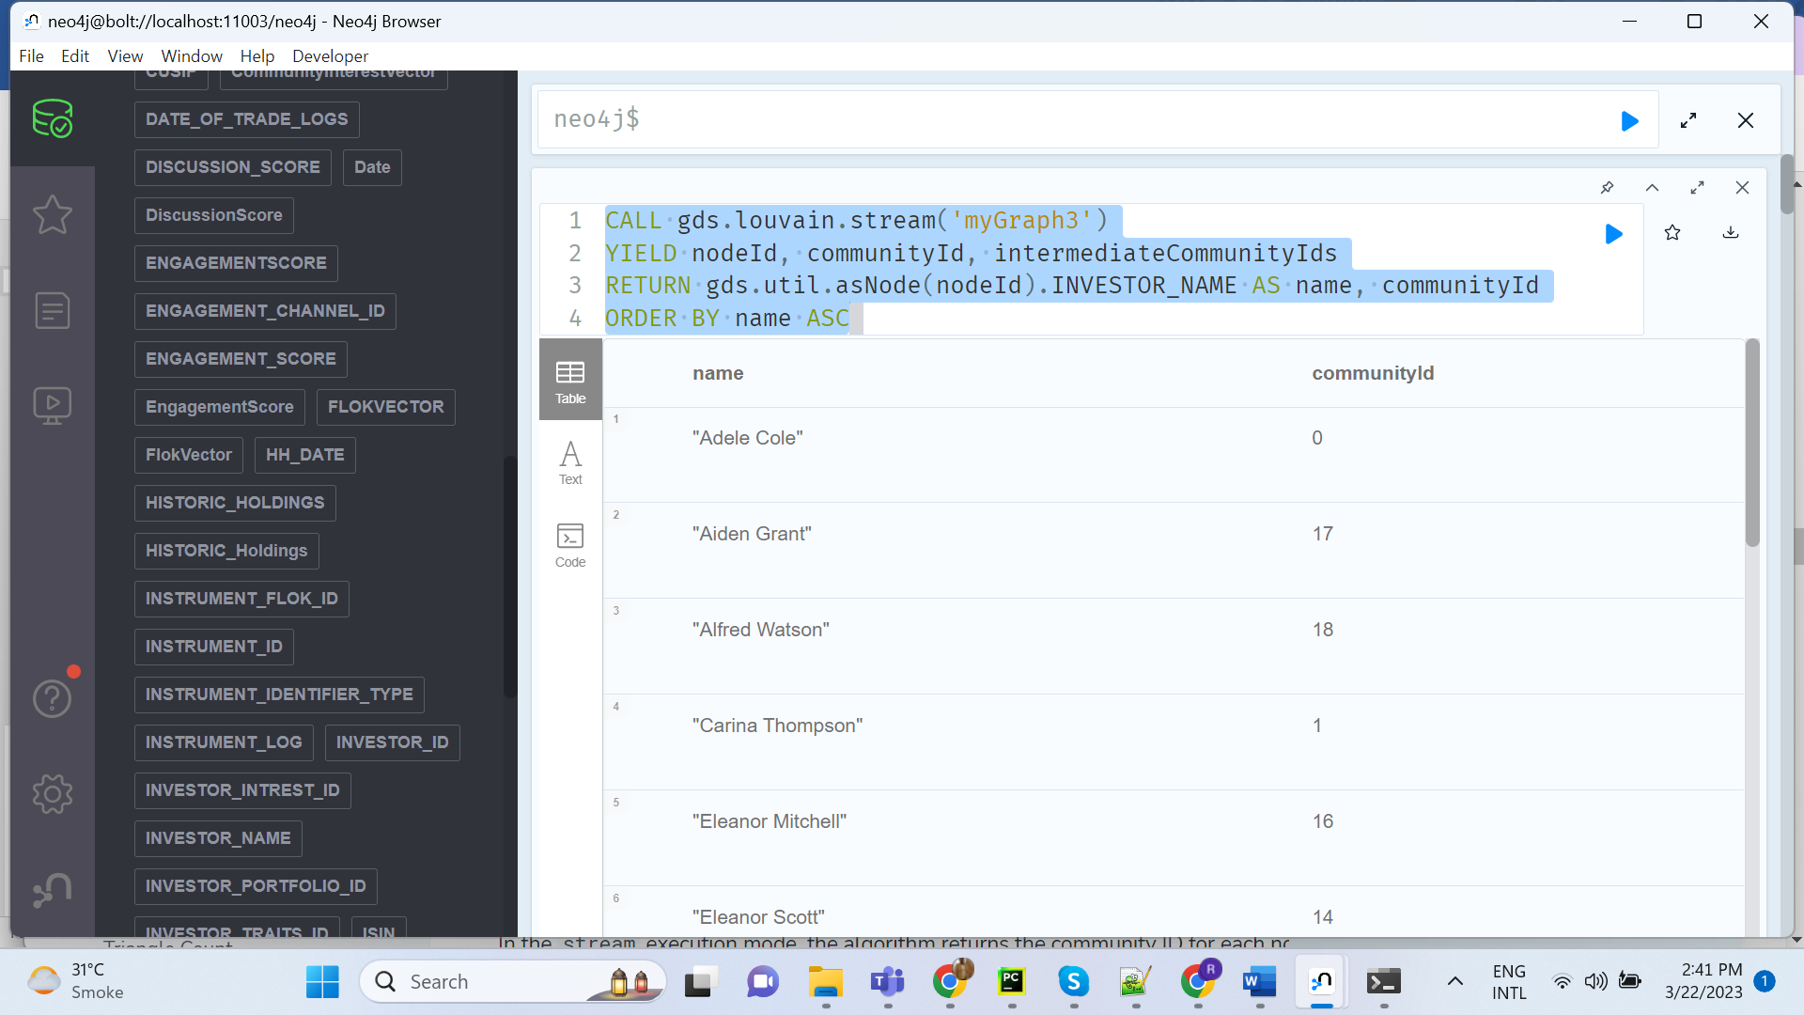

https://neo4j.com/docs/graph-data-science/current/machine-learning/node-embeddings/node2vec/

CALL gds.graph.create('myGraph', ['INVESTOR', 'STOCK'], 'INVESTED_IN');

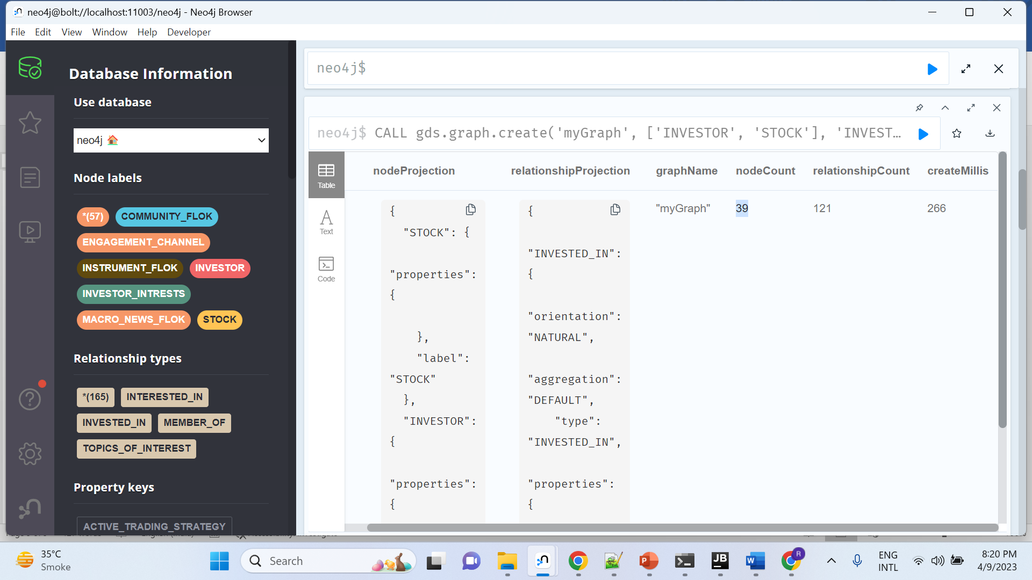

CALL gds.fastRP.stream('myGraph', {embeddingDimension: 2})
YIELD nodeId, embedding
RETURN nodeId, embedding

CALL gds.beta.node2vec.stream('myGraph', {embeddingDimension: 2})
YIELD nodeId, embedding
RETURN nodeId, embedding

CALL gds.graph.create(
'full_graph1',
'INVESTOR',
{
INVESTED_IN: {
properties: 'QUANTITY_HELD'
}
}
)
YIELD graphName

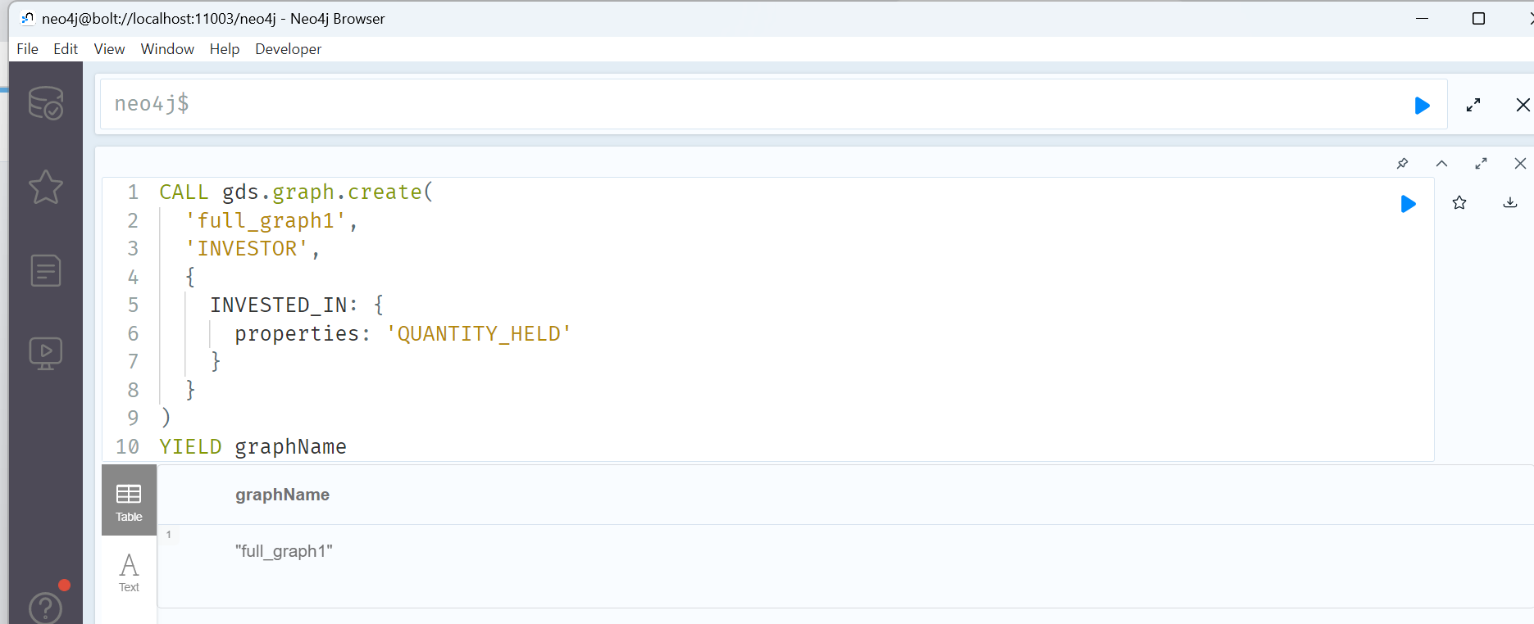

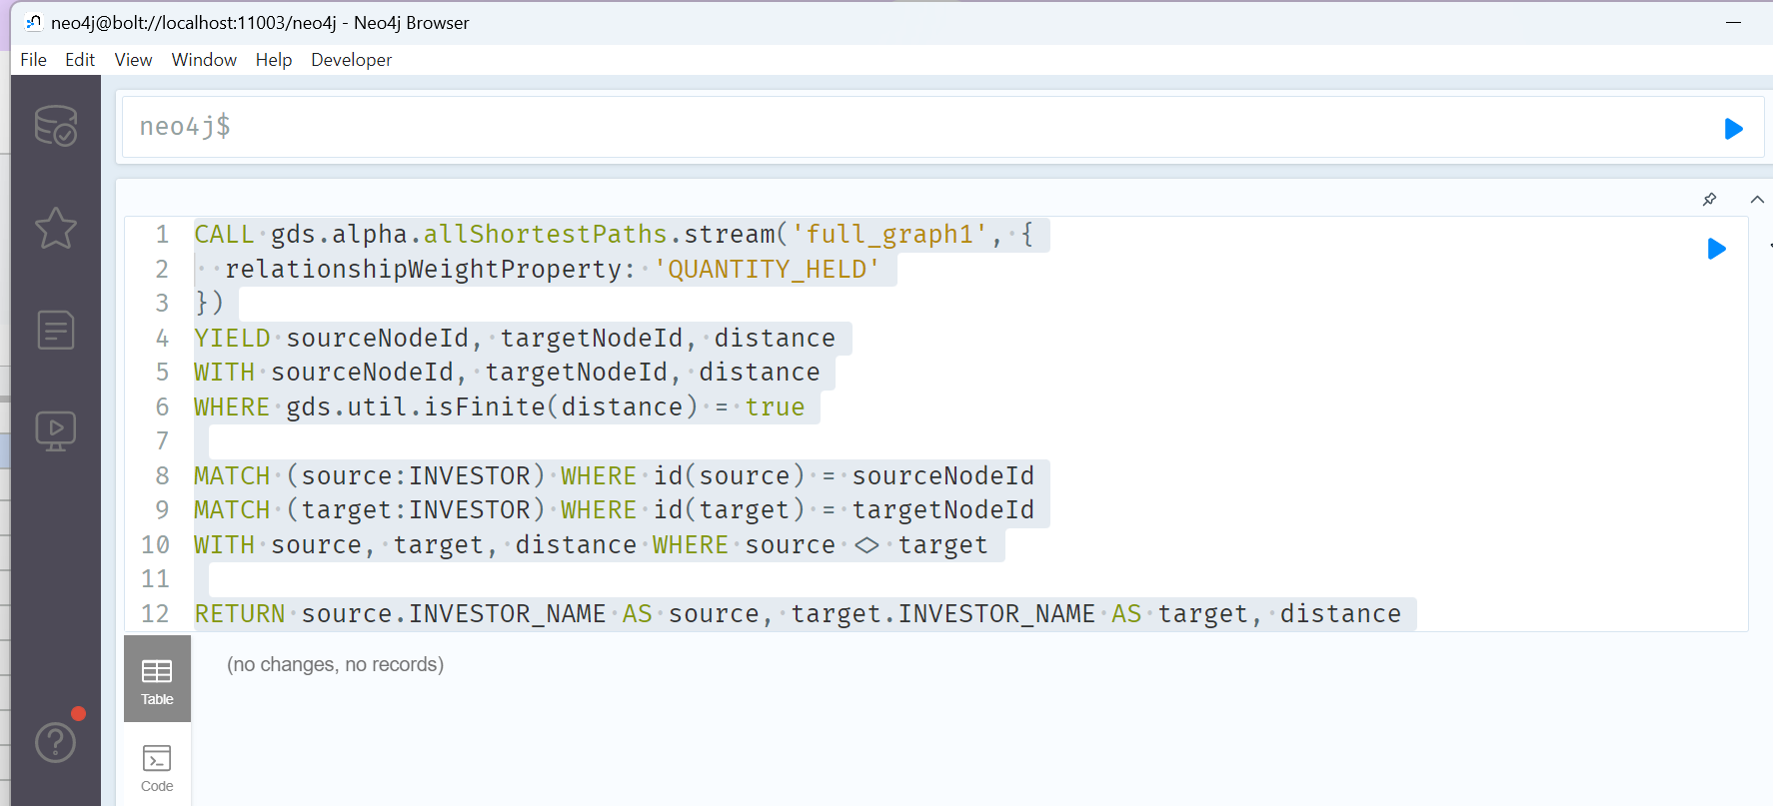
CALL gds.alpha.allShortestPaths.stream('full_graph1', {
relationshipWeightProperty: 'QUANTITY_HELD'
})
YIELD sourceNodeId, targetNodeId, distance
WITH sourceNodeId, targetNodeId, distance
WHERE gds.util.isFinite(distance) = true

MATCH (source:INVESTOR) WHERE id(source) = sourceNodeId
MATCH (target:INVESTOR) WHERE id(target) = targetNodeId
WITH source, target, distance WHERE source <> target

RETURN source.INVESTOR_NAME AS source, target.INVESTOR_NAME AS target, distance
ORDER BY distance DESC, source ASC, target ASC
LIMIT 10

