System Architecture Blueprint and Version Control Overview
SemiFab Analytics: Lithography Process Monitoring and Process-Quality Prediction

System Architecture and Design Specifications
SemiFab Analytics is a web-based semiconductor process analytics prototype designed to monitor lithography variables, contamination indicators, defect trends, SPC-style process behavior, and process-quality risk. The system belongs to the data analytics and manufacturing decision-support domain. The design is intentionally modular because semiconductor data can move through several stages before becoming useful: data generation or ingestion, database storage, validation, feature engineering, visualization, and prediction. Recent semiconductor research shows the value of data-driven defect analysis and synthetic or benchmark data for smart manufacturing analytics (Bao et al., 2024; Pendyala et al., 2024; Wei et al., 2023). Therefore, the architecture combines practical dashboard engineering with controlled machine-learning functionality.
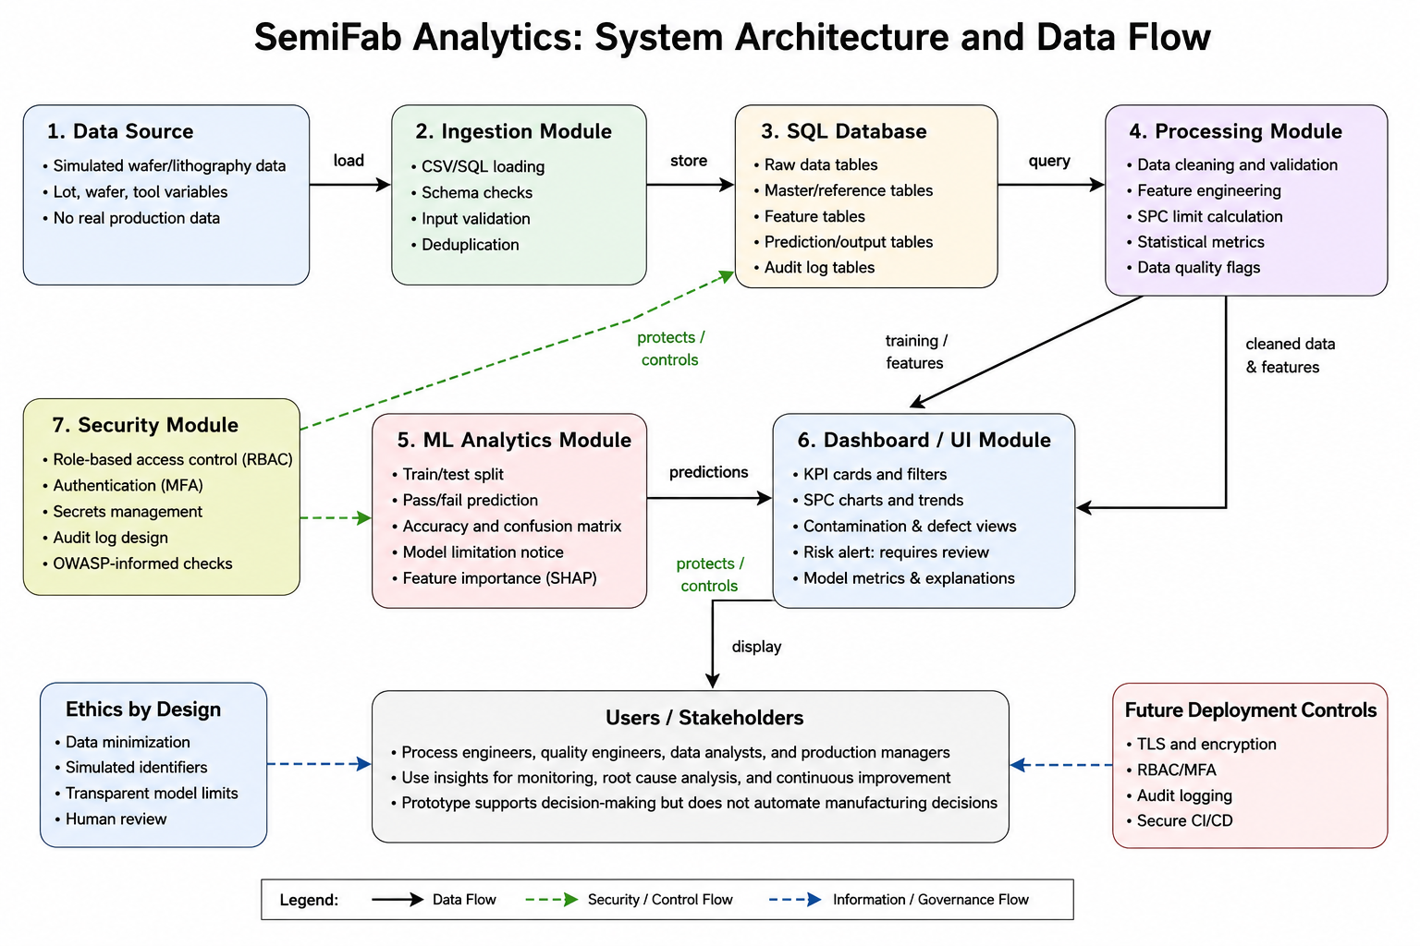
Figure 1. Proposed system architecture for SemiFab Analytics.

The architecture has seven modules. The simulated data source provides wafer, lot, tool, lithography, contamination, defect, and yield variables. The ingestion module loads CSV or SQL data, checks the schema, validates values, and rejects missing critical fields. The SQL database stores raw data, engineered features, and prediction outputs in separate tables to support traceability. The processing module cleans data, calculates derived variables, computes SPC limits, and creates data-quality flags. The machine-learning module trains and evaluates a pass/fail or risk classifier using scikit-learn. The dashboard module displays KPIs, filters, charts, control limits, and alerts. The security module defines role-based access, secret-management rules, audit logging, and secure development safeguards. These controls are consistent with ISO/IEC 27001, which emphasizes risk-based protection of confidentiality, integrity, and availability (International Organization for Standardization, 2022), and OWASP guidance on avoiding broken access control (OWASP Foundation, 2021).

2. Module-Wise Functional Specifications
Module | Input | Output | Methodology / Specification
Data Source | Simulated semiconductor process dataset | Structured wafer records | Synthetic lots, wafers, tools, lithography, contamination, defects, and yield values
Ingestion | CSV/SQL files | Validated staging table | Schema validation, missing-value checks, range checks, duplicate checks
SQL Database | Validated records | Queryable raw, feature, and prediction tables | SQLite/PostgreSQL schema with data dictionary and primary keys
Processing | Raw/staging data | Clean dataset and engineered features | Python, pandas, NumPy, SPC calculations, data-quality flags
ML Analytics | Feature table | Pass/fail or yield-risk prediction, metrics | Train/test split, logistic regression or random forest, confusion matrix
Dashboard/UI | Processed data and predictions | Interactive KPIs, charts, and alerts | Streamlit or Plotly Dash, filters, trend charts, SPC views
Security/Quality | Users, code, data, logs | Controlled access, traceability, test evidence | RBAC concept, secret exclusion, audit log design, Git workflow, tests

3. Functional and Non-Functional Requirements
ID | Functional Requirement
FR1 | The system shall load simulated wafer process data from CSV or SQL format.
FR2 | The system shall store wafer, lot, tool, process, defect, contamination, and yield data in a SQL database.
FR3 | The system shall display KPI cards for total wafers, pass rate, average yield, defect density, and high-risk lots.
FR4 | The system shall provide filters for date, lot, wafer, tool, process variable, and pass/fail status.
FR5 | The system shall display lithography, contamination, defect, and SPC-style control charts.
FR6 | The system shall train and display a simple model for pass/fail or yield-risk prediction.
FR7 | The system shall show prediction limitations and use alerts as review indicators, not automatic decisions.
NFR Category | Specification
Performance | Dashboard pages should load within approximately 5 seconds for the capstone dataset.
Usability | Interface should use clear labels, filters, chart titles, and simple risk legends.
Reliability | The system should validate data before analysis and handle missing or invalid values gracefully.
Scalability | The database schema and modular code should allow expansion to larger datasets or new process variables.
Security | Access-control concepts, input validation, secret exclusion, and audit logging should be included.
Maintainability | Code should be organized into folders, documented, and tracked through Git commits and branches.

4. Design Assumptions and Architectural Rationale
The first design assumption is that the capstone dataset will be synthetic but realistic enough to demonstrate common semiconductor process relationships. For example, the simulated data may show higher defect density when contamination score, particle count, overlay error, or focus offset moves outside normal ranges. This assumption allows the project to demonstrate analytics and prediction without using confidential manufacturing data.
The second design assumption is that the first implementation will be a single-user or small-user academic prototype, but the architecture should still be structured as if it could later support a controlled industrial pilot. For that reason, the design includes security and traceability concepts even if full enterprise deployment is outside the project scope. This means that access control, audit logging, input validation, documentation, and Git-based change history are treated as design requirements rather than optional additions.
The selected architecture also supports maintainability. Each module has a clear responsibility, so dashboard problems can be separated from data-processing problems, and model issues can be evaluated separately from database issues. This separation makes the project easier to test, explain, and extend during later capstone units.

5. Version Control and Collaboration Overview
Repository URL: https://github.com/dr-scientist/semifab-analytics
The repository will use a Git-based workflow with at least two branches: main and development. The main branch will contain stable, reviewed versions of the project. The development branch will contain active work on the dashboard, data processing, documentation, and design files. Feature-specific changes can be made in short-lived branches such as feature/data-simulation, feature/dashboard-kpis, feature/ml-model, and docs/design-report. Git branching supports parallel development while preserving a stable main line of work (Git Project, 2026).
The planned folder structure is: /src for Python source code, /data for sample simulated data, /database for schema files, /docs for reports and requirements, /design for architecture diagrams, /notebooks for experiments, /tests for validation scripts, and /screenshots for dashboard evidence. Clear commit messages will be used, such as “Add simulated wafer dataset schema,” “Implement SPC control chart,” “Add dashboard KPI cards,” and “Update security design section.” Version control improves traceability because each change is linked to a timestamp, author, message, and file difference. It also supports rollback if an error is introduced. NIST’s Secure Software Development Framework recommends protecting source code, maintaining integrity, and using secure development practices throughout the software lifecycle (National Institute of Standards and Technology, 2022).
Documentation will be stored with the code so that design decisions, requirements, and test evidence remain consistent. Pull requests from feature branches into development will be reviewed before merging. The final stable version will be merged from development into main when the dashboard, documentation, and tests are complete. This approach ensures that the project remains organized, auditable, and suitable for academic and portfolio review.

References
Bao, Y.-Y., Li, E.-C., Yang, H.-Q., & Jia, B.-B. (2024). Wafer map defect classification using autoencoder-based data augmentation and convolutional neural network. arXiv. https://arxiv.org/abs/2411.11029
European Union. (2016). General Data Protection Regulation, Article 5: Principles relating to processing of personal data. https://gdpr-info.eu/art-5-gdpr/
Git Project. (2026). Git branching: Branches in a nutshell. https://git-scm.com/book/en/v2/Git-Branching-Branches-in-a-Nutshell
Hu, Z., Schlosser, T., Friedrich, M., Vieira e Silva, A. L., Beuth, F., & Kowerko, D. (2024). Utilizing generative adversarial networks for image data augmentation and classification of semiconductor wafer dicing induced defects. arXiv. https://arxiv.org/abs/2407.20268
International Organization for Standardization. (2022). ISO/IEC 27001:2022: Information security, cybersecurity and privacy protection - Information security management systems - Requirements. https://www.iso.org/standard/27001
National Institute of Standards and Technology. (2022). Secure Software Development Framework (SSDF) version 1.1: Recommendations for mitigating the risk of software vulnerabilities (SP 800-218). https://csrc.nist.gov/pubs/sp/800/218/final
OWASP Foundation. (2021). A01:2021 - Broken access control. OWASP Top 10. https://owasp.org/Top10/2021/A01_2021-Broken_Access_Control/
Pendyala, V. K., Sarjoughian, H. S., Potineni, B., & Yellig, E. J. (2024). A benchmark time series dataset for semiconductor fabrication manufacturing constructed using component-based discrete-event simulation models. arXiv. https://arxiv.org/abs/2408.09307
Prasad, A., Dey, B., Blanco, V., & Halder, S. (2024). An evaluation of continual learning for advanced node semiconductor defect inspection. arXiv. https://arxiv.org/abs/2407.12724
Wei, Q., Zhao, W., Zheng, X., & Zeng, Z. (2023). Wafer map defect patterns semi-supervised classification using latent vector representation. arXiv. https://arxiv.org/abs/2311.12840

