SemiFab Analytics

Unit 6 Assignment: Parts A, B, and C
System Integration, Evaluation, and Deployment Planning

Submitted by:
Manoj Kumar Mahata

For the partial fulfilment of the requirements for MSIT 5910 Capstone Project

Department of CS & MSIT
University of the People
Term 5, July 2026

PART A: SYSTEM INTEGRATION & FEATURE COMPLETION
SemiFab Analytics was integrated as a cohesive prototype that connects data generation, database loading, analytics processing, machine-learning prediction, and dashboard visualization. The integrated workflow begins with simulated semiconductor wafer and lithography process records, validates and loads 360 records into the local database layer, calculates manufacturing KPIs, computes SPC-style limits for defect density, trains a pass/fail quality model, and presents risk alerts through a Streamlit dashboard. This directly supports the project objective of converting wafer, lithography, contamination, defect, and yield indicators into decision-support information for process engineers and quality analysts.
The implementation uses five modules. The data module creates realistic wafer records and failure-pattern categories. The database module creates and loads the local SQLite structure. The analytics module calculates KPIs, SPC limits, failure-pattern Pareto summaries, model accuracy, latency, and feature importance. The integration runner calls these modules in sequence and prints a structured JSON-style output. The dashboard module links the processed outputs to a user-facing Streamlit interface. This structure demonstrates inter-module communication rather than isolated scripts.
data = generate_wafer_data(n_rows=360)
load_to_database(data, db_path="semifab_unit6.db")
records = read_wafer_data(db_path="semifab_unit6.db")
kpis = calculate_kpis(records)
spc = calculate_spc_limits(records, metric="defect_density")
model_results = train_quality_model(records)
alerts = generate_risk_alerts(records)
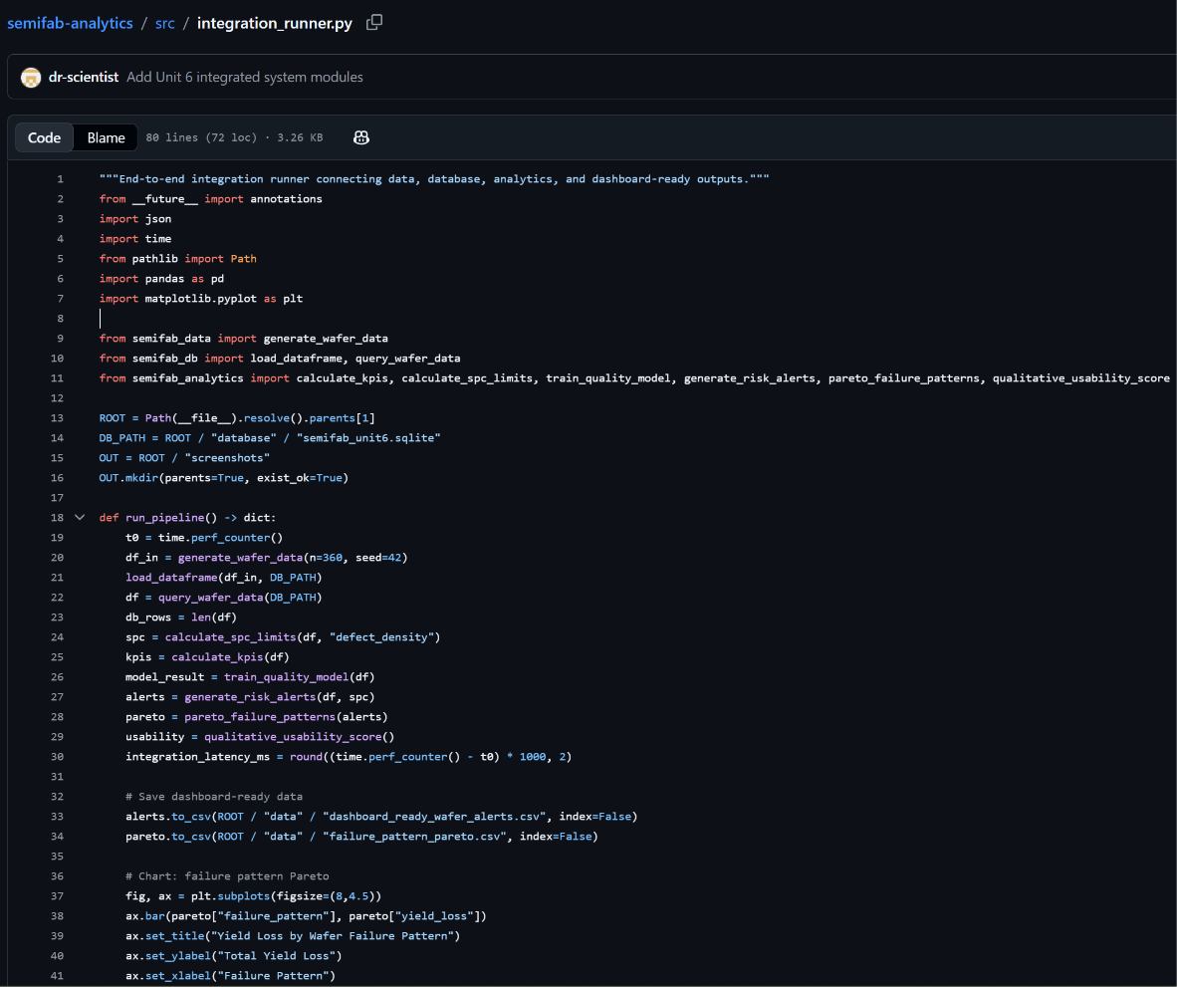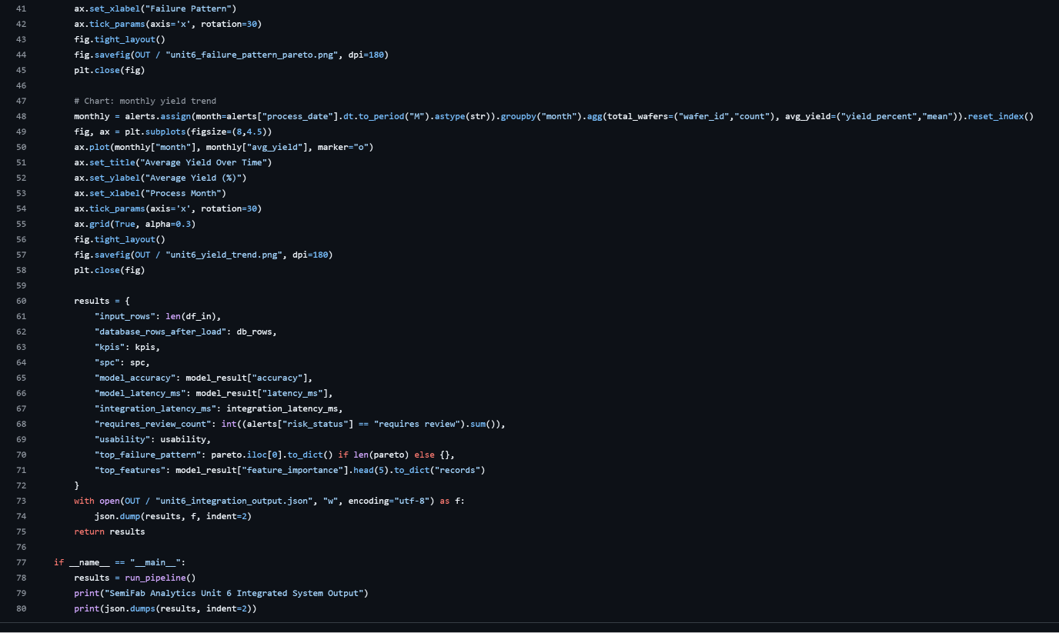
Figure 1. Integration runner code showing the module sequence for data generation, database loading, analytics, and output reporting.
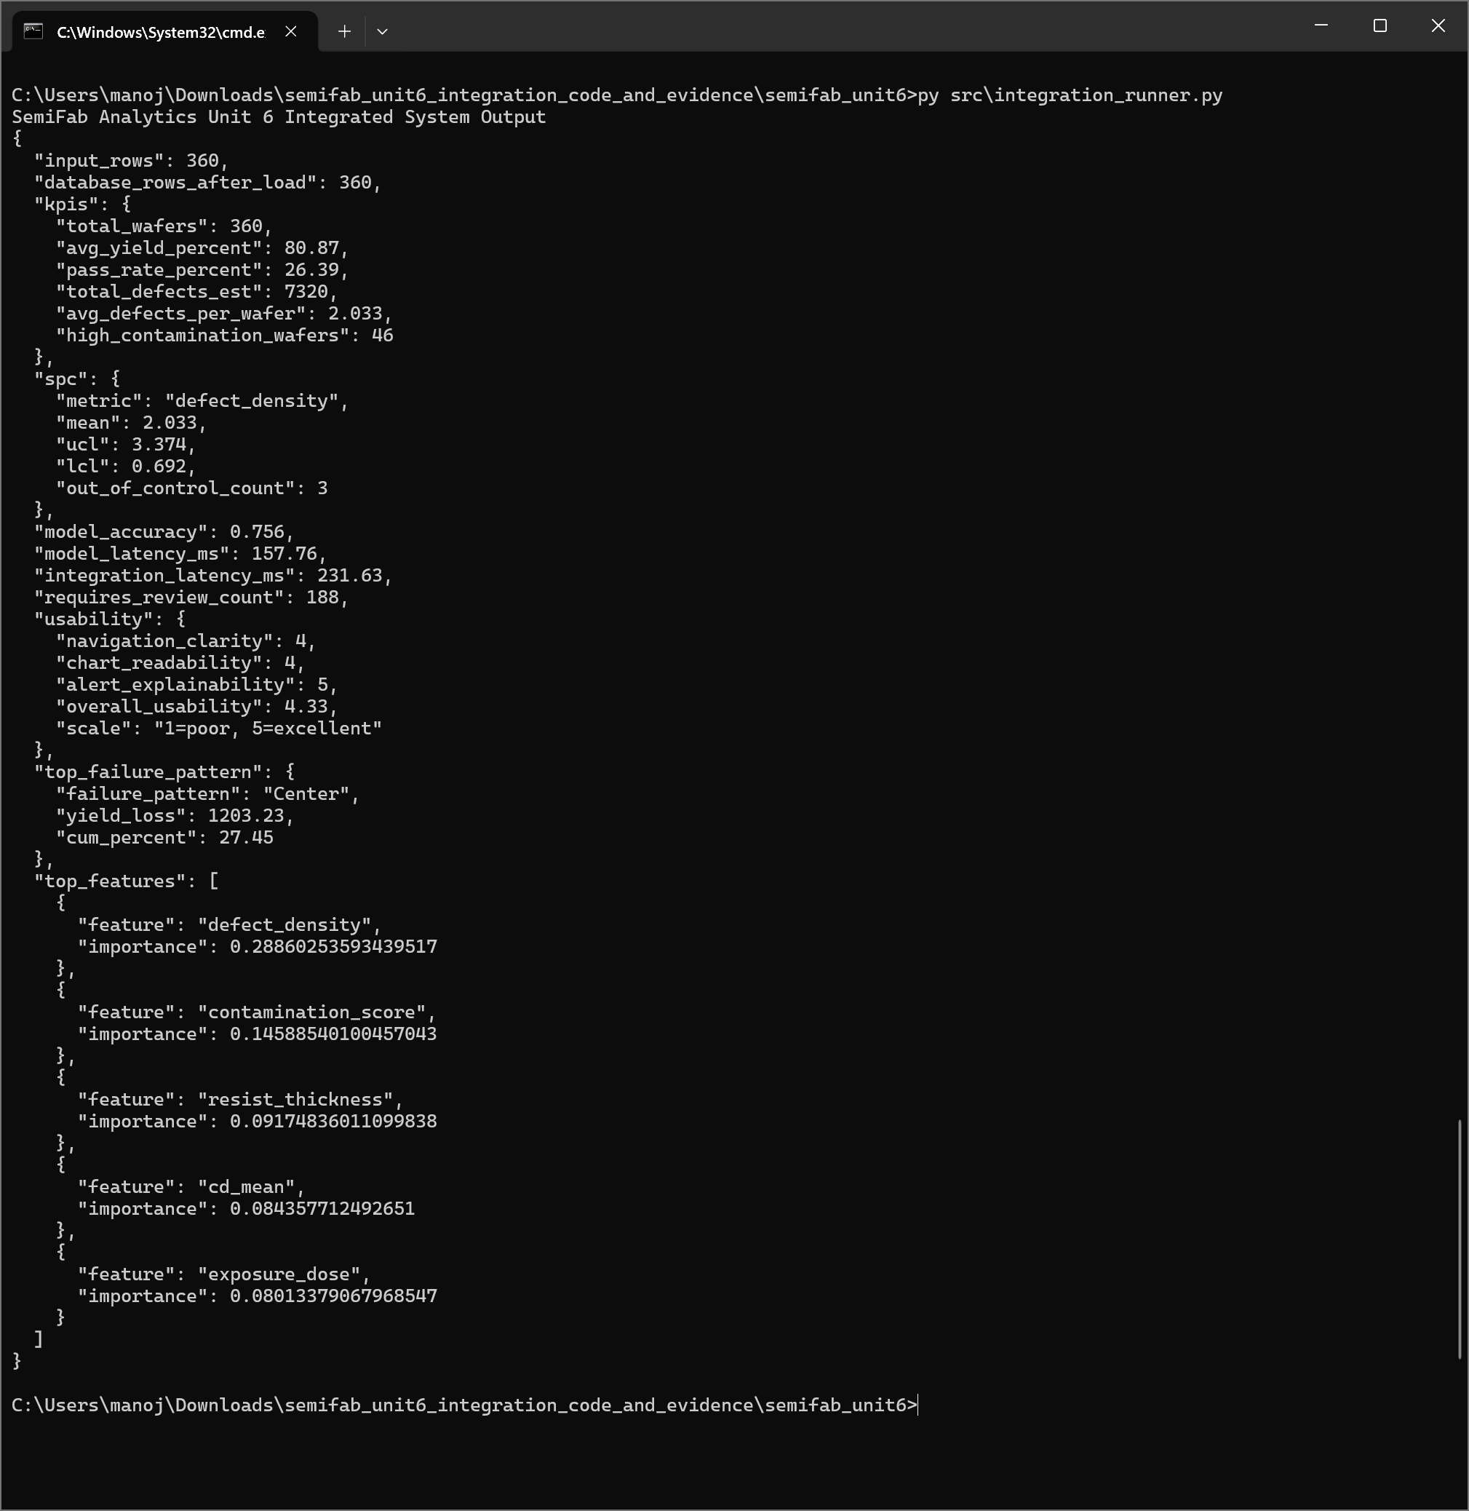
Figure 2. Integrated system output showing input rows, database load validation, KPI summary, SPC results, model accuracy, latency, usability score, failure-pattern analysis, and feature importance.
The input-output evidence shows that the system processed 360 input records and loaded 360 database rows, which verifies that the input pipeline and persistence layer remained consistent. The same output reports 80.87% average yield, 26.39% pass rate, 46 high-contamination wafers,
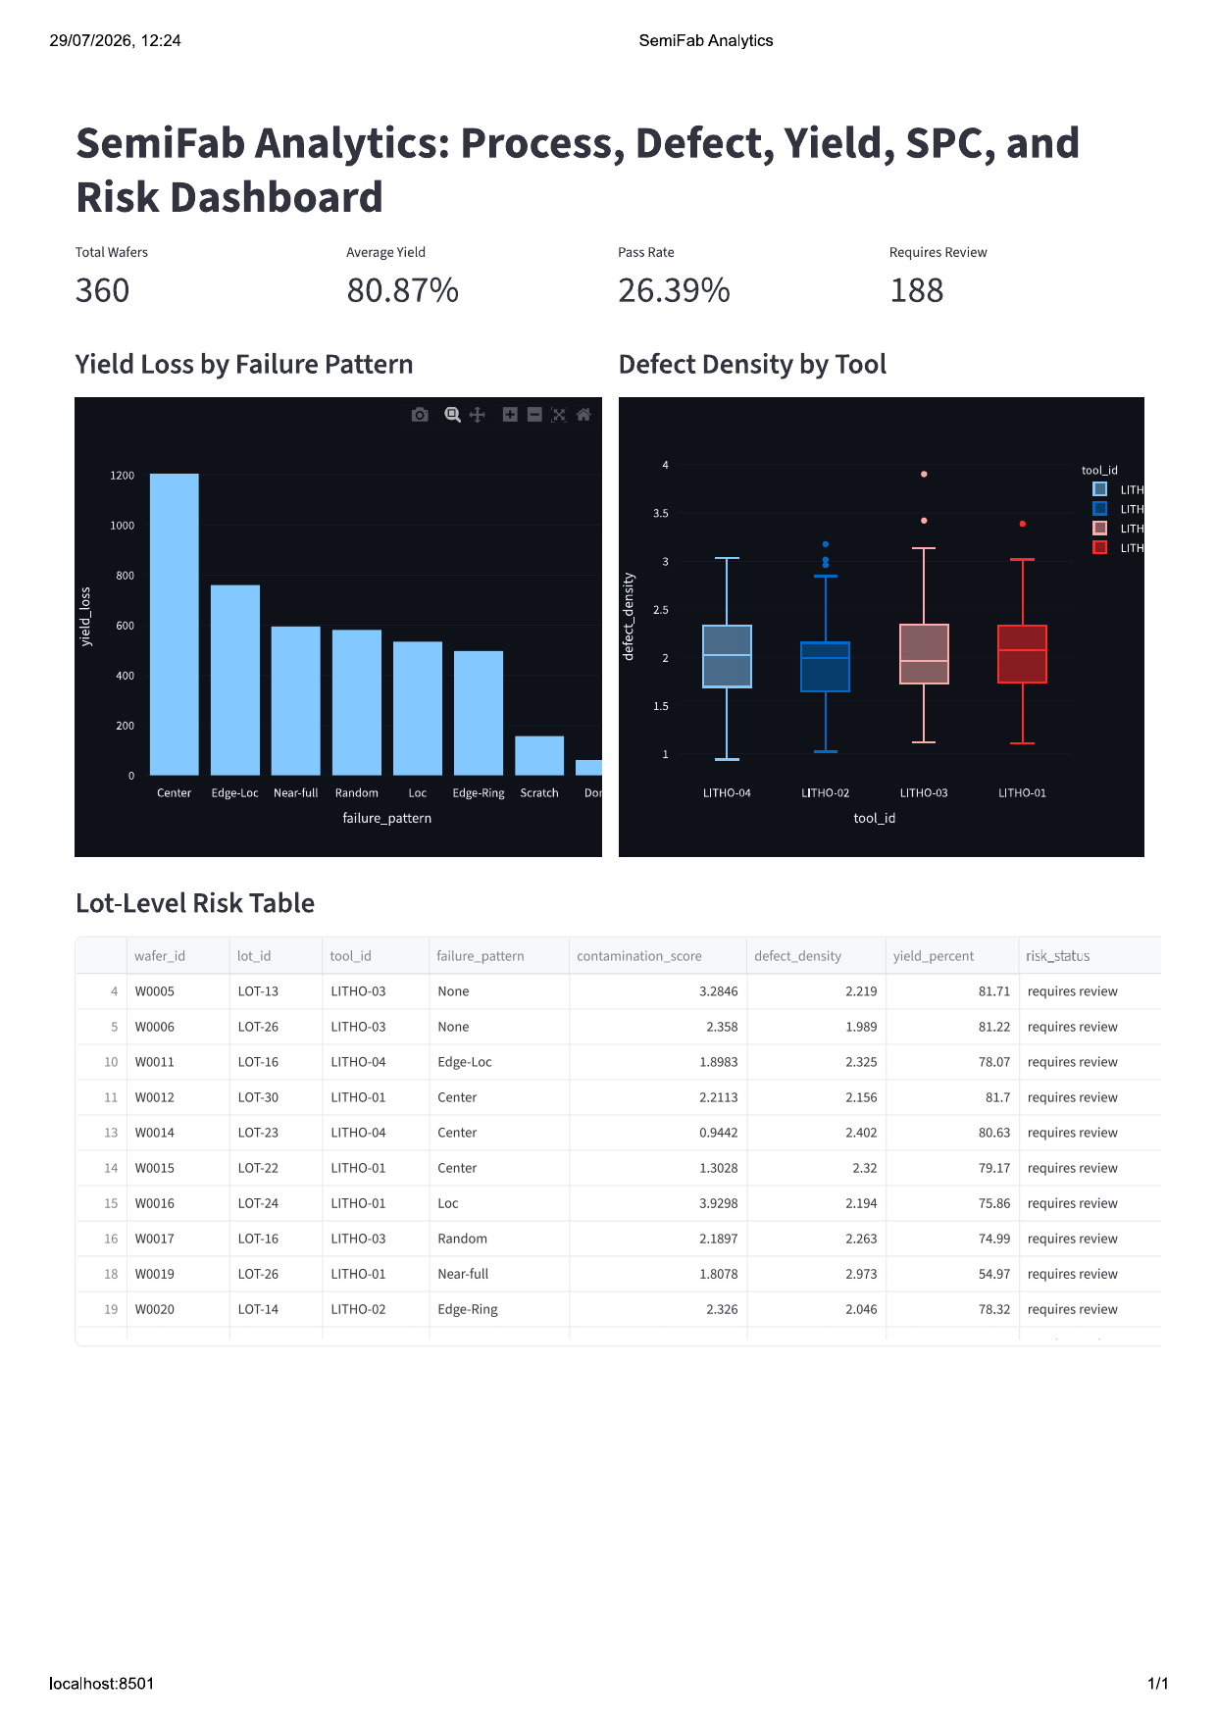
Figure 3. Streamlit dashboard interface showing KPI cards, yield-loss analysis by failure pattern, defect-density comparison by tool, and lot-level risk table.
three out-of-control defect-density observations, and 188 wafers requiring review. These outputs are useful because they connect raw simulated measurements to process-control and quality-risk decisions.

PART B: SYSTEM EVALUATION & METRICS REPORTING
System evaluation used both quantitative and qualitative indicators. Quantitative evaluation included model accuracy, model latency, integration latency, database row-count consistency, and automated test completion. The machine-learning model achieved 0.756 accuracy on the simulated pass/fail classification task. Although this is not sufficient for real production deployment, it is adequate for a capstone prototype because the model demonstrates feature-based prediction, model evaluation, and transparent feature importance. Model latency was 157.76 ms and full integration latency was 231.63 ms, showing that the prototype can execute quickly enough for interactive dashboard use on a small simulated dataset.
Metric | Result | Interpretation
Database row-count match | 360 input rows / 360 loaded rows | Pass
Model accuracy | 0.756 | Demonstrates predictive functionality
Model latency | 157.76 ms | Interactive prototype range
Integration latency | 231.63 ms | End-to-end execution within one second
PyTest integration result | 1 passed in 2.21 s | Integration test successful
Overall usability | 4.33 / 5 | Dashboard judged clear and interpretable

Table 1. Unit 6 evaluation metrics and interpretation.
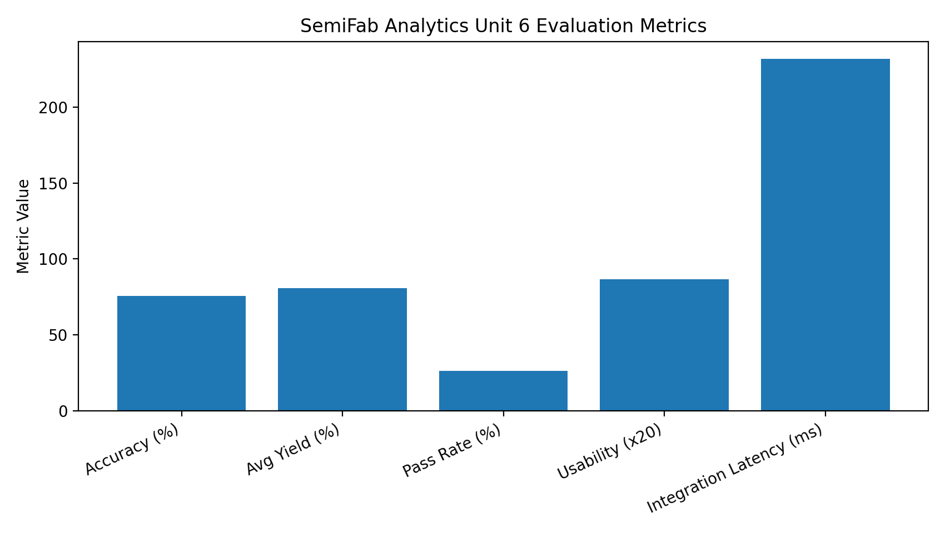
Figure 4. Evaluation metrics chart summarizing model accuracy, yield, pass rate, usability, and integration latency.
The qualitative usability metric used a simple 1-to-5 review scale for navigation clarity, chart readability, and alert explainability. The average usability score was 4.33 out of 5. This is meaningful because a process analytics dashboard must not only compute results; it must make them understandable to users. The dashboard uses four KPI cards, clear chart titles, and the phrase “requires review” for risk alerts. This wording avoids presenting predictions as automatic manufacturing decisions and supports human-in-the-loop review, which aligns with responsible analytics practice.
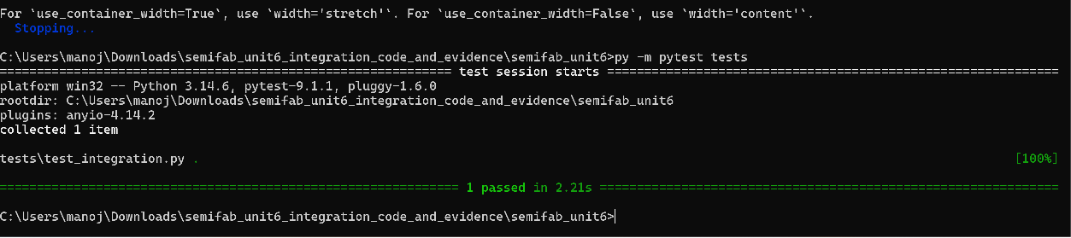
Figure 5. PyTest execution log showing successful completion of the Unit 6 integration test.

PART C: DEPLOYMENT & CONFIGURATION PLANNING OVERVIEW
The selected deployment approach is Streamlit Community Cloud connected to the public GitHub repository at https://github.com/dr-scientist/semifab-analytics. This approach is appropriate because the project is a Python-based analytics dashboard and Streamlit can deploy an app directly from a GitHub repository by selecting the repository, branch, and entrypoint file (Streamlit, 2026). A Docker container is a useful future option for stronger environment reproducibility, but Streamlit Community Cloud is simpler for academic review and portfolio demonstration.
Configuration management improves reliability by making dependencies, commands, file paths, and environment settings explicit. The repository should include requirements.txt, source modules in src/, data files in data/, test files in tests/, screenshots in screenshots/, and documentation in docs/. For local execution, the user installs dependencies with py -m pip install -r requirements.txt, runs the integration workflow with py src\integration_runner.py, starts the dashboard with py -m streamlit run src\dashboard_app.py, and executes tests with py -m pytest tests. These repeatable commands reduce ambiguity for future review.
- Operating system: Windows 10/11 or Linux/macOS with Python 3.12 or compatible Python runtime.
- Libraries: pandas, NumPy, scikit-learn, matplotlib, Plotly, Streamlit, and pytest.
- Repository branch: main for stable work, development for active work, and release tag v0.3-system-integration for this milestone.
- Environment variables: none required for the current prototype because the dataset is simulated and no secrets are used.
- Security configuration: keep secrets out of GitHub, use access control for any future production data, and follow OWASP and NIST secure-development guidance.
GitHub Actions or a similar CI tool can later run PyTest automatically whenever code is pushed. GitHub describes continuous integration as frequent integration of code changes supported by automated build and test workflows (GitHub Docs, 2026). NIST SP 800-218 also recommends secure software development practices that protect code integrity and reduce vulnerabilities across the software life cycle (NIST, 2022). Therefore, deployment planning for the final capstone should include documented configuration, dependency management, version tags, test evidence, and secure handling of any future non-simulated data.

REFERENCES
Bao, Y.-Y., Li, E.-C., Yang, H.-Q., & Jia, B.-B. (2024). Wafer map defect classification using autoencoder-based data augmentation and convolutional neural network. arXiv. https://arxiv.org/abs/2411.11029
GitHub Docs. (2026). About continuous integration. https://docs.github.com/en/actions/get-started/continuous-integration
Mishra, A., Kumar, S., Lingamoorthy, A., Das, A., & Kandasamy, N. (2024). Wafer2Spike: Spiking neural network for wafer map pattern classification. arXiv. https://arxiv.org/abs/2411.19422
National Institute of Standards and Technology. (2022). Secure Software Development Framework (SSDF) Version 1.1: Recommendations for mitigating the risk of software vulnerabilities (NIST SP 800-218). https://doi.org/10.6028/NIST.SP.800-218
OWASP Foundation. (2021). OWASP Top 10:2021. https://owasp.org/Top10/
pytest. (2026). How to invoke pytest. https://docs.pytest.org/
scikit-learn developers. (2025). Feature importances with a forest of trees. https://scikit-learn.org/
Streamlit. (2026). Deploy your app on Community Cloud. https://docs.streamlit.io/deploy/streamlit-community-cloud/deploy-your-app/deploy
Wei, Q., Zhao, W., Zheng, X., & Zeng, Z. (2023). Wafer map defect patterns semi-supervised classification using latent vector representation. arXiv. https://arxiv.org/abs/2311.12840

