Assignment Activity Unit 5
Core Logic Implementation, Unit Testing, and Version Control Management
SemiFab Analytics
Repository URL: https://github.com/dr-scientist/semifab-analytics
Part A: Core Logic Implementation and Output Validation
SemiFab Analytics is designed to support lithography process monitoring, contamination analysis, defect trend review, and process-quality prediction using simulated semiconductor wafer data. The core logic implemented for this milestone directly supports those objectives by converting raw simulated process variables into decision-support outputs. The implementation is organized in src/semifab_core.py and includes five central functions: generate_wafer_data(), calculate_kpis(), calculate_spc_limits(), train_quality_model(), and contamination_alerts(). These functions represent the first executable version of the data source, processing, analytics, and risk-alert modules defined in the system architecture.
The data-generation function creates a realistic simulated dataset with wafer ID, lot ID, tool ID, lithography variables, contamination score, defect density, yield percentage, and pass/fail label. This avoids the ethical and security risk of using confidential production data while still enabling meaningful validation of dashboard logic. The KPI function calculates total wafers, pass rate, average yield, average defect density, and number of high-contamination wafers. These values will later become dashboard cards. The SPC function calculates the mean, upper control limit, lower control limit, and out-of-control count using a three-sigma approach. This supports the project objective of detecting abnormal process behavior before it is treated as a confirmed manufacturing failure. The machine-learning function trains a Random Forest classifier to predict pass/fail status from lithography, contamination, and defect variables. Scikit-learn supports train-test splitting, supervised classifiers, and accuracy metrics, making it appropriate for a small academic prediction prototype (Pedregosa et al., 2011; scikit-learn developers, 2026).
Output validation was performed by running the complete pipeline from the command line. The output shows that the dataset is generated, KPIs are calculated, SPC limits are produced, model accuracy is reported, a confusion matrix is created, feature importance is displayed, and risk alerts are labeled as “requires review.” This wording is important because the system is designed as decision support, not as an automatic manufacturing decision-maker. A key challenge was designing simulated relationships that were realistic enough for testing but not misleadingly presented as real fab data. I resolved this by using controlled mathematical relationships: contamination score, particle count, overlay error, and focus offset increase defect density, while yield decreases as defect and contamination risk increase. Another challenge was keeping the model interpretable. I addressed this by reporting feature importance and confusion matrix output together with the prediction result.
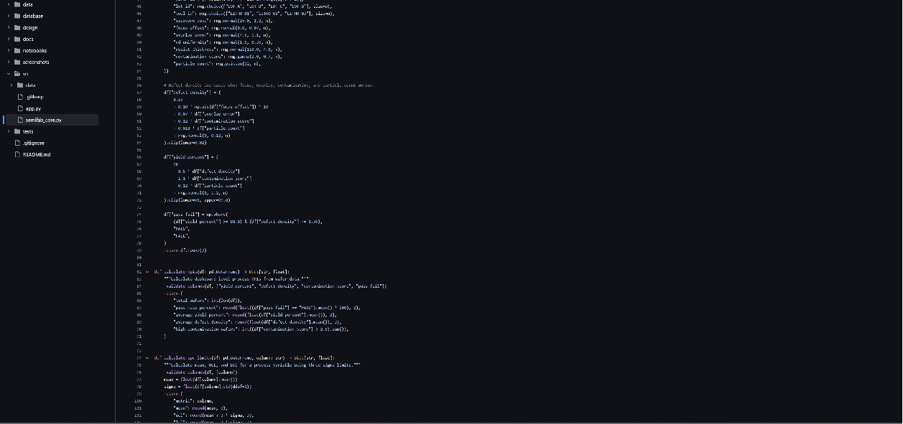
Figure 1. Essential core algorithm code sections showing data generation, KPI calculation, SPC limits, model training, and review-based alerts.

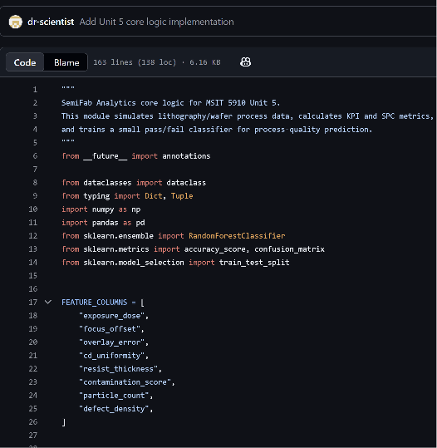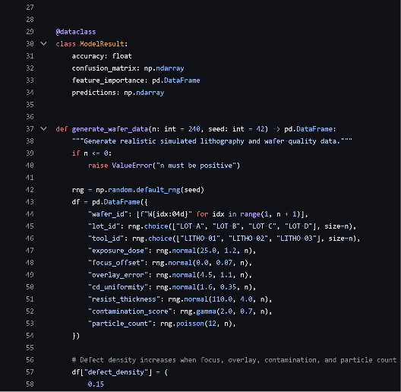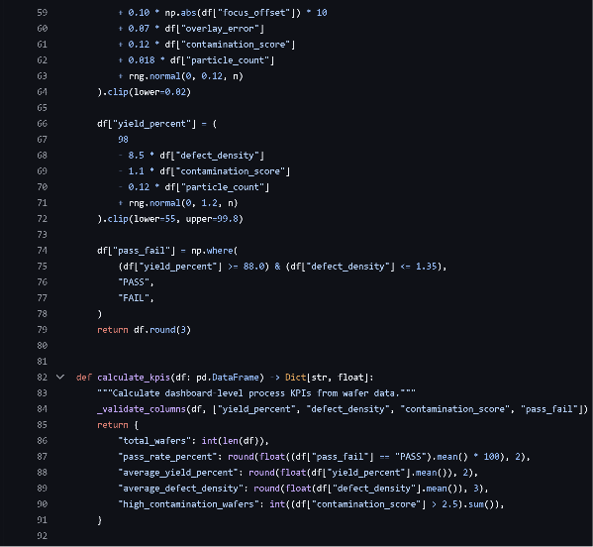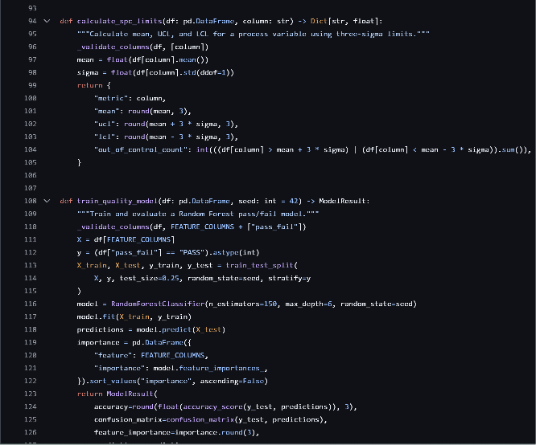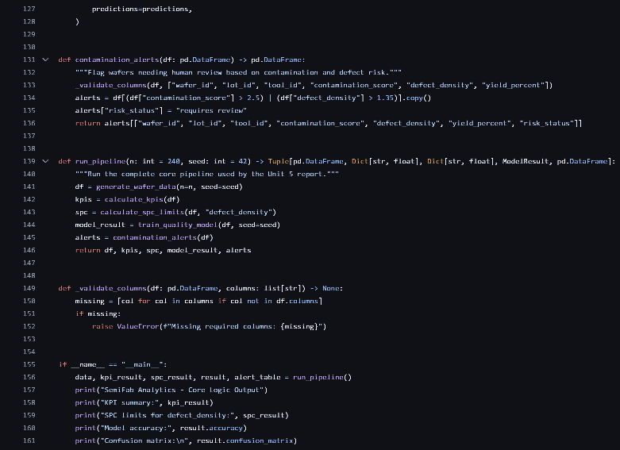
Figure 2. Core logic execution output validating KPI calculation, SPC limits, prediction accuracy, confusion matrix, feature importance, and alert output.

Part B: Unit Testing of Functional Modules
Unit testing was conducted with PyTest. PyTest is suitable for this project because its fixtures and test functions are explicit, modular, and scalable, which supports reliable testing of individual modules (pytest developers, 2026). The tests used both black-box and white-box unit testing. Black-box testing checked whether functions returned correct business-level results without depending on internal implementation details. For example, the KPI test verifies that total wafer count, pass rate, average yield, and defect density are within valid ranges. The model test checks that the classifier returns an accuracy value, a 2 x 2 confusion matrix, and a non-empty feature importance table. White-box testing checked internal validation behavior by intentionally passing a DataFrame with a missing required column and confirming that the module raises a ValueError.
The test suite includes six tests: data generation structure, KPI calculation, SPC limit calculation, model training output, contamination alert wording, and missing-column validation. The successful PyTest log shows that all six tests passed. These tests provide coverage evidence for the most important functional modules because they validate both normal behavior and failure behavior. The tests also helped improve the implementation. For example, the missing-column test led to adding a shared _validate_columns() helper, which makes errors clearer and prevents silent failures when future dashboard or database inputs are incomplete. The contamination alert test helped ensure that the output remains ethically careful by using “requires review” rather than automatic failure labeling.
Different types of unit tests include black-box tests, white-box tests, boundary tests, exception tests, and regression tests. Black-box tests verify expected outputs from given inputs. White-box tests examine internal paths or validation rules. Boundary tests check edge conditions such as empty datasets or extreme values. Exception tests verify that invalid inputs are handled safely. Regression tests ensure that earlier working behavior does not break after later changes. In SemiFab Analytics, unit testing improves reliability because each module can be verified independently before it is integrated into the dashboard. It also supports modular development because data generation, KPI calculation, SPC logic, model training, and alert generation can be changed separately as long as tests continue to pass. NIST’s Secure Software Development Framework recommends integrating secure and reliable software practices into the development lifecycle to reduce vulnerabilities and prevent recurring defects (National Institute of Standards and Technology, 2022).
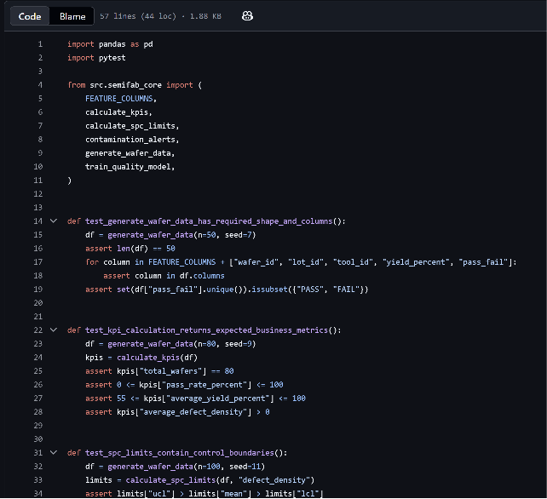
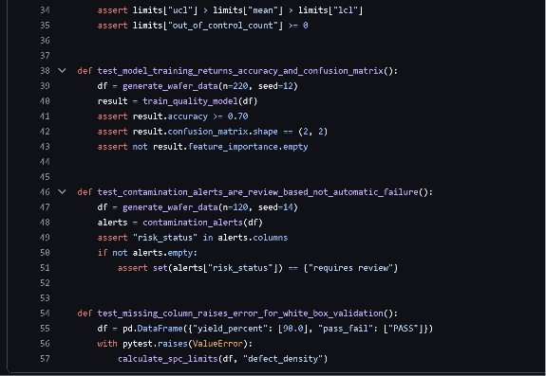
Figure 3. Unit test code sections showing black-box tests for expected outputs and white-box validation of error handling.
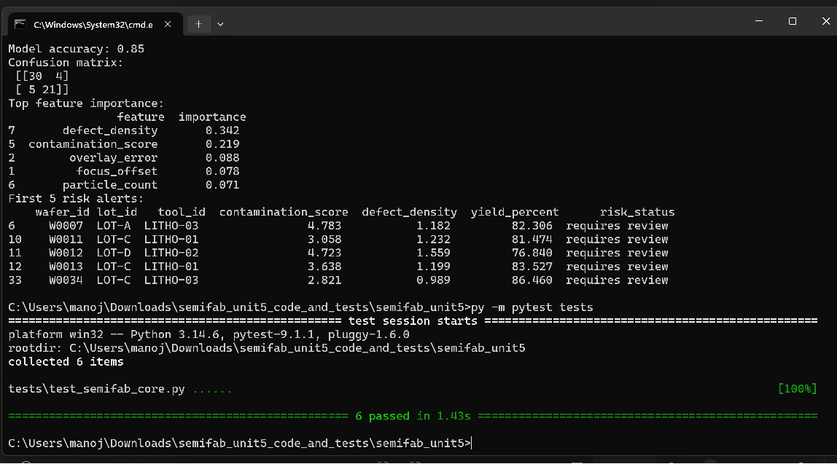
Figure 4. PyTest execution log showing successful completion of all Unit 5 tests.

Part C: Version Control Management
The project repository is available at https://github.com/dr-scientist/semifab-analytics. The repository is organized with folders for source code, simulated data, database schema, documentation, architecture diagrams, notebooks, tests, screenshots, and GitHub workflow files. The branching model uses main for stable reviewed work, development for active integration, and short-lived feature branches such as feature/data-simulation, feature/spc-charts, feature/ml-model, and feature/unit-tests. This model keeps the stable branch clean while allowing experimental or incomplete work to occur separately. Pull requests can then be used to review changes before they enter development or main.
For this milestone, the version-control plan includes tags and releases to record major progress points. The planned tags are v0.1-core-logic for completion of the data pipeline and analytics functions, and v0.2-unit-tests for completion of PyTest validation. Git supports annotated tags that store a message, tagger information, and date, making them useful for marking important project milestones (Git Project, 2026). GitHub releases are based on Git tags and can package a specific project iteration with release notes and downloadable source archives (GitHub, 2026). Therefore, releases help the instructor or reviewer identify exactly which version corresponds to the Unit 5 milestone.
Tagging and releases improve project monitoring because they create stable checkpoints. If later dashboard development introduces an error, I can compare the current code with the v0.2-unit-tests release and identify what changed. This supports traceability, rollback, and academic evaluation. A GitHub Actions workflow file is also prepared for future CI execution. The workflow will install Python dependencies and run pytest on pushes and pull requests to main or development. GitHub Actions is designed to automate development workflows such as testing and deployment, and research on workflow automation shows that these tools support collaborative development by reducing manual repetitive work (GitHub, 2026; Wessel et al., 2023). For the next milestone, the same process will be extended by adding simulated CSV data, dashboard KPI cards, and additional tests for database loading and visualization logic. Two GitHub releases were created to record Unit 5 milestones: v0.1-core-logic for implementation of the core logic and v0.2-unit-tests for completion of PyTest-based unit testing.
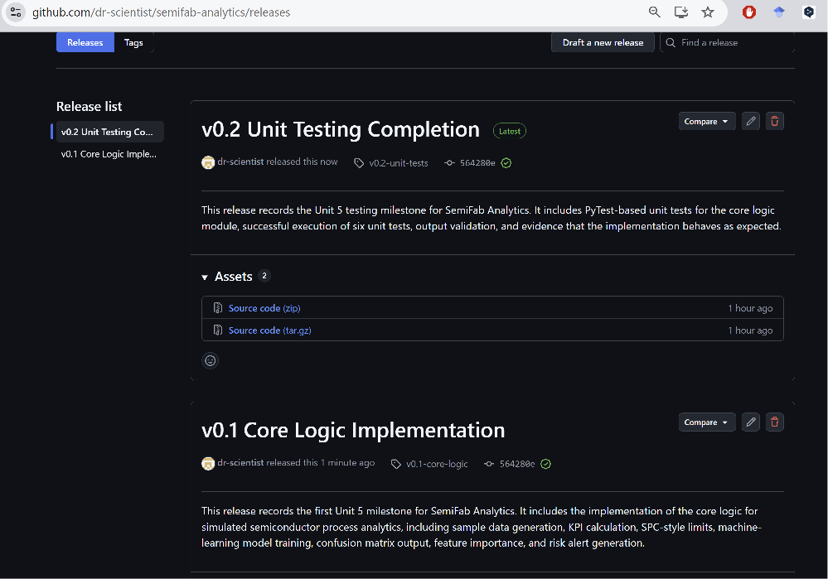
Figure 5. Version control milestone evidence showing local annotated tags and release notes draft for the Unit 5 milestone.

References
Git Project. (2026). Git basics - tagging. https://git-scm.com/book/en/v2/Git-Basics-Tagging
GitHub. (2026). About releases. GitHub Docs. https://docs.github.com/en/repositories/releasing-projects-on-github/about-releases
GitHub. (2026). Managing releases in a repository. GitHub Docs. https://docs.github.com/en/repositories/releasing-projects-on-github/managing-releases-in-a-repository
National Institute of Standards and Technology. (2022). Secure Software Development Framework (SSDF) version 1.1: Recommendations for mitigating the risk of software vulnerabilities (NIST SP 800-218). https://doi.org/10.6028/NIST.SP.800-218
Pedregosa, F., Varoquaux, G., Gramfort, A., Michel, V., Thirion, B., Grisel, O., Blondel, M., Prettenhofer, P., Weiss, R., Dubourg, V., Vanderplas, J., Passos, A., Cournapeau, D., Brucher, M., Perrot, M., & Duchesnay, E. (2011). Scikit-learn: Machine learning in Python. Journal of Machine Learning Research, 12, 2825-2830. https://jmlr.org/papers/v12/pedregosa11a.html
pytest developers. (2026). About fixtures. pytest documentation. https://docs.pytest.org/en/stable/explanation/fixtures.html
scikit-learn developers. (2026). scikit-learn user guide. https://scikit-learn.org/stable/user_guide.html
Wessel, M., Mens, T., Decan, A., & Rostami Mazrae, P. (2023). The GitHub development workflow automation ecosystems. arXiv. https://arxiv.org/abs/2305.04772

