Lebanese International University
Department of Computer Science and Information Technology
CSCI426 – Advanced Web Programming
STUDENT PORTAL SYSTEM
Project Report
Phase 1 and Phase 2
Prepared by:
Abdel Rahman Othman
Student ID: 22030084
Omar Zammar
Student ID: 22030061
Submitted to:
Dr. [Fouad Najm]
Semester:
Summer 2025–2026

1.Abstract:
The Student Portal System is a full-stack web application developed to simplify the management of student academic information and university services. The frontend was developed using ReactJS with a responsive and user-friendly interface that works on desktop and mobile devices. The application includes multiple pages such as Home, About, Courses, My Courses, Grades, Profile, Contact, Login, Signup, and administrative pages.
The backend was developed using Node.js and Express.js and connected to a MySQL database. The system provides secure user authentication using JSON Web Tokens and encrypted passwords. Students can create accounts, log in, update their profiles, view available courses, enroll in courses, and view their grades. Administrators can manage courses and student grades through complete Create, Read, Update, and Delete operations.
The database contains four related entities: users, courses, enrollments, and grades. Proper input validation, error handling, role-based authorization, and database relationships were implemented. The project demonstrates frontend development, backend development, database integration, version control using Git and GitHub, and the development of a complete functional web application.

2. System Design:
2.1 System Architecture
The Student Portal System follows a three-layer architecture consisting of the frontend, backend, and database layers.
The frontend layer was developed using ReactJS. It provides the user interface and allows students and administrators to interact with the system through different pages and forms.
The backend layer was developed using Node.js and Express.js. It receives requests from the frontend, validates user input, applies the system rules, performs authentication and authorization, and communicates with the database through REST API routes.
The database layer uses MySQL to store users, courses, enrollments, and grades. The backend connects to MySQL using the mysql2 package.
User
│
▼
ReactJS Frontend
│
│ HTTP Requests / JSON Responses
▼
Node.js and Express Backend
│
│ SQL Queries
▼
MySQL Database

2.2 System Users

The system includes two main user roles:

Student:
• Create a new account.
• Login securely.
• View and update the student profile.
• View available courses.
• Enroll in courses.
• View registered courses.
• Remove a course enrollment.
• View grades and academic results.

Administrator:
• Login using an administrator account.
• Add, view, update, and delete courses.
• View student enrollments.
• Add, update, and delete student grades.

2.3 Database Design

The database contains four related tables:

• users: Stores student and administrator account information.
• courses: Stores course information.
• enrollments: Connects students with registered courses.
• grades: Stores the grade related to each enrollment.

The database relationships are:

users → enrollments ← courses
↓
grades

One user can have many enrollments, and one course can have many enrollments. Each enrollment connects one student to one course. An enrollment may also have one related grade.

3. Technologies Used:
3.1 Frontend Technologies
ReactJS
ReactJS was used to develop the frontend user interface of the Student Portal System. It was used to create reusable components and dynamic pages such as Courses, My Courses, Grades, Profile, Login, Signup, and the administrator pages.
React Router
React Router was used to provide navigation between the different pages of the application without reloading the whole website.
JavaScript
JavaScript was used to implement the application logic, handle form submissions, communicate with the backend APIs, manage component state, and display dynamic data.
HTML5 and CSS3
HTML5 was used to structure the website content. CSS3 was used to design the pages, forms, navigation bar, tables, cards, buttons, and responsive layouts.
Vite
Vite was used as the frontend development and build tool. It provides a fast development server and supports the ReactJS project structure.

3.2 Backend Technologies:
.Node.js
Node.js was used to develop the server-side part of the application and execute JavaScript code on the backend.
.Express.js
Express.js was used to create the REST API routes for authentication, users, courses, enrollments, and grades. It also handles HTTP requests, middleware, validation, and error responses.
.JSON Web Token
JSON Web Token was used to authenticate users and protect private routes. The generated token stores the logged-in user ID and role.
.bcryptjs
bcryptjs was used to encrypt user passwords before storing them in the MySQL database. During login, the entered password is compared with the encrypted password.
.CORS
CORS was used to allow the ReactJS frontend to communicate with the Node.js backend running on a different port.
. dotenv
dotenv was used to load private configuration values from the .env file, including the database password, database name, server port, and JWT secret.

3.3 Database Technologies
.MySQL
MySQL was used as the relational database management system. It stores users, courses, enrollments, and grades.
.MySQL Workbench
MySQL Workbench was used to create the database, execute SQL queries, view stored data, manage the tables, and export the database schema.
.mysql2
The mysql2 package was used to connect the Node.js backend to the MySQL database and execute asynchronous parameterized SQL queries.

3.4 Development and Version Control Tools
.Visual Studio Code
Visual Studio Code was used to create, edit, organize, and run the frontend and backend project files.
.Git
Git was used for version control and recording the development history through commits.
.GitHub
GitHub was used to store the source code, README documentation, screenshots, and database schema.
.npm
npm was used to install and manage the required frontend and backend packages.

4. Key Code Snippets:
4.1 MySQL Database Connection:
const mysql = require("mysql2/promise");

const pool = mysql.createPool({
host: process.env.DB_HOST,
user: process.env.DB_USER,
password: process.env.DB_PASSWORD,
database: process.env.DB_NAME,
waitForConnections: true,
connectionLimit: 10,
});

module.exports = pool;

This code creates a connection pool between the Node.js backend and the MySQL database. The database configuration is loaded securely from environment variables.

Password Encryption During Signup:
const hashedPassword = await bcrypt.hash(password, 10);

await pool.query(
`INSERT INTO users
(full_name, student_id, email, password, major, role)
VALUES (?, ?, ?, ?, ?, 'student')`,
[
fullName,
studentId,
normalizedEmail,
hashedPassword,
major,
]
);
Before saving a student account, the password is encrypted using bcryptjs. The encrypted value is stored in MySQL instead of the original password.

JWT Authentication:
const token = jwt.sign(
{
userId: user.id,
role: user.role,
},
process.env.JWT_SECRET,
{
expiresIn: "2h",
}
);
After successful login, the backend generates a JSON Web Token containing the user ID and role. This token is used to access protected routes.

Authentication Middleware:
const authenticateToken = (req, res, next) => {
const authorizationHeader = req.headers.authorization;

if (
!authorizationHeader ||
!authorizationHeader.startsWith("Bearer ")
) {
return res.status(401).json({
success: false,
message: "Access denied. No token provided",
});
}

const token = authorizationHeader.split(" ")[1];
const decodedToken = jwt.verify(
token,
process.env.JWT_SECRET
);

req.user = decodedToken;
next();
};
This middleware verifies the JWT token before allowing access to protected student and administrator routes.
Admin Authorization
const requireAdmin = (req, res, next) => {
if (!req.user || req.user.role !== "admin") {
return res.status(403).json({
success: false,
message: "Access denied. Admin permission is required",
});
}

next();
};
This middleware prevents normal student accounts from using administrator operations such as adding courses or managing grades.

Dynamic Course Display in ReactJS
{courses.map((course) => (
<article className="course-card" key={course.id}>
<h2>{course.course_name}</h2>

<p>
<strong>Instructor:</strong> {course.instructor}
</p>

<p>
<strong>Credits:</strong> {course.credits}
</p>

<button onClick={() => handleEnrollment(course.id)}>
Enroll Now
</button>
</article>
))}
ReactJS displays the courses dynamically using the map function. The course information is retrieved from the backend and MySQL database.

Course Enrollment Request
const response = await fetch(
`http://localhost:5000/api/enrollments/${courseId}`,
{
method: "POST",
headers: {
"Content-Type": "application/json",
Authorization: `Bearer ${token}`,
},
body: JSON.stringify({
semester: "Summer 2025-2026",
}),
}
);
This frontend request sends the selected course ID, semester, and student authentication token to the backend to create a new enrollment.

5. Application Screenshots

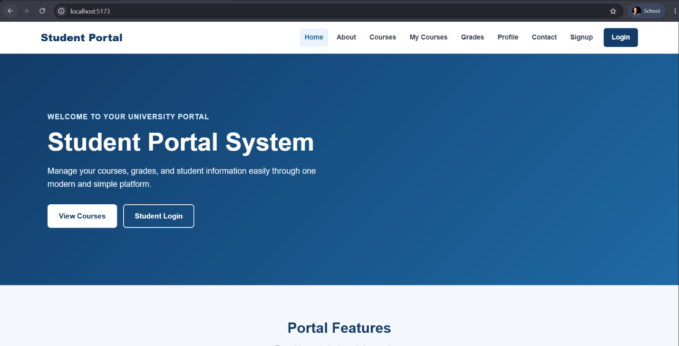
Figure 1: The responsive home page of the Student Portal System.

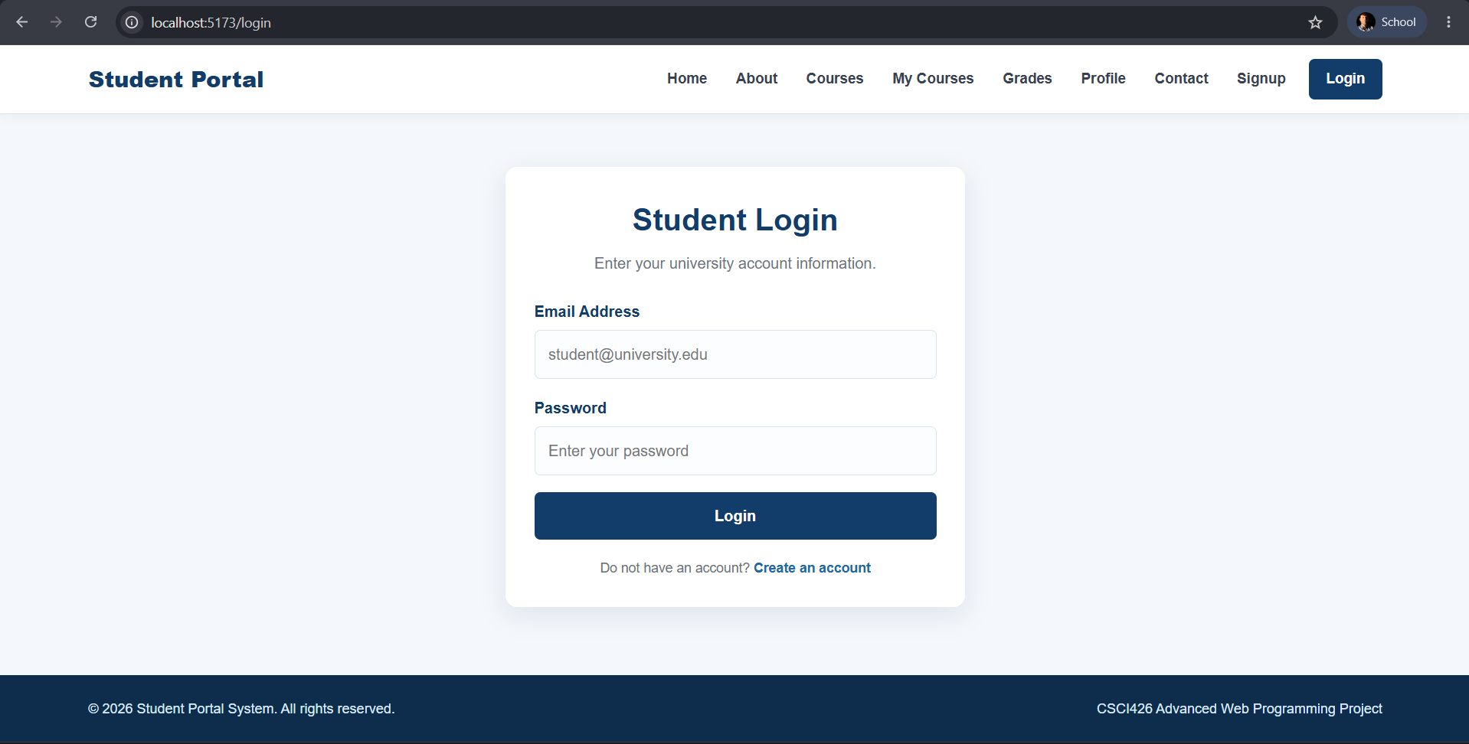
Figure 2: Student login page used to access the system securely.

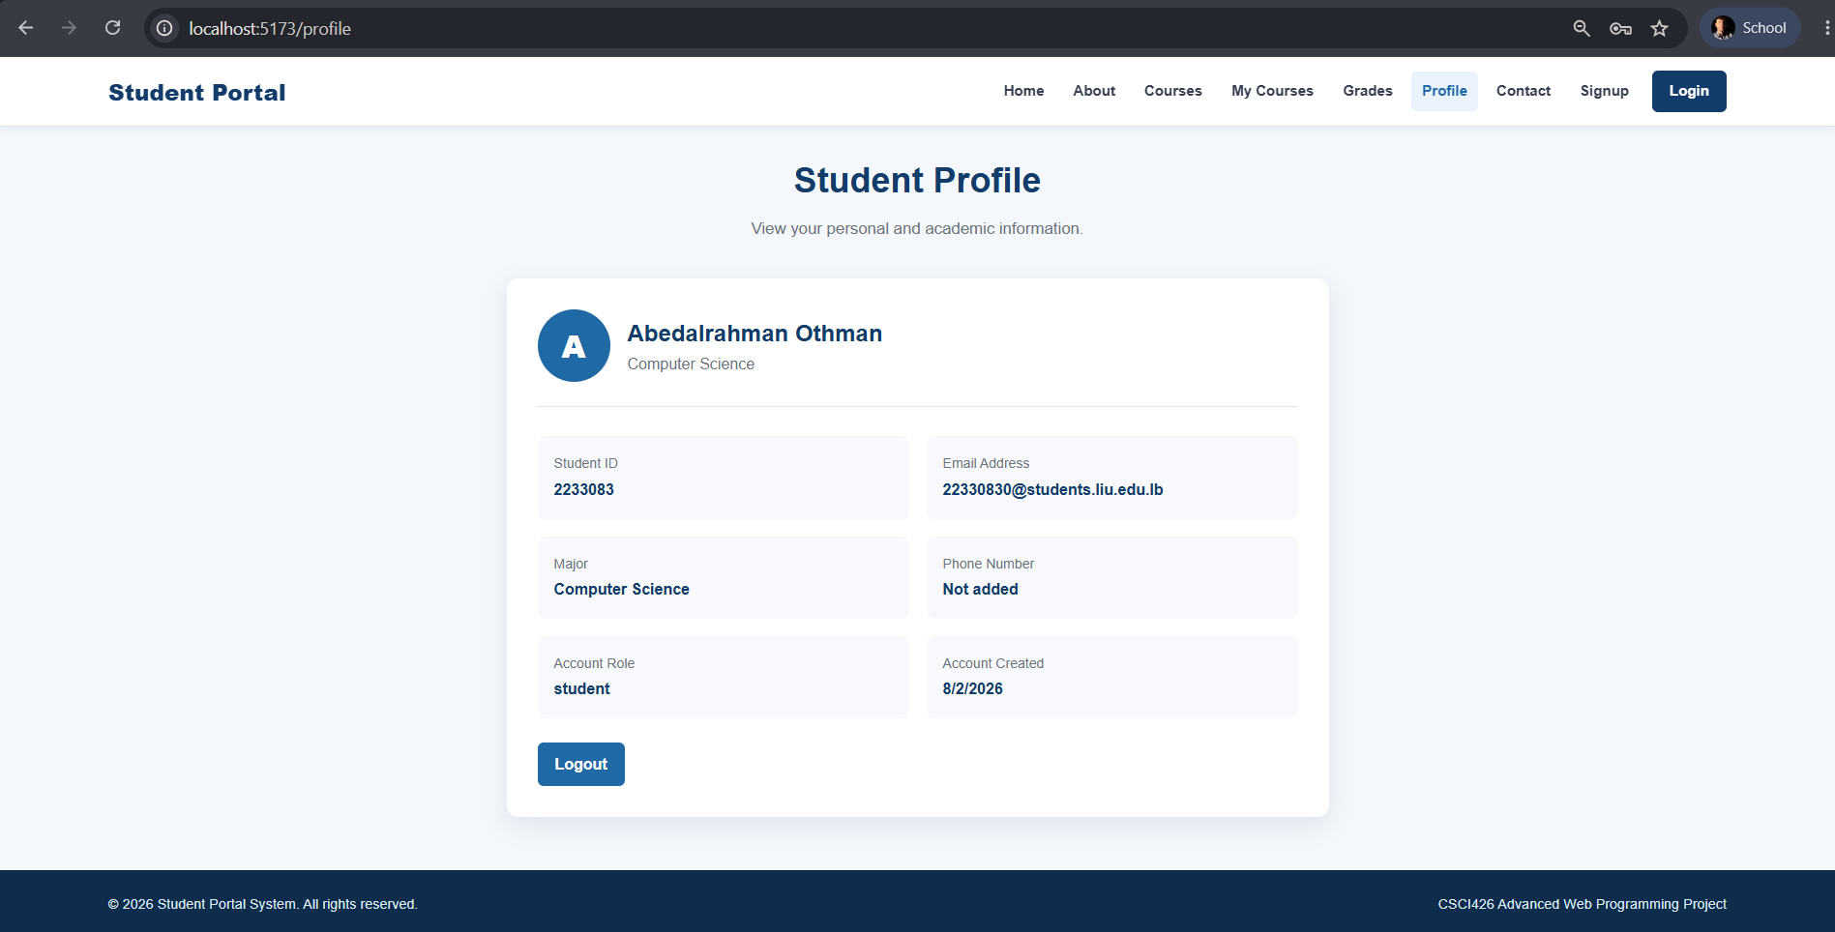
Figure 3: Student profile page displaying personal and academic information.

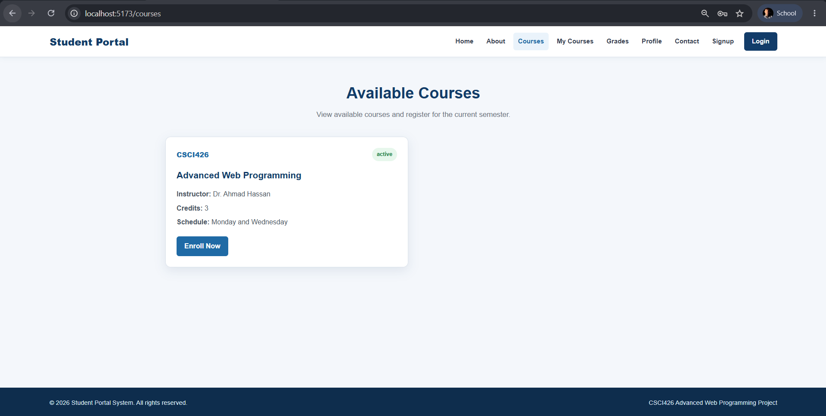
Figure 4: Available courses retrieved dynamically from the MySQL database.

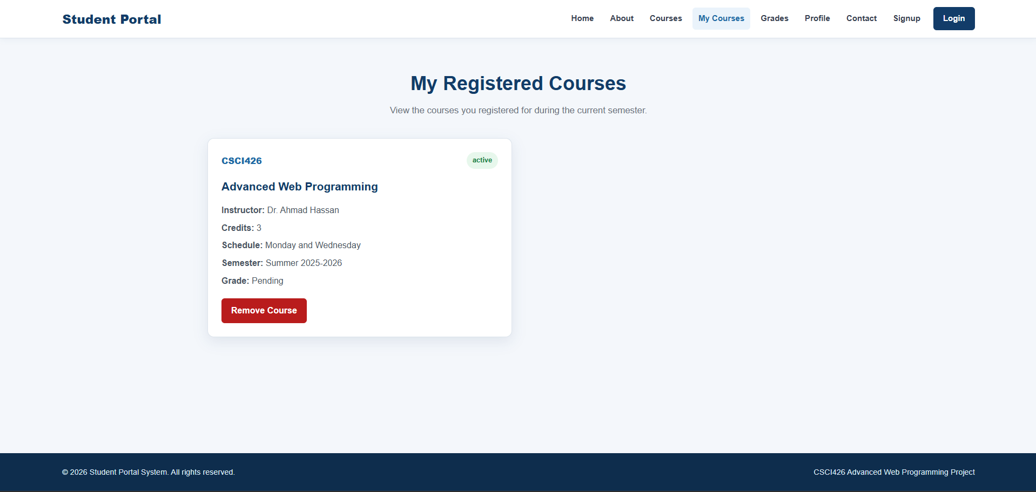
Figure 5: Registered courses associated with the logged-in student.

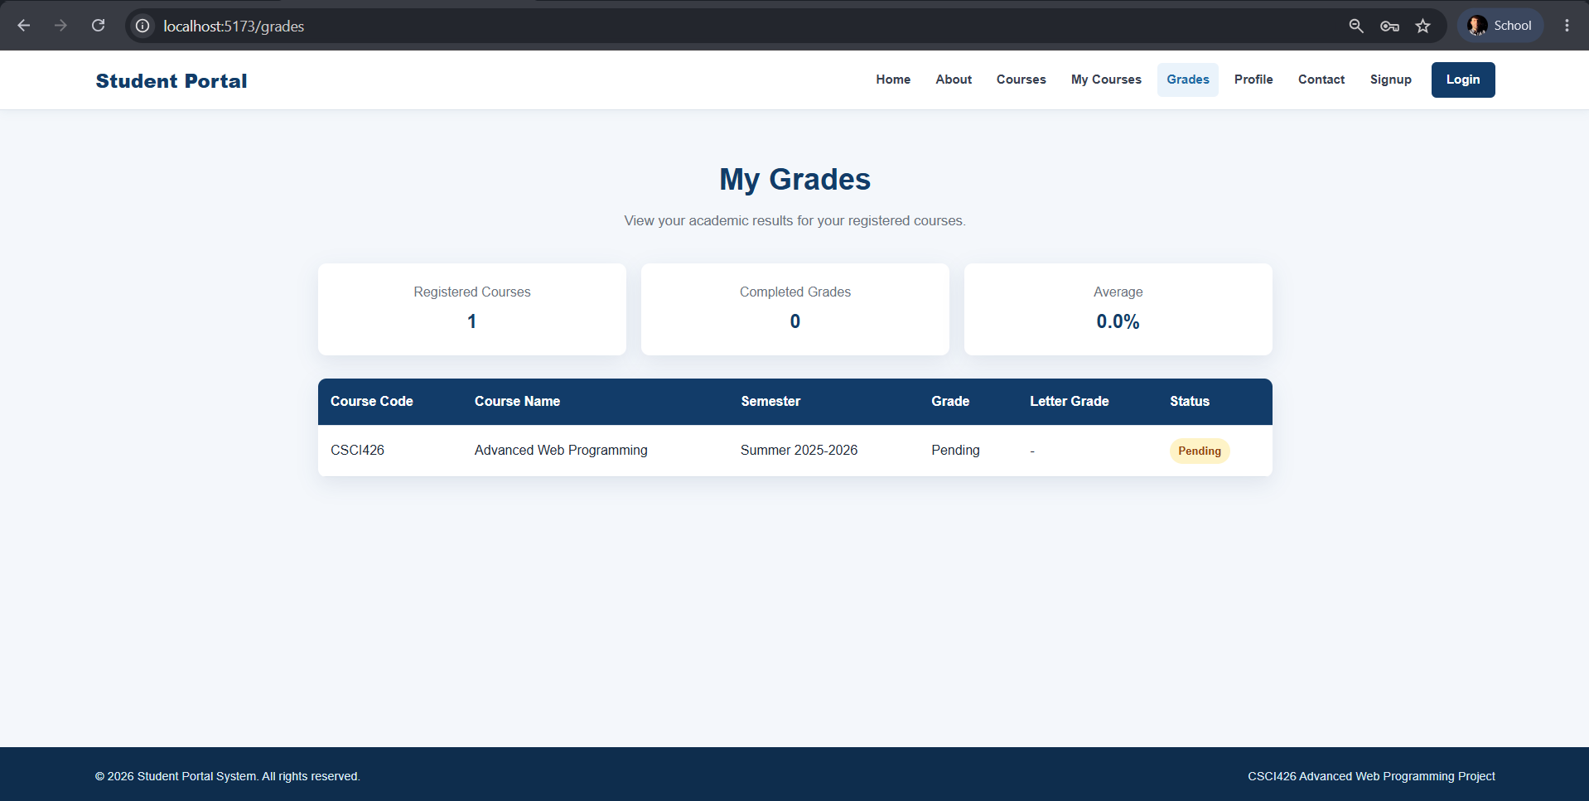
Figure 6: Student grades, letter grades, status, and academic average.

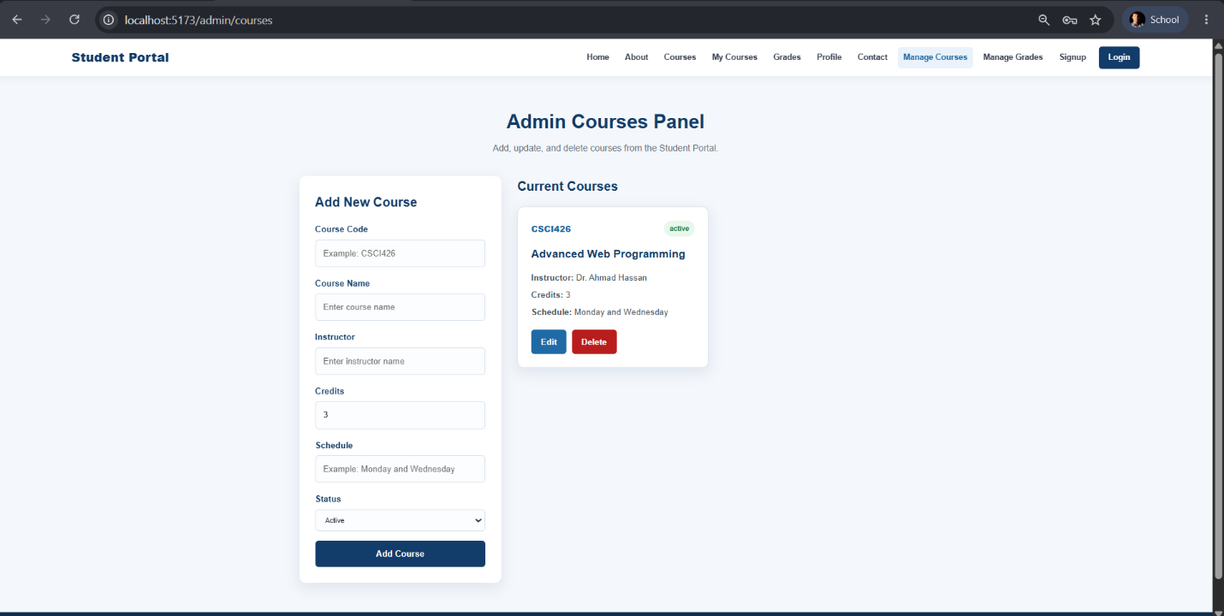
Figure 7: Administrator panel used to add, update, and delete courses.

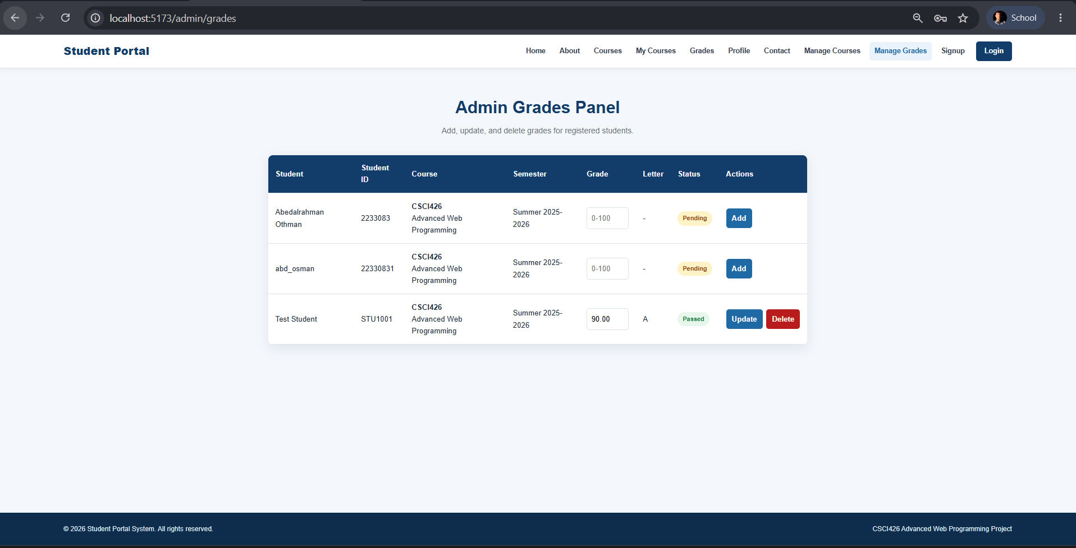
Figure 8: Administrator panel used to manage student grades.

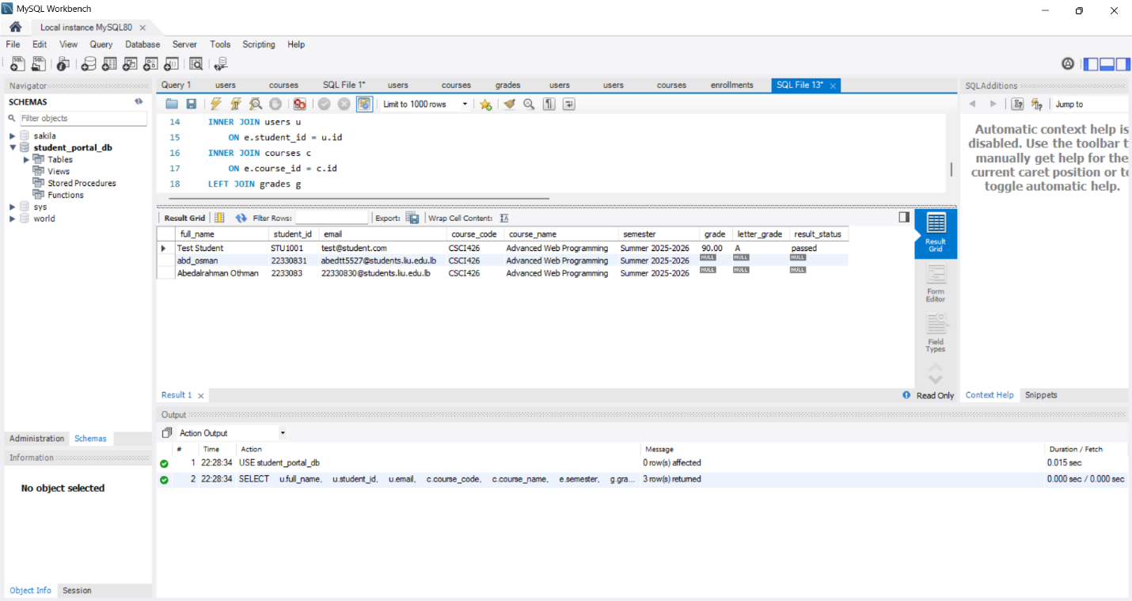
Figure 9: MySQL query result showing the relationships between students, courses, enrollments, and grades.

6. Conclusion and Future Scope
6.1 Conclusion:
The Student Portal System was successfully designed and developed as a complete full-stack web application. The project uses ReactJS to provide a responsive and user-friendly frontend, while Node.js and Express.js are used to manage the backend services and REST APIs. MySQL was used to store and manage the system data.

The application allows students to create accounts, log in securely, update their profiles, view available courses, register for courses, and view their academic grades. The administrator can manage courses and student grades through complete Create, Read, Update, and Delete operations.

The system also implements password encryption, JSON Web Token authentication, role-based authorization, input validation, error handling, and relationships between the users, courses, enrollments, and grades tables.

Git and GitHub were used for version control, project documentation, screenshots, and storing the database schema. The completed project satisfies the main functional and technical requirements of Phase 1 and Phase 2.

6.2 Future Scope:
The Student Portal System can be improved in the future by adding the following features:

• Email notifications for course registration and grade updates.
• Password reset and email verification.
• Attendance management.
• Course search and filtering.
• Student dashboard statistics and charts.
• Administrator management of student accounts.
• Online deployment using a cloud-based MySQL database.
• Mobile application support.
• Course materials and assignment submission.
• Academic advising and semester planning.

This project was completed individually by Abdel Rahman Othman. All frontend development, backend development, database design, testing, documentation, and version control tasks were completed individually.

