# HW 12 Solutions

## Stat 61

### Problem 1

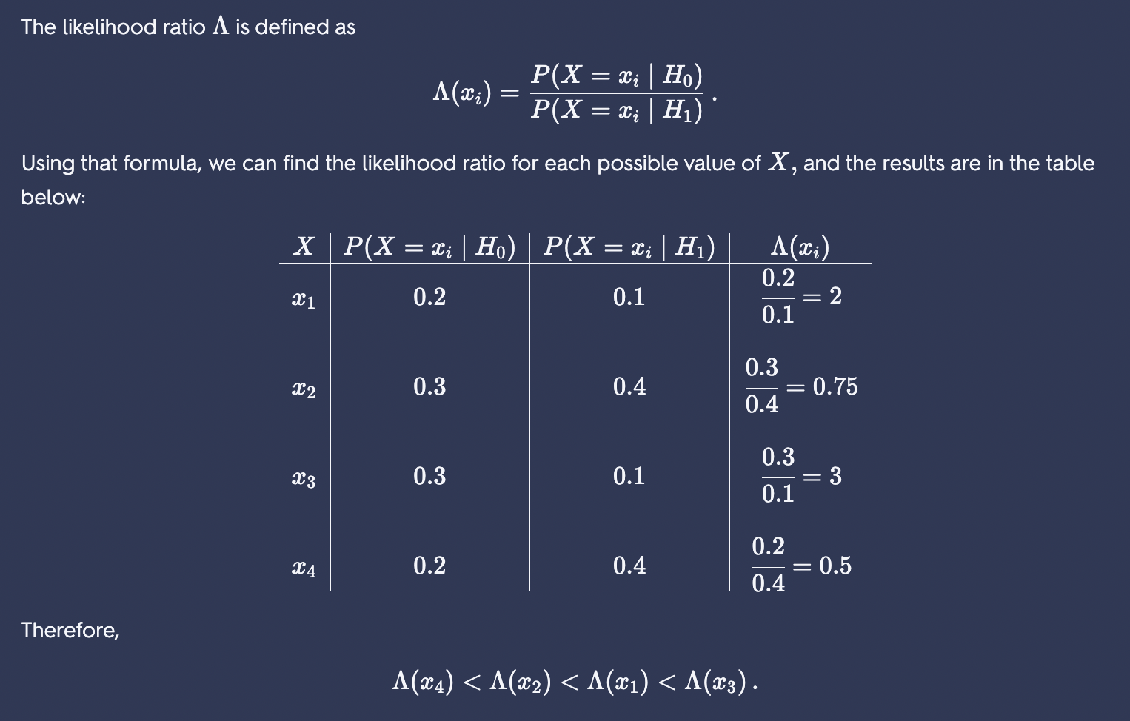

### Problem 2

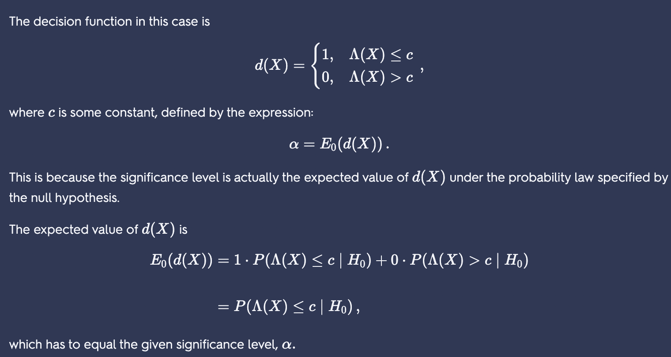

## 

### Problem 3

(a)

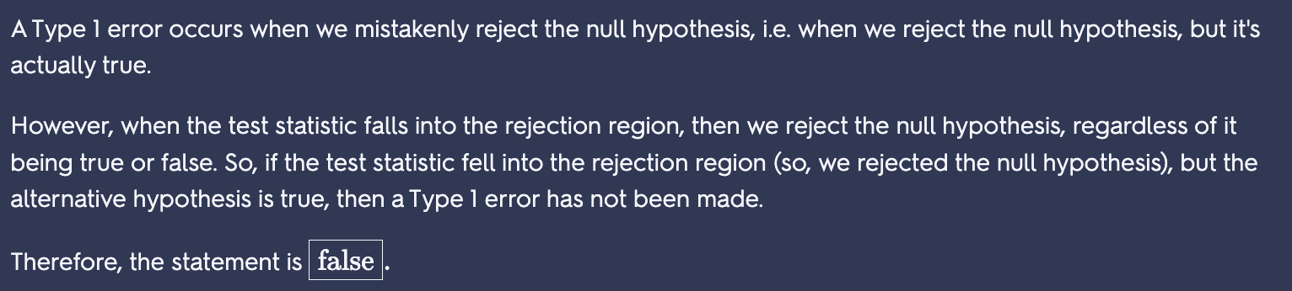

(b)

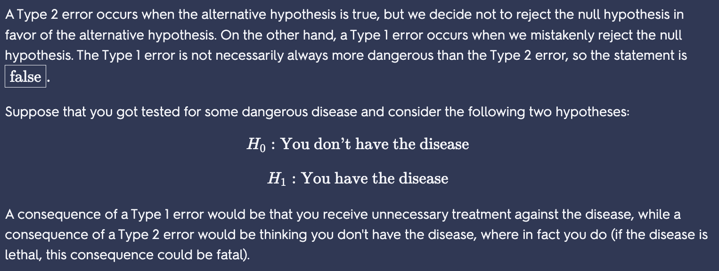

(c)

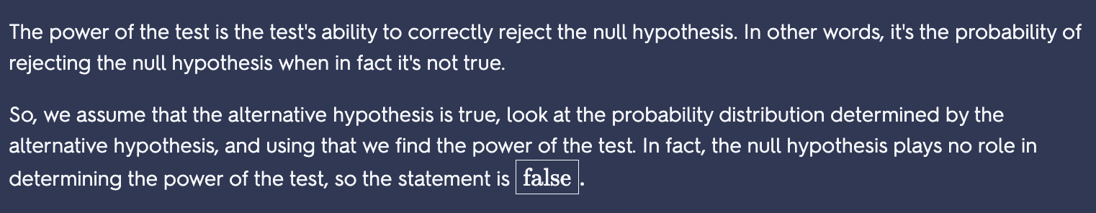

(d)

