# HW 15 Solutions

## Stat 61

### Problem 1

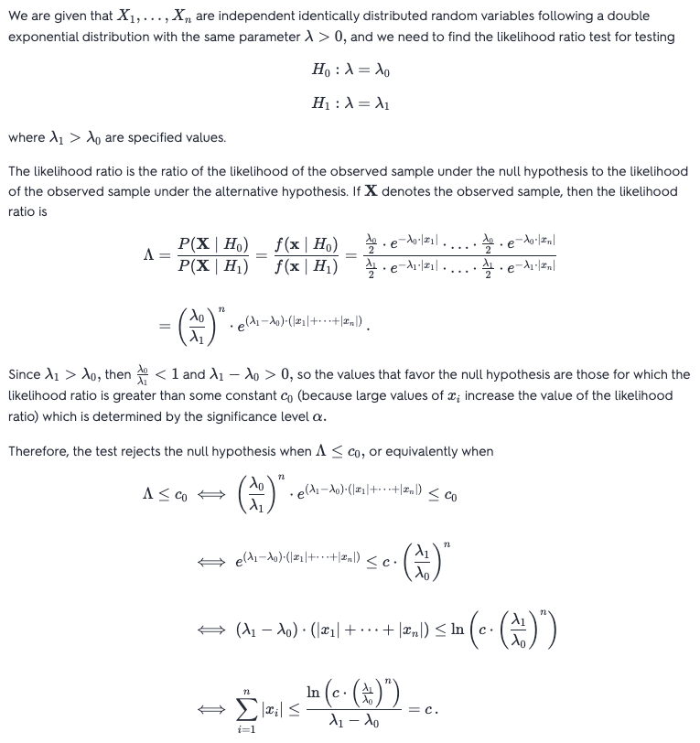



### Problem 2

## 

### Problem 3

