# HW 4 Solutions

## Stat 61

### Problem 1

### 

### Problem 2



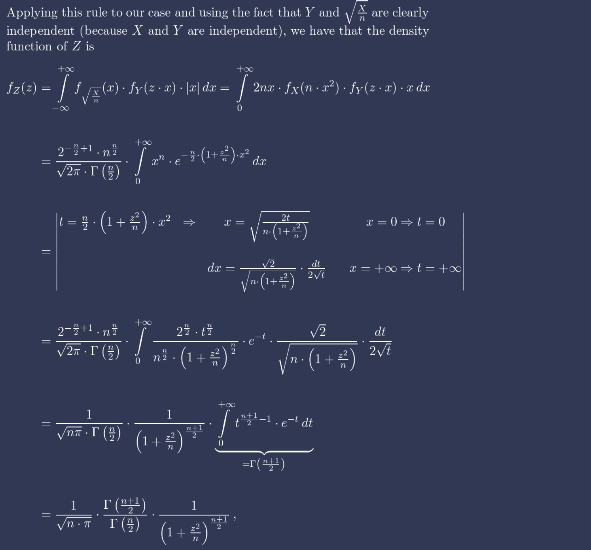

### Problem 3

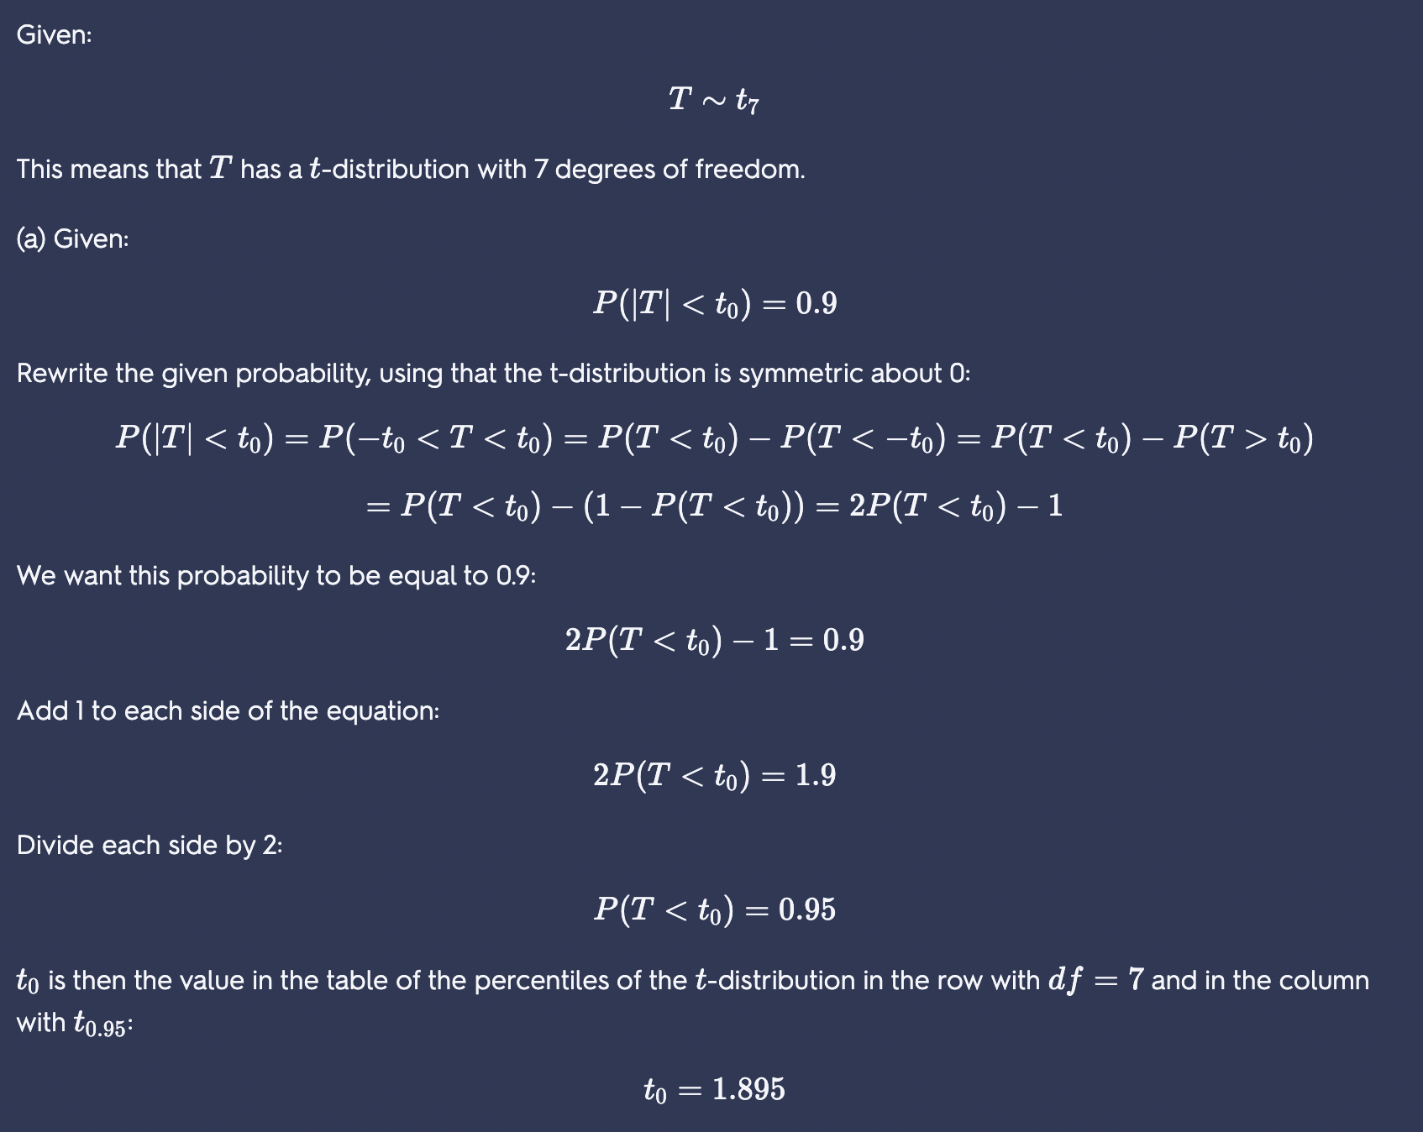

Or, you could use the following code in R to find the quantile:

> qt(.95, df=7, lower=TRUE)

[1] 1.894579