Hello, dear friends from Arturia. My name is Victor, I am your new customer and user of your impressive product Keylab-88. Since I bought your keys, I drew attention to the lack of drivers for Propellerhead Reason 10. I mean their Remote protocol, which allows to map knobs faders and buttons to the DAW. People recommended me not to use Arturia 88 or to change Reason to another DAW, but I like these products so much and wanted them to work together.

I thought the 61 differs from 88 only in the number of keys, so I tried to use Keylab-61 driver, but 4x4 pads did not work, so I decided to write remote files myself.

The work is finished and now I use my self-made remote codec. But while I was writing it, I found a mistake, which was the reason why keylab61 codec did not work with my keys (I mean non-working 4x4 pads). Let us look at it and I will explain:

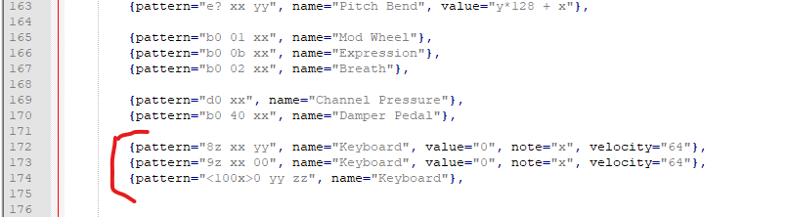

Here we can see patterns, that are responsible for black and white keys press: “<100x>0 yy zz” pattern.

The black and white keys up (off): “9z xx 00” pattern.

And 4x4 pad up off code: “8z xx yy” pattern.

But there is no pattern for the pressing 4x4 pad. So, it will not work. I fixed this problem by adding this line of code:

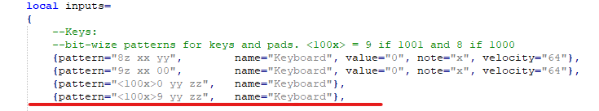

I fixed it in my codec for 88 keys, so I hope it can be used by your Arturia KeyLab users.

I recommend using my codec with included controller settings (the only thing is that all knobs set to relative mode).

Feel free to contact me for any questions. And I hope you will fix the issue with missing string of code that makes pads invalid in Reason. I also hope that my codec can be added to Propellerhead Reason I can contact them if you want.

I will add it to GitHub, and I think I will improve it for better usability in future.

I also include the remote files and keylab88 config in my message.

Best wishes, Victor.

[propellerheadvij@gmail.com](mailto:propellerheadvij@gmail.com), [just-dr-vij@yandex.ru](mailto:just-dr-vij@yandex.ru).