Ways to troubleshoot MCD if not working:

=> Check if there is a valid work order

=> Check if routers are running

=> Pull out MCD and troubleshoot in Design

1. See if there is a work order running on that machine. Get the MCD Id of the machine from machines.xlsx file. Take for example 10007.

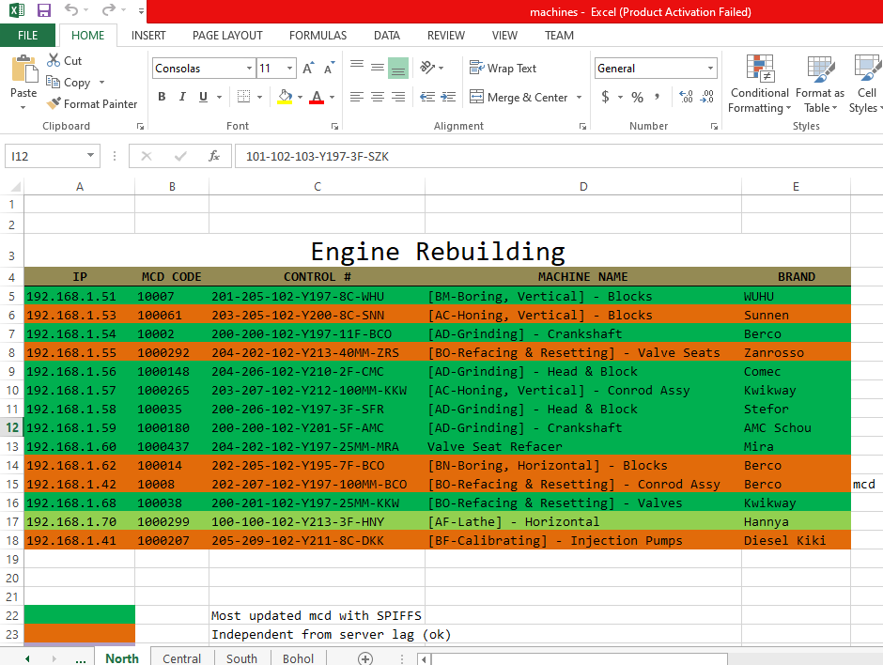

Open Postman and query test to see if there is work order running.

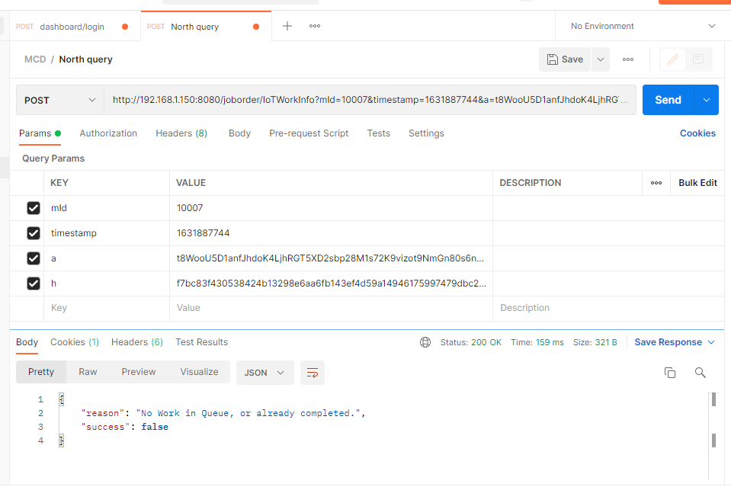

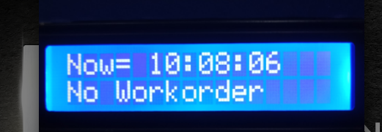

“No work in Queue, or already completed” means no work order and machine will not run since no electric supply from MCD.

Test query another machine, 100071 for example:

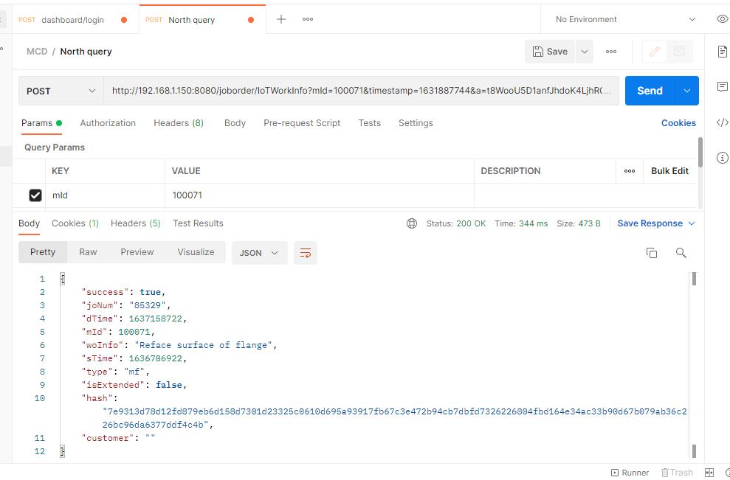

Go to epochconverter.com and paste epoch time (dTime) to see the readable date.

sTime (start time): 1636706922 = Monday, November 15, 2021 12:54:37 AM

dTime (deadline time): 1637158722 = Wednesday, November 17, 2021 2:18:42 PM

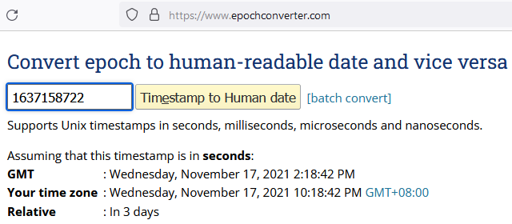

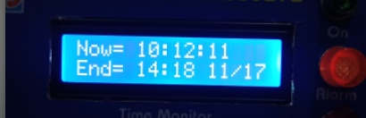

Work order starts at 11-15-2021 12:54:37 AM and ends at 11-17-2021 2:18:42 PM. The message tells us that there is work order and the machine should run.

2. See if RT-N12+ routers are running. There are 3 routers in north, 1 in central and 1 in south plant. MCDs connect to this routers so that they can access job order system. MCD located in ER connect to ER router, MCD located in MF connect to MF router, MCD located in Finance connect to Finance router. No router means no MCD working. They must be running at all times. Make sure to tighten the Ethernet cable to its Ethernet port.

ER router has an IP of 192.168.1.34. Enter the IP in the browser. If the router’s web page renders when typing its IP, the router is ok and running.

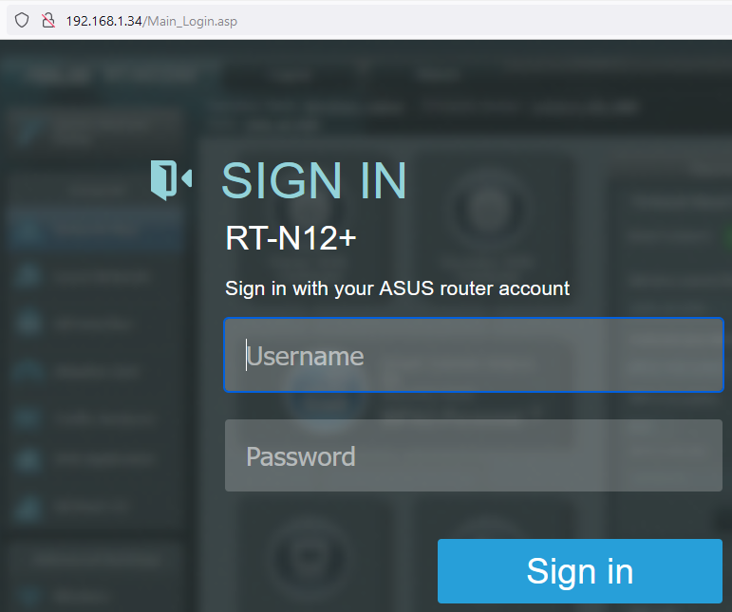

MF router has an IP of 192.168.1.3. Enter the IP in the browser. If the router’s web page renders when typing its IP, the router is ok and running.

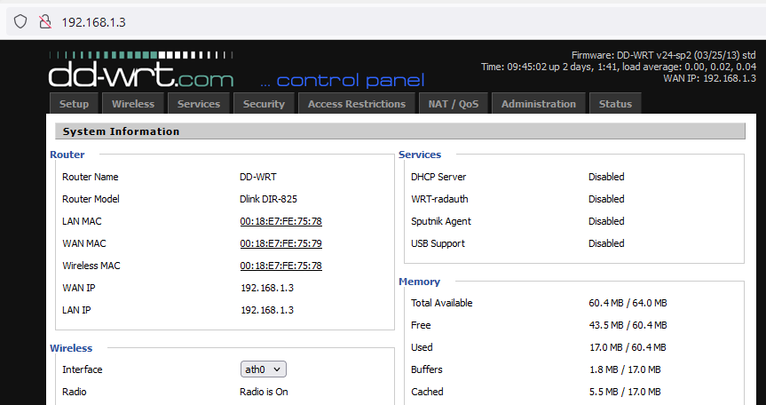

Finance router has an IP of 192.168.1.32. Enter the IP in the browser. If the router’s web page renders when typing its IP, the router is ok and running.

