SINGULAR VALUE DECOMPOSITION

Singular value decomposition in linear algebraic terms, is the process of decomposing a matrix into 3 matrices A = UDVT . In dimensionality reduction, U becomes a low rank approximation of the data matrix A.

Scatter plot results for S.V.D.

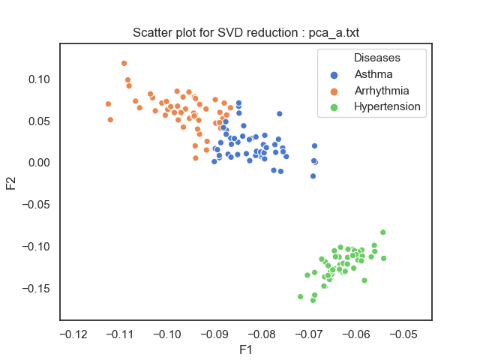

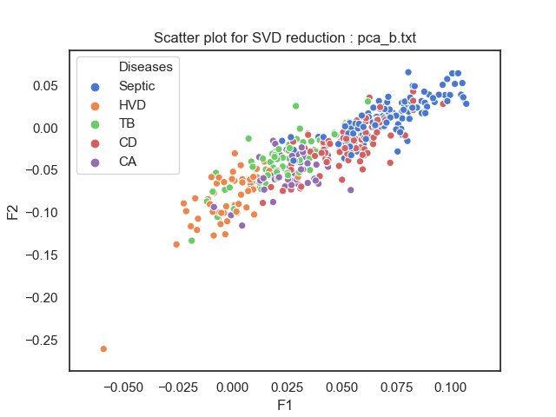

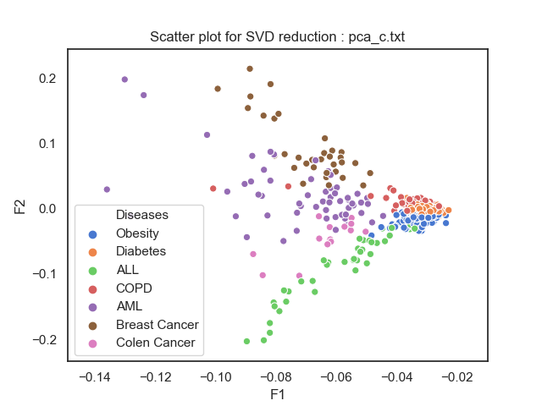

Since the value of D obtained in the result of S.V.D. are in sorted (descending) order, the inference is that the first 2 columns of U gives the strongest approximation of the original matrix. Secondly PCA gives the results centered around the mean, so if we give data centered around the mean we get results similar to PCA as shown.

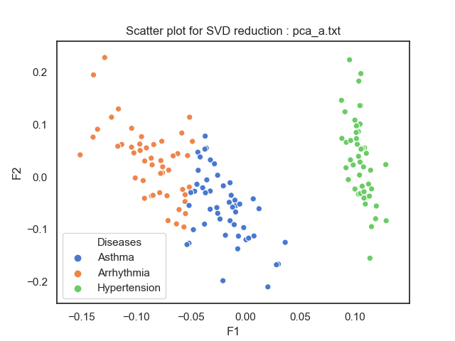

T-S.N.E. Results:

T-SNE method uses a probability distribution using the relationships between all the data points. It then projects it on lower dimensional space using a ‘t’ distribution that resembles the original one as closely as possible.

