Annual Salary Calculator

Madeline Field

# Specification

*To automatically calculate the salary and december bonus of an employee based on a “salary points” credit system.*

# Technical design

*PSUDOCODE:*

*calculateAnnualBaseSalary() //work out annual salary (no bonus)*

*calculateChristmasBonus() //work out Christmas bonus*

*calculateAnnualSalary() //work out final annual salary*

*calculateDecemberSalary() //work out December salary*

*main{*

*//read in the salary point*

*enter ("Enter the salary point: ")*

*annualBaseSalary = calculateAnnualBaseSalary()*

*christmasBonus = calculateChristmasBonus()*

*annualSalary = calculateAnnualSalary()*

*decemberSalary = calculateDecemberSalary()*

*output ("Annual salary is: £" + annualSalary)*

*output ("December monthly salary is: £" + decemberSalary )*

*}*

*calculateAnnualBaseSalary{*

*return pointsIn * scalePointValue*

*}*

*calculateChristmasBonus{*

*return ((annualBaseSalaryIn * bonusRate) / 100)*

*}*

*calculateAnnualSalary{*

*return annualBaseSalaryIn + christmasBonusIn*

*}*

*calculateDecemberSalary{*

*return monthlySalary + christmasBonus*

*}*

Flowchart:

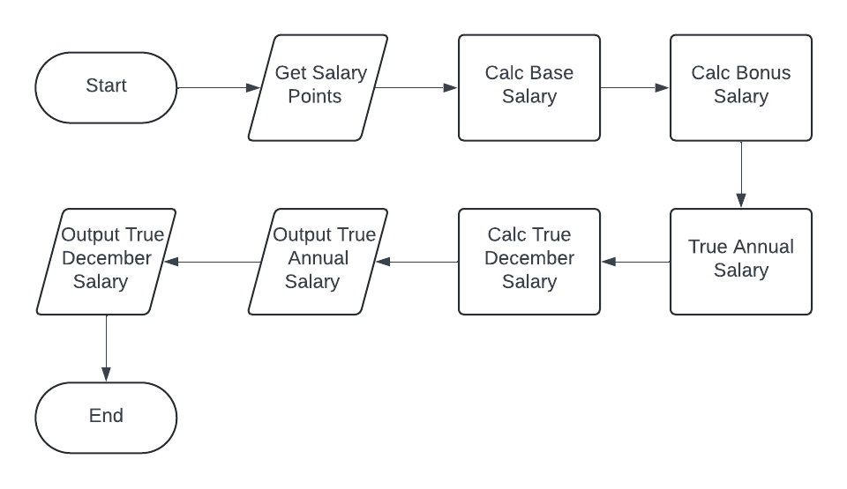

Procedure Dependency Diagram:

# Test plan

*Fill out the following testing table and fix any errors.*

|  |  |  |  |  |  |
| --- | --- | --- | --- | --- | --- |
| Input **salaryPoint** | Rationale | Output  **annualSalary** | | Output  **decemberSalary** | |
| Expected | Observed | Expected | Observed |
| 6 | Integer value, in range | 12300.00 | 12300.00 | 1300.00 | 1300.00 |
| 1 | Integer value, min value in range | 2050.00 | 2050.00 | 216.67 | 216.67 |
| 24 | Interger value, max in range | 49200.00 | 49200.00 | 5200 | 5200 |
| 0 | Integer value, out of range (null) | 2050.00 | 2050.00 | 216.67 | 216.67 |
| -1 | Integer value, out of range (low) | 2050.00 | 2050.00 | 216.67 | 216.67 |
| 999 | Integer value, out of range (High) | 49200.00 | 49200.00 | 5200 | 5200 |
| 1.2 | Float value | 2050.00 | 2050.00 | 216.67 | 216.67 |
| foo | Non number value | ? | 2050.00 | ? | 216.67 |

# GiT commit log

*All work should be kept on GiT (once it’s introduced in class), bitbucket and github are free to use. Make sure the repository is marked private or people will google the code and find it. A screen shot of the git commit log will suffice, it needs to show who did what and when. At level 4 it will take a while to learn to use GiT, but we will eventually.*

# Schedule

|  |  |  |
| --- | --- | --- |
| ***Task*** | ***Estimated Hrs*** | ***Actual Hrs*** |
| *Design* | *1* | *2* |
| *Implement* | *1* | *0.5* |
| *Debug and test* | *0.5* | *1* |
| *Uploading And Packing* | *0.25* | *0.25* |
| ***total*** | ***3.75*** | ***3.75*** |