Annual Salary Calculator
Madeline Field

Specification
To automatically calculate the salary and december bonus of an employee based on a “salary points” credit system.

Technical design

PSUDOCODE:

calculateAnnualBaseSalary() //work out annual salary (no bonus)
calculateChristmasBonus() //work out Christmas bonus
calculateAnnualSalary() //work out final annual salary
calculateDecemberSalary() //work out December salary

main{
//read in the salary point
salaryPoints = input ("Enter the salary point: ")
annualBaseSalary = calculateAnnualBaseSalary()
christmasBonus = calculateChristmasBonus()
annualSalary = calculateAnnualSalary()
decemberSalary = calculateDecemberSalary()

output ("Annual salary is: £" + annualSalary)
output ("December monthly salary is: £" + decemberSalary )
}

calculateAnnualBaseSalary{
return salaryPoints * scalePointValue
}

calculateChristmasBonus{
return ((annualBaseSalaryIn * bonusRate) / 100)
}

calculateAnnualSalary{
return annualBaseSalaryIn + christmasBonusIn
}

calculateDecemberSalary{
return monthlySalary + christmasBonus
}

Flowchart:
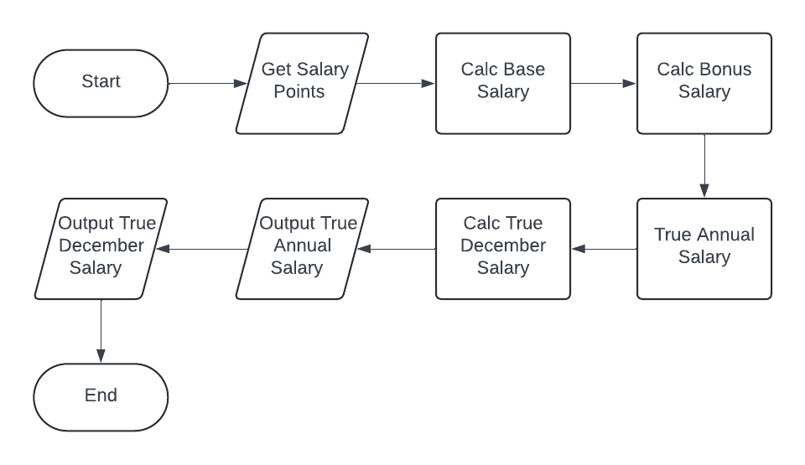
Procedure Dependency Diagram:

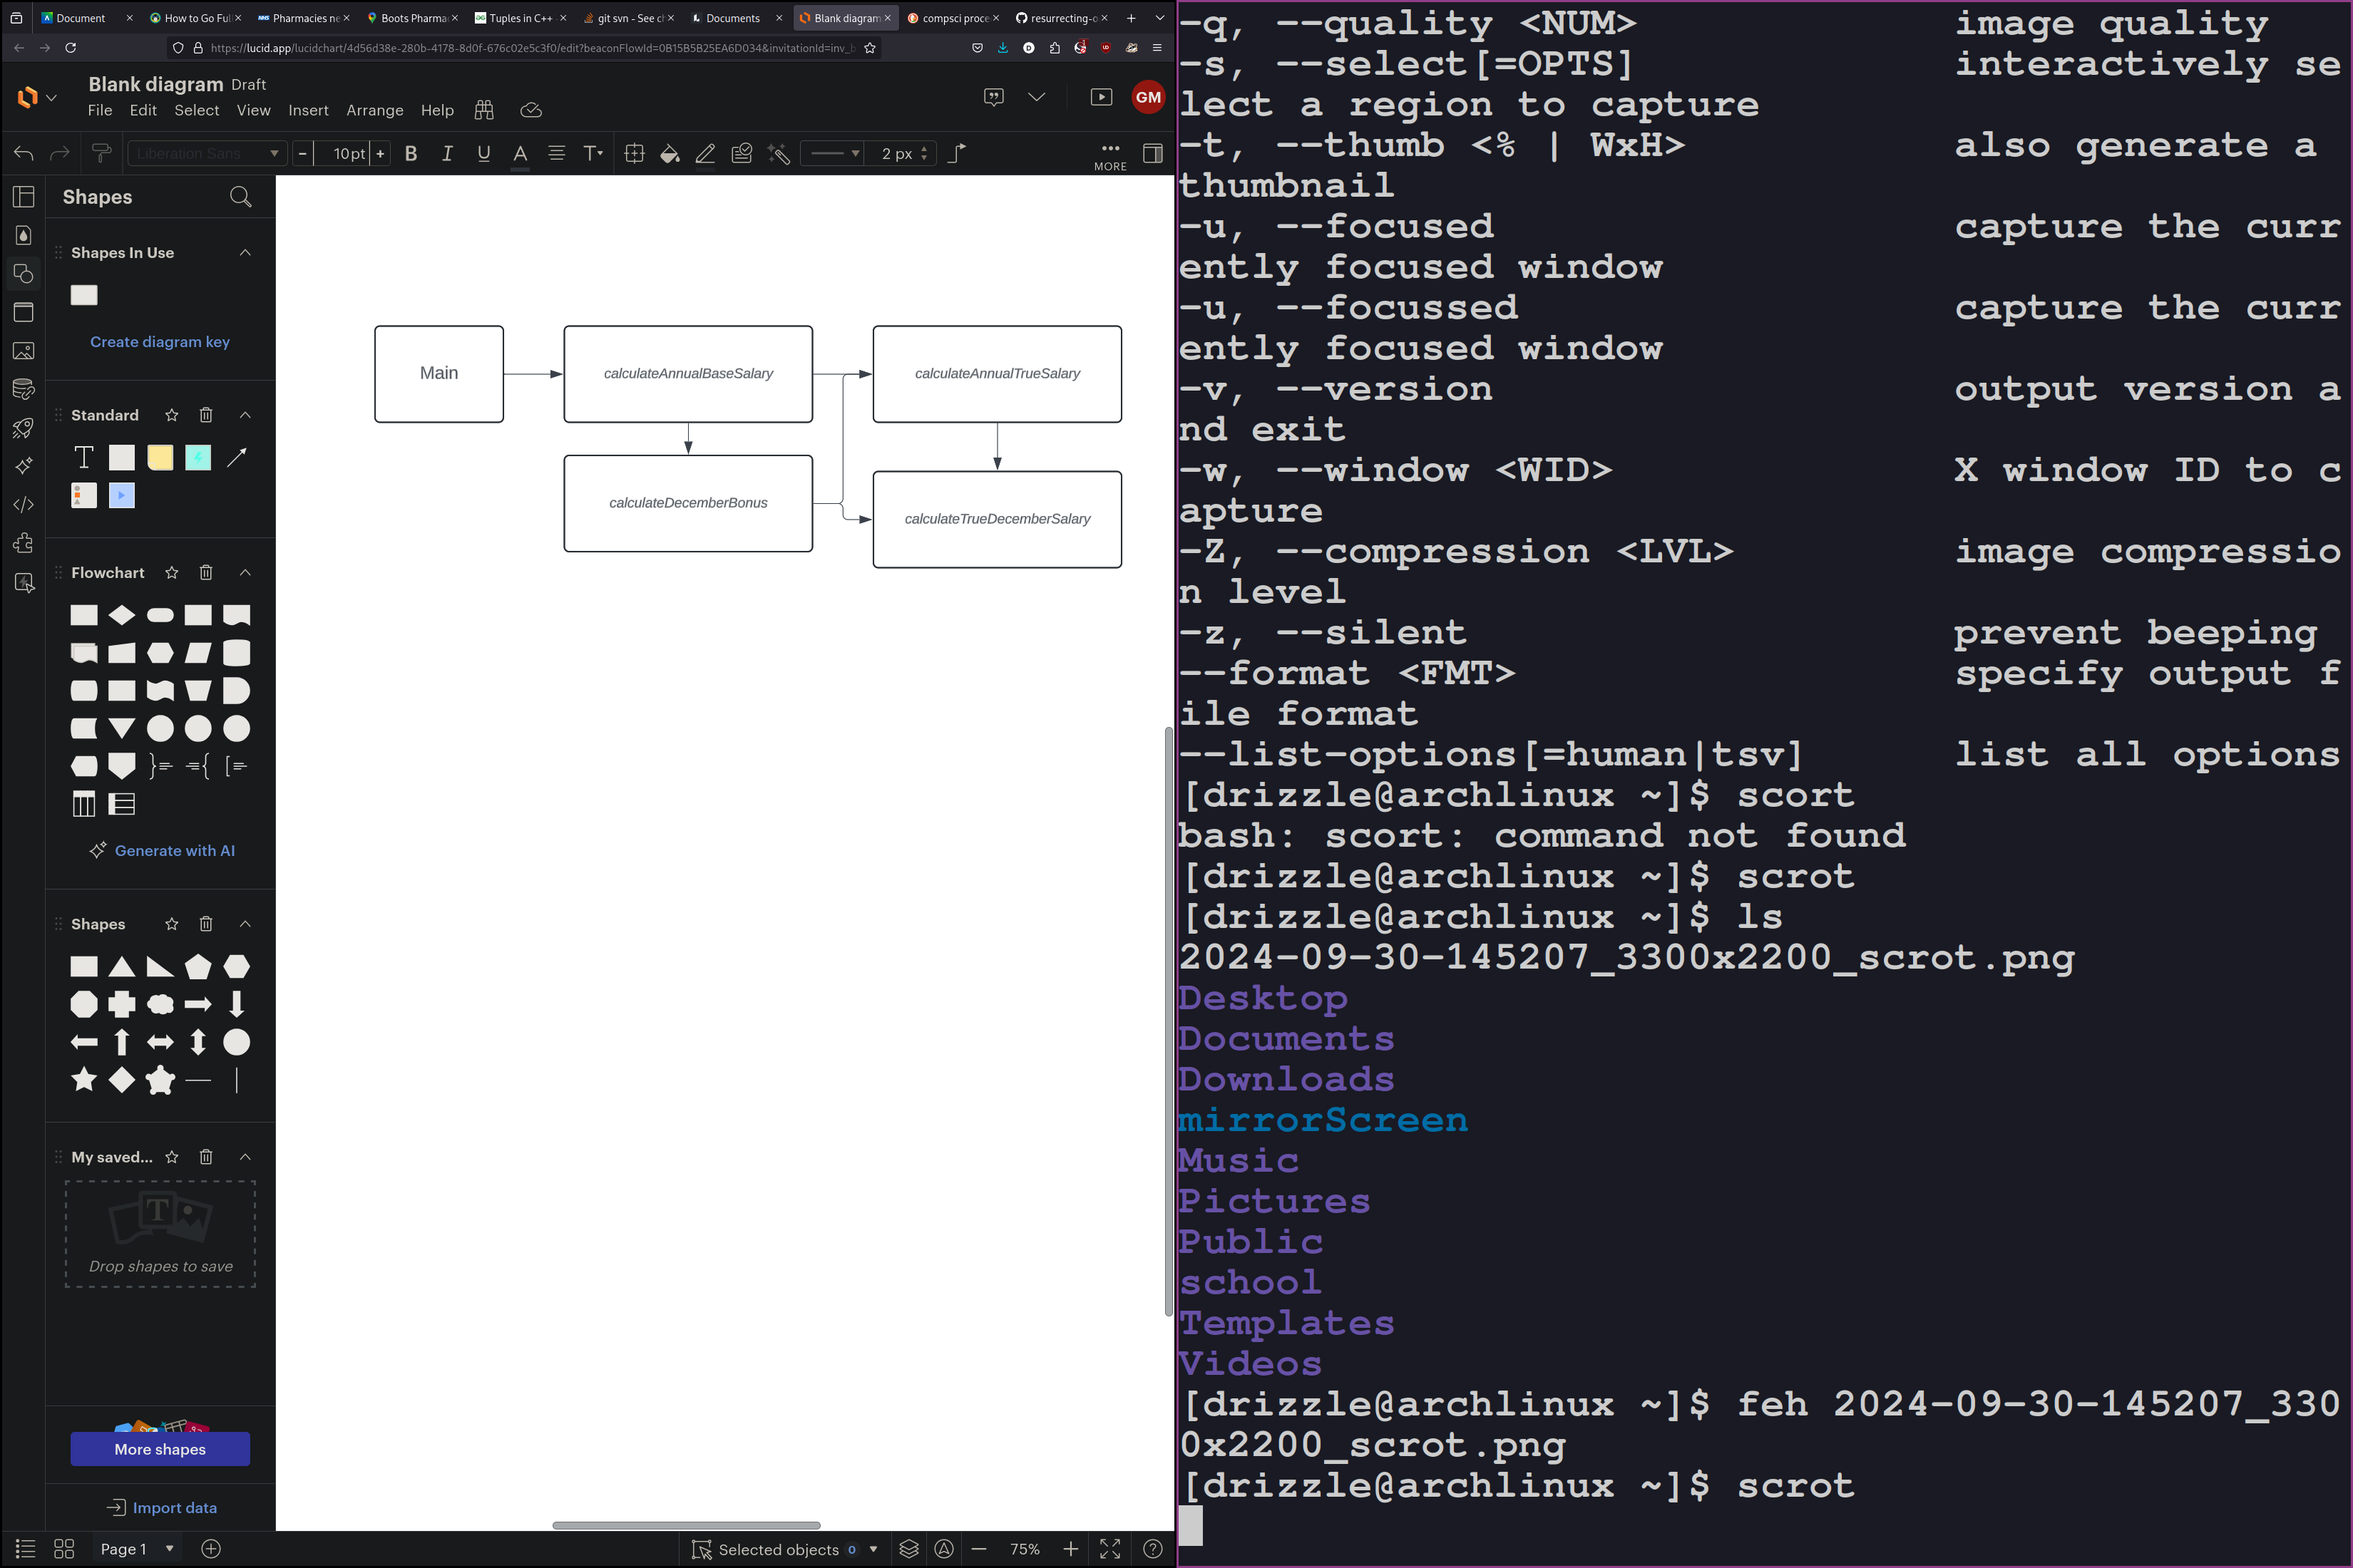
Test plan
Fill out the following testing table and fix any errors.
Input  salaryPoint | Rationale | Output  annualSalary |  | Output  decemberSalary
 |  | Expected | Observed | Expected | Observed
6 | Integer value, in range | 12300.00 | 12300.00 | 1300.00 | 1300.00
1 | Integer value, min value in range | 2050.00 | 2050.00 | 216.67 | 216.67
24 | Interger value, max in range | 49200.00 | 49200.00 | 5200 | 5200
0 | Integer value, out of range (null) | 2050.00 | 2050.00 | 216.67 | 216.67
-1 | Integer value, out of range (low) | 2050.00 | 2050.00 | 216.67 | 216.67
999 | Integer value, out of range (High) | 49200.00 | 49200.00 | 5200 | 5200
1.2 | Float value | 2050.00 | 2050.00 | 216.67 | 216.67
foo | Non number value | ? | 2050.00 | ? | 216.67

GiT commit log
All work should be kept on GiT (once it’s introduced in class), bitbucket and github are free to use. Make sure the repository is marked private or people will google the code and find it. A screen shot of the git commit log will suffice, it needs to show who did what and when. At level 4 it will take a while to learn to use GiT, but we will eventually.

Schedule

Task | Estimated Hrs | Actual Hrs
Design | 1 | 2
Implement | 1 | 0.5
Debug and test | 0.5 | 1
Uploading And Packing | 0.25 | 0.25
total | 3.75 | 3.75

