Side Scrolling Shmup Design Document

Understanding the template
In order to better understand the codebase i created a flowchart and procedure dependency for diagram for the template codebase. They are very simple for this template

Procedure Dependency Diagram
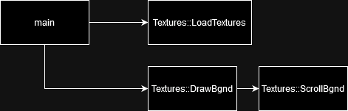

Flowchart
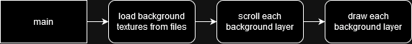

Upgrading the template
In order to help me plan the changes i wanna make i made a flowchart for the program after the planned upgrades
I dont think the current system of storing the sprites in the template is easily extendable, and as such i will be building my own system, storing the sprites within an entity object.

Entity object{
Float xPos, yPos
entSpr
initEnt{
setTexture()
setPos()
}
RenderIn{}
setPos{}
accellEnt{}
mvEnt{
clampToScreen()
}
updateEntPos{}
}

Ship::entity object{
handleUserInputs{
Vector2 inputtedDirect
getUsrInForInputtedDirect
accellEnt(inputtedDirect*MoveSpeed*deltaSinceLastFrame)
}
}

