Factory Battles SFML Proto
Madeline Field

Specification
- To allow learning sfml basics in a fun project
– head to head competitive factory builder with skill expression mechanically and strategically
– resource management/efficiency based gameplay using a crafting system aswell as limited resource gen per min
– Varying gameplay between matches
– online networking
– fun
– A fun multiplayer game with medium sized matches (~20 mins ish)

Technical design

PSUDOCODE:

Obj ent{
InitEnt()
RenderEnt()
RenderHeldItems()
AddToInv()
RemFromInv()
ProgressCrafting()
}

Obj item{
RenderItem()
}

Obj receipe{
SetRecipe()
CheckIfRecipePossible(ComponentsIn)
CalcNewComponentsAfterCrafting(ComponentsIn)

Obj grid{
FillGridspace()
EmptyGridspace()
DrawGrid()
ProgressCraftingForEntsInGrid()
}

Obj ui{
DrawHud()
ChangeSceneToGame()
ChangeSceneToMenu()
}

Obj multiplayer{
HostGame()
JoinGame()
SentUpdateTick()
RecUpdateTick()
SyncGamestates()
}

Flowchart:
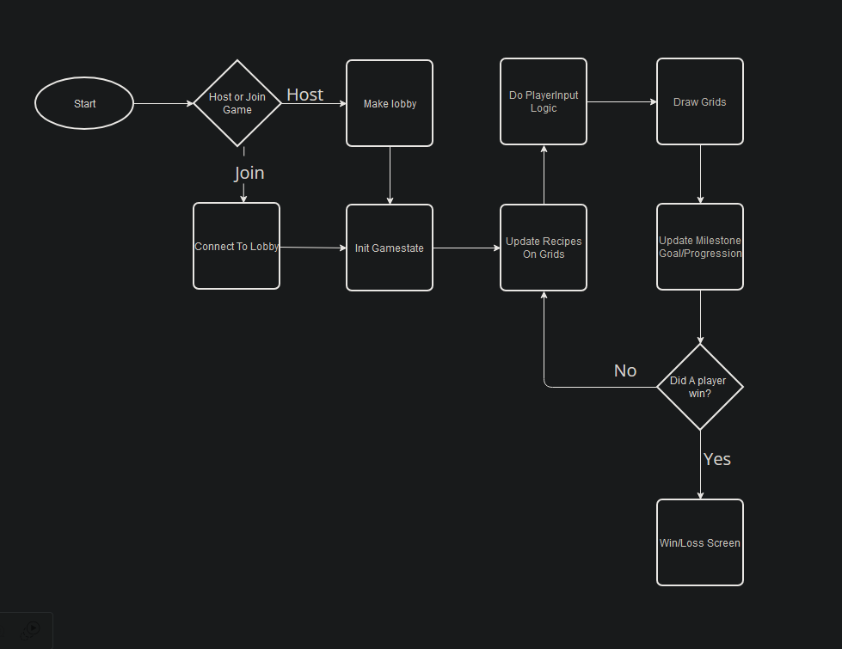
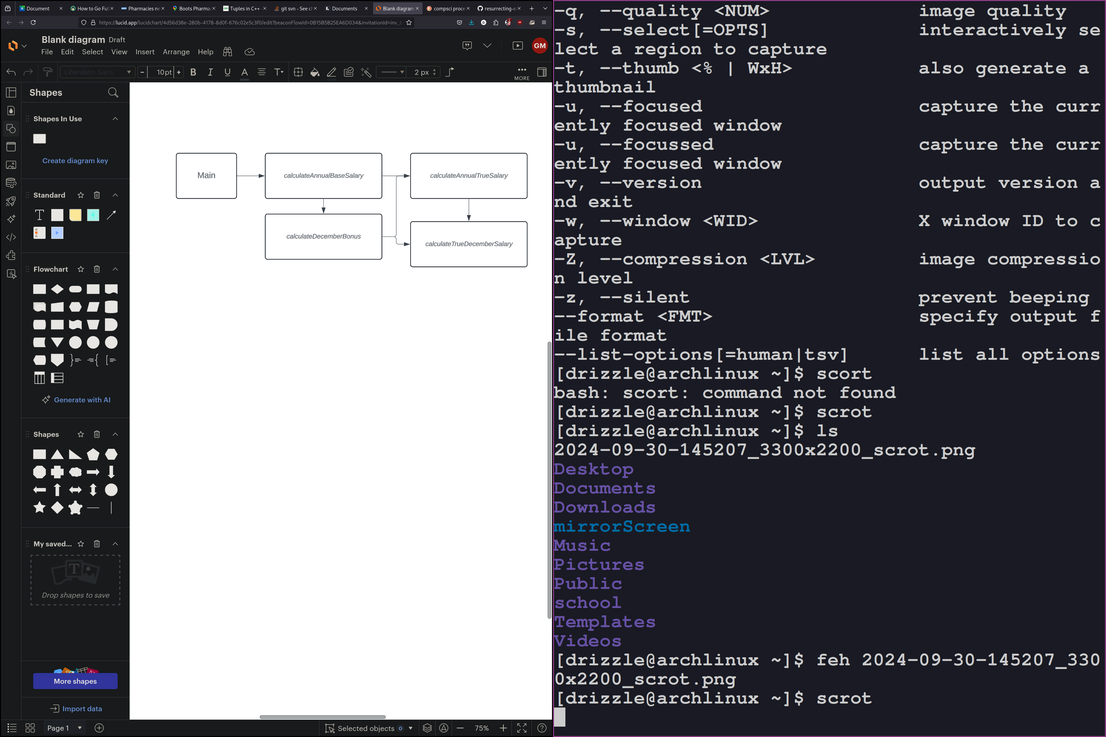
Procedure Dependency Diagram:

Test plan
Fill out the following testing table and fix any errors.
Input  TODO | Rationale | Output  annualSalary
 |  | Expected | Observed

GiT commit log

Schedule

Task | Estimated Hrs | Actual Hrs
Design Pass1 | 2 | 5
Implement MVP - grid | 1 | 4
Implement MVP - Ents | 1 | 5
Implement MVP - Items | 1 | 2
Implement MVP - Recipes/crafting | 2
Debug and test | 2
Design retrospective | 2
Implement changes | 1
Debug and test | 1
Playtesting | 4
Implement changes | 1
Debug and test | 1
Ship Game | 1
total | 20 | 16+

