# Blob array game design doc

### Understanding template

In order to better understand the codebase i created a flowchart and procedure dependency for diagram for the template codebase

#### Template Procedure Dependency diagram

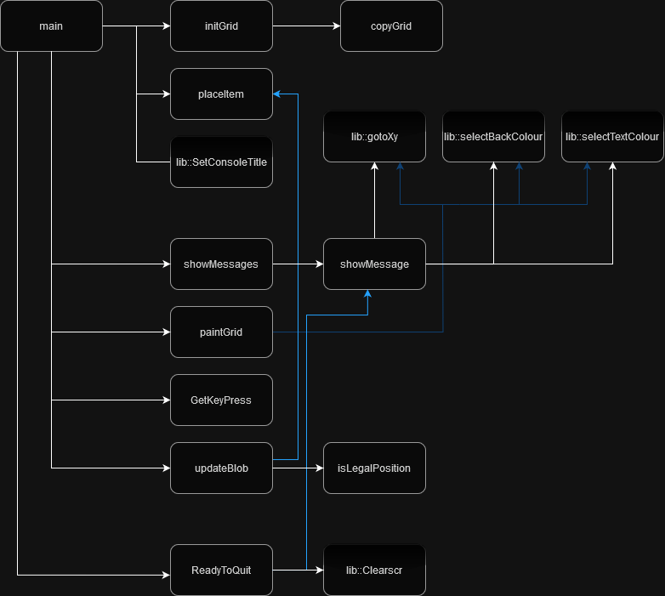

#### Template Flowchart

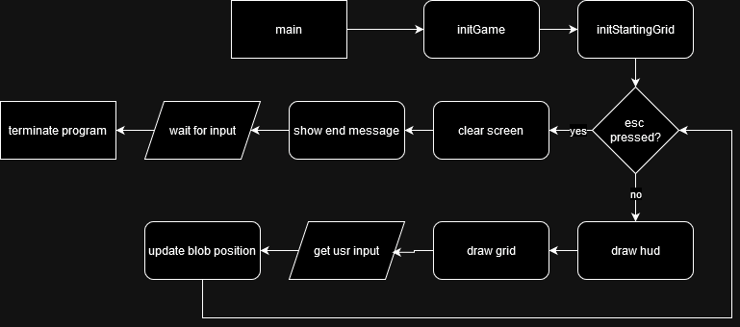

### Upgrading the template

In order to help me plan the changes i wanna make i made a flowchart for the program after the planned upgrades

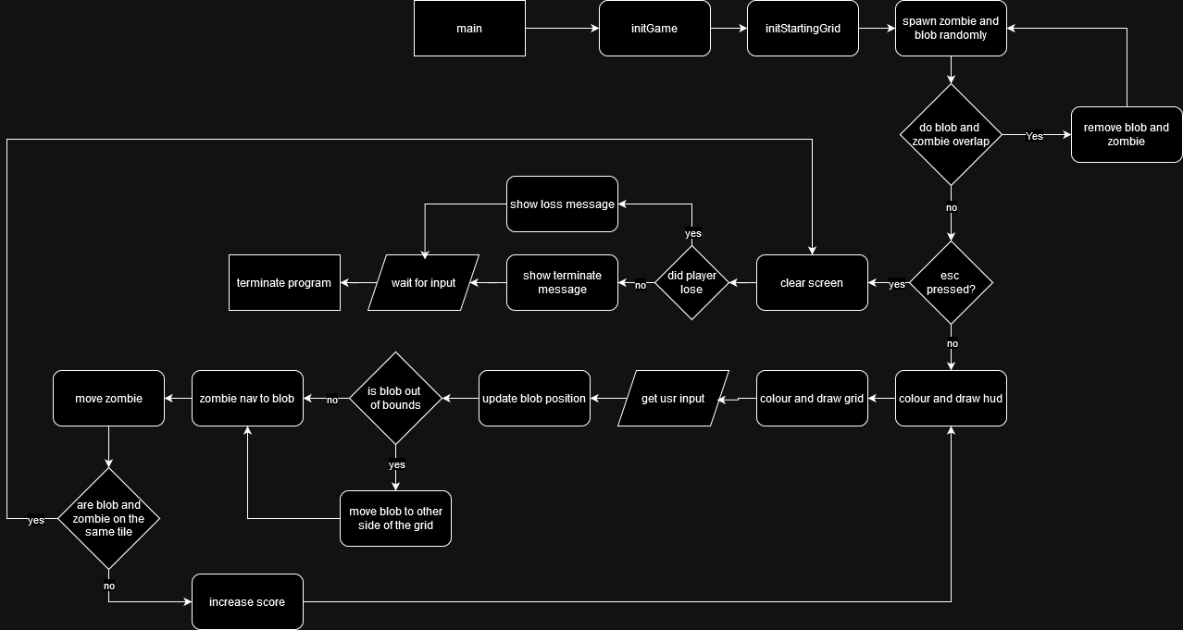

### Implementing these upgrades

#### Required procedure additions to codebase

flipPosAtWall()

move a chose coord to the other side of the grid, so player can scroll over the other side

UpdateZomb()

update the position of the zombie

Find the direction to the player and move in that direction

psudoCode:

UpdateZomb(){

//Take the zombie position away from the players position in each axis to find the direction to move, then move 1 tile in that direction for both axis

offset = blobPos – zombPos

setOffsetDistTo1Tile(offset)

limitToGridConfines(offset)

moveZomb(zombPos+offset)

}

CheckIfDead()

Check if the player and zombie are one the same tile

pickRandomEmptyPointOnGrid()

#### Other changes planned

I would like to change the draw function to put whitespace between grid items so it has a better looking aspect ratio

Should not affect the storage of the grid

Add a “cout << GRIDSPACE;” to each item outputted in the grid

Add a GRIDSPACE const

A case for the zombie in the colour switch in PaintGrid() function

The SIZEX and SIZEY consts needs changing plus as well as the initial grid.

Score display added to hud and death message.

Randomised spawns

## Post changes

#### Post mortem

The game is not fun? The zombie ai is very exploitable with the ability to teleport to the other side. There is a complete lack of skill expression possible within the current brief other then kiting the zombie around. Due to the speed of the zombie and the size and shape of the map it is impossible to kite the zombie for an extended period of time without using the teleport, and the teleport is not engaging or fun to use.

Is this fixable? I believe the teleport needs a major nerf to stop it being a required strategy, and more movement or fighting elements need to added to the players arsenal in order to allow them to fight the zombies. The zombie may also need to be slowed down or the stage size increased as in order to give the player more room to move around the zombie. More zombies would also give the player more things to keep track of, which may lead to more engaging decision making. Some form of hazard/obstacle may also be used to allow more skill expression when kiting the zombie(s).

### Plan to solve problems.

In order to solve this problem i would suggest to giving the player a way to kill the zombies, as well as add verticality to the map in order to increase the decision making and skill expression for the player. Along with a bigger map and more zombie spawns i believe alot of fun can be injected into the current game.

#### Bombs

To supplement the core gameplay pillar of kiting i think bombs that the player can kite multiple enemies over would give much needed game feel and skill expression, without overloading the interface or control.

#### Verticality

By adding in areas that are higher and lower then others i hope to give the player more thought in their movements then simply “run away from the zombie”, giving certain areas strategic importance over others.

### Git Log

|  |
| --- |
| commit a7a1a8c48d62eb7b0af0059fe9f218ae12f50149  Author: dr1zzleGDShu <c4024637@my.shu.ac.uk>  Date: Mon Nov 25 01:18:23 2024 +0000  Finned docx  commit 9d0be819875e00e20ace3cd4b37a8c5ca47d7ad2  Author: dr1zzleGDShu <c4024637@my.shu.ac.uk>  Date: Mon Nov 25 00:57:06 2024 +0000  fixes outlined  commit 8ecfe330fbd76bf3e816bdac5778dc8abec134e8  Author: dr1zzleGDShu <c4024637@my.shu.ac.uk>  Date: Mon Nov 25 00:29:45 2024 +0000  uptoPostMortem  commit 787fec84b5aa03dd55c9138b1e4100eb6632b4cc  Author: dr1zzleGDShu <c4024637@my.shu.ac.uk>  Date: Sun Nov 24 20:35:02 2024 +0000  randomSpawnPos  commit f6fb7cedbae489e9fa03ed8dd89c610f08f724b8  Author: dr1zzleGDShu <c4024637@my.shu.ac.uk>  Date: Sun Nov 24 20:10:51 2024 +0000  completedMinRequ  commit 3704ad30aa6ee0725fd3818635b854e1c4b74416  Author: dr1zzleGDShu <c4024637@my.shu.ac.uk>  Date: Sun Nov 24 19:20:14 2024 +0000  why it not movin da zombie????  commit d29b9c5098a617a3abf6a08ed5c497d265269f88  Author: dr1zzleGDShu <c4024637@my.shu.ac.uk>  Date: Sun Nov 24 18:03:16 2024 +0000  improvedFlowchart  commit fbed045e35fce811f1988b109aa24024e01a0d1c  Author: dr1zzleGDShu <c4024637@my.shu.ac.uk>  Date: Sat Nov 23 22:01:12 2024 +0000  started hw2  commit cf463ded1af63f78842036c77e11c30d8a2bda6c  Author: dr1zzleGDShu <c4024637@my.shu.ac.uk>  Date: Mon Nov 11 11:32:27 2024 +0000  importedBlobstarter |

## Testing

|  |  |  |
| --- | --- | --- |
| Test | Estimated Outcome | Outcome |
| Walk into zombie | Death | As expected |
| Walk into wall | Teleport to other side | As expected |
| Run away from zombie 1 tile away | Zombie follows, player survives | Zombie kills player |
| Input 2 directions at once | Zombie moves 2 spaces | As expected |
| Die and press any button | Game exits, no crash | As expected |

## Time spent estimations

## 

|  |  |  |
| --- | --- | --- |
| Task | Estimated time (approx hours) | Actual Time (approx hours) |
| Understand and diagram template | 2 | 1 |
| Plan and diagram improvement | 2 | 1 |
| Reformat output and bigger grid | 1 | 1 |
| Score system | 1 | 1 |
| Teleport when out of bounds | 1 | 1 |
| Zombie object | 1 | 1 |
| Pathfinding | 2 | 1 |
| Death Message | 0.5 | 1 |
| Comment codebase | 1 | 2 |
| Polish | 2 | 3 |
| Post mortem | 2 | 1 |
| Fin docs | 2 | 1 |
| Total | 17.5 | 15 |