Factory Battles SFML Proto

Madeline Field

# Specification

*- To allow learning sfml basics in a fun project*

*– head to head competitive factory builder with skill expression mechanically and strategically*

*– resource management/efficiency based gameplay using a crafting system aswell as limited resource gen per min*

*– Varying gameplay between matches*

*– online networking*

*– fun*

*– A fun multiplayer game with medium sized matches (~20 mins ish)*

# Technical design

*PSUDOCODE:*

Obj ent{

InitEnt()

RenderEnt()

RenderHeldItems()

AddToInv()

RemFromInv()

ProgressCrafting()

}

Obj item{

RenderItem()

}

Obj receipe{

SetRecipe()

CheckIfRecipePossible(ComponentsIn)

CalcNewComponentsAfterCrafting(ComponentsIn)

Obj grid{

FillGridspace()

EmptyGridspace()

DrawGrid()

ProgressCraftingForEntsInGrid()

}

Obj ui{

DrawHud()

ChangeSceneToGame()

ChangeSceneToMenu()

}

Obj multiplayer{

HostGame()

JoinGame()

SentUpdateTick()

RecUpdateTick()

SyncGamestates()

}

Flowchart:

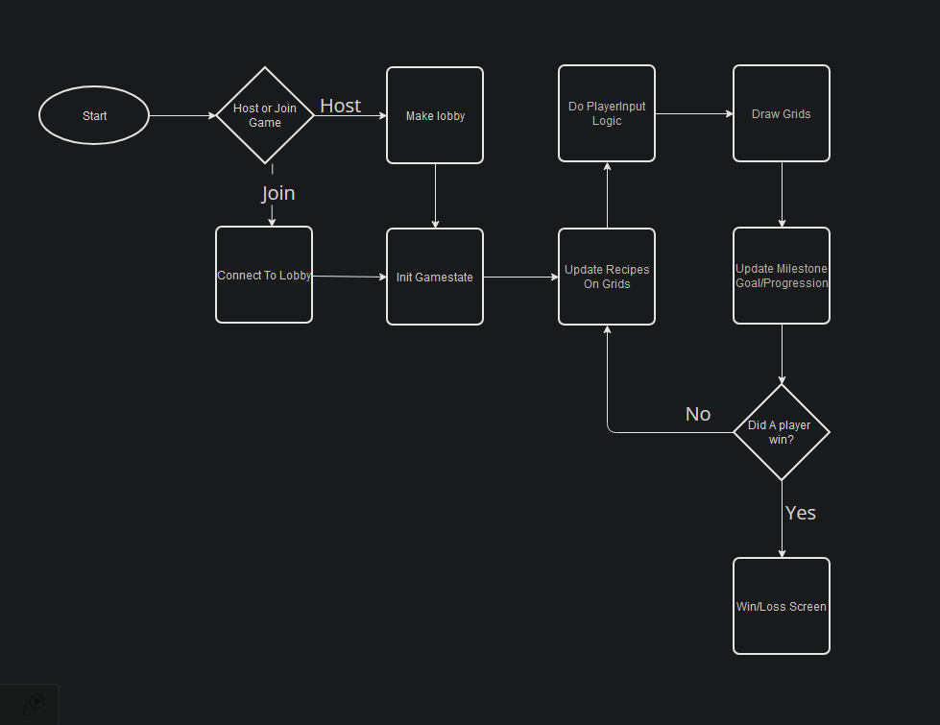

Procedure Dependency Diagram:

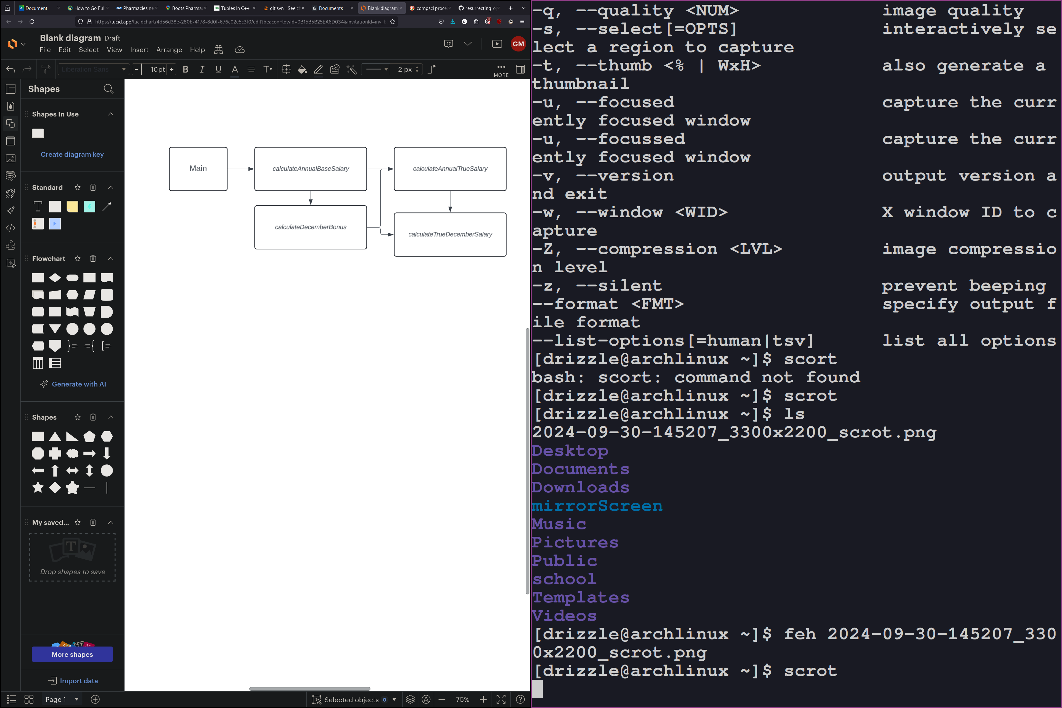

# Test plan

*Fill out the following testing table and fix any errors.*

|  |  |  |  |
| --- | --- | --- | --- |
| Input **TODO** | Rationale | Output  **annualSalary** | |
| Expected | Observed |
|  |  |  |  |

# GiT commit log

# Schedule

|  |  |  |
| --- | --- | --- |
| ***Task*** | ***Estimated Hrs*** | ***Actual Hrs*** |
| *Design Pass1* | *2* | *5* |
| *Implement MVP - grid* | *1* | *4* |
| *Implement MVP - Ents* | *1* | *5* |
| *Implement MVP - Items* | *1* | *2* |
| *Implement MVP - Recipes/crafting* | *2* |  |
| *Debug and test* | *2* |  |
| *Design retrospective* | *2* |  |
| *Implement changes* | *1* |  |
| *Debug and test* | *1* |  |
| *Playtesting* | *4* |  |
| *Implement changes* | *1* |  |
| *Debug and test* | *1* |  |
| *Ship Game* | *1* |  |
| ***total*** | ***20*** | ***16+*** |