Factory Battles

Game and Technical Design Doc

Madeline Field

# High Level Description

## Gameplay Overview

## Theme Setting and Factions

## Gameplay

## Gameplay Objectives

## Gameplay Mechanics

## Player Interaction

## Progression

## Art

## Machine Design

## Story

## World Design

## UI/UX

## Technical

## Dev Tools and Libs

## Target Platforms

## Machine and Entity Interaction

## Backend Entity Representation

## Multiplayer

## Misc

## Scoping

## Demographics

## 

High Level Description

Gameplay Overview

Factory Battles is a a fast paced PVP factory Builder. Players will be going head to head to turn resources into products which can be used to scale up production, defend their factory, sabotage their opponents factory, or complete Milestone Objectives. The first player to complete 3 Milestone Objectives will win the game, with each Milestone Objective completed giving the player new building or buffs for an upper hand over their opponent. The game features “Rock Paper Scissors Win” style balancing to incentive both risky greedy strategies, aswell as requiring players to react to each other in order to maximise chances of winning. To achieve this there are 4 categories of buildings

1. Production: Which will give more resources faster, allowing faster access both to the win conditions and constructing buildings, leading to a playing being able to run away with a lead.

2. Offence: Allowing players to sabotage each other.

3. Defence: Protects from attacks of offence type buildings.

4. Logistics: These buildings facilitate things like the completing Milestone Objectives and act as the glue for your factory, these are always required and present a weak point for the other player to attack, aswell as enforcing a one time “tax” on resources to nerf boring “spamming” tactics and reward efficient factory building, allowing for further skill expression.

These 4 building types lead to a triangle of balance that fuels fun PVP and increases replayability.

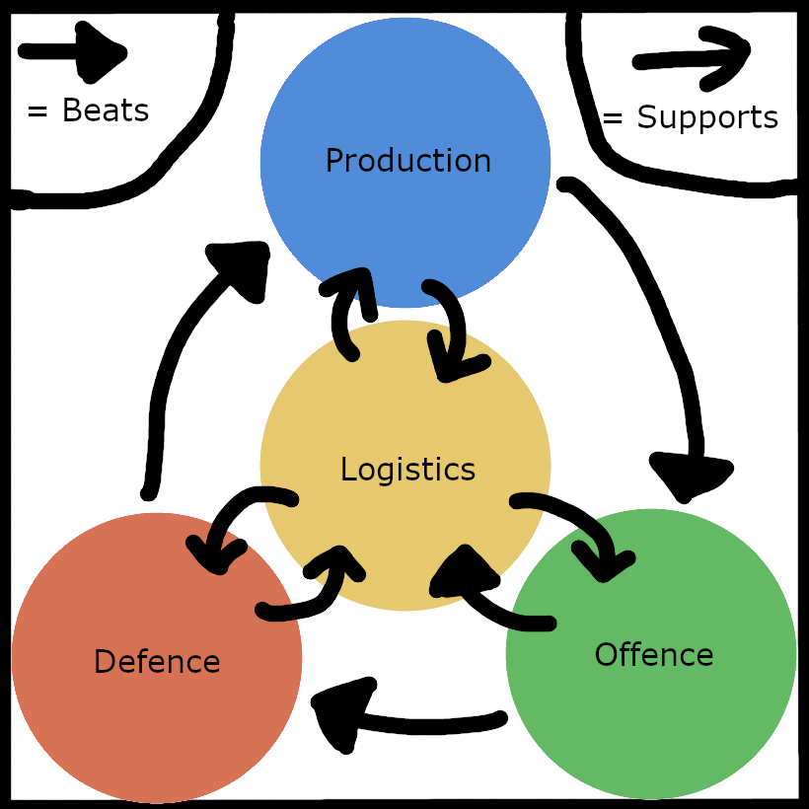

Theme, Setting and Factions

The games story and lore centrers around a fictional company travelling to the stars to in order to exploit the untapped natural resources of new far off planets. Due to the nature of space travel, new voyages to these planets bring with them multiple parties looking to prove themselves to the company in order to win the rights in perpetuity to the resources of this planet. The player is tasked with completing the Milestone Objectives faster then the competition in order to win these rights and secure themselves a lucrative future in the outer rim.

Gameplay

Gameplay Objectives

In order to complete the Milestone Objective the player must “sacrifice” resources in large numbers hit a certain score, with more complex resources being worth more points, and the diminishing returns of score per type of item sacrificed by either you or your opponent, incentivising the player to implement multiple strategies, and to increase the variety in the meta.

1. Complete the Milestone Objective (as fast as possible)
   1. Create Intermediate Materials as quickly as possible
   2. Increase the variety of materials
      1. Repurpose existing factory lines to create new types of item
2. Slow down the other player completing their Milestone Objective
   1. Tank the cost of the items that are relying on my sacrificing them yourself
   2. Attack their factory or logistics lines
3. Defend you factory from the other player
   1. Build defensive buildings
   2. Diversify your sacrificial items